Module: Creative Events Design and Planning (BMBM4000)
Assignment 2
Link Available to Elevator Pitch for the Creative Bubble: https://www.youtube.com/watch?v=XvgLQgX-JJc

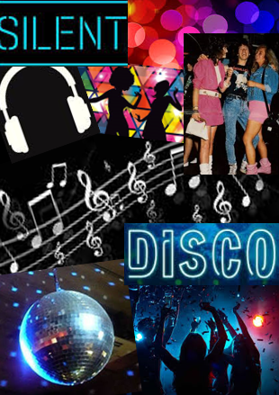
Moodboard

