9/2/2022

My Personal Development Reflection Report
(Academic and Employability Skills)
Prepared for:
Joanna Walsh
CertHE T1GW2 ACE

Muhammad Arif Reza
Student ID: 2130775
BMSW4001 ACE. GW2. Weekend.

Table of Content

Introduction Page 2

Time Management Page 3

Organising Study Page 5

Academic Writing Page 7

Conclusion Page 9

References Page 10

Appendix Page 11
Introduction

In this Reflective report I am going write about the area which I need to improve in my personal development plan where I am now and where I want to be. There are three areas I need to work on mostly after the SWOT analysis I discover that my most three weakness are as Time Management issue, Less educational qualification and less Training on development. In this modern era. I have to consistently improve myself to survive and chase my goal. I believe it’s essential for my day-to-day life development. I’m going to utilise my knowledge about this writing from my class lectures and supporting sources. I take the opportunity to describe my plan, thought and opinions for the nest Three topics.

Time Management

Time management is a skill that I need to work on and improve myself. It is the ability or process to use my time effectively with high productivity. It is a practical process to keep and follow-up everyday basis. There are some tools I can use to utilise time management skills like
- Prioritising: This is probably the first tool to decide which task is more important than others. As time keeping is very important for any kind of deadline, schedule or meeting I must prioritize which comes first. Sometime in life we can find two thing comes in same time with high priority but then I must decide which is more important for mine.

- Decision Making: It is very crucial for success. I must decide the right things on right time to get on time. In this stage I must decide which one I will, or I don’t. In this stage some time its stressful but always keep in mind the priority & urgency of that task.

- Delegation: it is somethings urgent for me but not important. So, I will try to delegate someone if they can do it for me to priorities my other tasks. Its something scheduling meeting, ordering something, book a trip & non important email check.

- Goal Setting: I have set a target in life as well as any task then and only I can check which deration I’m heading to. It is very important for any task to setup a goal first.

- Multitasking: It is a something increase productivity by doing more than one task at the same time. This way I can save more time by doing more things done.

- Problem solving: This tool will help me to understand better by solving any initial issues or problems. It’s also help me to manage my time more effectively.

- Strategic thinking: The more I can think strategically the better I can utilise my time. It is something come from experience and practical work.

 | Urgent | Not Urgent
Important | Do Now | Do Next
Not Important | Do Later  Or  Delegate | Ignore
Table: Time Management priority matrix

To develop myself I need to emphasise on my time management skills at first. As time is money so I must utilise it wisely. I need to be more organise by myself. Need to follow the strict time schedule with priority. Make sure I set the target and work on it to chase my goal. I need to be drive with motivation to perform better. I can follow up the JIT method to improve my time management skills as well. Just In Time (JIT) method process mainly use for inventory but can be utilise every aspect of life. It is something Priority, plan and make schedule for future workload. If I can keep up to date with all my work schedule it will be the ultimate success path for my life. It is not easy at all the time but its not impossible.


Organising Study

This is my second topic to develop myself. I was behind due to an academic degree. So now I started this course to learn and develop myself. It is always good to be back to study. It’s a great feeling. It is help me to be more confident about myself. It gives a good vives & motivation to set up a new target in my life. It has inspired me to do more and can-do attitude in my life as I can figure out potentiality and capability of myself. There is always room to start and do better development in life. Never stop dreaming just work hard on it until it is achieved.
Getting myself organised for study is very important. I feel there are some steps on it as below.

- Place to study: I think this is the first step to organise the study. Because we need to choose which place or where I’m going to study. There are different places for study like from home, distance learning, classroom, library or online learning. I personally like classroom study as its give direct interaction and physical motivation of study.
Location is very important for study environment. As its help the best use of you study time. University is the better option as always have good and better environment for study as they got lots of resources and facilities.
I need to organise my study materials as well. It’s very important how organise and science about my study. Such as I need to organise my notebooks, my university carry bags, need a laptop to perform my writings or use online resource.


- When to Study: I think it’s very crucial to manage time for study. As I am a family man and I got to work so I must balance my work, study and family life at the same time hence I decided to study at weekend now. This way I can continue my work and study smoothly without any time difficulty. I have to bear in mind the study load as well because if I start the fulltime study then it might be hampering my work life and other schedules. I must understand how much work load I can handle at a time when it comes most. So, choosing the right time slot available for study is very important. There is always option like daytime study or evening time study as well as weekdays or weekend.

- Developing a Network for Study: Networking always make life much easier. Its same for study life as well. If I can develop a study network, then I can easily get help from them to better understanding about my courses and assessments. So, it is very important for me to make good relationship with my teachers and my classmates. Help can be taken face to face on campus or some time I get through over the phone, email and even WhatsApp group. Any kind of challenge regarding study related can be more manageable through networking. Study networking can be made in library and even online same subject group. There are lots of Fan club’s groups founded in different online platform like Facebook, WhatsApp and online. Its always good to know when and how I can get a help form my classmate or teachers because some may be good in writing or same may be good in technology and some may be good in presenting or making understand. I feel when I face crisis time to time regarding the study related my mates and networking groups helps a lot to by offering help and advice which help to boost my motivation and morale positivity.

Academic Writing

This is my third topic to improve my personal development plan. As I just started study again now, I can recognise how I need to improve my writing skills. Academic writing is much more formal style, which is more Focussed, Informative, Precise and Structured with the help of lots of references. Writing is very important as a student also in life. I believe good writing helps to develop good communication skills. There are different types of academic writing such as Essay, Research Proposal, Presentation, Research Paper, Thesis or Dissertation. In my current course I learned how to write CV (Curriculum Vitae), Presentation and Essay. If I can improve my academic writing skills then it will be easy for me to access current job market through my CV, I can well communicate through organization and write essay for my next course work. It also helps me to learn how I can do referencing, Paraphrasing and Summarising. When I start academic writing, I consider some points are below.

- Identify the purpose and reader: I have to first remember to whom and why I’m writing. Most of the academic wring are argument basis so I have to remember why I write for and who is the assessor and what was the things they asked for when I get the brief in my class.

- Formal & Unbiased: Academic writing always more formal as it’s for institution and for further reading references. Like its should be same text format with spacing and well presented. As mostly it’s present argument so its can’t be biased. It has to back by all the references and sources to mentioned.

- Well Structured and Focused: When I start writing I feel I need to make it well structured. So, I need to plan ahead that which way I will write such as Cover page, Table of Content, Introduction, Argument, Conclusion and References. I have to create an overall structure with points in a logical order. I had to make couple of draft work before I start final writing.

- Well Sourced: Academic writing must be well sourced. There is a plagiarism check steps in the writing upload so there is no way I can copy and paste. I have to go through details and do In-text citation and References. I must quote and paraphrase if I use somebody’s writing.

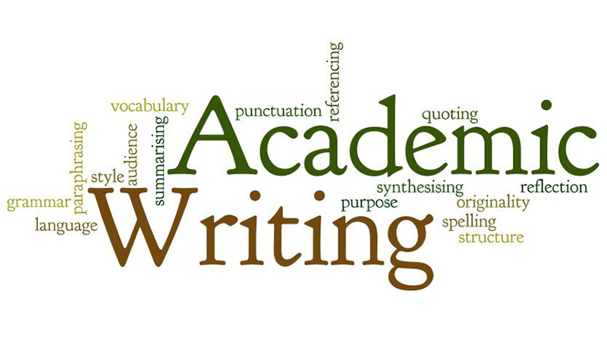

- Choose the correct tense and voice: There should be not too personal or long-winded sentence in the academic writing. Use of correct Past, Present and Future tense is very important. Normally past tense for method and present tense for conclusion and discussion establishment. In this reflective writing I use the first-person voice such as me, myself and I.

- Correct and Consistent: This one I consider as a last step of essay writing. In this stage I look for grammatical mistake, spelling, punctuation, numbers and abbreviations. If I write a lot with lots of grammar mistake it doesn’t mean nothing. I learn and practice Harvard referencing system on my reflective writing. I have to be more careful with presenting and writing while I deliver my academic writing.

Conclusion

This reflective writing gives me confident and motivation about academic writing. I write this one as a part of development plan PDP which I made a personal presentation earlier in the class. As this is my first writing it was bit difficult for me, but I enjoyed and learned a lot. I may not perfect writer, but I tried harder. I believe the more I write the better and accurate it will be. It is important for my development to continue my study with the use of time management skills to achieve my goal. I am personally working on it, and I will continue until I reach there.

References

- Claessens, B. J. C. et al. (2005) A review of the time management literature. Personnel Review, 36, 255-276.

- Cottrell, S. (2013) The study skills handbook, 4th ed., Palgrave Macmillan, Basingstoke, Hampshire.

- Getting Organise for Study (2022) Available at: https://www.skillsyouneed.com/learn/organise-study.html (Accessed: 27 August 2022)

- The Open University (2020) Time management skills. Available at: https://help.open.ac.uk/time-management-skills https://help.open.ac.uk/time-management-skills (Accessed: 24 August 2022).

- University of Leeds (2022) Academic Writing. Available at: https://library.leeds.ac.uk/info/14011/writing/106/academic_writing (Accessed: 25 August 2022).

- What is Academic Writing? (2022) Available at: https://www.scribbr.com/category/academic-writing/ (Accessed: 30 August 2022)

Appendix

Here I am going to attach my Power point Presentation below.

My Personal Development Plan

Prepared By;
Muhammad Arif Reza
Student ID: 2130775
BMSW4001 ACE. GW2. Weekend.

Course Teacher:
Joanna Walsh
CertHE T1GW2 ACE

Table of Content

- Introduction
- About Personal Development
- Deep down about myself
- Personal Analysis
- Time Management
- Just In Time (JIT)
- Conclusion
- References

Introduction

- I’m currently self employed as a private hire driver & doing car import business.
- I’m trying to improve my personal & professional experience through this course to enhance my future opportunity.
- To achieve my goal, I made a personal development plan which I will explain next couple of slides.

About Personal Development

Personal development is the ultimate process that is the hardest path to reach someone’s desire goal. To achieve that one, we always have to have a dream and ambition. We must work hard outside our comfort zone to make our dreams come true.
  - Self-awareness
  - Develops Direction
  - Motivation and Action

Deep down about myself

- My Strength
    - Flexible
    - Hardworking
    - Communicational skill
- Weakness
    - Behind with Uni degrees
    - Less training
    - Time management

Personal Analysis

- Threats
    - Working environment
    - Current job
    - Current business fluctuation
- Opportunities
    - Current degree from Uni
    - Present experience
    - Motivated for better future

Time Management

This is one of my major development plan to improve my future PDP plan which I need to work hard.
- Organize myself
- Strict time follow-up
- Chase my Future goal
- Drive with Motivation

Just in Time (JIT)

- I would like to be on time in every aspect of life. Just in time method drive me well motivated as when I started business with Japanese organization, I found they are always focus on JIT method to make 100% satisfaction with all their client.

Conclusion

I’m doing this course as a part to chase my goal in future. I want to see myself a successful businessman where I can create more job opportunities for others. I would say I like myself for my ambition which keeps me going.

References

- https://www.cips.org/intelligence-hub/operations-management/just-in-time (Accessed: 7 August 2022).
- https://www.investopedia.com/terms/s/swot.asp (Accessed: 8 August 2022).
- https://www.skillsyouneed.com/ps/personal-development.html (Accessed: 8 August 2022).
- https://ukcpd.co.uk/personal-development/what-is-personal-development/ (Accessed: 9 August 2022).

