

Changemakers: Creativity and Value Creation
Professions (BMHP5014)

Component 2: Assignment Report

Student name: Cristea Florin Cristian
Student number: 2328061
Lecturer’s name: Laila Surani

Table of contents
1.Introduction
2.Statement of problem
3.Who and effect
4.Executing
5.Timetable
6.Rules
7.Integrating Technology
8.Distribution
9.Conclusion
10.Pitch
11.References

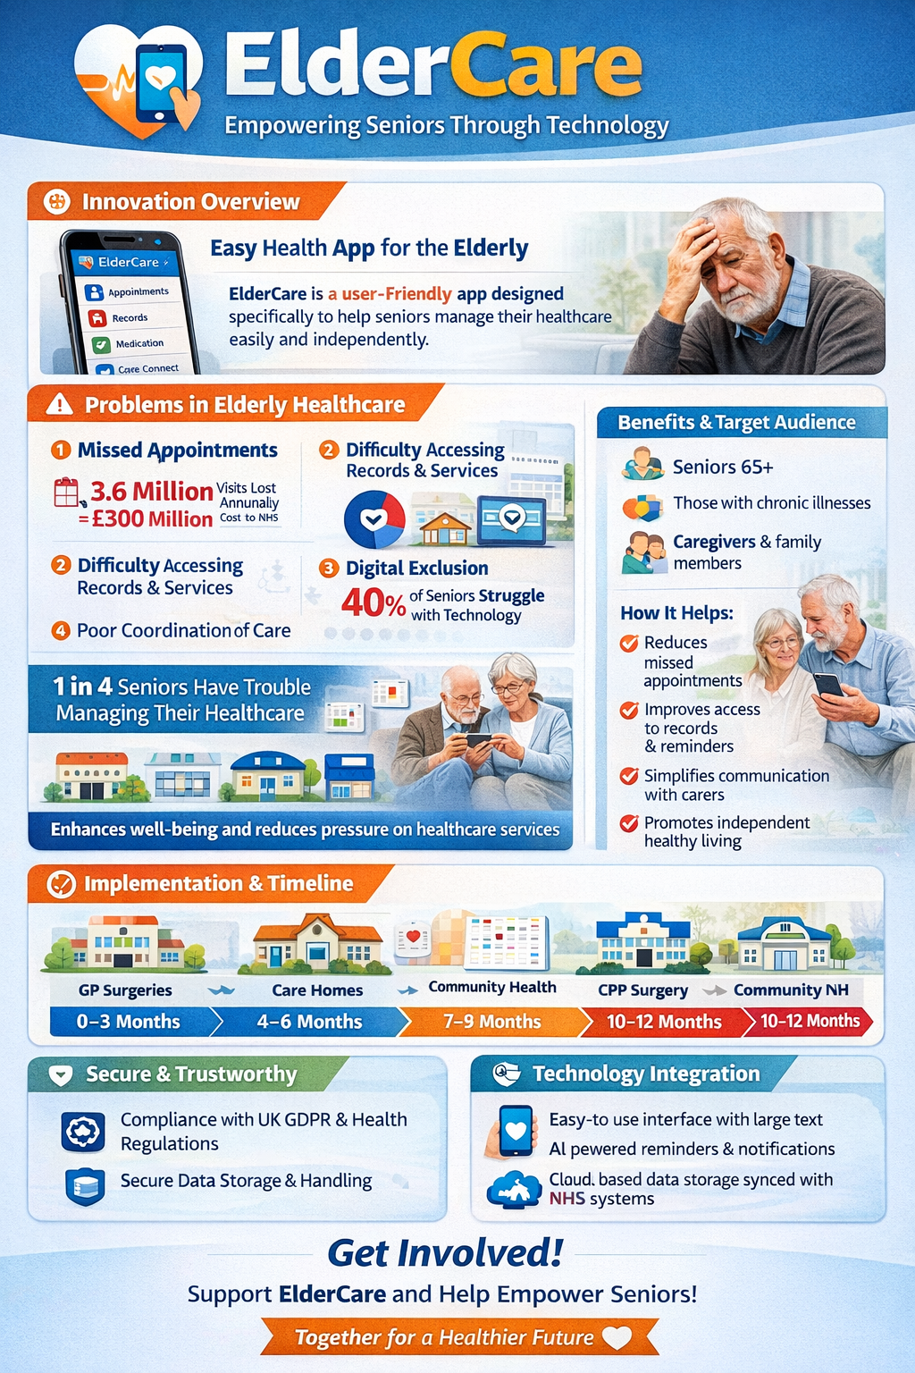
1. Introduction / Summary
ElderCare App: Helping Older People Stay Independent Essay
The ElderCare App allows seniors to access their healthcare information easily through their smartphone or tablet. Patients can view their NHS medical records, book or manage appointments, check blood test results, and see other vital health information in one place.
What sets ElderCare apart from other apps is its dedication to accessibility. The app has been designed specifically for elderly users with large text, simple icons, ease of navigation and has the optional use of voice assisted technology. Many popular health apps can be complicated to use and navigate, especially for older adults with little digital literacy. Using ElderCare will be easy, even for those who struggle with technology. By building something with the users in mind, ElderCare allows for a software tailored to an ageing population.
2. Statement of the problem
Senior citizens face significant barriers when it comes to accessing and managing their healthcare. From heavy usability problems with technology to a complete lack of confidence, ageing adults are unable to benefit from digital healthcare services. Missed appointments due to misunderstanding or not receiving reminders are costing the NHS millions every year.
The NHS Long Term Plan states ambitions to expand digital access for older adults and those with long-term conditions. However there is still a barrier of digital exclusion. Many older adults are not confident using technology like smartphones or apps.
The Care Act 2014 also puts emphasis on promoting independence and wellbeing. But currently there are limited resources and a lot of seniors rely on care workers and family members to organise their medical care.
As a result of these problems NHS services are missing appointments, providing late treatment, creating dependency and seeing patients suffer poorer health outcomes. There is a need for an accessible and inclusive solution and the ElderCare app can fill this gap.
3. Who and effect
Elderly people who require support from healthcare services are the primary users of the ElderCare app. Those over the age of 65 and particularly those with chronic conditions or ongoing healthcare needs will benefit most from the app. Careworkers, family members and doctors who support elderly people are the secondary users of the app.
ElderCare allows users to better support their own health and independence. With ElderCare users can keep track of appointments, view health records and more without having to rely on anyone else. They can reduce anxiety, help users feel more confident and encourages self management of healthcare.
As more and more people are able to access healthcare services through ElderCare, there will be a positive impact on society. Increasing access and equality to health services is good for everyone. By combatiing digital exclusion ElderCare allows older adults to benefit from new technology in the NHS. Missed appointments can also be reduced creating a more efficient system.
4. Executing
ElderCare will be implemented through partnerships with the NHS, local governments and community organisations. The app would be used in many health care environments such as GP surgeries, hospitals, care homes and clinics.
Doctors, nurses, and careworkers will be able to encourage their patients to use ElderCare to better manage their healthcare. Support and training workshops will be available to teach users how to navigate the app. These will be held at places like community centres, libraries and care homes.
ElderCare will be available to download onto phones and tablets. Easy to follow instructions and tutorials will be available to guide the user through using the app. By taking this approach we can ensure that the app is accessible to all users.
5. Timetable
Development and rollout of the ElderCare app will take place over the following timescale:
0-3 Months: User research and consultation with elderly users
4–6 Months: Build and test of app
7–9 Months: Pilot programme in selected hospitals
10–12 Months Expand across all NHS services
This phased rollout allows for feedback and changes to be made before nationally rolling out the app. It also allows us to ensure that the app is meeting the users requirements.
6. Rules
There are several rules that the ElderCare app will need to abide by. As we are storing medical information it will need to follow UK GDPR and the Data Protection Act 2018. This legislation covers how we can store patients personal and medical data.
We must also meet the standards set by The Care Quality Commission (CQC) who inspect health services and ensure that they are safe and of high quality. Healthcare professionals using the app will follow NICE guidance, ensuring best practice when advising patients.
Any professional healthcare workers will follow codes of practice set by their professional bodies. For nurses and care workers this may be the Nursing and Midwifery Council.
7. Integrating Technology
Technology makes the ElderCare app possible. Without technology we would not be able to store patient information or access it securely. Using cloud based systems allow access to patients information from any NHS service they need attend.
Artificial intelligence (AI) can be used within the app to provide customised reminders for medicines or appointments. Increasing adherence to medicine regimes and decreasing missed appointments or follow-ups.
Accessibility was a priority when designing the app. With features like large text, easy navigation and voice commands the app can be used by elderly people who struggle with technology. Technology allows the app to integrate with existing NHS systems. This means medical information can be updated in real time and users can be certain they are looking at the most up to date information.
Technology has the power to reduce errors, save time and improve the experience of elderly people when interacting with healthcare services.
8. Distribution
Many methods will be used to market and raise awareness of the ElderCare app. We will utilise social media and NHS websites to reach our target audience of elderly people and their families.
Informational leaflets and posters will be distributed in GP surgeries, hospitals and community centres. Events and workshops will be used to encourage engagement with the app and allow older people to try it first hand.
Practitioners working with elderly people can also promote the app to their patients. Partnering with charities and organisations who support older people is another great way to spread the word.
9.Conclusion
By creating Elder-Care we can solve major problems within the NHS. Seniors will be empowered by the ease of access and simplicity of use Elder-Care allows. Less reliance on others to manage healthcare appointments and information encourages independence and promotes wellbeing.
Having identified a need within healthcare provision for the elderly and have clearly defined how ElderCare will reach them, Elder-Care has the potential to be massively beneficial. By following laws and guidelines we can ensure Elder-Care is safe to use and build trust with users. Technology is the foundation Elder-Care is built on and allows us to create an app that saves time and minimises errors.

Pitch
The ElderCare App: Empowering Seniors Through Technology presents an application designed to make accessing health and care services easier for elderly people. While the introduction explains the purpose and functionality of the application itself, this conclusion will highlight its value, impact, and systems that would be implemented to encourage individuals to engage with it. The aim is to convince stakeholders to get behind this worthwhile innovation.
Access to health care services is becoming increasingly difficult for many people. In the UK, there is greater demand on health care services as the population is ageing. Older people are more likely to have long-term conditions and access healthcare regularly. Elderly people can feel as though their access to care is difficult, with growing cases of digital exclusion. Age UK (2023) found that many individuals over the age of 65 do not feel confident using online services because they lack the digital skills. This causes an inequality within healthcare as many services are moving online. Office for National Statistics (2021) also found that internet usage significantly decreases with age. Therefore, an application specifically designed for elderly people can help.
The ElderCare app would help to solve these issues by being tailored to the needs of elderly people. Larger fonts, simple design, and voice-assisted technology can be used to engage with users who struggle to use technology. Advocating for equality and inclusion is important in healthcare so that everyone can access the services they need. Empowering elderly people to book their own appointments, access health records, and receive notifications will support the values of autonomy and dignity.
From a national policy initiative, the ElderCare app links to the NHS Long Term plan (2019). This identified that using technology could benefit both patients and the NHS by allowing patients to have more control over their care and easier access to services. The plan also recognised the need to use technology better to improve patient experience and reduce demand. The Care Act 2014 focused on the areas of wellbeing, prevention, independence, and personalised care. Allowing individuals to book their appointments and access their own records supports these areas.
Evidence to show positive impact upon people can be found by assessing current statistics. Many missed appointments cost the NHS millions of pounds each year and cause unnecessary delays for treatment. The ability to have notifications and easily access the calendar on a smartphone will reduce missed appointments. Empowering individuals to have access to their health records will allow them to be better informed about their condition and the treatment they are receiving. As a result, patients can feel more involved and may be more likely to follow advice and take their medication as prescribed.
Positive impacts can also be seen by carers and professionals. Carers can more easily help the elderly if they have all the information accessible to them. Many health professionals could also benefit from the innovation. There would be better communication with patients and reduced workload for doctors and nurses when administration tasks are managed by patients.
The care services that will be involved in this innovation will introduce and monitor its use. NHS England will likely oversee the implementation of the technology. Nurses and General Practitioners can introduce the application to patients and ensure they know how to access it. Community centres and local councils can help run IT lessons to ensure elderly people know how to use computers.
The data that is accessed through the application will be regulated through UK GDPR and Data Protection Act (2018). Care Quality Commission will oversee the quality and safety of the innovation being used properly. National Institute for Health and Care Excellence will provide evidence-based guidance when using the app. Nursing and Midwifery Council will provide code of conducts that health professionals must follow.
Technology can be used to allow individuals to access the healthcare they need wherever they are. The personal health record will be stored on a secure cloud-based system that can be accessed through the application. Artificial intelligence can be used to improve adherence to medications and appointments.
Getting the public on board will be vital for the success of this innovation. The general public can help encourage elderly family members to use the application. Posters on social media, community centres, and in NHS waiting rooms can help raise awareness. Issuing leaflets and running workshops to demonstrate how the application works will ensure the elderly are not afraid to use technology.
Getting the public involved will help improve the healthcare system for everyone. Preventative care is key to stopping issues from escalating and will reduce the workload for nurses and doctors. By coming together to support innovations like this, we can make our healthcare system more efficient and improve the lives of others.

References:
NHS England (2019) The NHS Long Term Plan. London: NHS England. Available at: https://www.longtermplan.nhs.uk/ (Accessed: 23 April 2026).
Department of Health and Social Care (2014) Care Act 2014. London: The Stationery Office. Available at: https://www.legislation.gov.uk/ (Accessed: 23 April 2026).
Office for National Statistics (2021) Internet users, UK: 2021. Available at: https://www.ons.gov.uk/ (Accessed: 23 April 2026).
NHS Digital (2022) Digital inclusion for health and social care. Available at: https://digital.nhs.uk/ (Accessed: 22 April 2026).
Age UK (2023) Digital exclusion among older people . London: Age UK. Available at: https://www.ageuk.org.uk/ (Accessed: 24 April 2026).
Information Commissioner's Office (2023) Guide to the UK GDPR . Available at: https://ico.org.uk/ (Accessed: 24 April 2026).
National Institute for Health and Care Excellence (2022) Digital health technologies for patient care. London: NICE. Available at: https://www.nice.org.uk/ (Accessed: 24 April 2026).
Care Quality Commission (2023) Regulation and quality standards for health services . Available at: https://www.cqc.org.uk/ (Accessed: 22 April 2026).

