

Programme: Master of Business Administration
Module: International Business Concepts
Module code: LCMB7034

Word count: 5136
Lecturer : Dr Robert Ejike Undeogu
Student Name : Md Khaled Iqbal Sumel
Student ID: 2507096
Submission Date- Friday 20/03/2026 by
2pm

Table of Contents
1.0 Introduction ................................................................................... 1

2.0 Industry and Country Overview ..................................................... 3-8
3.0 Porter’s Diamond Model Analysis .................................................. 8-13
4.0 Critical Assessment of Novartis in Bangladesh ............................ 13-19
5.0 Conclusion .................................................................................... 19-20

6.0 References ................................................................................... 20-23

1.0 Introduction
The pharmaceutical industry in Bangladesh has become one of the most dynamic and strategic entities in South Asia, shifting away to a market dominated by multinational corporations in the 1980s into a market dominated by local firms similar to today, which supplies around 98% of internal medicine demand in the country (Export Promotion Bureau [EPB], 2024). Its industry has expanded exponentially in the last three decades, influenced by favourable government policies, favourable intellectual property exemption to the Least Developed Countries (LDCs), and entrepreneurial capacities of local companies (Azam, 2016). Pharmaceutical products produced in Bangladesh are presently exported to more than 150 countries with exports amounting to about USD 325 million in the fiscal year 2022-2023 making the nation to be an emerging force in the market of global generics (EPB, 2024). This report gives a detailed review of the Bangladesh pharmaceutical industry, including an analysis of its industry structure, industry rivalry, and competitiveness in the global front as applied in the Diamond Model by Porter. Moreover, it critically analyzes the operational environment of a big multinational organization, Novartis, which is based in Bangladesh by analyzing the political, economic, legal, and cultural environment of the country, which impacts its performance.
2.0 Industry and Country Overview
2.1 The present section aims to give a general overview of the industry and the country.
The industry in Bangladesh is a new business venture.The situation in Bangladesh with the pharmaceutical industry has undergone an incredible transformation following the passing of the Drug Control Ordinance of 1982 which is commonly believed to be the policy intervention that provided the sector with a new beginning (Reich, 1994). Before 1982, multinational companies dominated about 75 percent of the Bangladeshi pharmaceutical market, that produced mainly branded formula with very high prices which most citizens could not afford (Chowdhury, 1995). Drug Control Ordinance removed more than 1,700 useless or harmful drug products in the market, barred multinationals to produce simple formulations and the manufacture of simple medicines was left to the local firms (Reich, 1994). This market control operation established hedged market ground to local pharmaceutical companies such that they could build production capacity, and attain economies of scale.
The pharmaceutical sector in Bangladesh is estimated to have around 300 licensed pharmaceutical companies today, but the market is largely dominated by the top 20 companies which include nearly 85 percent of the total market revenue (Directorate General of Drug Administration [DGDA], 2023). The pharmaceutical value chain that the industry covers includes the production of active pharmaceutical ingredients (API), although this is not extensive, the development of formulations, their production, quality assurance and distribution. The main manufacturing centers are located in the cities of Dhaka, Gazipur, and Tongi, and there is even a single API industrial park in Munshiganj, where a backward integration should be encouraged (Bangladesh Association of Pharmaceutical Industries [BAPI], 2023).
The World Trade Organization (WTO) Trade-Related Aspects of Intellectual Property Rights (TRIPS) agreement has influenced the sector as well since the least developed countries such as Bangladesh have the exemption of pharmaceutical patent requirements until 2034 (World Trade Organization, 2022). This waiver will enable Bangladeshi companies to reverse engineer and produce generic products under the title and produce patented medicines, which will be a significant competitive asset both locally and abroad (Shadlen, 2007).
2.2 Size, Scope and Economic Importance.
As of 2023, the Bangladeshi pharmaceutical market is estimated to be USD 4.5 billion in the country, which makes it one of the largest and the fastest growing pharmaceutical markets in South Asia (IQVIA, 2023). Domestic market has shown a consistent growth of double digit in the last decade due to an increase in healthcare expenditure, rising per capita income, a growing access to healthcare, and an increase in non communicable disease burden attributed to urbanisation and changes in lifestyle (World Health Organization [WHO], 2023).
The industry also has an approximate GDP contribution of 1.5 percent and employs over 150,000 human beings directly, increased by numerous other jobs due to supply chain relationships such as raw material suppliers, packaging businesses, distribution channels, and retail pharmacies (BAPI, 2023). High skilled and semi skilled labor percentage especially pharmacists, chemists, microbiologists and engineers is another characteristic that makes the sector significant in the development of human capital in the country (Azam, 2016).
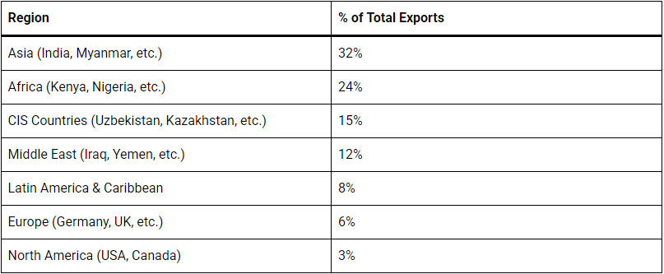
Source: PharmabossBD (2025).
The other aspect of the economic importance of industry that has gained significance is the export performance. The exports of pharmaceuticals increased approximately USD 325 million in 2022-2023, though the important destinations are Myanmar, Sri Lanka, Kenya, the Philippines, and various African and Latin American markets, which were approximately USD 50 million in 2010 (EPB, 2024). The industry has set the goal of exporting USD 5 billion annually by 2030, which is in line with ambitious growth prospects that will necessitate the need to improve regulatory compliance, product quality standards, and diversifying to international markets (BAPI, 2023).
The pharmaceutical sector is also critical to the health of the population as it provides affordable access to drugs in addition to making a significant contribution to the economy. The popularity of locally manufactured generic drugs at very low price compared to the originator drugs has increased access to medicine by the population of Bangladesh of over 170 million people (Chowdhury, 1995). The industry proved its strategic value during the COVID-19 pandemic, where the volume of the production of necessary medicines, personal protective equipment, and vaccine fill and finish increased quickly (The Daily Star, 2021).
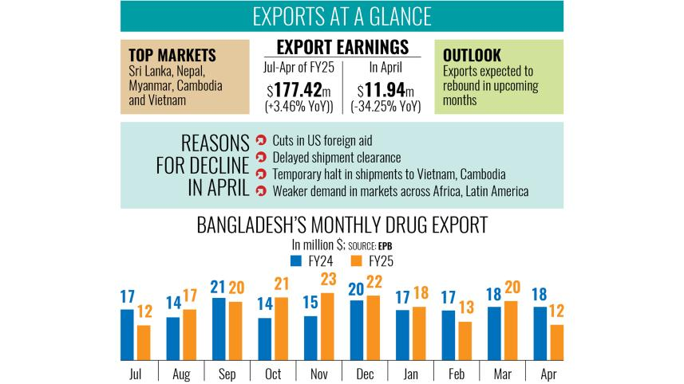
Source: Chakma (2025), The Daily Star.
2.3 Competitive Positioning and Big Companies.
The pharmaceutical market in Bangladesh is defined by a competitive nature with the strong presence of local companies in mass-market products and multinational corporations (MNCs) having a limited role in specialized and innovative products. Though the market-share information reveals that other companies like Square, Incepta, Beximco and Renata are the leaders, market share does not justify why local firms perform better than foreign MNCs. Instead, a better comparison is to evaluate firms on typical variables: product line, pricing structure, capability to manufacture products and legal standards, export orientation, and appropriateness to conditions of domestic demand.
The best example of competitive fit to the Bangladeshi picture is Square Pharmaceuticals, the owner of approximately 18% of the domestic market (IQVIA, 2023). Its powerfulness lies not just in the scale, but in the union of the wide product coverage of generic products, good access to physicians, and effective local distribution, and long-term investment in manufacturing quality. Square is a competent competitor since it caters to the highest percentage of the market the high-volume, price-elastic demand of basic and chronic medications. Its facilities that have been approved at the international level also facilitate exports enabling it to integrate local size with slow international modernization (Square Pharmaceuticals, 2023).
Incepta Pharmaceuticals, with a market share of about 11 percent, pursues a more actively developed model, which is founded on the rapid development of products, the range of the portfolio, and the penetration of new value categories such as vaccines, biologics and specialised dosage forms (Incepta Pharmaceuticals, 2023). Incepta also seems more expansionary and opportunity seeking, especially on newer segments compared to Square. This provides it with strategic flexibility, but its long-term competitiveness will remain determined by its ability or otherwise to translate product proliferation into greater regulatory and technological capacity.
With market share of approximately 9 percent, Beximco Pharmaceuticals is relatively more global-oriented than most of its local competitors. This is not only important in terms of domestic sales but its regulatory intentions such as approvals in tougher export markets and improved international generics visibility (Beximco Pharmaceuticals, 2023). Compared to other firms with major focus on domestic market, the position of Beximco points to a more developed upgrading process. Nevertheless, it is also more vulnerable to world competitiveness pressures, the forms of documentation and competition on prices through export-led competitiveness.
The presence in both human pharmaceuticals and animal health products gives Renata Limited a slightly differentiated position with the market share of about 7% (Renata Limited, 2023). This diversification will lessen reliance on one therapeutic market and provide the company with strength in the healthcare economy of Bangladesh. Although Renata is not as large as Square and does not have the export profile of Beximco, its diversified structure indicates a competitive approach that is founded on niche empowerment, as opposed to volume leadership.
In comparison, the multinational companies like Novartis Bangladesh, Sanofi Bangladesh, and GlaxoSmithKline Bangladesh are seen to occupy an insignificant share of the domestic market- about 8-10% on the aggregate (DGDA, 2023). It is not that they are less technologically sophisticated and are in their weaker position, but the institutional and demand environment of Bangladesh makes their business models less aligned. To start with, MNCs tend to have a higher dominance in innovative, patented, or highly specialised medicines compared to the Bangladeshi market that is dominated by demand on generic drugs that are affordable. Second, the local companies are more flexible in pricing, have cheaper cost structure, and have closer contacts with the domestic prescribers, distributors and retailers. Third, patent based differentiation is undermined under the TRIPS waiver since local companies are legally allowed to manufacture numerous products that would otherwise be secured in other jurisdictions (WTO, 2022; Shadlen, 2007).
This analogy implies that the domestic firms perform better than MNCs not only due to the history of protectionism, but because they have developed capabilities that exactly correspond to the form of local demand: low-cost production, diversified portfolios, local market penetration, and growing competence in manufacturing. The only way MNCs remain competitive is through complexity in the products, brand loyalty or therapeutic specialisation where local firms can hardly get in to. Thus, the Bangladeshi pharmaceutical market is not simply a local versus foreign competition in its basic form; it is a segmentation between the firms that are optimised towards the high-volume generic competition and the firms that are placed in the more narrow and innovation-based segments. This difference is the key to interpreting the current composition of the industry and strategic limitations of Novartis.

3.0 Porters diamond model analysis
The Diamond Model of National Advantage developed by Michael Porter (Porter, 1990), is a helpful tool of examining the competitive advantage of the Bangladesh pharmaceutical industry in the global markets. The model describes the process by which the factor conditions, the demand conditions, the related and supporting industries, firm strategy and rivalry, and the impact of government and chance define national competitiveness. By utilising this framework, a systematic analysis of the strengths and weaknesses of the international competitiveness of the pharmaceutical industry in Bangladesh can be conducted in terms of structures.
3.1 Factor Conditions
Bangladesh has a number of basic factor competencies that favour pharmaceutical production especially in generic formulations. There are many pharmacy graduates, chemists, engineers, and technicians in the country, and the labour costs are also lower, compared to such competitors as India and China (Azam, 2016; University Grants Commission, 2023). These have conditions that favour competitiveness in activities that are labour intensive such as formulation, packaging, and daily quality control.
These are however entry level rather than long lasting sources of international competitiveness. In regulated markets, low cost production has less to do with success but rather compliance capability, standards of documentation, bioequivalence tests, pharmacovigilance and regulatory credibility. Bangladesh has strength in the basic production and weaknesses in the advanced factor conditions necessary to upgrade.
This is a disparity in research and infrastructure. The R&D expenditure in the industry is less than a percent of revenue, and insufficient access to advanced labs and testing facilities will compel it to rely on assistance abroad (BAPI, 2023; Islam, 2018). Risks and cost escalation are caused by infrastructure limitations such as power unpredictability, ports, and cold chain gaps (ADB, 2022). The high reliance on imported APIs (approximately 85-90) also restrains the formation of the value and exposes companies to external shocks (DGDA, 2023). Comprehensively, the competitiveness is still superficial in nature.
3.2 Demand Conditions
The domestic market in Bangladesh is huge and growing, as the population is growing, urbanization is on the rise, income is rising, and non-communicable diseases are increasingly burdening the population (WHO, 2023). This book offers a very large base market, which allows the companies to scale production and have a wide coverage of therapeutic coverage.
Nevertheless, size is not as critical in the promotion of upgrading as demand sophistication is in the Porters terminology. The amount of spending made on health care is low and about 69 percent of this spending is out of pocket meaning that consumers and prescribers are very sensitive to prices (WHO, 2023). This promotes cost-effective generic products and promotes the competition on the basis of breadth, distribution, and cost as opposed to therapeutic differentiation and innovation. The lack of sophistication is further eroded by self-medication and poor prescription discipline and therefore the decision to purchase is usually more towards affordability and availability rather than quality deliverables (Ahmed et al., 2009). Such conditions contribute to the quick expansion of volumes but inhibit motivation to deepen the technologies and rely on the advanced quality systems or original research.
Simultaneously, there are portions that are becoming high-tech. The population of urban private hospitals, specialist doctors and an increasing population of middle-income earners combine to generate demand of quality medicines, specialised treatments, and quality regulatory guarantee (Islam, 2018). Although these segments are still small compared to the mass market, they can have more and more impact on the competition.
Critical judgement: Low-cost generics are now being favourable to domestic demand, whereas advanced pharmaceutical upgrading is poorly pressurised. The domestic market will not on its own, without substantial growth of quality-conscious, higher-income demand, be able to provide the capability development necessary to remain internationally competitive.
3.3 Supporting and Related industries.
One of the most evident structural limitations to the pharmaceutical upgrading of Bangladesh is the weakness of the related and supporting industries. The local production of APIs only provides a relatively minor portion of the industry needs, as niche packaging materials and high-quality pharmaceutical inputs continue to be greatly imported (DGDA, 2023; BAPI, 2023). This restricts local value addition and the firms are left with reliance on foreign suppliers as sources of inputs with strategic significance.
The implication of this is that the pharmaceutical competitiveness in Bangladesh is narrow. The companies are quite robust in the areas of formulation and final manufacture, yet they are weak in the fields of upstream chemistry, specialised materials and technical support services. This type of industrial profile is sustainable to domestic generic expansion, but limits the development of a complete pharmaceutical ecosystem to support advanced exports or production with an innovation component.
Positive developments are however, present. The extensive domestic distribution system provides businesses with wide access of the country and the gradual development of contract research and regulatory support services shows the early creation of the ecosystem (DGDA, 2023; Islam, 2018). However, these supporting industries are still so immature that they fail to generate the dense cluster effect of the more powerful pharmaceutical centres like India.
Critical judgement
This is one of the critical weaknesses of the Diamond in Bangladesh. The industry still relies on imported knowledge, inputs and testing systems and without more aggressive upstream integration and specialised support services, it will be constrained in its ability to resilience as well as in its ability to upgrade.
3.4 Strategy of the Firm, Structure of the Firm, and Rivalry.
Domestic competition is high in Bangladesh and this has been a major stimulus towards the capability development. The rivalry between major companies has promoted the investment in the variety of products, the volumes of production, the networks of physicians, and the permission to export (Mohiuddin, 2014). Local competition has thus, improved efficiency, commercial responsiveness and capturing domestic market share.
Nevertheless, this rivalry has contributed to a large extent to a generic imitation model as opposed to an innovation driven model. The TRIPS waiver receives set products and commercialise generics without entirely able intellectual property limitations found in developed markets (Shadlen, 2007). This has influenced strategic behaviour based on copying rather than technical innovation though it has been commercially profitable and socially desirable to medicine accessibility.
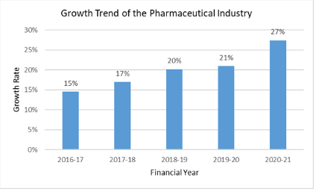
Source: Rahman (2024), Priti Research.
This brings about a strategic conflict. The upgrading may now be curtailed by the institutional conditions that favored the rapid catch-up. In case companies remain focused on generic imitation, wide portfolios, and scale at home, they may be underinvested in capabilities that the company will need by 2034, such as regulatory science, advanced formulations, biosimilars, bioequivalence testing, process innovation, and strong systems of R&D.
Critical judgement: Competition in Bangladesh is enough to base on efficiency but not radical enough to undergo radical upgrading. Speed, breadth, and low costs are more valued in the competitive system, rather than the capability to innovate. Although it is effective nowadays, this model is probably to lose its viability in the conditions of more severe post-TRIPS requirements, and will have to move towards the competition based on higher values and innovation.
3.5 Government and Chance
The pharmaceutical industry in Bangladesh has been influenced most of all by the government. The 1982 Drug Control Ordinance provided policy room to the domestic companies, and tax policies and support to manufacturing further boosted this sector (Reich, 1994; Government of Bangladesh, 2023). The TRIPS waiver was a short-term yet effective benefit in the generic production, allowing companies to grow fast and take the lead in the market.
This is however a short lived advantage. The more important issue is not whether the waiver has been advantageous- it undoubtedly has been- but is whether the industry is using this window to get ready to compete in a more competitive post-2034 environment. This will be achieved by enhancing domestic regulations, developing testing and compliance systems, developing more product locally and investing in more valuable products. Existing data indicate the partial improvement but not a fast upgrading pace.
Another chance event described by the COVID-19 pandemic in the Porters model was that it proved the strategic significance of domestic production capacity (The Daily Star, 2021). However the long term gains can be made when emergency responsiveness is converted into institutional and technological fortification.
Critical judgement: Government intervention created the platforms of Bangladesh pharmaceutical success, but the competitiveness in the future will depend less and less on the protection and more on the ability enhancement. The 2034 TRIPS deadline is not only a legal benchmark but a strategic stress point when it comes to the ability of the industry to stop being focused on low-cost generics, but rather on the production of greater value, based on innovation.
4.0 Critical Assessment of the activities of the company Novartis in Bangladesh.
4.1 Company Overview
Novartis AG is a Swiss multinational pharmaceutical firm with headquarters in Basel, Switzerland and is one of the largest pharmaceutical companies in the world by revenue with the company reporting global net sales of about USD 45.4 billion in 2023 (Novartis, 2024). The company targets innovative medicine in various areas of therapy such as oncology, cardiovascular, immunology, neuroscience and ophthalmology. Novartis has its presence in more than 140 countries and it has an employee base of approximately 78,000 people in many countries all over the world (Novartis, 2024).
Novartis has been operating in Bangladesh over the past decades with its subsidiary, Novartis (Bangladesh) Limited. The operations of the company in Bangladesh include marketing and distribution of the company in addition to some limited production of selected pharmaceutical products. The strategic positioning of Novartis in Bangladesh is dedicated to its innovative set of patented medicines especially in the therapeutic segments where local rivals do not possess the capacity like modernized oncology therapies and targeted medicines ( Novartis Bangladesh, 2023). But being in a market where generic competition is not legally limited by the TRIPS waiver is a basic strategic issue in the case of an innovation-oriented pharmaceutical multinational.
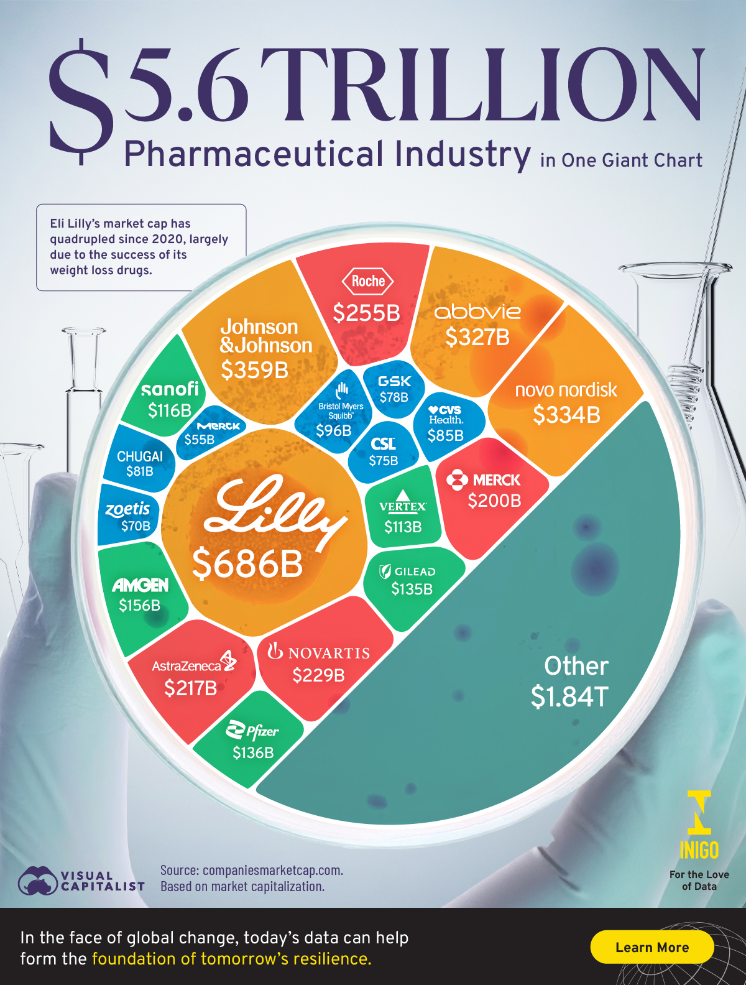
Source: Rahman (2024), Priti Research.

4.2 Political Factors
In the case of Novartis, the political climate is not as vital as an overall concern of state instability but rather as a way of how the regulation of business influences entry to the market and survival. In Bangladesh, political instability may impact logistics, add uncertainty to healthcare policy, and pose the threat of abrupt disruption of the political environment of a politically sensitive area like pharmaceuticals (Lewis, 2011; Al Jazeera, 2024). Nevertheless, the most strategically significant political concern of Novartis is how the state policy on the intellectual property of pharmaceuticals and public health is.
The continued support by Bangladesh of the TRIPS transition scheme is politically driven as an indicator of medicine access and domestic industrial growth over effective patent protection (WTO, 2022). This has a direct negative impact on the appropriability of the innovation-based advantage of Novartis. That is, the principal political issue facing Novartis is not just instability, but rather, that the policy regime is structurally more conducive to generic competition, as opposed to patent-based rents.
The second political issue is the quality of governance. Highly compliant companies like Novartis are disadvantaged by the global anti-bribery regulations and internal checks and balances, which increase the risks of weak state capacity and corruption during the procurement, registration and market supervision processes (Transparency International, 2023; Novartis, 2024). There is a possibility of local competitors being more institutionally fixed and more flexible in about negotiating informal systems. This is not to say that Novartis cannot be successful, but it does imply that it will be successful only when it has well-adhered behavior and sensitive stakeholder management as opposed to rampant market growth.
Firm-specific implication
Politically, Bangladesh is not a favorable market to Novartis as a patent based innovation business. It is feasible as a positioning and relationship building market of long terms, in case the company can decide compliance exposure and endure policy uncertainty.
4.3 Economic Factors
The situation in Bangladesh creates a clearly contradictory situation with Novartis, where the market is very large and is growing, but the buying structure is not conducive to high cost innovative medicines. Increased income, urbanisation and epidemiological transition are contributing to the growing long-term pharmaceutical demand such as chronic and complex conditions (World Bank, 2023; WHO, 2023). This principle should open up opportunities to Novartis.
Practically, though, the low levels of spending on health care, low insurance coverage, and high dependency on the out-of-pocket payment severely limit the addressable market of pricier goods (Ahmed et al., 2009; WHO, 2023). Novartis cannot be a traditional high-value growth market in Bangladesh. Rather, it needs to concentrate on therapeutic segments that are differentiated and where the readiness to pay is high e.g. oncology and other specialised treatment.
The TRIPS waiver increases this difficulty because the price of the legal local generics is able to compete directly with the global products, reducing the pricing power and limiting the growth of volume (Shadlen, 2007). Dilution of exchange rates also strains the margins of an MNC reliant on imported inputs and requirements to report accounting internationally (Bangladesh Bank, 2024).
Corporate implication: Bangladesh is a limited opportunity economically to Novartis: a promising country in terms of demographic and disease-burden, but a limited market commercially due to affordability and generic competition. The business approach of the company should consequently focus on selective high-value segments, brand credibility and discipline portfolio management as opposed to scale expansion on a wide level indicating a narrow targeted business model that fits the local economic and market climate.
4.4 Legal Factors
The most significant limitation of Novartis in Bangladesh is the legal environment. Being an innovation-based pharmaceutical firm, Novartis relies a lot on patent and exclusive rights enforceability. This central ownership advantage cannot be appropriated in the local market because Bangladesh is not obliged to pay pharmaceutical patent fees under WTO TRIPS transition period until the year 2034 (WTO, 2022). It is not a peripheral problem but a structural problem to the business model of the company.
Due to the fact that the local companies are legally allowed to produce generic versions of drugs, which would have been legally patent-protected in other countries, Novartis has a market whose core competitive advantage is the pipeline of its patented products, which will be significantly reduced. This is the reason why MNCs tend to be mostly concentrated within a smaller range of therapeutic segments in which the imitation by local manufacturers is less direct or where the technical complexity poses a barrier.
A second legal issue is regulatory capacity. Even though the drug registration process in Bangladesh is formal, the quality control and licensing, the enforcement process is uneven, and the capacity of the institutions remains underdeveloped (Islam, 2018). In the case of Novartis, inadequate regulation has a two-fold effect: it can diminish exposure to litigation in the near term, but it also brings about uncertainty, hike compliance costs and the inability to trust in healthy competition. When the level of inspection and quality in the market is lower, firms with a high level of standard incur the costs of compliance, which do not necessarily reflect their rewards.
It is therefore necessary that Novartis does not react to the same by legal safeguarding, but rather by reengineering its local operating logic. This probably involves the emphasis on complicated treatments, stricter control over the choice of partners, the high level of internal adherence, and the reduced exposure of the product line in which the law has legalized imitation returns unsightly.
Firm-specific implication
Bangladesh is not legally yet the market where Novartis can obtain a complete monetisation of its innovation model. Its existence can thus be considered strategically selective and future-oriented instead of being as commercial as possible in the current circumstances.
4.5 Cultural Factors
Cultural considerations are important to Novartis not in abstract national terms, but in that they define prescribing behaviour, relationships with stakeholders and how pharmaceutical strategy is actually conducted. Medical representatives, scientific interactions and key opinion leaders connections are particularly powerful in dictating product adoption in Bangladesh with high power distance and the physician-centred decision-making (Ahmed et al., 2009; Hofstede Insights, 2024). In the case of Novartis, it gives the company a chance to capitalize on scientific authority and expert interaction especially in complicated treatment divisions.
Meanwhile, compliance tension is caused by the relationship-oriented business culture. In the environment where business communication is likely to be affected by trust, informality and personal relationships, Novartis needs to have a harder line than most of the local companies since it is subject to not only local law but also to international internal compliance protocols and extraterritorial laws on anti-bribery (Novartis, 2024). It implies that a culturally competent approach in Bangladesh cannot merely reflect local relation patterns; it needs to map out the relationship building into a form of ethically regulated stakeholder ties.
Market access is also influenced by collectivist social norms and family-based decisions on healthcare. Other factors that usually mediate decisions regarding treatment include physicians, family affordability, community advice and the availability of pharmacies. This diminishes the value of premium branding as a sole tool and the value of access programmes, patient education and affordability measures in the broadening of reach.
Religions and social norms also influence product acceptance and medication compliance with regard to halal issues and Ramadan and treatment behaviour (Ahmed et al., 2009). These do not pose significant strategic obstacles, but they support the necessity of local adjustments instead of straightforward implementation of international marketing patterns.
Firm-specific implication
Novartis can win where it integrates scientific authority and relationship management applicable and local where management applies locally. It is not about entering the market, but about transforming medical influence into a sustainable growth without violating the international ethics.
4.6 Synthesis: Market Generally attractive.
Collectively, it would indicate that Bangladesh is no longer a highly appealing commercial destination of Novartis in the traditional meaning of revenue maximisation in the short term. The legal-economical restrictive factor is one of the factors; the level of buying power and generic substitutions make it a strong factor in decreasing the profitability of an innovation-based model. It is further strained by political and governance factors that add further friction by adding to compliance and operating risk.
This is however not to say that the market is not strategic. There are three types of greater-term relevancy in Bangladesh to Novartis. To begin with, it is a massive and expanding medical market that is characterized by the rising chronic disease burden. Second, there are still segments of selected specialists that leave the opportunity to differentiated products with weaker generic competition. Third, and most significantly, staying active until 2034 offers Novartis value in terms of options: it would enable the company to retain brand recognition, physician ties, market familiarity, and institutional credibility until the time of a potential tightening of the intellectual property environment.
To this extent, the most persuasive strategic decision is that the presence of Novartis in Bangladesh should be thought of as an option-value and strategic positioning decision making with components of legitimacy and selective commercial engagement, and not as a significant short-term growth gambit. It is thus advisable that the company does not leave the market, however in disciplined exposure: specialised therapies, high compliance and partnership controls, but developing capabilities that can be expanded more aggressively should legal and purchasing conditions be made more favourable after 2034.
5.0 Conclusion
The report analyzed pharmaceutical industry of Bangladesh based on the development of the industry, the competitive structure, the market that is favorable in the country, and the environment that multinational corporations are forced to deal with. The industry is now a lot different than it was in the early 1980s when the major players of the system were the multinational companies to the current situation where the domestic companies hold more than 90 percent of the pharmaceutical sales. There were two important policy tools that made this change possible two elements of the Drug Control Ordinance of 1982 and the TRIPS waiver acted in synergy to provide regulatory assurance and intellectual property leeway that enabled local firms to develop production capacity and be competitive.
Diamond analysis of Porter has shown that the competitiveness of Bangladesh was based on the good government policy, cost leadership, and the broadening industry potential. However, there are structural weaknesses that still plague the industry that include low sophisticated capacity to research, fairly unsophisticated domestic market and underdeveloped supporting industries such as active pharmaceutical ingredient manufacture. Dependence of TRIPS waiver is also a strategic risk because Bangladesh will be obliged to comply with the international intellectual protection laws by 2034.
The operating conditions are also complex in the case of multinational innovators such as Novartis the operating conditions are highly complicated with low patent protection, high price elasticity and political uncertainty. Bangladesh, though with such limitations, is still a location of strategic location with the situation of increasing healthcare demand and the long-term perspective of this nation since the regulatory standards of the country will eventually converge with the international pharmaceutical frameworks of the world.
References
Ahmed, S.M., Adams, A.M., Chowdhury, M. and Bhuiya, A. (2009) 'Changing health-seeking behaviour in Matlab, Bangladesh: Do development interventions matter?', Health Policy and Planning, 24(4), pp. 290–301.
Al Jazeera (2024) 'Bangladesh crisis: How Sheikh Hasina's government fell', Al Jazeera News, 6 August. Available at: https://www.aljazeera.com/news/2024/8/6/bangladesh-crisis (Accessed: 18 November 2024).
Asian Development Bank (2022) Bangladesh: Infrastructure development challenges and opportunities. Manila: ADB.
Azam, M.M. (2016) Intellectual property and public health in the developing world. Cambridge: Open Book Publishers.
Bangladesh Association of Pharmaceutical Industries (2023) Annual report 2022–2023. Dhaka: BAPI.
Bangladesh Bank (2024) Monthly economic trends. Dhaka: Bangladesh Bank.
Beximco Pharmaceuticals (2023) Annual report 2022–2023. Dhaka: Beximco Pharmaceuticals Limited.
Chakma, J. (2025) Despite April decline, pharma exports maintain upward trend. The Daily Star, 13 May. Available at: https://www.thedailystar.net/business/news/despite-april-decline-pharma-exports-maintain-upward-trend-3893341 (Accessed: 19 March 2026).
Chowdhury, Z. (1995) The politics of essential drugs: The makings of a successful health strategy—lessons from Bangladesh. London: Zed Books.
Directorate General of Drug Administration (2023) Annual drug bulletin 2022–2023. Dhaka: DGDA.
Dunning, J.H. (1993) Multinational enterprises and the global economy. Wokingham: Addison-Wesley.
Export Promotion Bureau (2024) Export statistics of Bangladesh 2022–2023. Dhaka: EPB, Ministry of Commerce.
Government of Bangladesh (2023) National drug policy 2016 (updated). Dhaka: Ministry of Health and Family Welfare.
Hofstede Insights (2024) Country comparison: Bangladesh. Available at: https://www.hofstede-insights.com/country-comparison/bangladesh/ (Accessed: 18 November 2024).
Hofstede, G. (2001) Culture's consequences: Comparing values, behaviours, institutions, and organizations across nations. 2nd edn. Thousand Oaks, CA: Sage.
Incepta Pharmaceuticals (2023) Annual report 2022–2023. Dhaka: Incepta Pharmaceuticals Limited.
International Monetary Fund (2023) Bangladesh: Article IV consultation—Staff report. Washington, DC: IMF.
IQVIA (2023) Bangladesh pharmaceutical market overview 2023. Durham, NC: IQVIA.
Islam, M.S. (2018) 'Pharmaceutical industry in Bangladesh: Prospects and challenges', Journal of Pharmaceutical Policy and Practice, 11(1), pp. 1–9.
Lewis, D. (2011) Bangladesh: Politics, economy and civil society. Cambridge: Cambridge University Press.
Lund-Thomsen, P. and Lindgreen, A. (2014) 'Corporate social responsibility in global value chains: Where are we now and where are we going?', Journal of Business Ethics, 123(1), pp. 11–22.
Mohiuddin, M. (2014) 'Overview of the pharmaceutical sector in Bangladesh', IOSR Journal of Business and Management, 16(12), pp. 47–51.
Novartis (2024) Annual report 2023. Basel: Novartis AG.
Novartis Bangladesh (2023) Company profile and operations overview. Dhaka: Novartis (Bangladesh) Limited.
Peng, M.W., Wang, D.Y.L. and Jiang, Y. (2009) 'An institution-based view of international business strategy: A focus on emerging economies', Journal of International Business Studies, 39(5), pp. 920–936.
Porter, M.E. (1990) The competitive advantage of nations. New York: Free Press.
PRITI Research & Consultancy Limited (n.d.) The rise of the pharmaceutical industry in Bangladesh. Available at: https://pritiresearch.com.bd/the-rise-of-the-pharmaceutical-industry-in-bangladesh/ (Accessed: 19 March 2026).
Reich, M.R. (1994) 'Bangladesh pharmaceutical policy and politics', Health Policy and Planning, 9(2), pp. 130–143.
Renata Limited (2023) Annual report 2022–2023. Dhaka: Renata Limited.
Salim, A.S. (2025) Bangladesh pharmaceutical export market 2025 & future outlook. PharmaBossBD. Available at: https://pharmabossbd.com/bangladesh-pharmaceutical-export-market-2025/ (Accessed: 19 March 2026).
Shadlen, K.C. (2007) 'The political economy of AIDS treatment: Intellectual property and the transformation of generic supply', International Studies Quarterly, 51(3), pp. 559–581.
Square Pharmaceuticals (2023) Annual report 2022–2023. Dhaka: Square Pharmaceuticals Limited.
The Daily Star (2021) 'Bangladesh pharma sector rises to COVID-19 challenge', The Daily Star, 15 March. Available at: https://www.thedailystar.net/business/news/bangladesh-pharma-sector-rises-covid-19-challenge (Accessed: 18 November 2024).
The Financial Express (2023) 'API park Munshiganj: Progress and challenges', The Financial Express, 22 September. Available at: https://thefinancialexpress.com.bd/trade/api-park-munshiganj (Accessed: 18 November 2024).
Transparency International (2023) Corruption perceptions index 2023. Berlin: Transparency International.
Trompenaars, F. and Hampden-Turner, C. (1997) Riding the waves of culture: Understanding cultural diversity in business. 2nd edn. London: Nicholas Brealey.
University Grants Commission (2023) Annual report 2022–2023. Dhaka: UGC.
Visual Capitalist (2023) The $5.6T pharma industry in one giant chart. [online] Available at: https://www.visualcapitalist.com/sp/the-5-6t-pharma-industry-in-one-giant-chart-ig01/?utm_source=chatgpt.com [Accessed 19 March 2026]
World Bank (2022) Doing business in Bangladesh: Reforms and challenges. Washington, DC: World Bank.
World Bank (2023) Bangladesh development update: Navigating uncertain times. Washington, DC: World Bank.
World Health Organization (2023) Bangladesh health system review. Geneva: WHO, South-East Asia Regional Office.
World Trade Organization (2022) Extension of the transition period under Article 66.1 for least developed country members. Geneva: WTO, Council for TRIPS.

