Laser Doppler Vibrometer - Brake Disc Modal Analysis

Jinhao Xia
2300256
MSc Automotive Engineering
17/03/2024
ACEA7013 Structural Integrity & Materials Evaluation

Abstract
In this experiment, the vibration response of a brake disc under excitation by a solenoid actuator is measured by laser Doppler vibrometer to identify the resonance frequency modes and shapes at different intrinsic frequencies, and also to analyse different resonance peaks and damping ratios. The factors that may produce errors in this experiment are also explained. The conclusions obtained in this paper are important for engineers to improve the design of brake discs, enhance braking performance, reduce unfavourable noise and vibration, and extend the service life of brake discs.

Apparatus
PolyTec PSV-400 Scanning Laser Doppler Vibrometer, is a non-contact measurement tool used in this experiment to measure the resonant frequency modes and shapes of a brake disc.
A solenoid actuator, which is controlled by the LDV function generator, generates vibrations of the appropriate frequency and force, which are used to strike the brake discs and make them vibrate.
A brake disc, as a sample in this experiment.

Introduction
In recent years, due to the rapid development of laser Doppler measurement technology and its advantages of wide response band, high velocity resolution, short measurement time and the possibility of long-distance measurements, it has been widely used in the automotive industry, medical and health care, quality inspection of agricultural products, and vibration testing of micro-structures (Xiaoming, Jian and Xingwu, 2014). Laser Doppler vibrometer adopts a non-contact measurement method, which can accurately measure the vibration displacement, velocity, acceleration and frequency of various objects.

Literature Review
Laser Doppler vibrometry is a well-established tool for non-contact vibration measurements in the automotive industry. The LDV method is not limited to measurements at a single test point, but can measure multiple points in a structure. However, 2D LDV has a number of limitations for whole vehicle modal analysis. Until the end of 2002, this problem was solved by the advent of 3D LDV. Schell et al. (Schell et al., 2006) used the latest 3D SLDV technique to analyse the modal behaviour of individual components, and combined the measurements of the different components of the vehicle to obtain the whole vehicle modal behaviour.

Johansmann et al (Johansmann, Fritzsche and Schell, 2011) propose a new method combining LDV and an optical Derotator to measure the resonance frequencies of rotating components in automobiles, e.g. wheels and brake discs. Mallareddy et al (Mallareddy et al., 2017) proposed a new method combining LDV and Scalable Automatic Modal Hammer to measure the vibration response of brake pads contactlessly using 3D SLDV and to strike the brake discs with precise and controllable force by SAM to get close to the dynamic characteristics of the brake pads in the actual braking. Ferhat et al. (Ferhat, Sarlo and Tarazaga, 2020) proposed a new method combining LDV and piezoelectric excitation, which can eliminate the inconsistency of the magnitude and direction of the excitation force of impact hammers, and can better obtain the dynamic characteristics of tyres, such as modal frequency and shape.

Laser Doppler Vibrometer Principle
Laser technology and vibration measurement technology has been continuously developed for decades, forming a variety of mature measurement techniques, there are: scattering interferometry, Moore's stripe grating method, laser Doppler measurement and other optical vibration measurement techniques (Rothberg et al., 2017). Among them, the laser Doppler vibration measurement technique has the advantages of simple operation method, large measurement range, strong anti-interference ability, high measurement accuracy, and short detection time. At present, the automotive industry has a great demand for laser Doppler vibration measurement technology, which is not affected by external factors such as pressure, temperature, humidity, surface roughness, and so on.

The beam emitted from the laser is divided into two parts by the beam splitter1, measuring light and reference light. Wherein the measurement light, after arriving at the object, is reflected twice and passes through the beam splitter 2 and 3 to reach the surface of the photodetector; The reference beam is modulated by the acousto-optic frequency shifter Bragg cell, and then reflected by the beam splitter3 to the surface of the photodetector to interfere with the measured light. By processing the dual frequency laser produced by this interferometric structure, the vibration measurement of an object can be performed, as shown in Figure 2.1. the LDV Schematic.
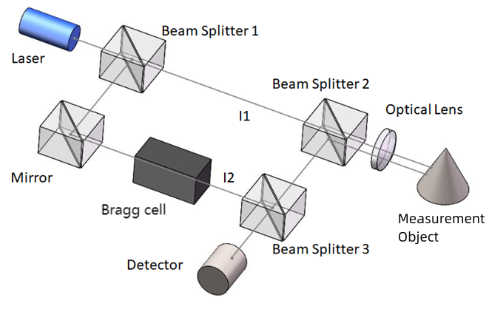
Figure 2.1. LDV Schematic

Experiment Procedure
- The brake disc was fixed on the table with a vise, the solenoid actuator was placed behind the brake disc as the excitation source of the experiment to strike the brake disc, and the plunger of the solenoid actuator was placed next to the rear surface of the brake disc to ensure that the vibration of the corresponding frequency and force could be effectively transmitted to the brake disc. The mounting position of the brake disc and a solenoid actuator is shown in Figure 2.2.
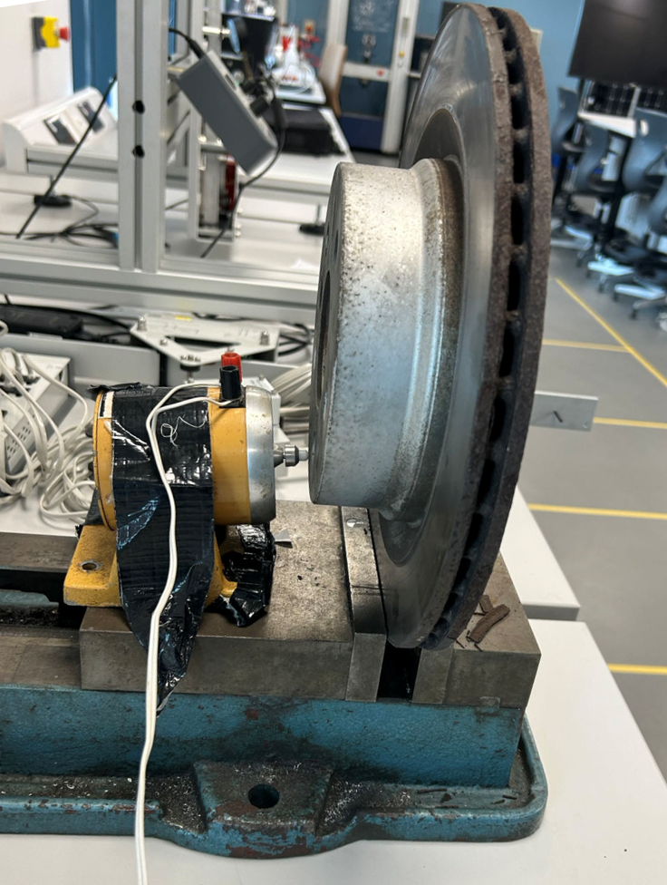
Figure 2.2. Installation position of brake disc and solenoid actuator
- Place the scanning head 1m in front of the brake disc and adjust the height of the scanning head to match the position of the brake disc.
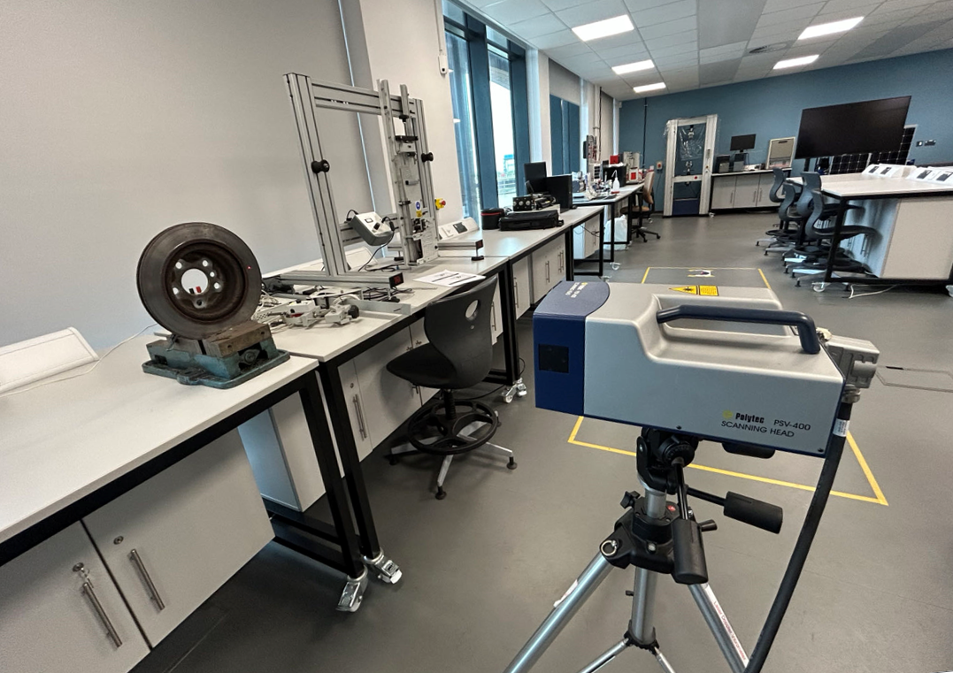
Figure 2.3. Installation position of scanning head
- Switch on the computer, signal generator, power amplifier and scanning head in turn.
- Open the PSV Acquisition software on your computer to set-up and perform analysis. open the setting in the acquisition menu of the software to set the parameters of the experimental equipment. Then set the bandwidth to 20kHz, so that you can see the vibration of the brake disc between 0 and 20kHz. Leave the other parameters related to the solenoid actuator as default.
- Open 2D Alignment in Setup to perform a 2D alignment of the scanning head, first autofocus the laser and set the z-distance between the scanning head and the object to 1 m. Next, define an alignment point on the surface of the object and repeat this step at least 5 times.
- Open Define Scan Points in Setup for selecting the scan points to be measured in the experiment. The scan points and scan states selected in this experiment are shown in Figure 2.4.
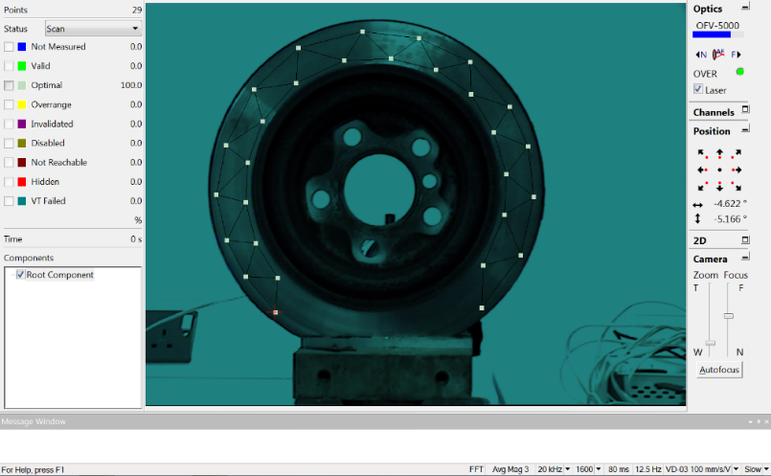
Figure 2.4. Scanning point position and scanning status
- Open the scan of acquisition menu, after the scanning is finished, you can see by the figure that the scanning status of all points is OPTIMAL, and it can be assumed that the measurement of each point is valid.
- Open the PSV analysis application, which is used to analyse the experimental data. Open the frequency band, you can see the curve that will be converted to frequency domain response after FFT, select the frequency band where the peaks appear in the curve, as shown in Figure 2.5. Then recalculate the frequency bands and you can see the vibration modes for each band.
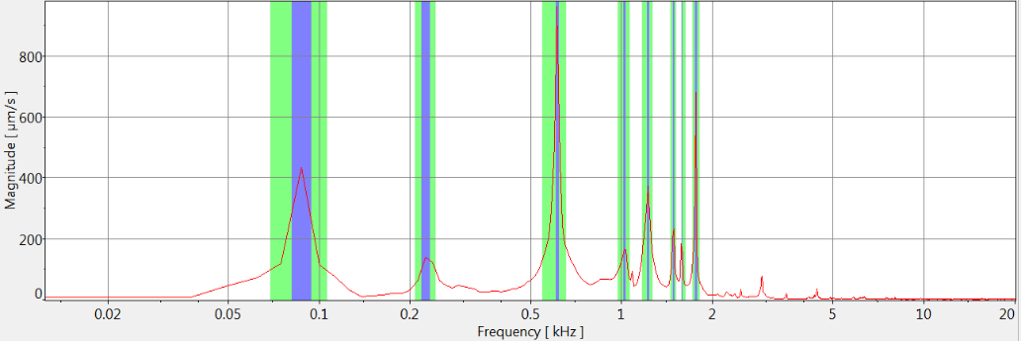
Figure 2.5. Frequency response graph

Measurements and Graph of Raw measurement
The frequency bands with 8 peaks were selected based on the Frequency response graph in Figure 2.5, as shown in Table 3.1.
Table3.1 Frequency Band Definition
No. | Peak (Hz) | Bandwidth (Hz)
1 | 87.5 | 25
2 | 225 | 25
3 | 612.5 | 100
4 | 1025 | 87.5
5 | 1225 | 87.5
6 | 1487.5 | 62.5
7 | 1575 | 50
8 | 1762.5 | 100

The vibration modes for each frequency band are shown in Figure 3.1.
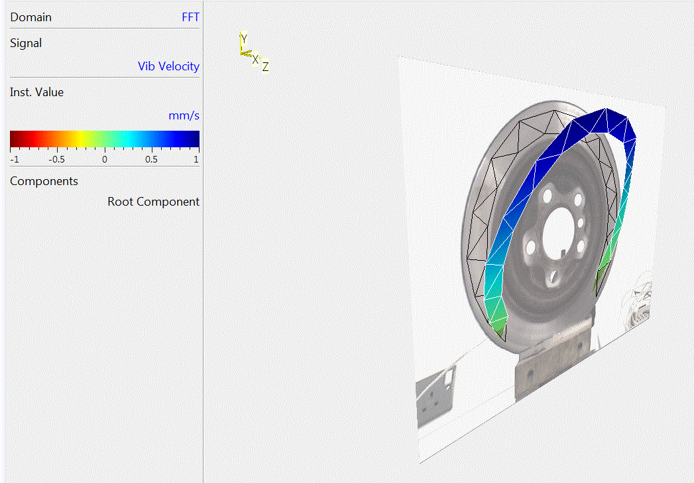  - $f=87.5Hz$ | 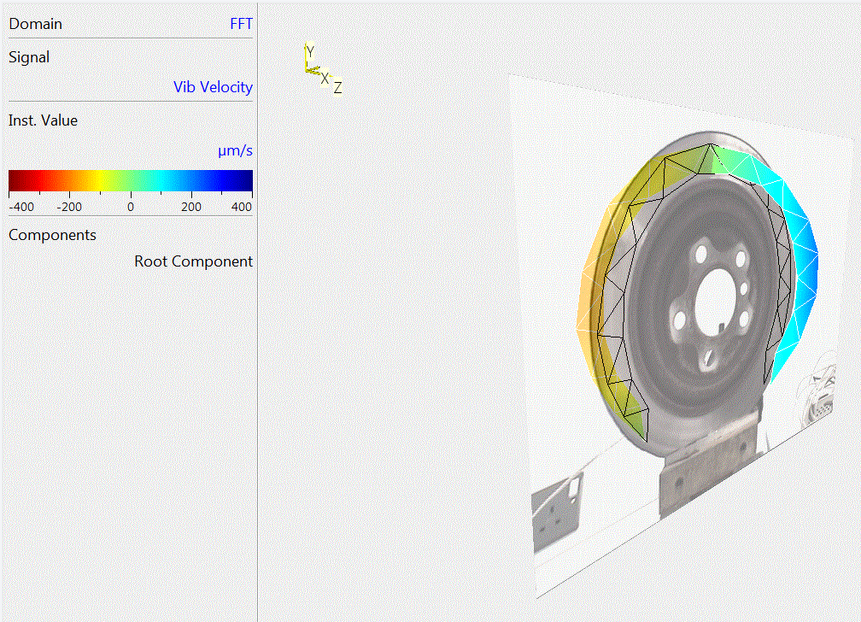  - $f=225Hz$
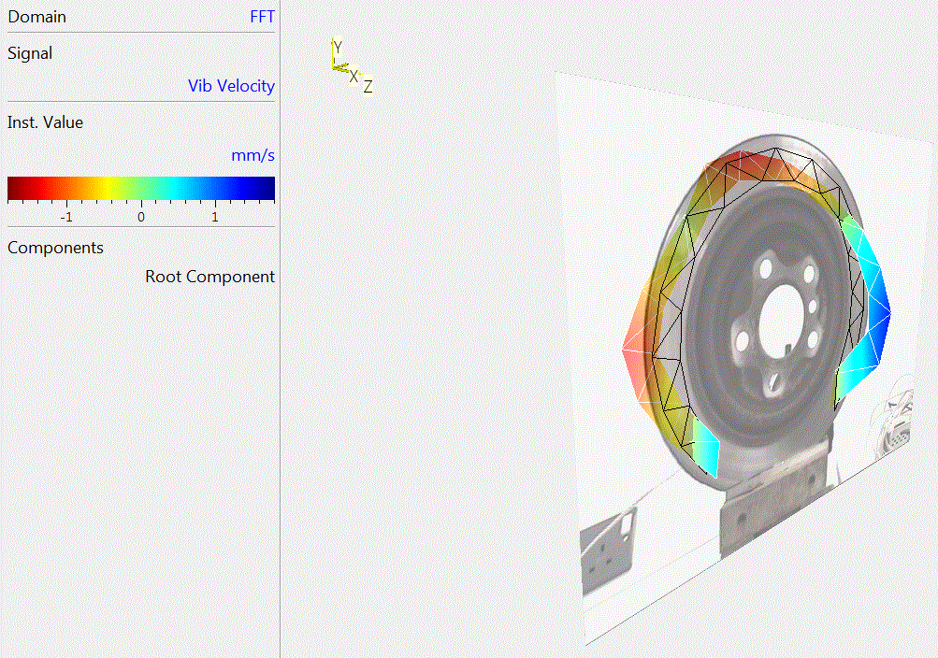  (c) $f=612.5Hz$ | 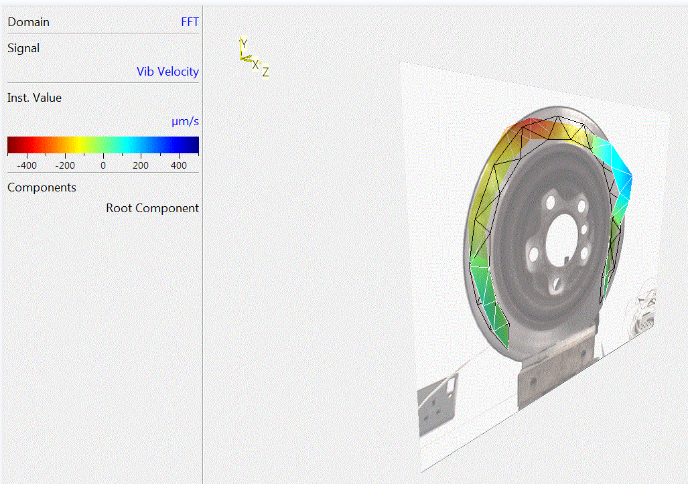  (d) $f=1025Hz$
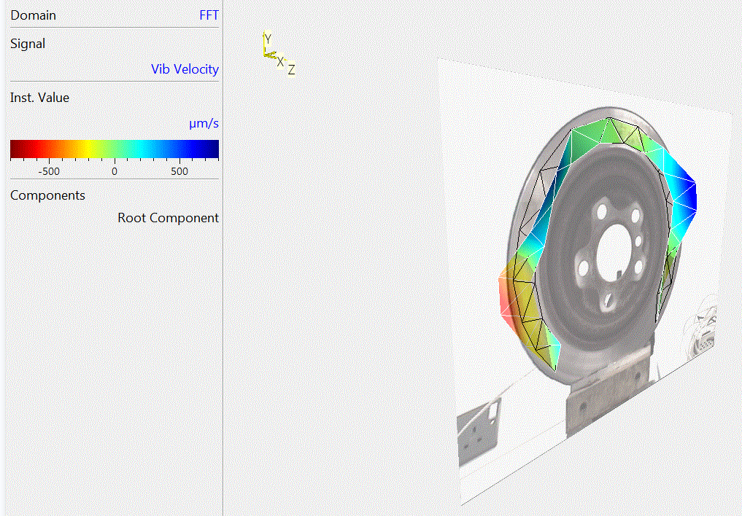  (e) $f=1225Hz$ | 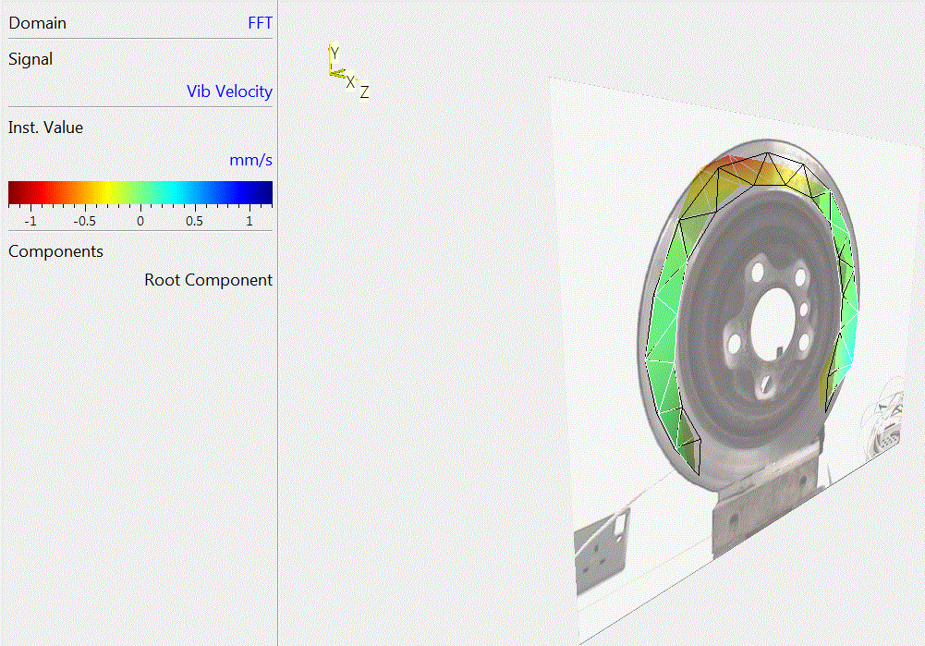  (f) $f=1487.5Hz$
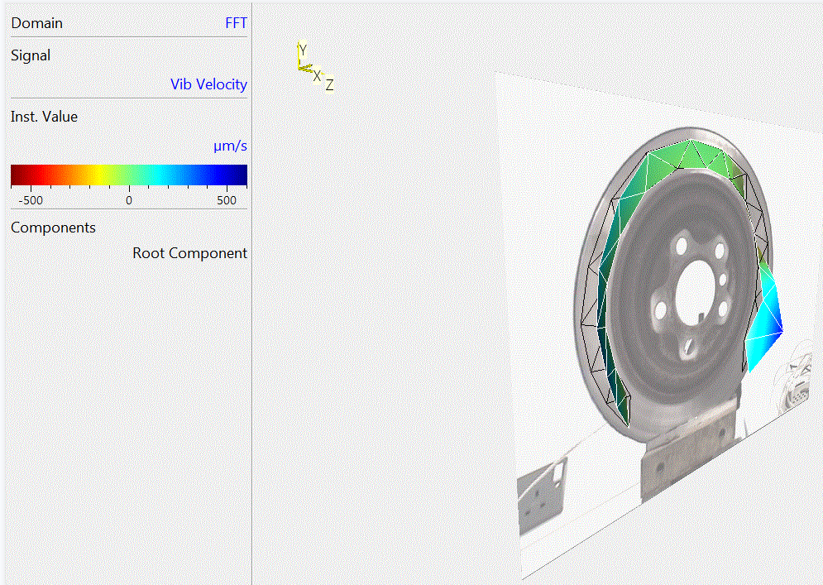  (g) $f=1575Hz$ | 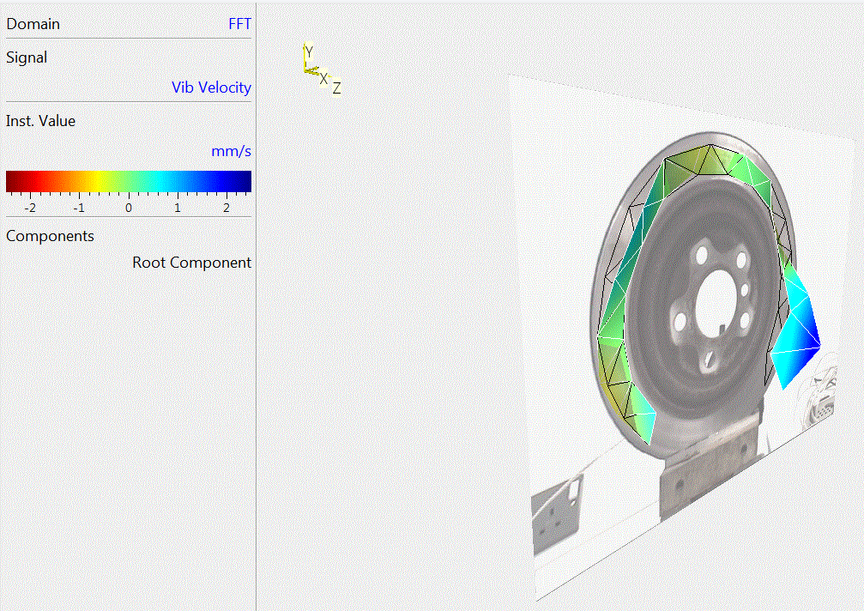  (h) $f=1762.5Hz$
Figure3.1. Vibration modes for each frequency band

Analysis and Error estimates

Analysis
Firstly, the Frequency response graph is analysed, in which the peaks at the four intrinsic frequencies of 1, 3, 5 and 8 are larger with larger amplitudes, which may produce larger vibration amplitudes when vibrating at these frequencies. At the same time, table3.1 shows that the peak widths at the four intrinsic frequencies of 3, 4, 5 and 8 are larger, and the damping at these intrinsic frequencies is larger, indicating that the vibration at these frequencies can be dissipated quickly. However, the peak widths at the four intrinsic frequencies 1, 2, 6 and 7 are smaller, indicating that the damping at these intrinsic frequencies is smaller, which may create more serious vibration and noise problems. Meanwhile, the samples tested in this experiment are brake discs, and annular components generally have two vibration traits, namely wave mode, which is usually the vibration of the brake disc appearing along the circumferential direction with peaks and troughs; and bent mode, which is manifested as the displacement or bending of the whole disc surface in a certain direction, for example, the disc surface may be bending to one side.

Next it was judged that the resonant frequency modes and shapes of a brake disc at each inherent frequency for this experiment are shown in Table 4.1.
Table4.1 the resonant frequency modes and shapes
Frequency (Hz) | mode | shape
87.5 | 1 | bent
225 | 2 | wave
612.5 | 3 | bent and wave
1025 | 4 | bent and wave
1225 | 5 | bent and wave
1487.5 | 6 | bent and wave
1575 | 7 | bent and wave
1762.5 | 8 | bent and wave
As shown in Fig. 3.1, when $f=87.5Hz$, there is no node in the vibration model and it is obviously curved to one side, so the main harmonic resonant mode is first order and the shape is bent.
When $f=225Hz$, there is one node in the vibration model of the brake disc, at the top of the disc, and vibration along the circumferential direction occurs on both sides of the disc, so the main harmonic resonant mode is second order, and the shape is wave.
When $f=612.5Hz$, there are two nodes in the vibration model and the vibration direction is the same on the left side and the top of the brake disc while the right side is in the opposite direction, the shape are more complex so therefore the main harmonic resonant mode is third order while the shape is a composite of bent and wave.
When $f=1025Hz$, there are four three nodes in the vibration mode and its trait is more complex, so therefore this frequency mode is third order and the shape is a composite of bent and wave. The other four main harmonic resonant mode increase with frequency and the shape are all more complex and difficult to determine, but all are composite of bent and wave.

Error estimates
The following factors may have produced errors in this experiment:
- The brake disc is fixed on the axle, and when the car brakes, the brake caliper and the brake disc come into contact, generating friction to achieve the effect of braking. In this experiment, only the lower end of the brake disc is fixed with a vise, which is quite different from the actual situation, and cannot well simulate the situation when the car is moving or braking, so the intrinsic frequency of the vibration of the brake disc will have a large error with the real situation.
- There can be other sources of vibration in the surrounding environment that interfere with the experiment, such as vibrations from operating equipment such as air conditioners or sound waves generated by people talking, which can lead to vibrations that do not belong to the intrinsic frequency of the brake disc itself in the frequency domain response curve.
- The unstable fixation of the solenoid actuator may result in the generation of inappropriate or unstable excitations, and the fact that the solenoid actuator was placed in only one place in this experiment may also result in some vibration models not being excited.
- In this experiment, the LDV is facing the window, although there are curtains to block most of the strong light from the window, it may still lead to the surface of the measured parts to interfere with the signal reception of the LDV.
All these factors may produce large errors, so the resonant frequency modes and shapes of a brake disc in this experiment may have some errors with some deviations from the actual situation.

Results
In this experiment, the vibration intrinsic frequency, main harmonic resonant modes and shapes of the brake disc are obtained. The disc surface is where the majority of the deformation is concentrated, as shown by the analysis of the 1-8 order vibration pattern diagram. This deformation manifests itself as axial runout, which may cause the brake disc to vibrate easily during the braking process in relation to other components of the braking system, such as the friction lining and so forth. Second, the intrinsic frequency of the brake disc will cause a large rise in vibration amplitude, which is easily resonant with other components. By altering the material or structure, it is possible to optimise the decrease of vibration at certain frequencies, reducing noise and improving braking performance while preventing resonance damage to the brake disc or friction lining.

Conclusion
In this experiment, PolyTec PSV-400 laser Doppler vibration instrument is used to measure and analyze the natural frequency mode and form of the brake disc. The experimental results show the vibration characteristics of the brake disc under different natural frequencies, including vibration mode, resonance frequency peak and damping characteristics. Wherein, the brake disc shows an increase in vibration amplitude at a specific frequency, and the damping at some frequencies is greater, indicating that the vibration energy is quickly dissipated at these frequencies. The brake discs show different vibration characteristics in different modes. Finally, some possible causes of errors are also analysed. These data and analyses are of great significance for improving the braking performance, reducing noise, prolonging the service life of brake discs and improving the experimental method.

Reference
Ferhat, I., Sarlo, R. and Tarazaga, P.A. (2020) ‘3D Modal Analysis of a Loaded Tire with Binary Random Noise Excitation’, Tire Science and Technology, 48(3), pp. 207–223. Available at: https://doi.org/10.2346/tire.19.170166.
Johansmann, M., Fritzsche, M. and Schell, J. (2011) A New Method for Measurement of Rotating Objects Utilizing Laser Doppler Vibrometry Combined with an Optical Derotator with Focus on Automotive Applications. Available at: https://doi.org/10.4271/2011-26-0043.
Mallareddy, T.T. et al. (2017) Brake Impedance Test Stand - Modal Testing of Brake Pads under Pressurized Condition Using 3D SLDV and a Scalable Automatic Modal Hammer. Available at: https://doi.org/10.4271/2017-01-2485.
Rothberg, S.J. et al. (2017) ‘An international review of laser Doppler vibrometry: Making light work of vibration measurement’, Optics and Lasers in Engineering, 99, pp. 11–22. Available at: https://doi.org/10.1016/j.optlaseng.2016.10.023.
Schell, J. et al. (2006) ‘Three Dimensional Vibration Testing in Automotive Applications Utilizing a New Non-Contact Scanning Method’, in. SAE 2006 World Congress & Exhibition, pp. 2006-01–1095. Available at: https://doi.org/10.4271/2006-01-1095.
Xiaoming, N., Jian, Z. and Xingwu, L. (2014) ‘Laser Doppler velocimeter for vehicle application with improved signal-to-noise ratio’, Applied Physics B, 116(3), pp. 637–641. Available at: https://doi.org/10.1007/s00340-013-5746-1.

