

Managing Enterprise in the 21st Century

Business Plan

Ibrahim kudu Uthman
Black kings
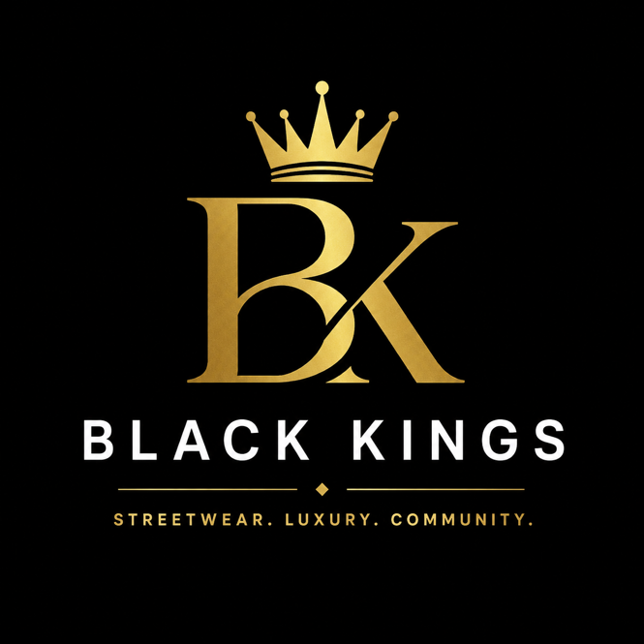
2514082

Submission Date: 27/07/2026
Lecturer: Shengfeng Mei
Course: Enterprise and Entrepreneurship (LCLM4006_LON)
Black Kings Ltd
Business Idea

Black Kings Ltd is a new UK-based clothing brand offering accessible streetwear with luxury-inspired design. Our central aim is to provide stylish, high-quality garments for shoppers who value premium artistry and aesthetics but find luxury prices beyond reach.

This comes from personal experience I have long preferred designer pieces for their superior cut, fabric, and finish, yet their cost made a versatile, quality wardrobe impractical. This revealed a clear market gap no single brand consistently delivers a premium feel, contemporary style, and lasting durability at prices suited to everyday buyers. Black Kings was founded to fill this space, allowing people to dress with confidence and express their identity without paying luxury markups.

Our first collection includes T-shirts, hoodies, tracksuits, sweatshirts, jackets, jeans, caps, and complementary accessories. Every item blends modern streetwear silhouettes with refined luxury detailing, prioritising longevity, and fair pricing. We design our garments to endure regular wear, keep their shape and colour, and provide exceptional value.

Brand Story

Black Kings is built on the belief that great fashion and the confidence it brings should not be a privilege reserved for the wealthy. Luxury brands are known for their artistry, precision, and ability to help people feel their best, yet their inflated costs exclude millions of style-conscious shoppers across the UK.

Driven by my own frustration at having to choose between quality and affordability, I created a brand that bridges this divide: one that delivers premium design without inflated pricing. Black Kings is more than clothing it stands for confidence, ambition, and inclusivity. We aim to build a tight-knit, loyal community where every customer feels seen and can express their personality freely through what they wear. We take our duty to people and the planet seriously.

Mission Statement
To provide affordable, high-quality streetwear and luxury-inspired clothing that lets people express themselves with confidence, while fostering an inclusive community and acting responsibly toward people and the environment.

Vision Statement
To become one of the UK’s leading independent streetwear brands, known for distinctive design, consistent quality, meaningful community involvement, and sustainable practice.

Business Objectives

- - Launch as a fully operational e-commerce business within 12 months of incorporation
- - Keep 90%+ customer satisfaction through strict quality control and responsive, personalised service
- - Grow an active social media following of 5,000+ in year one, rising to 20,000+ by year three
- - Remove all single-use plastics from packaging and fulfilment by the end of year two
- - Donate 10% of unsold stock and run at least two local clothing collection drives annually from launch
- - Open our first pop-up store within three years, and launch permanent retail premises within five yearsItemDetailsRegistered NameBlack Kings LtdBusiness TypeStreetwear and luxury-inspired apparel retailerLegal StructurePrivate Limited Company (Ltd)OwnershipFounder sole ownershipLiabilityLimited liability – personal assets are entirely separate from business debtsRationaleA limited company establishes a distinct legal identity, protects personal assets, builds credibility with suppliers and investors, and supports future growth, partnerships and funding applicationsMarket Analysis

Legal formats

Item | Details
Registered Business Name | Black Kings Ltd
Business Type | Streetwear and luxury-inspired apparel retailer
Legal Structure | Private Limited Company (Ltd)
Ownership | Sole ownership by the founder
Liability | Limited liability – personal assets are fully separate from business debts and obligations
Rationale for Ltd structure | A limited company creates a distinct legal identity, protects personal assets, builds trust with suppliers and investors, and supports future growth, partnerships, and funding applications.

Management Structure Table
CEO
I Uthman

Finance&administration
I Uthman
Marketing&sales
I Uthman
Customer service
I Uthman
Operation&production
I Uthman

Design&product manager
I Uthman

Customer service representative
I Uthman
Fashion designer
I Uthman
Operation manager
I Uthman
Marketing&sales manager
I Uthman
Finance officer
I Uthman

PESTEL Analysis

Political: The UK keeps regulations on employment, taxation, and consumer protection; Black Kings will follow these rules as a Private Limited Company.

Economic: Rising inflation and living costs prompt buyers to look for affordable fashion, opening prospects for Black Kings.

Social: Streetwear gains appeal among young adults, while shoppers increasingly favour sustainable and socially responsible brands.

Technological: Black Kings will function online and use social media such as Instagram, TikTok, and Facebook to promote its products.

Environmental: The business will adopt recyclable packaging and back clothing donation campaigns to cut waste and aid local communities.

Legal: Black Kings will adhere to UK laws on consumer rights, intellectual property, data protection (UK GDPR), product labelling, health, and safety.

Competitor AnalysisBlack Kings operates in the highly competitive UK fashion industry. Its main competitors include established retailers that offer affordable fashion and streetwear.

Direct Competitors

• Zara: Strong trend authority but higher prices and uneven durability – we match style and finish at lower cost with a more authentic brand identity.

• H&M: Broad range and low prices but quality varies and sustainability claims are often questioned we distinguish ourselves through streetwear-specific design and tangible local action.

• ASOS: Extensive reach and choice but lacks distinct personality – we build a clear values-driven identity that stands out.

• Boohoo: Low pricing but poor ethical and quality reputation – we prioritise consistent standards and transparency to earn long-term trust.

Indirect competitors include Primark (low cost but no luxury styling), Next and M&S (mainstream appeal with limited streetwear focus), Sports Direct (branded sportswear only), and TK Max (discounted stock without a consistent brand experience).

Future competitors include new independent labels, influencer-led lines, international fast-fashion entrants, and luxury diffusion ranges. We will defend our position through consistent quality, clear values, and genuine customer connection – attributes that are hard to replicate.

SWOT Analysis

Strengths | Weaknesses
Luxury-inspired design at far lower prices than premium brands | No existing brand recognition or customer base
Clear, purpose-driven identity focused on community and sustainability | Limited first funding compared to established retailers
Flexible, lean business model for fast decision-making | Smaller first product range
Digital-first approach to reach customers cost-effectively | Reliance on third-party manufacturers and suppliers
Founder’s personal understanding of target customer needs | Limited marketing budget in first stages

Opportunities | Threats
Fast-growing UK demand for affordable streetwear | Intense competition from both high-street and online brands
Expansion into European and international markets via e-commerce | Rapidly changing fashion trends requiring regular adaptation
Partnerships with local artists, youth groups, and micro-influencers | Rising costs of raw materials, manufacturing, and shipping
Growing preference for ethical, independent brands | Economic uncertainty reducing non-essential spending
Product line extensions into footwear and accessories | Latest brands entering the market with similar propositions

Marketing: STP Framework

• Segmentation: Men and women aged 18–35 across the UK (beginning in the West Midlands), who prize self-expression and ethical practice and review quality and brand values before buying.
• Targeting: Students, early-career professionals, streetwear fans, socially aware shoppers, and frequent users of visual social media.
• Positioning: “Black Kings delivers luxury-inspired streetwear built for everyday life: premium style, lasting quality, and fair prices, so you can dress with confidence and join a community that stands for more than fashion.

Channels & Activity: Instagram and TikTok for product, lifestyle, and behind-the-scenes content; partnerships with compatible micro-influencers; email updates offering exclusive access; student discounts, free UK delivery, and loyalty rewards; and active promotion of our charitable and community work.

Marketing Mix:

• Product: Curated streetwear with luxury detailing, consistent quality, and extended sizing
• Price: £25–£45 for core items, £50–£80 for outerwear – roughly 60–70% less than similar designer pieces.
• Place: E-commerce first; pop-ups from year two; long-term wholesale with independent boutiques.
• Promotion: Integrated digital marketing, influencer collaborations, and community-focused initiatives.

Financial Plan

Funding Requirement

The total first funding needed is £25,000, divided between personal investment and government-backed lending to reduce debt and keep full ownership.

Funding Source | Amount (£) | Rationale
Personal Savings | 10,000 | Demonstrates founder commitment and reduces external borrowing
Government Start Up Loan | 15,000 | Covers stock, launch costs and early operations without giving up equity
Total | 25,000

Cost Breakdown
One-off Start-up Costs

Item | Cost (£)
Initial stock (10 core designs) | 8,000
E-commerce website development | 2,000
Brand identity, logo, and artwork | 2,000
Packaging design and materials | 1,500
Launch marketing and content creation | 3,000
Equipment and software | 2,000
Company registration and insurance | 800
Total | 19,300

Monthly Fixed Costs

Item | Cost (£)
Storage and fulfilment services | 2,500
Part-time staff (customer service/operations) | 2,800
Website hosting and software | 150
Communications and utilities | 100
Business insurance | 100
Accounting and compliance support | 150
Marketing tools | 200
Total | 6,000

Variable Costs Per Unit

Item | Cost (£)
Manufacturing and materials | 25.00
Packaging | 2.00
UK delivery | 5.00
Payment processing fees | 3.00
Total | 35.00

Financial Projections

• Average selling price per item: £60
• Contribution per unit: £60 – £35 = £25
• Break-even point: £6,000 ÷ £25 = 240 units per month

This shows that Black Kings must sell 240 items each month to cover operating costs; any unit beyond this threshold produces profit. The total launch funding
supports start-up costs and one month of fixed expenses, offering a buffer while initial sales gain momentum.

Reference List

Companies House (2024) Running a limited company. Available at: https://www.gov.uk/run-limited-company (Accessed: 21 July 2026).

Department for Business and Trade (2024) Business support and guidance. Available at: https://www.gov.uk/browse/business (Accessed: 21 July 2026).

Office for National Statistics (2025) Economy. Available at: https://www.ons.gov.uk/economy (Accessed: 21 July 2026).

Statista (2025) Fashion - United Kingdom. Available at: https://www.statista.com/topics/4688/fashion-industry-in-the-united-kingdom/ (Accessed: 21 July 2026).

Chartered Institute of Marketing (2023) Marketing and digital strategy. Available at: https://www.cim.co.uk (Accessed: 21 July 2026).

