BSc (Hons) Health and Social Care
Module: Changemakers: Building your Personal Brand for Sustainable Employment
Module code: BMHP5015
Assignment Title: Component 2: Assignment (Report)
Lecturer: Olufemi Oluranti

Student: Mina Khorshid
ID: 2122088
Table of Contents
Introduction 3
Job advertisement 3
Employability Skills for Job Roles 4
Evaluate Your Own Skills 5
Self-Evaluation 5
Strengths: 5
Areas for Improvement: 5
Who Can Help? 6
Action Plan and Timeline 6
Action Plan: 6
Timeline 7
Building Your Personal Brand 7
Promoting Your Professional Identity 7
Building a Network for Successful Employment 8
Conclusion 9
References 10

Introduction
This paper examines the position of a Staff Nurse as advertised by The Royal Orthopedic Hospital NHS Foundation Trust.
The position emphasises the provision of safe, compassionate, and patient-centered care while functioning independently within a clinical team.
The staff nurse is tasked with evaluating patient requirements, devising, and executing care plans, giving medications, and facilitating service enhancement activities within the organization.
This study aims to assess my suitability for the work by analyzing the requisite employability skills, commenting on my competencies, and pinpointing opportunities for improvement. The study delineates an action plan for attaining the abilities necessary for a Band 5 Staff Nurse role in the NHS and specifies techniques for cultivating a professional personal brand that fosters sustainable employment in healthcare.
Enhancing employable skills and professional identity is crucial for healthcare professionals pursuing sustained career advancement (King, 2021).

Job advertisement
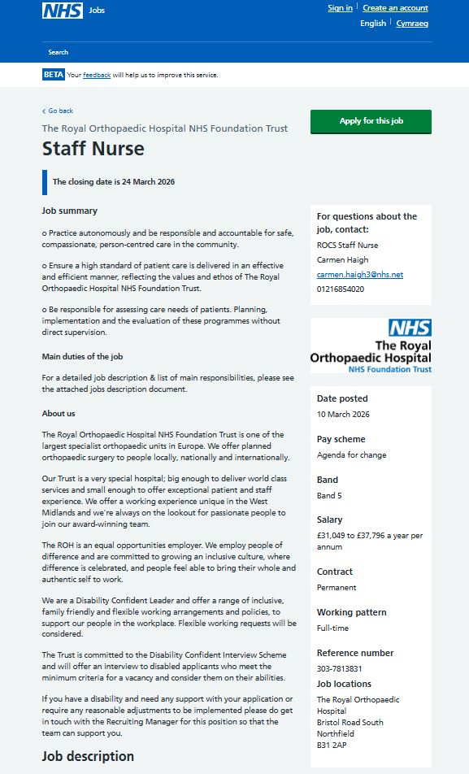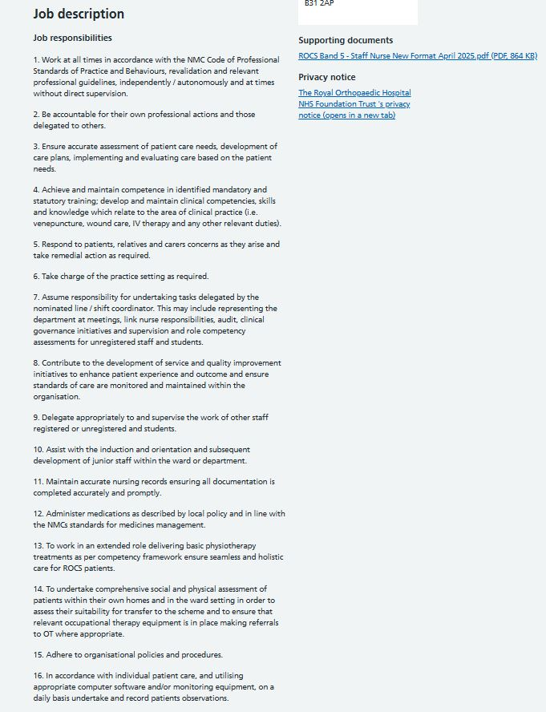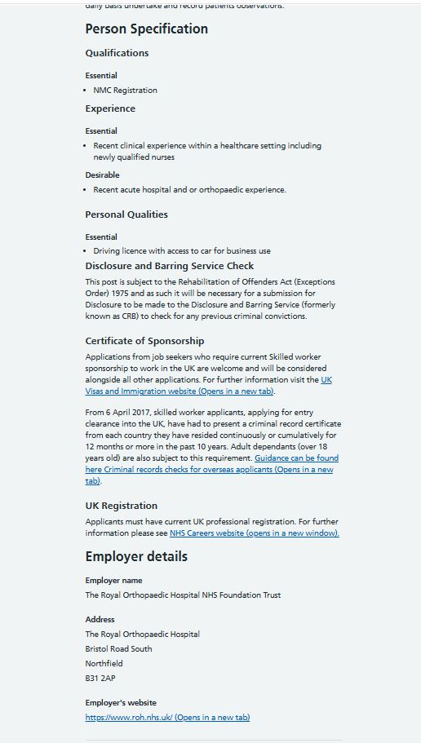
The job advertisement pertains to a Band 5 Staff Nurse vacancy at The Royal Orthopedic Hospital NHS Foundation Trust.
The position entails delivering exceptional patient care, conducting clinical evaluations, dispensing medication, ensuring precise patient documentation, and assisting subordinate personnel. The nurse is required to adhere to the Nursing and Midwifery Council (NMC) Code of Professional Standards and participate in quality improvement activities within the healthcare organization.
The person criteria stipulates that candidates must possess NMC registration, current clinical experience in a healthcare environment, and robust communication and teamwork abilities. Preferred qualifications encompass experience in orthopedics or acute hospital settings. The position necessitates the capacity for independent work, adherence to professional accountability, and collaboration with interdisciplinary healthcare teams.

Employability Skills for Job Roles
Staff nurses necessitate a synthesis of clinical expertise, people skills, and professional conduct to provide excellent patient care. Communication skills are essential as nurses must engage with patients, families, and multidisciplinary teams to guarantee coordinated and safe care (Raeissi et al., 2019).
Effective communication enables healthcare personnel to comprehend patient demands, minimise errors, and enhance health outcomes.
Collaboration is a crucial competency for nurses operating in hospital settings. Healthcare professionals must collaborate with physicians, therapists, and other personnel to deliver coordinated treatment regimens (Perry et al., 2021).
In high-pressure healthcare environments like orthopedic wards, collaboration is essential for maintaining patient safety and optimising service performance.
Clinical competence is essential for executing nursing tasks, including medicine administration, vital sign monitoring, and patient rehabilitation assistance. Nurses must possess current understanding of clinical practices and healthcare technologies to guarantee safe patient care (Hockenberry et al., 2023).
Time management and organisational abilities are equally essential, as nurses must prioritise patient care duties while addressing urgent clinical circumstances. Efficient time management allows nurses to deliver prompt treatment and uphold superior care standards (Busby et al., 2022).

Evaluate Your Own Skills

Self-Evaluation
I possess a Level 4 qualification in Health and Social Care, equipping me with insights into healthcare concepts, patient care, and professional ethics. Furthermore, I have already attained ESOL Level 1 and Level 2 certifications, as well as training pertinent to teaching aid. These training experiences facilitated the development of communication, collaboration, and patient support skills that are essential in healthcare settings.
I was employed as a nursery nurse in Iraq, where I acquired experience in assisting children with diverse requirements.
This position enabled me to cultivate patience, empathy, and accountability in the care of vulnerable individuals.
Firsthand experience in healthcare environments enhances professional competency (Daly et al., 2020).

Strengths:
One of my primary talents is my proficiency in various languages, including Arabic, English, Turkish, and Kurdish.
Multilingual communication can augment patient engagement and elevate culturally competent care in healthcare environments (Sadeghi et al., 2022).
I possess practical clinical expertise acquired from prior nursing employment in Iraq, where I assisted with medical operations and injections. These experiences enhanced my confidence in clinical settings and fortified my capacity to perform under duress. My eagerness to acquire knowledge and advance professionally is an additional asset that underpins my long-term career aspirations in nursing.

Areas for Improvement:
While I possess experience in healthcare settings, I acknowledge the necessity of acquiring further competencies in emergency care and specialised nursing techniques. Ongoing professional development is crucial for sustaining competence and adjusting to alterations in healthcare practice (Fawaz et al., 2018).
I must enhance my understanding of advanced clinical processes, patient safety protocols, and NHS clinical guidelines. Enhancing these competencies would augment my preparedness to function efficiently as a staff nurse in a hospital setting.

Who Can Help?
Mentors, professional groups, and training programs can facilitate the enhancement of these talents.
The NHS offers diverse clinical education programs that assist nurses in improving their skills and conforming to professional requirements (NHS, 2024).
Moreover, professional bodies like the Royal College of Nursing provide guidance, training, and professional support for nurses pursuing career advancement prospects (Badoer et al., 2021).
Interacting with seasoned mentors can yield invaluable counsel and pragmatic insights into clinical practice.

Action Plan and Timeline
The following action plan and timeframe provide a definitive framework for acquiring the information, abilities, and professional milestones necessary for the Band 5 Staff Nurse position.

Action Plan:
Objective | Specific Steps
Short-Term Objectives (0-1 year) | Complete Health and Social Care Level 4 and strengthen understanding of patient care, safeguarding and professional ethics.
Gain Healthcare Exposure | Seek volunteering, shadowing or support work opportunities in hospital or community healthcare settings to build confidence and practical insight.
Develop Core Clinical Knowledge | I attend short courses on infection prevention, manual handling, basic observations, record keeping and patient safety procedures.
Medium-Term Objectives (1-3 years) | Work towards recognised healthcare qualifications and build experience relevant to nursing practice and NHS expectations.
Obtain Relevant Certifications | Complete training such as Basic Life Support, safeguarding updates and any introductory clinical skills courses that improve employability.
Build Professional Readiness | Improve understanding of NHS values, multidisciplinary teamwork, documentation standards, and compassionate communication in practice.
Long-Term Objectives (3-5 years) | Progress towards NMC registration and prepare to apply for Band 5 Staff Nurse posts within NHS organisations.
Apply for Staff Nurse Roles | Use an updated CV, tailored cover letters, and evidence of continuing professional development to apply for suitable vacancies.
Continuing Professional Development | Maintain reflective learning, attend training events, and keep clinical knowledge current to support long-term career progression.

Timeline
Year | Milestones and Activities
Year 1 | - Complete Health and Social Care Level 4.  - Attend introductory healthcare and patient safety training.  - Begin shadowing, volunteering or support work experience.
Year 2 | - Gain more direct care experience in a health or social care setting.  - Complete Basic Life Support and safeguarding updates.  - Strengthen written communication and documentation skills.
Year 3 | - Pursue further nursing-related study or access pathway progression.  - Build confidence in teamwork, patient assessment, and care planning.  - Develop a stronger professional CV and online profile.
Year 4 | - Work towards meeting NMC registration requirements.  - Apply for relevant healthcare assistant, trainee, or pre-registration opportunities.  - Seek mentorship from qualified nurses or clinical educators.
Year 5 | - Complete registration pathway requirements where applicable.  - Apply for Band 5 Staff Nurse vacancies.  - Continue professional development through training and reflective practice.

Building Your Personal Brand
Establishing a robust personal brand is essential for healthcare professionals pursuing career prospects.
Personal branding enables individuals to convey their abilities, experiences, and professional ideals to prospective employers (Pizzuti et al., 2020).
Establishing a professional profile on networking platforms like LinkedIn can effectively highlight qualifications, clinical expertise, and professional accomplishments. Online professional networking has demonstrated the capacity to improve job prospects and increase employment exposure (Davis et al., 2020).
Upholding a competent web presence and disseminating healthcare-related knowledge can enhance my professional profile and exhibit dedication to the healthcare field.

Promoting Your Professional Identity
1. CV and Cover Letter: A professional curriculum vitae and cover letter are crucial for highlighting qualifications, experience, and personal attributes to prospective employers. My CV must prominently display my healthcare expertise, practical experience, communication proficiency, and bilingual capabilities. It should encompass my ongoing studies in Health and Social Care, prior nursing-related experience, and any pertinent training. The cover letter must be customised for the Staff Nurse position by articulating how my talents, values, and career objectives correspond with the organization's requirements. An effectively crafted CV and cover letter can enhance employability by clearly and professionally demonstrating suitability for the position (Jackson, 2016).

2. Online Presence: Cultivating a professional online presence is a crucial method for enhancing my professional identification. Platforms like LinkedIn may be utilised to highlight my qualifications, work experience, accomplishments, and career aspirations in a professional manner. An impressive web presence can assist companies in comprehending my competencies and dedication to healthcare practice. It enables me to network with specialists, monitor healthcare companies, and be apprised of contemporary advancements in the nursing field. Studies indicate that online professional networking can yield career advantages and enhance job prospects (Davis et al., 2020).

3. Networking and Professional Events: Participation in networking events, healthcare courses, and professional conferences can enhance my professional identification and augment job opportunities. These events offer opportunities to engage with seasoned professionals, acquire knowledge about contemporary healthcare practices, and receive guidance on career advancement. Networking can facilitate mentorship opportunities and foster relationships with individuals in therapeutic settings. This type of professional interaction enhances employability by boosting confidence, expertise, and visibility in the healthcare sector (Azorin et al., 2020).

Building a Network for Successful Employment
Establishing a professional network is crucial for attaining enduring employment in the healthcare industry. Networking facilitates the cultivation of relationships with seasoned professionals, acquisition of career guidance, and discovery of employment prospects. In nursing, professional networks are essential since they facilitate knowledge exchange, enhance confidence, and promote ongoing professional development, all of which are crucial for career advancement (King et al., 2021).
An efficient method for establishing a network is through internships, volunteer work, and training opportunities. These experiences enable individuals to engage with healthcare professionals, observe professional practices, and obtain guidance from mentors and supervisors. Mentorship is crucial as it enhances confidence, fortifies professional abilities, and offers support during preparation for employment in clinical environments (Busby et al., 2022).

Professional associations, such as the Royal College of Nursing, offer exceptional networking possibilities. By participating in such organisations, individuals can engage in workshops, conferences, and seminars, facilitating networking with other professionals and being updated on contemporary advancements in healthcare practice (Badoer et al., 2021). Moreover, online platforms like LinkedIn facilitate connections between individuals and employers, enable the sharing of accomplishments, and foster the development of a professional online persona. Consequently, cultivating a robust network can enhance employability, expand access to opportunities, and facilitate sustained success in the nursing profession (Davis et al., 2020).

Conclusion
This study analysed the prerequisites of the Staff Nurse post at The Royal Orthopedic Hospital NHS Foundation Trust and assessed my preparedness for this role. The investigation revealed essential employability abilities such as communication, collaboration, clinical proficiency, and time management.
Through self-assessment, I discovered strengths like multilingual communication and clinical experience, alongside areas necessitating additional growth, such as advanced nursing techniques. A strategic plan was established to facilitate my professional growth and direct my advancement towards acquiring NMC registration and attaining a Band 5 Staff Nurse role.
Establishing a robust personal brand, sustaining professional networks, and participating in ongoing professional development will be crucial methods for attaining lasting employment in the healthcare sector.

References
Job Link
https://www.jobs.nhs.uk/candidate/jobadvert/C9303-26-0046?searchFormType=main&keyword=peadiatriuc%20staff%20nurse&location=birmingham&language=en

Sources

Azorín, C., Harris, A. and Jones, M., 2020. Taking a distributed perspective on leading professional learning networks. School Leadership & Management, 40(2-3), pp.111-127.

Badoer, E., Hollings, Y. and Chester, A., 2021. Professional networking for undergraduate students: A scaffolded approach. Journal of further and Higher Education, 45(2), pp.197-210.

Busby, K.R., Draucker, C.B. and Reising, D.L., 2022. Exploring mentoring and nurse faculty: An integrative review. Journal of Professional Nursing, 38, pp.26-39.

Daly, J. and Jackson, D., 2020. Contexts of nursing: An introduction. Elsevier Health Sciences.

Davis, J., Wolff, H.G., Forret, M.L. and Sullivan, S.E., 2020. Networking via LinkedIn: An examination of usage and career benefits. Journal of Vocational Behavior, 118, p.103396.

Fawaz, M.A., Hamdan-Mansour, A.M. and Tassi, A., 2018. Challenges facing nursing education in the advanced healthcare environment. International journal of Africa nursing sciences, 9, pp.105-110.

Hockenberry, M.J., Bryant, R. and Hellsten, M.B., 2023. Wong's clinical manual of pediatric nursing E-book. Elsevier Health Sciences.

Jackson, D., 2016. Re-conceptualising graduate employability: The importance of pre-professional identity. Higher Education Research & Development, 35(5), pp.925-939.

King, R., Taylor, B., Talpur, A., Jackson, C., Manley, K., Ashby, N., Tod, A., Ryan, T., Wood, E., Senek, M. and Robertson, S., 2021. Factors that optimise the impact of continuing professional development in nursing: A rapid evidence review. Nurse education today, 98, p.104652.

NHS, 2024. “Education and Training (1) | NHS Frimley Health Foundation Trust.” Www.fhft.nhs.uk, 2024, www.fhft.nhs.uk/careers/clinical-education/education-centres/wph-pgmc/education-and-training-1/. (Accessed 13 March 2026.).

Perry, A.G., Potter, P.A., Ostendorf, W.R. and Laplante, N., 2021. Clinical Nursing Skills and Techniques-E-Book: Clinical Nursing Skills and Techniques-E-Book. Elsevier Health Sciences

Pizzuti, A.G., Patel, K.H., McCreary, E.K., Heil, E., Bland, C.M., Chinaeke, E., Love, B.L. and Bookstaver, P.B., 2020. Healthcare practitioners’ views of social media as an educational resource. PLoS One, 15(2), p.e0228372.

Raeissi, P., Zandian, H., Mirzarahimy, T., Delavari, S., Moghadam, T.Z. and Rahimi, G., 2019. Relationship between communication skills and emotional intelligence among nurses. Nursing Management, 26(2).

Sadeghi, N., Azizi, A., Tapak, L. and Oshvandi, K., 2022. Relationship between nurses’ cultural competence and observance of ethical codes. Nursing ethics, 29(4), pp.962-972.

