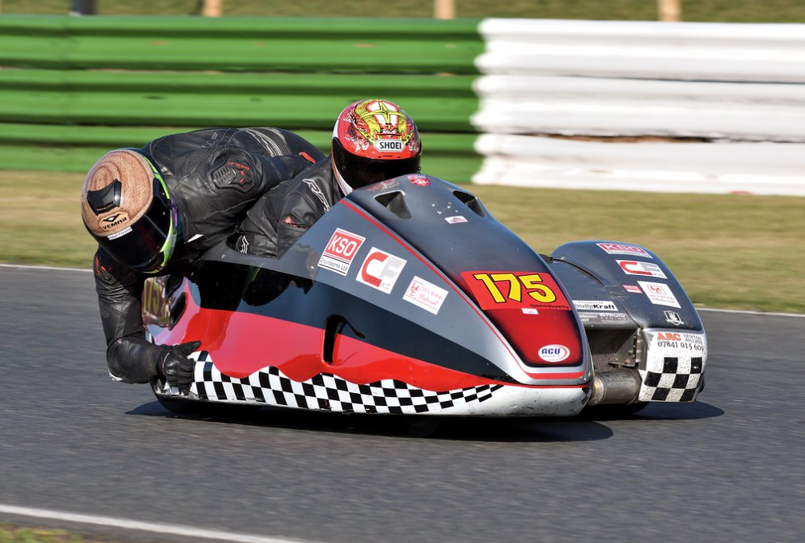
Figure 1 (Mallory Park EMRA September 2019 Finals - John Shipley Jnr… | Flickr, no date)

F2 Racing Sidecars Dynamic Simulation
  - Research proposal
Milo Ward | Autom0tive Engineering | 23/03/2021
Contents
Table of Figures 1
Table of Equations 1
1. Introduction 2
2. Industrial Relevance 2
3. History 3
4. Comparison of F1 and F2 5
5. Basis of research 7
6. Potential routes for this project 8
6.1 Matlab 8
6.2 MSC Adams 9
6.3 RFactor 10
7. Conclusion 11

Table of Figures
Figure 1 (Mallory Park EMRA September 2019 Finals - John Shipley Jnr… | Flickr, no date) 0
Figure 2 (Motorcycle Hero: Rolf Biland, no date) 4
Figure 3 Image of a Formula One Sidecar Chassis (Facebook, no date) 5
Figure 4 Image of a Formula Two Sidecar Chassis (Facebook, no date) 6
Figure 5 Fundamentals of a 6 Degrees of Freedom Model 8

Table of Equations
Equation 1 Newtons 2nd Law 7
Equation 2 Equation of Motion in Differential Form 7
Equation 3 The functions used to allow for the differentiation.((1) PDF File viewer | Microsoft Teams, n.d.) 7

Introduction
The following document will outline a proposal for research into the dynamics of a Formula 2 racing sidecar. Since the 1920s racing sidecars have featured at the Isle of Man TT and at various National and International, often allowing for home design and built sidecars. Throughout its history, there has been various developments and ingenuity in the engineering of sidecars. However, there is a severe lack of published research papers into the dynamics of a sidecar, with majority of dynamic papers being published are two or four wheels. With the exception of a small amount of research being conducted on three-wheel Auto rickshaws (Tuk Tuks) that are used as common modes of transport in some Asian countries (A look at Auto Rickshaws around the World (but mostly in Asia!), no date). These three already researched fields will be used as the basis of further development on creating a realistic dynamic simulation of a racing F2 sidecar.
This document will investigate the history of racing sidecars, the developments that have occurred and discuss the differences in the two main sidecars that are raced today, the Formula 1 (F1) chassis and Formula 2 (F2). Furthermore, analysis of published works of two-, three- and four-wheel dynamic models that may aid in the development of the proposed project. The final part of this document will explore the multiple different ways this project could be tackled, and the positives and negatives of each before concluding. Followed by suggesting the route that this research project should undertake, in order create a realistic dynamic simulation that would allow further research and development to progress from.

Industrial Relevance
In the modern era, sidecars are not common to be seen on UK roads, with no major manufactures producing racing sidecars either, with the biggest sidecar manufacture being LCR chassis. However, with only a small market, but an extremely competitive sport with National and International championship’s all over the world, there is money and some finical backing with some teams.
To purchase a brand-new chassis from a new sidecar brand such as Ryde’s racing sidecars, a chassis costs £25,000 plus VAT in the UK. However, this does not come with an engine, electronics or many other parts needed to build a competitive sidecar. To build a race ready LCR chassis sidecar, the cost would be somewhere in the region on £50,000-£75,000, dependent on the parts fitted.
However, with the competitive field of racing, once a base set up is given by who builds the sidecar, many competitors are left in the dark with understanding the dynamics of the vehicle and the effects of the changes to the set up that they make. The aim for this project will be to be able to create a dynamic simulation model that will accurately represent that characteristics of three-wheel racing sidecars. Allowing a greater understanding of the setup of the sidecar and the fundamentals of the physics.
With a base model produced, this would allow further development of a program that could show the effects of various set up changes. Allowing people to fully understand the overall impact that these changes would have on the vehicle. For motorcycles and cars there are various software’s and programs that already allow for this, for example in the motorcycle world ‘ZeroChassis’ by ZeroOne Racing (ZeroChassis | Zero One Racing | Motorcycle Chassis and Suspension Software, no date) dominates the chassis set up world, being used at International and National level racing. This software has the basic parameters of multiple motorcycles that then accuralty represents the set-up changes and shows the effect that these have. Allowing the team and rider to find a comfortable set up and make informed geometry changes to the motorcycle, rather than taking a stab in the dark.

History
As soon as motorcycles were produced the sidecar closely followed, with the first patent being filed in 1903 (Rebirth of the sidecar » British Motorcyclists Federation, no date) Sidecars were created for two main reasons, cheaper to purchase than a car and more practical than a motorcycle, adding in the fact that until the 1960s it was illegal to ride a motorcycle over 250cc without having a full license. However, when a sidecar was attached to the motorcycle, any capacity motorcycle could be ridden using a provisional license.
As with most forms of motorsport, as soon as a vehicle is produced, people start racing them, with the first sidecar race around the Isle of Man TT circuit being held in 1923. (History of the Isle of Man TT Races, no date) In 1949 the motorcycle world championships were born (now knows as Moto GP for solos and FIM World Sidecar Championships for sidecars) with sidecar racing on the bill. In the early days of sidecars, they were often described as a solo with a platform and some scaffolding to attach it, due to the lack of knowledge surrounding building sidecars.
These early sidecars were difficult to ride, due to the geometry of the solo not changing when the sidecar was attached, they were prone to darting left or right under braking and difficult to keep in a straight line while accelerating. However, this didn’t stop people racing them and these affects started to be counter acted by the sidecar passenger, who, by moving their weight around the platform and motorcycle could allow these early bikes to handle better.
Innovation in sidecar racing started early, however many of the riders built their own sidecars using existing solo machines. This resulted in the early sidecar innovation being based around the speed and aerodynamics rather than the geometry and chassis set up. Although, it didn’t take long for innovation to occur, by the early 1960s, the seating position for the driver started to change, dropping the driver into a more crouched position and they would often kneel over the engine. This was done to get the machine and driver as low to the ground as possible, lowering the center of gravity and allowing the sidecar to corner faster without the risk of flipping the sidecar. As the ‘dustbin’ fairings had been developed previously, these were adjusted to fit the newer styled sidecars and this concept is where the modern sidecars are derived from. (A brief history of motorcycle sidecars - Classic Racer, no date)
Throughout the early 1970s, innovation pushed sidecar racing to its limits, with many people over stepping the mark to what a ‘racing sidecar’ is. In 1980 Rolf Biland took this innovation to the max, creating the ‘BEO.’ A few years earlier, the conventional sidecar was changed by the first hub centric steering chassis, moving away from the standard motorcycle front end. ‘BEO’ created a divide in the World Sidecar Championship, with a new class being created, a prototype class for new technology and innovation and the more traditional sidecars. ‘BEO’ now would not be considered a sidecar, resembling a trike rather than a sidecar, with a 500CC two stroke engine at the rear of the vehicle and two rear wheels in line with each other. With this set up, the passengers movements became redundant, resulting with the passenger just sitting next to the driver. (Motorcycle Hero: Rolf Biland, no date)
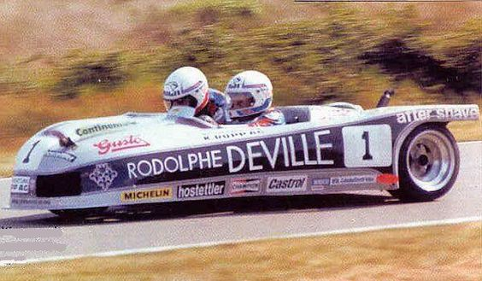
Figure 2 (Motorcycle Hero: Rolf Biland, no date)
In 1981, the FIM changed the rules, banning the uses of ‘trike’ styled sidecars and forcing the passenger to become an active part of the machine, rather than just sitting there. (▷ Secret Bases · Sidecar World Championship, no date) From 1981 to the modern era, the standard racing sidecar shape did not change much from the outside. What did develop was the chassis and geometry with new swing arms and trailing arm front suspension being tried and tested. As the engines that the sidecars used from the solo world were improving, the sidecar chassis had to be changed to suit.
In 1990, the Isle of Man TT banned the use of the F1 styled machines, these are what was used at the FIM World Championship. They were replaced at the Isle of Man TT by the F2 machines, these are shorter chassis and feature a 600CC engine. These machines were being used in multiple championships before and due to the increase speed at the Isle of Man TT, a move to these machines was completed to try and reduce the speed around the circuit.
In 2016, the FIM World Championship changed their rules again, moving from the long chassis 1000CC to use the long chassis but with a 600CC engine, renaming the class Formula 600 or F600. However, the main focus for many sidecar teams is the Isle of Man TT, requiring the use of the F2 chassis, which can also be raced in the FSRA F2 championship which is the British F2 Championship and they are eligible to race in the British F600 championship. Although, with the shorter chassis, these machines struggle to carry the same corner speed as the longer F600 chassis.

Comparison of F1 and F2
As well as the chassis length, there are multiple differences between the F1 and F2 sidecars, one of the main differences is the size of the tires used. Both machines used a 13-inch rim and tires with a 20-inch rolling diameter, however the width of the tires vary. For a F1, it is common to use an 8-inch front, 8-inch side and a 13- or 14-inch rear tyre. Whereas the F2 chassis would commonly use a 6- or 7-inch front and sidewheel, with a 9-inch rear tyre similar to the F1 chassis.
Another major difference between the two chassis is the position of the engine, for a F1 the engine is positioned behind the driver, putting more weight onto the rear of the sidecar for better grip. Whereas, in the more compact chassis of the F2, the engine is situated underneath the driver’s chest. The lack of weight being situated over the rear is then counteracted by the driver’s weight being placed just before the rear wheels to get as much weight over the rear wheel as possible.
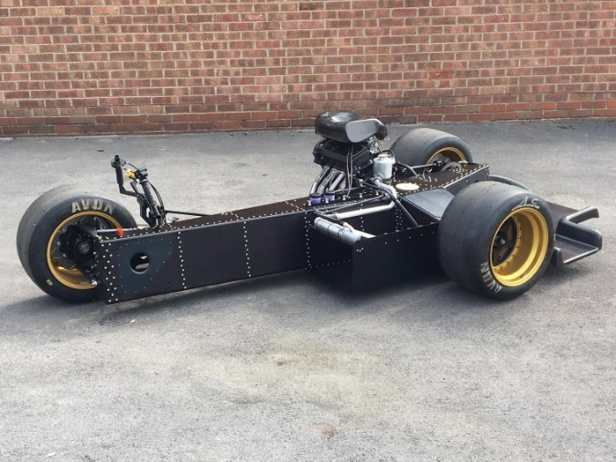
Figure 3 Image of a Formula One Sidecar Chassis (Facebook, no date)
A further difference between the two sidecars is the set up of the steering and suspension on the front of the vehicles. The F1 chassis uses a cantilever front suspension with the shock inside of the box section chassis. Whereas the F2 uses a trailing arm set up with two shocks. In F2, the F1 front end set up is banned by the ACU rules book (Road Racing Standing Regulations, no date) These steering set ups cause different effects on the rake and trail of the machines, with the F2 chassis have a fixed rake around 20 degrees, however different plates can be used at the bottom of the forks to adjust the trail dependent on the track. This style of set up is similar to that of a normal solo machine.
Whereas, the F1 set up doesn’t have a fixed rake, there is an axis of rotations defined by the top and bottom ball joints that are connected to the upright, by changing the position of the top and bottom ball joints, the rake of the sidecar can be adjusted. However, this is set up and measured similar to a car rather than a motorcycle as the sidecar doesn’t have a traditional front end set up.
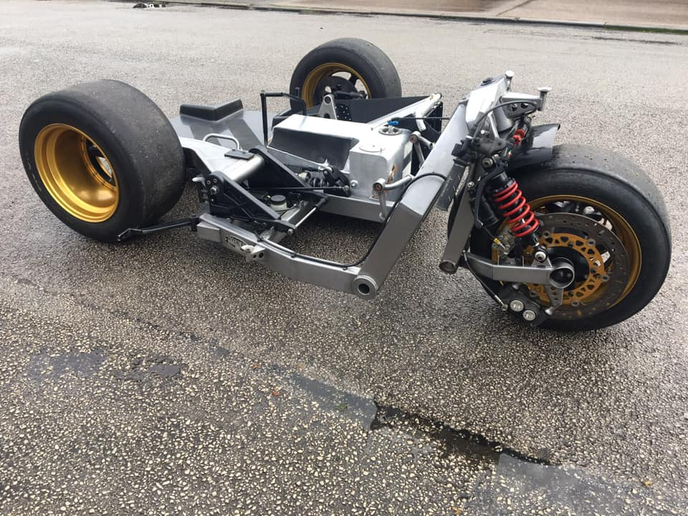
Figure 4 Image of a Formula Two Sidecar Chassis (Facebook, no date)
The F2 chassis was chosen to be taken forwards in this project and be the base for the dynamic simulation model, there is multiple reasons for this choice. The first reason for this is the ability to get hold of a F2 sidecar to be able to gather the starting data, with more sidecar teams focusing on the Isle of Man TT there is more of this styled sidecar in the UK. Furthermore, having the shorter chassis allows for easier transportation, making it more plausible to get the sidecar and gather the information that is needed. Another reason for this is that this project is being supported by John Holden, a TT race winner on a sidecar. With this support he is able to provide technical data on his F2, allow his sidecar to be used to gather data from. Provide real track data to compare the simulated data and aided in creating a link between this project and Maxton suspension, the main supplier for sidecar racing suspension.

Basis of research
Being an unresearched field, the main base for this project is understanding the fundamentals of two wheel and four-wheel dynamic simulation models. Starting with the basics, a one degree of freedom model shows a mass being supported by a spring and a damper. This can be used to represent a suspension set up on the front or rear of the motorcycle
Starting from basics Newtons 2nd law states “The acceleration of an object as produced by a net force is directly proportional to the magnitude of the net force, in the same direction as the net force, and inversely proportional to the mass of the object.(Newton’s Second Law of Motion, no date) This can also be shown as:
$$Force=Mass ×Acceleration$$
Equation 1 Newtons 2nd Law
By using the equations previously used in this report, Newtons 2nd law can be rearranged and as the spring force is the spring rate multiplied by the displacement. Then the damping force is mass multiplied by the velocity. Putting this straight into a differential equation form:
$$m\ddot{x}+c\dot{x}+kx=0$$
Equation 2 Equation of Motion in Differential Form
By making the equation homogeneous (Homogeneous | Definition of Homogeneous by Merriam-Webster, no date)meaning that as each variable is replaced by a constant time, it can be factored out, resulting in all the variables are the same degree. This results in allowing the equation to be differentiate and the use of the quadratic equation.
$Displacement= e^{rt}$ $Velocity=r*e^{rt}$ $Acceleration= r^{2}*e^{rt}$
Equation 3 The functions used to allow for the differentiation.((1) PDF File viewer | Microsoft Teams, n.d.)
The basic degrees of freedom model that can be used to model a four-wheel vehicle in its simplest form is a seven degrees of freedom model, this considers all four spring mass dampers on the vehicle, the pitch, roll and heave and all four tires. Although not a fully accurate model, due assuming rigid driver and not taking into account bushes or chassis flex. However, it is often difficult to know chassis stiffness and the effects of bushes is normally negligible. But the degrees of freedom model could be taken to the extreme to create the most realistic model.
The simplest degrees of freedom model for a sidecar are a six degrees of freedom model, this differs from the previous seven degrees of freedom by reducing one of the spring mass dampers that is used in the model. Even though the sidecar only has two sprung wheels, the front and the rear, the side wheel is modeled with a spring mass damper, however the spring and damper stiffness is modeled as extremely stiff to replicate the lack of movement here. Although, the upright for the sidecar would have a form of spring rate and damping, but in a simple model this could be ignored due to how small this would be.
Below are the basic fundamentals for a six degrees of freedom model for a racing sidecar:
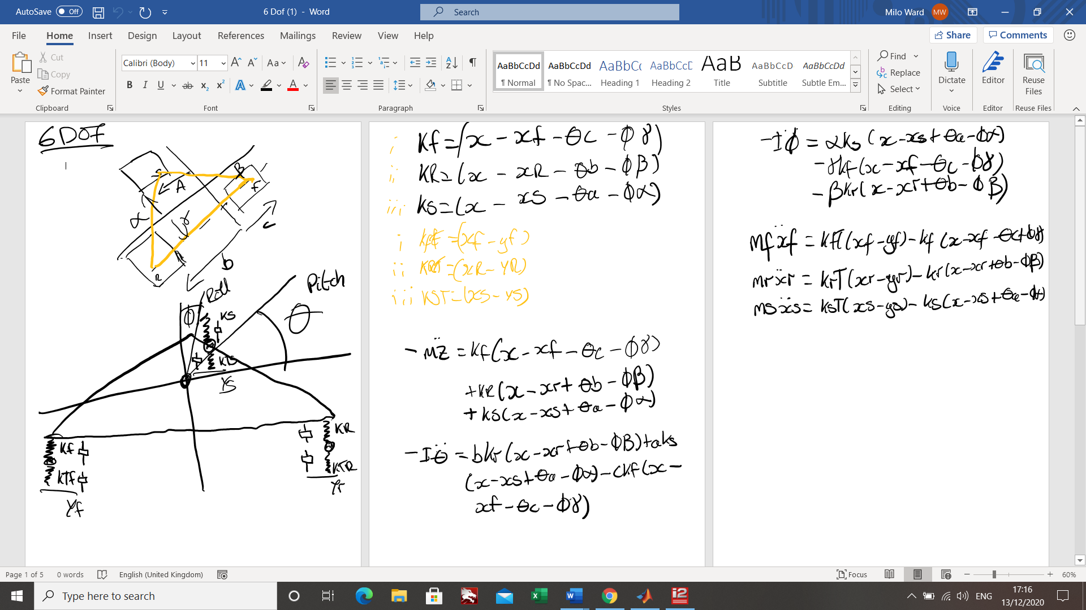
Figure 5 Fundamentals of a 6 Degrees of Freedom Model

Potential routes for this project

Matlab
When analyzing options for this project, it is clear that there are multiple ways that a dynamic simulation could be created. There are three main options, using the fundamentals, create an accurate MATLAB model of a racing sidecar, using precise data gathered from a real sidecar and with the support of Maxton suspension and others to do so. Using the base of the six degrees of freedom model, this could then be taken further and including the effect of chassis stiffness and the upright stiffness to create a more detailed picture of the sidecar.
There are multiple positives and negatives in taking this approach, using the fundamentals and having the Maths running the code in Matlab, providing the Maths is correct, this would produce the most accurate results for the model that is being produced as it is not being affected from any outside software. However, it does allow for mathematical errors to occur in the Matlab code if not inputted in correctly. A further positive for using Matlab is that the software allows animations to be produced. With this, it may be possible to generate an accurate representation of the sidecar that would adjust a diagram/animation dependent on the data inputted into the code.(cond (MATLAB Functions), no date) If this was implemented in, the code would be able to produce a visual representation as well as the data, incredibly useful for getting a quick over view of the potential effects of a geometry change.

MSC Adams
The second option for modeling the racing sidecar is by using the software MSC Adams, this software is a ‘Multibody Dynamics Simulation Solution’ (Adams - The Multibody Dynamics Simulation Solution, no date) This allows engineers to create dynamic simulations of vehicles in a realistic model, the model is first built by placing the required suspension and chassis components into the model. With a variety of different suspension components, this would allow for the trailing arm and front shocks as seen on the F2 sidecar.
With a limited supply of three wheeled vehicle dynamic simulations being published, it can be seen with what is out there many of them use MSC Adams to model Auto Rickshaws for the Asian market. For many of the Auto Rickshaw reports, when producing rigid body models for the report, Venkata Mangaraju Karanam1 , Anindya Chatterjee2 , Ashitava Ghosa calculated that the auto rickshaw had 52 degrees of freedom (Karanam, Chatterjee and Ghosal, 2011), which includes 6 degrees of freedom for the frame plus rigidly attached rider and passengers, 3 rotations and 3 translations for each of two trailing arms (total: 12) and 6 degrees of freedom for each rear suspension (total: 12), 1 rotation at the steering pivot, 3 wheel rotations, 3 rotations and 3 translations of the front suspension, including small flexibilities of bushes (total: 6) and 6 degrees of freedom of the trailing link. 3 rotations and 3 translations of the engine system (total: 6) However, due to the simplifying of the bushes and suspension units, the report uses 25 degrees of freedom for the model.
As it can be seen from the above report and in another report analyzing the wobble that occurs in a three wheeled in Auto Rickshaw, 25 degrees of freedom gives the most amount of detail on the dynamic simulation, without adding in the complexity of the bushes which effects would be negligible. (Karanam and Ghosal, 2013)
As an overall dynamic simulation, the MSC Adams model, if built correctly would be the most complete and relevant model of the racing sidecar. Although, it does come with some issues. The first issue is having to learn the software, having not used this university before, the first task would be to develop an understanding of the software and how to make it model the three-wheel vehicle accurately before it would be able to produce the desired results. Furthermore, another issue with this approach is the lack of software, MSC Adams is currently not on the university computers and there aren’t any plans for this to occur any time soon. Knowing this, an email has been sent to MSC Adams to see if they would be willing to support this project and provide a license to be able to create a model. However, at the moment MSC Adams are on the fence on whether they will provide this license for the project. Having spoken to the supervisor for this project, a member of staff at MSC Adams had contacted him and expressed that they are unsure whether to provide this license due to the university not planning on implementing in the MSC Adams into the university course. Without this license, it would not be possible to go down this route.

RFactor
A interesting third route is by using ‘RFactor’, this is a car simulator created in 2005 (rFactor Simulations, no date), this racing simulator uses real physics to create a life like gaming experience. It has been used in a variety of ways, from simulator driving, for example the simulator in UWTSD, to high profile Esports racing competitions. This suggests the trust and life like simulation that the game is able to produce from its physics engine. Often using lasered scanned circuits for the cars, the vehicles are able to produce lap times similar to real life, supporting the realism of the physics engine.
However, it is not a four-wheel vehicle that wants to be modeled, which is the only vehicle that ‘RFactor’ puts on its platform. But ‘Rfactor’ is one of the only games that has an open modding platform, which allows users to create their own vehicles. This means that the creators can specify their own springs, dampers, tires, track width among many other parameters. With this ability to create your own vehicles on the game, a group of modders created a 600cc sidecar to build their own racing sidecars championship using the ‘Rfactor’ physics model. ((1) 600cc F2 SideCar Racing - Updates | RaceDepartment, no date) Although this model has not been fully explored yet, a brief look into the engine parameters show that it has been model of real dyno data, proving torque outputs for all rpms.
Using this model as a base, some analysis works needs to be carried out to see if the physics model of the sidecars would work, then by inputting collected data from a real LCR F2 to make this as accurate as possible. With the current sidecar mod, a lap time that has been achieved on ‘RFactor’ is a 1 minute 12 around old Donington Park National circuit, with the real life lap record being 1 minutes 12.384 (Lap records doc - The Place, no date) Again, backing up and suggesting that the physic model on the sidecar, is realistic and a potential dynamic simulation platform.
One of the bonuses to using ‘Rfactor’ is the ability to pull out data from the lap that has been recorded, meaning that this could be compared to real data from a sidecar at the same track. If this was completed, it would show how close this simulation is to real sidecar racing.

Conclusion
Overall, with the current lack of license from MSC Adams, the best route for this research would be to combine both the Matlab fundamentals and creating a visual model with a higher degree of freedom than the simplified 6 degrees of freedom model. Which, by using the animation function in Matlab, may be able to show the effects of the set-up changes on the geometry and create a useful tool for racing side cars.
Couple this with a fully investigated sidecar ‘RFactor’ model that has been modified to suit the real data that will be gathered from the LCR F2 and the data logging tool. It may allow for the geometry changes from the Matlab code to be tested as close to real life as possible and show the effects that these had on the virtual sidecar. With the data being outputted, if the physics model and the Matlab code is correct, these tools together will be able to help validate each other.
So, in terms of a project that is possible and in the current climate achievable, using both the Matlab and Rfactor method should be able to achieve a dynamic simulation from the fundamentals on Matlab. Showing the geometry changes and the effect these would have on the set up on the sidecar. Then by implementing these geometry changes into the Rfactor model, see if the same change that was on Matlab can be seen on the virtual sidecar and the data that this model would produce.

References
(1) 600cc F2 SideCar Racing - Updates | RaceDepartment (no date). Available at: https://www.racedepartment.com/downloads/600cc-f2-sidecar-racing.7411/updates#resource-update-12188 (Accessed: 22 March 2021).
▷ Secret Bases · Sidecar World Championship (no date). Available at: https://www.secret-bases.co.uk/wiki/Sidecar_World_Championship (Accessed: 17 March 2021).
A brief history of motorcycle sidecars - Classic Racer (no date). Available at: https://www.classicracer.com/a-brief-history-of-motorcycle-sidecars/ (Accessed: 17 March 2021).
A look at Auto Rickshaws around the World (but mostly in Asia!) (no date). Available at: https://www.kathmanduandbeyond.com/auto-rickshaws-around-the-world/ (Accessed: 19 March 2021).
Adams - The Multibody Dynamics Simulation Solution (no date). Available at: https://www.mscsoftware.com/product/adams (Accessed: 22 March 2021).
cond (MATLAB Functions) (no date). Available at: http://matlab.izmiran.ru/help/techdoc/ref/cond.html (Accessed: 13 December 2020).
Facebook (no date). Available at: https://www.facebook.com/120985025094513/photos/a.120987891760893/863878920805116/ (Accessed: 13 December 2020).
History of the Isle of Man TT Races (no date). Available at: http://www.ttwebsite.com/history/ (Accessed: 16 March 2021).
Homogeneous | Definition of Homogeneous by Merriam-Webster (no date). Available at: https://www.merriam-webster.com/dictionary/homogeneous (Accessed: 13 December 2020).
Karanam, V. M., Chatterjee, A. and Ghosal, A. (2011) Procedural aspects of modeling the dynamics of a three wheeled vehicle using ADAMS-CAR. Available at: http://eprints.iisc.ernet.in/40423/ (Accessed: 22 March 2021).
Karanam, V. M. and Ghosal, A. (2013) ‘Studies on the wobble mode stability of a three-wheeled vehicle’, Proceedings of the Institution of Mechanical Engineers, Part D: Journal of Automobile Engineering, 227(8), pp. 1200–1209. doi: 10.1177/0954407012469498.
Lap records doc - The Place (no date). Available at: http://www.steveenglish.com/forum/viewtopic.php?f=66&t=51881 (Accessed: 22 March 2021).
Mallory Park EMRA September 2019 Finals - John Shipley Jnr… | Flickr (no date). Available at: https://www.flickr.com/photos/birdwatch53/49646749676/in/photolist-2iD7z1G-2i52R59-2aVdAi2-2hvofUa-2iaPufk-2i4BEVi-2hutZgC-25quQWH-2io5nsc-e5rrET-23CBHeF-2hEF7Fj-7dpRGX-XyHqJN-2hnHag2-2bcfVP7-2h9vRsx-aFr6o8-X6Y6bL-SEeVfZ-2h9xoYe-WUV4mw-YNz5t1-7i9wXA-rhXJE (Accessed: 16 March 2021).
Motorcycle Hero: Rolf Biland (no date). Available at: https://www.wemoto.com/news/article/993/motorcycle_hero_rolf_biland (Accessed: 17 March 2021).
Newton’s Second Law of Motion (no date). Available at: https://www.physicsclassroom.com/class/newtlaws/Lesson-3/Newton-s-Second-Law (Accessed: 12 December 2020).
Rebirth of the sidecar » British Motorcyclists Federation - The BMF is the UK’s largest motorcycle membership organisation and we aim to promote and protect motorcycling (no date). Available at: https://www.bmf.co.uk/news/show/rebirth-of-the-sidecar (Accessed: 16 March 2021).
rFactor Simulations (no date). Available at: https://www.rfactor.net/ (Accessed: 22 March 2021).
Road Racing Standing Regulations (no date).
ZeroChassis | Zero One Racing | Motorcycle Chassis and Suspension Software (no date). Available at: https://www.zerooneracing.com/zerochassis/ (Accessed: 20 March 2021).

