Data Handling and Business Intelligence LCBB5000
Assessment 2
Valentin Susanu 2019937
Table of Contents
Introduction 3
Part 1: Analysis of the Crime Data 3
1.1 Description of the given dataset 3
1.2 Data Preprocessing 3
1.3 Data Analysis and Visualisation 5
Part 2: Analysis of Ice Cream Data 11
2.1 Description of the given dataset 11
2.2 Data Analysis 12
2.2.1 Determination of the number of students like Vanilla Flavoured Ice Cream 12
2.2.2 Determination of the data distribution in terms of Gender 13
2.2.3 Determination of participants like Chocolate and Strawberry flavoured Ice Cream 14
2.3 Application of the clustering techniques 14
2.3.1 Application of the K-Means clustering 14
2.3.2 Explanation of the Data Mining and Text Mining Methods 16
2.3.3 Advantages and disadvantages of using SPSS and Excel 16
Conclusion 16
Reference List and Bibliography 17

Introduction
Data in the present age is the principal determinant in the decision making process. Data is the historical record that leaves an indication of the happenings. Proper and effective analysis of data helps to understand the aspects and the principal findings that have occurred earlier. Data analysis is also done to extract meaningful information from it. In the age of the internet, data and information extracted can help the business world to understand the advancements and processes that guide any organization to shine in the market structure. Having the proper knowledge of the business process can help the management of a company to make their plan to achieve sustainability in the marketplace as well as face the challenges from their peers. In the paper, two of the tasks consist of data analysis and the application of statistical and analytical concepts to extract information from the raw dataset.

Part 1: Analysis of the Crime Data

1.1 Description of the given dataset
In the given dataset, there are 27 columns explaining different features of the data and their meanings. In the dataset and the task is required to determine the relationship of the crime rate with other variables. Although many variables of the dataset explain different aspects of the data, however, to understand the questions and the relationships between the features of the given raw data some of them are necessary.
So, the necessary feature of data will be separated from the original data so that the modified features and the dataset can profoundly as well as properly describe all the aspects that the given dataset wants to explain. On the other hand, in the given data it can also be seen that there are 47 rows available meaning it explains the record and the information regarding the crime of the country for 47 different aspects. So, here, data preprocessing techniques will be used so that a proper and effective dataset or the sample of the given data can be chosen and analyzed properly. Finally, the information that has been extracted will be visualized properly so that the analysts can understand the hidden matrix as well as the meaning of the data.

1.2 Data Preprocessing
Data Preprocessing is the step of data analysis that allows the analysts to properly process the dataset by applying statistical and analytical concepts to transform the same understandably. It is one of the important steps that help to apply machine learning and analytical tools to the data. It is also very important to describe the features and understand their meaning critically. This process is also responsible to clean the raw data and select the features that are important in the process of analysis to extract meaningful and helpful information. In this stage, the analysts check the dataset carefully to understand and identify whether there are any null values present in the data. To remove any inconsistency from the data, this is the process that proves to be the most helpful during the time of analysis. Here to select the meaningful features of the dataset, this process will be employed.
After understanding and determining as well as explaining the features and their importance, some of the independent columns have been selected that may have a say in determining the nature of the crime rate in the country. So, after proper understanding the modified dataset is as follows:
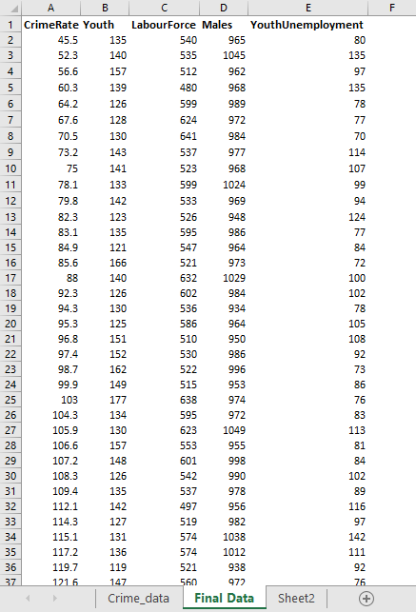
Table 1: The Modified Dataset
(Source: Created by the learner)
Data preprocessing is, alone, a combination of multiple steps and stages that helps to improve the quality of data and tries to extract the information that is required for the analysis. There are four major stages that can be identified in the data preprocessing measures:
- Data Cleaning: It is eventually the process that allows the analysts to clean any type of redundancy in the dataset. It is also helpful for removing any type of inaccurate or ill-formatted data from the data set. In this stage, the removal of the null values from the data series has been done. Here, any type of misrepresentation of data can also be pointed out and remedies those that help the data set to represent a proper meaning, which in turn, helps the analysis of the data. In the time of business analytics and application of any of the machine learning algorithms, this method helps to identify and remove those features that negatively impact the accuracy of the model.
- Data Integration: It is one of the stages of data processing that allows the analysts to integrate a small volume of data from various sources into one single data set to create an effective data set that helps to analyze and extract meaningful information from the analysis. Many times inefficient data collection techniques save and store several data into various data sources and without joining all of them into one single data set a meaningful and proper raw data can not be built. By this process, the base of data analysis has been laid upon which several algorithms and analytical models are applied.
- Data Reduction: This concept properly addresses the issue of the collection and the storage of data. In the modern age where the rate of generation of data has skyrocketed, the data reduction technique helps in the area and minimizes the size of the data without compromising its efficiency. This process essentially involves the transformation of numeric or alphabetic data points into an ordered manner so that it can guide analysis, which, in turn, optimizes the accuracy of the same.
- Data Transformation: It is the stage where the data is being transformed from one format into another to help the quality of the analysis to be optimized. The business organizations typically transformed the data into a pipeline with the help of two stages and this step is one of them. In the process, the analysts transform the type of the data from its original state into the desired state so that a better analysis can be done with the help of proper tools and concepts.

1.3 Data Analysis and Visualization
In the selected features of the data, the relationship between the predictors and the dependent variables will be accessed. Through the process, it will also be tried to see how the dependent variable changes with the change of the predictors. In the dataset it should be found that other than Crime data there are four the other variables, "Youth" signifies the number of the youth population of the locality, "LabourForce” signifies the number of labour in the area, “Males” denotes the number of men and the “YouthUnemployment” signifies how many of the youth people are unemployed currently.
So, now some of the interesting relationships and their findings will be presented:
Relationship between Crime rate and the number of labourers
These findings will help the analysts to understand the relationship between the number of labourers and the crime rate. It will help to find the probable relationship between two variables and the distribution of the data. To find the relationship properly, the "=VLOOKUP()” function will be employed.
Determination of the number of labourers where the crime rate is maximum: With the help of these findings the proper relationship between the labour force and their number of the crime rate in the area will be extracted. In this case, the main motto is to understand whether there is any type of fluctuation happening in the crime rate with the number of labourers. The formula that is used in this case is “=VLOOKUP(MAX(A2:A48), A2:E48,3,FALSE)". The answer is "631". It should be noted that with the highest crime rate in the area, the number of the labour force does not indicate the highest number.
Determination of the crime rate where the labour force is maximum: For this, another excel spreadsheet named "Further Modified data" has been produced to overcome the limitation of "VLOOKUP()" function by entering the "LabourForce" at the left-most column. It will cross check the previous findings. The formula that is used: "=VLOOKUP(MAX(A2:A48),A2:B48,2,FALSE)", which yields an answer as "70.5". From the dataset the maximum crime rate can be recorded as "161.8" and the maximum number of labourers is "641". To properly understand the relationship between them, visualisation will be done.
So, the visual representation is as follows:
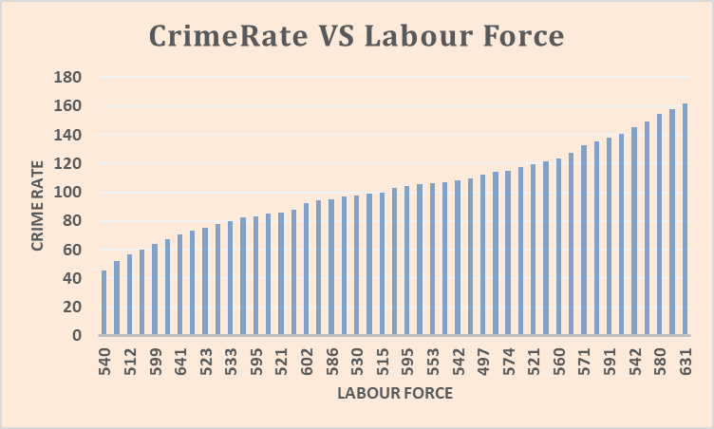
Figure 1: Crime rate vs Labour Force
(Source: Created by the learner)
So, it can be commented that with the rise in the Labour Force the crime rate in the area tends to rise as well.
Relationship between the Number of Youth and Crime rate
The data will show the relationship between the youth population of an area and the corresponding crime rate. For this two cases will be seen and here the “=VLOOKUP()” function and the Pivot Table will be used.
Determination of the number of youths where the crime rate is maximum: In the case, it is going to be seen how the number of youth population changes with the change in crime rate in the specified area. For this case, the "=VLOOKUP()" function has been used to determine whether the maximum crime rate in the data set yields the maximum or high youth population in the area or not. The formula, hence employed, "=VLOOKUP(MAX(A2:A48),A2:F48,2,FALSE)" is shown in the excel spreadsheet named "Final Data". The answer that it yields is "131", which signifies that there is a higher youth population in the concerned area.
Determination of the crime rate where the youth population is maximum: Here the crime rate will be determined where the youth population is maximum and try to understand whether the crime rate is high or not when an area has a higher population of youths. For this, the "=VLOOKUP(MAX(A2:A48), A2:B48,2,FALSE)” excel function has been used and the answer comes as "103". So, it can be commented that with the highest number of youth the crime rate is high but not the highest.
The visual representation is as follows:
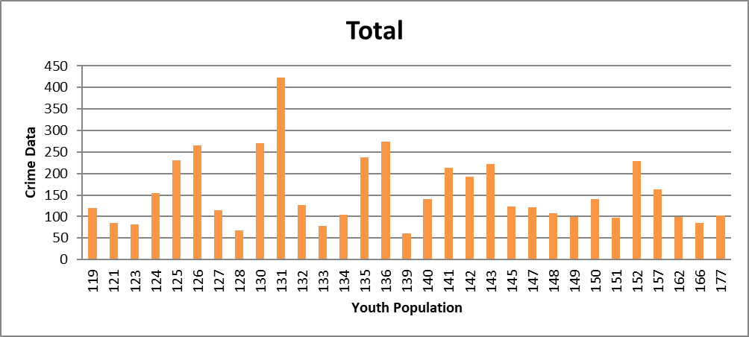
Figure 2: Youth VS Crime Rate
(Source: Created by the learner)
Relationship between the youth employment rate and crime in an area
Determination of Unemployment rate when the crime rate is the highest: From the given dataset, the youth unemployment rate has been determined as the unemployment rate may have a relationship with the crime rate in a particular area. To calculate the rate of unemployment among the youth population in the area, "YouthUnemployment” has been divided by the number of the youth population, then converted into percentages. For this "=VLOOKUP(MAX(A2:A48),A2:F48,6,FALSE)” formula has been used that yields the answer 78%. So, it can be said that the unemployment rate is high and the crime rate is the highest.
Determination of Crime rate when the Unemployment rate is the highest: By the operation, the crime rate is about to be determined when the youth unemployment rate is the highest. For this, “=VLOOKUP(MAX(A2:A48),A2:B48,2,FALSE)” has been used in the “Modified data_Unemployment” spreadsheet. After the application of the formula, the result comes, “115.1”, which is also great. So, it can be commented by observing both the results that there is a positive relationship between the crime rate and the unemployment level in an area.
So, the visualisation of the relationship is as follows:
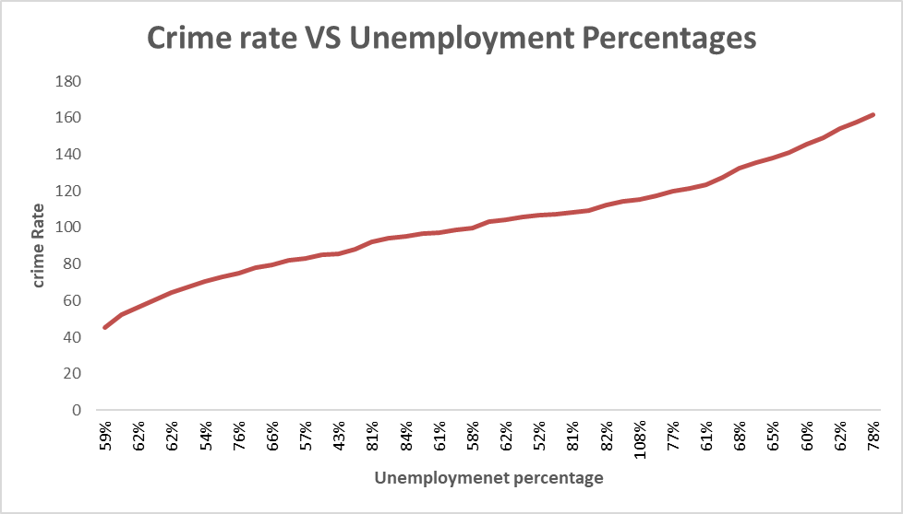
Figure 3: Crime rate VS Unemployment rate
(Source: Created by the learner)
Conditional Labelling of Crime rate
In the section, the "IF()" function will be used to label the crime rate in the area. Application of the function will determine and visualise whether the crime rate in an area is "High" or "Low". Before using the formula, the average crime rate has been determined with the help of "=AVERAGE(A2:A48)" and the idea is if the crime rate is higher than the average crime rate then it will be imputed as "High", otherwise "Low". The formula hence used "=IF(A2>$J$2, "High", "Low")” in the spreadsheet named “Application of "IF" function”. The following table shows the imputed dataset.
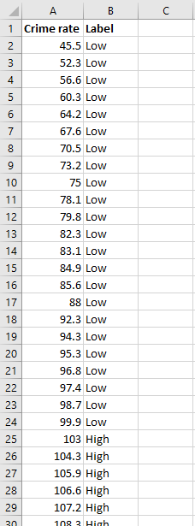
Table 2: Conditional Imputation
(Source: Created by the learner)

Part 2: Analysis of Ice Cream Data

2.1 Description of the given dataset
The given dataset is the transcript of the survey and the choices of the respondents regarding their favourite ice cream and the flavours. In the data, 20 high school students were surveyed and three of the options are there for them to select, Vanilla, Strawberry and Chocolate. In the dataset, there are 5 columns, named "‘id’, ‘female’, ‘ice_cream’, ‘video’ and ‘puzzle’". The column named "id” signifies the identification number of each of the respondents. After that, the “female" column denotes the gender of the respondents of the survey and "0" signifies "male" and "1" denotes that the person is associated with "female" gender labeling.
The column named "video” is the score that the person recorded in a video game that is the part of the survey study and “puzzle” denotes the score that one individual secures in the puzzle game. The principal aim of the survey study and analysis of the given dataset is to understand whether any type of relationship exists between the choice of ice cream flavour and the scores of video games and puzzles. In order to properly understand the labeling in the given data set, the imputation system of a column named "ice_cream" will be the focus of interest; here, "1" denotes respondents selecting "Vanilla" being their favourite flavour, "2" is the persons who prefer "Chocolate" over other flavours and "3" is the persons preferring "Strawberry". Having understood all the imputation techniques that data analysis can begin without much ado. The data set is as follows:
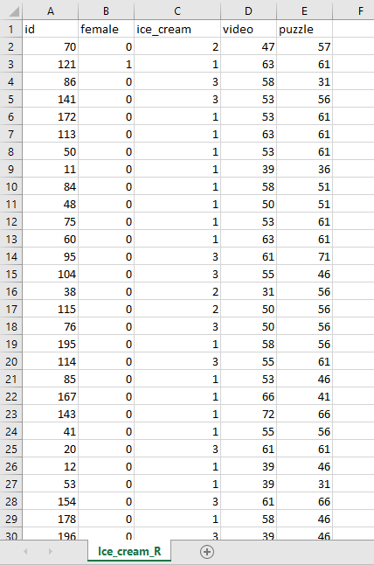
Table 3: Given the dataset
(Source: Assignment brief)

2.2 Data Analysis

2.2.1 Determination of the number of students like Vanilla Flavoured Ice Cream
In the section, the number of respondents selecting “Vanilla” flavoured ice cream will be determined. For this MS Excel will be used and the function that yields the desired answer is: “=COUNTIF(C2:C201, "1")". Having applied the formula the number of people favouring "Vanilla" ice cream has been determined and the result comes "95". It signifies that 95 individuals out of the 200 respondents selected “Vanilla” as their favourite flavour of ice cream. The following pie chart shows the distribution of the respondents' choices regarding their choice of ice creams.
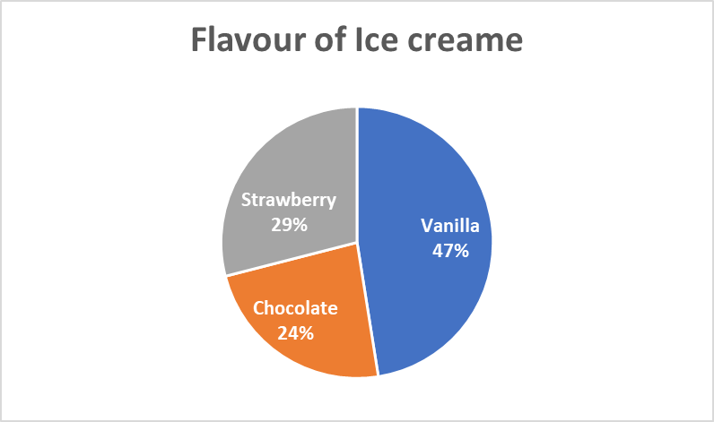
Figure 4: Flavours of ice cream
(Source: Created by the learner)

2.2.2 Determination of the data distribution in terms of Gender
In the section, the number of males and females will be determined. To determine the same, the "female” column is the subject of interest. Here, “0” is the number of males and “1” denotes the number of females respondents in the survey. In order to determine the number of males in the dataset “=COUNTIF(B2:B201, "0")” formula has been used and “=COUNTIF(B2:B201,"1")". By analysing the gender of the respondents of the survey the following curve can be drawn that has a clear say about the distribution of the data.
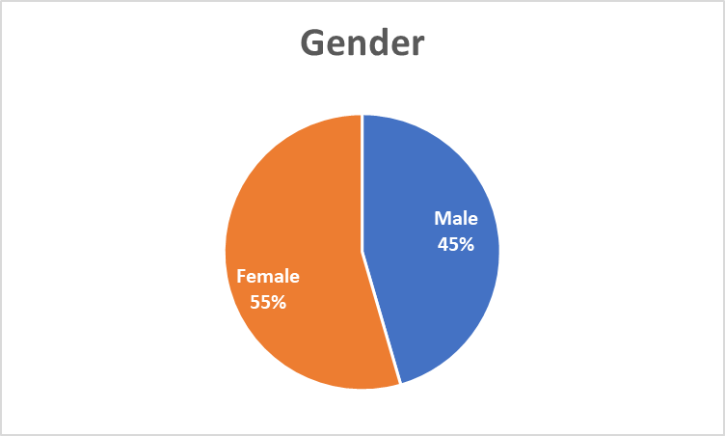
Figure 5: Gender distribution of respondents
(Source: Created by the learner)
From the above chart, it can be understood that 55% of the respondents are females and the rest of the individuals are males.

2.2.3 Determination of participants like Chocolate and Strawberry flavoured Ice Cream
In the section, the descriptive statistical measure of the participants who like Chocolate and Strawberry flavoured ice cream would be presented. The following table describes the descriptive statistical measure of the desired labels.
Descriptive Statistical Analysis
Mean of participants like chocolate flavoured ice cream | 47
Median of participants like chocolate flavoured ice cream | 47
Mean of participants like strawberry flavoured ice cream | 58
The median of participants like strawberry flavoured ice cream | 58
Table 4: Descriptive statistical measure
(Source: Created by the learner)

2.3 Application of the clustering techniques

2.3.1 Application of the K-Means clustering
K means clustering is the data analysis technique that helps to classify the unsupervised data set and cluster the data points according to the condition associated. In the algorithm, “K" is the variable that takes any numbers and classifies them as well as clustering the data points effectively. It is also used to understand how the data set and its consisting data points can be clustered or similar in terms of the given criteria.
In the data set, three of the clusters have been formed. The following table explains all the results:
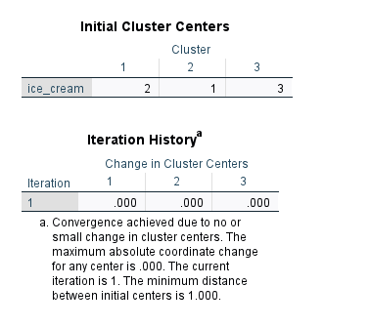
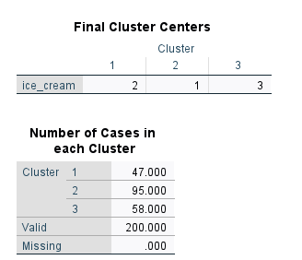
Table 5: K-means clustering of the data
(Source: Created by the author)
As the above table explains, in the first cluster, there are 95 elements that are related in some manner. In the cluster, the individuals have been selected who like "Chocolate” ice cream. In the second cluster, 47 elements are present and have those individuals like Vanilla. Lastly, the third cluster has been formed with individuals like Strawberry flavoured ice cream with 58 elements.

2.3.2 Explanation of the Data Mining and Text Mining Methods
Data mining is the analytical procedure that helps to identify the anomalies and patterns of the data set (Dabab et al., 2018). It is also very useful in the times of correlation calculation and predicting any outcome. The methods included:
- Anomaly detection procedure
- Regression analysis
- Prediction
- Neural Network
- Outlier detection and analysis
Text mining is the process that allows the analysts to interact with the computer system with the help of human intractable languages with the help of several powerful algorithms (Ferreira‐Mello et al., 2019). The methods include:
- Natural Language Processing
- Machine Learning Algorithms
- Association Rule

2.3.3 Advantages and disadvantages of using SPSS and Excel
Advantages of SPSS:
Determined statistical tests in SPSS are easier to determine.
Disadvantages:
It is not free to use software and needs to pay the company for a subscription.
Advantages of Excel:
Calculation of complex problems with the help of a formula is easy.
Disadvantages:
Does not have proper data security.

Conclusion
The paper analyses two of the data sets and uses Excel as well as SPSS as the data analysis tools. Several analytical tools and excel formulas have been used to extract meaningful findings from the raw data. The statistical analysis and the results from it have also been explained and interpreted. K means clustering has also been used along with data mining and text mining concepts as well as their methods. In the end, the merits and demerits of the use of excel and SPSS have also been summarised.

Reference List and Bibliography
Alexander, M., Kusleika, R. and Walkenbach, J., 2018. Excel 2019 Bible. John Wiley & Sons.
Burnett, C., Merchant, G. and Guest, I., 2022. Postcards from literacy classrooms: possibilities for teacher-generated data visualisation. Education 3-13, 50(2), pp.145-158.
Dabab, M., Freiling, M., Rahman, N. and Sagalowicz, D., 2018, August. A decision model for data mining techniques. In 2018 Portland International Conference on Management of Engineering and Technology (PICMET) (pp. 1-8). IEEE.
Denis, D.J., 2018. SPSS data analysis for univariate, bivariate, and multivariate statistics. John Wiley & Sons.
Ferreira‐Mello, R., André, M., Pinheiro, A., Costa, E. and Romero, C., 2019. Text mining in education. Wiley Interdisciplinary Reviews: Data Mining and Knowledge Discovery, 9(6), p.e1332.
Foulkes, L., 2020. Learn Microsoft Office 2019: A Comprehensive Guide to Getting Started with Word, PowerPoint, Excel, Access, and Outlook. Packt Publishing Ltd.
Held, B., Moriarty, B. and Richardson, T., 2019. Microsoft Excel Functions and Formulas with Excel 2019/Office 365. Stylus Publishing, LLC.
Kumar, S., Kar, A.K. and Ilavarasan, P.V., 2021. Applications of text mining in services management: A systematic literature review. International Journal of Information Management Data Insights, 1(1), p.100008.
Lathabhavan, R. and Akshar, K.M.S.V.D., 2021. Data Visualisation in Business. In Applications of Big Data in Large-and Small-Scale Systems (pp. 126-136). IGI Global.
Murshid, G., Parvez, T., Fezal, N., Azaz, L. and Asif, M., 2019. Data mining techniques to predict chronic kidney disease. Int. J. Scientific Res. Comput. Sci., Eng. Inf. Technol, 5(2), pp.1220-6.
Nota, G., Postiglione, A. and Carvello, R., 2022. Text mining techniques for the management of predictive maintenance. Procedia Computer Science, 200, pp.778-792.
Pallant, J., 2020. SPSS survival manual: A step by step guide to data analysis using IBM SPSS. Routledge.
Salloum, S.A., Al-Emran, M., Monem, A.A. and Shaalan, K., 2018. Using text mining techniques for extracting information from research articles. In Intelligent natural language processing: Trends and Applications (pp. 373-397). Springer, Cham.
Tandel, S.S., Jamadar, A. and Dudugu, S., 2019, March. A survey on text mining techniques. In 2019 5th International Conference on Advanced Computing & Communication Systems (ICACCS) (pp. 1022-1026). IEEE.
Tomasevic, N., Gvozdenovic, N. and Vranes, S., 2020. An overview and comparison of supervised data mining techniques for student exam performance prediction. Computers & education, 143, p.103676.

