Belbin
Dr Meredith Belbin in 1981 came up with the nine roles which is now believed to be the most accessible tool which is used to support team building (Belbin Associates, 2019). There were multiple candidates within the team for the role of project manager. Marjana showed a keen interest and the Belbin test showed her as a Shaper, which is someone who can work under stress and is motivated to meet challenges, so she was elected as Project Manager. Every team member played their part in the management of the project utilising project management tools in order to deliver the project successfully. The Belbin test showed the skills of each member and helped to best utilise these skills and come together as a team.

Quad Chart
A quad chart is a quality tool that predominantly assists in the overall knowledge of a project, it divides the issue into four component parts that aim to encourage management analysis and understanding. The four sections of the chart are: purpose, customers, desired end results and measures of success. (Paladino, 2010).

How it was used in the project
The team were given the task of managing the project of delivering a 3 hour workshop that provided relevant information on starting a business plan for the BME skills group. Completing the Quad chart structure at the beginning of the project gave the team a clear idea of what steps were needed next and motivated them to succeed.
Stakeholders: The BME skills group participants as they were who we were delivering the workshop to.
Desired result: Motivational presentation, interactive activities and expanding participants knowledge of business planning.
Measure the success: Open conversation, enthusiasm shown, questions asked.
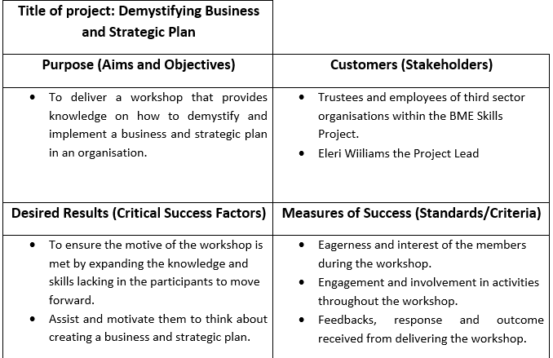

Updated Quad
We updated the QUAD to additionally identify our motivation behind the workshop. Our motivation was to “help companies ensure they make the best business plan”. We also found secondary benefits to the project which were gaining confidence, experience and practise.

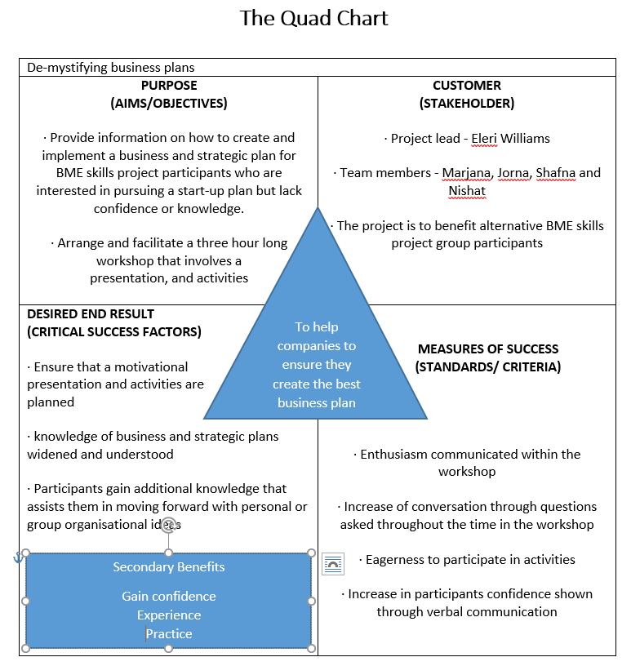

References
Belbin Associates, (2019) The Nine Belbin Team Roles. [Online]. Available at: https://www.belbin.com/about/belbin-team-roles/
[Accessed 16 05 2019].
Paladino, B. (2010). Innovative corporate performance management: five key principles to accelerate results, New Jersey: John Wiley & Sons, pp.300

