Automotive chassis systems

1901716
Mbemba Jammeh
  - ACHA5013

Contents
Introduction 2
Task1 3
Tubular Space Frame 3
Triangulated tube structure: 3
Sheet steel backbone chassis: 4
The Ultralight Steel Auto Body (ULSAULSAB was announced at the beginning of 1998) 4
Punt or platform structure 5
Task 2 5
Crash requirements: 5
Developments in manufacturing technology: 5
Pure monocoque: 6
Developments in materials: 6
Steel: 6
Low Carbon Mild Steel: 6
Aluminium: 6
Aluminium Alloys: 7
Task 3 7
Task 4 8
References 9

Introduction

This report focuses on vehicle structural development. This will be done by researching and analysing the task description to understand what’s the requirements for the report. A lot of research will be taken in place for a better understanding on the chassis types and reason whys it was made. There are four sections to this report
- Section 1 about different vehicle structures and how vehicle structures have historically changed and how the future hold as theirs less reliant on internal combustion engines.

- Section 2 has 3 mini headings to look into: Crash Requirements, Developments in manufacturing technology, Developments in materials.

- Using the simple structural surfaces (SSS) to assess the method to find the shear load on each panel.

- Discuss the 10 surfaces from task 3 and discuss the implications of improving to the rear of the van by introducing a large aperture to the surface 5 that I no longer act as a shear panel.

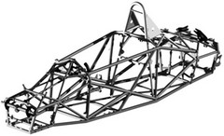
Task1

Tubular Space Frame

As the chassis of the ladder is not solid enough, the car racing engineers have developed a 3-dimensional design - Tubular space frame. An early example was the Maserati Tipo 61 "Birdcage" post-war racing car. Tubular space frame chassis employs dozens of circular-section tubes (some may use square-section tubes for easier connection to the body panels, though the circular section provides the maximum strength), positioned in different directions to provide mechanical strength against forces from anywhere. These tubes are welded together and form a very complex structure, as shown in the images above.
In the early 1950s, Mercedes-Benz created a 300 SLR racing car using a tubular spatial frame. It also brought the world's first tubular road car with spatial framing, 300 SL Gullwing. Because the threshold significantly reduced the affordability of carbon, Mercedes had to extend the doors to the roof so that the "Gullwings".
Since the mid-1960s, many premium sports cars have also adopted a tubular frame to improve the rigidity/weight ratio. However, many of them used space frames for the forward and aft structure and made the cab into a manhole to reduce costs.
Historically,
The Fokker Triplane from Baron Rouge (Manfred von Richton).
1917 used space-based framework. (Bowen, 1980, 21).
The space may be simple or complex, as indicated above.
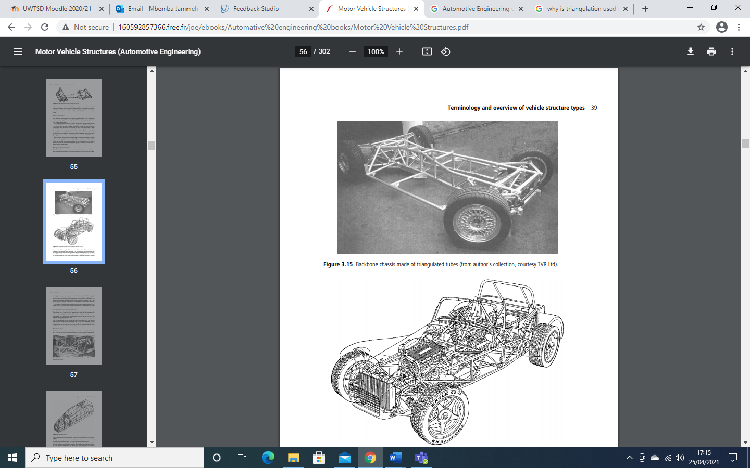
Recent European and American developments in Hydroforming and. There has been an increase in interest in automated construction procedures. Space framework for mass vehicles because of the absence of costly. Tooling and the ability to have a new vehicle designed and in production. A lot quick

Triangulated tube structure:

The placement of triangular tubes is not restricted to backbone structures. Perhaps. A more common approach using this principle, especially for sports vehicles, is the “bathtub”. Arrangement, in which the triangular structure surrounds the external body. A classic Example is the Caterham is shown in Figure 3.16. This approach has the added benefit. The course may be a thin sheet of cladding, attached directly to the frame. If the vehicle is an open vehicle, the large cockpit will interrupt the required “closed box”. For torsional stiffness, of course. In such cases, torsional rigidity is sometimes restored through “boxing”.

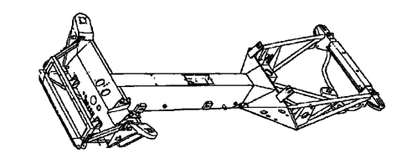
Sheet steel backbone chassis:
Backbone chassis is a type of construction chassis which is identical to the body on frame design. But it has a consists of a strong tubular backbone
Developing better road holding, thanks to a better understanding of. The geometry of the suspension made it essential to increase the rigidity of the body. That, and pushing it. Welded and stamped sheet steel body technology has resulted in widespread use of the “large”. Concept of section tube in car structures in the post-WWII period.

The Ultralight Steel Auto Body (ULSAULSAB was announced at the beginning of 1998)
In the 1990s, when stricter safety rules demanded a stiffer frame, the traditional steel monohull became heavier than ever. As a result, automakers have turned to alternative materials to replace steel, most notably aluminium. Although there is still no mass production car other than Audi A8 and A2 to completely eliminate steel in chassis construction, more and more cars use aluminium in body panels like bonnet and boot lid, suspension arms and mounting sub-frames. This is certainly not the desire of the steel industry.
Although there are still no mass production cars other than Audis to eliminate steel in chassis construction, more and more cars use aluminium body panels like bonnet and boot lid, suspension arms and mounting sub-frames.
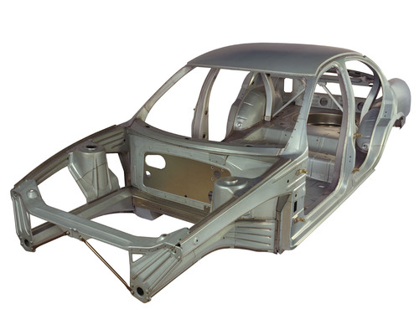

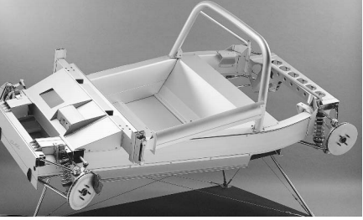
Punt or platform structure
A deck frame is similar to the deck frame, but in addition to the lower deck, there are also deep raised sides. ... Punt frames were frequently used by armoured vehicles. The armoured exterior body forms a sturdy manual that can be used as a dual-purpose chassis.

Task 2

Crash requirements:

Their many requirements involved that the chassis need to meet to make sure that its roadworthy these are few factors that are needed:
1)Crumble Zones: Part of the exterior of the vehicle designed to deform to absorb the force of an impact, the purpose of which is to keep the occupants protected in a hard shell.
2) Seat belt pre-tensioners: It can detect when a crash is about to happen and automatically tighten the seat belt to help the driver stay safe and firm in the seating position prior to the impact
3) Air bags: They are 4 major airbags system fitted into the vehicle firstly is the frontal air bag which was mantuary in vehicles on the road in 1988 a year later in 1999 all SUVs and picks up, vans became a standard equipment. A lot of new cars have a weight sensor in the front passenger seat that will prevent the airbag from expanding if a small child is sitting there. For older cars without a weight sensor, the force of the airbag can cause injuries in small children, so the government suggests that children under the age of 13 should ride in the back seat. (2) SIDE AIRBAGS: The side airbags protect passengers during lateral impact. Two main types exist: a torso side airbag and a curtain airbag. The side-impact torso airbag is usually located on the side of the seat and inflates between the driver and the door to protect the person's torso. (3) KNEE AIRBAGS: In the 2000s a lot of vehicles was manufactured with knee airbags which is positioned under the steering which in an event of a crash would deploy but it protects the passenger knee with contacting with the hard surfaces. (4) INFLATABLE SEAT BELTS: The inflatable seat belt is only available in certain designs. Even if it is categorized as an airbag, the inflatable seat belt is not really an airbag, it simply works as an airbag when deployed in an accident. While most air bags protect passengers, the air seat belt helps distribute the force of an accident over a larger area of a person's body.

4) Adaptive Restraint Systems: In the early 1990s, we developed a European air cushion system for drivers and front passengers for the European market. Since then, we have continued to expand and fine-tune our development processes. We are now in a position to develop highly sophisticated car safety systems that meet the specific requirements of the international market.
The seat restraint control system is central to a vehicle's passive safety concept. Acceleration and pressure detectors detect vehicle accidents. An Airbag Control Unit hosts all features for impact protection (Airbag firing, seatbelt pretensioning) and provides a number of other, safety- and homologation relevant features, such as the Event-Data-Recorder and seat-belt-reminders.
Heading towards the future for greater safety the use of special simulation tools for calculation and tests which allows different load cases The use of special simulation tools for calculation and tests enables us to check different load cases without destructive testing, which considerably reduces the need for prototypes and shortens development times.

Developments in manufacturing technology:
The purpose of vehicle control systems is to. Make vehicles safer by giving the driver more. Monitoring in non-linear and combined manoeuvres. It can be challenging or impossible to master. The chassis and suspension must please the client. Want agility, manoeuvrability, comfort and security. In Overall, the quality and attributes offered by. The chassis systems have made considerable progress over the course of the. Two years ago. That was enabled by. The engineering development of chassis systems and components continues with a steady increase. Comprehension by equipment manufacturers and suppliers of. Complex interplay of chassis elements.

Important differentiators and purchase decision criteria for vehicles of all categories and segments. The new chassis concepts should not only increase the safety potential of the vehicle, but also increase driving abilities and improve driving comfort. These attributes are no longer just evidence anymore. Engineering and technical ability and quality,
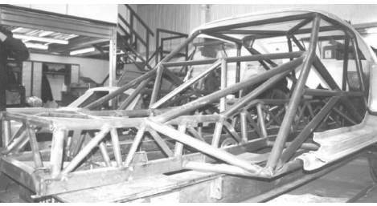

Pure monocoque:
The design of the monocoque is quite rare. It is limited in general use. Two racing vehicles, as shown in figure 3.18. There are a couple of reasons for that. First of all, to make the manual function effectively, it requires a completely closed tube. However, convenient vehicles need openings for passenger entry, outward visibility, Etc. This requires interrupts in the “one shell” that reduce it to an opening. Cross-section, with subsequent lowering of torsional rigidity.
The torsional strength of a racing vehicle in which the bearing. The cage has been built into the structure in several ways. That torsional rigidity can be increased by more than 500 percent in relation to the. Basic chassis frame. The contribution of the roller cage was determined by the degree of. Triangulation in the running stand, and how the running stand was connected to the. Everything else in the structure.

Developments in materials:

Steel:
Traditionally, the most commonly used material in the manufacture of the vehicle frame has been steel, in various. Forms. The steel is easy to obtain and the machinery necessary to handle the steel is easy as well. The most important reason for steel. Widely used in the frame building industry [3,7]. A wide range of steel grades can be used. Preparation of bodywork sheets. In the present work carbon steel material adopted.

Low Carbon Mild Steel:
Mild steel, also called standard carbon steel, is the most common form of steel and is relatively small. It also delivers. Material properties acceptable for many purposes, more than iron. High-carbon steel contains. Roughly 0.05 to 0.320% carbon makes it malleable and ductile. This property of carbon steel makes sense. Because it provides good surface wear features the only problem is that it leaves the core difficult. These Properties easily suggest that low carbon mild steel is a suitable material for the manufacture of car body plates.

Aluminium:
The aluminium chassis offers the best of both worlds when it comes to the design and construction of the chassis. Chassis, being the framework of the vehicle must be rigid to absorb and maintain the movements and vibrations of the. Power, suspension and axles. It must be as light as possible to improve the performance and fuel of the vehicle. Efficiency. Aluminium provides resistance and lightness properties. It also helps the vehicle to improve. With the power-to-weight ratio significantly reduced. After the alloy, the yield point is increased by a fine. Quantity but not much impact was observed on rigidity.
Despite being far more expensive than steel and extra. Work issues with aluminium have a secure place in the construction of the chassis. He is also less likely to be hurt. Corrosion in comparison with steel. The positive impact on the environment during the use phase is a big factor. More important role in environmental assessment than in the car industry.

Aluminium Alloys:
Aluminium alloys generally have an elastic module of about 70 GPA, or about a third of the elastic module. Most metals and alloys. In automobile engineering vehicles made of aluminium alloys use. Spatial frames made of extruded sections to ensure stiffness. That represents a radical change in comparison to the common. Approach to the current design of steel car, which depend on the bodywork for rigidity, known as uni-bodywork.

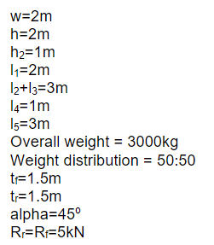
Task 3
Using the (SSS) method use the figures below to work out the shear loads for each panel q1 to q6 and the torsional load.



Task 4
Figure two shows the representation of a van in torsion which has 10 surfaces. If panel 5 was removed form the rear of the van would mean it would have more space from the back but that would mean bringing q3 and q6 out of the equation. But doing this would cause disruption to 6 and 10 meaning as it’s no longer acting as shear panel.

References
(n.d.). Retrieved from https://core.ac.uk/download/pdf/11034857.pdf
(n.d.). Retrieved from https://conti-engineering.com/technology-systems/systems-functions/restraint-control-system/
Automotive Engineering . (n.d.). Retrieved from https://books.google.co.uk/books?id=Ek0Cxo4rfnMC&pg=PA535&lpg=PA535&dq=Triangulated+sports+car+structure+(courtesy+of+Caterham+Cars+Ltd)&source=bl&ots=uOeQo6zapx&sig=ACfU3U3LVdCWBSCgYm_YqUA4Mo0bxynbzg&hl=en&sa=X&ved=2ahUKEwiomN2LzprwAhWmQxUIHe8pBIUQ6AEwD3
Brown, J. c. (2002). Retrieved from http://160592857366.free.fr/joe/ebooks/Automative%20engineering%20books/Motor%20Vehicle%20Structures.pdf
Steel, W. (2020). Retrieved from https://www.worldautosteel.org/projects/ulsab/
uk car.com. (2016). Retrieved from https://www.ukcar.com/features/tech/chassis/ulsab.htm

