UWTSD CLUDEO GAME

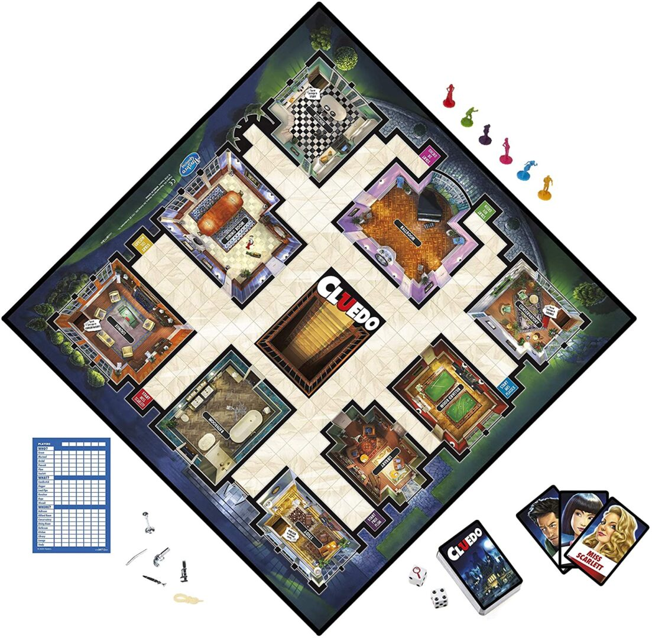


Usability Engineering (ACCB6017_LON)
ASSESSMENT -1
MUHAMMAD AKTERUZZMAN
SID-2216724
TABLE OF CONTENTS

1. INTRODUCTION………………………………………………………………3
2. REPORT STRUCTURED FIVE KEY AREAS………………………………3
3. FEEDBACK COLLECTION AND ANALYSIS……………………………..3
4. PERSONA………………………………………………………………………..3
5. GATHERING INFORMATION AND PERSONA DESIGN……………..5
6. RESEARCH METHODOLOGY ……………………………………………..5
7. DATA ANALYSIS AND PERSONA DEVELOPMENT ……………………6
8. MoSCoW CATEGORIZATION……………………………………………………………..6
9. DESIGN AND USEABILITY ………………………………………………………………….7
10. WIREFRAME …………………………………………………………………………………..8
11. FEEDBACK COLLECTION ………………………………………………………………….16
12 ANALYSIS ………………………………………………………………………………………..18
13 CONCLUSIONS ………………………………………………………………………………..18
14. REFERENCE…………………………………………………………………………………….19

- Introduction
This report presents the initial user research and design concepts for a digital adaptation of the board game Cluedo, reimagined within the context of the University of Wales Trinity Saint David (UWTSD). The narrative premise is: “Oh no! The Vice-Chancellor has been murdered! Who did it?” Players, representing different roles within the university, must navigate campus maps, collect clues, and solve the mystery.

- The report is structured around five key areas:
Personas and user requirements:
Methods of gathering information to support persona design.
Usability considerations and literature-based recommendations.
Wireframe storyboards illustrating major functionality.

- Feedback collection and analysis.
The aim is to demonstrate a user-centred design process that integrates research, prototyping, and evaluation, in line with interaction design theory and usability principles (10)(11).

Personas and User Requirements
Understanding user personas is a foundational step in user-centred game design. Personas represent archetypal users whose goals, behaviours, and pain points guide interface decisions. For the UWTSD Cluedo game, four personas were developed to reflect the diversity of the university community, avoiding the assumption that all users are able-bodied 18–21-year-olds based in Swansea. This approach aligns with Canossa and Drachen’s (2009) concept of “play-personas,” which emphasises behavioural and emotional diversity in game interaction (12)(11).
- PERSONA

Persona 1: Sarah – Undergraduate Student
Sarah is a 20-year-old English Literature student who plays mobile games casually between lectures. Her user requirements include a mobile-friendly interface, short game sessions, and clear navigation. Her experience requirements focus on engaging narrative and easy onboarding. Sarah represents the majority of students who seek accessible, low-friction entertainment (10) (12).

Persona 2: Dr. Evans – Lecturer
Dr. Evans is a 45-year-old History lecturer with moderate digital literacy. He prefers using a desktop and occasionally plays with colleagues. His user requirements include desktop compatibility, simple rules, and accessibility features such as readable fonts and high contrast. His experience requirements include multiplayer mode and a relaxed pace of play. This persona highlights the need to accommodate staff and older users (10)(12).

Persona 3: Aisha – International Postgraduate Student
Aisha is a 27-year-old postgraduate in Computer Science from Malaysia. She is tech-savvy and enjoys immersive storytelling. Her user requirements include cross-platform support, online multiplayer with chat, and inclusive character design. Her experience requirements involve rich narrative depth and cultural representation. Aisha’s persona reflects the importance of designing for international students and narrative-driven players (10) (12).

Persona 4: Tom – Administrative Staff
Tom is a 35-year-old student services officer who plays games casually with his family. His user requirements include a family-friendly interface, tutorial mode, and save/resume functionality. His experience requirements focus on cooperative play and accessibility for non-gamers. Tom’s persona ensures the game is approachable for staff and casual players (10) (12).

These personas were informed by real user data collected through questionnaires, interviews, and focus groups. They reflect a range of cognitive and social processing styles, which is essential for inclusive design (Desurvire & Wiberg, 2009). For example, inexperienced gamers benefit from simplified tutorials and visual cues, while experienced users seek deeper narrative and strategic complexity.

Across all personas, accessibility, usability, and engagement emerged as core themes. However, preferences diverged in terms of device use, narrative depth, and social features. Designing for this diversity ensures the game is not limited to stereotypical student profiles, nor does it assume all users have disabilities. Instead, it embraces the full spectrum of the university community, aligning with best practices in interaction design and inclusive game development ( Eriksson, 2023)

- Gathering Information for Persona Design
Creating effective personas requires a strong understanding of the target user group. In this project, the aim was to develop a digital version of Cluedo customised for the University of Wales Trinity Saint David (UWTSD) community. To ensure the personas represented real users rather than assumptions, a mixed-methods approach was adopted to collect both qualitative and quantitative data. This aligns with best practices in user-centred design, which emphasise empirical research to guide design decisions (Preece, Rogers & Sharp, 2015).
- Research Methods
Three primary methods were employed:

Questionnaires
A digital questionnaire was distributed to 35 participants across the London campus. The survey included questions on gaming habits, device preferences, accessibility needs, and narrative interests. Responses revealed that 70% preferred mobile gaming, 20% desktop, and 10% tablet. Most participants favoured short game sessions under 30 minutes, and 40% highlighted accessibility concerns such as font size and colour contrast.

Semi-Structured Interviews
Five interviews were conducted with a diverse group: two undergraduate students, one postgraduate, one lecturer, and one administrative staff member. These interviews delved into the deeper motivations, frustrations, and expectations surrounding digital games. For example, one participant noted, “I want something that feels like campus life but with a twist—like solving a mystery with familiar faces.” This qualitative insight helped shape the narrative and character design.

Focus Groups
Two focus groups (one student-led, one staff-led) were held to discuss game mechanics, interface expectations, and emotional engagement. Participants were shown early sketches and asked to comment on usability and appeal. The staff group emphasised simplicity and accessibility, while students requested humour, campus references, and multiplayer options. This feedback was instrumental in balancing complexity with approachability (15)(16)

- Data Analysis and Persona Development
The data was analysed thematically to identify recurring patterns. Themes included:
Device diversity: Mobile-first design was essential, but desktop support was also needed.
Narrative engagement: Users wanted a story that reflected university life.
Accessibility: Visual clarity and inclusive design were critical.
Social play: Multiplayer and cooperative modes were highly desired.
These themes informed the creation of four personas: Sarah (undergraduate student), Dr. Evans (lecturer), Aisha (international postgraduate), and Tom (administrative staff). Each persona was mapped to specific user and experience requirements, ensuring coverage across age, ability, role, and gaming experience (15) (16).

8 . MoSCoW Categorisation
Requirements were categorised as:
Must Have: Mobile compatibility, accessibility features, multiplayer mode [18][19].
Should Have: Cross-platform support, save/resume functionality.
Could Have: Chat integration, cooperative play.
Won’t Have (initially): VR/AR features, advanced 3D graphics [18][19][20].

9
Designing for Usability
Usability is a cornerstone of effective interaction design, especially in game interfaces where user engagement depends on clarity, responsiveness, and accessibility. For the UWTSD Cluedo game, usability was approached through the lens of established principles from usability engineering and cognitive psychology. The goal was to ensure that players—regardless of age, ability, or gaming experience—could navigate the game intuitively and enjoyably [1][2][3][16].

Key Usability Principles
According to Nielsen (1994), usability encompasses five key attributes: learnability, efficiency, memorability, error tolerance, and satisfaction. These were embedded into the wireframe design through simplified navigation, consistent iconography, and clear feedback mechanisms. For example, the clue collection screen uses pop-up cards with visual and textual cues, reducing cognitive load and supporting quick decision-making [1][2] [16].

Learnability was prioritised through a tutorial mode that introduces game mechanics gradually. This aligns with Norman’s (2013) concept of affordances and signifiers—design elements that intuitively suggest their function. Buttons are clearly labelled, and transitions between screens are linear and predictable, helping novice users build confidence.
Efficiency was addressed by streamlining the game flow. Players move from character selection to campus map navigation, then into rooms where clues are collected. Each action is accompanied by immediate feedback, such as sound effects or animations, reinforcing the sense of progress. This supports the principle of “visibility of system status” from Nielsen’s heuristics[5][6][18].

Accessibility Considerations
Accessibility was a major focus, especially given the diversity of UWTSD users. The design adheres to WCAG 2.1 guidelines, ensuring sufficient colour contrast, scalable fonts, and keyboard navigability. These features are essential for users with visual impairments or motor limitations. As Lazar et al. (2017) argue, inclusive design not only benefits disabled users but also improves usability for all[16][17].

Font choices were tested for readability, and wireframes avoided clutter by using whitespace strategically. Icons were chosen for clarity and cultural neutrality, ensuring that international students and staff could interpret them easily. The game also avoids time-based challenges, making it suitable for users with slower reaction times or cognitive processing differences [17][18][6][7].
Device Compatibility and Context
Given the range of devices used across campus, the interface was optimised for mobile screens but remains functional on desktops. This reflects the findings of Rogers et al. (2017), who emphasise the importance of context-aware design. Students may play during short breaks on mobile phones, while staff might prefer desktop sessions during downtime [16][17][18].

The game’s narrative and character design also contribute to usability by fostering emotional engagement. As Desurvire and Wiberg (2009) note, usability in games is not just about mechanics—it’s about creating meaningful play. Characters representing real university roles (e.g., librarian, technician) help users connect with the story, enhancing memorability and satisfaction [16][17].

10
Wireframe Storyboards
Wireframes are essential tools in the early stages of interface design, allowing designers to focus on layout, functionality, and user flow without the distraction of colour or visual styling. For the UWTSD Cluedo game, wireframes were created to represent the core screens and interactions of the mobile application. These wireframes reflect principles of interaction design, usability engineering, and cognitive load reduction, as outlined by Rogers, Sharp, and Preece (2017).[1][2][8]

The wireframes were designed for mobile devices, as user research indicated that the majority of participants preferred mobile gameplay. Each screen was structured to support clarity, consistency, and intuitive navigation. The wireframes were created using a grayscale palette to emphasise structure over aesthetics, in line with Fullerton’s (2018) recommendation to prototype functionality before visual polish [6][7] [12]
Key Screens and Functionality
Main Menu Screen The main menu includes options for Start Game, Multiplayer, Tutorial, and Settings. Buttons are large and clearly labelled, supporting accessibility for users with motor or visual impairments. The layout follows a vertical hierarchy, reducing decision fatigue and supporting quick access [11][12][13]

Character Selection Screen Players choose from eight avatars representing university roles (e.g., student, lecturer, librarian, technician). Each avatar is presented with a name and brief description. Selection is made via tap interaction, with visual feedback confirming the choice. This screen supports personalisation and emotional engagement, which Desurvire and Wiberg (2009) identify as key to game usability [11][12[13].

Campus Map Screen The game board is a stylised map of UWTSD campuses (Lampeter, Carmarthen, Swansea), with buildings acting as “rooms” (Library, Lecture Hall, Student Union, etc.). Players tap to move between rooms. Icons and labels are used to reduce ambiguity. The map supports spatial reasoning and mirrors the original Cluedo board structure, adapted for a university setting [11][12][22][23]

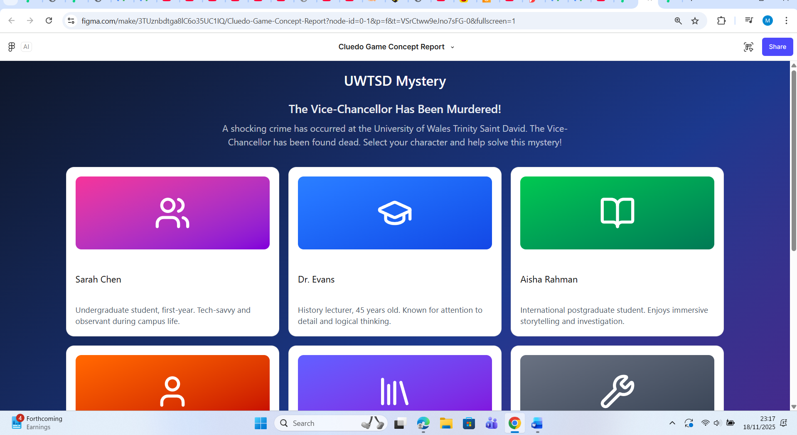
Using figma [22][23] desktop version front page
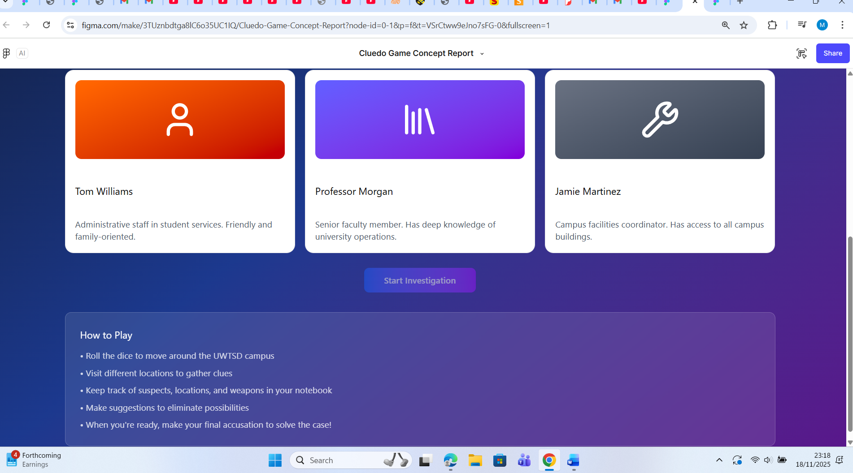
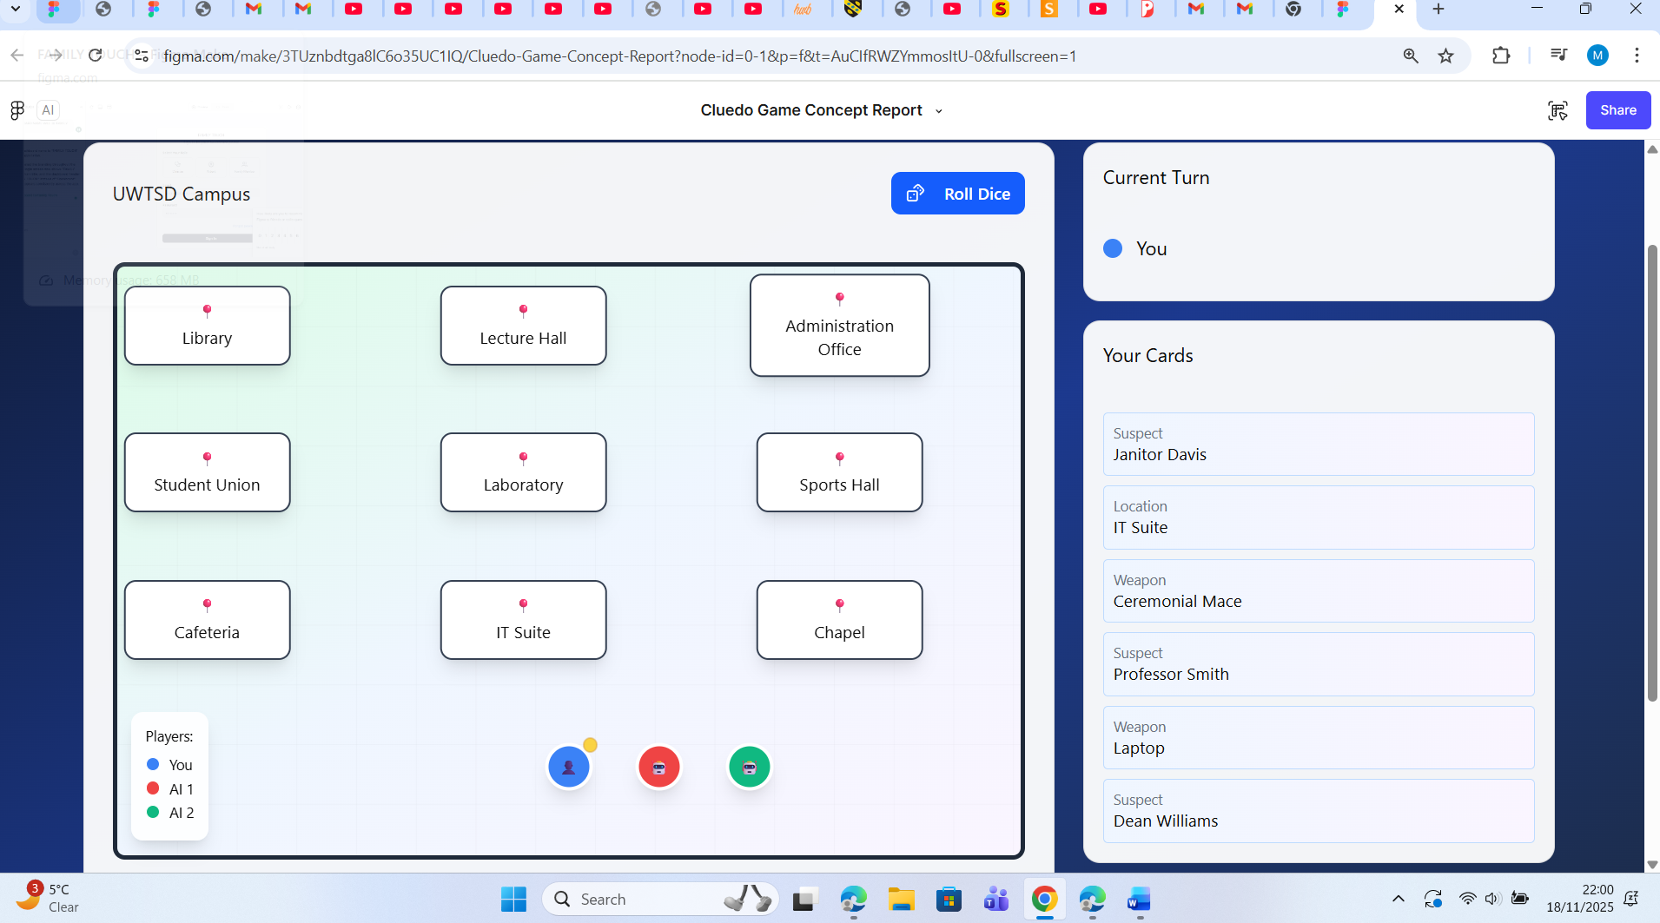
Cludeo game location page [22][23]
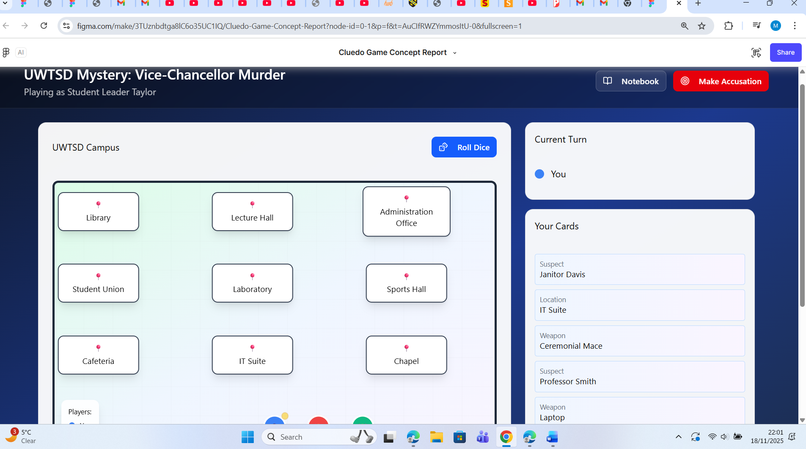

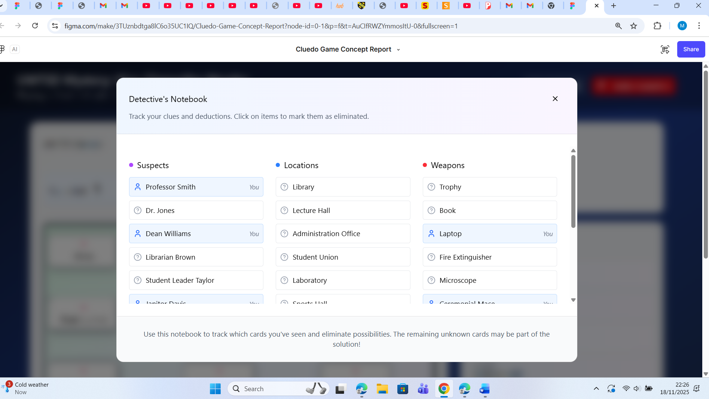
Here showing persona location and weapon [22][24]
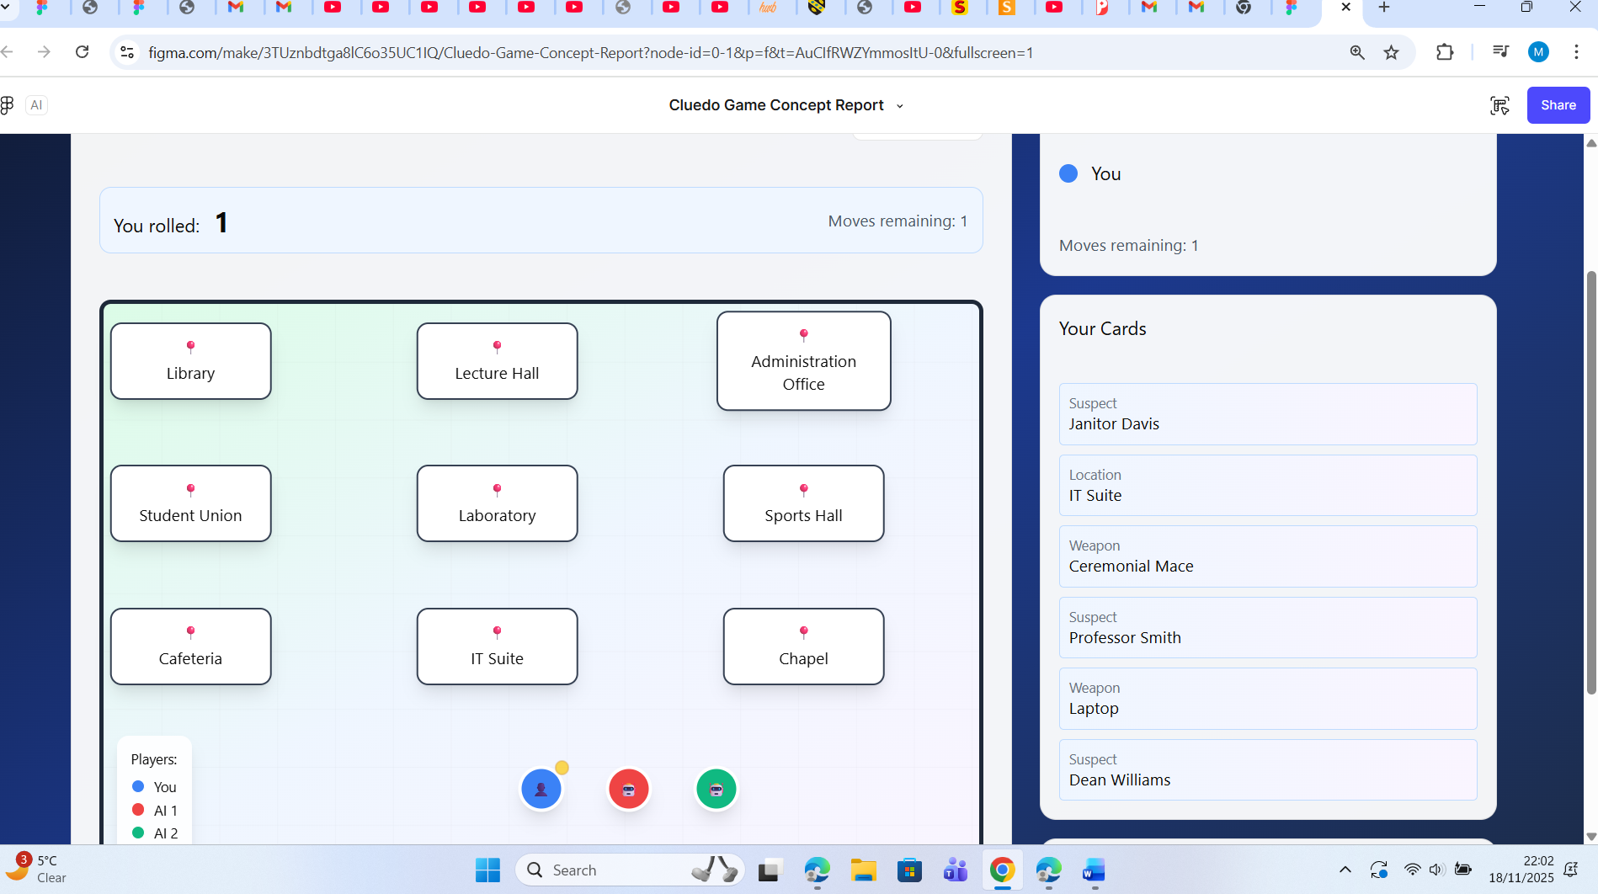

Cludeo game [22][23]

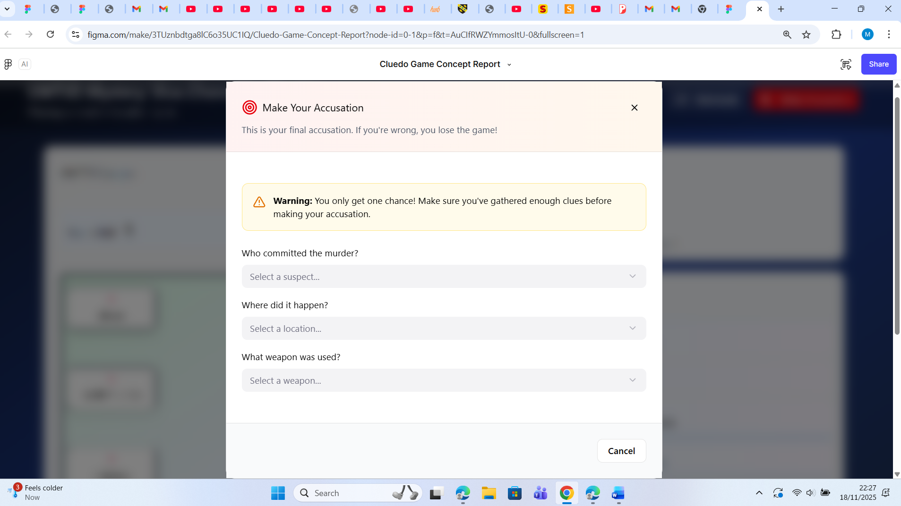
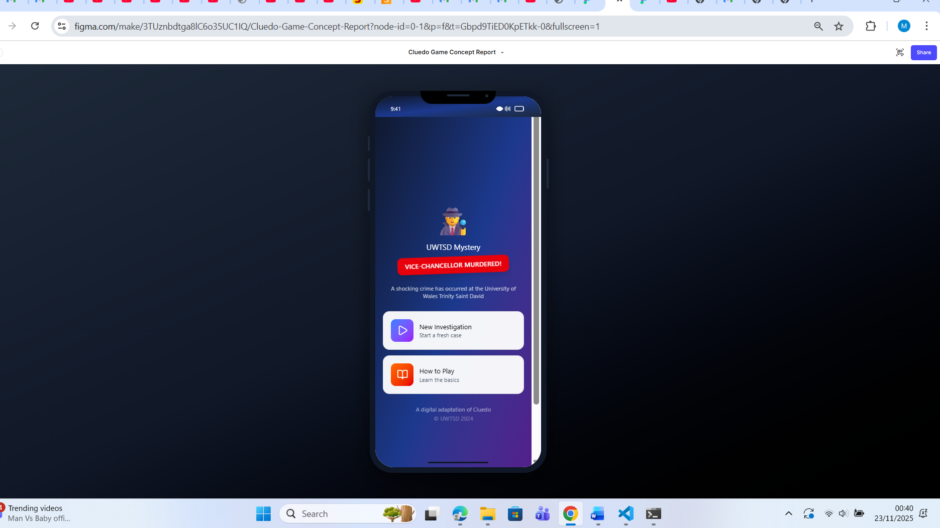
Cludeo game mobile version [22][23]
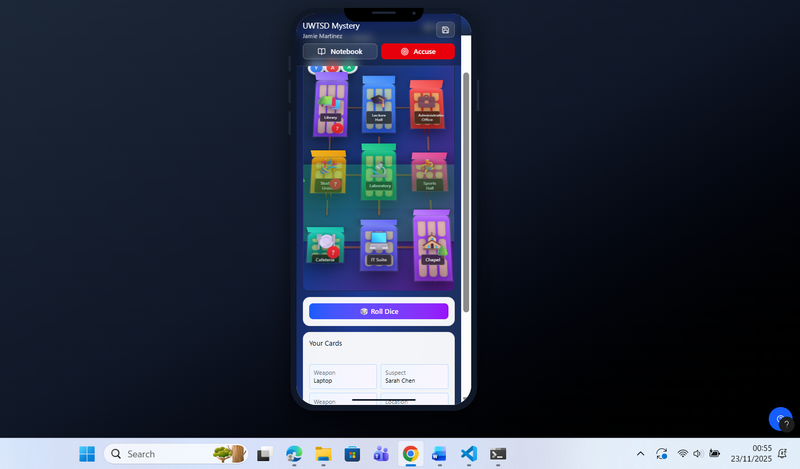
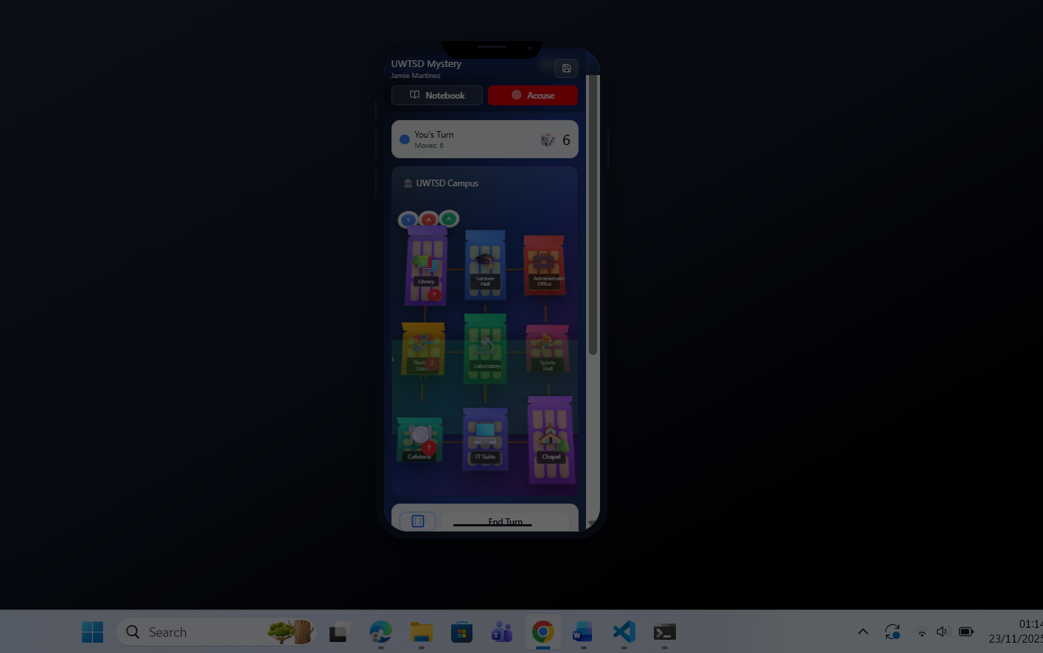
Mobile version game 3D location [22][23][12][13]
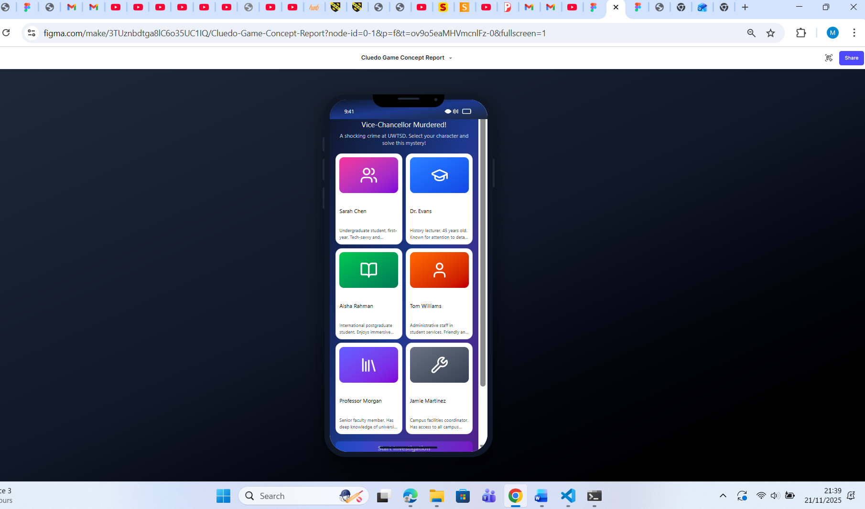
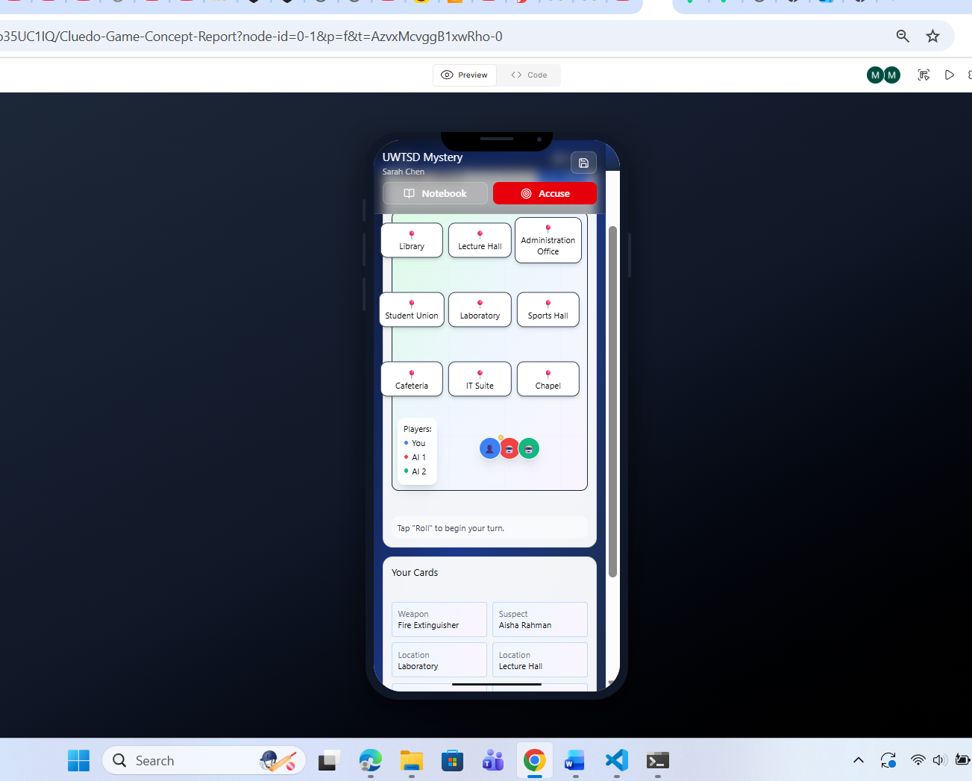
3D version [11][12][13]

Clue Collection Screen When entering a room, players receive a clue via a pop-up card. Clues include text and simple icons (e.g., magnifying glass, notebook). A “Collect” button allows users to store clues in their inventory. This screen uses minimal text and strong visual cues to reduce cognitive load and support quick comprehension.

Accusation Screen Players make their final guess by selecting a Suspect, Weapon, and Location. Dropdown menus or tap-based selectors are used. A confirmation screen summarises the accusation before submission. This screen supports decision-making and reinforces the game’s narrative climax.

interaction Flow
The wireframes were designed to support a linear and intuitive flow:

Main Menu → Character Selection → Campus Map → Room Entry → Clue Collection → Accusation → Outcome

The wireframe storyboards provide a clear blueprint for the UWTSD Cluedo game’s interface. They reflect usability principles, support diverse user needs, and align with interaction design theory. By focusing on structure and flow, the wireframes lay the foundation for a visually engaging and accessible final design [9][10][11][12]

11. Feedback Collection
Feedback was gathered to evaluate the initial wireframe prototypes and ensure they met the diverse needs of the personas identified earlier. A mixed group of twelve participants was recruited, including undergraduate and postgraduate students, lecturers, and administrative staff. This ensured coverage across the range of personas and avoided bias towards a single demographic [11][12][1]

Participants engaged in short usability sessions where they were asked to navigate the wireframes, select characters, move across the campus map, and simulate clue collection. Observations were recorded alongside verbal comments, following the “think-aloud” protocol recommended by Nielsen (1994). Emotional responses were also noted, as affective engagement is a critical component of game usability (Desurvire & Wiberg, 2009) [1][2][11][12]

Positive feedback highlighted the relatability of the campus setting, the diversity of characters, and the simplicity of navigation. Participants appreciated the clear flow between screens and the inclusion of multiplayer options. Negative feedback focused on the text-heavy nature of clues, limited visual richness in wireframes, and accessibility concerns such as font size and colour contrast [11][12][13].
Clue system too text-heavy; visuals requested.
Wireframes lacked colour, making final design hard to imagine.

Accessibility concerns (font size, contrast).
Desire for faster-paced gameplay.

12. Analysis
Feedback aligned with expectations regarding accessibility and narrative engagement. Unexpectedly, participants strongly emphasised visual richness, suggesting that even wireframes should hint at eventual aesthetics.

13. Conclusion
The initial design stage of the UWTSD Cluedo project has demonstrated the value of user‑centred research in shaping an inclusive and engaging digital game. By developing personas based on real user data, the project captured the diversity of the university community, including students, staff, and international participants. This ensured that design requirements reflected varied needs such as mobile accessibility, desktop usability, cultural inclusivity, and family‑friendly cooperative play [3][4][5][11][12].

Wireframe storyboards provided a clear blueprint for the game’s functionality, focusing on mobile‑first design, intuitive navigation, and accessibility features. Usability principles, informed by Nielsen’s heuristics and Norman’s theories of affordances, guided the design of screens and interactions. Accessibility considerations, aligned with WCAG guidelines, ensured that the interface would be usable by individuals with different abilities and preferences [9][10][11].

Feedback collection validated many of these design choices, with participants praising the relatability of the campus setting and intuitive flow, while also highlighting areas for improvement such as visual richness and font readability. These insights will inform the next iteration, particularly in enhancing aesthetics and refining accessibility [10][11][12].

In summary, this phase has established a strong foundation for the UWTSD Cluedo game, combining research, usability engineering, and prototype evaluation to create a design that is inclusive, engaging, and representative of the university community[8][9][10].

References
[1] Norman, D. (2013). The Design of Everyday Things. MIT Press.
[2] Nielsen, J. (1994). Usability Engineering. Morgan Kaufmann.
[3] Rogers, Y., Sharp, H., & Preece, J. (2017). Interaction Design: Beyond Human-Computer Interaction. Wiley.
[4] Salen, K., & Zimmerman, E. (2004). Rules of Play: Game Design Fundamentals. MIT Press.
[5] Fullerton, T. (2018). Game Design Workshop: A Playcentric Approach to Creating Innovative Games. CRC Press.

[6] Preece, J., Sharp, H., & Rogers, Y. (2015). Interaction Design: Human-Computer Interaction. Pearson.
[7] Canossa, A., & Drachen, A. (2009). Play-Personas: Behaviours and Belief Systems in User-Centred Game Design. Springer.
[8] Desurvire, H., & Wiberg, C. (2009). Game Approachability Principles for Inexperienced Gamers. Springer.
[9] Eriksson, J. (2023). User Profiling in Game Development: A Comparison of Theory and Practice. DiVA Portal.
[10] Häyhänen, E., Salminen, J., & Jansen, B. J. (2025). Why Are Personas the Way They Are? Identifying Six Persona Creation Strategies. Persona Studies, 11. https://doi.org/10.21153/psj2025vol11noart2002
[11] Isbister, K., & Hodent, C. (2022). Game Usability: Advice from the Experts for Advancing UX Strategy and Practice in Videogames (2nd ed.). CRC Press. https://doi.org/10.1201/9781003109389
[12] Miro. (2025). Wireframe vs. Storyboard: Understanding Their Purposes in Design. Retrieved from https://miro.com/wireframe/wireframe-vs-storyboard/
[13] Soegaard, M. (2024). UX Storyboards: Ultimate Guide. Interaction Design Foundation. https://www.interaction-design.org/literature/article/ux-storyboards
[14] Creswell, J. W., & Creswell, J. D. (2018). Research design: Qualitative, quantitative, and mixed methods approaches (5th ed.). SAGE Publications. → A foundational text explaining different research designs and how to structure methodology.
[15] Saunders, M., Lewis, P., & Thornhill, A. (2019). Research methods for business students (8th ed.). Pearson Education Limited. → Widely used in UK universities; covers data collection, sampling, and analysis methods.
[16] Pratt, A. E. (Designer). (1949). Cluedo [Board game]. Waddingtons Games, Leeds, UK. → Original publication of the game in Britain.
[17] Hasbro. (2024). Clue/Cluedo: The Classic Mystery Game. Hasbro Inc. → Current publisher and rights holder, with modern editions and adaptations.
[18] Bryman, A. (2016). Social research methods (5th ed.). Oxford University Press.
[19] Clegg, D., & Barker, J. (1994). Case Method Fast-Track: A RAD Approach. Addison-Wesley.
[20] Creswell, J. W., & Creswell, J. D. (2018). Research design: Qualitative, quantitative, and mixed methods approaches (5th ed.). SAGE Publications.
[21] Deterding, S., Dixon, D., Khaled, R., & Nacke, L. (2011). From game design elements to gamefulness: Defining gamification. Proceedings of the 15th International Academic MindTrek Conference, 9–15. ACM.
[22] Figma. (2025). Figma: The collaborative interface design tool. Retrieved from https://www.figma.com
[23] Figma. (2025). Figma for Education: Free tools for the classroom. Retrieved from https://www.figma.com/education/

