

Module Name: Digital Skills for Personal Development and Business Growth
Module Code: BMSW4008
Assignment Name: Evidence of learning (E- portfolio)
Student Name: Alexandra Marilena Furcoiu
Student Number: 2412154
Lecturer: Philippa Fitzgerald
Deadline: 20.06.2025

AI Acknowledgement
I confirm that I have not presented any AI generated materials as my own work.
I confirm that I have copies of my drafts, notes, and other resources I used, which I may be asked to provide in evidence.

E- portfolio contents
Task 1
- 1000-word analysis essay
- Questionnaire graphs
- Website design
- Marketing materials
- Reference list
Task 2
- Excel Spreadsheet- 12-month plan
- 750-word essay
- Reference list

Understanding customer preferences and wellness needs is crucial for developing products and services that resonate with a target audience which is why representatives of SNEP SPA conducted a customer preference questionnaire using Microsoft Forms to explore customer demographics, brand recognition and visibility, health concerns and purchasing behaviours. This essay presents a detailed analysis of mentioned aspects to reveal key insights that can inform marketing, product development and customer engagement strategies. For SNEP SPA, people’s opinions and needs matters, encouraging strong networking, honesty and professionalism ( San Juan, 2019).

The age distribution of participants revealed a majority between 25 to 44 who represents now SNEP SPA’s primary marketing appeal (Blankenship, 2023). This demographic is often associated with disposable income and awareness of their own wellbeing, individuals managing careers, family and health challenges altogether (Borden & Fones, 2025). This age range is particularly relevant to wellness brands, as they are typically more invested in monitoring their health and self- care strategies.
76% of participants between the age of 25 and 44 have shown the highest interest, while those under 25 have shown no records, which indicates a lack of engagement or targeting within younger demographics. The smallest yet significant age group is between 45 and 60, showing some interest in older adults. In conclusion, people with an available income and more self- aware of their needs are willing to look at what SNEP SPA has to offer.

In terms of recognition and visibility, most participants discovered the brand through social media posts or adverts, which has proved to be the best technique to engage and promote SNEP SPA’s products and services ( Vitorino, Lisbona & Antunes, 2020).
56% confirmed they have discovered SNEP SPA through social media platforms, suggesting that is a key channel for engagement. 28% represents existing customers or representatives, which indicates a strong base of loyalty and return engagement. 16% are minimally aware or completely unfamiliar with the brand, meaning there are opportunities to implement further marketing and outreach strategies. The data indicated that digital marketing, especially on social platforms, is highly effective for the business visibility and growth.

Participants shared concerns around their mental health and weight management, which suggests that there is a high demand for general wellness, need for relaxation and fitness programs.
The majority confirmed that they always feel tired, indicating fatigue and the need with energy- boosting. Stress, anxiety and insomnia represent significant concerns, suggesting that mental wellbeing is a major priority ( Tarafdar & Stich, 2021). Not being able to lose weight is a common issue. This could reflect concerns around metabolism, lifestyle, or diet. Other symptoms such as migraine, back pain, thyroid and soreness in the body should not be ignored as these indicates the presence of chronic pain or endocrine concerns. Surprisingly, there were no records for diabetes or the inability to gain weight, suggesting more interest towards preventive health and lifestyle management rather than managing chronic conditions.
Fatigue, stress, anxiety and weight management are the primary health concerns among participants. Fortunately, SNEP SPA can provide solutions such as nutritional support, stress relief therapies, natural supplements, fitness and weight management programs and more.

Looking at the consumer behaviour and purchasing priorities, a clear majority consists of 60% of participants stated that the quality is more important that price, suggesting that the target audience is value driven rather than cost driven. The data indicated that SNEP SPA can confidently position itself as a provider of high quality, result oriented solution, without having to compete on price ( Indeed, 2025).
However, 24% stated that they always check the price before purchasing, and an additional 16% expressed lack of trust on cheap products, fearing poor quality. This suggests that 40% of participants still considers price to be a significant factor, though not necessarily over quality. Occasionally, SNEP SPA offers limited time deals on products, bundles for both clients and representatives. Studies have proved that consumers are more likely to purchase if their desired product or bundle is on limited time sale or advertised as low stock (Evangelidis and Gunadi, 2023).
This insight reinforces the importance of maintaining high, trustworthy products and services standards for SNEP SPA. It also indicates the need to clearly communicate value and effectiveness, especially when price may be perceived as premium. Testimonials, before and after results and honest share of ingredients or service benefits could help justify the cost to sceptical buyers, while still look attractive to those who already prioritise quality.

Overall, the questionnaire findings point to a health- conscious, digitally connected demographic, experiencing high levels of fatigue and stress. They are keen to adopt lifestyle improvements, gain access to high quality products and services and improve their wellbeing.
From a product development perspective, the company could focus on solutions towards managing stress, boosting energy, improving sleep and supporting a healthy approach to weight loss. Mental wellness products such as calming teas, aromatherapy solutions or natural supplements to relieve fatigue and anxiety would resonate with the consumer’s needs.
In terms of services, SNEP SPA might benefit from launching educational channels, webinars or coaching to provide users with tools to take control of their health journeys (Dadwal, 2019).
From the marketing view, the company should keep prioritising social media engagement, while also considering collaborations with influencers who supports the brand’s values (Joshi, 2024). Customers testimonials, educational content of products and quality and visible results can strengthen consumer’s trust (Silkdrive, 2022).

Questionnaire graphs

The following screenshots attached present a visual representation of key responses collected through the SNEP SPA Customer Preference Survey.
These charts provide insights into the demographic profile, brand awareness, personal wellness concerns and purchasing attitudes of the targeted audience.

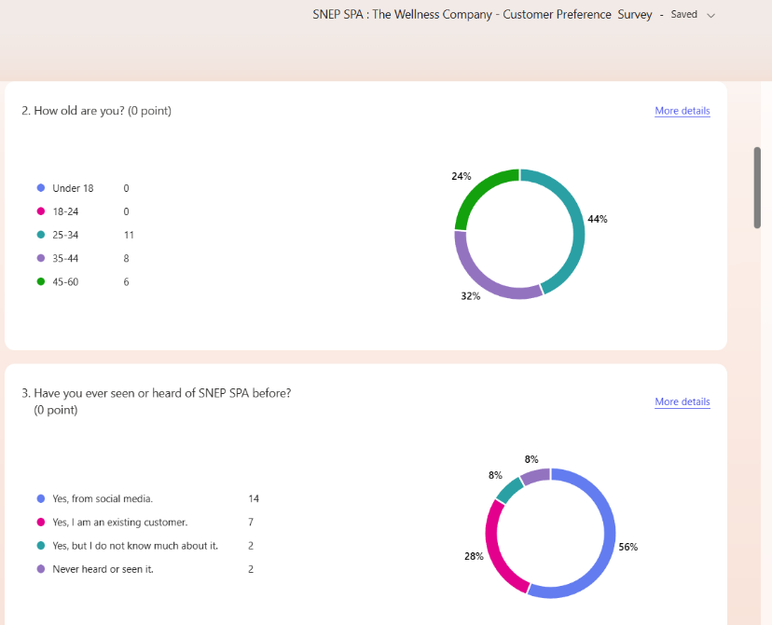

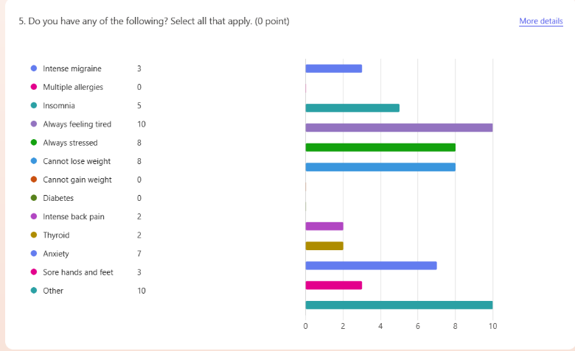

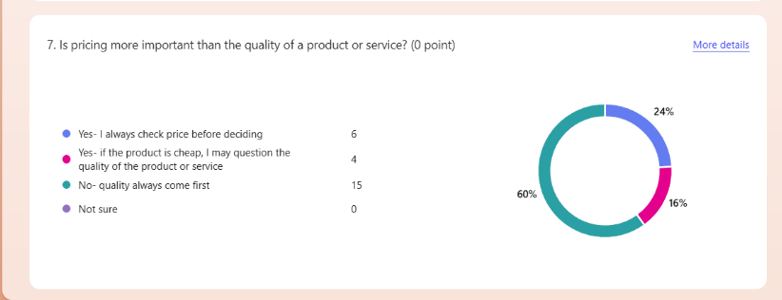

Website Design

The following images and links serve as proof of my involvement in promoting SNEP SPA through online platforms. They include screenshots of a website I designed on Weebly specifically to highlight and support the brand’s wellness services, as well as a website I am currently using in my role as a company representative.

Websites links: https://afurcoiusnep.weebly.com/
https://www.mysnep.com/en/440007898

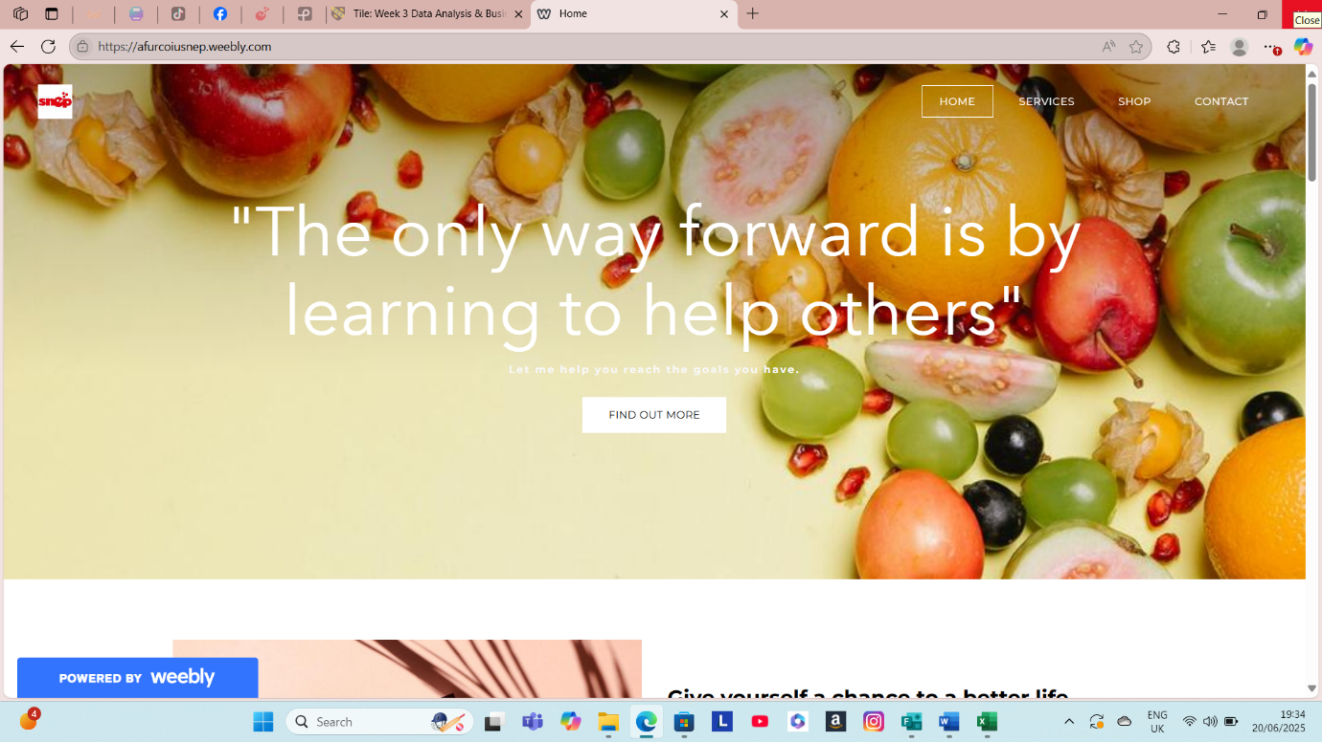

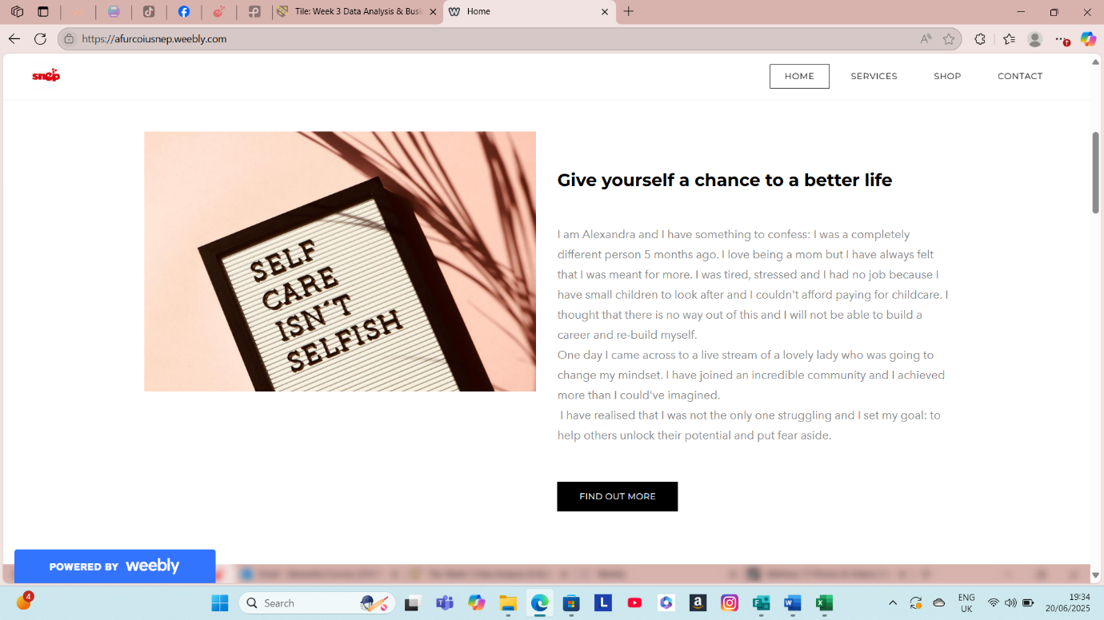
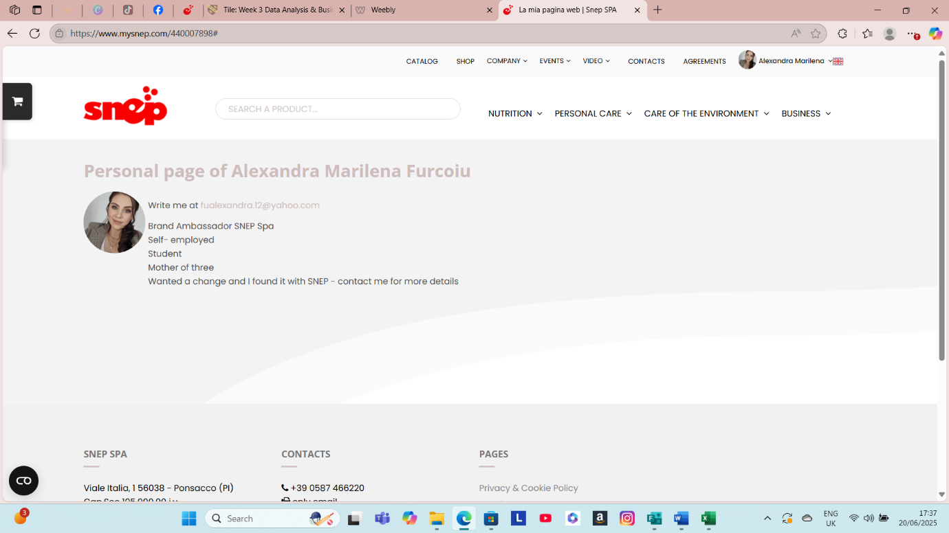

Marketing Materials

The following screenshots represent a selection of marketing materials created and used to promote SNEP SPA- The Wellness Company. These include digital flyers, social media posts, business cards, product highlights and promotion visuals designed to increase brand awareness, attract new clients, and support ongoing customer engagement.

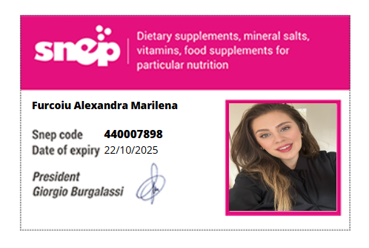

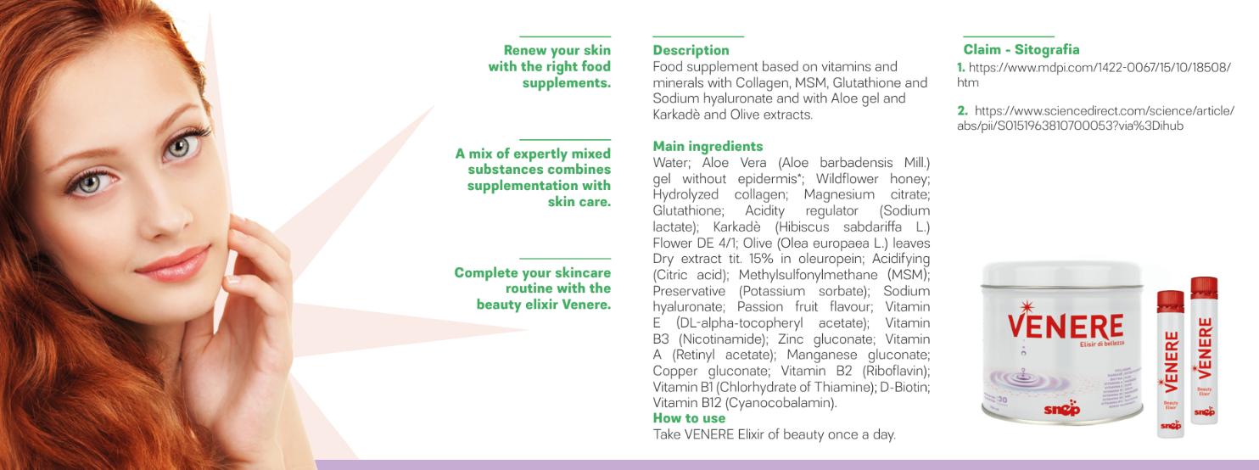

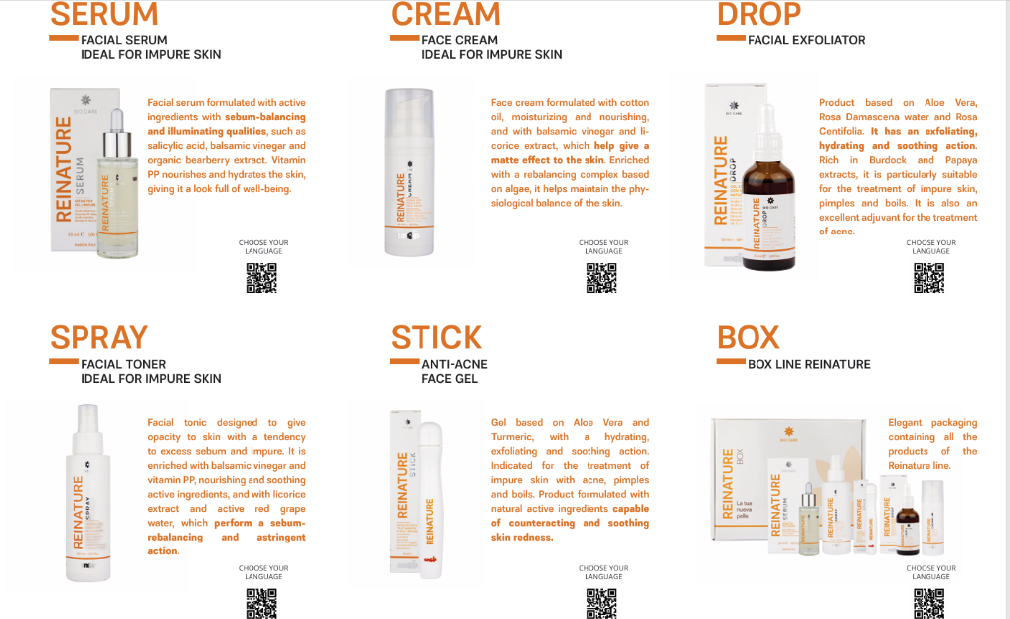

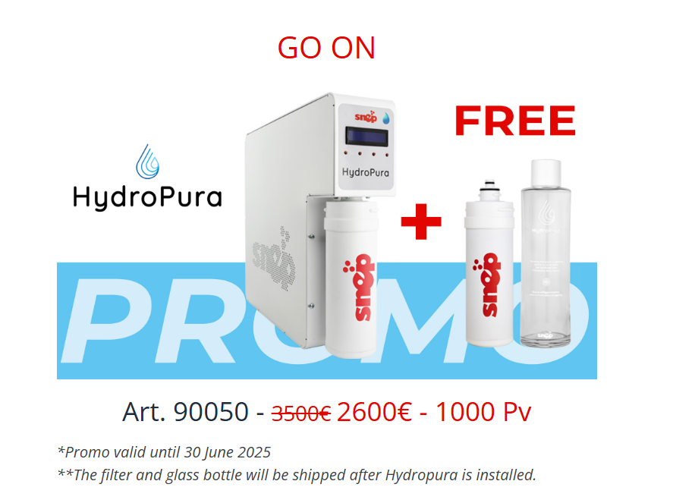

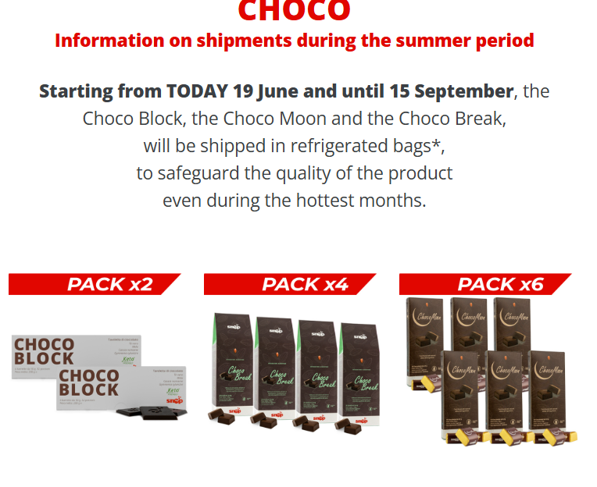



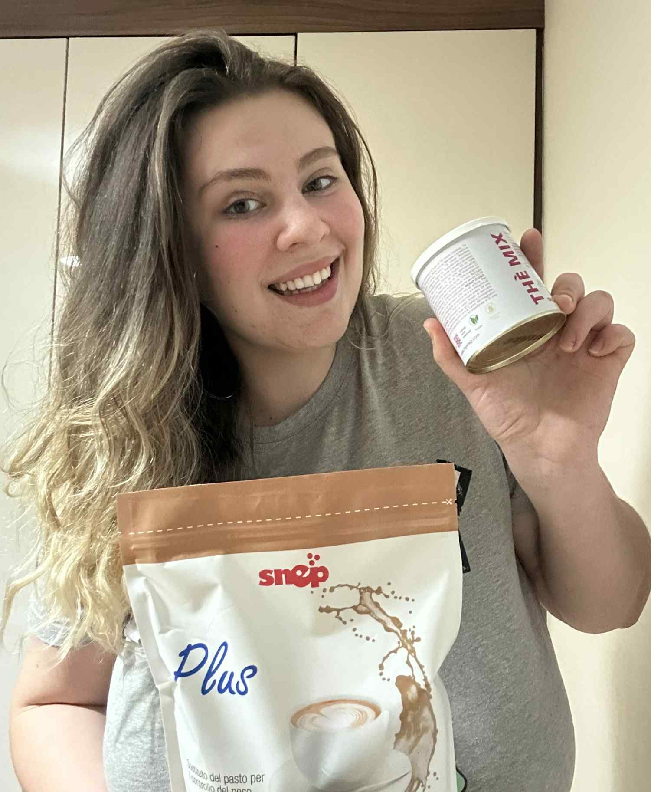
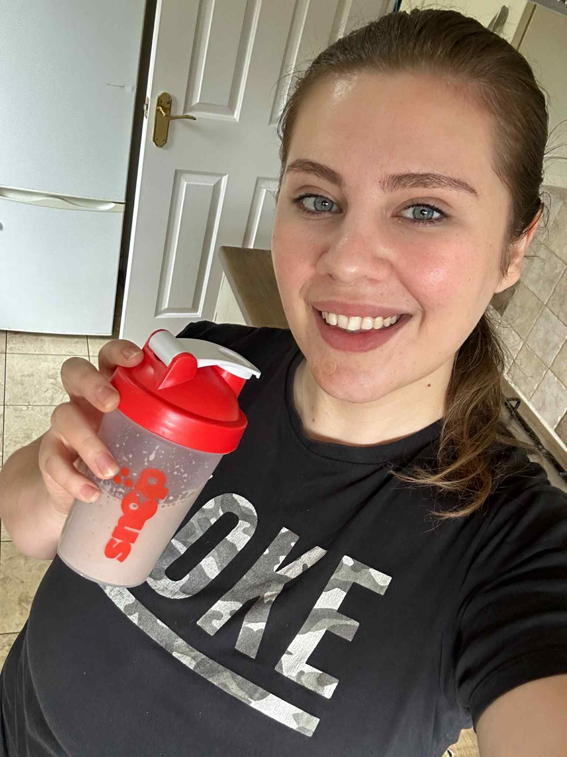

Reference list

Blankenship W. (2023). 7 of the best demographic segmentation examples we’ve ever seen, Drip, Available at: https://www.drip.com/blog/demographic-segmentation
Borden, D.S. and Fones, M. (2025) ‘Segmentation and strategy for promoting benefit corporation certification’, International journal of corporate social responsibility, 10(1), pp. 8-. Available at: https://doi.org/10.1186/s40991-025-00114-5.
Dadwal, S. (2019) Innovations in Technology and Marketing for the Connected Consumer, Edited by S. Dadwal. Hershey, Pennsylvania: IGI Global. Available at: https://doi.org/10.4018/978-1-7998-0131-3.
Evangelidis I. and Gunadi M. (2023). Pricing strategy Research: How price changes influence consumer’s buying decisions, Harvard Business Review. Available at: https://hbr.org/2023/01/research-how-price-changes-influence-consumers-buying-decisions
Indeed Editorial Team, (2025), Competition in Business: Importance and How to Handle It, Indeed, Available at: https://www.indeed.com/career-advice/career-development/competition-in-business
Joshi V. (2024), The Power of Social Media in Modern Marketing, Forbes business council, Available at: https://www.forbes.com/councils/forbesbusinesscouncil/2024/10/09/the-power-of-social-media-in-modern-marketing/
San Juan D. (2019). What’s more important: value or price? And how to project value to customers. Forbes agency council. Available at: https://www.forbes.com/councils/forbesagencycouncil/2019/11/12/whats-more-important-value-or-price-and-how-to-project-value-to-customers/
Silkdrive, (2022). 18 Global Marketing Strategies and Examples, Silkdrive, Growth Marketing Insights, Available at: https://www.silkdrive.com/insights/18-global-marketing-strategies-and-examples/
Tarafdar, M. and Stich, J. (2021). Virtual Work, Technology and Wellbeing. In: The SAGE Handbook of Organizational Wellbeing. Tony Wall, Cary L. Cooper and Paula Brough Editors, 55 City Road, London: SAGE Publications Ltd. pp. 159-171 Available at: https://doi.org/10.4135/9781529757187.n11
Vitorino, L. C., Lisboa, A., & Antunes, R. J. (2020). Digital Era: How Marketing Communication Develops Business Innovation – Case Studies. In F. Pinto & T. Guarda (Eds.), Digital Marketing Strategies and Models for Competitive Business (pp. 1-29). IGI Global Scientific Publishing. https://doi-org.ezproxy.uwtsd.ac.uk/10.4018/978-1-7998-2963-8.ch001
Task 2

The following image represents my 12-month cachflow forecast plan for my franchise under the name of SNEP SPA.
Due to technical errors, I was unable to attach my Excel document to Word. After many attempts, I realized that the only way to send my Excel Spreadsheet is via email to the lectrurer.

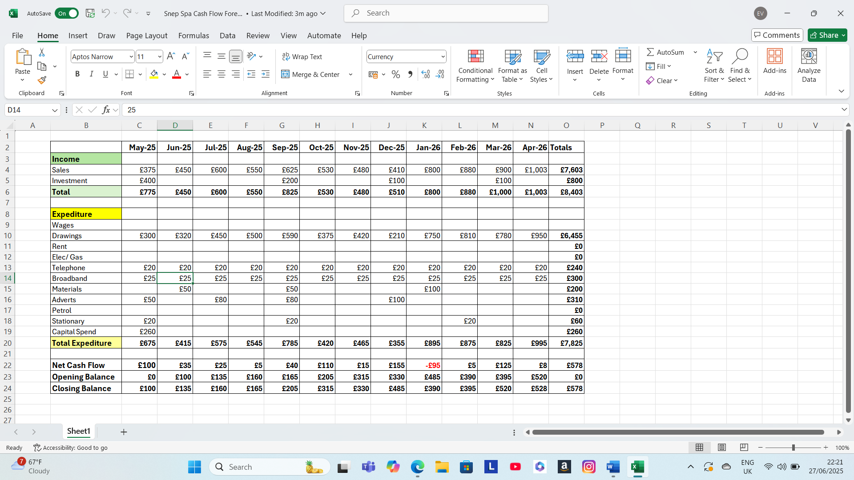

Word count: 750

In the digital era, the ability to use technology effectively is no longer a luxury but a necessity, especially for students aspiring to become entrepreneurs. One of the most powerful and accessible tools is Microsoft Excel. Intensively used across industries, Excel offers numerous features that support data management, financial planning, and strategic decision- making. For a student setting up a business, developing skills in Excel is not only advantageous but essential in building a successful, organised, and competitive enterprise.
One of the key strengths of Excel is its ability to organise and analyse data efficiently. As a student entrepreneur, dealing with information, whether is marketing research or financial records, is a daily reality. Excel allows users to create spreadsheets that are easy to navigate and update. With features like filtering, sorting, and conditional formatting, data can be quickly interpreted, helping users make sense of complex information without feeling overwhelmed. When conducting market research for a startup idea, Excel can be used to tabulate responses, identify trends, and create visual summaries in the form of charts and graphs.
Managing finances is critical when considering starting up a business and for that, Excel represents a powerful financial management tool. With the use of the right formulas, budgeting, forecasting, tracking income and expenses, and calculating profit margins, can all be easily done with Excel (Chan, 2022). For example, functions like AVERAGE or SUM allow users to create custom financial models that suit their business needs. As a student with limited financial resources, I find Excel especially useful for keeping my spending under control while planning ahead. By adding projected and actual expenses, I can identify areas where I need to cut costs or invest more wisely.
Creating business plans and presentations is also essential for business development. Excel can integrate data into report that can be presented professionally. For example, if I am presenting the growth potential of my business, Excel helps me display trends over time, compare products, or showcase customers feedback.
Excel is indispensable when it comes to inventory and project management, two areas where business often struggles. For example, if I were the owner of a small business selling handmade products, I would rely on Excel to keep track of stock levels, product ingredients, expiration dates, and supplier contacts (MOOC, 2022). This could prevent overordering, reduce waste, and ensure well preparation to meet customer demand. By creating charts and pivot tables, I could identify which products are more in demand and what improvements clients expected.
Its functionality goes even further with advanced tools and integration of automation. Furthermore, Excel supports data validation and error checking which is important in maintaining data accuracy (Excel Champ, 2025). These features save time and reduce human errors, which could be beneficial especially for those with multiple responsibilities.
Learning to use Excel is also a significant career and employability booster. Whether a student decide to pursue entrepreneurship or choose to work for an organisation, Excel is highly utilised across all industries, including marketing, finance, administration, and coordination. Excel is one of the top skills employers look for in potential candidates (Indeed, 2025). My experience of using Excel to manage the costs of a business has already given me practical skills that I can update into my CV and apply in future job roles.
What makes Excel more interesting is its scalability and accessibility (Shultz, 2022). As part of Microsoft 365, Excel is usually free for students in educational institutions. It can be used on laptops, tablets, and even mobile phones, allowing flexibility. As my business grows, Excel templates I have previously created can be expanded and customisable to fit my needs. The scalability ensures that Excel remains relevant no matter of stage of business development.
In conclusion, Microsoft Excel is more than a tool used for simple calculations, it is a digital assistant for student entrepreneurs (Grimes, 2021). From organising data and managing budgets to analysing customer trends and automating tasks, Excel is the key for making smart, essential business decisions (Scottish Business News, 2023). It also develops valuable skills that are transferable to almost any career path in today’s digital economy. As a student setting up a business, I consider Excel not just a useful tool but an essential partner in achieving both academic and entrepreneurial success.

Reference list

Chan, V. (2022), Why learn Excel? Here are the top 15 epic benefits of mastering Excel, Launch Excel, available at: https://www.launchexcel.com/why-learn-excel/
Excel Champ, (2025), Excel Automation: 6 ways to automate ( and how to do so), available at: https://www.excelhelp.com/excel-automation-six-functions-to-automate-and-how-to-do-so/
Grimes, B. H. (2021), 7 ways you can use Excel in business to save time & money, The Excel Experts, available at: https://www.theexcelexperts.com/importance-excel-business/
Indeed, (2025), 12 basic Excel skills to help you advance your career, Indeed Editorial Team, available at: https://uk.indeed.com/career-advice/career-development/basic-excel-skills
MOOC, (2022), How important is Excel in business? MOOC BLOG TEAM, available at: https://www.mooc.org/blog/how-important-is-excel-in-business
Scottish Business News, (2023), 6 ways students can use Excel in life and studies, available at:https://scottishbusinessnews.net/6-ways-students-can-use-excel-in-life-and-studies/
Shultz, W. (2022), Flexibility with Excel, LinkedIn, available at: https://www.linkedin.com/pulse/flexibility-excel-warren-schultz

