  Business Plan  28 June 2024 | Managing Enterprise in the 21st Century BMSW4011  Melanie Squire  Anna Misiak-Ali (2311228)  1584 words

Table of Contents
Company overview 2
Mission statement, aims and objectives 3
Location of a business 3
Human resources 4
Marketing activities 4
Market research 6
Questionnaire analysis 6
Personal S.W.O.T. analysis 8
Financial resources 9
Problems & solutions 9
Conclusion 10
Appendixes 10
Appendix 1 10
Appendix 2 11
Appendix 3 12
Appendix 4 13
References 14
Reflection 16

Company overview

,,Perfect cleaning’’, cleaning services company specialise in cleaning private homes and flats. Collaboration with rental agencies, real estate companies, offices and shops can be also provided. The offer contains regular cleaning, deep cleaning as well as specialized cleaning which can include:
- Cleaning after moving out.
- Cleaning after renovation.
- Contracted cleaning in offices and wellbeing premises.

Decision to start company as a sole trader means self-employment and taking 100% responsibility for all the aspects of running a business. According to Colman, E. (2022) being a sole trader means that you and your business are one and the same.

Pros and cons of a sole trader( Benwell, S. 2024):

Pros

- Keep all profits after tax.
- Administration is simple and easy.
- Tax efficient for businesses with lower profits.
- First year losses can be used to reduce other tax due.

Cons

- Unlimited personal liability for the business.
- Could lose personal assets if things go wrong.
- Harder to pass on the business through inheritance or via a sale.
- Some clients will not work with sole traders.
- Less tax efficient once profits exceed £20,000.
- Can be harder to raise finance.

Mission statement, aims and objectives

Mission statement:
,,Our mission is to provide exceptional cleaning services that create clean, healthy, and inspiring environment for our clients, while always prioritising sustainability and customer satisfaction.’’
Aims:
- provide cleaning service for customers.
- work on brand recognition.
- expanding business, find new clients and to employ new employees.
Objectives:
- to earn profits more than £3,000 per annum.
- to provide excellent service and satisfaction to the clients.

Location of a business

Location of a business will be virtual as rents are expensive. The average rent for small office in Cardiff can vary from £385- £900 per calendar month (Rightmove, no date). For a cleaning company there is no need to provide address as most of the orders can be done via phone call or booking through website at www.anna.perfectcleaning.com.uk. Personal home address will be available for correspondence with HMRC and council (see appendix 1).

Human resources

,,Perfect Cleaning’’ company at the beginning of its existence will focus on brand recognition and finding new clients as well as preserving existing ones. As a self-employed person the only associate will be accountant. At the beginning accountant will help with income and expenses calculation. Accountants manage everything from payroll processing and bookkeeping to financial forecasting and auditing (Tamplin. T, 2023)

Marketing activities

There are many available marketing strategies like email marketing, direct mail or social media marketing. One of the most popular marketing activities in recent years is content marketing which became profitable and can spread around the internet fast (Snyder, K. 2024 and B&B Press 2024). ,,Perfect Cleaning’’ company will operate mostly through internet and social media but for elder generation we will provide leaflet.

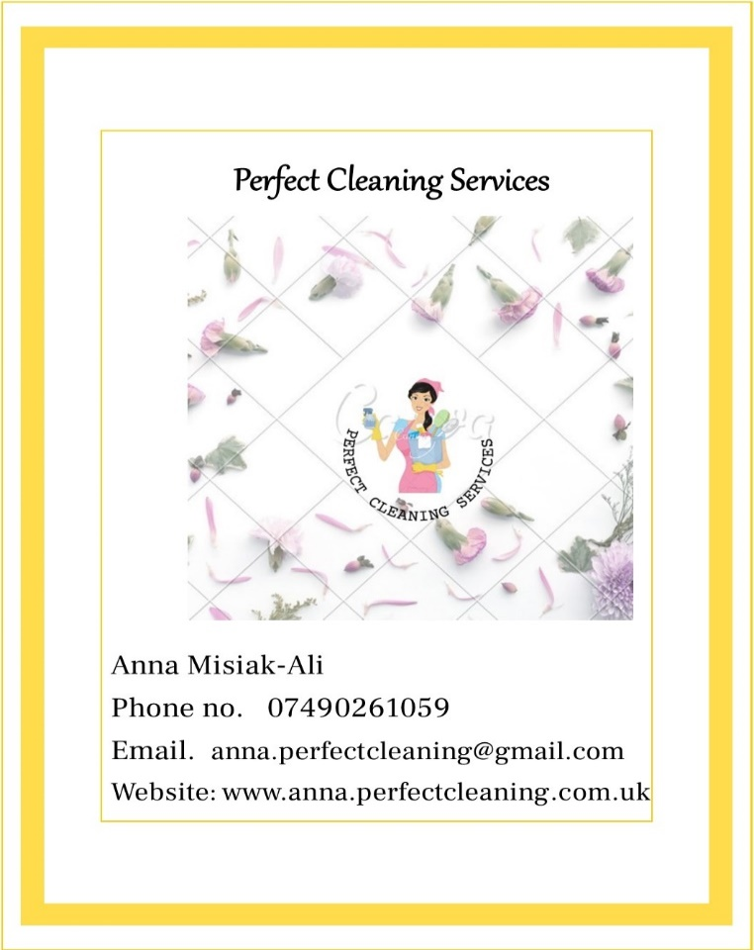
One of a strategy will be sending leaflets through post for elder people who do not really use social media. The idea is to let them know that they can just call and arrange meeting to quote service and pricing.
Platform like Facebook, and TikTok will be used to attract potential clients who mostly are busy working and prefer to find information on-line. Website www.anna.perfectcleaning.com.uk will also be available for people who wants to arrange cleaning service.

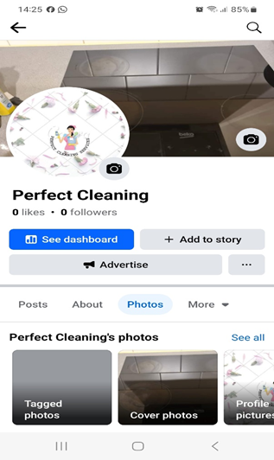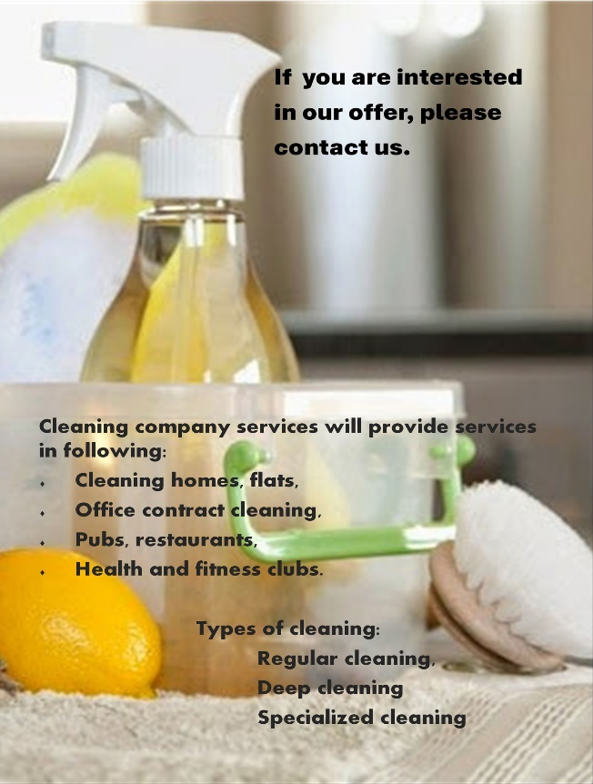

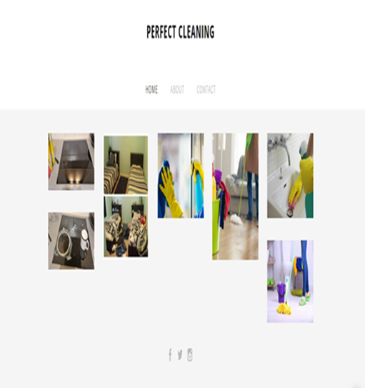

Market research

Williams, K. (2024) states that a questionnaire is a conversation on paper, online, or in digital format. Set of well-thought-out questions are designed to gather specific information from people. These questions are important to help researchers, businesses learn about behaviour and opinions of other people (Stiles, K. 2020).
At the beginning of the market research, questionnaire had been sent to define what type of cleaning respondents prefer. Questions were designed to find information about potential customer base for another cleaning company. The answers can be find here: https://docs.google.com/forms/d/e/1FAIpQLSc1C-NnlA8pLqH234PPhooUUWhlxf35eGP1PA_ePCI6ut42zw/viewform?usp=sf_link .

Questionnaire analysis

More than 87.5% of responders said ,,yes’’ to a question. It is more than ¾ of responders who can provide new customers list through suggestion and bring more clients and provide new network connections.
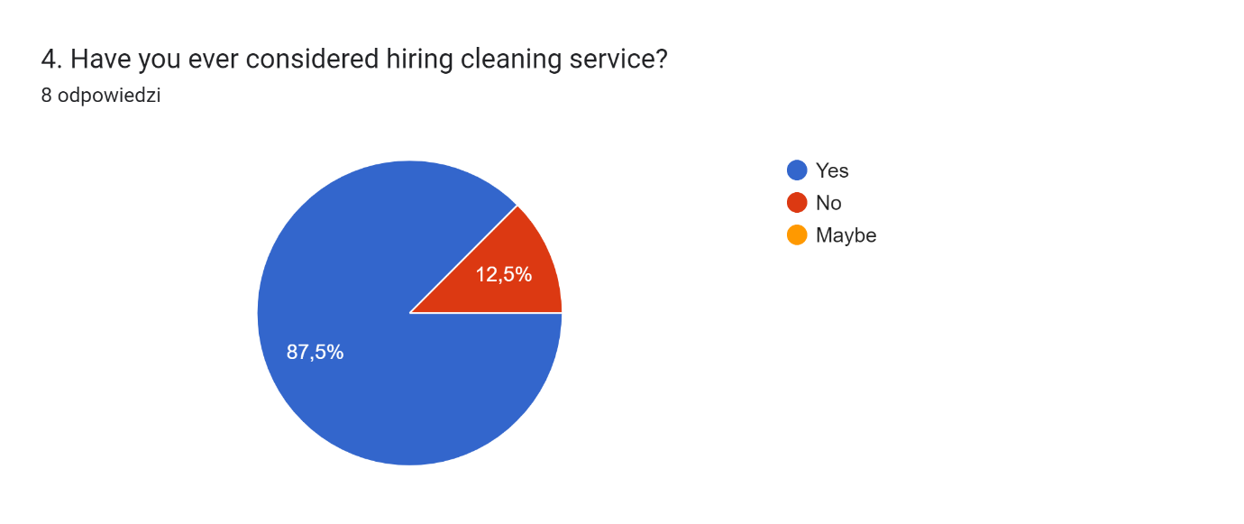

Perfect Cleaning company based in Cardiff can charge between £15-£20 per hour chose by 88.9% customers. According to answers obtained, only 11.1% were willing to pay between £20-£25 per hour for a service. Analysing those answers Perfect Cleaning company will set a price for £18 per hour for a regular cleaning.
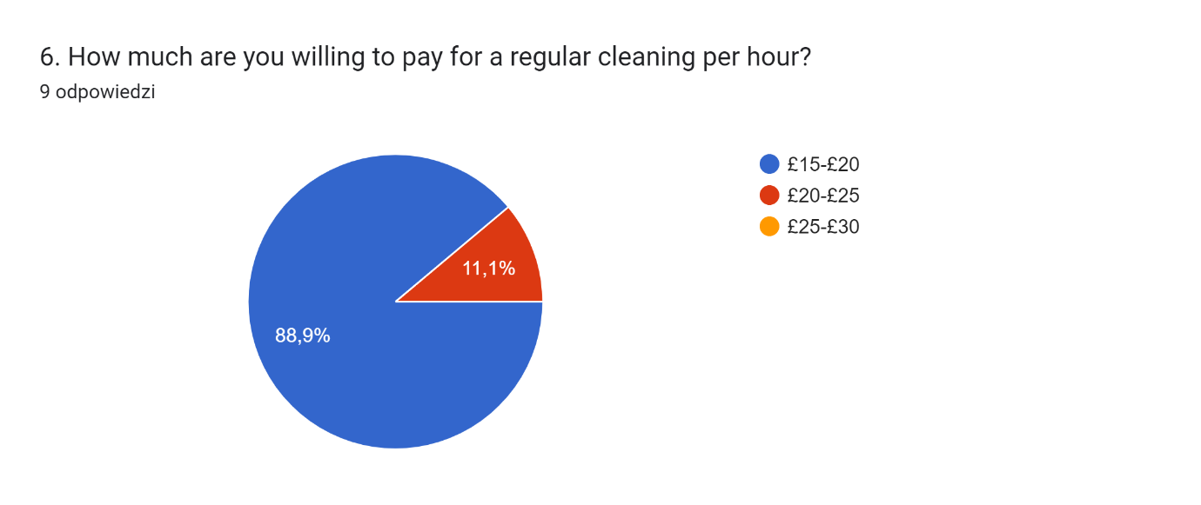

Based on answers in next question around 50% of customers wish to have a cleaning service once a week followed by 37.5% of customers to have a cleaning service once a month.
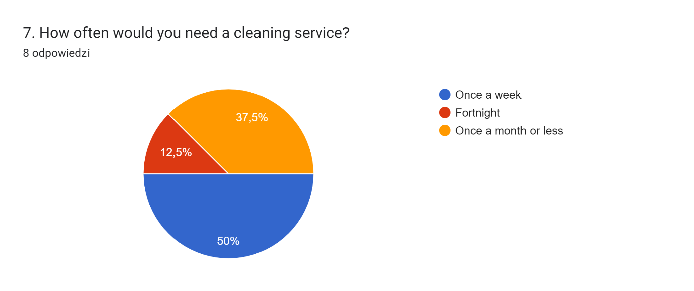

Personal S.W.O.T. analysis

S.W.O.T. analysis was done to provide closer look on characteristics of a cleaning person (Adam. 2024). Skills and advantages are required as followed:

Personal S.W.O.T. Analysis
STRENGHT | WEAKNESSES
- accuracy  - punctuality  - own transport  - confidentiality  - flexible service | - family issues  - sickness  - car broken down.  - time management
OPPORTUNITIES | THREATS
- expand business (cleaning carpets)  - employ new employees | - competition  - rising cost of living  - less clients

Source: self-implemented

Financial resources

Financial resources include personal savings of £1000. The most important equipment are mops, cleaning products and cloths. All the equipment must be clean, in good condition and suitable for the job (see appendix 3). Perfect Cleaning company will make sure that there is reduced cross contamination risks (see appendix 2). All mops and buckets will be colour coded (Amazon. 2024). This will remove the risk of using the same mop heads and buckets in multiple areas (McCubbin, K. 2023 and SCS no date). Cash flow forecast (see appendix 4) includes all the predicted income and expenses. Accountant fee cost £200 (Chechi, Z. 2024). The National Insurance Contributions for self-employed varies and depend on how much profit is made. There are two NICs to consider as a sole trader (Wright, I. 2024).
Sole trader needs to file a tax return every year as well as (Benwell, S. 2024):
- Keep business records and records of expenses.
- Pay Income Tax on your profits.
- Pay Class 2 and Class 4 National Insurance.
- Register for VAT if your turnover is over £85,000.

Problems & solutions

The biggest threat to the success of the business can be another pandemic which can contribute to lockdowns. Due to economy in recent years competition became harder (Lowe, L. 2021). One of the options to overcome problems is to develop competitive methods that will distinguish Perfect Cleaning company from others. Work through lockdown with safety measures and comply. Saving money can also help in the most tough times.

Conclusion

Perfect Cleaning company will work hard to satisfy customers and promote healthy lifestyle through cleanliness and hygiene. Mission, aims and objective of Perfect Cleaning, cleaning services are important aspects of company development.

Appendixes

Appendix 1

Location for correspondence
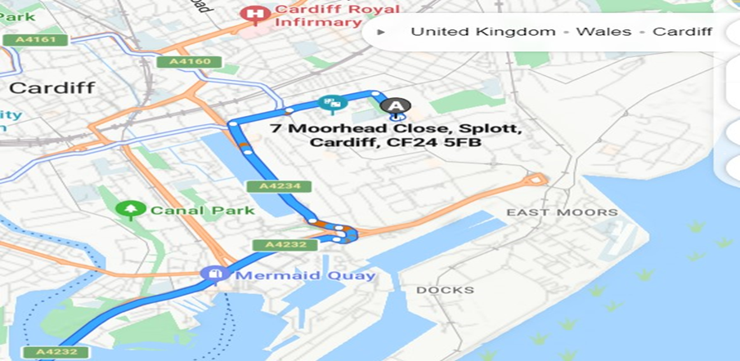

Appendix 2

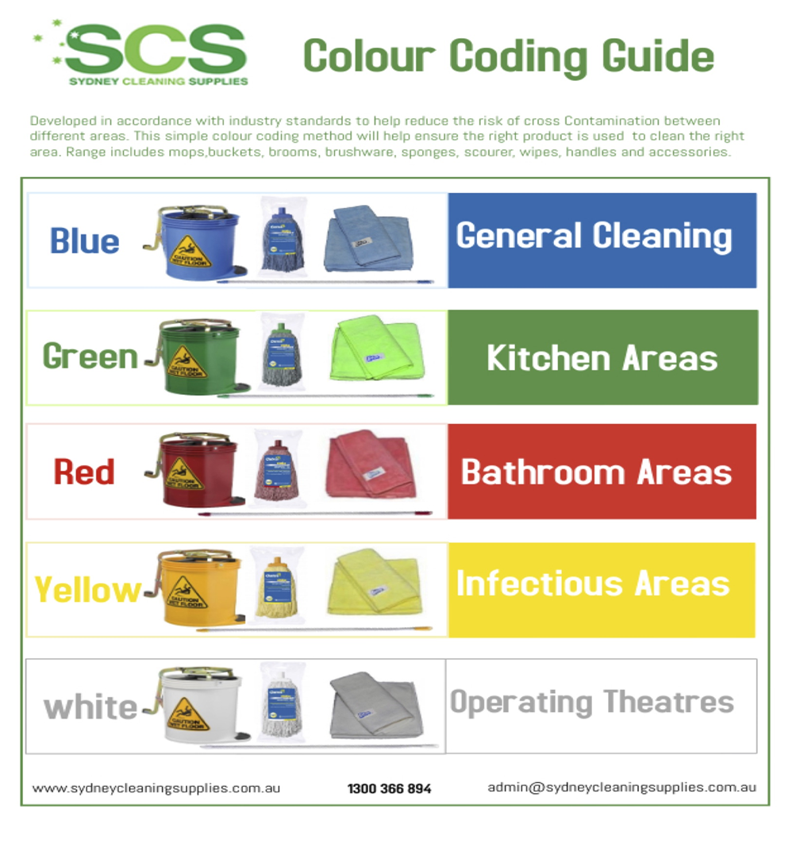

Appendix 3

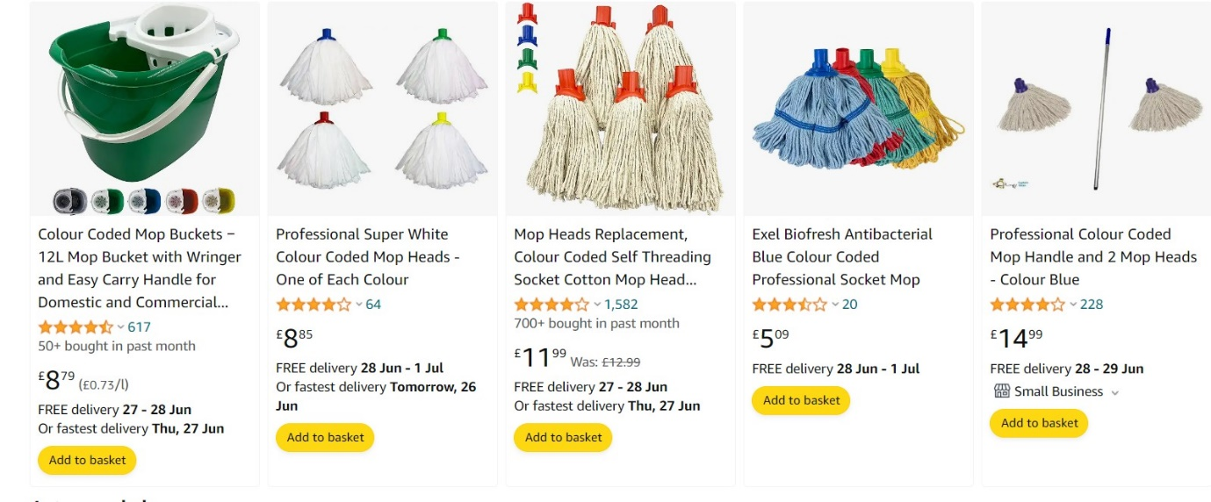
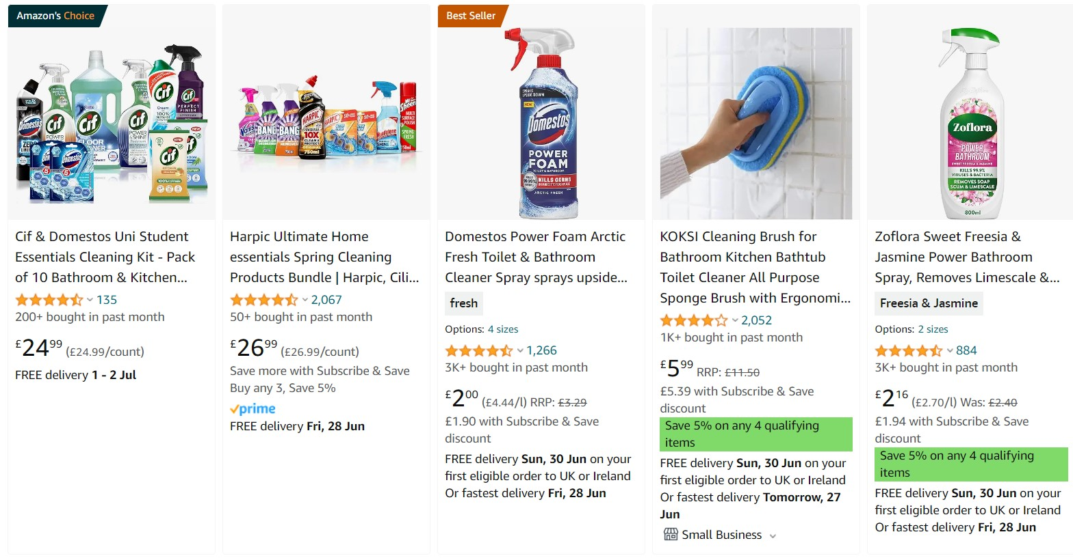

Appendix 4

CASH FLOW FORECAST


References
Adam. (2024). SWOT Analysis for a Residential Cleaning Business (Example). [Online]. SharpSheet. Last Updated: 9 January 2024. Available at: https://sharpsheets.io/blog/swot-analysis-residential-cleaning-business/ [Accessed 26 June 2024].
Amazon. (2024). Coloured coded mops. [Online]. Amazon. Last Updated: 2024. Available at: https://www.amazon.co.uk/s?k=coloured+coded+mops&crid=1V6YP3HAJ9DMK&sprefix=coloured+coded+mops%2Cap [Accessed 26 June 2024].
Benwell, S. (2024). Sole trader vs limited company: what’s best for you?. [Online]. Money. Last Updated: 16 January 2024. Available at: https://www.money.co.uk/business/sole-trader-vs-limited-company#:~:text=Pros%20and%20cons%20of%20a%2 [Accessed 26 June 2024].
B&B Press. (2024). The Advantages and Disadvantages of Leaflets for Advertising. [Online]. B&B Press. Last Updated: 2024. Available at: https://www.bbpress.co.uk/news/advantages-and-disadvantages-of-leaflets-for-advertising-in-2019 [Accessed 26 June 2024].
Chechi, Z. (2024). How Much Does an Accountant Cost?. [Online]. Expert Market. Last Updated: 29 January 2024. Available at: https://www.expertmarket.com/uk/accounting-services/how-much-accountant-cost#:~:text=The%20upcoming% [Accessed 26 June 2024].
Coltman, E. (2022). What is a sole trader? A small business guide. [Online]. Small Business UK. Last Updated: 10 August 2022. Available at: https://smallbusiness.co.uk/what-is-a-sole-trader-small-business-2534818/ [Accessed 20 June 2024].
Lowe, L. (2021). Top Challenges Cleaning Businesses are Facing Currently. [Online]. Cleanetto. Last Updated: 2021. Available at: https://www.cleanetto.com/blog/challenges-cleaning-businesses-are-facing-currently [Accessed 26 June 2024].
McCubbin, K. (2023). COSHH Cleaning Colour Coding – Training & Equipment. [Online]. Safe workers. Last Updated: 17 January 2023. Available at: https://www.safeworkers.co.uk/workplace-training/cleaning-colour-codes/#:~:text=All%20mops%20and%20b [Accessed 17June 2024].
Rightmove. (no date). To rent- commercial properties. [Online]. Rightmove. Last Updated: no date. Available at: https://www.rightmove.co.uk/properties/51618972#/?channel=COM_LET [Accessed 12 June 2024].
SCS.. (no date). Colour coding guide. [Online]. SCS. Available at https://sydneycleaningsupplies.com.au/wp-content/uploads/2017/06/colourcodingguide-768x1087.jpg. [Accessed 25 June 2024].
Snyder, K. (2024). What Is Marketing? Definition, Strategies & Best Practices. [Online]. Forbes Advisor. Last Updated: 6 June 2024. Available at: https://www.forbes.com/advisor/business/what-is-marketing/ [Accessed 13 June 2024].
Stiles, K. (2020). Why Is Market Research Important: We Give You 7 Reasons. [Online]. SC Blog. Last Updated: 2 June 2020. Available at: https://www.surveycrest.com/blog/why-market-research-is-important/ [Accessed 26 June 2024].
Tamplin, T. (2023). What Does an Accountant Do?. [Online]. Finance Strategists. Last Updated: 8 September 2023. Available at: https://www.financestrategists.com/financial-advisor/accountant/what-does-an-accountant-do/ [Accessed 15 June 2024].
Williams, K. (2024). What Are Questionnaires? Benefits, Importance and Examples. [Online]. Survey Sparrow. Last Updated: 29 May 2024. Available at: https://surveysparrow.com/blog/questionnaires/ [Accessed 10June 2024].
Wright, I. (2024). How Much Tax Does A Sole Trader Pay In The UK?. [Online]. Business Finicing.co.uk. Last Updated: 5 June 2024. Available at: https://businessfinancing.co.uk/accounting/sole-trader-tax/#:~:text=These%20are%20the%20income%20tax [Accessed 20 June 2024].

Reflection

We are coming to the end of an academic year and yet still a lot of work to do. One of the most important assignments needs to be completed. Writing a business plan is difficult. It is a process of planning my future life. At the time of coming out with the proposition of my business I felt insecure and deeded reassurance that I can go through this process and succeed. I was trying to find my place, I was trying to
find,, the thing’’ I am good at and turn it into business proposition. I have 2 small children and until they are big enough I need to be around a lot. Starting,, Perfect Cleaning’’ company will let me to work my schedule around my children and gives me some sort of freedom when I can work. My next steps are doing research about the profession and labour market. I am still unsure if I can fit

, if I can carry on the task but as I have been doing my research I learned that I am able to do cash flow forecast and predict my expenses. I have learned much more about legal actions and what is expected from me as a sole trader. I also know much more about myself after completing S.W.O.T. analyses. During the process of collecting data, I have concluded that a lot of marketing can be done for free through the social media. Part of my research was sending questionnaire to my student colleagues to find what is the demand for my business proposition and the result where optimistic. During the process of research and putting all that business plan together I have learned that I am good at settlements and really enjoy all the paperwork that comes with it. I need to know more about accounting to be able to do it myself to safe money for expanding my Perfect Cleaning company. Working on MC Excel is also fun, who can believe that, but I really enjoy those numbers and formulas. After thinking about my entrepreneurial skills, I know that I need to work more on my time management skills. I can adapt fast to the changing environment by being fragile and flexible. Working with people can be challenging and frustrating at some point but I am patience and can withstand a lot. My motives to continue this journey are quite simple, I just want to work to support my family, and this gives me a courage to move forward and complete assignments and studies. I know that I have still a lot to learn and to understand about business, but I am optimistic that with a time I gain more experience and knowledge, and I will find my place among all those other cleaning services, and we will compete, but I am sure that one thing will not change that we want to make our clients life better.

