UNIVERSITY OF WALES TRINITY SAINT DAVID
BIRMINGHAM CAMPUS

PERSONNEL RESOURCING
AND
DEVELOPMENT

M5X01921 – Assignment 2

Lecturer: ABDY RAHMAN

Student: FLORIN AMOS - 1815218

Table of Contents
Introduction: 3
Task 1 3
Organizational overview 3
Current issues in the hospitality industry 3
The surge in sharing economy 3
Changing customer demands 4
Changing marketing tools 4
Shortage of skilled workforce 5
Task 2 6
Current issues for Accor Hotels in terms of employee engagement 6
Comparison of the issues with other organizations 6
Task 3 7
Suggestions to increase employee engagement and retain employees 7
Reward staff with rooms 7
Cross-training sessions 7
Introduce lobby dogs 7
Task 4 8
Definition of primary research 8
Addressing definite issue 8
Better control over sample 8
Reason to not choose generalized research methods 8
Conclusion 9
References 10

Introduction
A research proposal is often regarded as a ‘blueprint’ for a particular intended study, and once relevant bodies accept the proposal, the research is carried out. A well-structured proposal letter is the backbone of any research and thus is a very important step of the research itself. The main objective of the proposal to obtain certain approvals from committees such as ethics, grants, IRB, etc. However, even today, most research proposal application is substandard because the researchers fail to point out the right hypothesis and focus of the study. In this proposal, I will focus on a study related to the impact of personnel development on the hotel industry. I will refer to several secondary researches to focus on the current issue in this business sector and relate it to the topic of employee engagement. A holistic suggestion will also be provided based on the research findings, along with a brief explanation of the advantages of different research methods used.

Task 1

Organizational overview
The organization on which the proposal will be written is Accor S.A, a French multinational hotel chain that is currently operating within more than 100 countries in the world with a huge line up of 4900 hotels and employing over 290,000 employees across the globe. The headquarter of the company is located in Issy-Les-Moulineauz, France.

Current issues in the hospitality industry
Hotel management as interesting as it may sound is often difficult in this era of innovation and constant technological evolvement. For many years, the hospitality industry has been one of the fastest-growing business sectors all over the world (Book, Gatling and Kim, 2019). However, different changes in the business environment have had a heavy impact on this industry.

The surge in sharing economy
With the sudden surge in the sharing economy, services like Airbnb, Couchsurfing have reshaped the tourism industry greatly. At this moment, the biggest consumer of the hotel industry, the travellers and tourists, are leaning towards services such as Airbnb due to its convenience and cost-effectiveness (Demirçiftçi and Kızılırmak, 2016). So, the constant change in consumer expectations is one of the major changes that happened to this industry in the last decade.
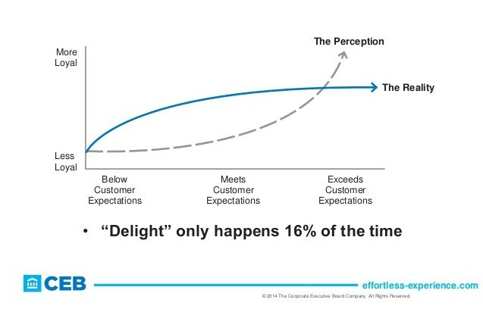
Figure 1: Changing the employee satisfaction rate.

Changing customer demands
According to CEB Global, Customers experience services that are above their expectations, only 16% of the time from traditional hotels these days. More importantly, the services that delighted a customer a year ago may only be just an expectation now. The technological advancements in the industry are also shaping consumer behaviour as more consumers are beginning to set their expectation benchmark comparing with other alternative services in terms of conveniences and efficiency (Karatepe, 2016). The increasing technological usage is also owing the companies to increase their digital footprints as customers are more involved in digital channels and social media now. So, keeping up with customer expectations in this highly dynamic business environment is also a big challenge for the hospitality industry.

Changing marketing tools
With the rapid growth of technology and social media users, its hard for traditional organizations all around the world to create promotional content the way they did a few years ago. Historically, hotel companies have always resorted to print media and mass marketing channels to promote their services. However, as the runtime of the smartphone is increasing day by day, the visibility of print media is decreasing exponentially. So hotel companies are required to utilize online marketing c channels to target their audience effectively (Dogru et al., 2020). Consumers are also getting more cautious these days. So maintaining a digital presence through a website and social media pages is also becoming mandatory as the industry is getting largely dependent on review services from companies like TripAdvisor or Expedia.

Shortage of skilled workforce
Currently, one of the biggest challenges in the industry revolves around the high turnover rate in the hospitality industry as a specialist argues that the rate is close to double in this industry compared to other ones.

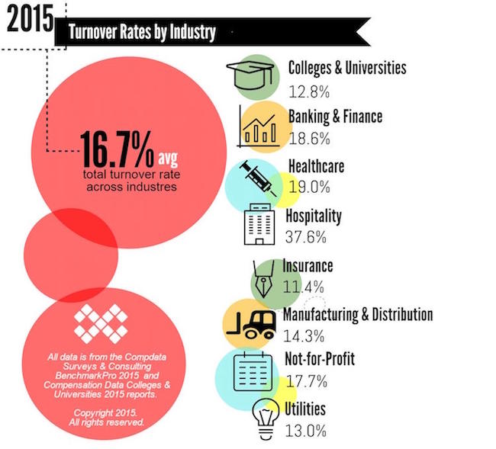
Figure 2: Turnover rate of the hotel industry.
This high turnover rate, complemented by the increasing technological advancement, has further flamed the decreasing growth in this sector. Consumers' expectations have increased, leading the staff of traditional hotels to work irregular hours (Holston Okae, 2018). Even though the most important motivation factor for the employees of the hotel industry is salary, the changing dynamics in the business environment has made them more conscious about other factors. Most of the staff in the hospitality industry are now interested in training and development programs that can facilitate their career progression. In this proposal, my main theme will also revolve around the impact of employee engagement on the growth of the hospitality industry in the future.

Task 2

Current issues for Accor Hotels in terms of employee engagement
Accor hotels are currently experiencing a lot of challenges in terms of retaining their employees. The means using which the company can overcome this problem is the main focus of this research proposal. Insights business review has identified several reasons which lead to employees leaving hotel companies. Among which, the high proximity of metropolitan areas to some remote hotels are one of the key reasons why employees leave and choose a nearby hotel to work at. Accor has also mentioned that over the last few years, different staffing departments in their hotels have also become challenging, and there was a severe lack of candidates (Karatepe, 2016). The employees who join this industry also do not possess any hesitation to leave. The key factor that professionals and tourism managers identified, which can keep the employees stick with their hotels, is finding out new and innovative ways to keep in contact with the staff. An improved internal communication method might just be what the company needs at this moment.

Comparison of the issues with other organizations
The issues that are prevalent in Accor’s management is a very familiar case among the hotel industry. The level of employee engagement and motivational factors are also similar. However, there are still several companies that have done excellently over the years and got minimally affected due to the changes in the business environment. A good example that was found in the secondary research is St Regis by Marriott Hotel Group, the hotel; has been established in Manhattan’s Fifth Avenue street in 1904. Since its inception, it has been providing uncompromising luxurious and bespoke services. One of the unique services St Regis offers is butler services personalized according to each guests’ requirements. To this day, it remains the only hotel that provides such a service by combining the sophistication of classic art and providing modern services at the same time (Kim and Gatling, 2018). However, besides their signature services, few good practices by Marriott have made them become the world leader in the hotel industry. This point is further proved when the staff at different Marriott hotels have been interviewed. According to secondary research, it was found that there is an active culture of work appraisal in the hotel, which has greatly impacted the motivation of employees as they keep getting complimented by the line managers for their success. Personalizing rewarding techniques is also evident in the hotels as the higher performing employees are continuously getting reminded of their efforts. The staff at Marriott are also reviewed from time to time based on guest cards provided to each guest to mark the services they received from each staff. This further allows the company to allocate bonuses to them. However, Accor is not too far behind, as well. The company's team-based approach to involve their staff in critical decision-making processes and making them feel an integral part of the organizations has greatly contributed to their success (Mansour Ghazi, 2016). The staff is also allowed to provide feedback on key decisions and thus are more loyal compared to other organizations.

Task 3

Suggestions to increase employee engagement and retain employees
As the employee turnover rate in the hotel industry is all-time high now, there are few steps hotels can take that can greatly reduce the rate at which employees leave and keep them to stay motivated. Some of them which have been found from a number of secondary research are

Reward staff with rooms
Rewarding the staff who shows excellent performance or those who have birthdays or anniversaries to celebrate with empty rooms is an excellent way hotels can retain the employees. The cleaning costs of providing such a room is also linked with this reward; Unsold inventory can easily be capitalized in this opportunity to not lose any revenue over such perks as monetary reward would be (O'Fallon and Rutherford, 2017).

Cross-training sessions
If existing employees are provided with the responsibility to train the recruits, it greatly motivates them and makes them feel good about themselves as sharing knowledge often gives individuals a sense of pride and ownership. Knowing that some are depending on their guidance will further motivate them to thrive. These sessions will, of course, be paid for additionally (Hcareers, 2020).

Introduce lobby dogs
Studies have shown that the contribution of dogs in the social support system of individuals is great and an excellent way to reduce their stress. It was also found that the hotels that have lobby dogs have higher employee job satisfaction and employee retention rates (Free and Ruane, 2020). When the hotels face slow seasons, playing and caring for the dogs is also something the employees look up to, which makes them feel at home at their workplaces.

Task 4

Definition of primary research
Primary research can be described as a method of research that largely depends on the researchers who collect data directly instead of being dependent on the existing data on the internet, journal, or books. So, Primary research data are mostly fresh and original, which gives a more in-depth idea of the problem to the researchers.

Addressing definite issue
In often cases, researchers do not find the secondary research elements directly relevant to the issue they are trying to address through primary research. For example, if a marketer wants to know how consumers from certain age perceive a new product in the market, the available data may not specifically fit the need of the marketer (Ross, 2018). It can be through the unwanted sample size or sample demographic.

Better control over sample
Besides facilitating research to target specific issues, Primary research techniques also help the researchers have better control over the information they want to collect. For example, they can decide and choose the number of samples they want to survey or the location where the survey will be conducted. The time and objective of the research can also be communicated to effectively control the research progression.

Reason to not choose generalized research methods
When research is carried out, a researcher must identify the objective of the research, which will eventually lead to the method of carrying it out. If research is aiming to find areas of improvement done on existing research, secondary research existing on the specific topic may suffice to make amendments or provide recommendations (Laerum, 2005). However, it is not adequate to use only secondary research when fresh and new research is required to comment on a completely new issue that hasn’t been discussed before. Thus, a researcher must identify the objective of the research clearly and then decide on the research method

Conclusion

As the core business of hotels revolves around human resources and human interaction, it is utmost necessary to keep their human resources motivated if human interaction needs to be improved. A demotivated employee can never provide superior services to customers, which will lead them back to the hotels. As the cost of acquiring new customers is rising, businesses such as hotels mainly depend on returning customers. So, the need for customer engagement must be addressed if the hotel companies want to ensure long term success.

References :
Book, L., Gatling, A. and Kim, J., 2019. The effects of leadership satisfaction on employee engagement, loyalty, and retention in the hospitality industry. Journal of Human Resources in Hospitality & Tourism, 18(3), pp.368-393.
Demirçiftçi, T. and Kızılırmak, İ., 2016. Strategic Branding in Hospitality: Case of Accor Hotels. Journal of Tourismology, 2(1).
Dogru, T., Mody, M., Suess, C., McGinley, S. and Line, N., 2020. The Airbnb paradox: Positive employment effects in the hospitality industry. Tourism Management, 77, p.104001.
Free, T. and Ruane, J., 2020. The Surprising Way Hotels Are Motivating Their Staff - Beekeeper. [online] Beekeeper. Available at: <https://www.beekeeper.io/blog/the-surprising-way-hotels-are-motivating-their-staff/> [Accessed 25 March 2020].
Hcareers.com. 2020. Hcareers. [online] Available at: <https://www.hcareers.com/article/employer-articles/8-ways-hotel-managers-can-motivate-their-employees> [Accessed 25 March 2020].
Holston Okae, B., 2018. The Effect of Employee Turnover in the Hospitality Industry: Quantitative Correlational Study. International Journal of Learning and Development, 8(1), p.156.
Human Resource Management International Digest, 2016. Marriott Hotels attempts to banish the long‐hours culture. 10(4), pp.13-15.
Karatepe, O., 2016. High-performance work practices and hotel employee performance: The mediation of work engagement. International Journal of Hospitality Management, 32, pp.132-140.
Kim, J. and Gatling, A., 2018. The impact of using a virtual employee engagement platform (VEEP) on employee engagement and intention to stay. International Journal of Contemporary Hospitality Management, 30(1), pp.242-259.
Laerum, E., 2005. Research in Your Own Practice Advantages and Difficulties. Scandinavian Journal of Primary Health Care, 11(sup2), pp.22-24.
Mansour Ghazi, K., 2016. Hotel Maintenance Management Practices. Journal of Hotel & Business Management, 5(1).
O'Fallon, M. and Rutherford, D., 2017. Hotel Management And Operations.
Rajini, G., 2016. Fostering Employee Engagement: Factors Contributing to Quality of Services in Hospitality Sector. SSRN Electronic Journal,.
Ross, G., 2018. Management-employee divergences among hospitality industry employee service quality ideals. International Journal of Hospitality Management, 14(1), pp.11-24.
Sarah W. Kamau, 2015. Hospitality industry employer’s expectation of employees’ competences in Nairobi Hotels. Journal of Hospitality Management and Tourism, 3(4).

