


Wireless sensor networks educational application
By
XXXXXXXX

Supervisor: XXXXXXXX
Second marker: XXXXXXXX

Project submitted as part of the requirements for the award of BSc (Hons) Computer Networks

April 2017
Declaration of Originality

I, ................................................................………………………………… declare that I am the sole author of this Project; that all references cited have been consulted; that I have conducted all work of which this is a record, and that the finished work lies within the prescribed word limits.

This work has not previously been accepted as part of any other degree submission.

Signed: .............................................

Date: .................................................

FORM OF CONSENT

I .................................................…………………………………… hereby consent that my Project, submitted in candidature for the B.Sc.(Hons) Computer Networks degree, if successful, may be made available for inter-library loan or photocopying (subject to the law of copyright), and that the title and abstract may be made available to outside organisations.

Signed: .............................................

Date: .................................................

Copyright Acknowledgement
I acknowledge that the copyright of this project report, and any product developed as part of the project, belong to University of Wales Trinity Saint David, Swansea.

ABSTRACT/SYNPOSIS

This project focuses on the utilisation of wireless sensor networks in an educational application. Through physical and simulation models, a proof of concept will be attempted against criteria as set-out in the previous proposal. Whilst the primary goal is to demonstrate the operation of sensor network and how it can work with the internet of things (IoT). There will be secondary objectives that will be identified as the project moves forward. Part of this report will focus on the necessary knowledge required to understand this project looks to prove. The fundamental research will identify the sensor technology and protocols that they operate under. It will also show related works that have helped guide the project and using these as guidance to develop the hypothesis. Following on from the literature review a physical design will be discussed based on the sensor technology discussed in chapter two. This design will also be replicated through into the simulation utilising Cisco Packet Tracer software which allows for (IoT). Both the physical and simulation models will be discussed prior to the review of the findings set against the objectives as laid out in chapter one. Upon the completion of the tests the author will conclude and reflect on how this report has been compiled and what has been positive and negative throughout the process. It will identify further research and improvements based on personal experience as to how this project has been completed.

Table of Content

Abstract
Table of Content
List of Figures
List of Tables
List of Appendices
List of Abbreviations
Acknowledgements

1. Introduction and background 12
1.1 Introduction 12
1.2 Aim 13
1.3 Objectives 13
1.4 Structure Of The Project 13
2. RESEARCH & REVIEW OF LITERATURE 15
2.1 Introduction 15
2.2 Wireless Sensor Networks 15
2.2.1 Bandwidth and Power supply 15
2.2.2 Technology and Protocols 17
2.2.3 Security 20
2.2.4 Wireless Sensors 25
2.3 Related work 29
2.3.1 A Scalable intelligent room based on WSN [46] 29
2.3.2 An intelligent classroom management system [48] 30
2.3.3 Smart Classroom: Concept to Construction [50] 33
2.3.4 ZigBee and GoAhead Tech in the Smart Classroom [51] 36
2.4 Conclusion 38
3. RESEARCH METHODOLOGY 39
3.1 Introduction 39
3.2 Research Methods 39
3.2.1 Research Overview 39
3.2.2 Research Process 40
3.2.3 Research Philosophy 41
3.2.4 Research Approach 41
3.2.5 Research Strategy 41
3.2.6 Research Time Scale 41
3.2.7 Research Literature and Data Collection 42
3.3 Research Design 43
3.3.1 Research Deliverables 43
3.3.2 Triangulation 43
3.4 Conclusion 43
4. DESIGN & IMPLEMENTATION 44
4.1 Introduction 44
4.2 Problem Formulation 44
4.2.1 What is the problem? 44
4.2.2 What are the advantages in solving the PROBLEM? 44
4.3 Design 44
4.3.1 Physical Architecture 44
4.3.2 Physical Implementation 45
4.3.3 Simulation Architecture 50
4.3.4 Simulation Implementation 51
4.4 Conclusion 53
5. Testing and Evaluation 54
5.1 Introduction 54
5.2 Physical Model 54
5.2.1 Overview of Parameters for tests 54
5.2.2 Review of Findings 55
5.3 Simulation Model 61
5.3.1 Overview of Parameters for tests 61
5.3.2 Review of Findings 61
5.4 Conclusion 65
6. Conclusions and Recommendations 66
6.1 Conclusion 66
6.2 Recommendations for further research 67
7. Reflections 68
7.1 Overview 68
7.2 Lessons learnt 68
7.3 Things that could have been done differantly 68
7.4 Barriers experienced 69
7.5 Positives 69
7.6 Guidance to future students 69
7.7 Summary 70
8. References 70
9. Appendix 74
10. Project Management 88
10.1 Overview 88
10.2 Alterations to Original Gannt Chart 88

LIST OF FIGURES
Figure 1.1 – Smart Cities Worldwide [12] 12
Figure 2.1 – Bandwidth for technologies in WSN [18] 15
Figure 2.2 – Power supply for WSN technology [18] 16
Figure 2.3 – ZigBee topologies [28] 18
Figure 2.4 – BSS, IBSS and ESS example 802.11 architecture [27] 19
Figure 2.5 – TKIP Encapsulation [32] 21
Figure 2.6 – CCMP frame processing (encryption) [32] 22
Figure 2.7 – CCMP encapsulation [32] 22
Figure 2.8 – Pairwise key structure [32] 23
Figure 2.9 – Group master key (GMK) structure [32] 24
Figure 2.10 – Four-way key handshake [32] 24
Figure 2.11 – Temperature sensor [39] 25
Figure 2.12 – Humidity sensor [40] 26
Figure 2.13 – Motion detection sensor [41] 26
Figure 2.14 – Light meter sensor [42] 27
Figure 2.15 – Light detection sensor [43] 27
Figure 2.16 – Ethernet gateway (POE) [44] 28
Figure 2.17 – iMonnit software [45] 28
Figure 2.18 – Proposed system architecture [48] 31
Figure 2.19 – Bayesian approach [48] 32
Figure 2.20 – Room layout in Chung Hua University [48] 32
Figure 2.21 – iSMART model [50] 34
Figure 2.22 – Architecture of the proposed model [51] 37
Figure 2.23 – Gateway microprocessor [51] 37
Figure 3.1 – “Research Onion” [54] 39
Figure 3.2 – Research process based on the “onion” [54] 40
Figure 4.1 – Blueprint for MH505 Cisco Lab 45
Figure 4.2 – Node placement in MH505 45
Figure 4.3 – Ethernet gateway installation in MH505 46
Figure 4.4 – Configuration for Humidity sensor [45] 47
Figure 4.5 – Configuration of notification settings [45] 48
Figure 4.6 – Humidity report configuration [45] 49
Figure 4.7 – Packet Tracer simulation MH505 [58] 50
Figure 4.8 – Network configuration Humidity Sensor 51
Figure 4.9 – Remote Server configuration 52
Figure 4.10 – Sensor status online web portal 52
Figure 4.11 – Sensor Conditions online portal 53
Figure 5.1 – MH505 Lab 55
Figure 5.2 – Temperature Sensor readings 21st and 22nd April 2017 56
Figure 5.3 – Humidity and Dew Point data MH505 Lab 57
Figure 5.4 – LUX levels for MH505 lab 58
Figure 5.5 – Light detection in MH505 59
Figure 5.6 – Motion detection MH505 lab 60
Figure 5.7 – Simulation moving from in-active to active 61
Figure 5.8 – Login to the registration server 62
Figure 5.9 – Registration desktop portal 62
Figure 5.10 – In-active sensors on portal 63
Figure 5.11 – Active sensors on portal 63
Figure 5.12 – CO_{²} monitoring in-active 64
Figure 5.13 – CO_{²} monitoring activated 64
Figure 5.14 – Motion detection in-active 65
Figure 5.15 – Motion detection activated 65
Figure 10.1 – (Phase 3) Main Project altered Gannt chart 88
Figure 10.2 – (Phase 4) Implementation altered Gannt chart 89
Figure 10.3 – (Phase 5) Final Year Project altered Gannt Chart 89
Figure 10.4 – (Phase 6) VIVA and Poster altered Gannt Chart 89

LIST OF TABLES
Table 1 – Characteristics of WSN technologies 17
Table 2 – IEEE 802.11 standards 19
Table 3 – RSNA and pre-RSNA security algorithms 20
Table 4 – Literature and Data collection methods 42
Table 5 – Nodes ID and Codes listing 46

List of Appendices
Appendix i – Temperature sensor data sheet [39] 73
Appendix ii – Humidity Sensor data sheet [40] 74
Appendix iii – Motion Detection sensor data sheet [41] 75
Appendix iv – Light Detection sensor data sheet [43] 76
Appendix v – Ethernet Gateway data sheet - [44] 77
Appendix vi – iMonnit Software data sheet [45] 78
Appendix vii – S5PV210 Microprocessor Chip underside view [52] 79
Appendix viii – S5PV210 Microprocessor Chip topside view [52] 79
Appendix ix – Online Portal Gateway 80
Appendix x – Online portal Sensor Overview 80
Appendix xi – Online Portal Notification Overview 81
Appendix xii – Online Portal Reporting Overview 81
Appendix xiii – Email Humidity Report received 82
Appendix xiv – Emailed Alert Temperature Sensor Over Range 82
Appendix xv – 21st April testing Students present in room 83
Appendix xvi – 22nd April testing No students and windows closed 83
Appendix xvii – iMonnit Premiere Online Software [45] 84
Appendix xviii – Ethernet Gateway installed 84
Appendix xix – Original Gannt Chart Overview [47] 85
Appendix xx – Original Phase One Gannt Chart [47] 85
Appendix xxi – Original Phase Two Gannt Chart [47] 85
Appendix xxii – Original Phase Three Gannt Chart [47] 85
Appendix xxiii – Original Phase Four Gannt Chart [47] 86
Appendix xxiv – Original Phase Five Gannt Chart [47] 86
Appendix xxv – Original Phase Six Gannt Chart [47] 86

LIST OF ABBREVIATIONS
AES Advanced Encryption Standard
AP Access Point
BSS Basic Service Set
BYOD Bring your own device
CCM Counter with CBC-MAC
EAPoL Extensible Authentication Protocol (EAP) over LAN
FCS Frame Check Sequence
FFD Full-Function Device
GFSK Gaussian Frequency Shift Keying
GHz Gigahertz
GMK Group Master Key
GUI Graphical User Interface
HRS Human Recognition System
IEEE Institute of Electrical and Electronics Engineers
ID Identification
IoT Internet of Things
KCK Key Confirmation Key
KEK Key Encryption Key
LAN Local Area Network
NAC Network Access Control
PAN Personal Area Network
PC Personal Computer
PMK Pairwise Master Key
PoE Power over Ethernet
PRF Pseudorandom Function
PTK Pairwise Transient Key
RFID Radio Frequency Identification
RFD Reduced-Function Device
RSN Robust Security Network
RSNA Robust Security Network Association
TDD Time-Division Duplex
TKIP Temporal Key Integrity Protocol
WEP Wired Equivalent Privacy
Wi-Fi Wireless Fidelity
WLAN Wireless Local Area Network
WPAN Wireless Personal Area Network
WSN Wireless Sensor Network
ACKNOWLEDGEMENTS

I feel that it is important to thank a number of people within this report, as some I have made suffer from my continual questioning and what ifs. Others I have just needed for guidance and support, the amount of times I have heard the words you can do it, stop doubting yourself, and my favourite see you can do it after checking results. Whilst I may not thank everyone I would like to say a huge thanks to the university, friends, and family who have made this milestone in my life possible.

So, to the person who made this all possible my friend, soul mate, and wife Zoe, you have given me the strength to take this challenge on and succeed. Who would have thought back three years ago what would have happened had you not pushed me to the registration desk and coach for an open day? Well we will never know as in fact I did get accepted and throughout all of my struggles from exams to my doubts over my ability you never once said you can’t do this. Your support along with the children has given the drive to push myself to learn and develop new skills to cope in so many areas. I cannot thank you enough for your love and support I hope I have made you as proud as I am of you.

At this point I would like to thank this person for their support and guidance over the last three years. Although the road has not been plain sailing and waters have sometimes been muddied Carlene Campbell has supported my academic journey positively. With her laid-back style and chilled out Jamaican attitude it has been a pleasure to have got to know you.

The following thank you is to my parents to whom I owe so much. Both of you have been supportive and backed my every decision I have made, even when they were the wrong ones. Your strength and togetherness has shown me what is needed to make a success of life. I know that the decision to make me return to Wales back in 2014 was hard, however I believe that this was a massive turning point in my life and for that I will be eternally grateful. I am proud to have such loving parents and cannot wait for you to see me graduate. My final thanks go to David Toft and Carrie Griffiths who have been instrumental in my continued development both academically and personally. Throughout this journey, they have taught me how to approach situations and control my anxieties and for that I cannot thank them enough.

Introduction and background

Introduction

This project focuses on the use of Wireless Sensor Networks (WSN) [1]–[4]. Specifically, within an educational based environment. This form of technology is becoming recognised by many industries. Currently, the healthcare sector is benefitting from such technology, as the many studies into body sensors demonstrate [5]-[6]. Sensor networks contain ‘nodes’ [7] operating on low computing power and energy. These nodes can be tiny in size compared to a larger visible device. Regrettably, a negative with WSNs is their susceptibility to both physical and network connection intrusions. Consideration therefore should be given to the application of the WSN and to the integrity of the data being collected [8]. Ultimately, this technology is the future; this modernisation will affect all areas of life. Smart cities [9]–[11] are the catalyst for the future of this technology utilised in areas such as waste management, utilities, traffic control, parking allocation, retail marketing, emergency services, and security. As seen in figure 1.1 below smart city growth will be exponential from 2013 to 2025 [12].
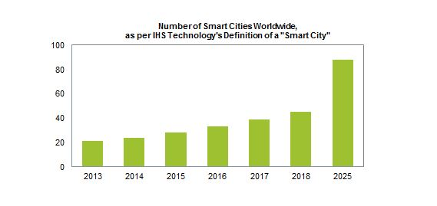
Figure 1.1 – Smart Cities Worldwide [12]
Some of the technologies already deployed across industry sectors include radio frequency identification (RFID) [13], motion detectors [14], and temperature, humidity, light and weather sensors [9]. Individually these technologies are being deployed in bespoke environments along with building management software [15]. Following the natural evolution of this technology progression into the educational sector is inevitable. An experiment based on the use of this technology is detailed within this report. This technology, along with future advancements, will be reviewed to gain a better understanding of the potential usage.

As University of Wales Trinity St. David (UWTSD) currently utilises a small part of this technology, it makes for an ideal case study. UWTSD deploys RFID tags within the identification (ID) cards, on external access doors, printers, and the library service. A small number of classes have trialled RFID readers to monitor attendance. Motion detection is installed in public access areas for automated lighting systems. A secondary aim for the project will be to assist in the reduction of the university’s carbon footprint on the local environment [16].

Aim

This project will demonstrate the operation of a wireless sensor network utilised in a classroom environment.

Objectives

- Review current technologies
- Compare previous studies
- Development of a working simulation of a wireless sensor network utilising the working classroom model
- Compare results of simulation vs physical model
- Identify future research

Structure Of The Project

The following report is separated into three sections. Firstly, an outline of the project, its background and methodology is provided. A review of literature and previous studies will be essential to the expansion of this project. Secondly, a simulation of the required WSN and a physical model will be developed. Both the simulation and physical models will form the basis for testing and proof of concept. The final phase, will draw conclusions from the results and evaluation of phase two. Identifying the findings, future research, and a summary of the project.

Chapter one provides a synopsis of the report. It specifies the aims and highlights the objectives required to achieve success to the project.

Chapter two focusses on the research, literature, and previous case studies relating to WSN technologies. Background knowledge is vital to the understanding and development of this project.

Chapter three concentrates on the methodology employed. It provides a comprehensive breakdown of the processes and philosophy behind the report. Data collection and the procedures required to manage the data collected.

Chapter four will highlight the current problem and the proposed design solution. Information on the simulation software to be deployed. A summary of the implementation can be found at the end of this chapter.

Chapter five shows the test and evaluation of both the physical and simulated models. A review of the current design will be discussed including: lessons learnt, issues with design, what worked well and areas for improvement.

Chapter six will summarise the previous chapters together. Utilising this summary, a conclusion will be drawn showing what has been developed. This conclusion will also show what research has been completed highlighting any significant results for future development.

Chapter seven reflection, this section will discuss what has been achieved against the aims and objectives set out in chapter one. It will also focus on what the author felt went well or could have been improved on.

Chapter eight will comprise a comprehensive list of references used throughout the report.

RESEARCH & REVIEW OF LITERATURE

Introduction

This section is broken into two distinct areas, firstly, a review of the current technologies used in WSNs. This review will focus on the protocols used, types of sensor available and the applications currently being utilised. Secondly, it will focus on the associated literature that helped guide and provide a comparison for the experiments. During the process the author utilised the “IEEE Xplore digital library” [17] to access peer reviewed journals, white papers and conference proceedings. Additional research has been collated using google scholar and various industry standard websites. The methods employed during the production of the research and literature review contained in the report are discussed in chapter three.

Wireless Sensor Networks

Bandwidth and Power supply

Traditionally a WSN design focuses on the network utilising a management tool contained within an existing corporate structure. Dependent on the application a sensor network will operate a communication protocol as seen in figure 2.1 below. As this technology can be deployed in varying environments it is considered good practice to establish the correct technology to be implemented. These protocols offer different features for connectivity and communication [18].
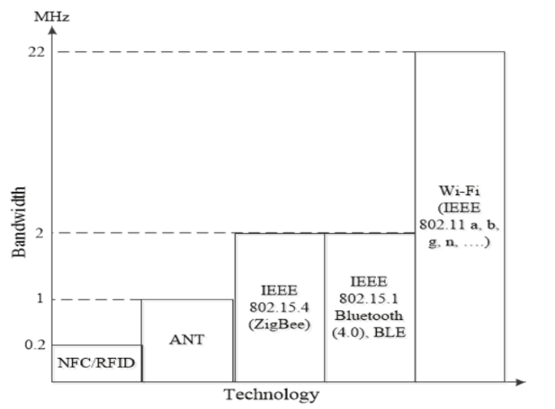
Figure 2.1 – Bandwidth for technologies in WSN [18]
Figure 2.1 clearly identifies a vast difference within the bandwidth provided by each technology. Although Wi-Fi offers the larger bandwidth the draw back to this is the high-power consumption. As a majority of WSNs don’t require high end transmission connections this technology is not a preferred solution [18].
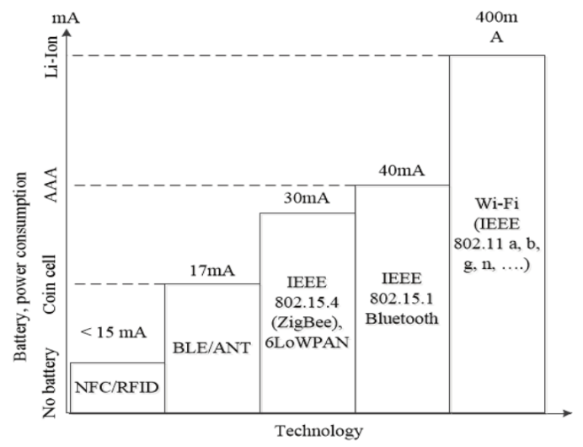
Figure 2.2 – Power supply for WSN technology [18]
With regards to the consumption levels, Wi-Fi has the greatest power usage. In part this almost rules out the use of this technology when considering a WSN. The more commonly utilised technology within WSN is RFID, Bluetooth and ZigBee. RFID technology uses mains power for the RFID reader but the card or NFC does not require power directly. However, batteries are required in Bluetooth and ZigBee technologies. Figure 2.2 illustrates the essential power supply for their process and the types of batteries used in WSN [18]. A coin cell battery is commonly utilised within small devices such as watches, hearing aids, it can also be found in PC attached to mother board for the computer clock. Delivering small amounts of volts the coin cell batteries can be alkaline, zinc-air, lithium and silver in production [19]. The AAA battery is highly recognisable by many as the power supply to the TV remote control. The life span of this form of battery is very high, some are known to last for a number of years. The best form of this battery is the lithium as it far outlasts the more commonly known alkaline battery [20]. Li-Ion batteries come in differing sizes and types to suit the application it has been designed for. Some of the applications that utilise this form of battery are: tablets, iPods, laptops, notebooks and smart phones. A key feature of this battery is its portability hence its deployment in newer technologies such as wearables [21]. In closing this section regarding power consumption it should be noted that Wi-Fi technology is being researched and developed continually with a possibility of an improvement in energy consumption [18].

Technology and Protocols

The power and bandwidth together are not the overall deciding factor it is important to have an in-depth view of the technology and what its key characteristics are, this can be seen in table below [18].
Table 1 – Characteristics of WSN technologies
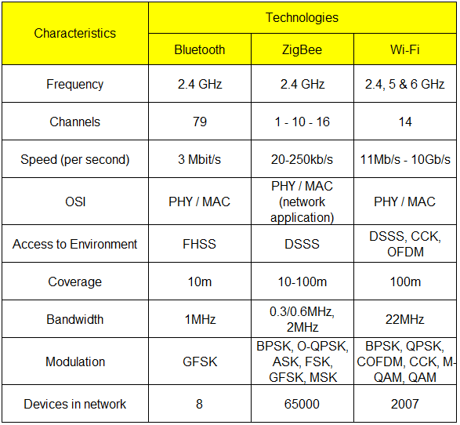
Source: Second International Scientific-Practical Conference (2015) [18]
Bluetooth
Institute of Electrical and Electronics Engineers (IEEE) [22], [23] identifies this technology as the 802.15.1 standard. Developed as a substitute to the cables in wireless personal area network (WPAN) [24], however, a limitation to Bluetooth technology is the lack of range or distance. Furthermore, the key features outweigh this disadvantage, with relatively low cost, power consumption and its robustness it is still deployed in many personal devices. Bluetooth can adapt its transceiver to prevent fading and interference as it uses a “frequency hop spread spectrum”[25] [26]. To reduce transceiver complexity a modulation technique is employed, this technology is defined as “Gaussian shaped, binary frequency shift keying” (GFSK) [26]. Utilising a full duplex transmission in conjunction with the time-division duplex (TDD) scheme Bluetooth provides seamless connectivity [25].

ZigBee
Much like the Bluetooth standard IEEE identifies ZigBee technology as 802.15.4. This type of WSN protocol utilises very little power and often operates in a smaller area of approximately 10m. Traditionally networks operate under a mesh topology as seen in figure 2.3 as this extends the range out to a maximum of 100m [27].
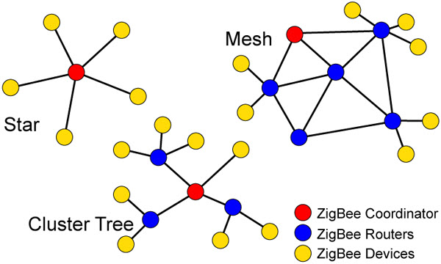
Figure 2.3 – ZigBee topologies [28]
The mesh topology allows the end devices to communicate through each other until they reach the main node, identified above as ZigBee coordinator. Although the mesh topology is the more commonly deployed the alternatives offer different solutions. The star offers end devices direct connection with the coordinator, this design would be used in short range smaller WSNs. The cluster topology offers the ability to link star topologies together with a central coordinator linked by a single ZigBee router. This design would be utilised in a building with multiple rooms and floors [28]. A feature of the ZigBee protocol is its ability to operate in differing environments and working with devices utilising batteries with very little power consumption. As seen in figure 2.3 there are 3 main components in a ZigBee network they are the coordinator, router and the device. These are also known as a full-function device (FFD) and reduced-function device (RFD) [27]. The FFD can operate as an end device, coordinator or alternatively it will be used as a “personal area network” (PAN) coordinator [29]. However, the RFD sole purpose is to operate a basic application for example; switch or small sensor. This is due in part to the small amounts of data being transmitted. In any of the topologies an RFD will only communicate with one FFD at a time. This cannot be said for the FFD as it will associate with RFDs and any FFDs contained within its network structure [29].

Wi-Fi
When considering the vast amounts of power consumption that is used in wireless fidelity (Wi-Fi) technologies it is not surprising to see that its deployment in a WSN is limited and costly. IEEE standards for Wi-Fi are covered in 802.11, however they are separated into differing standards as seen in table 2 below.
Table 2 – IEEE 802.11 standards
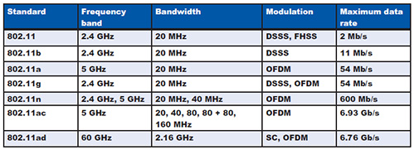
Source: IEEE Standards association [30]
The 802.11 standards all connect to the internet via a “wireless local area network” [31] (WLAN). This access to internet is provided through an access point (AP) and its connection will be dependent on the technology used. However most mobile devices will access APs through the frequency bands of 2.4 and 5 gigahertz (GHz). WLANs are defined in the IEEE 802.11 architecture [31] as comprising of a number of stations that interact to allow wireless connectivity. Stations form a local area network (LAN) known as a basic service set (BSS) to remain in communication with stations contained within it is important that the stations remain in the same BSS. However, an alternative solution to this is the extended service set (ESS). This solution requires a number of BSSs linked together with APs which in turn are connected to a distribution system [27], [31]. The 802.11 architecture model can be seen in figure 2.4 below
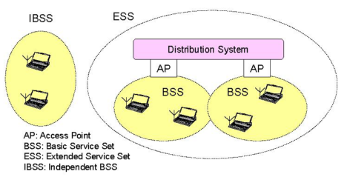
Figure 2.4 – BSS, IBSS and ESS example 802.11 architecture [27]

Security

A major concern within any network either wired or wireless is how to protect and ensure data integrity. The 802.11 structure contains two classes of security processes known as robust security network association (RSNA) and pre-RSNA [31]. These processes contain algorithms that enable the required security level for the 802.11 protocol. Pre-RSNA technology cannot be utilised within sensor networks as it is vulnerable to attack. The exception to this is Open System authentication which is a null authentication algorithm [31]. This algorithm is the default verification protocol for pre-RSNA devices. Table 3 identifies what algorithms are utilised in both RSNA and pre-RSNA security.
Table 3 – RSNA and pre-RSNA security algorithms
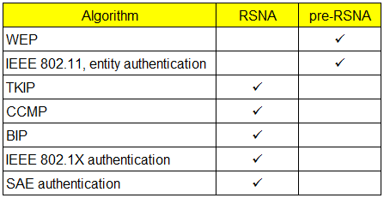
Source: IEEE Standard for Information technology [31]
TKIP
Temporal Key Integrity Protocol (TKIP) is known as one of the first newly developed link layer encryption protocols. Its overall aim was to advance the security of wired equivalent privacy (WEP). During its development most of the WEP architecture was retained, however it was bolstered by tackling WEPs vulnerabilities [32]. TKIP utilises master keys, this was not true with WEP as it only deployed a single master key. TKIP can also manage these keys to enable secure refreshing of new keys [33]. Whilst TKIP stills deploys the RC4-based frame encryption used in WEP, it obtains an exclusive RC4 key for each frame to alleviate attacks. This process is sometimes identified as key mixing [32]. A defence against the reply attack is the sequence counter, any frames flagged as being out-of-order are identified as each frame is numbered in sequence. Thus, preventing any potential intercepted data to be transmitted at a later date. WEPs hash has been replaced by TKIPs algorithm known as “Michael” [34] in using a stronger cryptographic integrity check it is easier to identify counterfeit frames. However, TKIP is still vulnerable to an active attack as it was developed to be used on hardware already in use. Countermeasures were also designed within TKIP to reduce to implications from such an attack [32]. MIC failures should be recorded and flagged for review by a network / systems administrator, this could be a warning of an active attack. These failures must be kept to no more than two in a sixty second period. If more than two are detected in a sixty second period the STAs and APs need to be disabled for a predetermined period [32]. The figure 2.5 below show the encapsulation for TKIP.
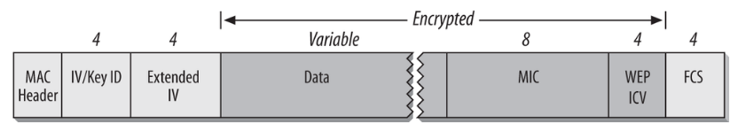
Figure 2.5 – TKIP Encapsulation [32]
CCMP (CBC-MAC)
Much like TKIP Counter Mode with CBC-MAC (CCMP) was developed to replace the older WEP protocol. However, as this newly designed cryptographic tool was going to not be backwards compatible it took longer to develop. Primarily CCMP was designed with Advanced Encryption Standard (AES) in mind. It is known that the AES uses both 128-bit keys and 128-bit blocks, thus making it far stronger in security than the 802.11 RC4 standard [32]. As detailed in RFC 3610 (2003) CCMP is derived from the utilisation of the block cipher contained within the Counter Mode with CBC-MAC (CCM). CCM offers encryption for confidentiality and forms a cryptographically secure integrity check value, this is made possible due to its combined operation [35]. The CCMP process offers a provision for encryption and integrity protection simultaneously, as shown in figure 2.6. CCMP utilises the frame, however in addition it will use a “temporal key” which will be attached to both encryption and authentication of the frame. A “key identifier” is required as “multiple keys” are deployed for use. At this point one key will be attached to a frame. To identify transmission a unique “packet number” is issued, this number will increase upon each frames transmission. However, should the frame require to be resent this number will not increase [32].

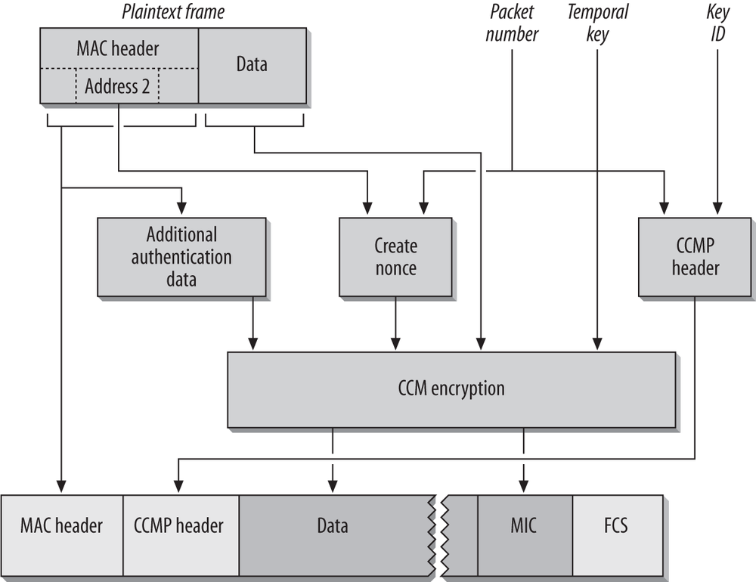
Figure 2.6 – CCMP frame processing (encryption) [32]
When comparing the encapsulation against TKIP it appears as though CCMP is simpler. Subsequent to the MAC header is where the CCMP header is placed, this header retains the “packet number” and “key ID”. Like TKIP the following frames containing the “data” and “MIC” are encrypted. The frame check sequence (FCS) follows to allow upper layer data to be transmitted [32]. as seen in figure 2.7
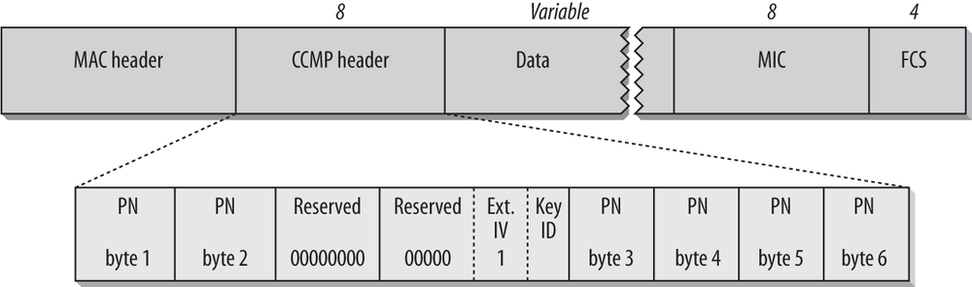
Figure 2.7 – CCMP encapsulation [32]
RSN operations
Although TKIP and CCMP are defined within the 802.11 procedures there is another standard called Robust Security Networks (RSNs). Contained within an RSN are keys and this standard identifies as to how they are derived and used. Both TKIP and CCMP utilise keys for frame protection they are known as “pairwise keys” and “group keys” [32]. These keys are vital to the successful protection of frames contained in an RSN. The pairwise keys offer security between the station and access point (AP). Communication between the AP and clients is secured by the use of group keys even when broadcast or multicast traffic is used. With both TKIP and CCMP using one “master key” and breaking it down as required to offer frame security. Utilising a master key, encryption can be refreshed on stations without the need to start the authentication process again. With the master key becoming the priority it is vital that it is secure as it is used to create all other keys for TKIP and CCMP as seen in figure 2.8 the aim of the key structure is to secure the transmission of temporal keys [31]. At the top of the structure is the Pairwise Master Key (PMK), this key is 256-bits in length. A PMK can be obtained from either the WPA-PSK or an authentication server [32].
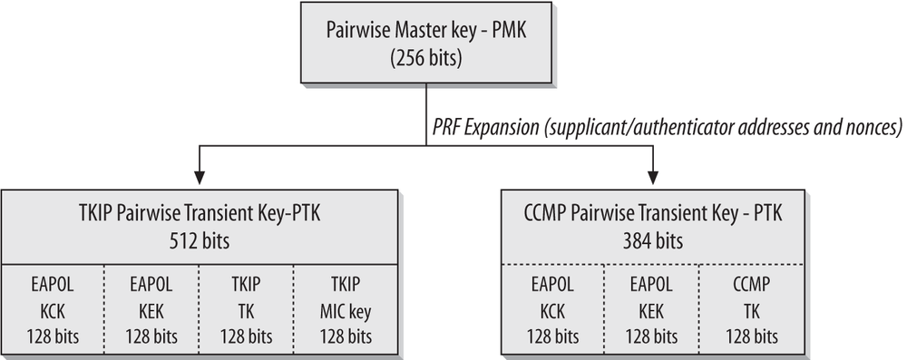
Figure 2.8 – Pairwise key structure [32]
As previously mentioned in this chapter a temporal key is obtained from the expansion of the PMK, this is defined as “pseudorandom function” (PRF) [36], [37]. Additional randomisation of the data uses the MAC addresses obtained from the client and AP in addition to this two completely random nonce values are contained within the four-way key exchange handshake. TKIP and CCMP both employ the PRF method to expand the PMKs 256-bits into a “pairwise transient key” (PTK) [36], [37]. Both TKIP and CCMP utilise the 128-bits to secure the temporal keys during the transmission of data. As seen in figure 2.2.3.4 both TKIP and CCMP deploy the Extensible Authentication Protocol over LAN (EAPoL) [31] these protect the transmission of keying information. Each block has an allocation of 128-bits and are identified as “key confirmation key” (KCK) and “key encryption key” (KEK) [32]. Another master key that is utilised is the “group master key” (GMK). This GMK operates at the link layer as a security protocol, it is deployed in broadcast and multicast transmissions [36]. As PMKs have to be different for each and every station within the network, it is not possible to utilise a single key for multiple destinations. The GMK is maintained by the authenticator for use with the temporal keys. As before in the pairwise key structure the GMK hierarchy is expanded using the PRF as seen in figure 2.9 unlike the previous structure it does not contain KCK or KEK [32].
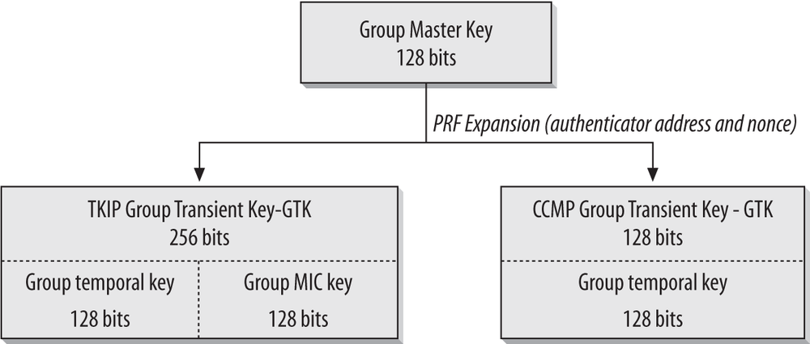
Figure 2.9 – Group master key (GMK) structure [32]
As mentioned previously in the chapter the four-way handshake is used in pairwise or unicast communications. In this handshake both the client and AP use a pairwise master key. During the handshake, it is established that the temporal key can be obtained to allow encrypted communication to take place [32] at each stage of the process messages are acknowledged as seen in figure 2.10
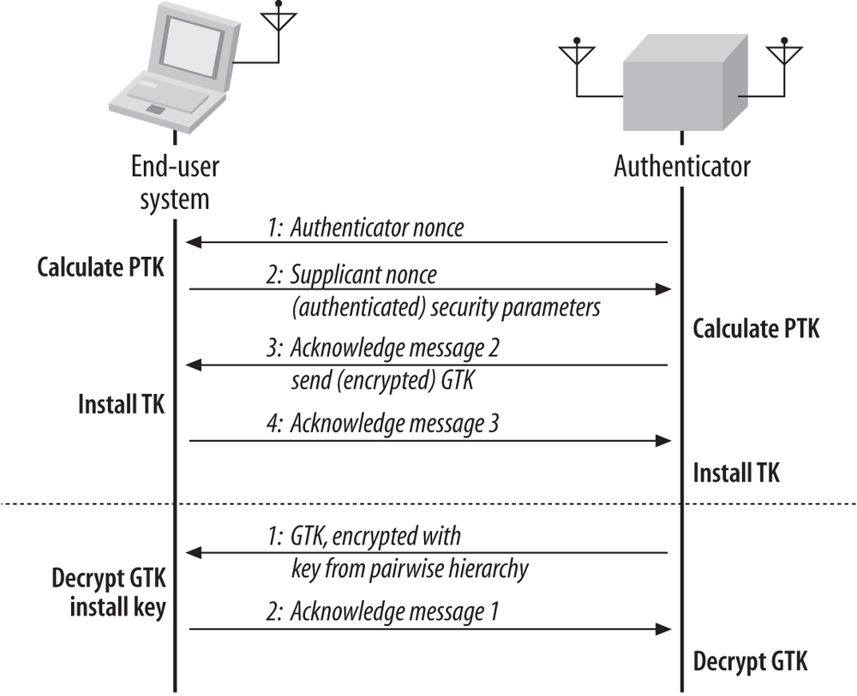
Figure 2.10 – Four-way key handshake [32]

Wireless Sensors

As there are a number of sensor suppliers within the market place this section will mainly focus on what sensors are required in the completion of this project. For this project a number of manufacturers were considered, however after looking at the solutions provided by Measurement Systems Ltd (MSL) [38] it was decided to acquire the following wireless sensors and software. The data sheets for each sensor can be found in the appendix.
- Temperature
- Humidity
- Motion detection
- Light meter
- Light detection
- Ethernet gateway (POE)
- iMonnit Premiere software
Temperature sensor
This sensor can be utilised in many differing locations but its primary role is to monitor the ambient temperature. These sensors are more commonly deployed within data centres, server rooms, clean room and environmental monitoring. The traditional output for this sensor is degrees Fahrenheit. The Monnit temperature sensor as seen in figure 2.11 works in conjunction with the ethernet gateway. It operates using a coin cell battery as discussed earlier in this chapter giving it a long life span [39].
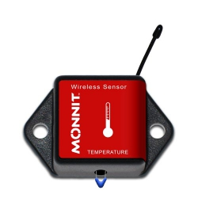
Figure 2.11 – Temperature sensor [39]
Humidity sensor
Much like the temperature sensor the humidity sensor can operate in environmental monitoring this could be in a green house, agriculture, museum, and general weather monitoring. Again, this sensor needs the gateway to communicate its collated data. As an added bonus this sensor can also read temperature as it forms a key component when calculating humidity. The battery supply used in this sensor is also coin cell offering a long usage level. The figure 2.12 below is an example of the Monnit humidity sensor [40].
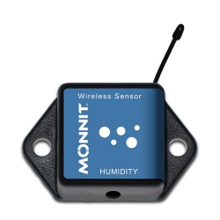
Figure 2.12 – Humidity sensor [40]
Motion detection sensor
As the name suggests this sensor is solely for the detection of movement within a room or specified area. Some applications for this type of sensor include, lighting, automatic door access, and security. As before this sensor doe require the gateway to send the notification of movement to the software being utilised. The power source for this sensor is a coin cell but it is not limited to this as it could operate using ‘AA’ size battery also. This sensor can be ceiling or wall mounted as the range and angle can differ dependent on the application. Figure 2.13 shows an example of the Monnit motion detection sensor [41].
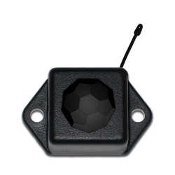
Figure 2.13 – Motion detection sensor [41]
Light meter sensor
Although this sensor works with the light is specifically looks at the luminescence (lux) levels from 0 – 1000 lux (for indoor application). Measuring the intensity of the light in a room or area could be vital dependent on its usage. Offices, museums, and art galleries often utilise this sensor to maximise the potential to manage the light levels. As this sensor consumes larger amounts of power it utilises two ‘AA’ sized batteries. An example of a Monnit light meter sensor can be seen in figure 2.14 [42].
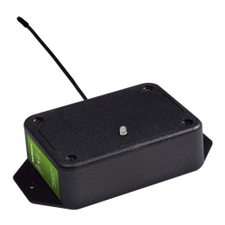
Figure 2.14 – Light meter sensor [42]
Light detection sensor
Unlike the light meter sensor, the sole purpose of the detector is to simply identify if light is present. The output for this sensor is a basic light or no light signal. This data is transmitted again through the gateway, some of the uses of this sensor are to notify if lights have been left on within a room or specific area. Like the humidity sensor the power options can vary from coin cell to ‘AA’ sized batteries. The figure 2.15 gives an example of what the Monnit light detection sensor looks like [43].
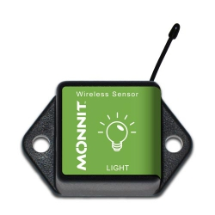
Figure 2.15 – Light detection sensor [43]
Ethernet gateway
To enable the sensors all to communicate across the network this gateway is required. The gateway transmits the data across the internet or local area network dependent on the software application being used. These devices are often seen in data centres, property management, and commercial facilities utilising any of the sensors previously discussed. The gateway can be powered using a low-cost approach known as power over ethernet (POE), utilises the network cable to provide the necessary power required. However, the more traditional route of power will be provided by an AC power supply. The gateway can been seen in figure 2.16 [44].
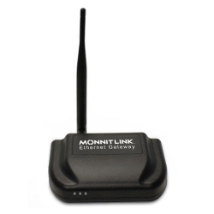
Figure 2.16 – Ethernet gateway (POE) [44]
iMonnit Premier software
Although there are four distinct options for an end-user to access data recorded by the sensors. All are labelled as iMonnit, options are basic, premiere, express and an enterprise solutions. The outputs and configurations for sensors associated to networks can be managed via any of these applications. The software can be accessed on mobile devices, laptop or desktop PC as seen in figure 2.17 [45]

Figure 2.17 – iMonnit software [45]

Related work

This section of the report is going to focus on the literature that has been influential in guiding both the research and experiments being used. The four main papers being discussed have all been sourced from the IEEE Xplore digital library [17]. Three of these papers concentrate on smart classrooms utilising wireless sensor networks. The final paper again looks at the use of sensor networks in an intelligent room.

A Scalable intelligent room based on WSN [46]

The focus for Altamirano and Henriquez (2010) [46] paper is on wireless and RFID technologies being deployed into a smart classroom. The protocol utilised within this implementation to control the wireless network is ZigBee. The authors have considered five elements in the design structure. Starting with the ‘main controller’ [46] its main function will be to operate as the server utilising the management application. Following on from this are the sensors, there primary function is to operate as environmental monitoring devices. Working in conjunction with the sensors are the actuators, there function is the control of the air cooling system, light operation, and finally the door access. With the door access requiring RFID tags the fourth element is the RFID reader, this data will be accessed from the server or main controller. The last element of the design is the communication, known as the routing protocol. This protocol will allow the transmission of data across a network, one of the main roles for this protocol is to prevent data-loops [46], [47]. Considering the design, the authors explain in detail the actual implementation and it identifies a four-stage approach as the model. Hardware is considered to be the first stage, this includes the nodes, RFID technology and gateway. The second consideration is again the communication, the authors fail at this point to identify in any depth what is to be used. However, they do give thought as to the links and their reliability between the RFID reader and any tags being used. At this point the authors combine the third and fourth stages into one section. Covering both the software and application the authors repeat information on obtained on the gateway, RFID, and sensors. During the description, it highlights the actuator node and what operations it performs within the design. At this point an image is utilised to visualise the proposed topology, although identified as the routing protocol example [46], [47].

In reviewing what has been proposed in the implementation Altamirano and Henriquez (2010) [46] demonstrate a sound understanding of the principles required for achieving a WSN. In spite of this it is strange that this paper fails to identify if window, blinds and humidity control will be utilised within the network. Considering that the RFID technology is deployed it is disappointing to see that occupancy data recording is not considered. Another area of concern is the concentration on the configurations of the each of the elements, when no real information is offered on the management database and software. As this paper does identify certain commands and data collation it would have been helpful for the authors to touch upon what software would have been considered. Not wishing to speak ill of this paper however it does lack heavily in reporting the actual results obtained and justifications for the statement given by Altamirano and Henriquez [46], [47].
‘The implementation described in the previous Section was evaluated under a controlled environment and it works as expected’
Unfortunately, the omission of evidence in the form of graphical data representation it is hard for any reader to accept the author’s findings. It would strengthen the paper if the authors had provided information regarding any potential issues, fault finding, and amendments made to the original design. That said overall this paper has identified a working solution that will be helpful in the achievement of the objectives for this project [46], [47].

An intelligent classroom management system [48]

This paper takes a different perspective to approach above, Chiou and Tseng (2015) [48] look at the smart classroom from a diverse angle. Although they employ a sensor network their approach is to identify student behaviour through a series of nodes monitoring the environment. Much like the Altamirano and Henriquez (2010) [46] design this implementation will also use the ZigBee WSN. The proposed architecture for the ‘Intelligent Classroom Management system’ [47], [48] sees the authors breaking this into three different operations these are identified as the environmental, instruction, and finally the learning behaviour management systems. In summary the environment will monitor the classroom, the instruction will give power to a lecturer to alternate learning tasks and the learning behaviour will concentrate on the students attention levels [48]. this can be seen in figure 2.18
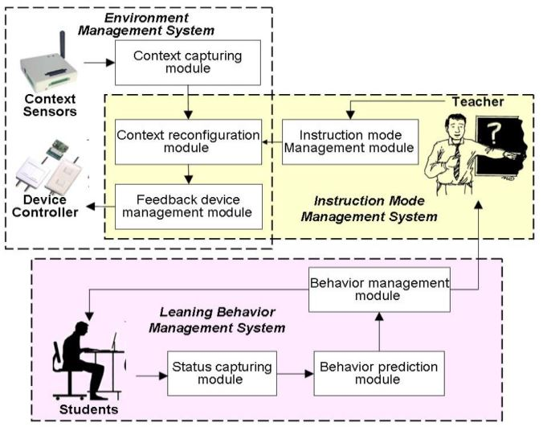
Figure 2.18 – Proposed system architecture [48]
As seen in the figure 2.18 the creation of sub-levels contained with the main management system this are known as modules. The first of the main systems covers the environment monitoring, it is proposed to gather data from temperature, humidity, illumination, and CO₂ sensors. It is suggested that these sensors will communicate with the feedback device modules to maintain or alter the environment. The second system is the instruction, this area focuses solely on the lecturer. Giving control of learning tasks it is identified that the lecturer can alternate through four modes, blackboard, multimedia, slide, and rest. As the environment monitoring it will communicate with the feedback devices to initiate the required changes. Learning behaviour control is the final system, deploying a structured Bayesian [48] approach it is proposed that the students will be monitored using camera and sensor technologies. This structure will allow for the feedback to be initiated for both student and lecturer, the main focus for learning behaviour is on fatigue and inattentive. The Bayesian approach utilises a three-tier system focusing on behaviours, features, and sensors [47], [48]. The figure 2.19 shows the Bayesian approach.
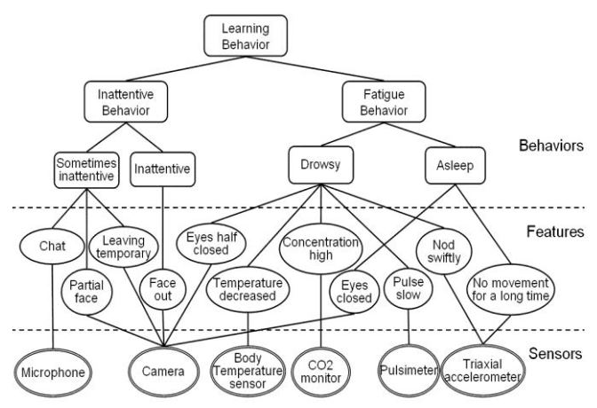
Figure 2.19 – Bayesian approach [48]
Utilising the approach above the student will receive feedback via a combination of a light-emitting diode (LED) [49] and vibrating wrist band. At this point the lecturer is also notified as to what status the student is currently at. The proposed location for the system is Chung Hua University, Taiwan. It will consist of a room containing twenty-four desks equipped with the feedback devices and sensors. The classroom will also have an installation of the sensors as discussed earlier and the ZigBee WSN will be implemented. The implementation can be seen in figure 2.20.
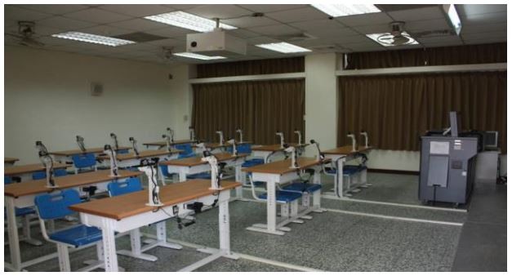
Figure 2.20 – Room layout in Chung Hua University [48]
The desktop monitoring software identifies each of the sensors and the feedback devices that can be controlled by the lecturer. This software uses a simple tabbed approach to make alterations easy to implement, and the use of red and green to signify that a sensor is performing within tolerances. In concluding this paper, the authors have proposed a strong solution that definitely meets their objectives. Much like the Altamirano and Henriquez (2010) [46] paper it lacks in evidential results to provide a strong conclusion. The authors confirm that the system is currently in operation and has been monitored both manually and via the feedback system. The results of these tests aren’t presented within the paper just a few lines to say that the manual tests matched the automated system. The authors plan to further the research and continue in its further development [47], [48].

Smart Classroom: Concept to Construction [50]

The authors of this paper Song Shuqiang, Zhong Xiaoliu, Li Haixia, Du Jing and Nie Fenghua (2014) focused on a case study with regards to a physical implementation of a smart classroom. The location utilised in collaboration with the authors is “Wudaokou School of Finance of Tsinghua University” which is based in mainland China [50]. Firstly, the paper focusses on the history of the classroom and it many developments through the years. Looking at the research the authors identify three stages of evolution, starting in the multimedia period. This period introduced the personal computer and devices which aided in the teaching of subjects from projection screens, audio and visual presentations. In part this was used to evolve from the more traditional chalk and board method [50]. The network period followed the multimedia age, with a focus on the introduction of internet and online learning. At this point teaching then became an online resource with the ability to research and provide teaching to areas previously inaccessible via online video technologies [50]. So, to the present day and the next evolution, known as the “Smart Classroom” this current period is a culmination of the two previous periods. The evolution sees the introduction of the “Internet of Things” (IoT), cloud computing and big data [50]. As the use of computing evolves to a mobile world and smart technologies the authors identify the smart classroom as a new trend. The use of smart applications, technology and management becoming the characteristics of the classroom of the future [50]. The second part of the paper identifies what the needs and the concept of the smart classroom should be. It is quite clear from the research the authors will heavily rely on the internet and the cloud as a backbone for their proposal. Mentioning that an intelligent classroom should be able to operate in conjunction with the environment and learning experience. The third stage in this paper talks about the “iSMART” [50] concept which links together the smart approach with the infrastructure. This development consists of six distinct approaches, infrastructure, network sensor, central management, augmented reality, real-time recording, and ubiquitous technology [50] as seen in figure 2.21
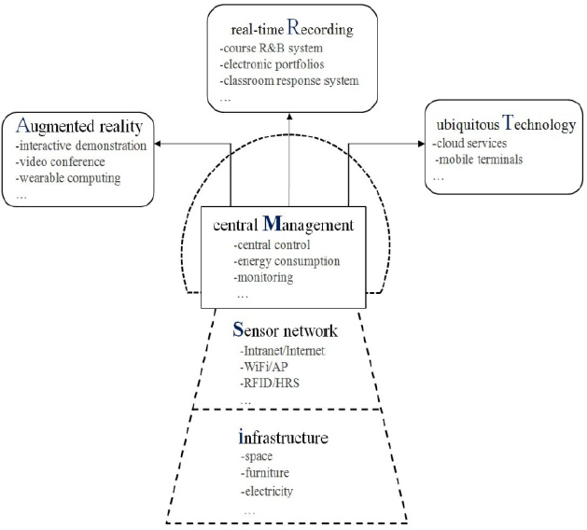
Figure 2.21 – iSMART model [50]
When breaking down the model the authors explain that the infrastructure element looks at the objects contained within the classroom, tables, chairs, lighting and power supply. It is consider that the utilisation of the space will conform to allow the maximum usage of the physical space so that the environmental systems can be installed with a view to reducing the overall economic impact to the university [50].
Moving onto the second part of the model the network sensors, it is unclear as to whether the proposal suggests that they will be either wired or wireless. However, the sensors will provide “Network Access Control” (NAC), RFID, and a “Human Recognition System” (HRS) [50]. The central management system is an integral part of the iSMART system. Having the ability to monitor the environment, power consumption, and the activities within a classroom. Acting as the main brain of the operation it can analyse the software, hardware and internet usage to ensure that the classroom is performing efficiently [50]. It is slightly clouded as to what the augmented reality actually does, Shuqiang et al (2014) states:
“The augmented reality module embodies sub-systems of interactive demonstration, networked video conference and wearable computing. Through the wearable computing system, the physical environment and the virtual environment are seamlessly connected [50]”
After reading this statement I feel that this could have been covered comfortably in the network sensors module, most wearable technology operates currently through Bluetooth or Wi-Fi as previously discussed in this chapter. The real-time recording element offers a student the option of accessing a lecture being broadcast live or previously recorded. With lectures being recorded both student and academic staff can access to create a working module of content, recording responses and lecturer interactions [50]. The final element in the model is the ubiquitous technology which will focus on the cloud computing aspect of “bring your own device” (BYOD). It will also include the resources within the university Wi-Fi, internet and applications [50].
At this point the paper moves to the physical deployment of the case study and it discusses the requirements with regards to the lecture theatre. The initial construction will be a seventy-seated fan-shaped lecture room. Although not previously mentioned in the paper the requirement for the room to have acoustic reverberation and a sound insulation coefficient [50] is also included within the design. With regards to the technology it appears as though the authors are proposing to place HRS system outside the two entrances to the room. Along with the HRS an RFID device will be installed which will monitor the attendance. The environment will be monitored by the installation of two humidity and temperature sensors. To aid student’s connectivity to the university network and cloud service each table will have a network interface included. To allow for redundancy a wireless router will be included to cover the entire lecture theatre [50]. In concluding this paper, it is clear to see that the authors do not mention if the concept actual works or in fact has been installed. Whilst the processes and iSMART module [50] appear to meet the objectives as outlined in the early stages of the case study. It is disappointing to see that no further research has been located or been referred to in the papers own conclusion. It is implied that future research will be based around the teaching activities and how they can be supported in an intelligent way [50].

ZigBee and GoAhead Tech in the Smart Classroom [51]

The direction that the authors Sun Jianmei and Liu Dan (2013) take differs from the previous papers. Their focus is solely on the ZigBee and GoAhead technologies only and considers no other alternatives. The authors look to demonstrate a smart classroom and management system that is both low-cost and low in power consumption [51]. As previously seen within this chapter the ZigBee technology offers a highly reliable and scalable technology. Identified in the research for ZigBee is three wireless network models, stellate, cluster tree, and reticular shapes [51]. There is no other significant research within the ZigBee protocol. The paper then moves to the GoAhead embedded web server, in most cases this application is device based. The use of web interfaces is nothing new however the GoAhead web server is open source by availability and it supports various methods of coding. Being able to operate a “graphical user interface” (GUI) makes the control and management of the sensor network possible both remotely and statically. In section three of the paper the architecture and operation is discussed. The design is proposed to comprise of identity cards, wireless sensor nodes, and mechanical nodes within the classroom[51]. The sensor nodes deployed within this room cover the environmental elements, in addition to these nodes the switches and control mechanisms can be configured from a central management system. The design is centred around a classroom gateway, this device will be utilised for the transmission of data. The strange element within the design is that the authors propose to allow all smart devices to connect with the network to allow remote connectivity. Along with the RFID tag and smart device students attendance will be monitored this information will be transmitted securely to the attendance server [51]. The figure 2.22 shows the proposed structure of the model.
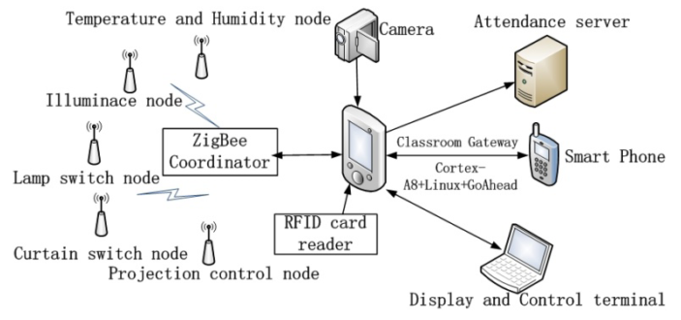
Figure 2.22 – Architecture of the proposed model [51]
The structure of the topology above demonstrates the stellate model, it makes the ZigBee coordinator the organiser of the network. The coordinator manages the data traffic from the sensor nodes in the topology, it then pushes this data toward the GUI system [51]. The next section discusses the hardware and its interaction within the network. Within the gateway is a chip provided by Samsung S5PV210 [52], for full details on this chip see appendix. This chip is based on the kernel of ARMCortexTM-A8 [51], [53] the figure 2.23 shows the microprocessor and its relative modules.
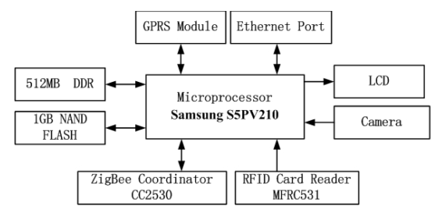
Figure 2.23 – Gateway microprocessor [51]
The following sections discuss the software design and how it is incorporated within the implementation. In summarising the development process, it can be broken down into five different operations. Firstly, loading the boot program which initialises the device for use upon a power up. Secondly, the transplant of the embedded operating system, as it is open source it makes the application is completely compatible. Thirdly, the embedding of the root file system, during start-up this process is initiated which creates a number of files and directories for use in the network. The fourth process is the transplant of the web server GoAhead, much like the previous stage upon start-up the web server embeds itself utilising various operating systems. The fifth and final process is the application of the gateway, during the start-up the GUI system is initiated for use with gateway [51]. Bringing this paper to conclusion the main concern felt by the author of this report is the lack of security or mention of access rights. In concluding the report the authors clearly inform us that the system operates and end users can indeed access this web portal from any smart device or control interface. Much like the previous study this report does not show any results as to what has been recorded to prove that this system operated as expected [51].

Conclusion

This chapter has covered the fundamental research and technologies required to gain knowledge necessary to complete the experiments and report. After a brief introduction to the chapter the writer moved onto the wireless sensor networks. This section concentrates on the bandwidths employed within the network and how they impact the power supply. To gain further knowledge it is necessary to understand the technologies that are available and what protocols they operate with. Unlike a number of the papers discussed in the literature review a focus on security was felt by the author to be essential. Confidentiality and data integrity forms as major role in the implementation of correct security protocols and policies. The author introduced the readers to the sensors, hardware, and software to be utilised within the experiment. At this point it has become clear what technology is required and what manufacturer is going to be used within this project. The final stage of the research is the literature review which covers the related work that formed the basis of the knowledge. Each of the papers discusses different options to implement a smart classroom, however, the solutions appear to be fundamentally unique to each other. Despite these differences each paper achieves a similar conclusion that a smart classroom is the future and is certainly achievable in the 21st century. The following chapter will discuss the research methods and philosophy behind this project.

RESEARCH METHODOLOGY

Introduction

The chapter will breakdown and analyse the philosophies, approaches, strategies and time scale involved with the project. Also, covered in this chapter is what formed the methodology behind the literature review and the validity of the sources. The final part of this chapter will link directly to the experiments and how the research has guided both the data collection and physical and simulation experiments.

Research Methods

Research Overview

For this project, it was important to identify and develop a research methodology. This strategy has been guided by the “research onion” as produced by Saunders, Thornhill and Lewis (2012) [54]. As seen in figure 3.1
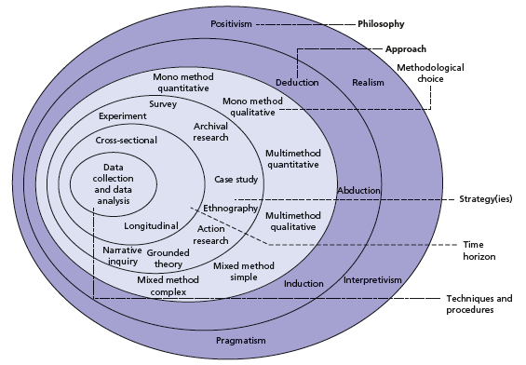
Figure 3.1 – “Research Onion” [54]
In establishing the methodology for the project the onion formed the basis or starting point for reference. To aid in simplifying of this model a flow chart has been developed identifying those key areas to form the research process. Breaking down each stage within this chapter will give a fundamental understanding as to why it was appropriate to select certain elements [54]. This flow chart can be seen in figure 3.2 each of the selected events contained in the flow chart are highlight in a yellow colour or to left of the decision box.
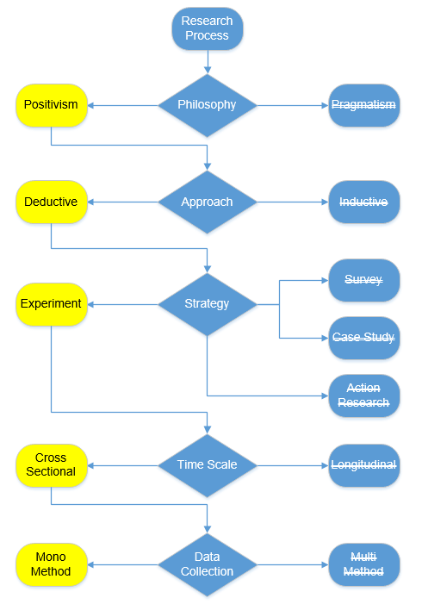
Figure 3.2 – Research process based on the “onion” [54]

Research Process

Although the process above has been used there is consideration at each level for change and amendment based on the development of the project. This flexibility is required as the experiments are an unknown quantity and movement needs to be allowed for throughout its application [54]. The following sections will justify the choices made above at each stage.

Research Philosophy

So why has the author chosen to use “positivism” as the philosophy? It is known that this knowledge is based around the principles of observation and real world experiences. As the project is adopting an experimental theme around a topic that is both highly researched, and has existing theories and experiments that are well documented. It is viewed that this would be correct path to work with as this links onto the deductive approach [54], [47].

Research Approach

The deductive approach whilst linked to the above philosophy is seen as to test theory. Leading the author to develop a hypothesis to test the projects theory and objectives. It is important to acknowledge at this stage that this approach allows for the collection of quantitative data. Being very rigid in its structure it is ideal to provide a simple ‘yes’ or ‘no’ to an experiment. Testing the theories outlined in the design chapter it is fair to say this method will allow for a definitive outcome in the experiments against the objectives [54], [47].

Research Strategy

As previously discussed the only real way to determine the success for this project is through the medium of experimentation. An experiment is used to take theory into actual application, in this project both simulation and live experiments will be carried out. It will identify also as to what the project is looking prove, again this will be identified in chapter four. A case study could have been considered at this stage however the author felt that there was not suitable installation or application locally available. The experiments have also received the backing from the School of Applied Computing within UWTSD [54], [47].

Research Time Scale

At this point the author has struggled to determine as to how the experiments should be run, the project itself has run for a period of nine-months so far. The indecision has been driven by the purchase of the equipment required to complete the live experiments. It is seen that the cross-sectional approach will provide a sufficient snapshot of data to perform a good analysis. It is felt by the author that this element could be fluid and potentially moveable [54], [47].

Research Literature and Data Collection

The following section will show where the research has been sourced for the literature carried out in the previous chapter. It will also identify how the data will be collated from the experiments due to be completed [54].
Table 4 – Literature and Data collection methods
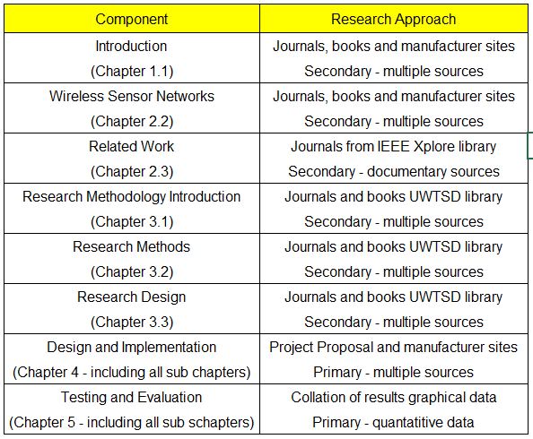
Source: developed from Saunders et al. (2012) [54]
Utilising the above table and comparing the findings from the literature review and data collected from chapter five it is possible to triangulate the results. This method will be discussed further on in this chapter [54].

Research Design

Research Deliverables

The experiments look to produce results based on actual recorded data collected by the cloud based server application provided by iMonnit Premiere [45] the simulations will produce results that will be exported and translated into graphical data presentation. The results analysis and findings can be found in chapter five, included with this chapter will be a review of the objectives and aims.

Triangulation

Creating a conclusion based on the actual results in comparison to the literature will be the main aim. The term triangulation in this scenario means that the results from chapter fives findings will be compared against the simulations. At this point it will give validity to the data and its potential use within the report [54].

Conclusion

In summarising this chapter, it has established the necessary methods in place to ensure the success of the project. Setting out the philosophy from the beginning has aided and guided the project along the correct path. Giving the research structure is vital to keep a project on task and to be delivered in a timely fashion. When considering the literature and data collated throughout chapter two it was essential to ensure that they were taken from primary and secondary sources as highlighted in table four. As the report moves to the design stage in chapter five it is important that this chapter be reviewed prior to the completion of the report.

DESIGN & IMPLEMENTATION

Introduction

The following chapter explores the network design topology, technology and software that will be implemented to meet the objectives and aims of the project. Split into three keys areas identifying firstly the problem, then moving onto the actual physical and simulation designs. Finally, looking at the full implementation and what has been achieved to meet the initial problem identification [47].

Problem Formulation

What is the problem?

At this stage, the UWTSD School of Applied Computing doesn’t utilise the IoT to monitor and control any part of the classroom experience. Under consultation with Carlene Campbell (project supervisor) and Chris House (UWTSD lecturer) it is seen that the university will benefit from the smart classroom technology. The university currently employs a paper based approach to the recording of attendance [47].

What are the advantages in solving the PROBLEM?

It is proposed that in solving the problem the university will benefit from accurate environmental readings from the various installed sensor nodes. A potential reduction in the power consumption for the experimental room, although this may not be fully quantified in the experiment. It is seen that the lecturer could have complete control of the learning environment for students to encourage stronger learning within the classroom. An additional area to be covered is the accurate recording of attendance utilising technology already being utilised by UWTSD [47].

Design

Physical Architecture

In regards to the physical application the room to be utilised is on the fifth floor of the Mount Pleasant building on UWTSDs Swansea campus. The actual room is the Cisco lab known as MH505, as seen in figure 4.1 below. The physical network will comprise of sensor nodes as discussed in chapter two along with the gateway [44]. The iMonnit software [45] as discussed within this section will be used to collate the data and provide a graphical representation of the recorded values for comparison [47].
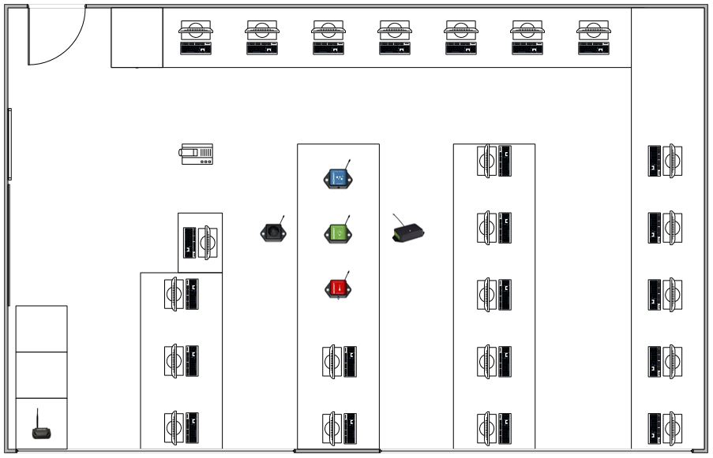
Figure 4.1 – Blueprint for MH505 Cisco Lab

Physical Implementation

Upon the delivery of the sensors and gateway it was important to ensure that the installation for the room was performed to adhere to the guidelines set out by iMonnit. It is advised that the sensors should not be placed within a foot of another node as this potentially could interfere for the transmission of the data signal [55]. The nodes are placed in a configuration centrally within MH505, prior to the power sources being activated this can been seen in the figure 4.2
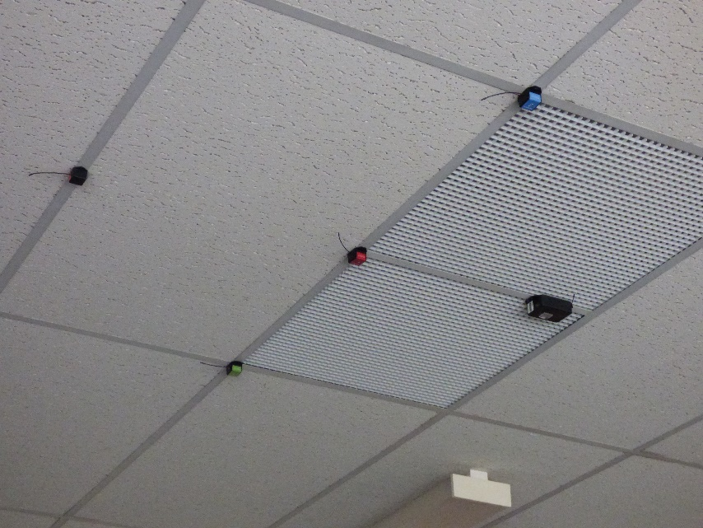
Figure 4.2 – Node placement in MH505
The image is taken directly after the installation, the ethernet gateway has been installed in conjunction with the nearest access point for internet. After configuring the gateway as seen in figure 4.3
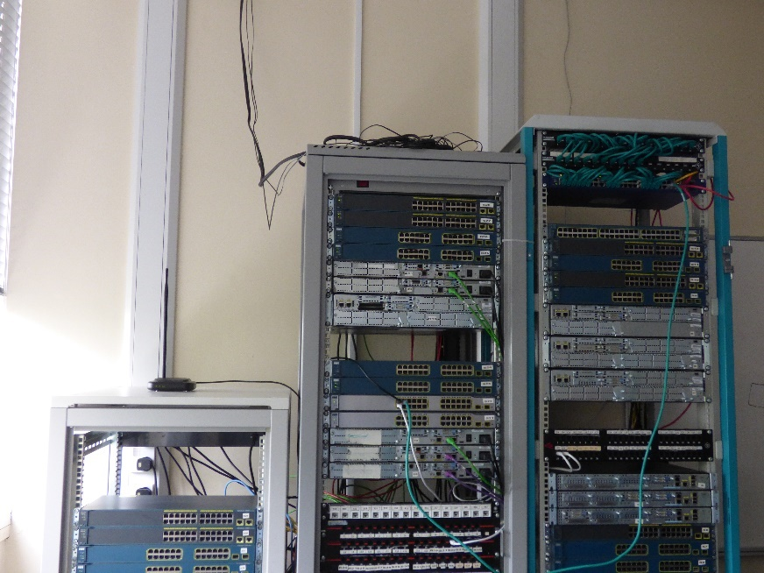
Figure 4.3 – Ethernet gateway installation in MH505
At this point the sensors were added to the network identified as MH505 – Cisco Lab. The nodes being used are given unique identification and codes. Table five identifies the details for each of the installed sensors.
Table 5 – Nodes ID and Codes listing
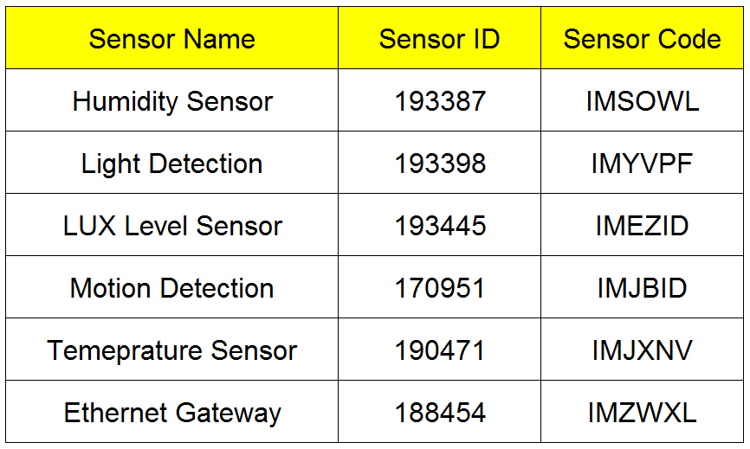
Source: developed from data supplied by Monnit sensors

Upon the entering of the codes the gateway is ready to link and make a pairing. The power source either coin cell or ‘AA’ batteries were placed within each node and after sixty seconds the basic details for each sensor are displayed on the iMonnit software [45]. At this point each individual sensor can be calibrated and configured dependant on what it is tasked for. An example of the humidity sensor configuration is seen in figure 4.4
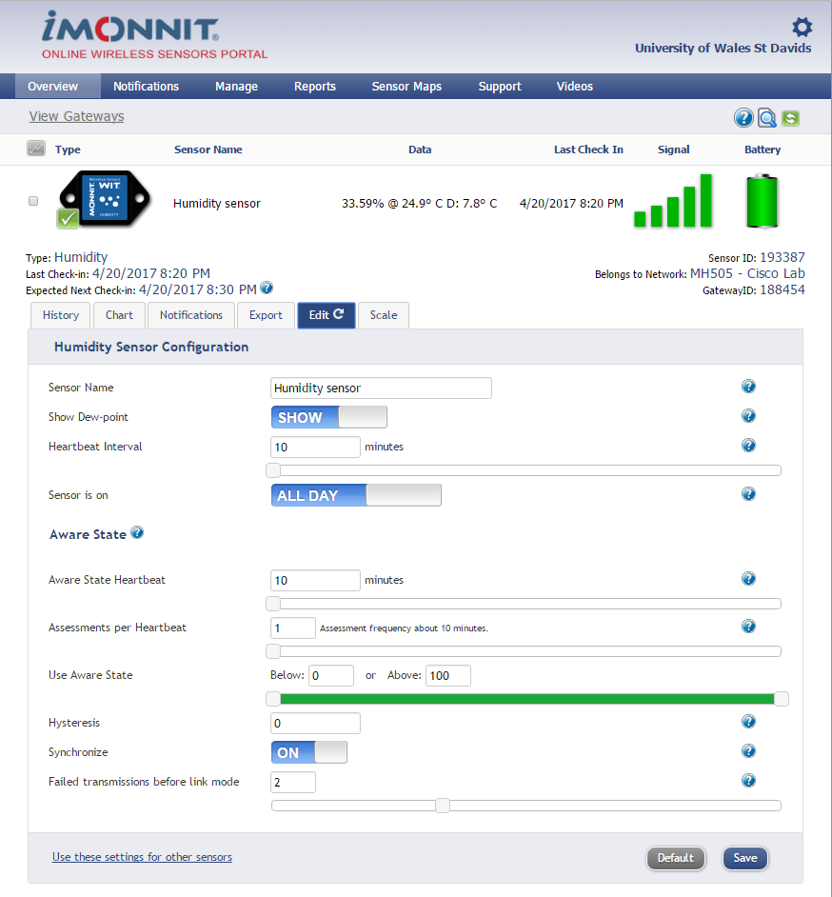
Figure 4.4 – Configuration for Humidity sensor [45]
At this point all the sensors configurations vary depending on the installation for clarification this report will focus on the Humidity sensor. An option is given to show the Dew-point which measures in degrees Fahrenheit or Celsius. This dew-point monitors the level of water saturation within the air, the lower the value the more comfortable environment. The heartbeat registers the link with the gateway in periods of inactivity. The default setting is 120 minutes however it is felt for the experiment it was important to decrease this time to 10 minutes. As the sensor should not go inactive it is important to know if the sensor fails so the shorter timescale offers this protection. The sensor has been set to operate only between the hours of 8 am to 10 pm. This timescale allows for when the university is occupied by lecturers and students. The aware state is triggered when a sensor becomes active. Each sensor can be configured again with more specific measurements however in all the nodes it has been set with almost the default values. The only changes made to the configuration is the aware state heartbeat and synchronise options. The aware state has been set to match the heartbeat interval of 10 minutes. Much like the heartbeat this aware state communicates with the gateway during active periods. The synchronisation of the sensor allows small networks to transmit data within 5 seconds of each other. This option should not be utilised if the network has ten or more sensor nodes [40], [45], [55], [56]. Following on from the configuration is the notifications setting, allowing the end user to pre-set alerts. These are configured to notify the user of readings that either equal, greater, and less than a predefined value. For the humidity sensor, the level is set to greater than 50% [56], [57]. This can be seen in figure 4.5

Figure 4.5 – Configuration of notification settings [45]
The final stage for the implementation of sensors and software is to allocate a suitable reporting process this is done via the reports section on the iMonnit online portal [45]. The reports can be configured to send as much as little amounts of data as required. It is also possible to select if the user wants daily, weekly, or monthly reporting. The report settings for the humidity sensor can be seen in figure 4.6 the reports can be sent by email to a single or multiple recipients [56], [57].
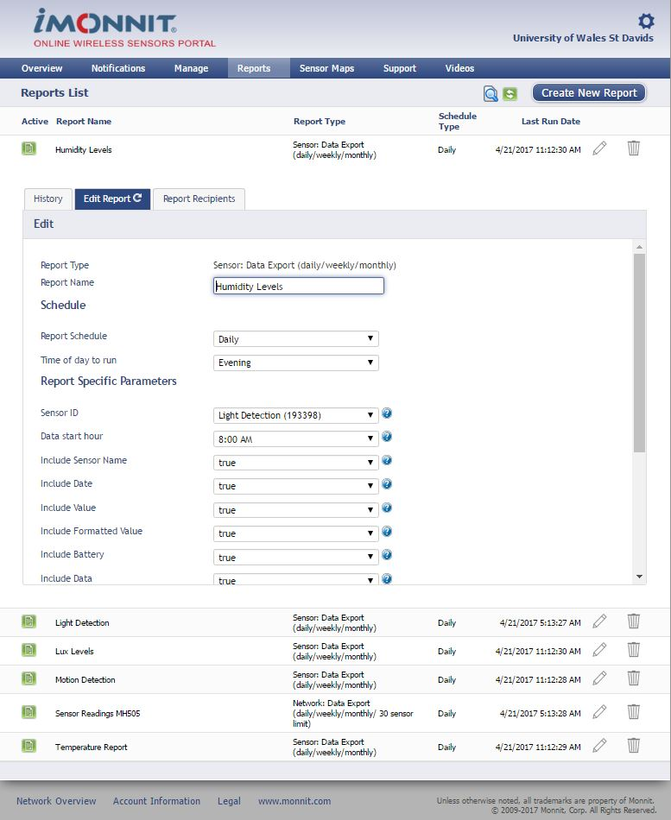
Figure 4.6 – Humidity report configuration [45]
At this point the WSN has been installed and is ready for use the following section covers the simulation design. Further images can be found in the appendix.

Simulation Architecture

The software being deployed to perform the simulations is the latest Cisco Packet Tracer [58]. The latest version seven utilises the IoT deployment and gives full control through a registration server to control a series of nodes. The nodes can be configured to mimic real world environment and can simulate the transfer of data to assist in the proving of concept. The simulation will be based on the physical interpretation and uses the MH505 layout. Figure 4.7 demonstrates the blueprint of the installation, further images and screenshots can be found within the appendix after chapter eight [47]. With the ability to program and configure the sensors to interact with the room it has been possible to evaluate how automation will impact this room. As simulation is used to test theory and allow for test data to be analysed it has enabled the author to perform additional functions not able to be done at within the physical model.
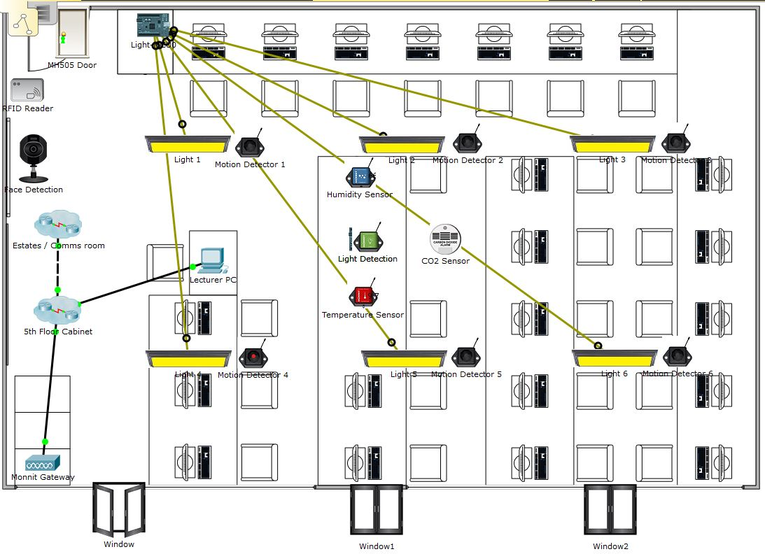
Figure 4.7 – Packet Tracer simulation MH505 [58]
It should be noted that the wireless connections are not visible as this distorts the image and prevents the reader from being able to see the sensor nodes. The following section will discuss how this WSN has been implemented.

Simulation Implementation

Unlike the physical model the deployment of sensor nodes is simplified by a drag and drop method into a working area. As seen in figure 4.7 this implementation sees some additional nodes being utilised. Along with the sensors installed in physical model there is six motion detection sensors that are linked to each light, face detection linked to access via an RFID reader. Opening and closing windows are also present within the model. Each of the nodes is linked directly to the gateway which allocates an IP address via DHCP creating a secured network. Unlike the physical model a registration server has to be initiated and linked to the network. Contained on this server is the remote software created to manage the nodes and network, much like the iMonnit software. Figure 4.8 shows the initial configuration settings to access the wireless network and obtaining the IP address to allow communication with the registration server.
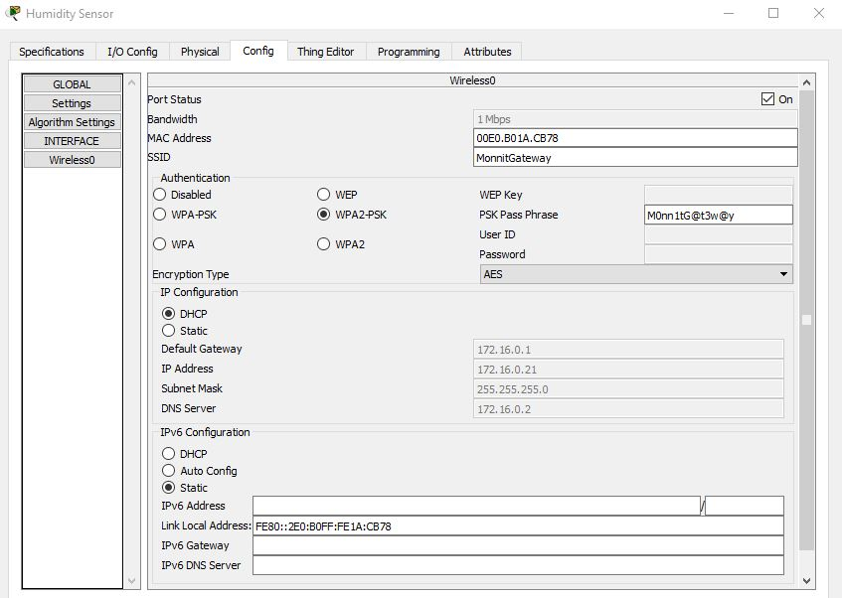
Figure 4.8 – Network configuration Humidity Sensor
As discussed in chapter 2 security is vital and this sensor employs the WPA2-PSK protocol and utilises a unique pass phrase. The IPv4 address is allocated and to ensure connectivity across the network it has establish the default gateway and dns server details. The next stage for the humidity sensor is the configuration details to connect to the registration server, this must include the IP address and username and password. Once this has been configured the sensor can communicate with the server and it will allow data transmission between them. The figure 4.9 shows this configuration completed and connected.
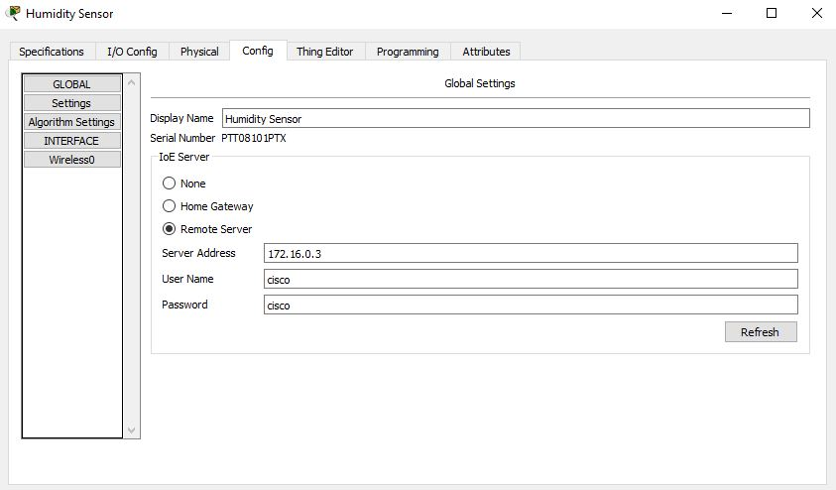
Figure 4.9 – Remote Server configuration
Following the correct installation of all the sensors contained in the network they will be displayed onto the web interface as seen in figure 4.10
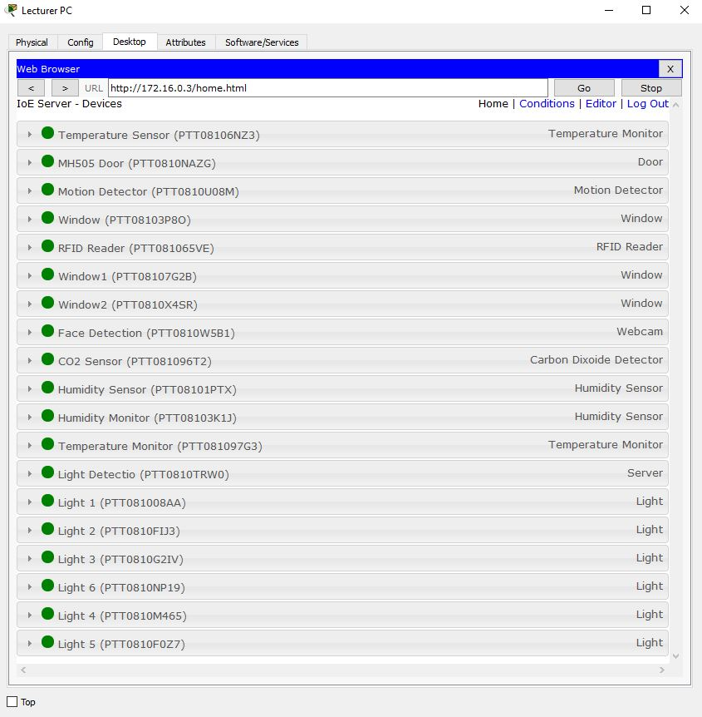
Figure 4.10 – Sensor status online web portal
At this point the user needs to setup the conditions required from the sensors and this can be done again on the online portal this can be seen in figure 4.11
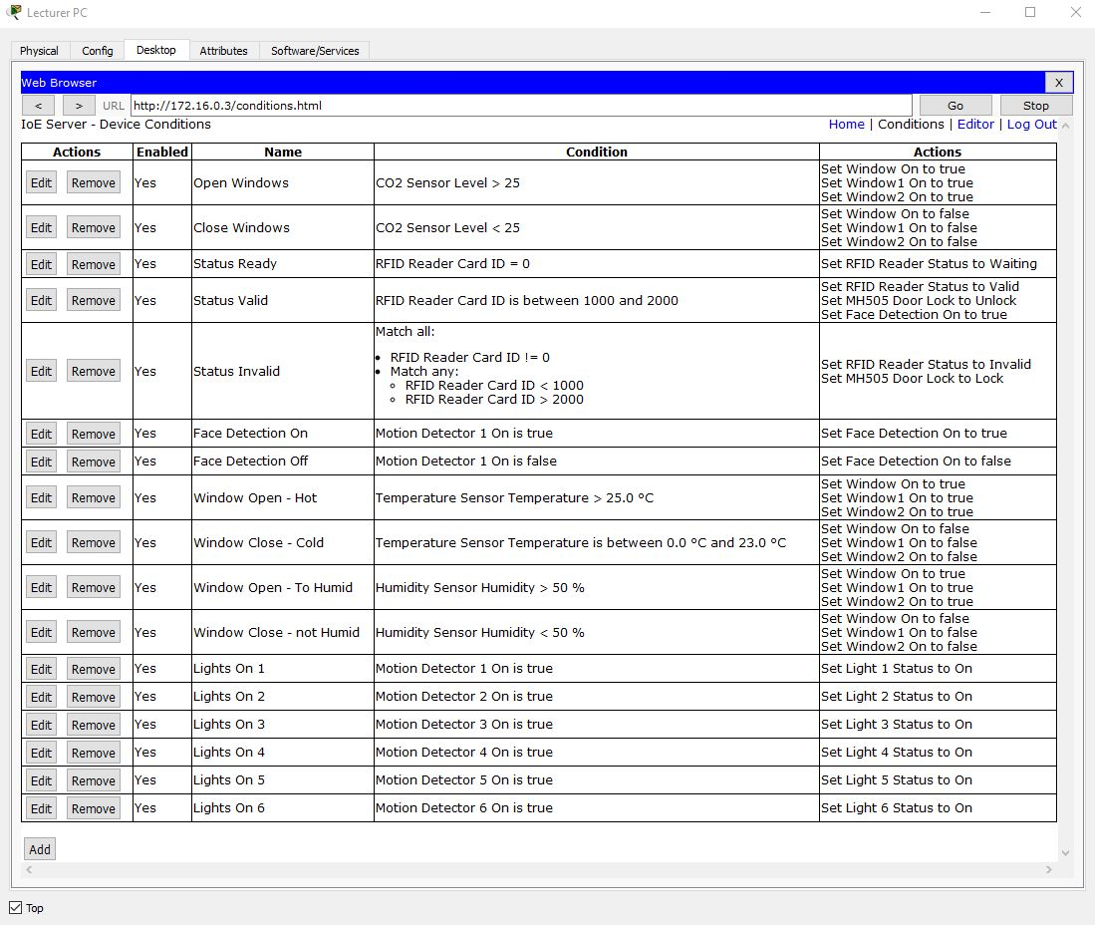
Figure 4.11 – Sensor Conditions online portal
In controlling the sensors, the room has now become almost automated and it can be said that this room is now employing the IoT principles. If this web portal was accessible via a smart device it is perceived that configurations can maintained or altered remotely.

Conclusion

Bringing this chapter to a close the author has demonstrated what is required to ensure a sound implementation of the WSN. Although the installations are similar it has highlighted that a simulation is a cost-effective way of demonstrating if a particular model will work and it allows for more scope. At this stage both models are ready to start recording data and be prepared for the following chapter where implementation moves from theory to practical and results are obtained under recorded conditions.

Testing and Evaluation

Introduction

Covered in this chapter is the test results from both the physical and simulation models. There will be an outline as to what the conditions were for each of the tests performed with a justification as to what, why and how each met the objectives. At the end of this chapter it will conclude the findings and draw on the experiences to identify if in fact the aims of the project have been met. This chapter will utilise graphical data exported from the iMonnit and Packet Tracer software. The graphs will be collated and produced and shown in the relevant sections below.

Physical Model

Overview of Parameters for tests

The following conditions have been put in place for the 2 days of testing on the WSN. These tests unfortunately can only be done over a period of two days, this is shorter than previously scheduled. A control experiment has been carried out in MH505 on the 21st and 22nd April 2017, the hours for the experiments are 8 am to 10 pm. On day one of the tests the room has a simulated automation as the author acted as the motor for each sensor. This meant that should the temperature increase above expected levels it would be the author who will open the windows or activate the air cooling fan. The lights have also been monitored to ensure correct operation. Students are present within the room and are aware of the test conditions and agree to not interfere with the testing process. On 22nd April, the MH505 lab conditions differ slightly from the previous day, no students are present the room. No windows or doors are opened and the blinds remain in the open position. Meteorological data has been utilised to confirm as to the outside temperature and atmospheric conditions were on each of the days being tested. It should be noted that in this room there are a number of desktop computers being used. The room also includes two and half rack mounted switches and routers supplied by Cisco, these have all been turned on to simulate that the room is being used. An image of the room can be seen in figure 5.1 as this picture shows the blinds in the room have been raised to allow as much light into the room as possible. additional images will be included within the appendix contained at the end of the report.
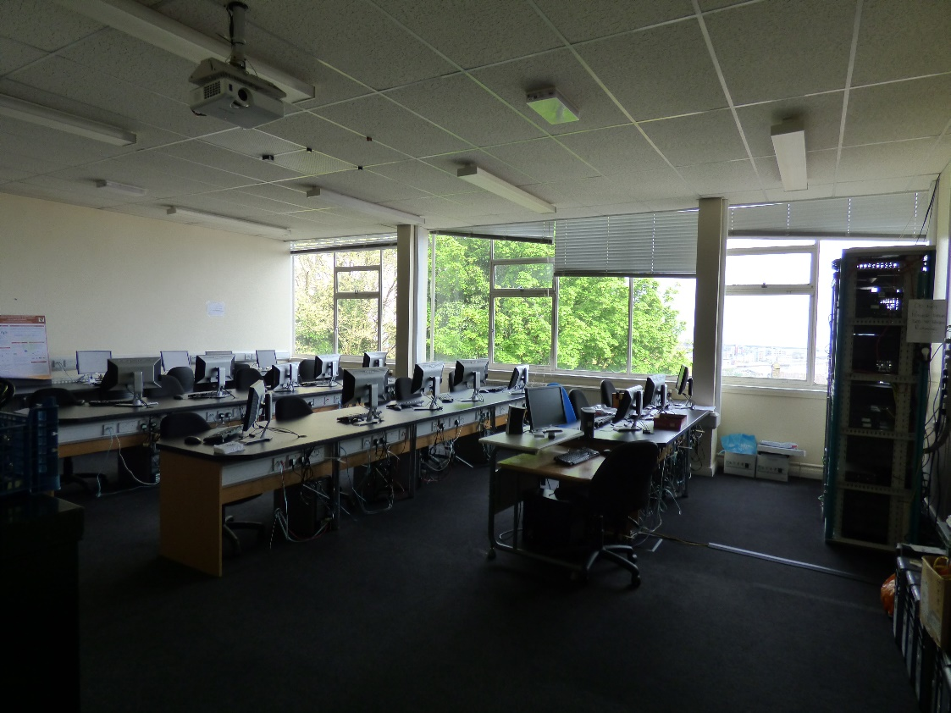
Figure 5.1 – MH505 Lab

Review of Findings

The results from each of the sensors have been collected and input directly into Microsoft Excel to produce graphical representations. Each of the graphs produced for each sensor will contain the data as outlined in the previous section. Additional data has been collated from the meteorological data collected from the Met office [59] and the Weather Company [60]. Like the sensor data this will be used to establish the pattern for particular results. These findings will also be used to confirm that the objectives set-out in chapter 1 have been achieved.

Temperature Sensor
The following figure 5.2 shows the temperature readings taken between 8 am and 10 pm with half hourly checks. The data also includes the external temperature readings taken for the Mount Pleasant area. Firstly, in comparing this graph it is important to highlight the differences from inside and outside of MH505. The yellow and grey lines are the temperature readings taken form the websites as mentioned earlier. The blue and orange lines identify the readings taken directly from the iMonnit software using the export data function.
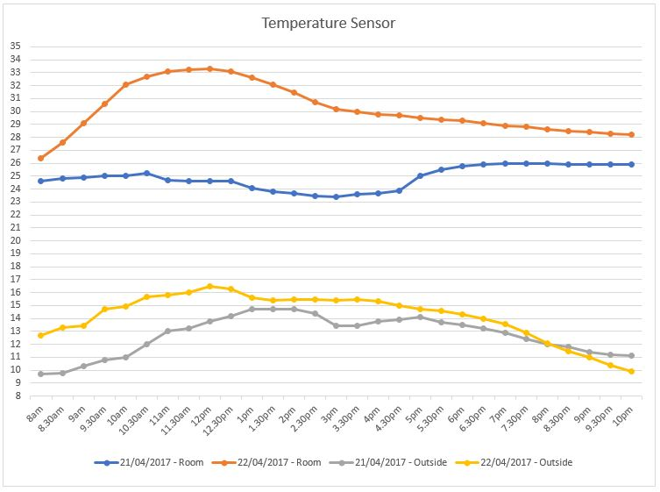
Figure 5.2 – Temperature Sensor readings 21st and 22nd April 2017
In comparing the two days it’s clear to see that the room temperature clearly increases in conjunction with the external temperature, a steady increase is recorded from 8am reading of 24.6° to its highest point in the morning of 25.2° taken at 10.30 am. When looking at the outside temperature at the same times stamps it is clear to see the trend does in fact follow 9.7° at 8 am and then an increase to 12° by 10.30 am. The reason for selecting 10.30 am on the 21st April as a reference point is due to students entering the room and opening all windows. At this point, all though the temperature externally increases the room clearly changes and starts to fall. However, at 1.30 pm with the room at a temperature of 23.8° the internal air cooling desktop fan was operated. This results in a continued drop in the temperature until 4.30 pm when the room was closed down as all students had finished for the day. In comparing the 22nd a similar trend can be seen in the room and external temperatures. The room reaches a staggering 33.3° by midday in the MH505 lab and externally it has reached 16.5° at this point both internal and external readings appear to fall away in a symmetrical pattern.

Humidity
Similar to the temperature readings taken previously figure 5.3 show the two testing days. The graph below will discuss the MH505 data for the humidity and dew points.
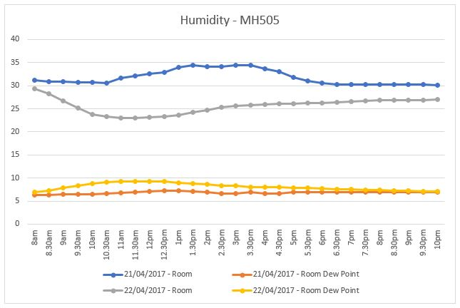
Figure 5.3 – Humidity and Dew Point data MH505 Lab
When looking closely at the graph it appears to have somewhat of a contradiction at a first glance for the blue and grey lines. This can be explained in very similar circumstances as the temperature sensor readings. On the 21st April, similar readings are taken from 8am 31.13% to 10.30 am 30.59%, however as identified in the previous section students entered the room. At this point with the windows opened, natural body heat and temperature this has a direct impact on the humidity levels recorded. The drop off that is seen at 3.30 pm 34.42% when the reading taken is at its highest can be explained as only one student remained until 4.30 pm at this point the room again was closed. The dew point remains fairly stable on both days, apart from the period as discussed previously when the students entered the lab.

LUX Sensor
The first thing to identify is that the readings for the LUX sensor are not as they should be. Due to incorrect placement of the sensor within the lab it is very apparent that the light levels are very misleading. Data taken from a reports into lighting within schools shows that the lux levels should at a minimum be 300 lux for an average learning environment [61], [62]. As the graph will show the sensor is either incorrectly operating or as the author suspects is incorrectly placed. Figure 5.4 shows the lux levels on both days.
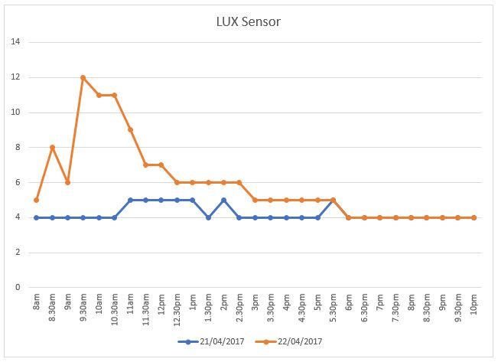
Figure 5.4 – LUX levels for MH505 lab
In analysing the results the 21st April does demonstrate a slight change at 10.30 am to 11 am this change in lux was in part due to the author raising the blinds to an open state. As for the changes within the room they do in fact relate to the light detection sensor which will be discussed in the next section. The lux levels on the 22nd April are the result of the extremely light conditions across the Mount Pleasant area and in fact this can be related back to the temperature settings. However as stated earlier within this analysis these levels are still extremely below the expected for this type of sensor [61], [62].

Light Detection
Although this sensor has only a reading of ‘1’ for active and ‘0’ for in-active some data has been recorded. This data can be seen in figure 5.5 for both days.
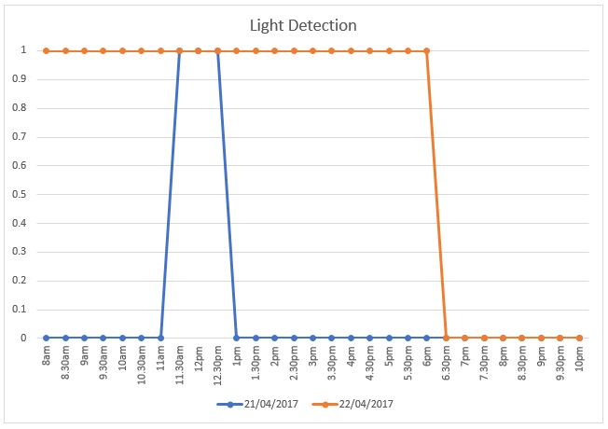
Figure 5.5 – Light detection in MH505
The strange appearance of the table is due in part to the limited data recording of ‘1’ and ‘0’. As the lights were utilised by the students during the day on 21st April between 11 am and 1 pm, at this point they were switched off and the room couldn’t locate another suitable source of light. However as seen in the lux sensor the 22nd April demonstrates a very bright day and this is reflected in the results seeing that the detection started at 8 am and doesn’t in fact go in-active until 6.30 pm. At this point the author has felt that further research into the use of this sensor will be vital to the success of further developments of this project.

Motion Detection
Much like the light detection this sensor operates on the premise of ‘1’ active and ‘0’ in-active. The figure 5.6 shows the graph for both days. Although there are results to discuss during the testing phase it has become apparent that it only detected movement in a smaller area than the author felt it would cover. After a careful review of the size of the room and the coverage required at least six motion detectors would be required [41], [57].
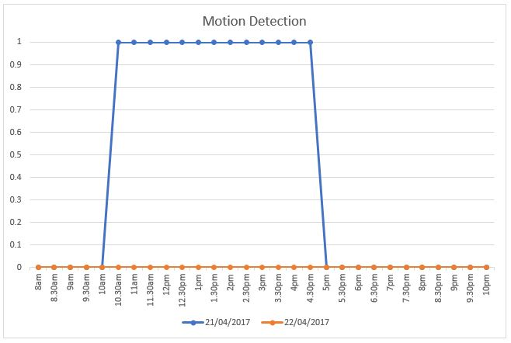
Figure 5.6 – Motion detection MH505 lab
As previously outlined in the conditions no motion was detected on the 22nd April as there was no people present within the room. Having these results from the one sensor has demonstrated that it is possible to utilise a motion detector to assist in the management of a smart classroom.

Simulation Model

Overview of Parameters for tests

The WSN simulation has been designed to allow for full automation of the heating, cooling, and window operation. Included within this room is the ability to show how RFID and face detection will operate together as an attendance application. The motion detectors also activate the lights and allow them to follow a student to whatever area of the room they occupy. The last area of sensor readings is to monitor the CO_{²} levels that naturally occur within a classroom. However, this simulation has a draw back as it has produced no results to analyse at this stage. The author will cover this within the conclusion of this chapter. The figures contained in the review section will show the operation of the sensors as outlined in the previous chapter.

Review of Findings

The figure 5.7 shows the start of the simulation in room MH505. As explained above these figures will demonstrate the operations of the sensors.
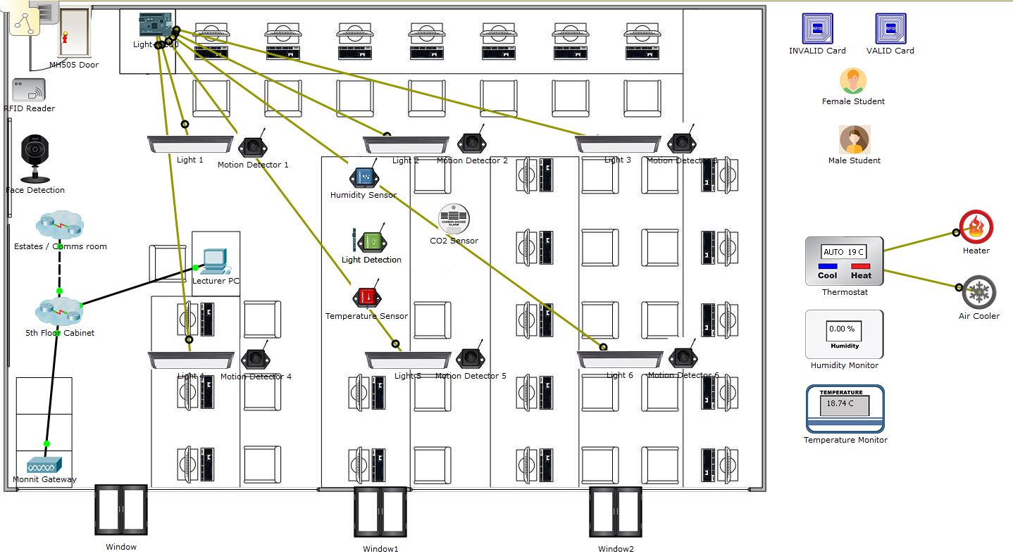
Figure 5.7 – Simulation moving from in-active to active
To start the simulation in the room, it is important to start up the thermostat which controls the heater and air cooler.
The following figures 5.8 and 5.9 show how to login into the registration server and the registration desktop.
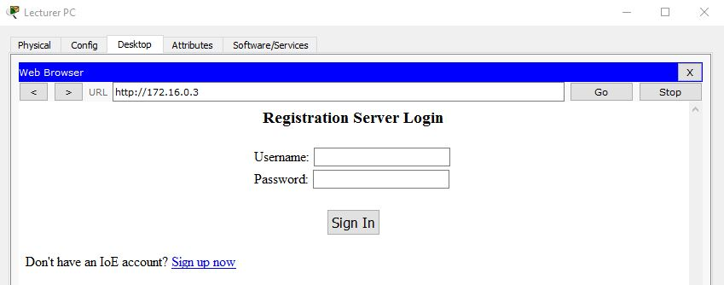
Figure 5.8 – Login to the registration server
The username and password can be configured for unique use by lecturers and estates management staff as required, this ensures data integrity.
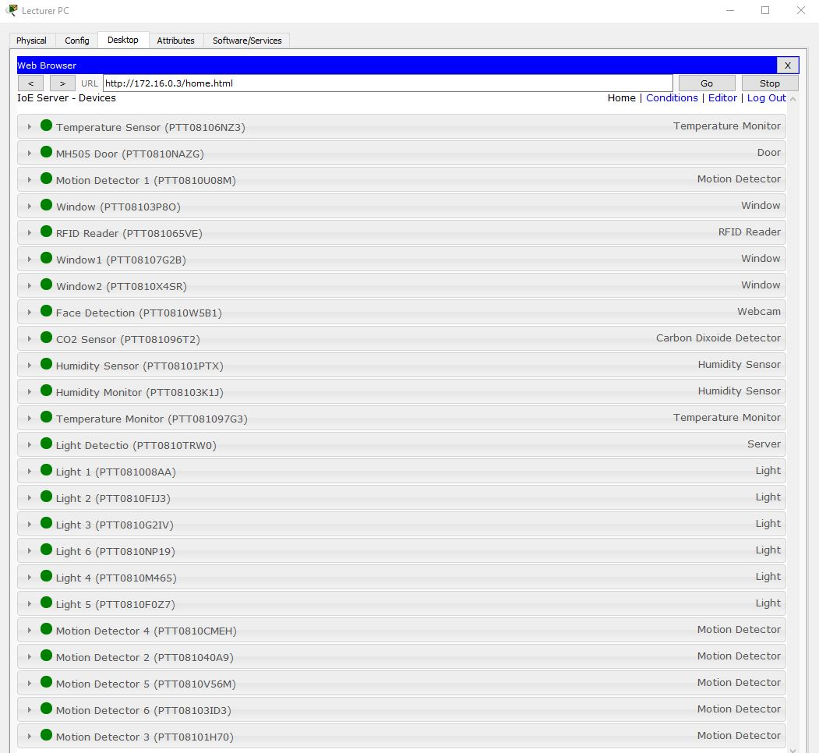
Figure 5.9 – Registration desktop portal
The figure above shows what the desktop that is logged into after entering your login credentials. At this point the user can see the status of any sensor in the network.
The following two figures 5.10 and 5.11 show the sensors prior to activation and then after being activated. The image shows temperature, door, motion detector 1, RFID reader, and finally the face detection camera.
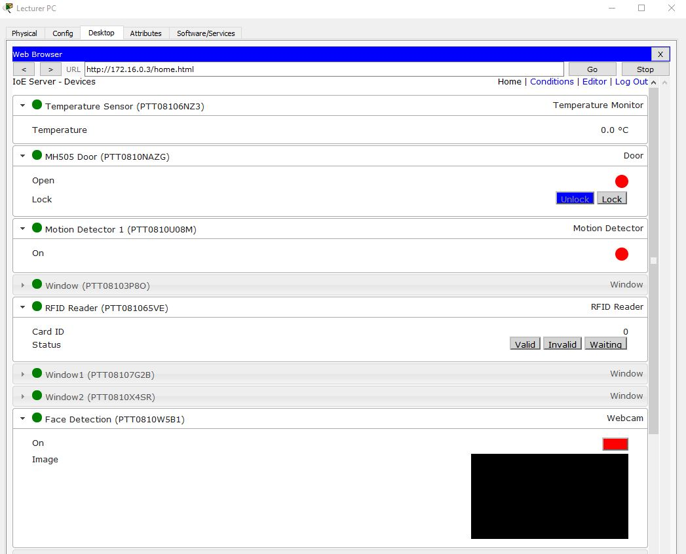
Figure 5.10 – In-active sensors on portal
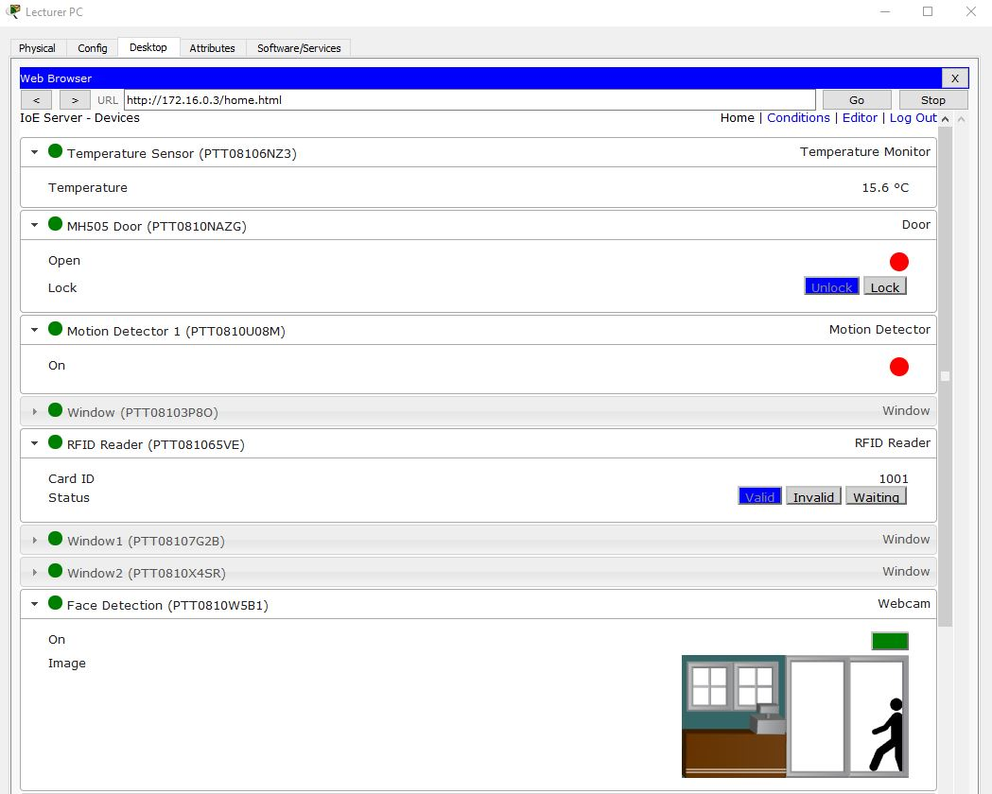
Figure 5.11 – Active sensors on portal
Figure 5.11 shows the sensor being operated the temperature is now registering 15.6° and the RFID reader shows a valid card. The RFID also activates the face detection camera and this can be seen in the image. The following figures of 5.12 and 5.13 demonstrate the operation of the CO_{²} monitor. Image one is taken during its in-active period, image two then moves to an active state.
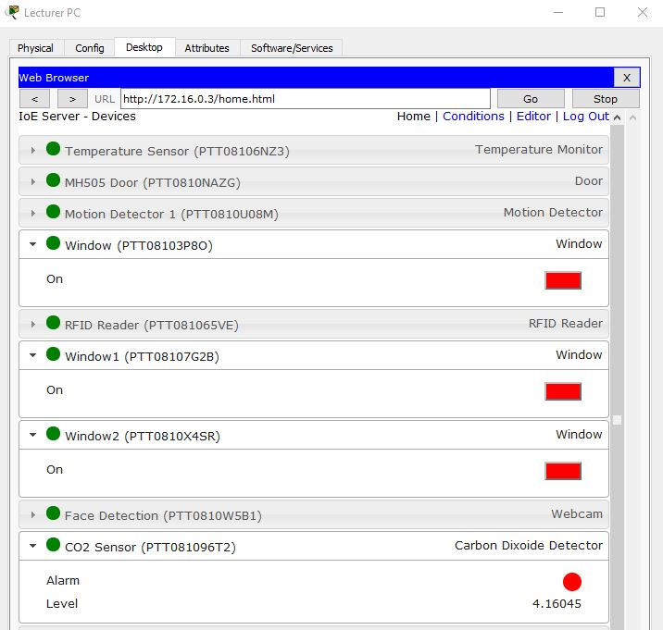
Figure 5.12 – CO_{²} monitoring in-active
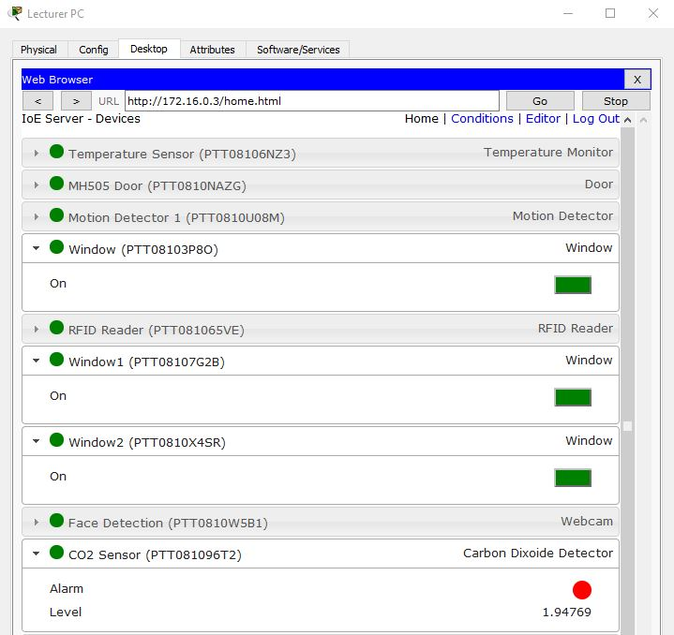
Figure 5.13 – CO_{²} monitoring activated
The alarm when activated operates the windows and helps reduce the CO_{²} level from greater than 15%. The next images 5.14 and 5.15 will show the operation of the motion detection in conjunction with the lights as stated in chapter four.
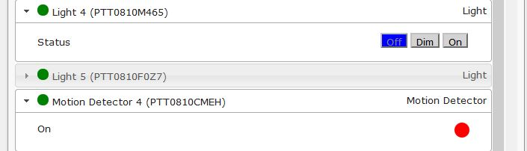
Figure 5.14 – Motion detection in-active
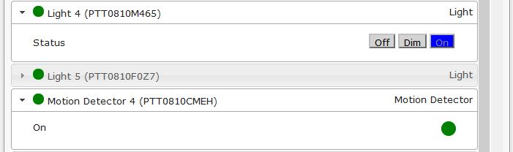
Figure 5.15 – Motion detection activated
The above figures 5.14 and 5.15 show that the motion detection sensors work in tandem with the lights. In this example motion detector four activates after sensing movement in its zone. When activated it sends a signal to light four which then illuminates. Unfortunately, at this stage the author is unclear as to how to programme the sensor to monitor the room continuously to enable the light to remain on or be shut off.

Conclusion

In concluding this chapter, the author has felt that the objectives as set-out early in chapter one have been met. The physical implementation has worked well and shows that he lights, cooling, and windows can be operated by the management application. The temperature sensor has certainly performed to expected levels and has proved that the concept of a smart classroom based on the aims of the project is achievable. A disappointment for the author is the lack of results in the simulation as part of the objectives was to compare the physical and simulation models results. However, the simulation has performed as expected and shown the benefit of using simulation against a physical installation. Overall the author is pleased with how the testing proceeded although it is felt that a longer period of testing would cement the results and provide a stronger basis for conclusion.

Conclusions and Recommendations

Conclusion
The following conclusion will bring together all the chapters into a single overview with the view of proving that the original aim of the project has been fulfilled. The project set-out to demonstrate ‘the operation of a wireless sensor network utilised in a classroom environment’. The author feels as though the main aim has been achieved and in conjunction with this the objectives have been met as laid out in chapter one. The conclusion will start back in chapter two where the fundamental background knowledge was established for the project. A focus on the bandwidth and power supply identified that the ZigBee protocol is a preferred option when consider a WSN. This was further strengthened in the review of the technologies and protocols involved with WSNs. A review of security protocols required to ensure the integrity and confidentiality of data being transmitted across the network followed. In this review, it was highlighted that newer technologies have been developed to fulfil a gap between security protocols with the introduction of WSN technology. Prior to the related works that assisted in the literature review the author has introduced us to the sensors, software, and hardware to be utilised within the network. The author felt that the fours papers reviewed in chapter 2 backed up the aims and objectives of this report. In all of the papers areas of interest that linked with this report were identified, this also included the testing parameters and results.

Following the literature and technology review came the chapter on the research methods employed throughout the production of the report and its experiments. This section identified the process taken to ensure that structure was given to the collation of research to the collection of the results. The research was based around the ‘onion’ developed by Saunders, Thornhill and Lewis (2012) [54]. This chapter also identified primary and secondary sources and how they will be utilised within the structure of the report. The fourth chapter dealt with the design and implementation of the project. At this point the author highlights the problem and what its impact is on UWTSD, it also identifies the advantages of proving that a WSN can make an impact on the universities sustainability and environmental impact on the Swansea area. During this chapter, a full description of the physical and simulation implementations was discussed and this identified the blueprints being used for installation. During the installation of the simulation it became apparent that it could be used to confirm further theories regarding motion detection, face detection and RFID technology. Chapter five focuses on the testing and collecting of test data. During the test phase, it was identified that some of the physical sensors had been installed into incorrect positions affecting the overall data collected. It also highlighted that the simulation is a cost-effective way to test theory, however lack of software knowledge has prevented in the collection of data. A positive from the physical and simulations are that they both prove that a WSN can operate in an educational setting. The test results further identify further research that is required and this will be discussed in the following section.

In closing the conclusion, the author feels that this project has satisfied the objectives and aims that were agreed in chapter one. Furthermore, this is backed up by the production of graphical results contained in chapter five, and the screen shots taken from the simulation.

Recommendations for further research
During the production of the experiments and report it has become evident that the author needs to complete further study into WSN and its operation in the smart classroom. To aid this research a stronger knowledge of the Packet Tracer software is essential, whilst the knowledge has been sufficient to produce a working model the lack of technical understanding in producing real-time data is disappointing. Further knowledge of the coverage areas for both motion detection and light level (LUX) sensors would aid any future implementations as this will ensure stronger results are obtained. The final area for future research would be to develop the sensors and software application from concept to realisation, this would involve undertaken further training but it would provide a more bespoke product and outcome. The following chapter will now reflect on how the author feels about this project and how it has been from proposal to completion.

Reflections

Overview

So, what has this project taught me about myself and how can I take the new skills I have learned forward into my career or further education. I have listed some of the more important skills learnt or enriched during this project.
- Dealing with change – Historically I have not dealt well with change and it sometimes can throw me into a down wood spiral. However, I have been able to compartmentalise and switch between tasks to ensure that additional work is completed alongside the major project.
- Time management – what’s a clock? My management of time is somewhat of a mystery to some. I am pleased however that I have incorporated this into this project and I have a better knowledge of how to use time wisely.
- Working with deadlines – in the past I have seen these as movable objects however I now have a better appreciation for deadlines and why sometimes these just cannot be changed. In implementing my new time management and change strategies I know feel that I can work with tight deadlines.
- How to formulate a back-up plan – previously I wouldn’t change I would simply blunder on through and not have a back-up this project has clearly had its challenges and I have made improvements to ensure that I didn’t stagnate I changed direction if required.

Lessons learnt

Time Management
How to multitask
Prioritising major over menial tasks
Sticking on track and not deviate from the original aims and objectives
Ability to identify a back-up plan

Things that could have been done differantly

The write up should have been started earlier, to avoid rushing elements nearer to the deadline.
More related work papers would have made the justification stronger and assist in the production of a strong literature review.
The ordering of the sensors, hardware and software should have been completed before Christmas.
Stick to the project plan to prevent too much multitasking
Meet with my supervisor more regularly

Barriers experienced

Procrastination, lots of time to do other things
Lack of knowledge on Packet Tracer Environment settings
Self-doubt, am I researching the right papers, are the tests enough etc.
Delay in delivery time and lack of internet connection

Positives

Sticking it out even when the going got tough
Being able to swap tasks and not get hung up, suffering from Asperger syndrome it’s easy to be blinded and not be able to change easily
Make the project a success
Keeping focused and not rely on others to do it for me

Guidance to future students

- Plan your time out, short term and long term
- Do a topic that you have an interest in
- Keep a log to help with dates and research, and those little nuggets of information people give you.
- Take help if its offered from a supervisor or lecturer
- Prioritise tasks into vital, important, can be done later etc.
- Learn from others, talk to as many students and lecturers as possible
- Most importantly identify all the deadlines and finish early to give yourself breathing room
- Challenge the university but don’t step out of line somethings just can’t be done.

Summary

The overall feeling of achievement in completing this project on time and delivering the aim and objectives is something that won’t be forgotten. Skills have been gained during this project and areas of self-learning have increased week-by-week. Having a form of autism makes completing any tasks difficult but when you consider that this project has lasted for the best part of 12 months I am delighted to have completed this to such a high standard. Having worked on projects previously I now have a stronger understanding of managing and what it takes to keep a major project on track. I am looking forward to taking these new skills forward into PHD research and my future endeavours.

References

[1] D. He, C. Chen, S. Chan, and J. Bu, “SDRP: A secure and distributed reprogramming protocol for wireless sensor networks,” Ind. Electron. IEEE …, vol. 59, no. 11, pp. 4155–4163, 2012.
[2] Q. Chi, H. Yan, C. Zhang, Z. Pang, and L. Da Xu, “A reconfigurable smart sensor interface for industrial WSN in IoT environment,” IEEE Trans. Ind. Informatics, vol. 10, no. 2, pp. 1417–1425, 2014.
[3] G. P. Hancke and V. C. Gungor, “Guest editorial special section on industrial wireless sensor networks,” IEEE Trans. Ind. Informatics, vol. 10, no. 1, pp. 762–765, 2014.
[4] V. C. Gungor, B. Lu, and G. P. Hancke, “Opportunities and Challenges of Wireless Sensor Networks in Smart Grid,” IEEE Trans. Ind. Electron., vol. 57, no. 10, pp. 3557–3564, 2010.
[5] K.-H. Yeh, “A Secure IoT-based Healthcare System with Body Sensor Networks,” IEEE Access, pp. 1–1, 2016.
[6] P. Gope and T. Hwang, “BSN-Care: A Secure IoT-Based Modern Healthcare System Using Body Sensor Network,” IEEE Sens. J., vol. 16, no. 5, pp. 1368–1376, 2016.
[7] A. Hoskins and J. Mccann, “Beasties: Simple Wireless Sensor Nodes.”
[8] S.-I. Chu, Y.-J. Huang, and W.-C. Lin, “Authentication Protocol Design and Low-Cost Key Encryption Function Implementation for Wireless Sensor Networks,” IEEE Syst. J., vol. PP, no. 99, pp. 1–8, 2015.
[9] a Zanella, N. Bui, a Castellani, L. Vangelista, and M. Zorzi, “Internet of Things for Smart Cities,” IEEE Internet Things J., vol. 1, no. 1, pp. 22–32, 2014.
[10] E. Patti and A. Acquaviva, “IoT platform for Smart Cities: Requirements and implementation case studies,” in 2016 IEEE 2nd International Forum on Research and Technologies for Society and Industry Leveraging a better tomorrow (RTSI), 2016, pp. 1–6.
[11] F. G. Brundu, E. Patti, A. Osello, M. Del Giudice, N. Rapetti, A. Krylovskiy, M. Jahn, V. Verda, E. Guelpa, L. Rietto, and A. Acquaviva, “IoT Software Infrastructure for Energy Management and Simulation in Smart Cities,” IEEE Trans. Ind. Informatics, pp. 1–1, 2016.
[12] IHS, “Smart Cities to Rise Fourfold in Number from 2013 to 2025,” 2014. [Online]. Available: http://press.ihs.com/press-release/design-supply-chain-media/smart-cities-rise-fourfold-number-2013-2025. [Accessed: 16-Dec-2015].
[13] C.-C. Tsao, P.-S. Fan, C.-Y. Fan, and P.-C. Chang, “Innovation values in the radio frequency identification device industry,” in Proceedings of the 2014 IEEE 18th International Conference on Computer Supported Cooperative Work in Design (CSCWD), 2014, pp. 153–158.
[14] C. Y. Yong, R. Sudirman, and K. M. Chew, “Motion Detection and Analysis with Four Different Detectors,” in 2011 Third International Conference on Computational Intelligence, Modelling & Simulation, 2011, pp. 46–50.
[15] S. E. Global, “BUILDING MANAGEMENT SYSTEM.” [Online]. Available: http://www.schneider-electric.com/en/product-category/1200-building-management-system/?filter=business-2-building-management-and-security. [Accessed: 20-Dec-2015].
[16] F. Saffre, “Tutorial – Ii,” 2015 11th Int. Conf. Innov. Inf. Technol., p. 4244, Nov. 2015.
[17] I. of E. and E. Engineers, “IEEE Xplore Digital Library.” [Online]. Available: http://ieeexplore.ieee.org/Xplore/home.jsp. [Accessed: 27-Mar-2017].
[18] A. Proskochylo, A. Vorobyov, M. Zriakhov, A. Kravchuk, A. Akulynichev, and V. Lukin, “Overview of wireless technologies for organizing sensor networks,” in 2015 Second International Scientific-Practical Conference Problems of Infocommunications Science and Technology (PIC S&T), 2015, pp. 39–41.
[19] PC Mag, “button cell Definition from PC Magazine Encyclopedia,” PC Magazine. [Online]. Available: http://www.pcmag.com/encyclopedia/term/65856/button-cell. [Accessed: 30-Mar-2017].
[20] C. Randolph, “AA and AAA Battery FAQ,” 2017. [Online]. Available: http://www.greenbatteries.com/aa-and-aaa-battery-faq/. [Accessed: 30-Mar-2017].
[21] M. Rouse, “What is Lithium Ion battery (Li-Ion)? - Definition from WhatIs.com,” Tech Target (WhatIs.com), 2016. [Online]. Available: http://searchmobilecomputing.techtarget.com/definition/Lithium-Ion-battery. [Accessed: 30-Mar-2017].
[22] “IEEE - The world’s largest technical professional organization dedicated to advancing technology for the benefit of humanity.” [Online]. Available: http://www.ieee.org/index.html?WT.mc_id=mn_ieee. [Accessed: 30-Mar-2017].
[23] M. Rouse, “What is IEEE (Institute of Electrical and Electronics Engineers)? - Definition from WhatIs.com,” Tech Target (WhatIs.com), 2011. [Online]. Available: http://whatis.techtarget.com/definition/IEEE-Institute-of-Electrical-and-Electronics-Engineers. [Accessed: 30-Mar-2017].
[24] “What is a Wireless Personal Area Network (WPAN)? - Definition from Techopedia,” Techopedia (Dictionary). [Online]. Available: https://www.techopedia.com/definition/5109/wireless-personal-area-network-wpan. [Accessed: 30-Mar-2017].
[25] C. Buratti, A. Conti, D. Dardari, and R. Verdone, “An Overview on Wireless Sensor Networks Technology and Evolution,” Sensors, vol. 9, pp. 6869–6896, 2009.
[26] S. M. Schwartz, “Direct Sequence Spread Spectrum (DSSS) in Broadband Wireless Access (BWA) and Wireless LAN (WLAN).”
[27] J. Lee, Y. Su, and C. Shen, “A Comparative Study of Wireless Protocols :,” IECON Proc. (Industrial Electron. Conf., pp. 46–51, 2007.
[28] T. Agarwal, “What is ZigBee Technology, Architecture and its Applications?,” El-Pro-Cus, p. 14, 2015.
[29] P. N. Ravichandran, S. Kulkarni, S. Sharma, H. S. Vasudevamurthy, M. Vanitha, and P. Lakshminarsimhan, “Wireless telecommand and telemetry systems for satellite communication using ZigBee network,” ARTCom 2009 - Int. Conf. Adv. Recent Technol. Commun. Comput., pp. 274–278, 2009.
[30] “IEEE-SA -IEEE Get 802 Program - 802.11: Wireless LANs.” [Online]. Available: http://standards.ieee.org/about/get/802/802.11.html. [Accessed: 06-Apr-2017].
[31] IEEE, IEEE Standard for Information technology--Telecommunications and information exchange between systems Local and metropolitan area networks--Specific requirements Part 11: Wireless LAN Medium Access Control (MAC) and Physical Layer (PHY) Specifications, vol. 2012, no. March. 2012.
[32] M. Gast, 802.11 wireless networks : the definitive guide. O’Reilly, 2005.
[33] K. Benton, “The Evolution of 802.11 Wireless Security,” 2010.
[34] TEch-FAQ, “MIC (Message Integrity Check),” 2016. [Online]. Available: http://www.tech-faq.com/mic-message-integrity-check.html. [Accessed: 16-Apr-2017].
[35] D. W. R. H. N.Ferguson, “RFC 3610 - Counter with CBC-MAC …CCM—,” Netw. Work. Gr., 2003.
[36] M. Bellare, P. Rogaway, A. Barroso, K. Bell, K. Bimpikis, A. Boldyreva, D. Boswell, B. Buesker, M. Burton, C. Calabro, S. Davis, A. Gantman, B. Huffaker, H. Min Kang, V. Manpuria, C. Namprempre, A. Palacio, W. Rao, F. Schneider, and J. Wong, “Introduction to Modern Cryptography,” 1997.
[37] M. Bellare and P. Rogaway, “Pseudorandom Functions.”
[38] “About MSL, Wireless Sensors and Monnit.” [Online]. Available: http://wireless-sensors.co.uk/about. [Accessed: 17-Apr-2017].
[39] Monnit, “Wireless Temperature Sensor,” p. 2, 2015.
[40] Monnit, “Wireless Humidity (RH) Sensor,” p. 2, 2015.
[41] Monnit, “Wireless Motion Detection Sensor,” p. 2, 2015.
[42] Monnit, “Wireless Light Meter (AA) AA Remote Monitoring,” 2015. [Online]. Available: http://wireless-sensors.co.uk/wireless-light-meter-aa. [Accessed: 17-Apr-2017].
[43] Monnit, “Wireless Light Detection Sensor,” p. 2, 2015.
[44] Monnit, “Ethernet Gateway Technical Overview The Leader in Low Cost Wireless Sensors,” p. 2, 2015.
[45] Monnit, “Monnit Software,” p. 2, 2015.
[46] I. Cabrera Altamirano and F. Rodríguez Henríquez, “A scalable intelligent room based on wireless sensor networks and RFIDs,” Progr. Abstr. B. - 2010 7th Int. Conf. Electr. Eng. Comput. Sci. Autom. Control. CCE 2010, no. Cce, pp. 434–439, Sep. 2010.
[47] S. Downes, “P143943 - Reserch Methods M5X01051 - assignment,” 2016.
[48] C.-K. Chiou and J. C. R. Tseng, “An intelligent classroom management system based on wireless sensor networks,” in 2015 8th International Conference on Ubi-Media Computing (UMEDIA), 2015, pp. 44–48.
[49] M. Rouse, “What is light-emitting diode (LED)? - Definition from WhatIs.com,” Tech Target (WhatIs.com), 2005. [Online]. Available: http://whatis.techtarget.com/definition/light-emitting-diode-LED. [Accessed: 26-Apr-2017].
[50] S. Song, X. Zhong, H. Li, J. Du, and F. Nie, “Smart Classroom: From Conceptualization to Construction,” in 2014 International Conference on Intelligent Environments, 2014, pp. 330–332.
[51] S. Jianmei and L. Dan, “Application of the ZigBee and GoAhead technology in the system of smart classroom,” in Proceedings of 2013 3rd International Conference on Computer Science and Network Technology, 2013, pp. 646–649.
[52] Samsung Electronics, “User ’ s Manual Development Kit.” Samsung Electronics Ltd., p. 32, 2009.
[53] S. Kumar and S. Tapaswi, “A centralized detection and prevention technique against ARP poisoning,” Proc. 2012 Int. Conf. Cyber Secur. Cyber Warf. Digit. Forensic, CyberSec 2012, pp. 259–264, 2012.
[54] M. N. K. Saunders, P. Lewis, and A. Thornhill, Research Methods for business students, Sixth. Pearson, 2012.
[55] “Monnit Remote Monitoring Solutions Sensor Installation -Quick Start Guide General Wireless Sensor Mounting Back of Sensor Wireless Humidity Sensors.”
[56] Monnit Corp, “Monnit Knowledge Base.” [Online]. Available: http://www.monnit.com/support. [Accessed: 21-Apr-2017].
[57] Monnit Corp, “Monnit Knowledge Base | How to Create Sensor Notifications in iMonnit.” [Online]. Available: http://www.monnit.com/support/software/imonnit/how-to-create-sensor-notifications-in-imonnit. [Accessed: 21-Apr-2017].
[58] Cisco Systems Inc., “Cisco Packet Tracer Data Sheet,” p. 3, 2010.
[59] “UK weather forecast - Met Office.” [Online]. Available: http://www.metoffice.gov.uk/public/weather/forecast. [Accessed: 22-Apr-2017].
[60] The Weather Company, “About Us | Weather Underground,” 2017. [Online]. Available: https://www.wunderground.com/about/our-company. [Accessed: 22-Apr-2017].
[61] T. de Bruin-Hordijk and E. de Groot, “Lighting in schools,” IEA ECBCS Annex 45 Tech. Rep., pp. 1–10, 2005.
[62] A. G. To, E. Efficient, and C. E. Lighting, “Energy Efficient and Cost Effective Lighting,” Sustain. Energy, vol. 6, no. 3, pp. 1–7, 2007.

Appendix
Appendix i – Temperature sensor data sheet [39]
Appendix ii – Humidity Sensor data sheet [40]
Appendix iii – Motion Detection sensor data sheet [41]
Appendix iv – Light Detection sensor data sheet [43]
Appendix v – Ethernet Gateway data sheet - [44]
Appendix vi – iMonnit Software data sheet [45]
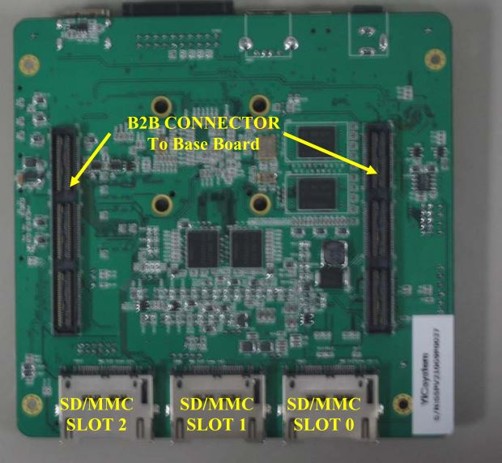
Appendix vii – S5PV210 Microprocessor Chip underside view [52]
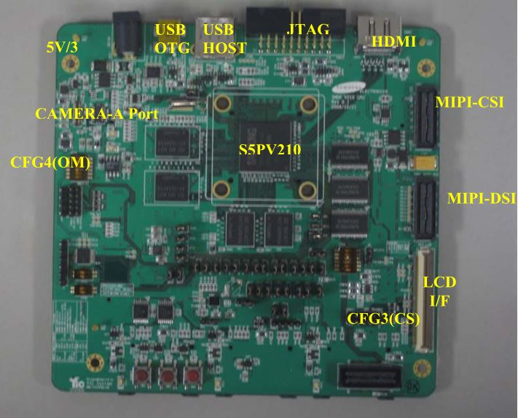
Appendix viii – S5PV210 Microprocessor Chip topside view [52]
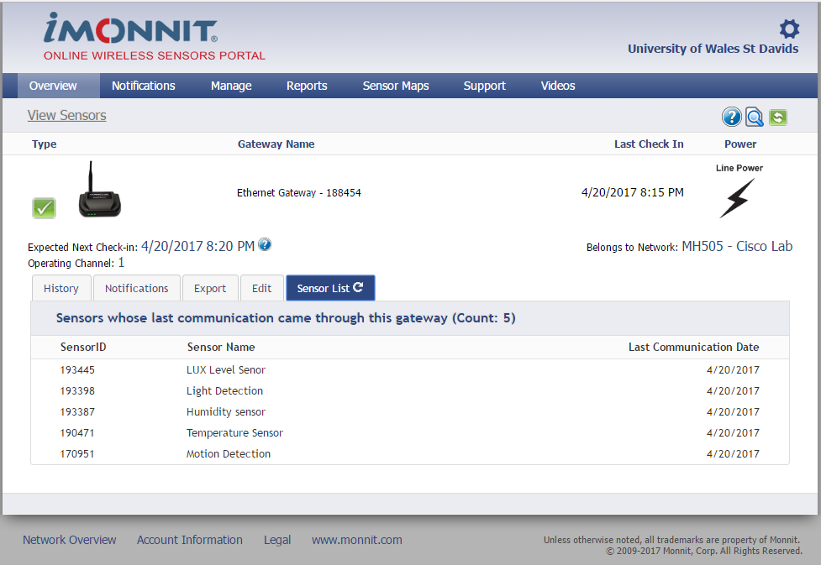
Appendix ix – Online Portal Gateway
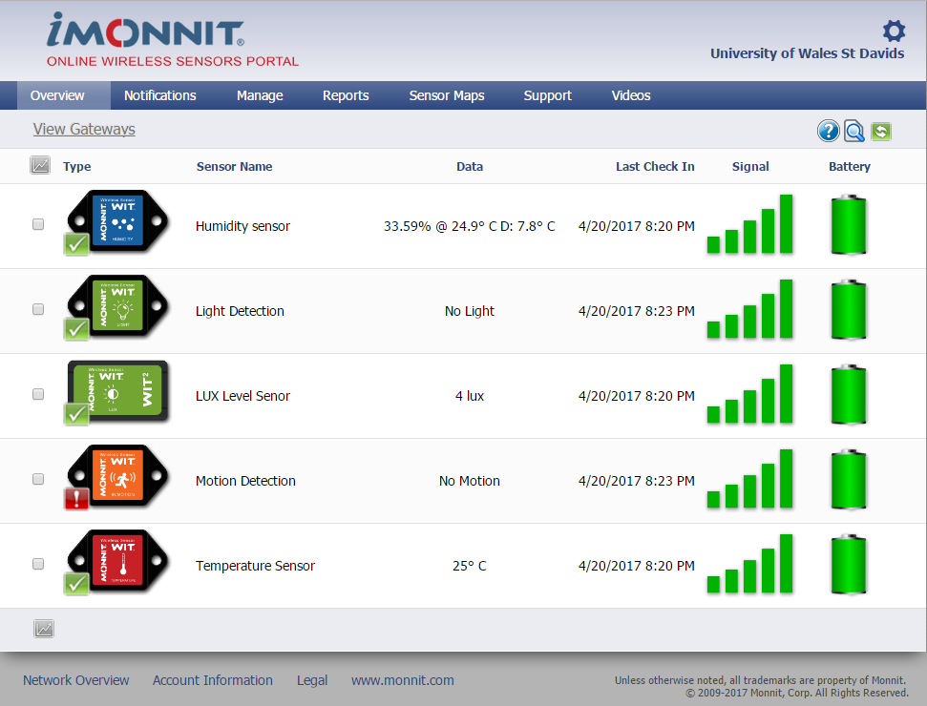
Appendix x – Online portal Sensor Overview
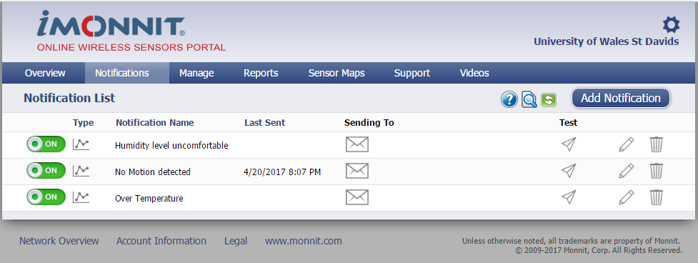
Appendix xi – Online Portal Notification Overview
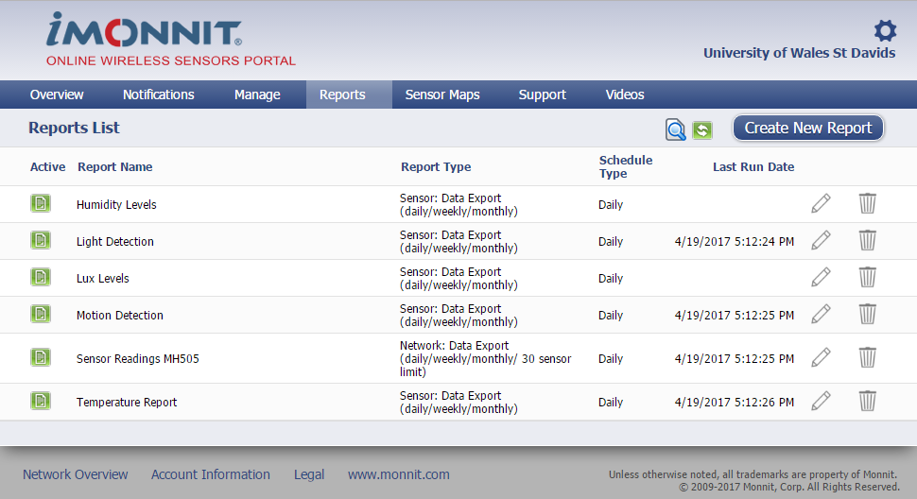
Appendix xii – Online Portal Reporting Overview

Appendix xiii – Email Humidity Report received

Appendix xiv – Emailed Alert Temperature Sensor Over Range
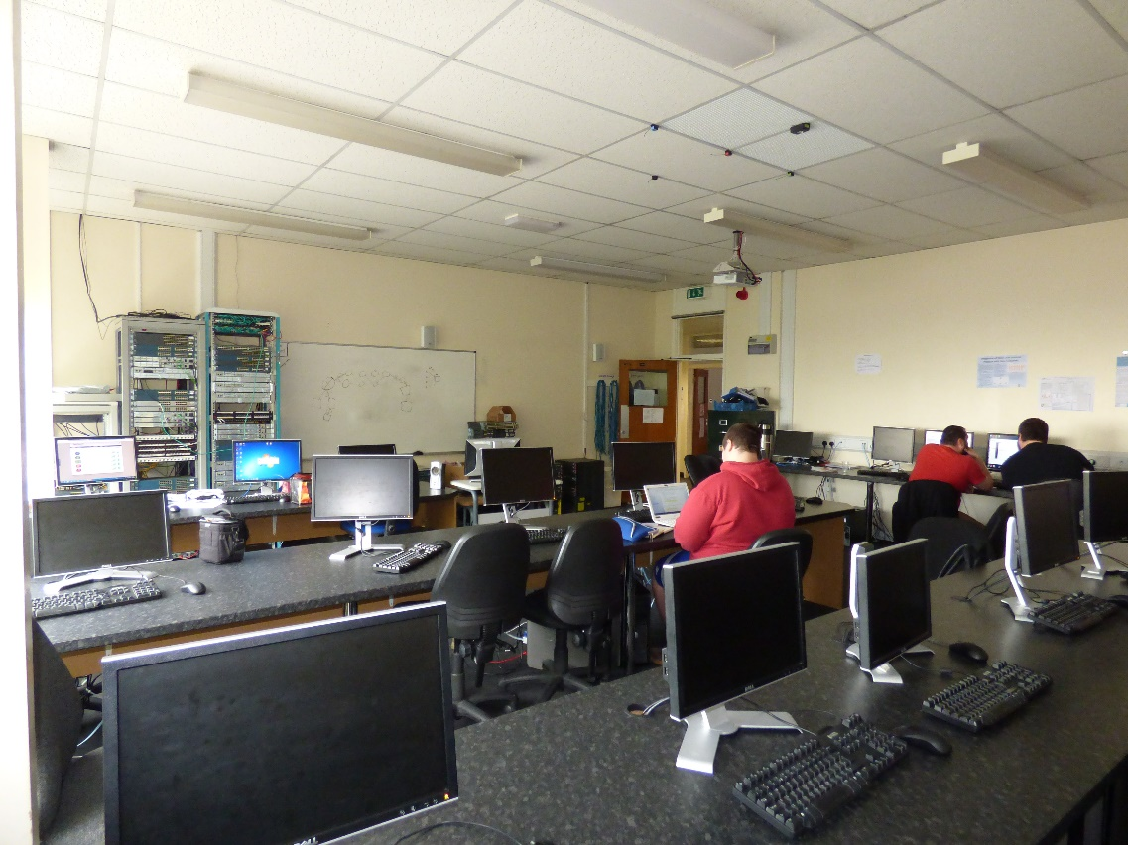
Appendix xv – 21st April testing Students present in room
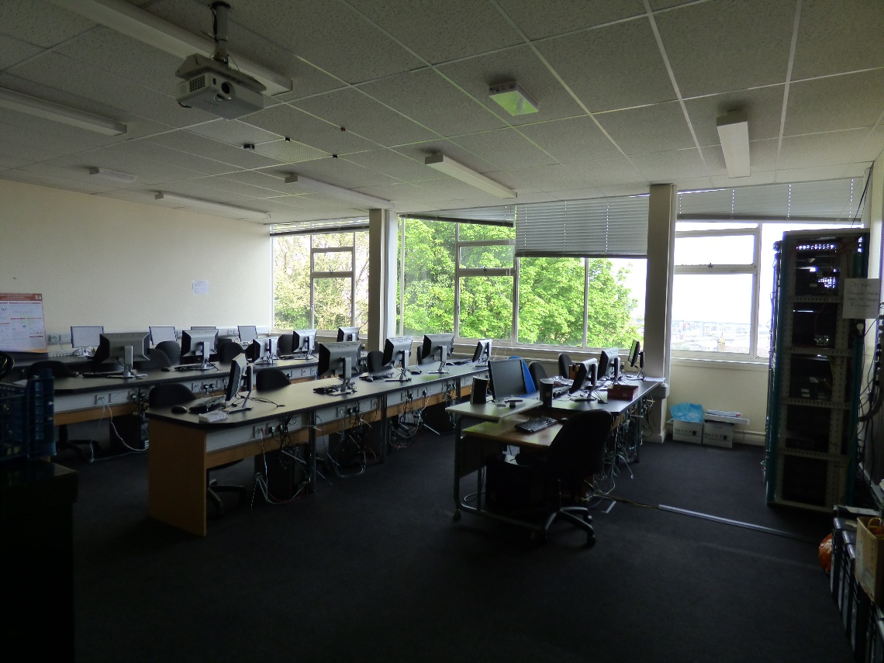
Appendix xvi – 22nd April testing No students and windows closed
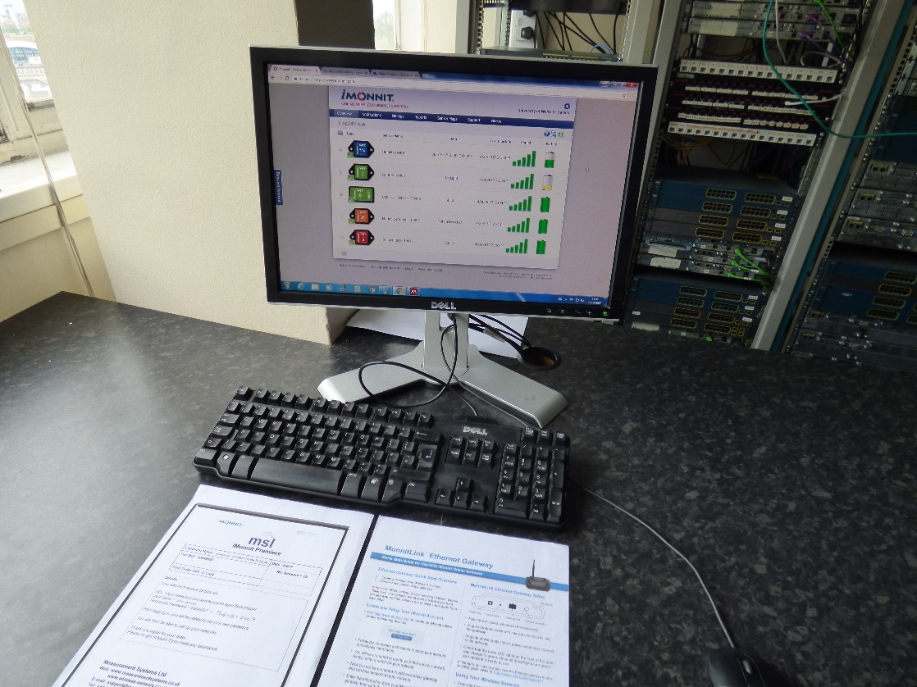
Appendix xvii – iMonnit Premiere Online Software [45]
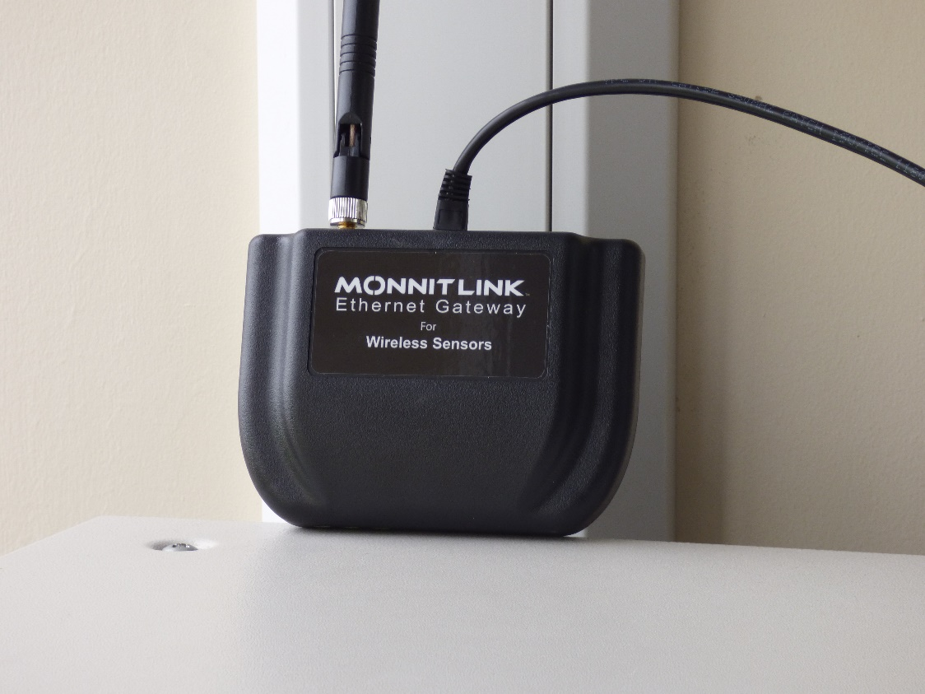
Appendix xviii – Ethernet Gateway installed
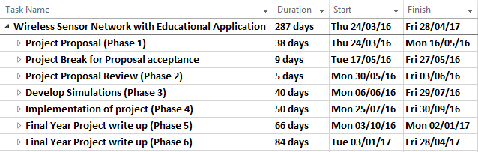
Appendix xix – Original Gantt Chart Overview [47]

Appendix xx – Original Phase One Gantt Chart [47]

Appendix xxi – Original Phase Two Gantt Chart [47]
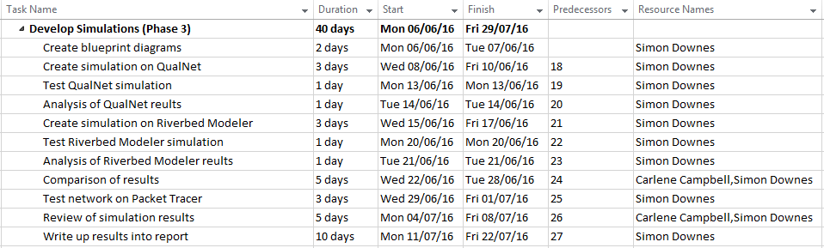
Appendix xxii – Original Phase Three Gantt Chart [47]

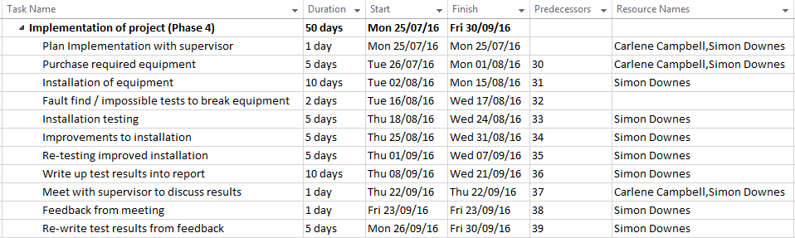
Appendix xxiii – Original Phase Four Gantt Chart [47]

Appendix xxiv – Original Phase Five Gantt Chart [47]

Appendix xxv – Original Phase Six Gantt Chart [47]

Project Management

Overview
During the process of this project it became apparent that the original proposed Gantt chart as seen in the appendix required reviewing. There are various reasons for the changes this chapter will identify and justify as to what was changed and why. At the end of this chapter the finalised project management Gantt chart will be presented, some of the changes have already been discussed within the reflections chapter earlier within this report.

Alterations to Original Gannt Chart
The first of the changes is seen in the third phase as the original document started back in semester two of year two. Whilst this proposal was handed into the university on time there was no update made to the Gantt chart to change the timings for the start of the project in semester one of year three. The actual start date should have read 03/10/2017. At this point the whole of phases 3, 4, 5, and 6 are completely different from the original developed Gantt chart. The main reasons for changes is the continuation of the literature review and the change in the type of project from utilising a number of specialist simulation software to actual physical implementation. All of these changes are shown in figures 10.1 to 10.6 below.

Figure 10.1 – (Phase 3) Main Project altered Gantt chart
This phase covers the initial periods of the project up until the end of chapter 4 being produced on the 10/04/2017
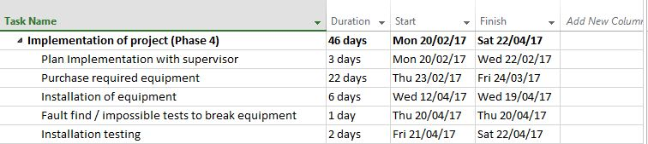
Figure 10.2 – (Phase 4) Implementation altered Gantt chart
This phase deals solely with the implementation and testing of the WSN physical and simulation models.

Figure 10.3 – (Phase 5) Final Year Project altered Gantt chart
This phase is concerned with the final write-up and production of the report, it also covers the final deadline for the written report.

Figure 10.4 – (Phase 6) VIVA and Poster altered Gantt chart
This phase continues after the official hand-in of the major project report. It concentrates on the production of both the Exhibition Poster and the final VIVA presentation.

