By Shane Thomas

Evaluating the use of GIS software as a modelling tool for environmental analysis
GIS & Data Analysis

Module Code: M6X01081

Lecturer: Beverley Holland
Contents:
1.0 Introduction: 3
1.1 What is a GIS – 3
2.0 Literature Review: 4
2.1 Types of Data: 4
2.1.1 Raster – 4
2.1.2 Vector – 5
2.2 MapInfo: 6
3.0 Methodology: 7
4.0 Results 9
5.0 Analysis: 11
5.1 Analysis of Deprivation Data – 11
5.1.1 Townsend Deprivation Index – 11
5.1.2 Welsh Index of Multiple Deprivation (WIMD) – 12
6.0 References: 14

Table of Figures:
Figure 1: An example best illustrating a raster data map and the number of individual cells that a map of a small area may contain. 5
Figure 2: Demonstrates a polygon-based dataset which is exhibiting the frequency of fires in a defined area using a colour-based scale to measure number of fires in each region. 6
Figure 3: An image of the latest MapInfo Pro package being used to examine statistics on the North American continent. 6
Figure 4: The way in which the Townsend Score was calculated in Excel is shown in this image with the Z-score needing to first be calculated by subtracting the mean value which would then be divided through standard deviation. Following this the Townsend Score could be determined by adding up the sum of the Z-score to get the final answer (Moore, 2019). 8
Figure 5: This image shows how the data from the Townsend and WIMD Scores appeared on the MapInfo display screen in the process of map creation. 9
Figure 6: This MapInfo map incorporates data from both car ownership and the Townsend Index Score (Moore, B, 2019). 9
Figure 7: Townsend Index data results for Swansea exhibited in this map (Moore, B, 2019). 10
Figure 8: This map exhibits the results obtained from the Welsh Index of Multiple Deprivation that was applied to this region of Swansea (Moore, B, 2019). 10
Figure 9: Map of the Welsh Index of Deprivation (2014) for the entirety of Wales. 13

Introduction:

1.1 What is a GIS –
A geographical information system (GIS) is a computer system used to gather, store analyse and display data in relation to positions on the surface of the earth (National Geographic, 2019; ESRI, 2019). The key word to GIS technology is ‘geography’ which means that some part of the data is spatial (University of Wisconsin, 2019; Dempsey, C, 2017). Originally based off CAD/CAM systems, it works by merging seemingly unrelated forms of data to allow the user to see spatial patterns and relationships (Holland, B 2019, pers comm, 1 February; National Geographic, 2019). The GIS system offers the user a model of geographical reality by use of any information that includes location (Holland, B 2019, pers comm, 1 February).
There are many functions/tasks a GIS system can be used to complete such as the following –
- Location of features
- Where the highest or lowest amount of a feature exists
- The density of features in a defined geographical space
- What is occurring in an area that is being examined
- What features are located inside a specific area or region.
- Learning what is happening within a pre-defined distance of a selected feature by use of geoprocessing tools such as BUFFER
- Mapping change over time
(Wisconsin University, 2019)
The GIS has allowed geographers to move away from time-consuming cartography for in map referencing and instead use a quicker more effective digital solution (Ordnance Survey, 2019). This is evident in the fact that the OS (Ordnance Survey) department were forced in the 1990s to convert as many physical map copies to digital format as possible by the year 1995, which it achieved making the UK the first country in the world to have completed a programme involving large-scale electronic mapping (Ordnance Survey, 2019). In real terms this meant that all field surveyors after this used hand-held computers to take measurements while out in the field, resulting in data being able to be electronically sent to the office for analysis, therefore speeding up the entire process (Ordnance Survey, 2019).

Literature Review:

2.1 Types of Data:
Broadly speaking, GIS can be divided into two categories – ‘spatially referenced’ and ‘attribute tables’ which are displayed in tabular format (Dempsey, C, 2017). The spatially referenced data can be subdivided in to vector and raster data sets, with the majority of GIS applications focusing on usage/manipulation in vector geodatabases with added parts to accommodate the function of raster geodatabases (Dempsey, C, 2017).

2.1.1 Raster –
A raster is simply the entire area of a map subdivided in to rows and columns of small cells which form a grid (ArcGIS, 2016; Ordnance Survey, 2019). It is used to display any data that is continuous across an area and is unsuitable for being divided in to vector format (QGIS, 2019). Each cell in the grid holds a value displaying specific information, for example temperature or elevation which would be an example of continuous data (ArcGIS, 2016; Dempsey, C, 2017). When data is contained in raster form it demonstrates real world phenomena, an example of thematic data (i.e. discrete data) could be population density (ArcGIS, 2016). One other form of raster data other than continuous and thematic is ‘picture raster’ which is used to provide added information about the features of a map (ArcGIS, 2016).
Despite the structure of raster data being relatively simple it is used in sophisticated GIS models, often as a basemap, whereby it forms the background display to other layers (ArcGIS, 2016). The three most popular examples of base maps are:
- Orthophotos derived from aerial photography
- satellite imagery; and
- Scanned Maps
(ArcGIS, 2016)
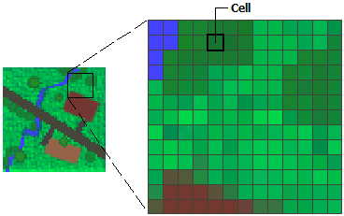

Figure 1: An example best illustrating a raster data map and the number of individual cells that a map of a small area may contain.
The benefits that raster data has in comparison to vector is its relatively high data volume, visually appealing and the fact that it inherently stores how features should appear in a GIS. The main disadvantages of raster data are that it includes no attribute information and has a slower display in comparison with vector data (Ordnance Survey, 2019).

2.1.2 Vector –
Vector data is best described as a list of values (Ordnance Survey, 2019) which can be divided in to three simple parts, that being, point, arc and polygon (Dempsey, C, 2017). Points are used to measure non-adjacent features and as you cannot measure height or length from this dataset they are used to mark the locations of non-mobile features such as schools, drains hospitals, etc (Dempsey, C, 2017). Arc data is used to represent streets and rivers etc for example, as they are linear features (Dempsey, C, 2017). Lastly, polygon features are two dimensional and as a result are suited to measuring the area or perimeter of a geographic feature (Dempsey, C, 2017).
Vector data allows the user to represent features of the real world within a GIS package (QGIS, 2019). These features are anything that can be seen on the landscape trees, buildings, roads and so forth (QGIS, 2019). The features in vector data can be assigned attributes which convey information about a feature in the form of text or numerical information (QGIS, 2019). The features in vector are recorded one-by-one with the shapes and positions of a building being taken as a series of four pairs containing numerical coordinates (Ordinance Survey, 2019).
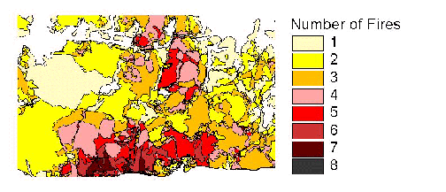
Figure 2: Demonstrates a polygon-based dataset which is exhibiting the frequency of fires in a defined area using a colour-based scale to measure number of fires in each region.

2.2 MapInfo:
The Pitney Bowes MapInfo software allows the user to create, manage and visualize geospatial data (GIS Geography, 2018). It places a focus on usability (GIS Geography, 2018). To facilitate geographic based data analysis, the MapInfo software allows the integration and analysis of disparate graphic/tabular data sets (Acuity Training, 2012). It has been used by businesses and departments in both the public and private sector since its release on to the commercial GIS market in 1986 (Acuity Training, 2012). An example of how MapInfo can be used would be the creation of a map that shows the geographic area covered by a specific postcode (Acuity Training, 2012).
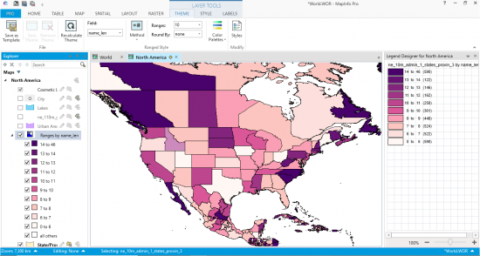
Figure 3: An image of the latest MapInfo Pro package being used to examine statistics on the North American continent.
The MapInfo software is compatible with other data analysis tools, such as spreadsheets and or databases allowing the user to integrate the MapInfo package with programs being used to gather and manipulate data (Acuity Training 2012). In the commercial GIS market, MapInfo recently gained a technological advantage over its main competitor ESRI’s ArcGIS following the release of its new 64-bit compatibility system forcing ESRI to release its own 64-bit system soon after (GIS Geography, 2018).
The software has a varied user base which include the following –
- Marketing
- Crime Analysis
- Natural Resources
- Insurance companies
- Environment
- Engineering
- Government
- Retail
(GIS Geography, 2018; ESRI, 2019)

Methodology:
To begin with, data first had to be obtained from the UK Data Service website regarding the Super Output Areas for the Swansea region. Additionally, data needed to be gathered from this same source to make the Townsend data map. Following this, maps could then be created using the MapInfo software package to highlight the areas which were the target of this report (SA1 & SA3) and determine deprivation scores of these areas respectively.
Although, this was not the only way that data was gathered. It was decided that students participating in the study were to have a set number of questionnaires handed to them each to have filled in by residents from a mix of both SA1 & SA3 postal districts of Swansea. This culminated in a total of 42 respondents having filled in the REAP Petite questionnaires. After the data had been collected it had to first be sorted (or cleansed) so that it was eligible to be used for assigning a Townsend Index Deprivation Score to both SA1 & SA3.
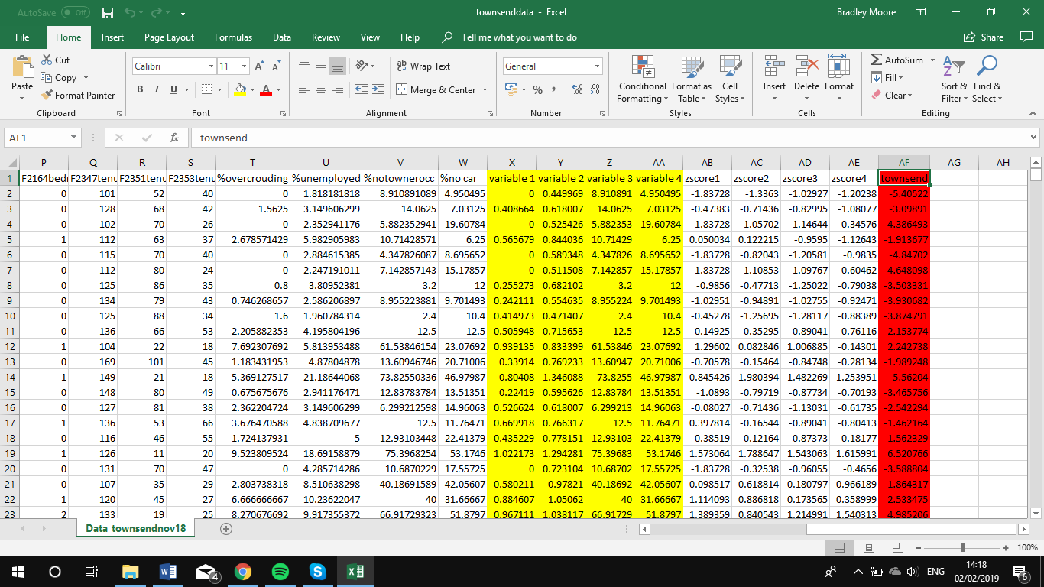
Figure 4: The way in which the Townsend Score was calculated in Excel is shown in this image with the Z-score needing to first be calculated by subtracting the mean value which would then be divided through standard deviation. Following this the Townsend Score could be determined by adding up the sum of the Z-score to get the final answer (Moore, 2019).
After obtaining the score from the Townsend Index Score, this info was then sent to a MapInfo workbook, this then allowed data to be analysed in the MapInfo package (Moore, B, 2019). Figure 5 is a screenshot exhibiting a portion of the data used by the MapInfo package that could be used to examine the deprivation in both SA1 & SA3.
There were differences in the way in which both the REAP & Townsend data were shifted in to MapInfo. For example, the Townsend data required geocoding of its data to an output area in order for it to join with MapInfo. Whereas REAP had to first be connected to MapInfo via postcodes its postcodes for transferal of its data.
The maps for the WIMD and Townsend statistics were then made with the addition of a theme which then enabled them to be transferred to the Swansea Super Output Area Map
Following these steps allowed for the creation of numerous maps highlighting which aided in highlighting themes in the data.
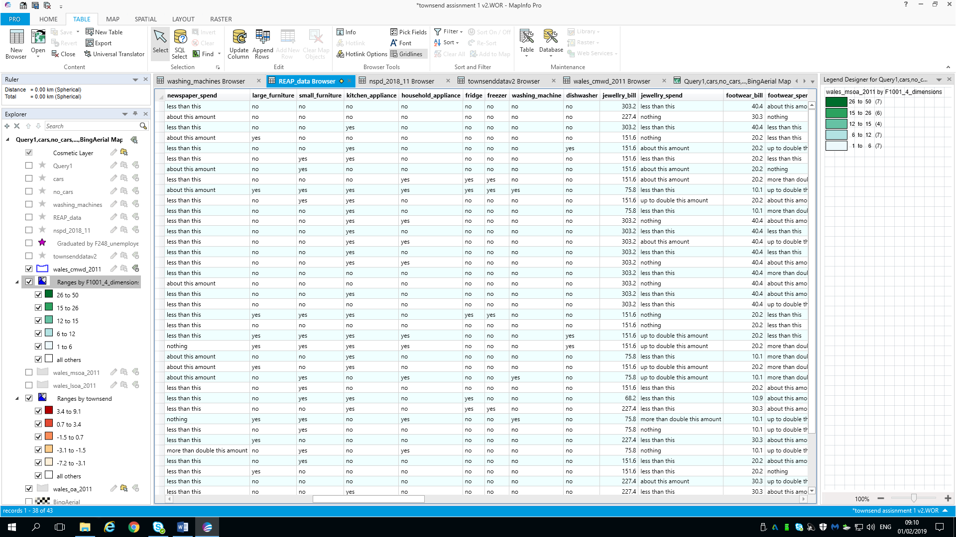
Figure 5: This image shows how the data from the Townsend and WIMD Scores appeared on the MapInfo display screen in the process of map creation.

Results
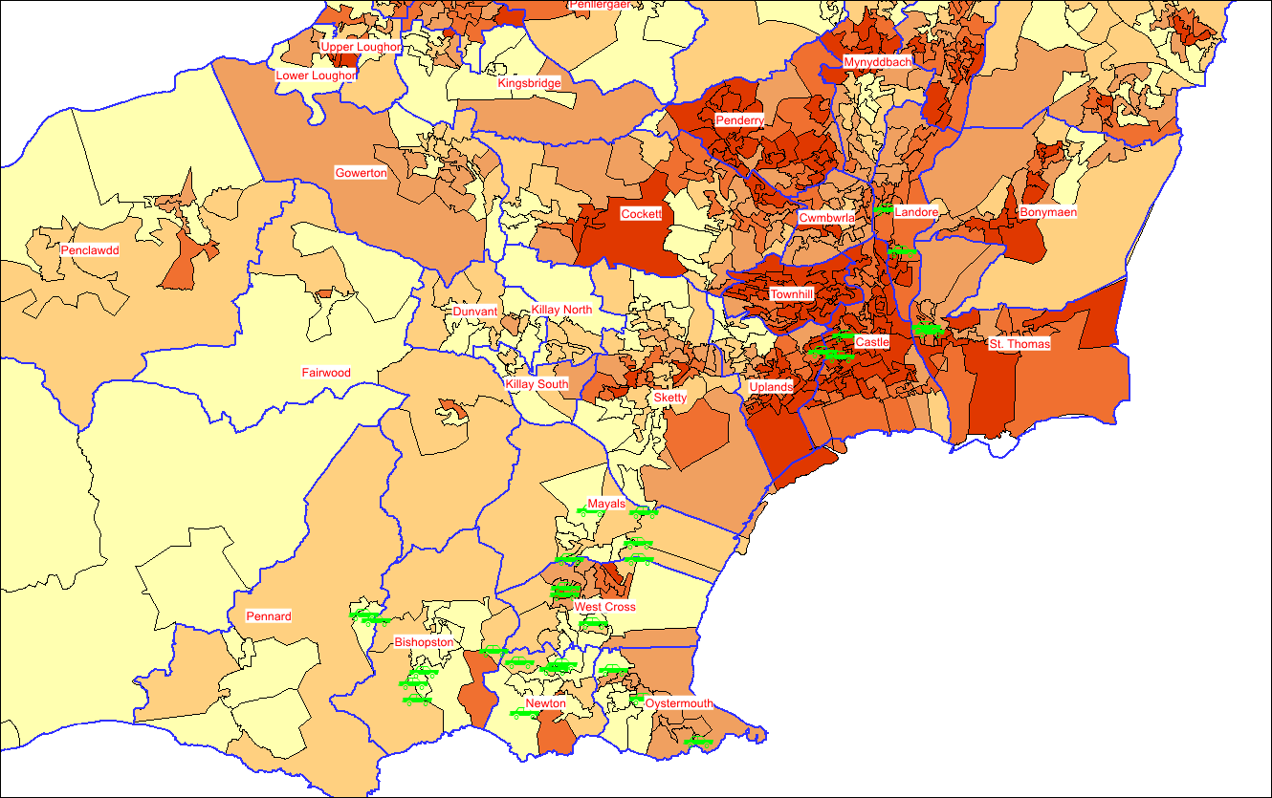
The following results are from fellow student B Moore (2019) who produced these maps using the results obtained by all students. The maps represent the results for the Townsend Index and WIMD score for deprivation within the SA1 & SA3 regions of Swansea which were all produced using the GIS MapInfo Pro software, therefore visually demonstrating this software’s versatility to in presenting a visually appealing and professional looking format –

Figure 6: This MapInfo map incorporates data from both car ownership and the Townsend Index Score (Moore, B, 2019).
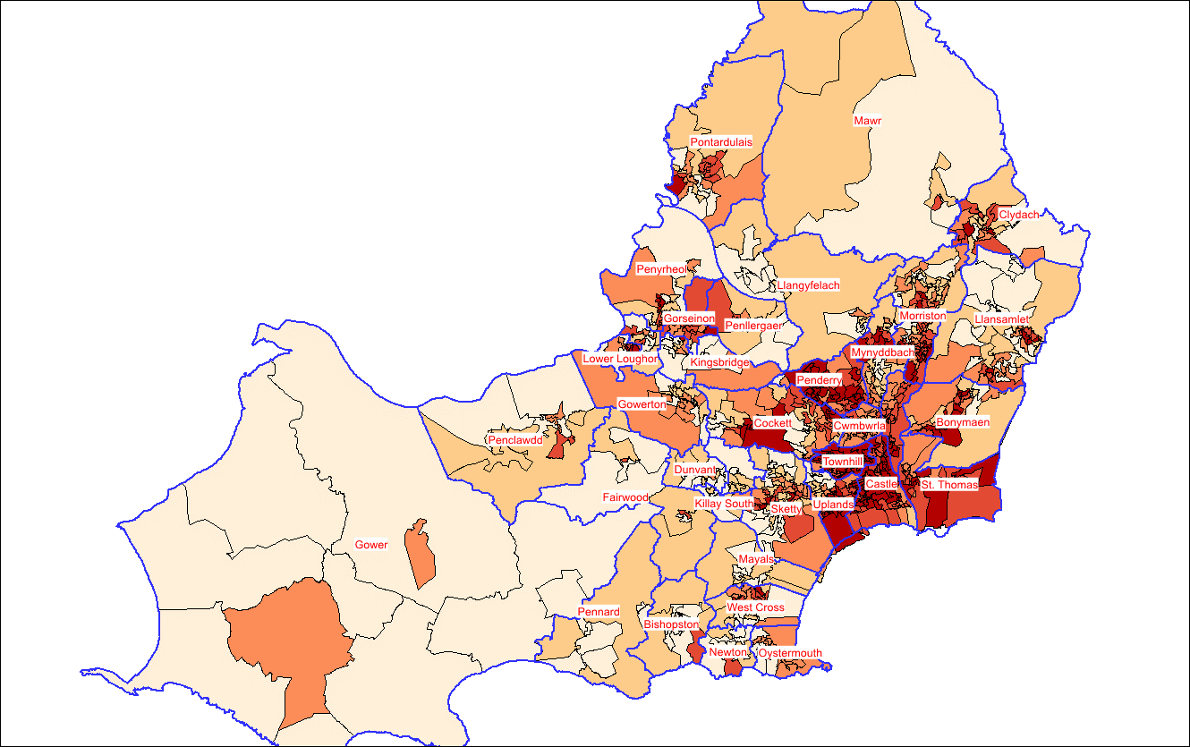
Figure 7: Townsend Index data results for Swansea exhibited in this map (Moore, B, 2019).
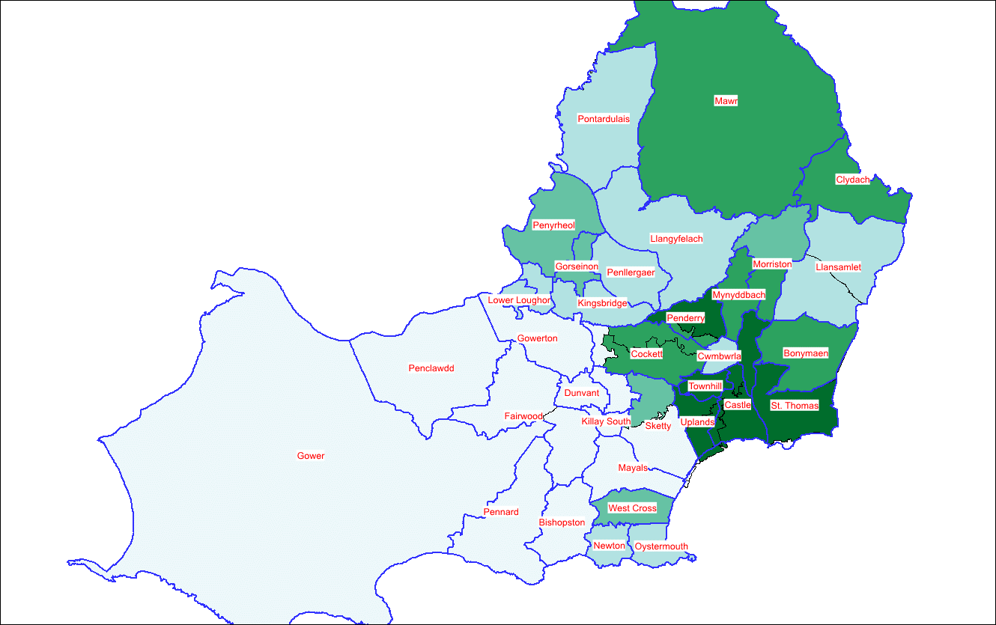
Figure 8: This map exhibits the results obtained from the Welsh Index of Multiple Deprivation that was applied to this region of Swansea (Moore, B, 2019).

Analysis:

5.1 Analysis of Deprivation Data –
In this report we examine two types of deprivation index – The Townsend Deprivation Index which analyses deprivation across the whole of the UK and then the Welsh Index of Multiple Deprivation (WIMD) which focuses on deprivation specifically in Wales and was designed by the Welsh Government.

5.1.1 Townsend Deprivation Index –
Developed by Peter Townsend in 1987, it is simply a census-based index focussing on material deprivation (UK Data Service, 2019). It calculates this by measuring four census variables –
- Households without a car
- Households that are non-property owners
- Number of persons unemployed
- Overcrowded Households
(University of Southampton, 2019)
The Townsend Index can be used on any geographical location that has census data available; UK census data usually updated every 10 years 1981, 1991, 2001, 2011. The index usually calculates areas such as wards, output areas and enumeration districts (Southampton University, 2019).
According to Townsend “deprivation is the consequence of a lack of income and other resources, which cumulatively can be seen as living in poverty” (Townsend, 1979). Townsend expanded on this by stating that poverty is “those people whose resources are so seriously below those commanded by the average individual or family that they are, in effect, excluded from ordinary living patterns, customs and activities” (Townsend, 1979).
It has long been used in trying to determine any relationships in health, crime, education and deprivation (UK Data Service, 2019) and with simplicity of the score and its use of readily-available data allows for it to be used to calculate any geographical areas that have census data available (University of Southampton, 2019).
This deprivation index has not been without its criticism as to its accuracy. The main issues are that data is often out-of-date due to the long time periods between the update to each national census (i.e. 10 year gap), this is particularly evident in housing tenure (PHAST, 2017). There are no estimates as to the proportion of people in an area who are suffering from deprivation (PHAST, 2017). Additionally, is has been argued that it is more suited to urban areas rather than rural (PHAST, 2017).

5.1.2 Welsh Index of Multiple Deprivation (WIMD) –
This is the means used by the Welsh Government to measure deprivation in different areas of Wales by examining eight separate factors each based off a range of different indicators –
- Income
- Employment
- Health
- Housing
- Access to Services
- Environment
- Community Safety
- Education
(NHS Wales, 2017)
It was designed to identify those small areas where there are the highest concentrations of several types of deprivation. It was designed to recognise areas where there are high concentrations of multiple different types of deprivation (Cardiff Council, 2017). It works by assigning a deprivation rank to over 1909 different areas in Wales known as LSOAs (Lower Super Output Areas), 1 being the most deprived and 1909 being the least (NHS Wales, 2017; Welsh Government, 2018). The WIMD which is updated every 4-5 years published its most recent index in 2014 (Stats Wales, 2019).
There are a few inconsistencies with the WIMD, firstly not all individuals that are classed as living in a deprived area are actually deprived, the area itself is not what is deprived but the circumstances and actions of the individuals inhabiting the area which influences the deprivation ranks (NHS Wales, 2017). The scores of the WIMD cannot be compared with other deprivation indexes such as the Townsend index as well as the fact that previous WIMD scores cannot be compared with updated ones (NHS Wales, 2017). Lastly, if an area is ranked the 50th most deprived area and another the 200th, it cannot then assume that one area is 4 times more deprived than the other (NHS Wales, 2017).
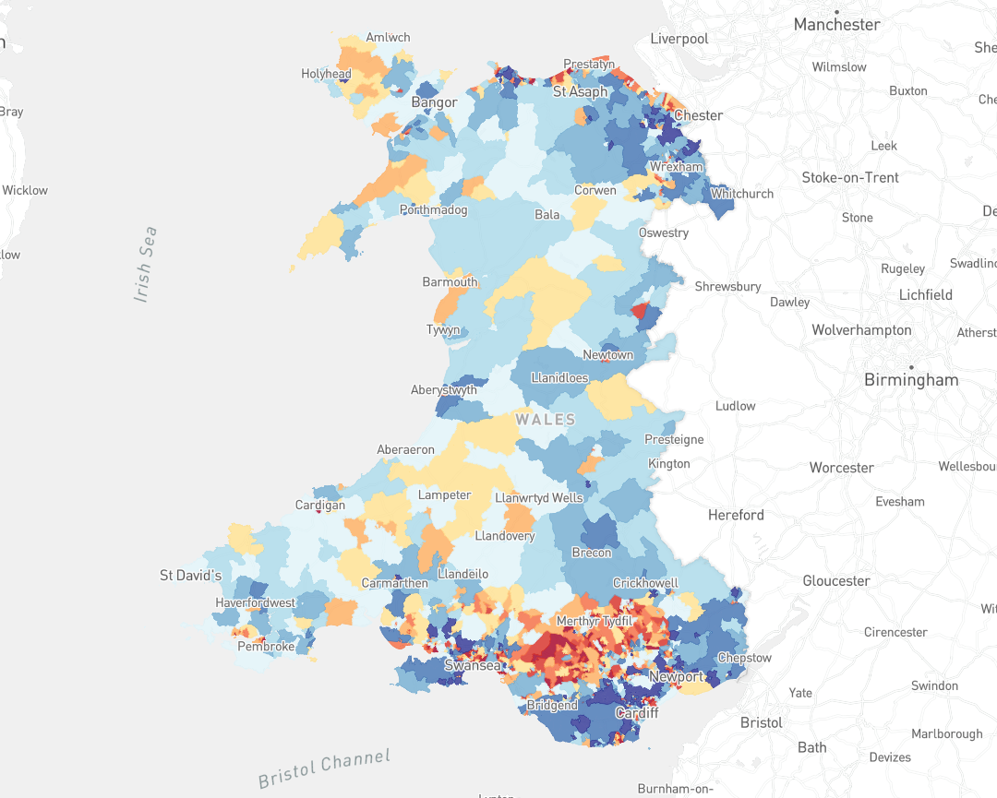
Figure 9: Map of the Welsh Index of Deprivation (2014) for the entirety of Wales.
The index is used not only to rank LSOAs from most-least deprived but is also used to analyse change over time. Additionally, the index allows for more speculative analysis by allowing comparison of multiple LSOAs to be compared to see variation in performance in the eight examined factors listed above (WIMD, 2014). Unlike the Townsend Index the WIMD is restricted to use in LSOAs in Wales only.

References:
Acuity Training. 2012. What is MapInfo and why do I need it. [Online]. [Accessed 10 February 2019]. Available from: http://www.mapinfo-training.co.uk/blog/what-is-mapinfo-and-why-do-i-need-it
ArcMap. 2016. What is Raster Data. [Online]. [Accessed 11 February 2019]. Available from: http://desktop.arcgis.com/en/arcmap/10.3/manage-data/raster-and-images/what-is-raster-data.htm
Cardiff Council. 2017. Welsh Index of Multiple Deprivation. [Online]. [Accessed 11 February 2019]. Available from: https://www.cardiff.gov.uk/ENG/Your-Council/Have-your-say/Area-Profiles/Welsh-Index-of-Multiple-Deprivation/Pages/default.aspx
Dempsey, C. 2017. Types of GIS Data Explored: Vector and Raster. 1 May. GIS Lounge. [Online]. [Accessed 10 February 2019]. Available from: https://www.gislounge.com/geodatabases-explored-vector-and-raster-data/
ESRI. 2019. What is GIS. [Online]. [Accessed 10 February 2019]. Available from: https://www.esriuk.com/en-gb/what-is-gis/overview
GIS Geography. 2018. MapInfo Professional by Pitney Bowes. [Online]. [Accessed 10 February 2019]. Available from: https://gisgeography.com/mapinfo-professional-pitney-bowes/
Holland, B, 2019. Conversation with Beverley Holland, 1 February.
NHS Wales. 2017. Welsh Index of Multiple Deprivation (WIMD). [Online]. [Accessed 10 February 2019]. Available from: http://www.publichealthwalesobservatory.wales.nhs.uk/wimd
Ordnance Survey. 2019. Raster and Vector Data. [Online]. [Accessed 11 February 2019]. Available from: https://www.ordnancesurvey.co.uk/support/understanding-gis/raster-vector.html
Public Health Action Support Team. 2017. Deprivation Measures. [Online]. [Accessed 10 February 2019]. Available from: https://www.healthknowledge.org.uk/public-health-textbook/research-methods/1c-health-care-evaluation-health-care-assessment/deprivation-measures
Poverty & Social Exclusion. 2016. Deprivation and poverty. [Online]. [Accessed 10 February 2019]. Available from: http://www.poverty.ac.uk/definitions-poverty/deprivation-and-poverty
QGIS Testing. 2019. Raster Data: Overview. [Online]. [Accessed 11 February 2019]. Available from: https://docs.qgis.org/testing/en/docs/gentle_gis_introduction/raster_data.html
QGIS Testing. 2019. Vector Data: Overview. [Online]. [Accessed 10 February 2019]. Available from: https://docs.qgis.org/2.8/en/docs/gentle_gis_introduction/vector_data.html
Stats Wales. 2019. Welsh Index of Multiple Deprivation. [Online]. [Accessed 10 February 2019]. Available from: https://statswales.gov.wales/Catalogue/Community-Safety-and-Social-Inclusion/Welsh-Index-of-Multiple-Deprivation
Trimble, J. 2014. Map of the Welsh Index of Multiple Deprivation (WIMD) 2014. Cardiff: Welsh Government.
UK Data Service. 2019. 2011 UK Townsend Deprivation Scores. [Online]. [Accessed 11 February 2019]. Available from: https://www.statistics.digitalresources.jisc.ac.uk/dataset/2011-uk-townsend-deprivation-scores
University of Southampton. 2019. Townsend Deprivation Index. [Online]. [Accessed 10 February 2019]. Available from: http://www.restore.ac.uk/geo-refer/36229dtuks00y19810000.php
Welsh Government. 2015. Statistics for Wales: Welsh Index of Multiple Deprivation. [Online]. Cardiff: Welsh Government. [Accessed 11 February 2019]. Available from: https://gov.wales/docs/statistics/2015/150812-wimd-2014-summary-revised-en.pdf
Welsh Government. 2014. Welsh Index of Multiple Deprivation 2014 (WIMD 2014). [Online]. Cardiff: Welsh Government. [Accessed 10 February 2019]. Available from: https://www.torfaen.gov.uk/cy/Related-Documents/Research-and-Citizen-Engagement/Statistics-and-Census-Information/141112-wimd-2014-guidance-en.pdf
Wisconsin University. 2019. Mapping and Geographic Information Systems (GIS) : What is GIS?. [Online]. [Accessed 11 February 2019]. Available from: https://researchguides.library.wisc.edu/GIS

