AGS Consulting System Research and methods
Table of Contents
0. AGS Consulting System Research and methods 1
1. Introduction 1
2. Objectives 1
2.1 Problems 1
2.2 Project scope 2
2.3 Investigation 2
3. Literature Review 3
3.1 Similar systems already created? 3
4. Approach and methods 5
Work plan 5
5. Project impact 6
6. Limitations 6
7. Ethical and legal considerations 6
8. Gantt chart 7
9. Bibliography 8

Introduction
AGS Consulting operates as a stand-alone single employee consulting firm, specialising in IT and Technical solutions. . They currently track the effort expended against each client project in an inconsistent manner, namely they rely on recollection and guess work to ensure the customer is appropriately charged, they recognise that this is wrong for both them and their customers; they wish to be seen as a trustworthy and thorough organisation. So my purpose system will be the fix to their wish of being seen as trustworthy and thorough organisation.

Objectives

2.1 Problems
The customer, AGS Consulting, has limited information about the detail of their requirements, has no data to support the accuracy of their current time recording system, and limited IT experience to support the project.

2.2 Project scope
The initial requirements and design phases will allow us to ensure we extract high-level details relating to the desired business outcomes, and also ensure that the solution we are proposing is heading in a direction that AGS Consulting sees as viable. Utilising an Agile delivery approach will then allow us to adapt our solution to meet the emerging needs of AGS Consulting as the project progresses.

2.3 Investigation
From my meetings with AGS Consulting I have gathered that they do not have any system or process in place to support their current method of recording time/effort for each customer, therefore I have approached the analysis with the assumption that it will need to start from a position of zero knowledge and will develop the solution based on a set on meetings and discussions with AGS Consulting (initially pre-project, and then on an on-going basis during the project delivery). The output of these meetings will be a set of agreed requirements, delivery schedule, budget, risk, assumption, issues, and dependencies.

Literature Review

3.1 Similar systems already created?

3.11 System 1 Get harvest
^{[1]}As a full package I could use an app called “Harvest” which tracks time spent, creates invoices with the calculations, and it’s very compatible with other project management tools and easy to integrate. Even comes with ways of payment options with PayPal, tripe and more
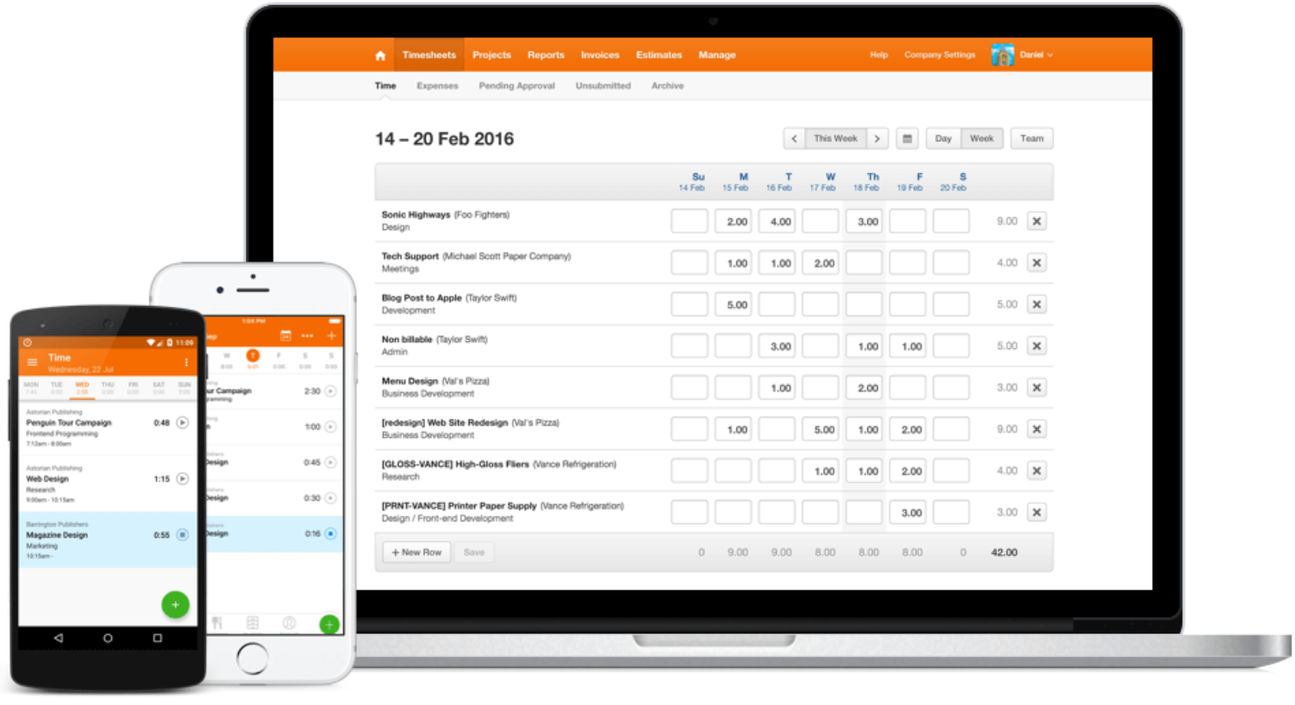
Figure 1 [1] Harvest Software
The cost of the app very depending on the number of employees AGS consulting have, $12 or £9 per person, no deals or multipack.

3.12 Review
On most website it gets mostly an above average review with this example giving below giving
^{[2]}Merchant maverick is known for review company products like this one

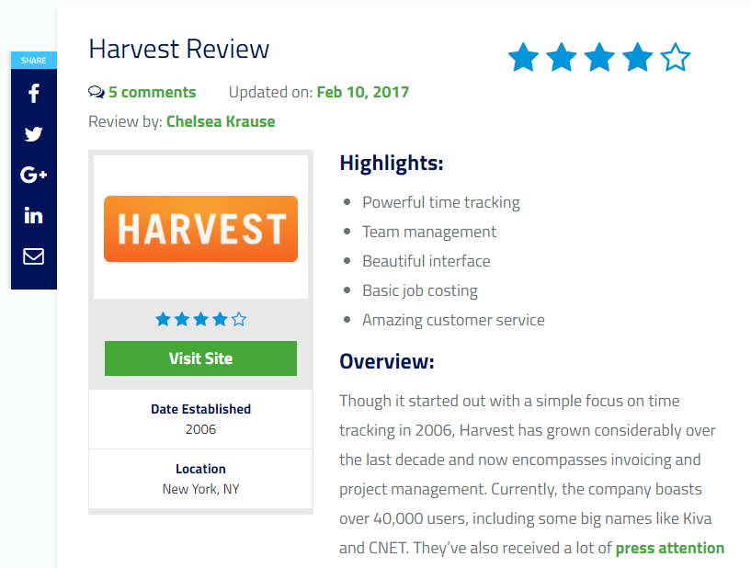
Figure 2 [2] Website Reviewer
Overall it speaks about what it does well and its presentation but it does underline some problems that “Harvest” has like:
No Dashboard – be nice to see the status of current projects, employee’s invoices and expenses all in one place instead of moving around the app
No Separate billing address – In the Client Manage section, there is no way to enter separate shipping and billing addresses
Not always intuitive – you don’t seem to find things where you would expect to find it for example expenses are entered under timesheets
^{[2]}Dollar sign (shouldn’t be a problem but perhaps other symbols are similarly odd) – Not sure what that symbol is supposed to be (supposed to be a dollar sign)
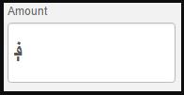

3.13 Evaluation
So what I can learn from this software is to try to not fall for its same mistakes on UI and make it easy for user to navigate the site without problem, and perhaps think about pricing of the product better depending on single and multi-use.

3.2 Open source option
^{[3]} “Account sight” is good example of open source software due to being well known and even praised for its pricing (when it comes to multi-use)
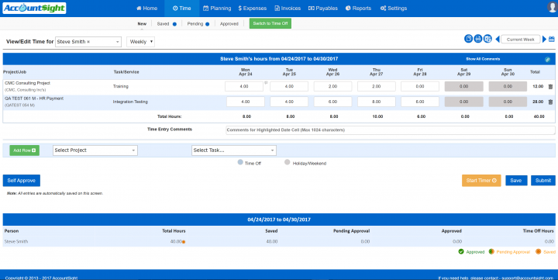
Figure 3 [4] Account sight software
^{[5]}The highest praise I find for this tool is that it’s easy to use, great for new people and those who haven’t used the software before. Also people find the quality of this to be “fantastic” and also are a great overall for project management, time tracking, and billing, expenses and resource management.
It does tend to be slow due to the number of features given from this product. Also getting support isn’t perfect, but mostly people find the software to “lag” or “stutter” a lot. So a few optimise issues do accrue.

Approach and methods
^{[6]}My approach has change due to my research into the creation on my system, and I now know what methods will be needed and how to approach such things. For example to allow my system to speak with a server and get access to data from it, the use of a SQL server and PHP to communicate it will be required, also HTML for the basic webpage function. Also other methods will need to be considered when creating this system like java/Jason/encrypting data and so on.

Work plan
^{[7]}I hope with using a Gantt chart, I will be able to keep track and perform these task before theses dates, as I’ve giving myself leeway between them. But I also got to consider as this being my first time using any real working plan, this will be a good test of how well I can stick to goals and keeping track of time, therefor I will be using other methods alongside this chart to ensure my tracking of time.

Project impact
The overall impact of this system will allow every employee who performs billable work to record and evidence the time they have expended against each project and task. It is hoped that this will improve the accuracy of billing, improve the efficiency of billing/charging, and provide a single source of information to allow AGS Consulting to improve the accuracy of the estimating processes. Overall saving the company money on more accurate data, being seen as honest and trustworthy to all customers and therefor receiving more clients.

Limitations
There are of course limitations to my current project. First of it needed to be done within 8 months, the cost of needed depending on what root is chosen (e.g. purchase a premade web page) and also cost for my time spent on this project, my current skill set is new to this so I will be imitated due to time (learning). Lastly the company itself I’m working with, will they know what they want, will communication be quick and effective and so on.

Ethical and legal considerations
^{[8]}The biggest problem that must be considered when creating this system is the “Data Protection Act” this system will be holding information on all users, so security must be discussed to ensure no data to be lost/stolen/misused. Also there are to be future changes to the DPA so preparation to ensure we follow such rules must be applied accordingly.

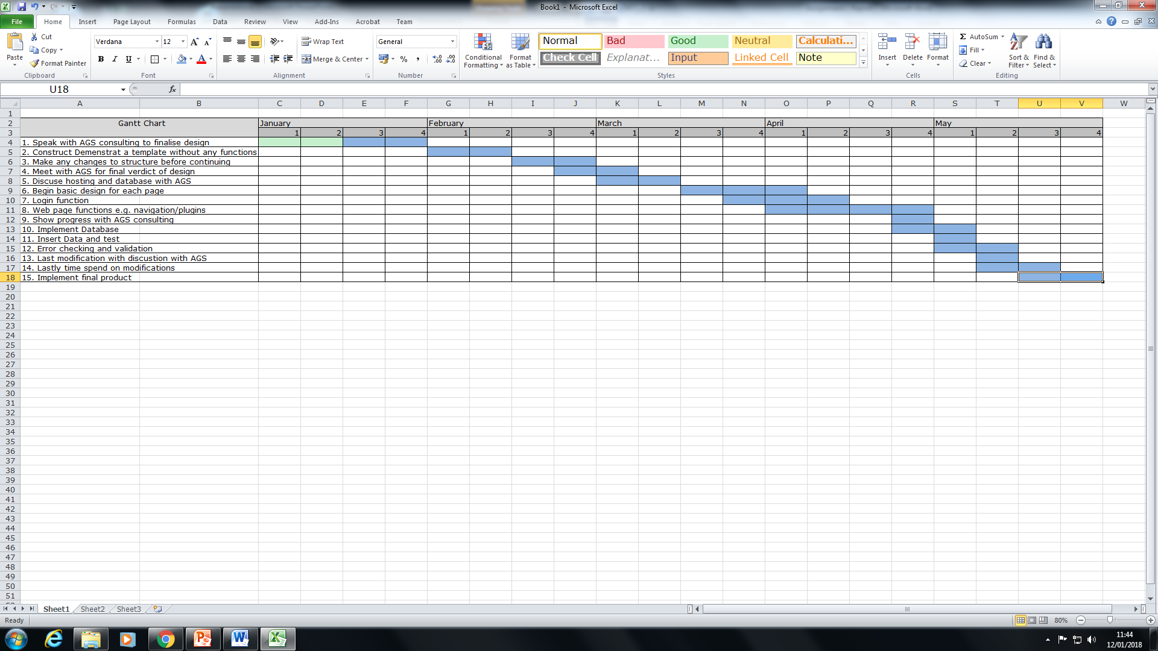
Gantt chart

9. Bibliography
[1] Liu, Shawn; Business tracker; 2006-2017; Harvest; https://www.getharvest.com/; 02/10/2017
None open source product, similar to what I am designing
[2] Founder: Amad Ebrahimi; Writer: Tom Desimone; Harvest Review: 10/02/2017; MerchantMaverick; https://www.merchantmaverick.com/reviews/harvest-review/; 02/10/2017
Reviews on such product
[3] N/A, N/A; Business tracker; 2013-2017; AccountSite; https://www.accountsight.com/; 02/10/2017
Gathing information about the program
[4] N/A, N/A; Google Search; Accountsite software; https://blog.capterra.com/wp-content/uploads/2016/05/Accountsite-720x361.png; 02/10/2017
Image
[5] Review Site; Software advice; January 2018; https://www.softwareadvice.com/uk/psa/accountsight-profile/; 05/01/2018
Account sight review
[6] roughsealtd; 11/10/2010; https://www.youtube.com/watch?v=M-X--_0Z6xs; 12/01/2018
Understand how php speaks with SQL
[7] Gantt chart guide; Project Manager; n/a; https://www.projectmanager.com/gantt-chart; 13/12/2018
[8] Data protection act; 1998; https://www.legislation.gov.uk/ukpga/1998/29/contents; continues

