

Evaluating Statistical and Machine Learning Time Series Forecasting Techniques for Public Sector Decision Making

by
Jonathan Wilcox

Supervisor: Mark Huntly

Project submitted as part of the requirements for the award of
BSc (Hons) Computing (Data and Information Systems)

July 2026

Declaration

I, Jonathan Wilcox declare that I am the sole author of this Project; that all references cited have been consulted; that I have conducted all work of which this is a record, and that the finished work lies within the prescribed word limits.

This work has not previously been accepted as part of any other degree submission.

Jonathan Wilcox:
Date: 20/07/2026

Form Of Consent

I Jonathan Wilcox hereby consent that my Project, submitted in candidature for the B.Sc.(Hons) Computing (stream) degree, if successful, may be made available for inter-library loan or photocopying (subject to the law of copyright), and that the title and abstract may be made available to outside organisations.

Jonathan Wilcox:
Date: 20/07/2026

Abstract
This project investigates how statistical and machine learning time series forecasting models compare in accuracy when applied to operational data within a public sector organisation, and whether presenting the outputs through a Business Intelligence (BI) dashboard can help support improved decision-making. The aim of the project was to design, implement, and evaluate multiple forecasting models and determine their suitability for supporting decision-making when used in an interactive BI dashboard.

To achieve this aim, three forecasting models were implemented and compared: ARIMA, Prophet, and the machine learning model XGBoost. The models were trained and evaluated using the same operational transaction datasets from four DVLA transaction services. Forecast accuracy was assessed using widely used evaluation metrics including Mean Absolute Error (MAE), Root Mean Squared Error (RMSE), and Mean Absolute Percentage Error (MAPE). A Diebold–Mariano statistical test was also used to determine whether differences in forecasting accuracy between models were statistically significant by comparing their forecast errors. Forecast outputs were integrated into a BI dashboard that allows users to visualise trends, compare model predictions, and view forecasting performance interactively. A short questionnaire was completed with end users to evaluate the usability of the dashboard.

The experimental results showed that XGBoost consistently produced the lowest forecasting errors over all datasets investigated. However, Diebold–Mariano testing indicated that these improvements were only statistically significant in two of the four model comparisons. This suggests that while machine learning techniques can provide better predictive performance, traditional statistical models such as ARIMA and Prophet are still competitive depending on the characteristics of the data and may offer advantages when it comes to model interpretability. User feedback indicated that the BI dashboard improved the understanding and interpretation of forecasting results.

Overall, the project shows that combining forecasting models with interactive BI dashboards can improve analytical insights and support operational decision-making within public sector organisations. The results clearly show that machine learning methods provide the best predictive performance, while traditional statistical models such as ARIMA remain competitive depending on the characteristics of the dataset.
Table of Contents
Abstract 3
List of Figures 7
List of Tables 8
Abbreviations 9
1. Introduction 10
2. Research & Review of Literature 12
2.1 Introduction to the Literature Review 12
2.2 Data Analytics in the Public Sector 12
2.3 Business Intelligence Systems and Dashboard Design 14
2.4 Time Series Forecasting Techniques 15
2.4.1 Statistical Forecasting Models 16
2.4.2 Machine Learning Forecasting Models 17
2.4.3 Comparison Methods 19
2.5 Forecast Evaluation Metrics and Model Assessment 20
2.6 Summary of Literature and Identified Research Gap 22
3. Research Methodology 24
3.1 Introduction 24
3.2 Research Philosophy and Design 24
3.2.1 Research Philosophy 24
3.2.2 Research Approach – Deductive and Experimental 25
3.2.3 Research Strategy – Experimental Case Study 25
3.2.4 Time Horizon 26
3.3 Experimental Design 26
3.4 Experimental Workflow 27
3.5 BI Dashboard Development 29
3.6 Hardware Resources 29
3.7 Software Resources 29
3.8 Ethical Issues 29
3.9 Validity, Reliability & Generalisability 29
4. Design 31
4.1 Introduction 31
4.2 Design 31
4.2.1 Requirements 31
4.2.2 Forecasting Script Design 33
4.2.4 Dashboard Design 35
5. Implementation 36
5.1 Forecasting Script Implementation 36
5.1.1 Data Loading and Preparation 36
5.1.2 Exploratory Data Analysis 37
5.1.3 Feature Engineering 38
5.1.4 Model Development 39
5.1.5 Model Evaluation 40
5.1.6 Exporting Results for Dashboard Integration 41
5.2 Power BI Dashboard Implementation 42
5.2.1 Data Import and Integration 42
5.2.2 Data Model Design 43
5.2.3 Dashboard Visualisation Pages 44
6. Results 46
6.1 Experiment Results 46
6.1.1 I Want a Provisional Driving Licence 46
6.1.2 I Want to Renew My Driving Licence 47
6.1.3 I Want to Register a Vehicle 47
6.1.4 I Want to Tax My Vehicle 48
6.1.5 Summary of Experimental Results 49
6.2 Dashboard Evaluation Results 50
6.2.1 Questionnaire Design 50
6.2.2 Participant Feedback 50
6.2.3 Summary of Findings 50
7. Evaluation 51
8. Conclusions & Recommendations 53
8.1 Conclusions 53
8.2 Recommendations and Future Work 54
9. Reflection 55
References 57
BIBLIOGRAPHY 61
APPENDIX A – Dashboard Design 62
Front Cover 62
Trends Page 62
Forecast Page 63
Forecast Evaluation 63
APPENDIX B – Questionnaire 64
APPENDIX C – Link Script Video Demo 65

List of Figures
Figure 1. Formula for Mean Absolute Error 22
Figure 2. Formula for Root Mean Squared Error (RMSE) 22
Figure 3. Formula for Mean Absolute Percentage Error (MAPE) 22
Figure 4. Formula for Mean Absolute Scaled Error (MASE) 23
Figure 5. MoSCoW analysis of project tasks based on priority and time constraints. 33
Figure 6. Forecast pipeline design 34
Figure 7. Dashboard design wireframe 36
Figure 8. Sample Code - Data Loading and Preparation 37
Figure 9. Sample Code - Ability to skip a model based on config file parameters 38
Figure 10. Seasonal Decomposition chart output example 39
Figure 11. Time based features used in the XGBoost Model 40
Figure 12. Example Prophet Model used to predict 12 months of data. 41
Figure 13. Example ARIMA Model Hyperparameter tuning 41
Figure 14. Example of recording and plotting of evaluation metrics 42
Figure 15. Outputting model results and evaluation metrics 43
Figure 16. Power Query transformations 44
Figure 17. Power BI data model 45
Figure 18. Power BI forecast page displaying 12-month forecast 46
Figure 19. Power BI forecast Review displaying test vs prediction 46

List of Tables
Table 1 - Comparison of Time Series Forecasting Techniques 21
Table 2: Want a Provisional Driving Licence - evaluation metric results 47
Table 3: I Want a Provisional Driving Licence - Diebold–Mariano test results 47
Table 4: I Want to Renew My Driving Licence - Evaluation metric results 48
Table 5: I Want to Renew My Driving Licence - Diebold–Mariano test results 48
Table 6: I Want to Register a Vehicle - Evaluation metric results 48
Table 7: I Want to Register a Vehicle - Diebold–Mariano test results 49
Table 8: I Want to Tax My Vehicle - Evaluation metric results 49
Table 9: I Want to Tax My Vehicle – Diebold – Mariano test results 49
Table 10: Dashboard questionnaire summary 51

Abbreviations
Abbreviation | Full Term
ARIMA | AutoRegressive Integrated Moving Average
BI | Business Intelligence
DVLA | Driver and Vehicle Licensing Agency
KPI | Key Performance Indicator
LSTM | Long Short-Term Memory
MAE | Mean Absolute Error
MAPE | Mean Absolute Percentage Error
MASE | Mean Absolute Scaled Error
ML | Machine Learning
NAO | National Audit Office
RMSE | Root Mean Squared Error
SARIMA | Seasonal AutoRegressive Integrated Moving Average
XGBoost | eXtreme Gradient Boosting
ARIMA | AutoRegressive Integrated Moving Average
SVR | Support Vector Regression
BI | Business Intelligence
DVLA | Driver and Vehicle Licensing Agency
KPI | Key Performance Indicator
SQL | Structured Query Language
DM | Diebold–Mariano

1. Introduction
Data plays a vital role in supporting strategic planning and operational decision-making within public sector organisations. While government departments collect large volumes of data, the tools used to analyse and forecast this data have not always kept pace with increasing complexity and scale. Many public sector organisations continue to rely on spreadsheet-based tools, such as Microsoft Excel, due to their familiarity and ease of use [1], [2]. These tools have many limitations in relation to scalability, automation, error management, and the ability to apply advanced analytical and forecasting techniques.

The Driver and Vehicle Licensing Agency (DVLA) spreadsheet-based approaches are commonly used for reporting operational volumes and producing forecasts to support planning and resourcing decisions. As data volumes increase and decisions become more time-sensitive, reliance on manual spreadsheet processes can restrict effective use of the data. Spreadsheet forecasting functions are often limited to basic statistical methods and are not suited to modelling complex and large datasets. This can result in reduced forecast accuracy, increased manual intervention, and potential impacts on the quality of the decision-making.

Business Intelligence (BI) systems offer a alternative to these legacy approaches. Modern BI platforms are designed to manage large datasets, automate data processing, and present information through dashboards. When combined with advanced time series forecasting techniques, BI dashboards can provide predictive insights that support evidence-based decision-making. Although there is widespread adoption of these techniques in the private sector, there is limited evidence of their use and effectiveness within public sector organisations [3]. To address these challenges, this project focuses on evaluating statistical and machine learning time series forecasting techniques for public sector decision support.

The main research questions explored in this project is:

- How do statistical and machine learning time series forecasting models compare in forecasting accuracy when applied to operational data in a public sector organisation?
- Does presenting forecasting outputs through a Business Intelligence dashboard improve the interpretation and use of forecasting information for decision-making?
The overall aim of this project is:

- To design, implement, and evaluate multiple time series forecasting techniques, including machine learning approaches, to determine their suitability for supporting decision-making within a public sector organisation.
To achieve this aim, the project focuses on four main objectives that include:

- Conduct a critical review of academic and industry literature relating to Business Intelligence systems and time series forecasting within public sector contexts to identify existing approaches, limitations, and research gaps.
- Design and develop a BI dashboard that integrates forecasting models with interactive visual reporting features.
- Implement and evaluate multiple forecasting techniques using appropriate statistical accuracy metrics.
- Assess the usability and effectiveness of the developed dashboard in supporting decision-making using user feedback collected through a survey.

This report describes the process and outcomes of the project. It begins with a review of relevant literature, the methodology is then outlined, including the research approach, forecasting methods, and evaluation techniques used. The design and implementation of the forecast-driven BI dashboard are discussed and presented, followed by an assessment of the project's outcomes against the initial aims and objectives. Finally, the report concludes with a summary of key findings, recommendations for future work and a reflection of the project.

2. Research & Review of Literature

2.1 Introduction to the Literature Review
This section reviews academic and industry literature on public sector data analytics, decision-support approaches, time series forecasting techniques, and model evaluation methods. The review looks at both technical and organisational perspectives and provides a basis for the methodology used in this project.

Forecasting supports decision-making by helping organisations predict future trends rather than relying only on historical reporting [4]. Time series forecasting uses historical data to identify patterns and generate future predictions [5]. Techniques range from traditional statistical models to machine learning methods and have been applied across many industries. However, their effectiveness depends on factors such as data quality, access to data, and organisational limitations. In the public sector, further challenges include legacy systems, strict data governance requirements, and the need for transparency.

The literature review first examines public sector data analytics, including spreadsheet-based tools and their limitations. It then considers adoption challenges, including skills gaps and governance issues that can restrict advanced analytical solutions. The review also examines BI systems and dashboard design as tools for presenting insights to decision-makers. It then compares statistical and machine learning forecasting techniques, before reviewing evaluation metrics used to assess model performance.

2.2 Data Analytics in the Public Sector
The public sector increasingly rely on data to support decision-making, resource allocation, and service delivery. However, many public sector bodies continue to rely on legacy analytical tools, particularly spreadsheet-based software such as Microsoft Excel [2]. Within organisations such as the DVLA, Excel is widely used due to its availability, familiarity, and integration with the Microsoft Office platform. However, existing research suggests that continued reliance on these tools creates challenges as data volumes and analytical requirements increase.
Government and audit reports indicate the critical need to move away from spreadsheet-based software towards more advanced data platforms. The UK Government’s digital transformation strategy advises the adoption of modern analytics systems that support real-time reporting, automation, and predictive analytics [1]. A National Audit Office report highlights weaknesses in the current public-sector data approaches due to outdated analytical methods [2]. Together, these sources confirm a clear strategic objective to modernise public sector data analytics, while also acknowledging ongoing challenges with legacy systems and continued reliance on familiar reporting methods.
Academic research further identifies several limitations of spreadsheet-based tools. Research shows that Excel performs poorly with large, complex datasets, often resulting in slow processing and system issues, for example freezing [6]. Other studies demonstrate that spreadsheet-based analysis consumes significantly more compute power than programming-based alternatives such as Python or R, even for simple analytical tasks [7]. These limitations limit scalability, automation, and the implementation of advanced forecasting techniques. In recent years, operational data volumes and reporting frequency have increased, making manual spreadsheet-based processes ever more difficult to manage effectively. In addition, research shows that spreadsheet tools are often liable to human error due to manual data manipulation requirements and limited validation functions, which can lower data quality and reduce customer confidence in their results [8].
Existing research clearly highlights the technical shortcomings of legacy tools, however, another key limitation relates to organisational culture and resistance to adopting new technology. Public sector organisations are often risk-averse, operate within strict governance guidance and face accountability requirements that can discourage experimentation with unfamiliar tools. As a result, the ease of use of legacy systems and concerns around transparency continue to reinforce reliance on established spreadsheet-based methods [8].
In addition to technical and organisational restrictions, a recent government report highlights a skills gap within public sector that limits the adoption of advanced analytics [9]. At the DVLA, many staff responsible for data analysis are not formally trained in programming tools or advanced forecasting methods, resulting in continued reliance on spreadsheets. This skills gap restricts the use of more sophisticated forecasting models, even where organisational data would justify their use. Excel's built-in forecasting functionality is limited to basic techniques and provides limited support for model evaluation, comparison, or automation. This limits public sector organisation’s ability to assess forecast accuracy and build trust in their outputs.
Much of the existing literature on advanced analytics adoption focuses on private-sector case studies, which limits its relevance to public-sector contexts. For example, studies such as Wilkinson et al. [10] and Shatat et al. [11] demonstrate the effectiveness of advanced dashboards and analytics tools in improving decision-making and operational performance within sales focused organisations. These studies assume higher levels of technical expertise and fewer organisational data constraints than are normally present within public-sector environments. While they highlight positive performance outcomes, they place less emphasis on issues of usability and interpretability, which are critical in public-sector organisations. As a result, there remains limited research examining how advanced forecasting techniques can be introduced, evaluated, and adopted within a public-sector setting where transparency and accountability are essential.
Overall, the literature review indicates that while legacy spreadsheet tools remain embedded within the public sector, they are becoming outdated with the demands of modern data analytics and forecasting. Technical limitations, organisational reluctance, and skills constraints create barriers to the adoption of advanced forecasting methods. This highlights the need for a solution that evaluates modern forecasting techniques within a public sector setting, while also considering usability and organisational policies.

2.3 Business Intelligence Systems and Dashboard Design
BI systems are widely used to support organisational decision-making by transforming raw data into meaningful, actionable information. BI is defined as a set of methods, processes and technologies that transform raw data into meaningful and valuable information to support decision-making [12]. BI systems can be used as a delivery tool, enabling decision-makers to interpret analytical results and monitor performance more effectively than relying on raw code outputs, by presenting results through visualisations and reports that are understandable and usable for non-technical users.

Modern BI platforms combine data from multiple data sources, automate reporting processes, and provide dashboards that allow users to explore data dynamically [13]. These abilities give a business faster access to information and reduce reliance on manual reporting. BI has become an important component of data-driven decision-making strategies across many sectors.

Dashboards are a key component of BI systems and play a crucial role in communicating analytical outputs to end users. Dashboards provide visual overviews of key performance indicators (KPIs) and trends, enabling users to quickly understand complex data. Research on dashboard design identifies several important principles, including clarity, relevance and consistency. Effective dashboards avoid unnecessary visual complexity, prioritise key metrics, and present information in a clear format [14]. Interactivity, for example, filtering, drill-downs, and tooltips are essential for enabling users to explore underlying data and gain deeper insight from results.

Interactivity is particularly important when showing forecasting outputs in the public-sector, research shows that interactive dashboard features improve interpretability for non-technical users [14]. Forecasting models produce predictions that may influence operational planning and resource allocation, this means users must understand the predicted values but also the underlying trends and performance metrics. Interactive dashboards enable users to explore historical data, compare actual versus forecasted values, and investigate accuracy measures, improving transparency and confidence in the results. In public sector settings, where accountability and explainability are essential, this transparency supports more informed decision-making.

Most research on BI systems is based on private-sector case studies, with limited evidence relating to public-sector effectiveness. For example, Shatat et al. [15] evaluated the implementation of BI dashboards in a commercial organisational setting. They found that BI adoption improved decision-making speed, leading to better customer service outcomes. The study also reported reductions in manual reporting and improvements in the communication of analytical results. However, the evaluation focuses mainly on performance and efficiency within a commercial environment, with less focus on issues such as interpretability, governance, and accountability. In another study, Khan [4] showed that transitioning from Excel to a BI dashboard with Machine learning forecasting increased prediction accuracy to 92%. These findings show the potential value of BI dashboards as a decision-support tool. However, their relevance to public-sector organisations remains uncertain due to a difference in organisational conditions and decision-making requirements.

While UK government strategies promote the use of dashboards and data-driven decision-making, there is relatively little research evaluating how BI systems perform in real public sector environments [9]. Existing studies focus on policy objectives and technical capabilities rather than looking at usability, interpretability, and organisational effectiveness. This highlights a clear gap in the literature, where there is a need for research to assess how dashboards support the interpretation of analytical and forecasting outputs, how users interact with predictive information, and whether BI systems can improve decision-making in the public sector.

A BI dashboard is not the primary focus of this project but is a critical supporting tool for delivering forecasting results. The dashboard will need to present forecast outputs in an interpretable format, enabling users to explore trends, easily assess forecast accuracy, and understand predictive insights. The final output will need to prioritise usability, transparency, and interactivity to help earn trust in the forecasting models and ensure that analytical results can be clearly communicated to decision-makers. This will address gaps identified in the literature review by evaluating BI dashboards specifically for forecasting insights in a public-sector environment.

2.4 Time Series Forecasting Techniques
Time series forecasting is an important part of data analytics and decision-support systems, enabling organisations to predict future values by identifying patterns and trends within historical data [16]. In the public sector, forecasting is widely used to support operational planning, resource management, and performance monitoring, where accurate predictions can directly influence staffing levels, service availability, and policy decisions. As data volumes andcomplexity have increased, traditional forecasting approaches such as reliance on Microsoft Excel’s built-in functions are becoming increasingly insufficient, particularly when applied to large or complex datasets [2].
Existing research indicates there is a shift from traditional statistical forecasting techniques towards machine learning approaches. While statistical models remain widely used due to their transparency and interpretability, recent studies increasingly focus on improving predictive accuracy through data-driven machine learning techniques. However, this progression also introduces new challenges, including increased model complexity, reduced interpretability, and deployment issues, particularly within public sector environments. This section critically reviews the main time series forecasting techniques used today, comparing their effectiveness, limitations, and suitability for the public sector.

2.4.1 Statistical Forecasting Models
Statistical forecasting models are widely used in time series analysis due to their transparency, interpretability, and relatively low computational requirements. Common approaches include AutoRegressive Integrated Moving Average (ARIMA), Seasonal ARIMA (SARIMA), and more recent statistical models such as Facebook’s Prophet. These techniques are frequently applied where explainability is essential for decision-making [17], [18]. ARIMA models generate forecasts by modelling relationships between current and past observations, removing long-term trends through differencing, and correcting predictions using patterns in historical forecast errors. SARIMA extends this method by introducing seasonal parameters, enabling the modelling of seasonal patterns [19].
Kumar et al [20] used ARIMA to predict concentrations of multiple air pollutants using historical time series data. The study demonstrates that ARIMA can produce accurate forecasts and is suitable for decision making that requires transparent and interpretable models. However, the evaluation is limited to a single approach and does not compare ARIMA performance against alternative forecasting techniques, restricting insight into its effectiveness.
Further research highlights how often ARIMA and SARIMA are used to benchmark models against newer more advanced techniques. Hasan et al. [18] used a SARIMA model as a baseline for comparison with more advanced forecasting techniques, including Prophet. While Prophet achieved improved forecasting accuracy, the study reported that SARIMA still produced reliable results, supporting its role as a relevant model, even against more advanced methods.
A study by Makridakis et al. [21] analysed the results of large-scale time series forecasting competitions, comparing the performance of statistical and machine learning methods using accuracy measures such as MAPE and MASE. Their findings showed that traditional statistical methods remained highly competitive with machine learning approaches and in many cases outperformed more complex models. However, no single method consistently outperformed others across all datasets. These findings suggest that while ARIMA and similar statistical models perform strongly for structured and stable time series data, forecasting performance can decrease when the data becomes more complex and less linear.
Prophet is a more recent additive statistical forecasting model designed to simplify forecasting for business and operational datasets. It is based on a regression model that decomposes a time series into three components trend, seasonality, and holiday / event effects [22]. Compared to ARIMA models, Prophet requires less parameter tuning and is more robust to missing data and outliers, making it suitable for forecasting scenarios where data quality may be inconsistent. Although Prophet often improves on traditional methods, it is limited with the same issues as ARIMA when looking at non-linear datasets.
A study by Fuller et al. [23] compared ARIMA and Prophet models for forecasting malaria in Uganda. Model performance was evaluated using MAE, MAPE, and RMSE, where lower values indicate better predictive accuracy. The study found that ARIMA beat Prophet at both national and regional levels. Nationally, ARIMA achieved a MAPE of 11.9 compared to 23.9 for Prophet. Regionally, ARIMA performed better in 14 of 15 regions. However, both models still achieved low MAPE values showing there were both capable of achieve good forecasting accuracy.
Despite their strengths, statistical forecasting models have limitations and are best suited to linear data and often find it difficult to capture non-linear patterns. However, despite the growing adoption of machine learning techniques, statistical forecasting models remain viable due to their transparency and interpretability. In public sector environments, where explainability and accountability are essential, these features continue to play an important role in decision-support systems. In addition, statistical models offer a valuable baseline reference, enabling machine learning forecasts to be evaluated, validated, and compared against transparent and understood benchmarks.

2.4.2 Machine Learning Forecasting Models
Machine learning (ML) forecasting models can capture complex, non-linear relationships that traditional statistical methods often find difficult to model [24]. Common ML models used in time series forecasting include Long Short-Term Memory (LSTM) networks and tree-based methods, such as eXtreme Gradient Boosting (XGBoost) [25], [26].

LSTM networks are a type of forecasting model designed to work with time series data by identifying meaningful patterns from historical observations and using them to predict future values. LSTMs can remember relevant historical patterns over longer periods, making them effective for identifying trends and changes in complex datasets. These models process data step-by-step over time, deciding which information to remember, update, or discard. At each step, the model receives new data alongside information retained from previous observations and decides which past patterns remain relevant for forecasting. By selectively retaining important historical information and ignoring less useful data, LSTMs can recognise long-term temporal patterns more effectively than traditional models [25].

Bandara et al. [27] evaluated LSTM-based models on a range of time series datasets and reported improved accuracy compared to statistical approaches such as ARIMA. However, the study also highlights that LSTM models introduce greater complexity and do not consistently deliver significant accuracy improvements on simpler or more stable datasets. This suggests that LSTM-based approaches may be unnecessary for low-complexity forecasting problems.

Another widely used approach to time series forecasting is tree-based ensemble methods, such as XGBoost, which model relationships in data using decision trees. Rather than relying on a single model, XGBoost combines the outputs of many simple decision trees, with each tree focusing on correcting errors made by previous ones. For time series forecasting, historical values and time-based features are used as inputs, allowing the model to learn patterns and relationships that allow accurate future predictions. Compared to LSTM models, XGBoost typically requires less training time and fewer computational resources, while still delivering a strong predictive performance [28].

Kumar et al. [29] analysed 15 years of hourly traffic data to evaluate the performance of Prophet and XGBoost models for traffic forecasting. The study highlights good results for both models, producing MAPE scores of less than 5% for short-term prediction and MAPE of less than 10% for long-term prediction. The paper also compares the models suggesting that XGBoost performs better for short-term forecasting and Prophet is better suited to longer-term (30-day) predictions. However, the study provides limited comparison with traditional statistical forecasting methods, making it unclear how XGBoost performs relative to established techniques such as ARIMA.

XGBoost offers improved transparency compared to neural network models because it is based on decision trees, where model decisions are made through rule-based splits that can be inspected and understood. Despite this advantage, XGBoost still requires careful feature engineering and parameter tuning to achieve good performance [28]. While existing studies show encouraging results, there remains limited research evaluating the use of ML models such as XGBoost within public sector decision-support environments, where explainability, governance, and user trust are essential.

Kontopoulou et al. [32] compared ARIMA models with machine learning approaches for multiple forecasting including finance, healthcare, weather, and utilities. The paper found that machine learning models often achieved lower forecasting errors, particularly for complex and non-linear datasets. For example, in COVID-19 forecasting, machine learning models achieved RMSE values up to 40 times lower than ARIMA with an MSE 21% lower than ARIMA. This demonstrates the potential of ML models. However, the study also notes that ARIMA models can outperform machine learning approaches in certain area for example where datasets are smaller, more linear, or have strongly seasonal patterns.

Other machine learning forecasting techniques, including Support Vector Regression (SVR) and Random Forest Regression which are commonly used in time series forecasting. SVR performs well on smaller datasets and is efficient with dataset with non-linear relationships [45]. Random Forest models can handle complex large datasets whilst limiting any overfitting. More advanced deep learning models are also becoming popular, however these methods usually require larger datasets and use more compute resources.

Several studies investigated hybrid forecasting models that combine the strengths of traditional statistical techniques and machine learning methods. For example, Zhang et al. [30] used a hybrid model where ARIMA was used to capture linear and seasonal trends of a time series and machine learning models were applied to the non-linear patterns. Their results show that hybrid ARIMA and LSTM models often outperform standalone statistical and machine learning approaches.

Wang and Guo [31] evaluated ARIMA, XGBoost, and a hybrid DWT-ARIMA-GSXGB model across ten datasets using RMSE and MAEas accuracy metrics. The results show the ARIMA model achieved an RMSE of 0.675 with an accuracy of 54.6%, compared to 0.00539 and 73.7% for XGBoost. The hybrid DWT-ARIMA-GSXGB model further reduced RMSE to 0.00174 and increased accuracy to 87.9%. These results highlight that combining statistical modelling with machine learning techniques can substantially improve performance.

Existing hybrid forecasting studies also have limitations. While many report improvements in forecasting accuracy, there is limited discussion of the additional model complexity, increased computational requirements, and greater implementation effort required. Furthermore, there is limited research examining whether hybrid models provide significant benefits within public sector environments.

2.4.3 Comparison Methods
Table 2.1 below gives a summary of the key characteristics, strengths, and limitations of statistical, machine learning, and hybrid forecasting techniques. The comparison highlights balances between forecasting accuracy, interpretability, and implementation complexity, which directly influence the experimental approach adopted in this project.

Table 1 - Comparison of Time Series Forecasting Techniques

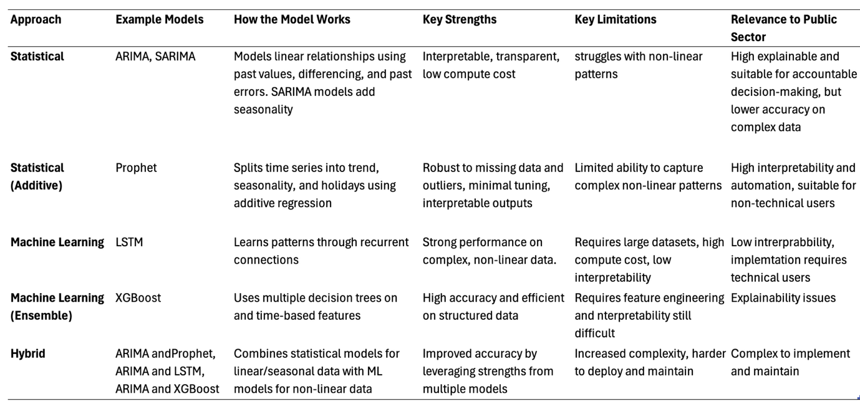

The literature on time series forecasting identifies a clear progression from traditional statistical models towards machine learning and hybrid methods, particularly due to increasing data volume, higher computer capabilities, and developments in machine learning technologies. While machine learning and hybrid techniques frequently show improvements in accuracy, they also mean higher computational requirements and reduced transparency. It remains unclear whether these approaches provide a significant advantage over traditional statistical methods when applied to public sector datasets, where interpretability, accountability, and ease of deployment are essential.

By implementing and directly comparing statistical and machine learning models on the same public sector dataset, this project addresses gaps in the existing research. This research aims to evaluate which models offer the most appropriate balance between accuracy, interpretability, and usability within a public sector operation.

2.5 Forecast Evaluation Metrics and Model Assessment
To ensure that forecasting models are reliable and suitable for decision-making, it is essential to evaluate their performance using appropriate accuracy metrics. Forecast evaluation measures provide a method for quantifying prediction errors and enabling comparison between models. In public sector contexts, where forecasts may directly influence resource allocation, operational planning, and policy decisions, both the accuracy and interpretability of evaluation metrics are critical. Selecting appropriate performance measures therefore plays an important part in determining the suitability of forecasting techniques.

There are several widely adopted error-based metrics for evaluating time series forecasting performance, including Mean Absolute Error (MAE), Root Mean Squared Error (RMSE), Mean Absolute Percentage Error (MAPE), and Mean Absolute Scaled Error (MASE) [32].

Mean Absolute Error measures the average scale of forecasting errors by calculating the mean of the differences between predicted and observed values. As discussed by Matsopoulos et al. [32], MAE treats all errors equally regardless of direction and scale, making it easy to interpret.
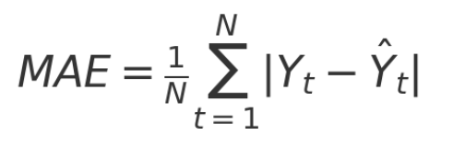
Figure 1. Formula for Mean Absolute Error

Root Mean Squared Error measures forecasting accuracy by calculating the difference between predicted and actual values, squaring those differences, finding their average, and then taking the square root [33]. Because the errors are squared before averaging, larger mistakes have a greater impact on the final score. This makes RMSE more sensitive to large forecasting errors. Willmott et al. [34] explain that RMSE is particularly useful when large forecasting errors have serious consequences, because it gives greater weight to bigger mistakes. However, this can also be a disadvantage, as RMSE may overstate error levels when datasets contain outliers or sudden irregular changes.
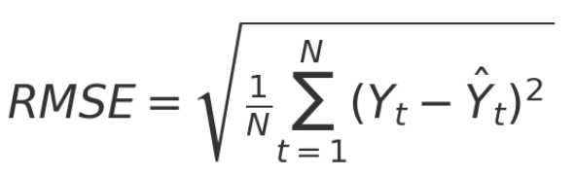
Figure 2. Formula for Root Mean Squared Error

Mean Absolute Percentage Error outputs forecast errors as a percentage of actual values, improving interpretability and enabling comparison across datasets of different scales. MAPE is widely used in forecasting due to its easy to understand percentage output [35]. However, this metric can become unreliable when the actual values are very close to zero, because even small prediction errors can appear extremely large. This limits its usefulness for certain types of datasets.
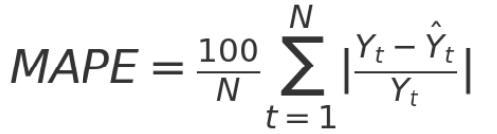
Figure 3. Formula for Mean Absolute Percentage Error
Mean Absolute Scaled Error addresses problems with comparing forecast accuracy across different datasets [27]. Unlike the others, MASE compares a model’s errors to a simple baseline forecast. This makes it easier to see whether a model is performing well. Because it adjusts for scale, MASE allows fair comparisons between different time series datasets.

Figure 4. Formula for Mean Absolute Scaled Error

Research on forecasting evaluation metrics supports the use of multi-metric evaluation methods, acknowledging that no single measure fully captures model performance. Botchkarev et al. [37] demonstrate that different metrics highlight different aspects of forecasting behaviour, such as overall error size or ease of interpretation. The study recommends combining metrics rather than relying on a single method. RMSE is widely used throughout many studies due to its ability to penalise large errors and MAPE is ideal for end users as it offers a percentage-based interpretation that may be more understandable for non-technical stakeholders.

A key gap in the literature is studies that compare statistical and machine learning forecasting models using consistent evaluation metrics on the same operational public sector dataset. This project addresses that gap by evaluating models using multiple complementary accuracy measures, ensuring robust comparisons and interpretability for decision-makers.

2.6 Summary of Literature and Identified Research Gap
The literature review highlights significant limitations in current public sector data analytics processes. Many organisations continue to rely heavily on spreadsheet-based tools such as Microsoft Excel. While familiar and accessible for users, these tools have clear technical limitations, including limited scalability, manual processing, increased risk of human error, and limited support for advanced forecasting and automated analytics. Government strategies support modernisation, but organisational barriers including risk prevention, governance and workforce skills shortages restrict implementation of more advanced approaches.
BI systems and interactive dashboards are widely recognised as effective tools for improving decision-support through automation, visualisation, and interactivity. However, existing research is largely based on private-sector case studies, with limited evidence examining BI effectiveness within public sector companies. Also, there is insufficient focus on usability and interpretability of forecasting outputs and how they are communicated to a non-technical audience.
The review of time series forecasting techniques identified a progression from traditional statistical models, such as ARIMA and SARIMA, towards machine learning methods, including, Random forest, SVR, LSTM, XGBoost and hybrid approaches. Machine learning and hybrid models often achieve improved predictive accuracy however, they introduce higher compute requirements, greater implementation complexity, and reduced transparency. In a public sector environment, accountability and explainability are critical and this limitation can become significant. Furthermore, much of the forecasting literature evaluates models in private sector settings, with limited research done with a public organisation. The literature regularly identifies XGBoost as one of the most popular and effective machine learning methods for time series forecasting.
Although hybrid models have shown strong performance in previous studies, they were not selected for this project. This is because of their increased complexity and the difficulty in interpreting combined model outputs.
A significant gap in the literature is the lack of experimentation comparing statistical and machine learning forecasting techniques using consistent evaluation metrics on the same public sector dataset. There is also limited research examining how forecasting accuracy should be balanced with interpretability and usability when results are delivered through BI dashboards.
This gap directly motivates the experimental evaluation conducted in this project. By implementing and comparing statistical and machine learning forecasting models within a public sector setting, and integrating results into an interactive BI dashboard, the project aims to identify the most appropriate balance between accuracy, transparency, and usability.
Based on the literature reviewed, ARIMA, Prophet, and XGBoost were identified as suitable models for the experiment element of the project. These models were selected because they represent different approaches to time series forecasting while also being commonly used within existing research. ARIMA was chosen as a traditional statistical forecasting method that has high interpretability and a good baseline for comparison. Prophet was selected due to its more advanced statistical approach and ability to handle seasonality. XGBoost was chosen as the machine learning approach because the literature frequently identifies it as a popular and effective model for time series forecasting, making it suitable for this experiment. These models provide a appropriate comparison between traditional statistical and machine learning forecasting techniques within a public sector context.

3. Research Methodology

3.1 Introduction
This section outlines the research and development methodology used to investigate the effectiveness of statistical and machine learning time series forecasting techniques within a public sector context. The methodology is designed to answer the research question:

How do statistical and machine learning time series forecasting models compare in forecasting accuracy when applied to data in a public sector organisation, and does presenting the forecasts through a Business Intelligence dashboard support improved decision-making?

The literature review identified several gaps. There is limited research comparing statistical and machine learning forecasting models using consistent evaluation metrics on the same public sector dataset. While there a lot or literature on forecasting accuracy, there is a limited studies that examine how interpretability and usability should be balanced when results are delivered through BI dashboards. Most forecasting studies are conducted in private-sector organisations, limiting their relevance to public-sector data, where accountability and transparency are essential.

To address these gaps, this project adopts a mixed-methods approach combining:
- Quantitative experimental model evaluation (ARIMA, Prophet, and XGBoost).
- A BI dashboard development for forecast delivery.
- Dashboard Usability assessment through a survey.
This methodology ensures that forecasting techniques are evaluated not only on predictive accuracy but also on usability for public sector decision making. The overall methodological structure follows the Research Onion framework developed by Saunders et al. [38], which provides a methodical approach to research design over six layers: research philosophy, research approach, research strategy, methodological choice, time horizon, and techniques and procedures.

3.2 Research Philosophy and Design

3.2.1 Research Philosophy
The research philosophy for this project will be based on positivism, this means the research will be objective and focused on measurable outcomes. This philosophy supports the primary aim of the project, which is to evaluate the effectiveness of forecasting models and a BI dashboard.

Forecasting techniques such as ARIMA, Prophet, and XGBoost are evaluated using recognised statistical accuracy metrics including MAE, RMSE and MAPE.

These objective measures enable hypothesis testing and comparison. Although a usability survey is conducted, it is structured using closed Likert scale questions and analysed quantitatively. The purpose is to measure usability in a structured and measurable way rather than to explore subjective answers.

3.2.2 Research Approach – Deductive and Experimental
The study uses a deductive research approach. Existing literature suggests that machine learning models frequently outperform traditional statistical approaches in predictive accuracy, particularly when modelling non-linear patterns. This project tests whether this applies to operational public sector data within the DVLA context. The study tests the following hypotheses:

H₀ (Null Hypothesis):
H₀: There is no statistically significant difference in forecasting accuracy between ARIMA, Prophet, and XGBoost when evaluated using the same accuracy metrics.

H₁ (Alternative Hypothesis):
H₁: There is a statistically significant difference in forecasting accuracy between ARIMA, Prophet, and XGBoost when evaluated using the same accuracy metrics.

While predictive performance is a primary focus, the study also recognises that higher statistical accuracy does not necessarily mean better practical suitability. Factors such as interpretability, transparency, and implementation complexity may influence the overall appropriateness of a forecasting model within a public sector environment.

3.2.3 Research Strategy – Experimental Case Study
This project uses three research strategies: software development, experimental evaluation, and a survey-based assessment.

Software Development Strategy:
A development-based strategy is used to design and implement a forecast driven BI dashboard. The dashboard is vital to deliver the research output to allow for evaluation of forecasting models. The dashboard is developed to display forecast outputs, historical trends, and key performance metrics from DVLA data. Forecasting models are implemented using Python based libraries, including ARIMA, Prophet, and XGBoost, with outputs integrated into the dashboard for visualisation and analysis. The development process follows Agile principles, involving iterative design, incremental feature implementation, and regular testing to ensure functionality [39].

Experimental Strategy:
An experimental strategy is used to evaluate forecasting model performance under controlled conditions. ARIMA, Prophet, and XGBoost are implemented using the same DVLA dataset, identical preprocessing procedures, and a consistent train and test split.

Forecast accuracy is assessed using recognised statistical metrics, including MAE, RMSE and MAPE. These metrics enable comparison of model performance to determine which technique produces the lowest forecasting error.

Survey Strategy:
A survey will be used to assess the usability and suitability of the dashboard. The survey will involve approximately 5 DVLA staff members from two groups: data analysts who are familiar with forecasting, reporting, and existing Excel-based processes, and operational staff who use reporting information in their everyday work. This allows the dashboard to be evaluated from both a technical and operational viewpoint. Participation will be voluntary and responses will be anonymised. The survey will mainly consist of Likert scale questions, which will be analysed quantitatively, with optional written feedback included for additional comments and suggestions.

3.2.4 Time Horizon
This research adopts a cross-sectional time horizon, involving the analysis of data within a defined timeframe rather than over an extended period. Historical DVLA operational data is used to train forecasting models, with performance evaluated over a predefined test period. The assessment of model effectiveness occurs within a single time period rather than through repeated measurement. This cross-sectional design enables a controlled comparison of forecasting techniques within the time constraints of the project.

3.3 Experimental Design
Three forecasting techniques were selected based on the literature review, as they represent different modelling approaches within time series forecasting and enable comparison using the same public sector dataset. Together they represent both statistical and machine learning methods. Hybrid forecasting methods were considered but not included to keep the comparison between models fair and consistent. Hybrid models are also more complex and less interpretable, which limit their suitability in a public sector setting where transparency is important.

ARIMA
ARIMA was selected due to its extensive use in the time series forecasting literature and its suitability for modelling linear data patterns. It is one of the most widely used statistical forecasting techniques in both research and operational environments.
ARIMA captures autoregressive and moving average components while incorporating differencing to address non-stationarity [19]. The model is transparent and interpretable, which makes it particularly appropriate for public sector data where accountability and explainability are important considerations.
Prophet
Prophet was selected as a statistical forecasting model as its designed for business and operational time series data. It separates a time series into trend and seasonal components, making it suitable for data that shows regular patterns over time.

Prophet requires minimal manual tuning and is robust to missing values and outliers, making it practical for real-world operational datasets such as those used by the DVLA. It remains interpretable while capturing more complex seasonal patterns than traditional statistical models such as ARIMA.

XGBoost
XGBoost was selected as a machine learning model capable of handling more complex data patterns. By using values from previous time periods to predict future values, it can capture relationships that simpler statistical models may not be able to. The literature review indicates that XGBoost performs well on structured data and provides metrics that are more interpretability compared to other machine learning models.

3.4 Experimental Workflow
The experimental process will follow a structured forecasting pipeline as described below to ensure consistency. A more detailed process can be found in the implementation design in section 4.

Step 1 – Data Collection
Historical operational time series data will be extracted from DVLA systems and exported to CSV format for analysis. The dataset will consist of aggregated transaction volumes used for operational planning and resource allocation. No personal or sensitive data will be included. Four transaction datasets will be evaluated and compared.

Step 2 – Data Pre-processing
Data pre-processing will be applied consistently across all models to ensure comparability. This will include:

- Removal of unnecessary features
- Date formatting
- Handling any missing values
- Inspection of outliers
- Splitting the data into test/train
Step 3 – Exploratory Data Analysis
Exploratory Data Analysis will be conducted prior to model implementation to better understand the features of the dataset. This will include:

- Visual inspection of trends and seasonal patterns
- Summary statistics
This step will help with model configuration and tuning and ensure that the dataset is suitable for the selected forecasting models.

Step 4 – Model Implementation
Each forecasting model will be implemented separately using the training dataset. A consistent train and test split will be applied to ensure fair comparison across all models.

ARIMA:

- The dataset will be indexed by date and set to a monthly time frequency.
- The data will be split into training and testing sets.
- A range of ARIMA parameters will be tested using hyperparameter tuning to identify the most suitable configuration.
- The final ARIMA model will be fitted using the selected parameters on the training data.
Prophet:

- The dataset will be formatted into the required Prophet structure
- The data will be split into training and testing sets.
- Key model parameters will be tested to identify the most appropriate configuration using hyperparameter tunning.
- The final Prophet model will be trained using the training data.
XGBoost:

- The dataset will be formated into a supervised learning format.
- Lag-based and time-based features (e.g., month, year) will be created.
- The data will be split into training and testing sets.
- Hyperparameter tuning will be performed to identify the best model configuration.
- Final XGBoost model will be trained using the selected parameters.
Step 5 – Forecast Generation
Each model will produce forecasts for a 12-month test period. Forecasts will be generated over the same period for each model to enable direct comparison.

Step 6 – Model Evaluation
Forecast accuracy will be evaluated using multiple statistical performance metrics against the same test data:

- Mean Absolute Error
- Root Mean Squared Error
- Mean Absolute Percentage Error
Using multiple evaluation metrics will reduce dependence on a single metric

3.5 BI Dashboard Development
An iterative development approach was used to refine the dashboard’s functionality, design, and usability throughout the project. This was appropriate because requirements could evolve during model implementation and forecast outputs could influence the final dashboard design. Wireframes and prototypes supported testing and refinement during implementation.

The dashboard was designed to support public sector decision-making through clear, transparent, and interpretable visualisations. Key features include:

- Clear visual presentation of forecast numbers
- Direct comparison between forecast and actual performance
- Display of key accuracy metrics
- Minimal visual clutter to reduce cognitive overload
- Interactive filtering to enable user exploration
These design and development decisions ensure that forecasting outputs are presented in a way suitable for operational use.

3.6 Hardware Resources
The project will be developed using a standard laptop with sufficient compute power to support dashboard development and the running of forecasting scripts. All outputs, including datasets, scripts, and dashboard files, will be stored locally on the machine, with regular backups using a secure cloud storage solution.

3.7 Software Resources
The following software and tools will be required to complete the project:

- Python 3.11 data preparation and forecasting model development
- Forecasting libraries including Prophet, XGBoost, and ARIMA
- Microsoft Power BI for dashboard design and development
- Visual Studio Code for script writing and project management

3.8 Ethical Issues
This project has a low ethical risk. No sensitive or personal data will be used. Any operational data used will be anonymised and follow GDPR guidelines and DVLA data policies. An ethics form with a more detailed assessment will be submitted to UWTSD for approval.

3.9 Validity, Reliability & Generalisability
Validity
The methods used in this project include building a dashboard, applying forecasting models, and evaluating how well they perform. These provide a good way to investigate if a forecast driven BI dashboard can help improve decision-making. The literature review showed that similar methods have been used in research before, which makes them suitable for this project.

Reliability
The project will use common forecasting packages such as Prophet and XGBoost, and results will be evaluated using established statistical metrics. All methods will be clearly documented to ensure that future researchers can follow the same methodology and obtain similar results.

Generalisability
The project is focused on the DVLA, however the methods and tools used are designed to be relevant to other public sector organisations with similar operational structures. The forecasting techniques and dashboard design will be adaptable for use in other departments that manage similar types of data.

4. Design

4.1 Introduction
This section shows the design of the forecast script and BI dashboard developed for the DVLA. The previous section described the methodological framework and experimental strategy, this chapter explains how the proposed forecasting approach was designed. The solution consisted of two elements:

- A forecasting script developed in Python.
- An interactive dashboard implemented in Microsoft Power BI.

The system was designed by first identifying the requirements and then structuring the forecasting models and dashboard to meet those needs. The solution was developed in stages, with testing conducted throughout the development process. Emphasis is placed on clarity and transparency to ensure it is appropriate for a public sector setting.

4.2 Design

4.2.1 Requirements
System requirements were identified by reviewing the current DVLA reporting and forecasting processes. The existing approach relies heavily on spreadsheet tools, particularly Microsoft Excel, which require manual data handling and provide limited automation. This makes it difficult to manage large datasets, apply advanced analytics, and produce automated forecasts, reducing efficiency and making long-term planning more difficult.

The proposed system aims to address these limitations by integrating forecasting models with an interactive dashboard. It is designed to automate where possible and provide predictive insights that are accessible to non-technical users.

A MoSCoW prioritisation analysis was used to plan the system requirements. This method categorises requirements into Must Have, Should Have, Could Have, and Won’t Have features. This helps define the minimum viable product (MVP), while identifying additional features that could be included if time allows. The results are shown in Figure 5.

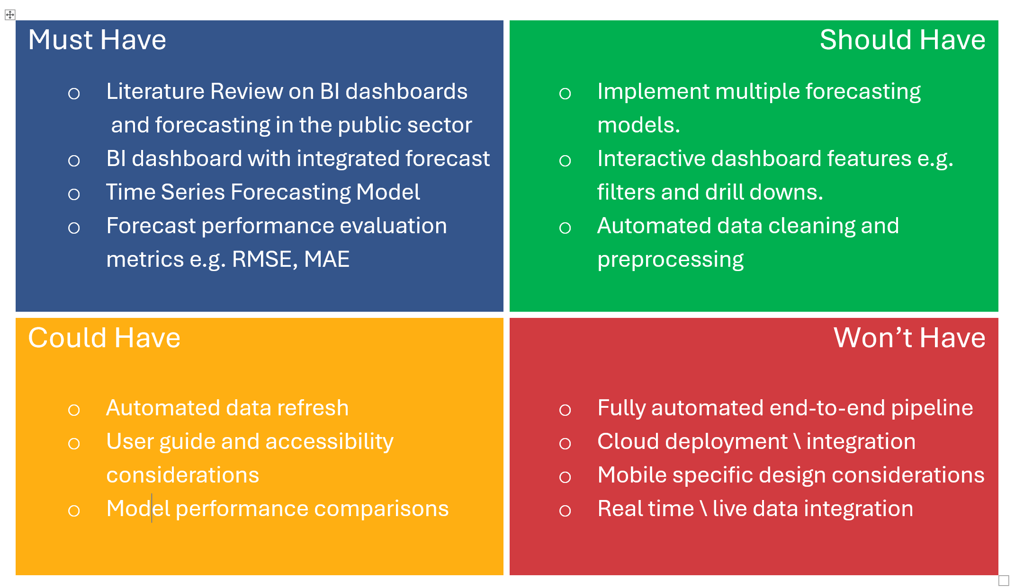

Figure 5. MoSCoW analysis of project tasks based on priority and time constraints.

Based on the identified requirements, the proposed system must provide the following capabilities.

- The system must implement multiple forecasting models, including ARIMA, Prophet, and XGBoost with appropriate evaluation metrics to determine the best approach. This aligns with research objective of determining whether machine learning models can improve forecasting accuracy compared with traditional statistical models.

- The system must generate twelve-month forecasts using historical DVLA transaction data using the most appropriate forecasting method. These forecasts are expected to support operational planning and resource allocation by providing a view of future trends.

- The system must evaluate forecast performance using well known statistical metrics. These metrics will help understand model accuracy and enable comparison between forecasting techniques.

- The system must show forecasting outputs and performance metrics through an interactive BI dashboard designed for non-technical users. The dashboard must include clear visualisations, navigation, and interpretable forecast results.

4.2.2 Forecasting Script Design
The forecasting design followed a structured pipeline, illustrated in Figure 6. The script is designed to be developed in Python. The pipeline was divided into four stages, data preparation, model preparation, model runs and data exports. Each stage of the process is described below.
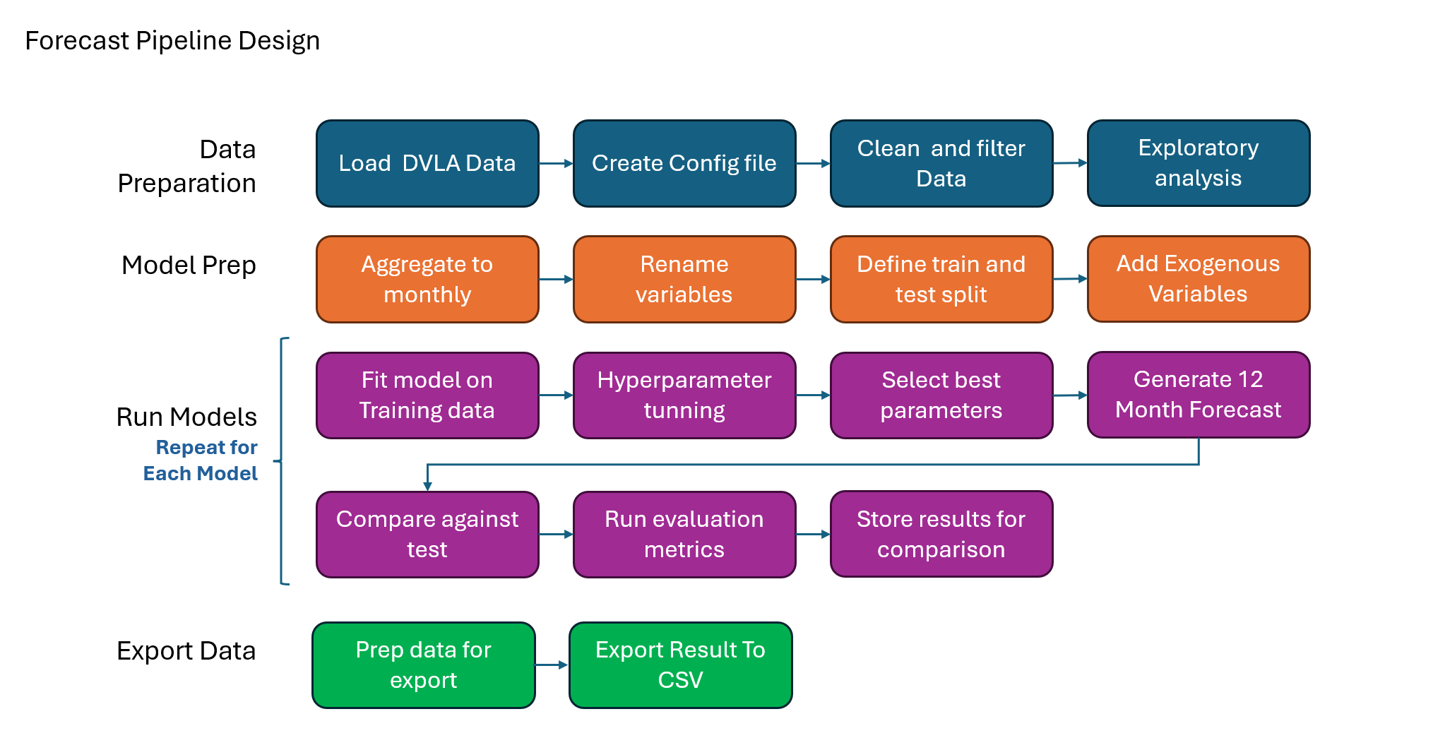
Figure 6. Forecast pipeline design

1 - Load DVLA Data
The first step is loading historical DVLA operational data from csv files. Multiple files were combined into a single data frame to allow for easier analysis. All files follow the same structure and contain 60 months of operational data over multiple transactions.

2 - Create Configuration Structure
A configuration file is needed to control key parameters, including forecast period (12 months), testing period (12 months), Transaction type and model selection flags. This configuration design allows the forecasting process to be flexible and easy to adjust.

3 - Clean and Filter Data
At this stage the data is filtered and cleaned, including, removing any null values and filtering the dataset to focus on a specific transaction service. This ensures that forecasts were created for a single operational service rather than a mixture of unrelated services. Data cleaning helps prevent errors during aggregation and training.

4 - Exploratory Analysis
Exploratory analysis is required to understand the overall trend and seasonality within the dataset. Visual inspection helps decisions regarding aggregation frequency and model suitability.

5 - Aggregate to Monthly
As there is a mixture of daily and monthly transaction data, the data was aggregated to monthly totals. Monthly aggregation was selected to align with organisational reporting to better support operational decision-making within the DVLA.

6 - Define Train and Test Split
The dataset then needs to be divided into training and testing periods, with the most recent 12 months reserved for testing. The test period will also match the 12 months future forecast requirement.

7 - Rename Variables
Certain models require specific columns names. At this stage columns will be renamed to ensure model compatibility.

8 - Add Exogenous Variables
External variables will be merged onto the dataset, for example Bank Holidays Count. These variables intend to help model performance by feeding in data that may influence transaction volumes.

9 - Model Preparation
Before training, model-specific preparation steps must be applied for example
defining hyperparameter variables.

10 -Model Training and Hyperparameter Tuning
Each model will be fitted using training data. Hyperparameter tuning and cross validation is completed using grid search techniques to select best parameters.

11 - Forecast Generation
Each model produces a 12-month forecast using the best parameter configuration identified in the previous step.

12 -Evaluation Against Test Data
Predictions are then compared against the 12-month test period. Performance metrics such as RMSE are calculated to help understand predictive accuracy.

13 - Steps 9 to 12 are repeated for each model (ARIMA, Prophet and XGBoost)

14 - Model Comparison
Performance metrics from all models are stored and compared. This enables automatic identification of the best-performing model based on accuracy figures.

15 -Export and Output Preparation
Final outputs are standardised and exported to CSV format. The exported datasets included forecast values, actual values, performance metrics, this structure enables seamless integration into the BI dashboard.

4.2.4 Dashboard Design
The dashboard is designed to support clear and efficient interpretation of forecasting results. The interface is required to:

- Easily distinguish between historical and forecast values
- Enable comparison between forecasting models
- Display evaluation metrics transparently
- Minimise cognitive overload
- Allow interactive filtering and exploration of both past and future values
- Apply the DVLA theme

As the dashboard is intended to support decision-making, simplicity and interpretability is essential. The final dashboard was implemented using Microsoft Power BI. Power BI was selected as the dashboard platform due to its advanced visualisation capabilities and its growing adoption as an alternative to spreadsheet-based reporting tools. Gotay highlights the shift from Excel-based reporting towards modern BI platforms such as Power BI and Tableau, indicating the increasing demand for scalable and interactive solutions [40].
Before implementing the dashboard, a wireframe was developed to outline the layout, structure, and interaction features of the interface. Developing the wireframe before implementation helped reduced the changes of redesign during implementation and provided a template for development
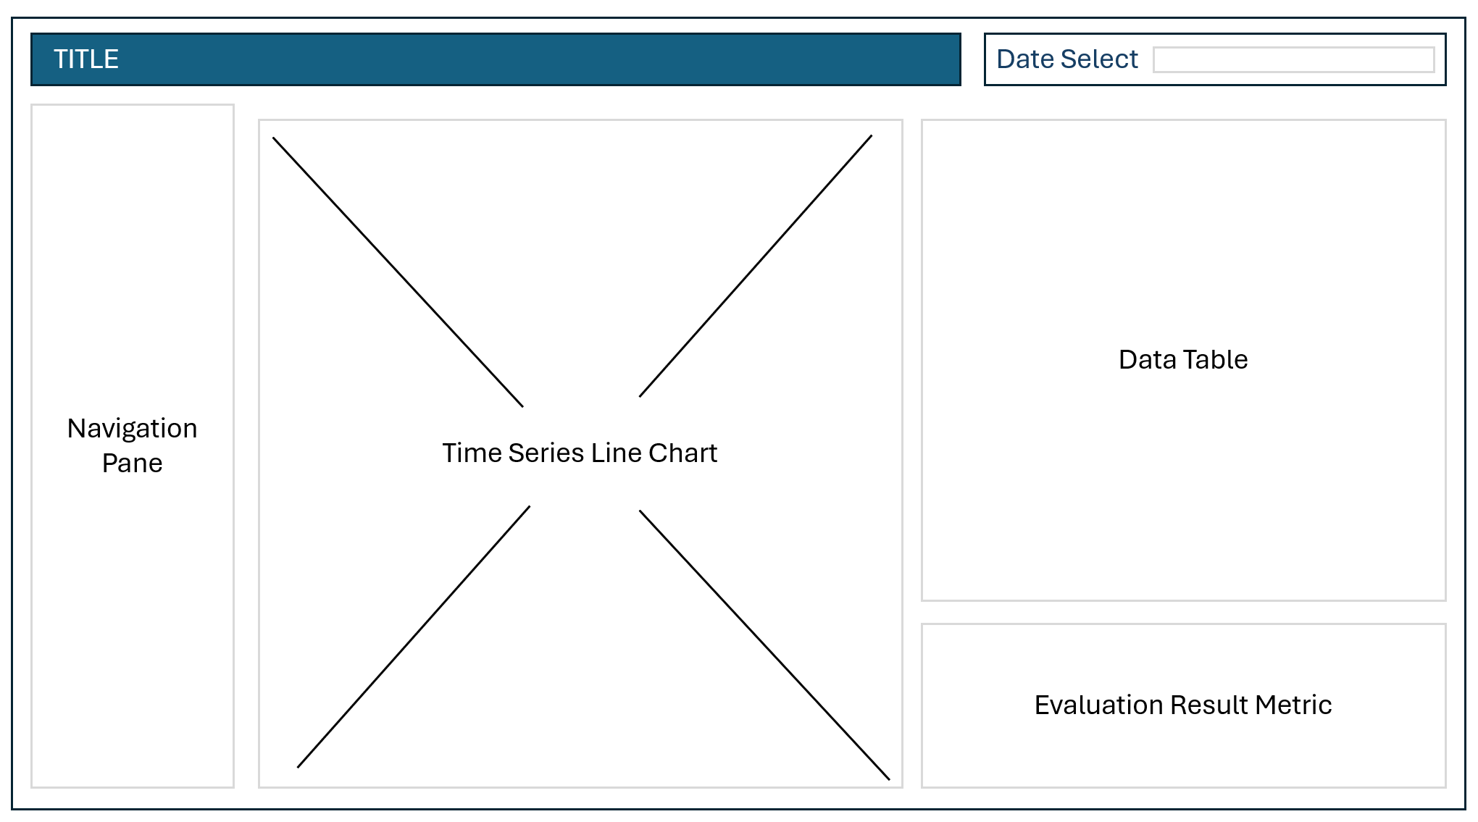
Figure 7. Dashboard design wireframe

5. Implementation

5.1 Forecasting Script Implementation
The forecasting element of the project was implemented using a Python script developed in Jupyter Notebook. The script read historical DVLA operational data, generated 12-month forecasts using multiple time series models, and evaluated each model’s accuracy. The outputs were then imported into a Power BI dashboard.

The workflow followed a structured pipeline covering data preparation, exploratory analysis, feature engineering, model development, evaluation, and output. The pipeline accepted one transaction at a time through a configuration file, allowing models to be tested consistently and results to be reproduced.

5.1.1 Data Loading and Preparation
The first stage of implementation involved loading and preparing the dataset. Historical DVLA operational data was exported from an internal SQL database and stored in Excel format so it could be read into Python. The dataset contained timestamped transaction volumes, which required preprocessing before the forecasting models could be applied. This included converting the date column to datetime format, setting the index and target variable, removing null values, and grouping the data by month.
A configuration section was also created to control key parameters, including the transaction service, date ranges, and file paths. This allowed the script to be reused with different datasets without changing the main code, making the pipeline easier to manage and update.
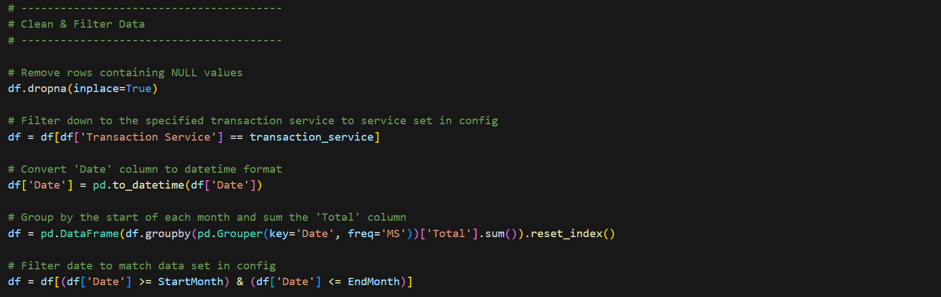
Figure 8. Sample Code - Data Loading and Preparation

One challenge encountered during this stage was ensuring that the monthly aggregation of the transactional data was performed correctly. Some transaction services were recorded daily while others were already aggregated monthly. To overcome this, it was required to group and sum the daily records to ensure that all data was grouped as a monthly volume before being used for forecasting.
Testing the full forecasting script was time-consuming because each model needed to be trained and run. To overcome this, options were added to the configuration file allowing individual models to be skipped during testing, which helped speed up development and bug fixing.
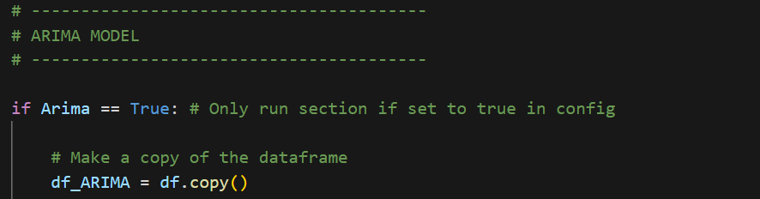
Figure 9. Sample Code – Ability to skip a model based on config file parameters

5.1.2 Exploratory Data Analysis
Following data preparation, exploratory data analysis was conducted to understand the structure and trends of the dataset. This involved reviewing historical transaction data across the four services to identify trends, seasonal patterns, and any issues that could affect forecasting performance. This helped confirm that the datasets were suitable for the forecasting approach and did not contain major structural issues.
Plots were generated to show how transaction volumes changed over time. These were used to identify overall trends and potential seasonality, such as monthly fluctuations in transaction volumes. Identifying these patterns was important because some forecasting models allow seasonal parameters to be enabled when seasonality is present.
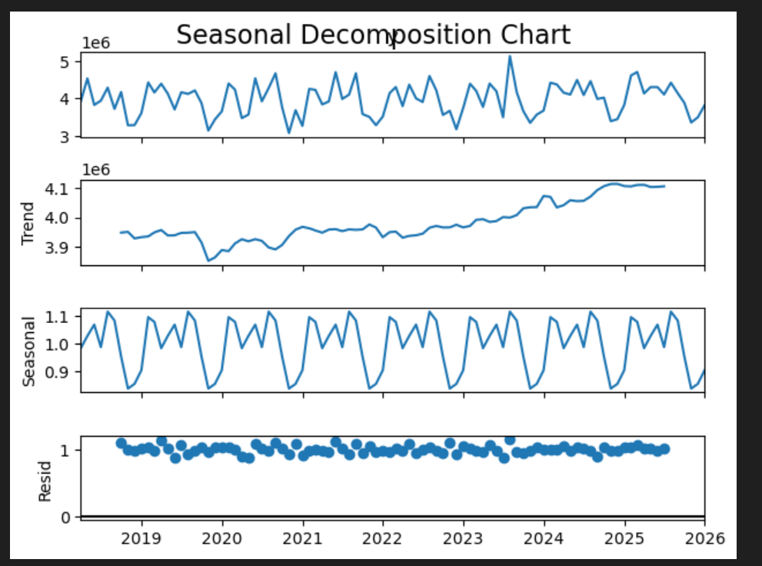
Figure 10. Seasonal Decomposition chart output example
The analysis also identified unusual spikes that could affect forecasting accuracy. Data inspection showed that the four datasets followed relatively stable trends and were suitable for forecasting techniques such as ARIMA and Prophet. No major data quality issues were identified. Understanding how transaction volumes changed over time also helped later modelling decisions, including model parameter configuration.

One challenge was distinguishing genuine operational spikes from potential anomalies. Some transactions showed large volume changes, so visual inspection and comparison across time periods were used to confirm that these were actual operational fluctuations rather than data errors. In a real-world operational environment, this level of manual analysis would not usually be practical for thousands of transaction services. Instead, models would likely be applied automatically and evaluated using accuracy metrics.

5.1.3 Feature Engineering
Feature engineering was implemented to improve the ability of machine learning models to detect patterns within the dataset. Feature engineering is the process of creating additional variables to improve the performance of predictive models [41]. While traditional time series models such as ARIMA rely on historical observations only, machine learning models benefit from additional features that describe behaviour, for example bank holidays.
To address this, several time-based features were created based original timestamp variable. These included variables such as the month of the year and the quarter. These additional features help models capture patterns that occur regularly within the data.
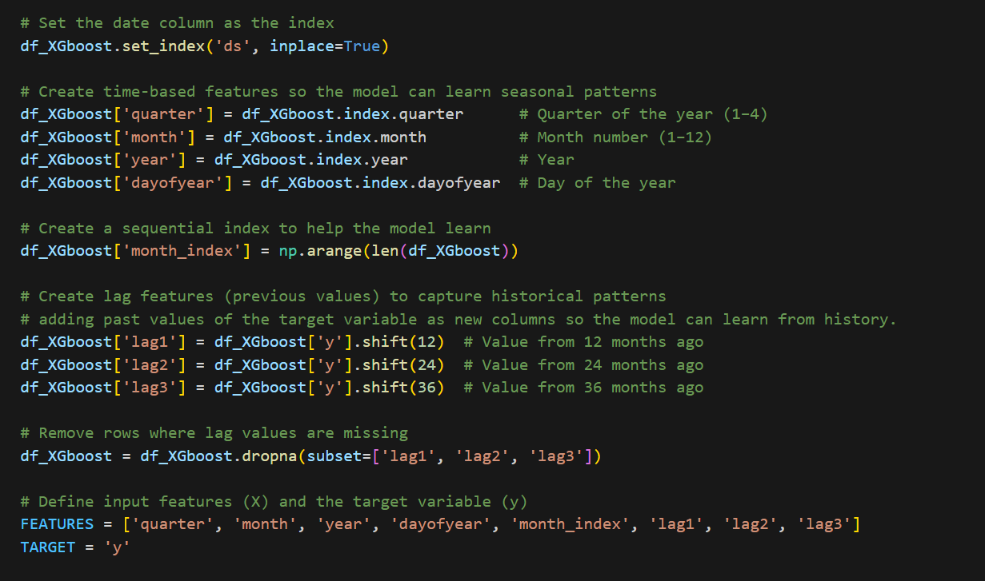
Figure 11. Time based features used in the XGBoost Model
Many public sector processes follow consistent cycles where workload levels vary depending on the time of the year. By implementing these time-based features, machine learning models such as XGBoost can identify relationships between these factors and the data.
One challenge encountered during this stage was determining which features were useful without adding unnecessary data. Including too many variables can increase model training time and introduce unwanted noise into the model. Therefore, only a small number of features were included for this experiment, for example month of year and quarter.

5.1.4 Model Development
The forecasting models were developed to predict future operational trends using historical data. During early development, a Holt-Winters (HW) model was used to test the forecasting pipeline, but it was not included in the final experiment. The final comparison focused on ARIMA, Prophet, and XGBoost, as these models were identified in the literature review as suitable statistical and machine learning approaches for time series forecasting.

To compare the models fairly, the dataset was split into training and testing data. Each model was trained on historical data and then used to predict unseen test data. This allowed model performance to be evaluated under the same conditions.

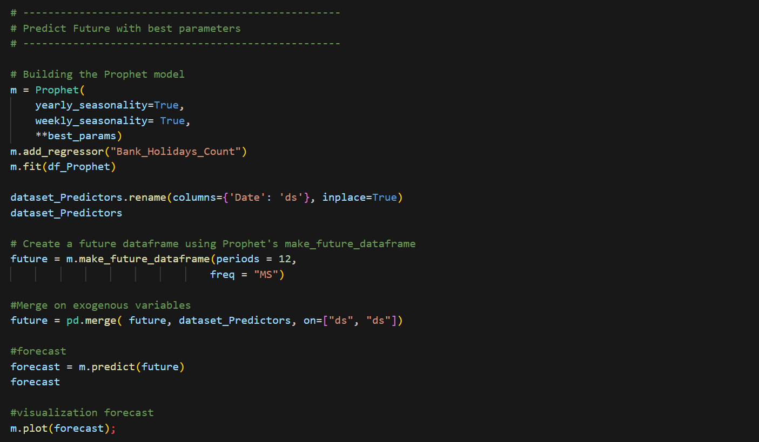
Figure 12. Example Prophet Model used to predict 12 months of data
Hyperparameter tuning was implemented to each model to improve model performance. Hyperparameter tuning is the process of adjusting model settings to improve forecasting accuracy and overall model performance [42]. These settings control how the model learns from the data and must be chosen before the model is trained. Tunning involves testing a range of parameters to determine which ones perform the best, the best parameters are then stored to be used on the future predictions.
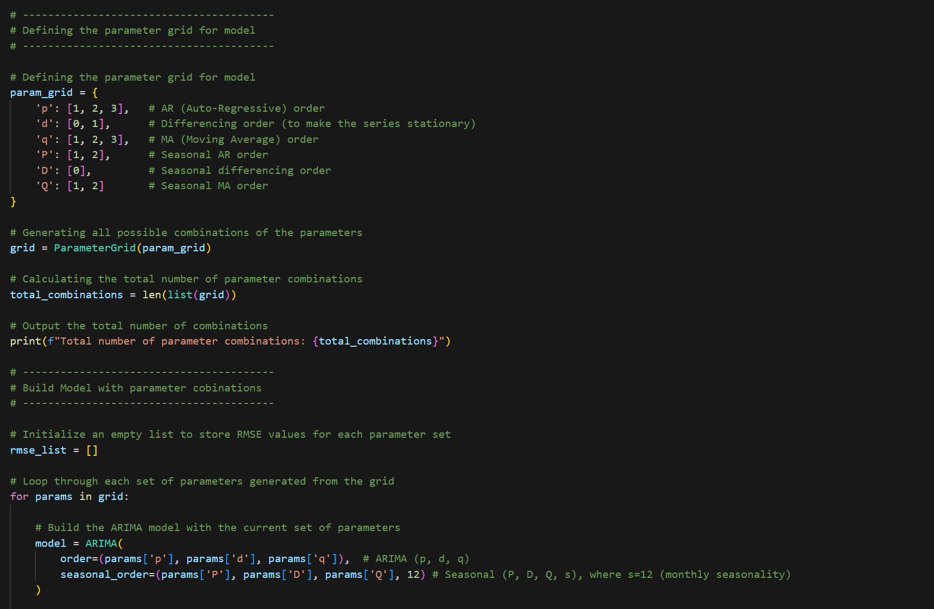
Figure 13. Example ARIMA Model Hyperparameter tuning
Cross-validation was also used on the ARIMA and Prophet models to assess forecasting performance across different time periods. Cross-validation is a model evaluation technique that involves repeatedly splitting data into training and validation sets in order to assess how well a model performs on unseen data [43]. Combining cross-validation with hyperparameter tuning is a powerful technique that helps improve model performance and provides the best opportunity for the model to produce accurate predictions.
During model implementation, one of the main challenges was selecting appropriate model parameters for tuning, particularly for the ARIMA model. Parameter tuning required experimentation to identify settings that produced suitable forecasts. Testing was carried out not to introduce to many unnecessary parameters as this would make the script overly complex leading to longer run times.

5.1.5 Model Evaluation
Once the forecasting models were developed, their performance was evaluated using accuracy metrics. This was an important stage of the forecasting pipeline because it provides the results to determine which model produces the most accurate predictions. The models were evaluated using error metrics including MAE, MAPE and RMSE. These metrics measure the difference between predicted values and the actual test data.
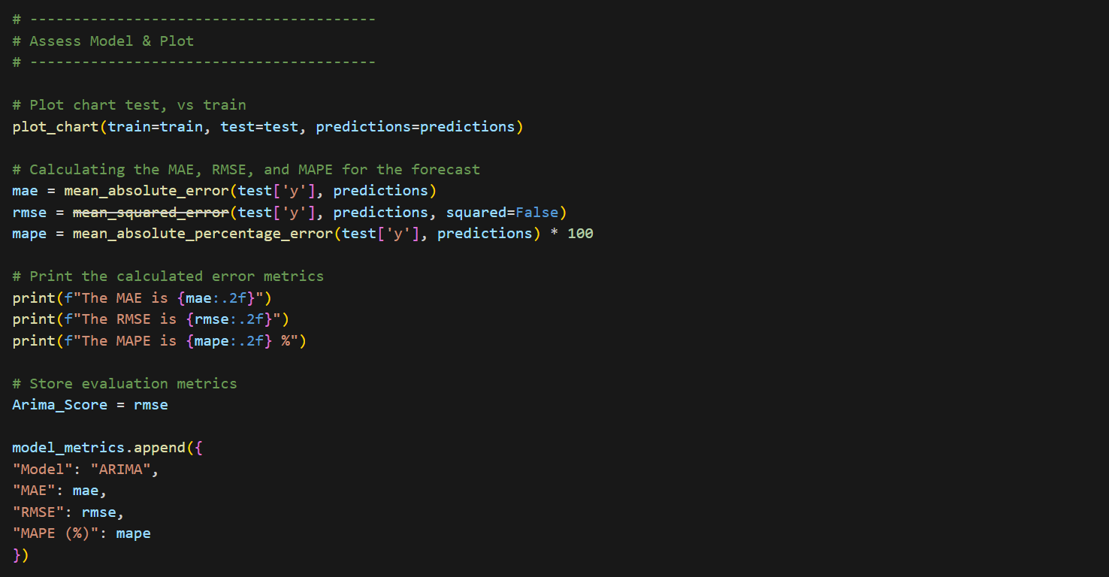
Figure 14. Example of recording and plotting of evaluation metrics
While multiple evaluation metrics were used to assess model performance during the experiment, RMSE was used within the forecasting pipeline to identify the best performing model. RMSE places greater emphasis on larger prediction errors, helping highlight models that produce less accurate forecasts.
These evaluation metrics allowed the performance of each forecasting model to be directly compared. The results of these comparisons are discussed in detail in the results chapter, where the performance of each forecasting technique is analysed.

5.1.6 Exporting Results for Dashboard Integration
The final stage of the forecasting script involved exporting the model outputs for use within the BI dashboard. Once the forecasts had been generated and evaluated, the prediction results were stored in datasets that could be imported into Power BI.
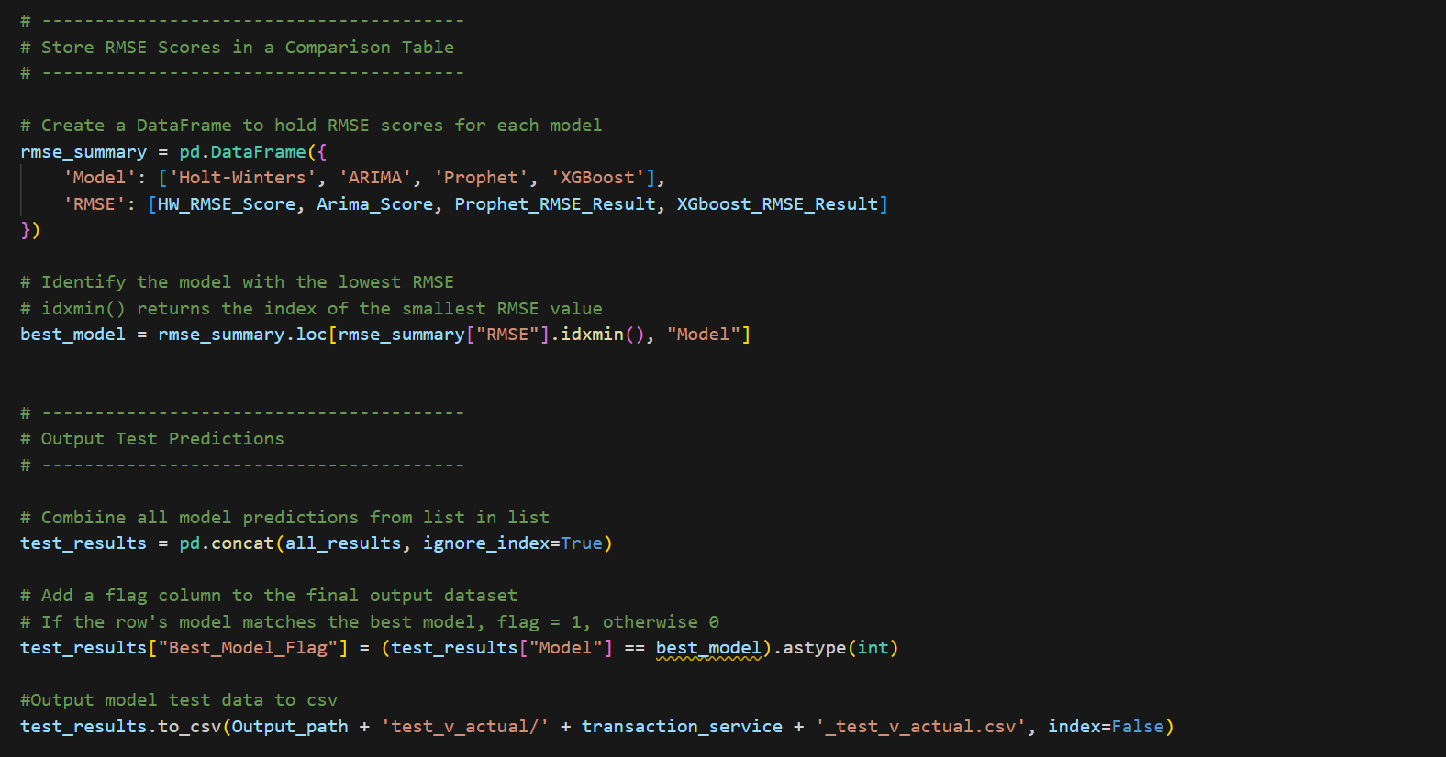
Figure 15. Outputting model results and evaluation metrics
These exported datasets included historical observations, test data and forecasted values. By structuring the data in this way, the dashboard could visualise both past trends and predicted future values easily. A marker was added to the output to identify the model with the lowest RMSE. This allows Power BI to highlight the best performing model to the end user within the dashboard.
This step was important because the aim of the project was not only to produce forecasts but also to present them in a way that supports decision-making to non-technical users. By embedding the forecast outputs into an interactive dashboard, users can explore trends and assess future projections more effectively.
A challenge encountered during this stage was ensuring that the exported datasets were formatted correctly for Power BI. The data structure had to be designed so that visualisations within the dashboard could dynamically show the forecast results and trends per transaction.

5.2 Power BI Dashboard Implementation
Following the development of the forecasting models a dashboard was developed using Microsoft Power BI to present the results in an easy to read and interactive format. The purpose of the dashboard was to allow users to explore historical trends, view forecast predictions, and compare the performance of different forecasting models. The dashboard was designed with a focus on clarity and usability to make sure that the forecasting outputs could help decision-making. Full dashboard screenshots can be found in the appendix.

5.2.1 Data Import and Integration
The forecasting results outputted by the Python scripts were exported into CSV datasets and imported into Power BI. Power Query was used within Power BI to perform additional data transformations before loading the data into the dashboard. These transformations included ensuring that fields were stored in the correct data formats and creating additional columns to identify historical data, testing periods, and future forecast values. This allowed the dashboard visualisations to clearly distinguish between historic data and future predictions.
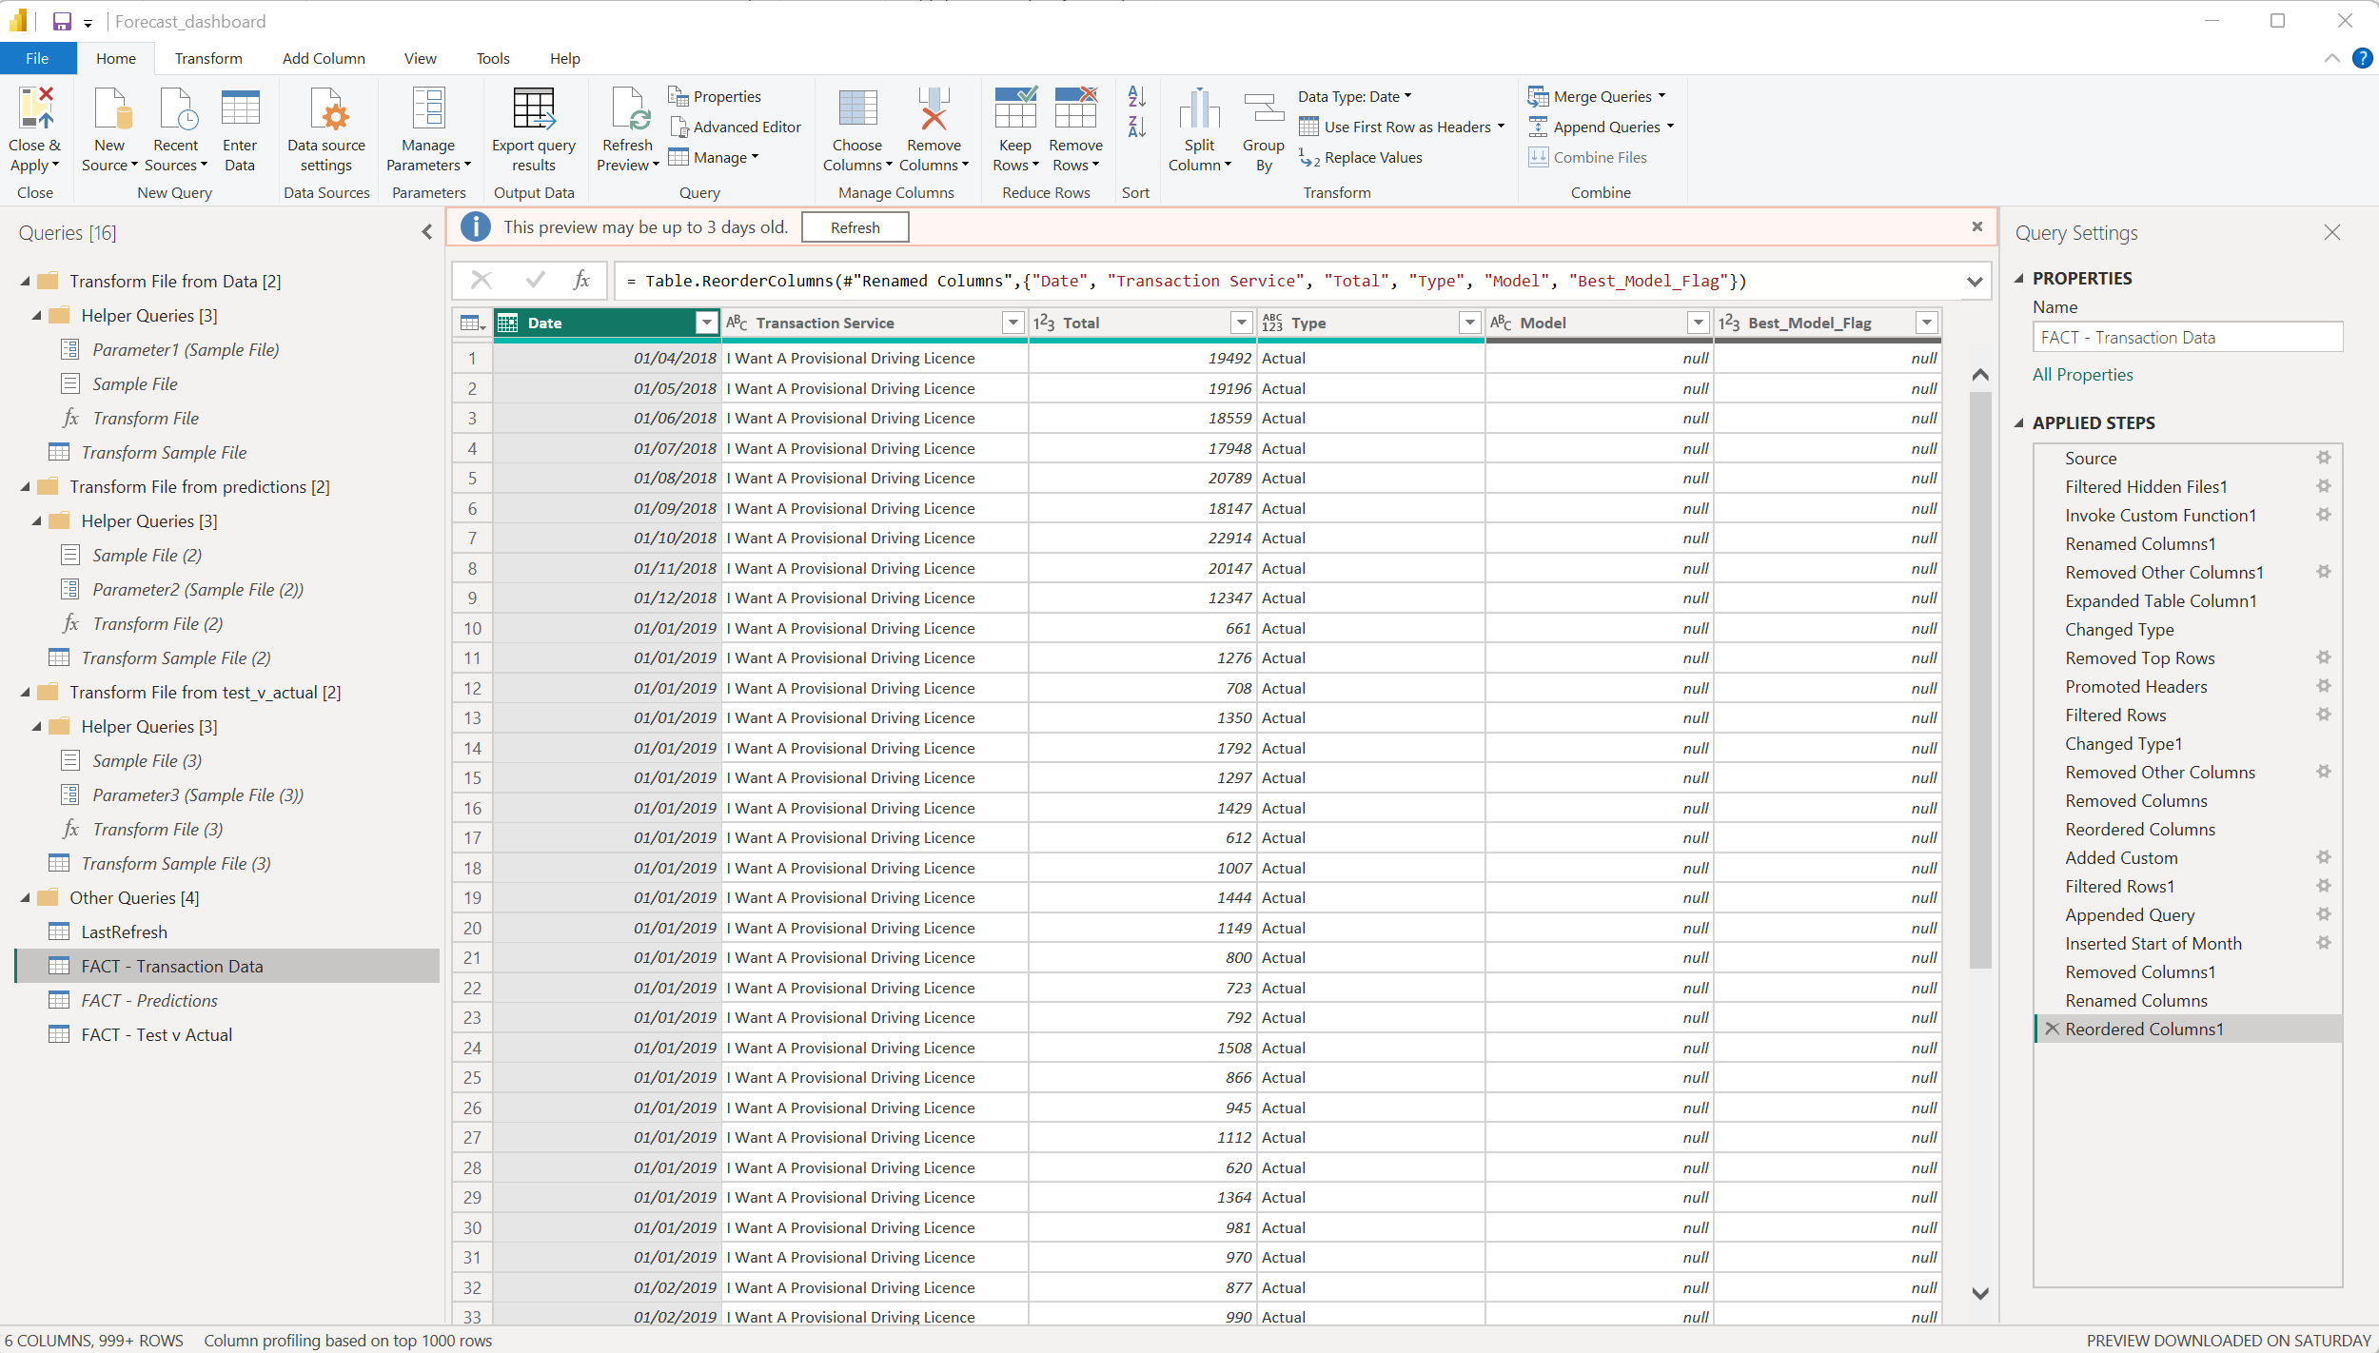
Figure 16. Power Query transformations
One challenge encountered during this stage was automatically combining the outputs from multiple forecasting models into a single dataset. Each model generated its own set of forecast results, which needed to be appended and structured consistently so they could be used within the Power BI dashboard. This was resolved by transforming and appending the datasets within Power Query, ensuring that all model outputs followed the same structure.

5.2.2 Data Model Design
Once the data was imported into Power BI, a data model was created to organise the datasets and enable relationships between the different tables. The model was designed to link historical transaction data and forecast outputs, and a date calendar table.
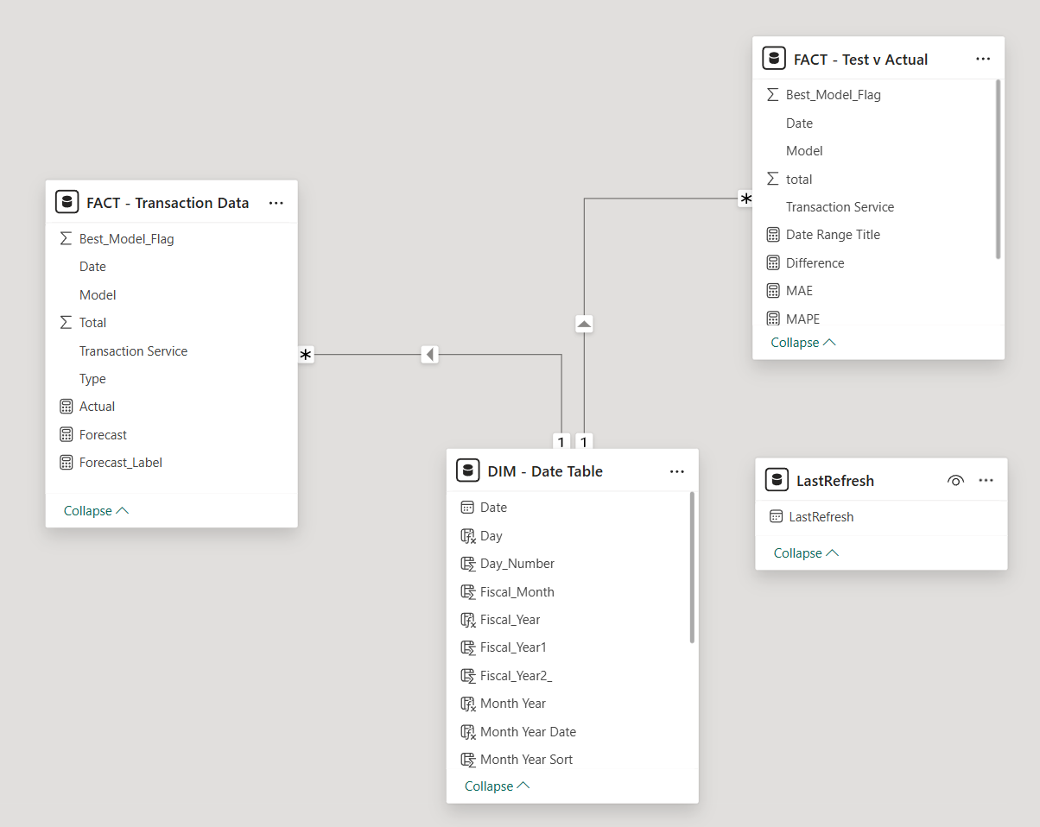
Figure 17. Power BI data model
Creating a data model ensures that the dashboard can efficiently filter and calculate data across different visualisations. This also allows users to interact with the dashboard using slicers and filters, enabling them to transaction services, forecast models over different time periods.

5.2.3 Dashboard Visualisation Pages
The dashboard was organised into separate pages for trends, forecast predictions, and model comparisons, allowing users to navigate between the main reporting views.

Trends Page
The trends page provides an overview of historical transaction volumes. Visualisations show how transaction levels changed over time, helping users identify trends, seasonal patterns, and periods of increased activity. This gives context before users review the forecasted values.

Forecast Page
The forecast page displays the predicted values generated by the forecasting models alongside the historical data. This allows users to visually compare past trends with future predictions.

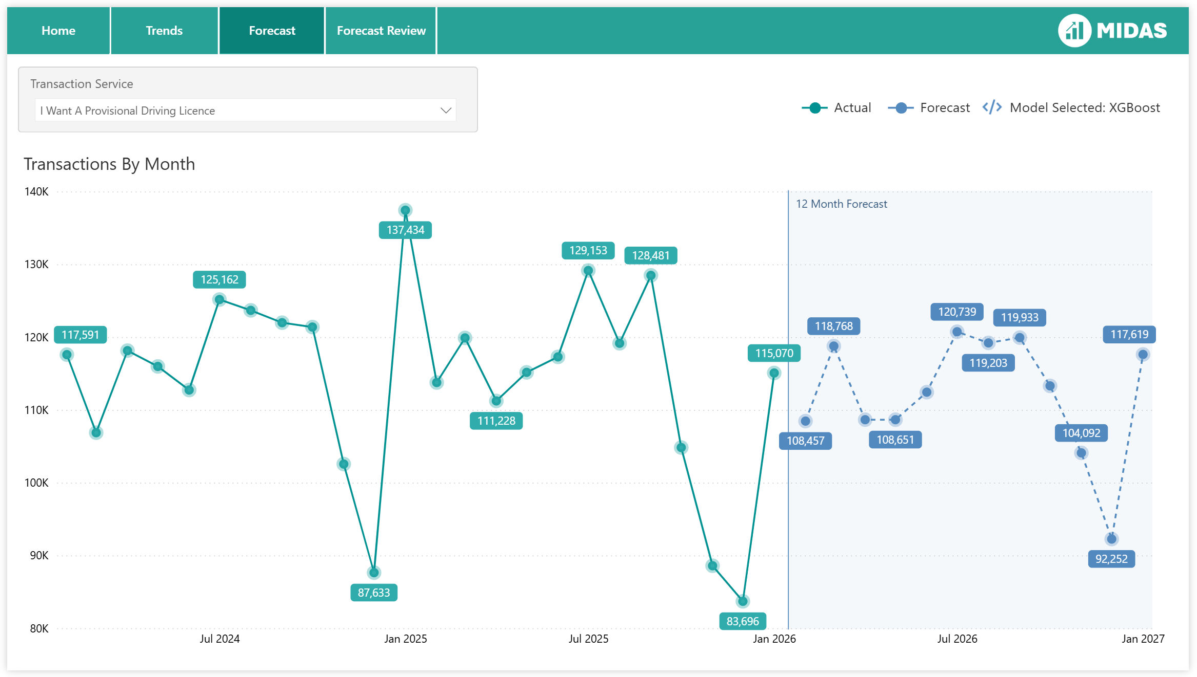
Figure 18. Power BI forecast page displaying 12-month forecast
Displaying forecasts alongside historical data makes it easier for users to interpret the predictions and assess whether the forecast behaviour appears realistic and consistent with previous trends. The page automatically shows the model with the lowest RMSE based on the output flag produced by the pipeline script.
Model Comparison Page
A dedicated model comparison page was also created to allow users to compare the performance of the different forecasting models, this page is designed for more advanced analytics, for example by a data analyst, not a typical end user. This page presents evaluation metrics for each model showing test vs prediction data, enabling users to understand all forecasting methods tested.

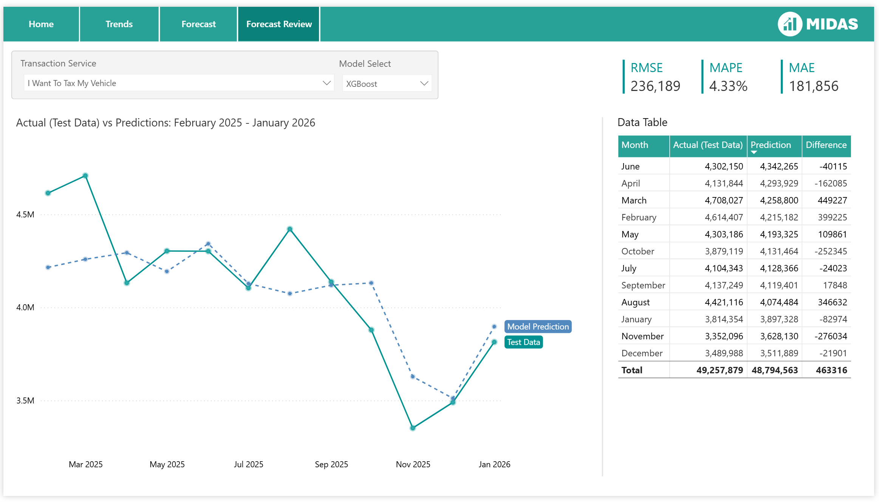
Figure 19. Power BI forecast Review displaying test vs prediction

6. Results
This section presents the results of the forecasting experiments conducted on four DVLA transaction services. Three models were evaluated: ARIMA, Prophet, and XGBoost, covering both traditional statistical forecasting and machine learning approaches. Each model was trained on the same historical data, tested over the same period, and assessed using MAE, RMSE, and MAPE.

A Diebold–Mariano (DM) test was also applied to determine whether differences in forecasting accuracy between models were statistically significant. The DM test compares forecast errors between two models and tests whether the difference in predictive accuracy is statistically significant [44].

6.1 Experiment Results
Four transaction services were analysed: I Want a Provisional Driving Licence, I Want to Renew My Driving Licence, I Want to Register a Vehicle, and I Want to Tax My Vehicle.

6.1.1 I Want a Provisional Driving Licence
The forecasting results for the provisional driving licence service are presented in Table 2 below.

Table 2: Want a Provisional Driving Licence evaluation metric results

Model | MAE | RMSE | MAPE (%)
ARIMA | 11,610 | 15,667 | 11.75
Prophet | 13,233 | 15,891 | 12.35
XGBoost | 9,338 | 10,346 | 8.83

From the three models evaluated, XGBoost achieved the lowest forecasting errors across all evaluation metrics. XGBoost produced an MAE of 9,338, an RMSE of 10,346, and a MAPE of 8.83%. In comparison, ARIMA produced an MAE of 11,610 and an RMSE of 15,667, while Prophet produced an MAE of 13,233 and an RMSE of 15,891. Since lower values of MAE, RMSE, and MAPE indicate better forecasting accuracy, these results show that XGBoost provided the most accurate forecasts for this dataset.

Although there were clear differences in forecast accuracy, the Diebold–Mariano test results show that the improvements in performance were not statistically significant. The comparison between XGBoost and ARIMA produced a DM result of 1.46 with a p-value of 0.17, while the comparison between XGBoost and Prophet produced a DM statistic of 1.65 with a p-value of 0.13.

Table 3: I Want a Provisional Driving Licence - Diebold–Mariano test results

Model Comparison | Diebold–Mariano test | p-value | Significant (≤ 0.05)
XGBoost vs ARIMA | 1.46 | 0.17 | No
XGBoost vs Prophet | 1.65 | 0.13 | No
ARIMA vs Prophet | -0.06 | 0.96 | No

Both p-values exceed the significance threshold of 0.05. The comparison between both statistical models. ARIMA and Prophet showed no significant difference (p = 0.96). These findings suggest that while XGBoost achieved lower error metrics, but the improvement over the statistical forecasting approaches was not sufficiently large to be considered statistically significant.

6.1.2 I Want to Renew My Driving Licence
The results for the driving licence renewal service show a more noticeable difference between models. XGBoost again achieved the lowest forecasting errors, producing a MAE of 15,462, an RMSE of 19,523, and a MAPE of 3.13%. In contrast, ARIMA produced a MAE of 30,647 and an RMSE of 39,027, while Prophet performed significantly worse, with a MAE of 63,863 and an RMSE of 73,170.

Table 4: I Want to Renew My Driving Licence - Evaluation metric results

Model | MAE | RMSE | MAPE (%)
ARIMA | 30,647 | 39,027 | 6.17
Prophet | 63,863 | 73,170 | 12.87
XGBoost | 15,462 | 19,523 | 3.13

These results indicate that the machine learning model was able to capture the underlying patterns more effectively than the traditional statistical approaches for this dataset.

Table 5: I Want to Renew My Driving Licence - Diebold–Mariano test results

Model Comparison | Diebold–Mariano test | p-value | Significant (≤ 0.05)
XGBoost vs ARIMA | 1.76 | 0.11 | No
XGBoost vs Prophet | 3.15 | 0.01 | Yes
ARIMA vs Prophet | -2.18 | 0.06 | No

The DM statistical test also highlights the effectiveness of XGBoost. When comparing XGBoost and Prophet the results show a DM statistic of 3.15 and a p-value of 0.01, indicating a statistically significant difference in forecasting accuracy.

However, the comparison between XGBoost and ARIMA was not statistically significant (p = 0.11), suggesting that while XGBoost achieved lower error values, the improvement over ARIMA was not large enough to show a statistical significance. The comparison between ARIMA and Prophet produced a p-value of 0.06, which is close to the significance threshold but was not considered statistically significant in this analysis.

6.1.3 I Want to Register a Vehicle
The forecasting results for the vehicle registration service again show XGBoost achieving the lowest forecasting errors. The model produced a MAE of 14,467, an RMSE of 18,510, and a MAPE of 6.36%. Prophet produced a MAE of 17,222 and an RMSE of 23,960, and ARIMA performed slightly worse, with a MAE of 27,150 and an RMSE of 36,997.

Table 6: I Want to Register a Vehicle - Evaluation metric results

Model | MAE | RMSE | MAPE (%)
ARIMA | 27,150 | 36,997 | 11.61
Prophet | 17,222 | 23,960 | 9.88
XGBoost | 14,467 | 18,510 | 6.36

Although XGBoost demonstrated the best overall performance based on the error metrics, the Diebold–Mariano tests indicate that these improvements were not statistically significant. The comparison between XGBoost and ARIMA give a p-value of 0.11, the comparison between XGBoost and Prophet give a p-value of 0.47. The comparison between ARIMA and Prophet returned a p-value of 0.34.

Table 7: I Want to Register a Vehicle - Diebold–Mariano test results

Model Comparison | Diebold–Mariano test | p-value | Significant (≤ 0.05)
XGBoost vs ARIMA | 1.72 | 0.11 | No
XGBoost vs Prophet | 0.75 | 0.47 | No
ARIMA vs Prophet | 0.99 | 0.34 | No

6.1.4 I Want to Tax My Vehicle
The vehicle taxation service has the highest-volume data used in this study. As expected, forecasting errors were larger due to the higher transaction volumes. However, the relative performance of the models can still be compared using the error metrics.

Table 8: I Want to Tax My Vehicle - Evaluation metric results

Model | MAE | RMSE | MAPE (%)
ARIMA | 275,653 | 327,020 | 6.84
Prophet | 208,171 | 273,195 | 4.95
XGBoost | 181,856 | 236,189 | 4.33

XGBoost again produced the lowest errors, achieving a MAE of 181,856, an RMSE of 236,189, and a MAPE of 4.33%. Prophet produced slightly higher errors, with a MAE of 208,171 and an RMSE of 273,195, while ARIMA performed worst, with a MAE of 275,653 and an RMSE of 327,020.

Table 9: I Want to Tax My Vehicle – Diebold – Mariano test results

Model Comparison | Diebold–Mariano test | p-value | Significant (≤ 0.05)
XGBoost vs ARIMA | 2.24 | 0.05 | Yes
XGBoost vs Prophet | 0.78 | 0.45 | No
ARIMA vs Prophet | 0.94 | 0.37 | No

The Diebold–Mariano test results indicate that the difference between XGBoost and ARIMA was statistically significant (p = 0.05). This result show that XGBoost provides significantly more accurate forecasts than ARIMA for this high-volume transactional dataset. However, the comparison between XGBoost and Prophet was not statistically significant (p = 0.45. The comparison between ARIMA and Prophet was also not statistically significant (p = 0.37).

6.1.5 Summary of Experimental Results
The forecasting experiments provide an understanding of how different time series forecasting approaches perform when applied to government transaction data. Three models were evaluated covering both traditional statistical forecasting and machine learning approaches.
Across all four transaction services, XGBoost produced the lowest forecasting errors when evaluated using MAE, RMSE, and MAPE. This indicates that the machine learning model was generally better at capturing patterns within the transaction data than the statistical models. These findings support previous research suggesting that machine learning models can outperform traditional approaches when modelling more complex datasets with non-linear relationships.
However, the Diebold–Mariano tests showed that these improvements were not always statistically significant. Only two comparisons across the four datasets showed statistically significant differences. XGBoost significantly outperformed Prophet for the driving licence renewal service and ARIMA for the vehicle taxation service. In the other comparisons, XGBoost still produced lower errors, but the differences were not statistically significant. The small test period of 12 monthly observations may have reduced the ability of the test to detect significant differences between models.
Model performance also varied between transaction services. Although XGBoost produced the lowest errors overall, the size of improvement varied across datasets. For example, the difference between models was smaller for the provisional driving licence dataset but more noticeable for the driving licence renewal service. This suggests that transaction volume and seasonal behaviour may influence which forecasting method performs best.
The vehicle taxation dataset showed a statistically significant difference between XGBoost and ARIMA. As this was the highest-volume dataset and likely contained stronger seasonal patterns, XGBoost’s ability to capture non-linear relationships may explain its stronger performance. This supports previous studies showing that machine learning models can perform well when forecasting high-volume transactional data with non-linear patterns [29].
Although XGBoost performed best overall, the results also show that statistical models remain competitive. ARIMA and Prophet produced strong results across several transaction services, supporting literature that suggests traditional statistical models can perform well on stable time series data [20], [21]. Prophet showed more variable performance, producing reasonable results for some services but weaker results for the licence renewal dataset.
Overall, the results mostly support the hypothesis that machine learning models can outperform statistical forecasting approaches. XGBoost consistently produced the lowest forecasting errors, although the statistical tests showed that these improvements were not always significant.

6.2 Dashboard Evaluation Results
A short questionnaire was used to evaluate the usefulness of the dashboard. It was completed by DVLA staff from two groups: data analysts familiar with forecasting and reporting, and operational staff who use reporting information in their day-to-day work. The evaluation assessed whether the dashboard was easy to understand and whether it could support decision-making compared with spreadsheet-based reporting.

6.2.1 Questionnaire Design
The questionnaire consisted of six questions designed to evaluate the usability of the dashboard and its usefulness for supporting decision-making. Users were asked to rate each question using a five-point Likert scale ranging from 1 (Strongly Disagree) to 5 (Strongly Agree). An optional comment section was also included to allow people to provide additional feedback.

6.2.2 Participant Feedback
The questionnaire results showed positive feedback on the usability and usefulness of the dashboard. All participants agreed that the dashboard was easy to understand and that the visualisations clearly presented both historical trends and forecast information.

Users were also positive about the model comparison page, which helped identify the best-performing forecasting model without requiring detailed knowledge of statistical metrics. Comments suggested that the dashboard made it easier to interpret trends, compare forecast results, and use filtering options.

6.2.3 Summary of Findings
Table 10: Dashboard questionnaire summary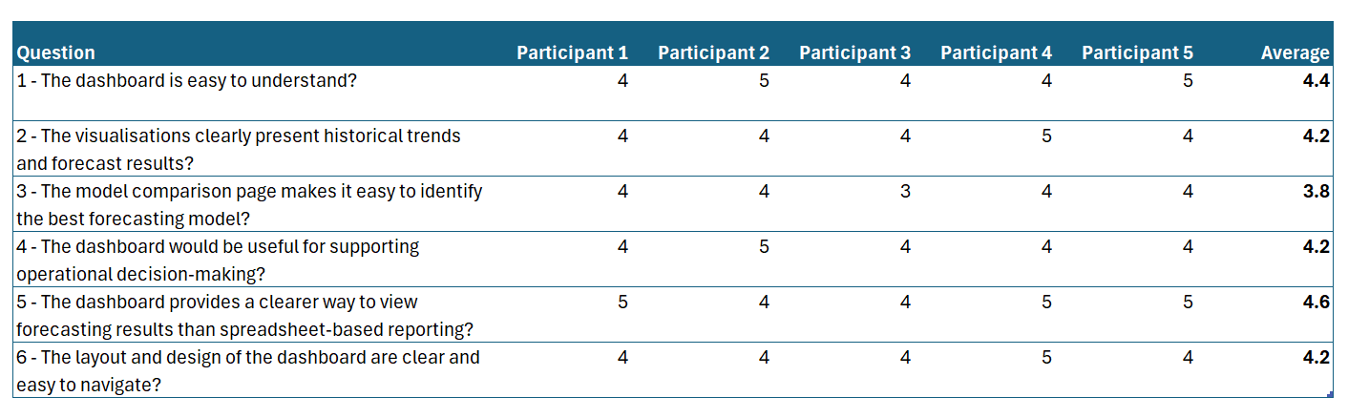
The questionnaire results show that the dashboard makes forecasting information easier to access and understand. The dashboard allows the forecasting results to be presented in a clear and interactive format that is easier for users to interpret and use. Although the evaluation only involved a small number of users, the results indicate that integrating forecasting outputs in a BI dashboard can improve how operational forecasting information is presented and understood.

7. Evaluation
The experimental results show clear differences in forecasting performance between the statistical and machine learning models tested. Across the four DVLA transaction services, XGBoost consistently produced the lowest error values when evaluated using MAE, RMSE, and MAPE. This indicates that the machine learning model was generally more effective at modelling patterns in the operational time series data. ARIMA and Prophet also produced accurate forecasts, but generally performed slightly worse than XGBoost. ARIMA remained competitive in some datasets, particularly where seasonal patterns were present, while Prophet showed more variable performance.

The Diebold–Mariano tests were used to assess whether differences in forecasting accuracy were statistically significant. Although XGBoost often achieved lower error values, the differences were not always statistically significant at the 0.05 level. This shows that machine learning models can improve forecasting accuracy, but the improvement may depend on the dataset and may not always be large enough to be statistically significant.

In relation to the hypotheses, the findings partially support the alternative hypothesis. The lower MAE, RMSE and MAPE values achieved by XGBoost suggest that machine learning can improve forecasting accuracy. However, because the Diebold–Mariano tests were not statistically significant for all comparisons, the null hypothesis cannot be rejected across the whole experiment. Machine learning offers better performance, but not consistently significant improvements.

Other considerations were also identified during evaluation. Once the pipeline was implemented, XGBoost was much faster to train and produce forecasts than the statistical models. ARIMA took approximately five minutes to run, Prophet around four minutes, while XGBoost completed the process in approximately two seconds. This provides an efficiency advantage if forecasts need to be generated regularly or applied across multiple transaction services.

However, the trade-off between forecasting accuracy and interpretability must be considered, particularly in a public sector setting. Statistical models such as ARIMA are easier to interpret because their parameters relate more directly to trends and seasonality. XGBoost uses a more complex predictive model, making it harder to explain individual predictions. This may create challenges in public sector environments where transparency and explainability are important.

The findings support the literature reviewed earlier in the project. Previous research suggests that machine learning models often outperform traditional statistical methods when applied to complex or non-linear datasets. The results of this study align with this, as XGBoost consistently achieved the lowest forecasting errors. However, the results also identify the continued relevance of statistical forecasting models, as ARIMA and Prophet remained competitive across several transaction services.

The dashboard also addressed the usability issues identified in the literature review. By presenting forecasting results through an interactive BI interface, users were able to explore trends, compare forecast outputs, and review model performance. Questionnaire feedback suggested that users found the dashboard useful for understanding trends and comparing forecasts. This supports previous research showing that interactive dashboards can improve the accessibility and interpretation of analytical outputs.

Overall, the project achieved its main objectives. ARIMA, Prophet, and XGBoost were implemented and compared using operational datasets and multiple forecasting accuracy metrics. The Diebold–Mariano test added statistical evaluation, ensuring that conclusions were not based only on error metrics. A forecast-driven BI dashboard was also developed to present forecast outputs and performance measures in an interactive format.

The research aim was to evaluate how statistical and machine learning forecasting models compare when applied to operational public sector data, and whether presenting the results through a BI dashboard can support decision-making. Based on the results, this aim was achieved. XGBoost provided the strongest forecasting performance across the selected datasets, while the dashboard improved the accessibility and interpretation of the forecasting outputs.

Although the project achieved its objectives, several limitations remain. Only three forecasting models were evaluated, meaning future research could include additional methods such as LSTM or hybrid models. The analysis could also be expanded across more datasets and longer time periods to provide stronger evidence. The dashboard evaluation was also limited by the small number of users. A larger usability study, or focus groups, could provide deeper insight into how users interpret forecasting outputs and apply them to decision-making.

Overall, the project aligns with existing research while also providing practical insight into how forecasting models and Business Intelligence dashboards can be applied within a public sector environment.

8. Conclusions & Recommendations

8.1 Conclusions
The aim of this project was to evaluate how statistical and machine learning time series forecasting models compare in forecasting accuracy when applied to operational public sector data, and to investigate whether presenting forecasting outputs through a BI dashboard can improve decision-making.

A review of existing literature showed that traditional statistical models such as ARIMA remain widely used because they are transparent and interpretable, while machine learning approaches can provide improved predictive performance on more complex datasets. The literature also highlighted that presenting forecasting outputs clearly to decision-makers can be a challenge.

To test this, a forecasting pipeline was implemented using ARIMA, Prophet, and XGBoost. These models were applied to operational transaction data and evaluated using MAE, RMSE, and MAPE. A Diebold–Mariano test was also used to assess whether differences in forecasting accuracy were statistically significant. A BI dashboard was then developed to present forecast outputs and model performance in an interactive format, with user feedback collected through a short questionnaire.

The results showed clear differences between the models. XGBoost consistently produced the lowest forecasting errors, suggesting that it was generally more effective at capturing patterns in the operational data. However, ARIMA and Prophet also produced accurate forecasts. ARIMA remained competitive in several cases, particularly where seasonal patterns were present, while Prophet showed more varying performance.

The Diebold–Mariano test showed that although XGBoost often produced lower errors, these differences were not always statistically significant. This suggests that machine learning models can improve forecasting accuracy, but traditional statistical models remain valid approaches, especially where interpretability is important. The hypothesis was partially supported, XGBoost consistently achieved the lowest forecasting errors, but the statistical tests showed that the difference was not significant in every comparison. This means machine learning showed stronger predictive performance overall, while statistical models remained valid alternatives.

Practical considerations were also identified. XGBoost was faster to train and generate forecasts once the pipeline had been implemented, while ARIMA and Prophet required more parameter tuning and cross-validation. However, XGBoost is more complex and harder to explain, which may be a limitation in public sector environments where transparency and trust are important.

The dashboard evaluation showed that presenting forecasting outputs through an interactive BI interface improved how easily results could be understood. User feedback suggested that the dashboard helped with interpreting trends and comparing forecast outputs. Although the number of participants was limited, the feedback indicates that dashboards can provide a useful way to present forecasting information to decision-makers.
Overall, the findings show that both statistical and machine learning forecasting models have value when applied to operational data. XGBoost provided the strongest forecasting performance, while ARIMA remained a suitable alternative where interpretability is more important. When combined with BI visualisation tools such as Power BI, forecasting models have the potential to support more informed and data-driven decision-making within public sector organisations.

8.2 Recommendations and Future Work
Based on the findings, XGBoost is recommended where forecasting accuracy and processing speed are the main priorities. Across the datasets evaluated, XGBoost achieved the lowest forecasting errors and required less training time than the statistical models. However, organisations should consider the balance between accuracy and interpretability. Where transparency and explainability is essential, ARIMA remains a suitable alternative because it is easier to interpret and still produced competitive results.

It is also recommended that forecasting outputs are presented through interactive BI dashboards. Dashboards allow users to explore trends, compare model outputs, and interpret forecasting information more easily than static reports or raw data outputs. Integrating forecasting outputs into existing BI tools could help organisations make better use of predictive analytics for decision-making.

Future work could evaluate additional forecasting models, including deep learning methods such as LSTM or hybrid models. This would provide a wider comparison of forecasting methods. The models could also be tested across more datasets and longer time periods to provide more evidence about whether performance differences remain consistent.

Finally, the dashboard evaluation could be expanded. A larger usability study involving users from different roles would provide better insight into how forecasting dashboards influence decision-making. Focus groups could also collect more detailed feedback on how users interpret forecast outputs and how they are used in real world scenarios.

9. Reflection
This project provided an opportunity to apply both technical and research skills to a real world data analysis problem. Throughout the process of completing the project, I developed a better understanding of forecasting techniques, data analysis, and the issues involved in implementing solutions within a public sector environment. In addition to developing my technical skill, the project also increased my professional skills, including time management, problem solving, and independent research.

One of the most significant areas of learning was gaining practical experience with time series forecasting methods in Python. Before this project, my understanding of forecasting models such as ARIMA, Prophet, and machine learning techniques were very limited. Through implementing these models and evaluating their performance I gained insight into the strengths and limitations of different modelling approaches. For example, while machine learning models such as XGBoost produced strong predictive performance, they were more complex to interpret compared to statistical models such as ARIMA. This highlighted the importance of considering both predictive accuracy and interpretability when selecting analytical models for use in a public service setting.

Another learning experience was understanding the importance of data preparation and exploration. During the implementation stage, it became clear that forecasting performance can be influenced by how the data is structured and prepared. For example, tasks such as selecting appropriate training and testing periods, and evaluating different modelling approaches required a lot of consideration and trial and error. This process helped me to appreciate that successful data analysis involves experimentation rather than a single straightforward solution.

The project also helped me develop my programming and analytical skills. Implementing multiple forecasting models required learning how to work with different Python libraries and understanding how to evaluate model performance using multiple forecasting accuracy metrics such as MAE, RMSE, MAPE. Implementing the Diebold–Mariano statistical test introduced me to a more advanced approach for evaluating forecasting model performance, which was a new technique for me during this project. This increased my ability to critically analyse results rather than simply relying on a single performance metric.

Developing the BI dashboard was another valued learning experience. While much of the focus of the project was on forecasting models, presenting the results in a clear and usable way was also important. Creating the dashboard required me to think about how users would interact with the data and how complex outputs could be communicated effectively. The feedback collected from the user questionnaire highlighted how visualisation can improve the accessibility of forecasting results and make them easier to interpret. This reinforced the importance of combining technical analysis with effective communication when delivering insights.

Time management was another important skill developed during this project. As a large independent project conducted alongside other academic and family commitments, it required careful planning to ensure that each stage of the research process was completed within the planned timeframe. Early stages of the project involved an extensive literature review and experimentation with forecasting models, which sometimes took longer than anticipated. As a result, I had to adjust my schedule and prioritise key tasks in order to ensure that the implementation, and evaluation could be completed on time. This highlighted the importance of planning when managing larger projects.

The project also had several challenges which required a lot of problem-solving. For example, implementing multiple forecasting models and ensuring that they could be compared consistently required careful design of the pipeline. Also, interpreting statistical testing results and ensuring that they were evaluated correctly required research and understanding. Overcoming these issues helped develop my ability to research solutions and apply them within a real-world context.

Reflecting on the overall project, there are several features that could potentially be improved if the work were to be repeated. One area for improvement would be allowing more time for experimentation with additional forecasting models or different parameter configurations. The project successfully compared several models but exploring a more methods or tunning techniques may have provided further insights into forecasting performance. Another improvement would be expanding the evaluation of the dashboard by involving a larger group of users. Although the questionnaire provided useful feedback, a larger sample size would provide better evidence regarding the effectiveness of the dashboard in supporting decision-making.

Overall, this project has significantly improved my ability to conduct independent research and apply forecasting techniques to real-world problems. It has increased both my technical knowledge of forecasting methods and my understanding of how solutions can be implemented and communicated within an organisational environment. The experience has also improved my confidence in managing complex projects and overcoming challenges. These skills will be valuable in future professional roles involving data analysis and analytics.

References
[1] Cabinet Office, “Transforming for a Digital Future: 2022 to 2025 Roadmap for Digital and Data, June 2022”, Gov.uk [Online]. Available: https://www.gov.uk/government/publications/roadmap-for-digital-and-data-2022-to-2025 [Accessed 24/01/2026]

[2] National Audit Office, “Challenges in using data across government, 2021”, NAO [Online]. Available: https://www.nao.org.uk/reports/challenges-in-using-data-across-government [Accessed 24/01/2026].

[3] Mheuka, Tafadzwa. (2021). Comparison of forecasting and prediction model accuracy using traditional, machine learning and deep learning algorithms. A case study of nando`s zimbabwe sales data. 10.13140/rg.2.2.30091.05927.

[4] Khan, M. A., Saqib, S., Alyas, T., Ur Rehman, A., Saeed, Y., Zeb, A., Zareei, M., & Mohamed, E. M. (2020). Effective Demand Forecasting Model Using Business Intelligence Empowered With Machine Learning. IEEE Access, 8, 116013–116023. https://doi.org/10.1109/ACCESS.2020.3003790

[5] Introduction to Time Series and Forecasting, Second Edition” The American mathematical monthly, vol. 110, no. 5, p. 461.

[6] L. Rosener, "When to Use Excel and When to Use Python for Data Analysis" BSL Lausanne Blog, 2024. [Online]. https://www.bsl-lausanne.ch/blog/when-to-use-excel-and-when-to-use-python-jupyter-notebook-for-data-analysis/

[7] K. Kelvin, W. Wahab, and M. Wulandari, “Computer Resource Utilization Analysis for Microsoft Excel and Python in Data Processing” J. EMACS (Engineering, Mathematics and Computer Science), vol. 6, no. 2, pp. 137–142, May 2024, doi: 10.21512/emacsjournal.v6i2.11736.

[8] R. R. Panko and D. Port, “End-User Computing: The Dark Matter (and Dark Energy) of Corporate IT” J. Organ. End User Comput., vol. 31, no. 4, pp. 1–23, 2020.

[9] Central Digital and Data Office (CDDO), “State of Digital Government Review” UK Government, 2023. [Online]. Available: https://www.gov.uk/government/publications/state-of-digital-government-review [Accessed 01/02/2026].

[10] M. D. Wilkinson, R. Jäschke, A. Winter, and C. Goble, “What do we talk about when we talk about dashboards?,” Patterns, vol. 2, no. 11, p. 100363, Nov. 2021, doi: 10.1016/j.patter.2021.100363.

[11] A. Shatat, M. Altahoo, and M. Almannaei, “The impact of Business Intelligence on decision-making process and customer service” in Proc. 2024 ASU Int. Conf. Emerging Technologies for Sustainability and Intelligent Systems (ICETSIS), pp. 355–360, 2024, doi: 10.1109/ICETSIS61505.2024.10459599.

[12] É. Foley and M. G. Guillemette, “What is Business Intelligence?,” International journal of business intelligence research, vol. 1, no. 4, pp. 1–28, doi: 10.4018/jbir.2010100101.

[13] M. A. Khan et al, “Effective demand forecasting model using business intelligence empowered with machine learning,”IEEE Access, vol. 8, pp. 116013–116023, 2020, doi: 10.1109/ACCESS.2020.3003790.

[14] M. D. Wilkinson, R. Jäschke, A. Winter, and C. Goble, “What do we talk about when we talk about dashboards?,” Patterns, vol. 2, no. 11, 2021, doi: 10.1016/j.patter.2021.100363.

[15] A. Shatat, M. Altahoo, and M. Almannaei, “The impact of business intelligence on decision-making process and customer service,” in Proc. 2024 ASU Int. Conf. Emerging Technologies for Sustainability and Intelligent Systems (ICETSIS), 2024, pp. 355–360, doi: 10.1109/ICETSIS61505.2024.10459599.

[16] R. Abdalla, Ed., Time Series Analysis : New Insights. London: IntechOpen, 2023.

[17] J. G. De Gooijer and R. J. Hyndman, “25 years of time series forecasting,” International journal of forecasting, vol. 22, no. 3, pp. 443–473, 2006, doi: 10.1016/j.ijforecast.2006.01.001.

[18] M. M. Hasan, K. T. W. Ng, S. Ray, A. Assuah, and T. S. Mahmud, “Prophet time series modeling of waste disposal rates in four North American cities,” Environmental science and pollution research international, vol. 31, no. 21, pp. 31343–31354, 2024, doi: 10.1007/s11356-024-33335-5.

[19] Noble, J, “What are ARIMA models?”, IBM [Online]. Available: https://www.ibm.com/think/topics/arima-model [Accessed 07/02/2026]

[20] U. Kumar and V. K. Jain, “ARIMA forecasting of ambient air pollutants (O3, NO, NO2 and CO),” Stochastic environmental research and risk assessment, vol. 24, no. 5, pp. 751–760, 2010, doi: 10.1007/s00477-009-0361-8.

[21] S. Makridakis, E. Spiliotis, and V. Assimakopoulos, “Statistical and machine learning forecasting methods: Concerns and ways forward” IEEE Access, vol. 6, pp. 594–612.

[22] “Prophet – Focasting at scale”, facebook [Online]. Available: https://facebook.github.io/prophet/model [Accessed 07/02/2026]

[23] B. Fuller et al., “Comparison of ARIMA and FB-Prophet time series models for the prediction of national and regional malaria incidence in Uganda,” Malaria journal, vol. 24, no. 1, Art. no. 289, 2025, doi: 10.1186/s12936-025-05547-8.

[24] Kufel, J., Bargieł-Łączek, K., Kocot, S., Koźlik, M., Bartnikowska, W., Janik, M., Czogalik, Ł., Dudek, P., Magiera, M., Lis, A., Paszkiewicz, I., Nawrat, Z., Cebula, M., & Gruszczyńska, K. (2023). What Is Machine Learning, Artificial Neural Networks and Deep Learning?—Examples of Practical Applications in Medicine. Diagnostics (Basel), 13(15), 2582. https://doi.org/10.3390/diagnostics13152582

[25] Tarek, K, “Future Forecasting Of Time Series using LSTM: A Quick Guide For Business Leaders”, Medium [Online]. Available: https://medium.com/data-science-collective/future-forecasting-of-time-series-using-lstm-a-quick-guide-for-business-leaders-370661c574c9 [Accessed 08/02/2026]

[26] T. Hall and K. Rasheed, “A Survey of Machine Learning Methods for Time Series Prediction,” Applied sciences, vol. 15, no. 11, p. 5957, 2025, doi: 10.3390/app15115957.

[27] K. Bandara, C. Bergmeir, and S. Smyl, “Forecasting across time series databases using recurrent neural networks on groups of similar series: A clustering approach,” Expert systems with applications, vol. 140, Art. no. 112896, 2020, doi: 10.1016/j.eswa.2019.112896.

[28] Vashistha, V, “Time Series Forecasting with XGBoost”, Medium [Online]. Available: https://medium.com/data-science-collective/time-series-forecasting-with-xgboost-dc5dc4510238 [Accessed 08/02/2026]

[29] G. Jain and R. R. Prasad, "Machine learning, Prophet and XGBoost algorithm: Analysis of Traffic Forecasting in Telecom Networks with time series data," 2020 8th International Conference on Reliability, Infocom Technologies and Optimization (Trends and Future Directions) (ICRITO), Noida, India, 2020, pp. 893-897, doi: 10.1109/ICRITO48877.2020.9197864.
[30] H. Lyu, “Hybrid ARIMA-LSTM Model for Stock Market Prediction: A Time Series and Deep Learning Integration Approach” Informatica (Ljubljana), vol. 49, no. 22, pp. 51–68, 2025, doi: 10.31449/inf.v49122.8510.
[31] Y. Wang and Y. Guo, “Forecasting method of stock market volatility in time series data based on mixed model of ARIMA and XGBoost” China communications, vol. 17, no. 3, pp. 205–221, 2020, doi: 10.23919/JCC.2020.03.017.
[32] V. I. Kontopoulou, A. D. Panagopoulos, I. Kakkos, and G. K. Matsopoulos, “A Review of ARIMA vs. Machine Learning Approaches for Time Series Forecasting in Data Driven Networks” Future internet, vol. 15, no. 8, p. 255, 2023, doi: 10.3390/fi15080255.

[33] V. Cerqueira, L. Torgo, and I. Mozetič, “Evaluating time series forecasting models: an empirical study on performance estimation methods,” Machine learning, vol. 109, no. 11, pp. 1997–2028, 2020, doi: 10.1007/s10994-020-05910-7.

[34] C. J. Willmott and K. Matsuura, “Advantages of the mean absolute error (MAE) over the root mean square error (RMSE) in assessing average model performance,” Climate research, vol. 30, no. 1, pp. 79–82, 2005, doi: 10.3354/cr030079.

[35] S. Kim and H. Kim, “A new metric of absolute percentage error for intermittent demand forecasts,” International journal of forecasting, vol. 32, no. 3, pp. 669–679, 2016, doi: 10.1016/j.ijforecast.2015.12.003.

[36] R. J. Hyndman and A. B. Koehler, “Another look at measures of forecast accuracy,” International journal of forecasting, vol. 22, no. 4, pp. 679–688, 2006, doi: 10.1016/j.ijforecast.2006.03.001.

[37] A. Botchkarev, “A New Typology Design of Performance Metrics to Measure Errors in Machine Learning Regression Algorithms,” Interdisciplinary journal of information, knowledge, and management, vol. 14, pp. 45–76, 2019, doi: 10.28945/4184.

[38] M. Saunders, P. Lewis, and A. Thornhill, Research Methods for Business Students, 5th ed. Harlow, England: Pearson Education Limited, 2007.

[39] I. Roper, R. Prouska, and U. Chatrakul Na Ayudhya, “The rhetorics of ‘agile’ and the practices of ‘agile working’: Consequences for the worker experience and uncertain implications for HR practice,” International journal of human resource management, vol. 33, no. 22, pp. 4440–4467, 2022, doi: 10.1080/09585192.2022.2099751.

[40] J. Gotay, “Excel vs. Power BI vs. Tableau: Which tool is right for you?” Business credit, vol. 126, no. 10, National Association of Credit Management, p. 24, 2024.

[41] S. Galli, Python feature engineering cookbook : a complete guide to crafting powerful features for your machine learning models, Third edition. Birmingham, UK: Packt Publishing Ltd., 2024.

[42] H. Dhake, Y. Kashyap, and P. Kosmopoulos, “Algorithms for Hyperparameter Tuning of LSTMs for Time Series Forecasting,” Remote sensing (Basel, Switzerland), vol. 15, no. 8, p. 2076, Apr. 2023, doi: 10.3390/rs15082076.

[43] S. Siamba, A. Otieno, and J. Koech, “Application of ARIMA, and hybrid ARIMA Models in predicting and forecasting tuberculosis incidences among children in Homa Bay and Turkana Counties, Kenya,” PLOS digital health, vol. 2, no. 2, p. e0000084, Feb. 2023, doi: 10.1371/journal.pdig.0000084.

[44] J. Nam and S. Sim, “Forecast accuracy of abalone producer prices by shell size in the Republic of Korea: Modified Diebold-Mariano tests of selected autoregressive models,” Aquaculture economics & management, vol. 22, no. 4, pp. 474–489, Oct. 2018, doi: 10.1080/13657305.2017.1298008.

[45] J. M. Valente and S. Maldonado, “SVR-FFS: A novel forward feature selection approach for high-frequency time series forecasting using support vector regression,” Expert systems with applications, vol. 160, Art. no. 113729, Dec. 2020, doi: 10.1016/j.eswa.2020.113729.

BIBLIOGRAPHY
Lazy Programmer and publisher Packt Publishing, Birmingham, England. Data science : time series forecasting with Facebook Prophet in Python, (2023).

X. Song, L. Deng, H. Wang, Y. Zhang, Y. He, and W. Cao, “Deep learning-based time series forecasting: Deep learning-based time series forecasting,” The Artificial intelligence review, vol. 58, no. 1, Art. no. 23, Jan. 2025, doi: 10.1007/s10462-024-10989-8.

T. LeBlanc and B. Merchant, Microsoft Power BI performance best practices : learn practical techniques for building high-speed Power BI solutions, second edition, 2nd ed. Place of publication not identified: Packt Publishing, 2024. [Online]. Available at: https://portal.igpublish.com/iglibrary/search/PACKT0007526.html

APPENDIX A – Dashboard Design

Front Cover
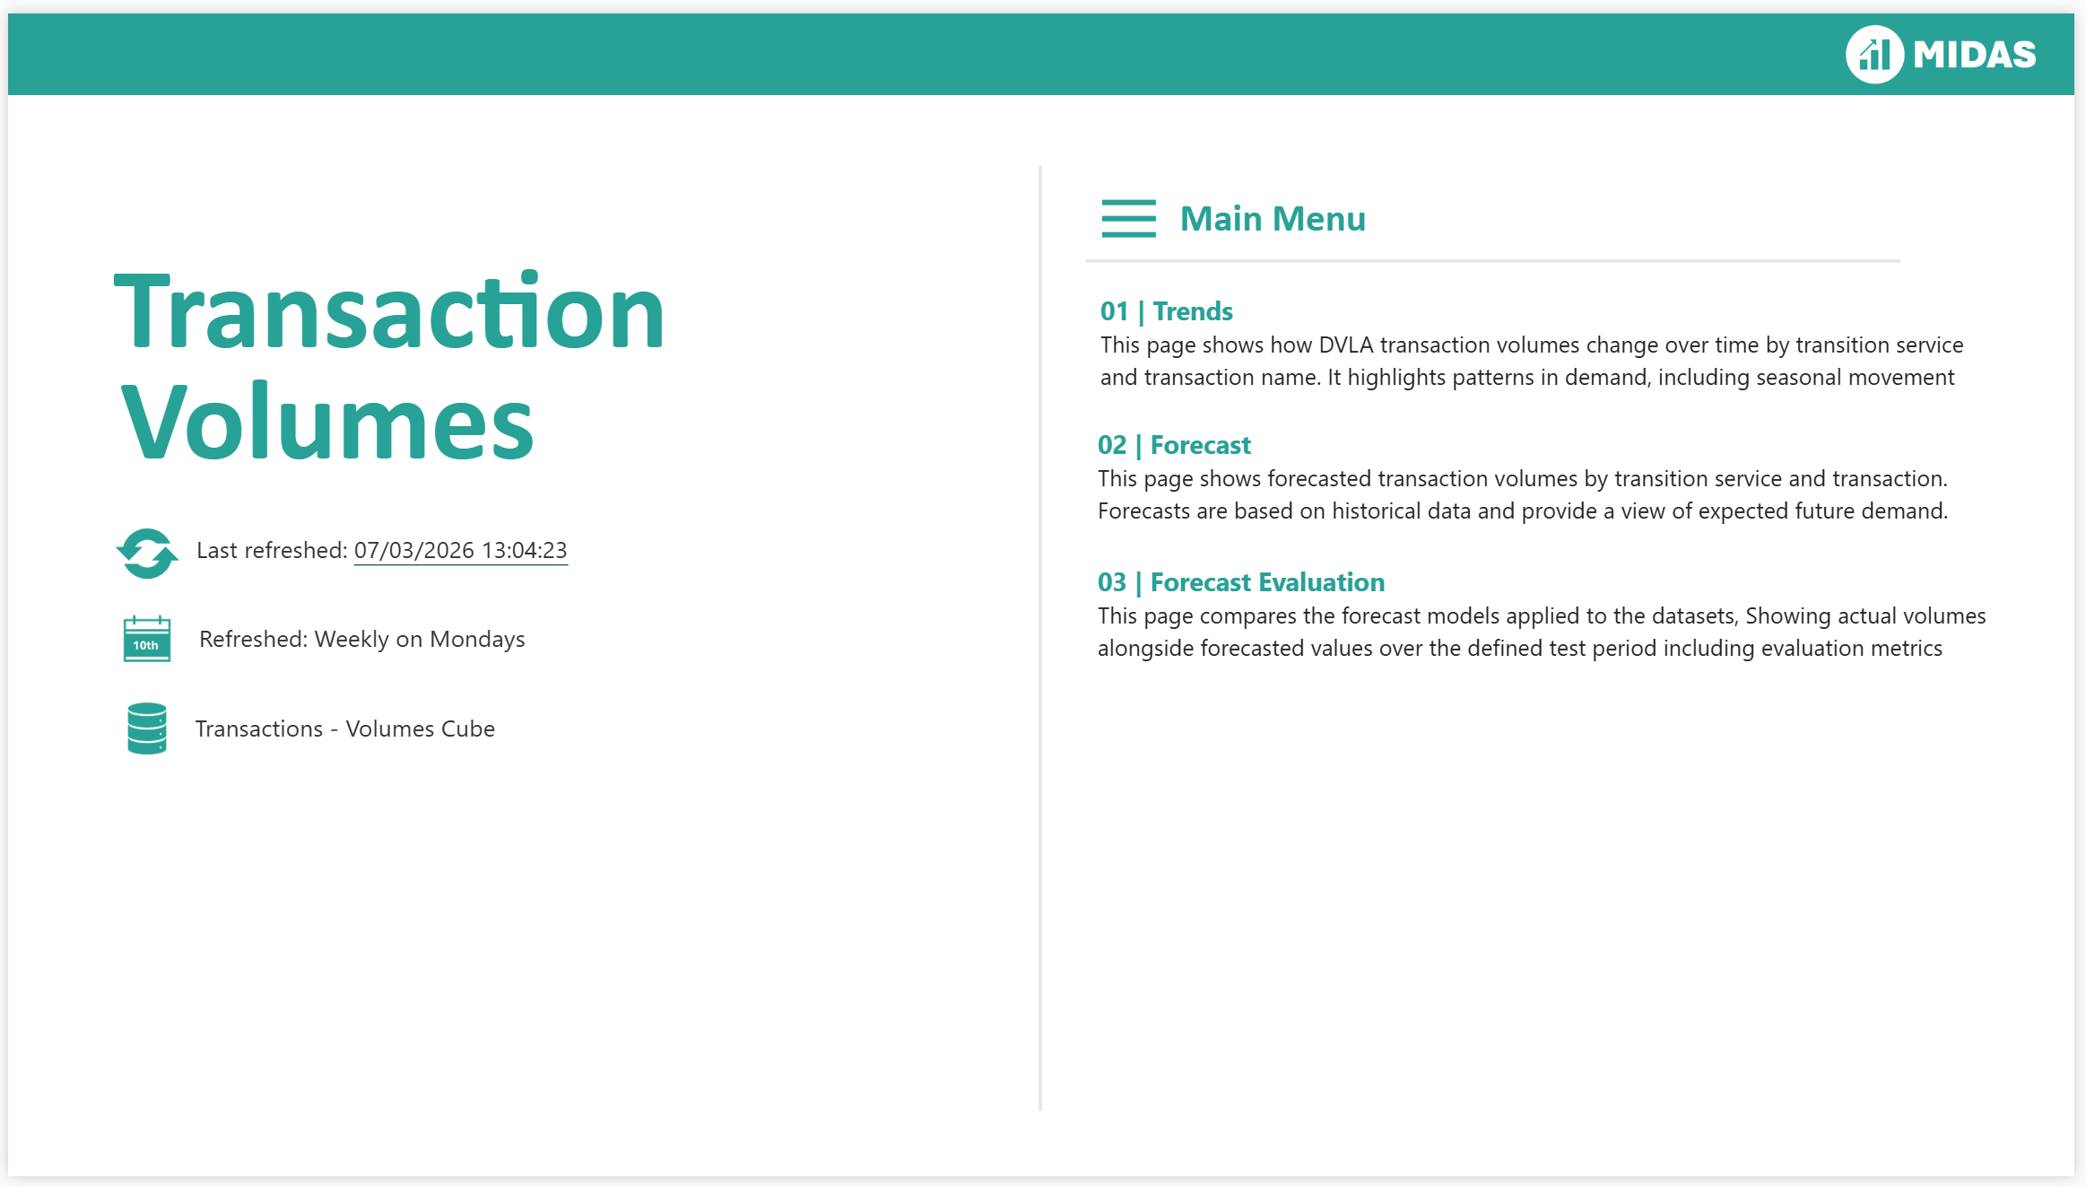

Trends Page
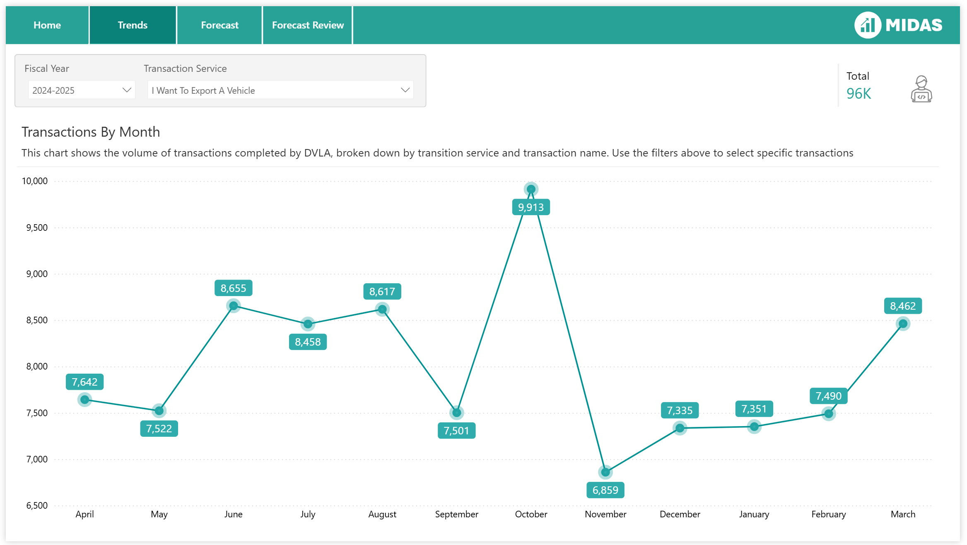

Forecast Page

Forecast Evaluation

APPENDIX B – Questionnaire
1 - The dashboard is easy to understand?
[ ] 1 – Strongly Disagree
[ ] 2 – Disagree
[ ] 3 – Neutral
[ ] 4 – Agree
[ ] 5 – Strongly Agree

2 - The visualisations clearly present historical trends and forecast results?
[ ] 1 – Strongly Disagree
[ ] 2 – Disagree
[ ] 3 – Neutral
[ ] 4 – Agree
[ ] 5 – Strongly Agree

3 - The model comparison page makes it easy to identify the best forecasting model?
[ ] 1 – Strongly Disagree
[ ] 2 – Disagree
[ ] 3 – Neutral
[ ] 4 – Agree
[ ] 5 – Strongly Agree

4 - The dashboard would be useful for supporting operational decision-making?
[ ] 1 – Strongly Disagree
[ ] 2 – Disagree
[ ] 3 – Neutral
[ ] 4 – Agree
[ ] 5 – Strongly Agree

5 - The dashboard provides a clearer way to view forecasting results than spreadsheet-based reporting?
[ ] 1 – Strongly Disagree
[ ] 2 – Disagree
[ ] 3 – Neutral
[ ] 4 – Agree
[ ] 5 – Strongly Agree

6 - The layout and design of the dashboard are clear and easy to navigate?
[ ] 1 – Strongly Disagree
[ ] 2 – Disagree
[ ] 3 – Neutral
[ ] 4 – Agree
[ ] 5 – Strongly Agree

APPENDIX C – Link Script Video Demo
https://youtu.be/F0ei8e92lgg

