LEVEL 5 ASSESSMENT SPECIFICATION

Student name: | Laetiti badaro | Student ID number: | 2325368
Programme: | BSc (Hons) Computing Portfolio
Module: | Computer Forensics
Module code: | ACCD5000 | Contribution to Overall Module Assessment (%): | 100%
Lecturer: | Dr Nitheesh Kaliyamurthy | Internal Verifier: | Munyaradzi Murira
Assignment Title: | Synthesize a solution to a potential real life scenario | Word count (or equivalent): | 4000
Submission deadline: | 26th April 2024 (Report)  29th April 2024 (Presentation) | Return date of provisional marks & written feedback:
Submission method: | All written assessments, where practical and possible, must be submitted via Turnitin unless otherwise instructed by the Lecturer. (Please DO NOT put this assessment specification into Turnitin or it will match many similarities with other students’ submissions.)  Alternative submission method (if applicable):  Late submission of the assessment will result in a late penalty mark. Penalties for late submission: Up to one week late, maximum mark of 40%. Over one week late, 0%. Only the Extenuating Circumstances Panel may approve a change to submission dates.
Academic honesty / referencing: | Academic honesty is required. In the main body of your submission you must give credit to authors on whose research and ideas your work is based. Append to your submission a reference list that indicates the books, articles, etc. that you have used, cited or quoted in order to complete this assessment.

Task 1 – Research and Report:

- Definition
Computer forensics: Computer forensics is a branch of digital forensics that involves investigating, analysing, and preserving computer and digital storage media. Its primary objective is to gather digital evidence for legal reasons or to disclose hidden information. Computer forensics relies on examining the evidence located within computers and digital gadgets.
https://www.coursera.org/articles/computer-forensics
Digital forensics: it is the act of examining electronic devices, networks, and information to uncover, retrieve, and interpret data. It is crucial to maintain the integrity of the information to be utilized as evidence in legal matters, whether criminal or cvil https://www.bcs.org/articles-opinion-and-research/what-is-digital-forensics/

- History :
The field of computer forensics emerged in the late 70s to analyse computer systems for criminal evidence. With the increased use of personal computers in the 80s, there was a rise in computer crimes, which led to the development of forensic strategies. By the 1990s, techniques for investigating computer systems had been established. In the late 1990s, with the expansion of the internet, computer forensics became digital forensics and began to encompass a wider range of devices such as mobile phones, and address issues like identity theft. This transformation marked the shift from computer forensics to digital forensics. In the early 2000s, the rise of cybercrime prompted efforts to standardize digital forensic processes. Organizations like IA CIS and NIST were established to establish best practices as investigators adapted to new technologies.
https://online.champlain.edu/blog/evolution-digital-forensics#:~:text=Emergence%20in%20the%201980s%20and%201990s&text=In%20its%20earliest%20stages%2C%20digital,collecting%20evidence%20and%20investigating%20crimes.

- Digital vs computer forensics
Digital forensics :
- The general term for the retrieval and investigation of digital evidence from any type of electronic devices
- Includes all the forensics such as computer forensics network forensics cloud forensics …
- Digital forensics sets the guidelines and procedures for managing evidence in a way that complies with the law, guaranteeing its acceptance in court
Computer forensics :
- It is situated inside digital forensics, it's the subfield of digital forensics, its job is to recover evidence from computer laptops and desktops
- Hard discs and solid-state drives (SSDs) are the main subjects of traditional computer forensics, while peripherals like USB drives may also be included.
- Computer forensics techniques are well-established and sometimes entail making forensic copies of storage devices in order to preserve the original evidence.
https://www.quora.com/What-is-the-difference-between-computer-forensics-and-traditional-forensics

- Application and present cases :
The case of Dennis Rader alias serial killer "BTK" highlights the importance of computer and digital forensics in criminal investigations. After he sent a floppy disk that he thought could not be traced, the computer forensics managed to discover a deleted Microsoft Word file form it which contained metadata linking authorship of the document to Rader’s name .Recovering erased data and tracing digital artifacts to their source with computer forensics. Also, linking the digital evidence to Rader's physical identity using digital forensics was critical owing to a link in the metadata file found within Rader’s documents showing that he belonged to a Lutheran Church as a Deacon, marking the largest known association between these two disparate realms at the time
https://www.infosecinstitute.com/resources/digital-forensics/notable-computer-forensics-cases/#:~:text=Dennis%20Rader%20(2005)%3A%20The,a%20deleted%20Microsoft%20Word%20fil

There was a critical rule that was played by digital forensics when it comes to cases such as Ross Compton’s in which significant proofs are stored in electronic gadgets. In the scenario that happened with this client, workout information that had been received from a pacemaker located inside him served as one of the main sources disputing his claims about time and location. For proof that he had been at the fire scene during the incidence time, Compton’s heart rate and its variance had to be analyzed by digital forensic experts using the pacemaker data together with other parameters like demand for pacing signals or changes in rhythm readings.Also, medical experts collaborated with forensic analysts interpreters so as to accurately interpret the data from his pacemaker. Review of Compton's medical records, submitted alongside the pacemaker data, pointed out some disparities effectively confirming that his claims are false. This case indicates clearly the importance of digital forensics in unearthing the truth behind digital evidence which helps prosecute criminals.
https://precisedigital.com/4-cases-solved-with-digital-evidence/#:~:text=One%20of%20the%20earlier%20cases,supposed%20suicide%20by%20sleeping%20pills.

Task 3: Investigate and Report

Introduction:

Title: forensics report
Case Reference Number: 0001
Date of Examination: 04/25/20024
Investigators: Laetitia Badaro
Subject: cyberbullying
In today's forensics report, we are analyzing images videos links, and other evidence to see if a cyber crime was committed. To be able to identify and prove if a cyber crime has happened we are going to need to use multiple forensics tools to analyse the evidence, work in a team, use our critical thinking go through a chain of custody, and finally see if a crime has been committed.

Chain of custody:
Evidence number | Description
01 | USB flash drive storage SanDisk cruzer  Contains evidence
02 | 4 E0 files, 1 CVS file and one README

Evidence number | date/time | Received from | Released to | Comment
01 | 11/0/.2024 17:00hrs | John Morgan | Laetitia Badaro | An image file was created using FTK Imager 4.3.11 on an isolated virtual machine with the software write blocking in place all USB storage device
02 | 10/04/2024  15:00hrs | John Morgan | Laetitia Badaro | We chose the easiest file to open which is 4 E0 files , it was opened with two different software autopsy and FDK imager that gave us the same content

Tools :
Autopsy
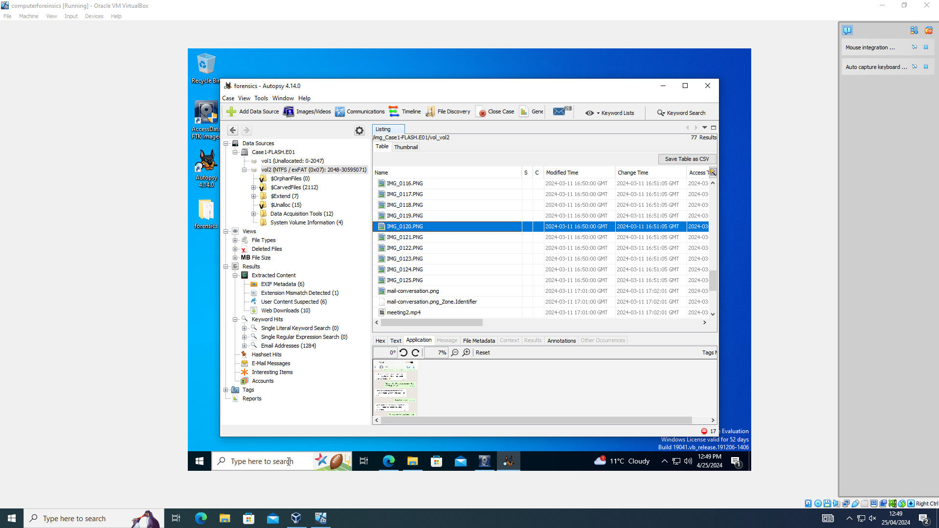
Autopsy is a digital forensics tool, it is used to examine file systems, disc images, and other digital artefacts. It is perfect for thorough forensic examinations since it provides investigators with an easy-to-use interface for examining evidence, including timeline analysis, file analysis, and keyword search.

FTk

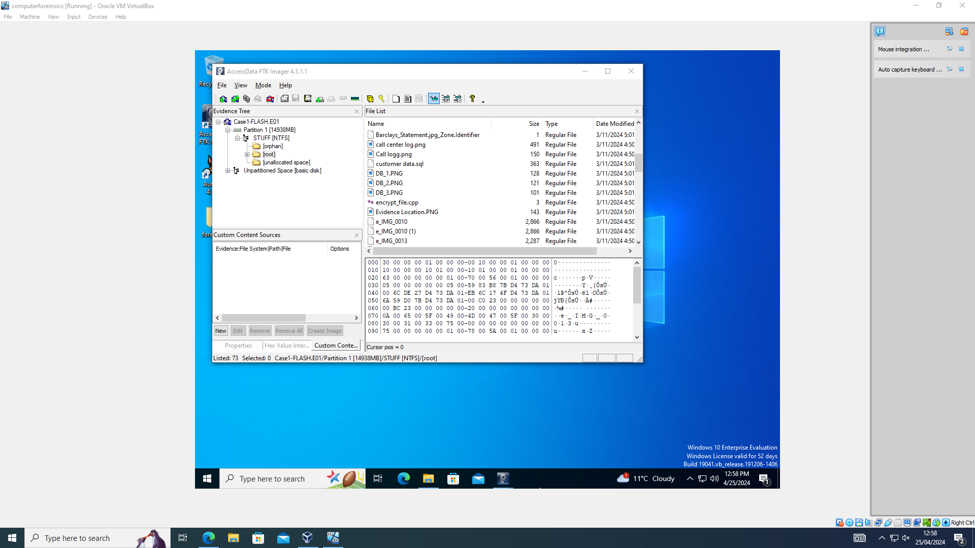
FTK Imager is mostly used to create forensic images of storage devices. Although it can also analyse these images, its primary advantage is that it can make disc copies that are exact replicas of the original, protecting the integrity of the evidence.

Visual studio

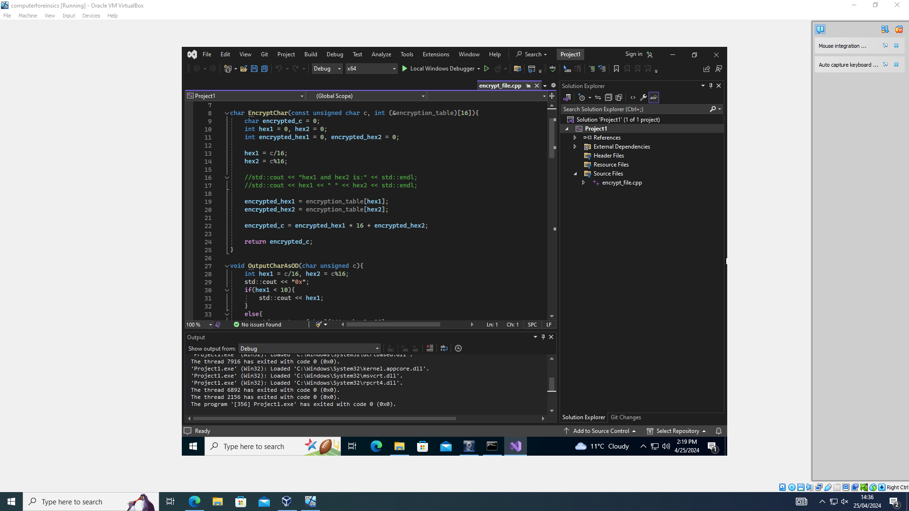

Visual Studio is a powerful integrated development environment ,It is equipped with quite comprehensive library support and debugging tools which makes it an efficient environment to test-supervised decryption software implementations. This adaptability permits forensic analysts to customize decryption procedures in regards to specific image file layouts and encryption schemes thereby raising their ability in drawing useful information from opaque images.

Command prompt

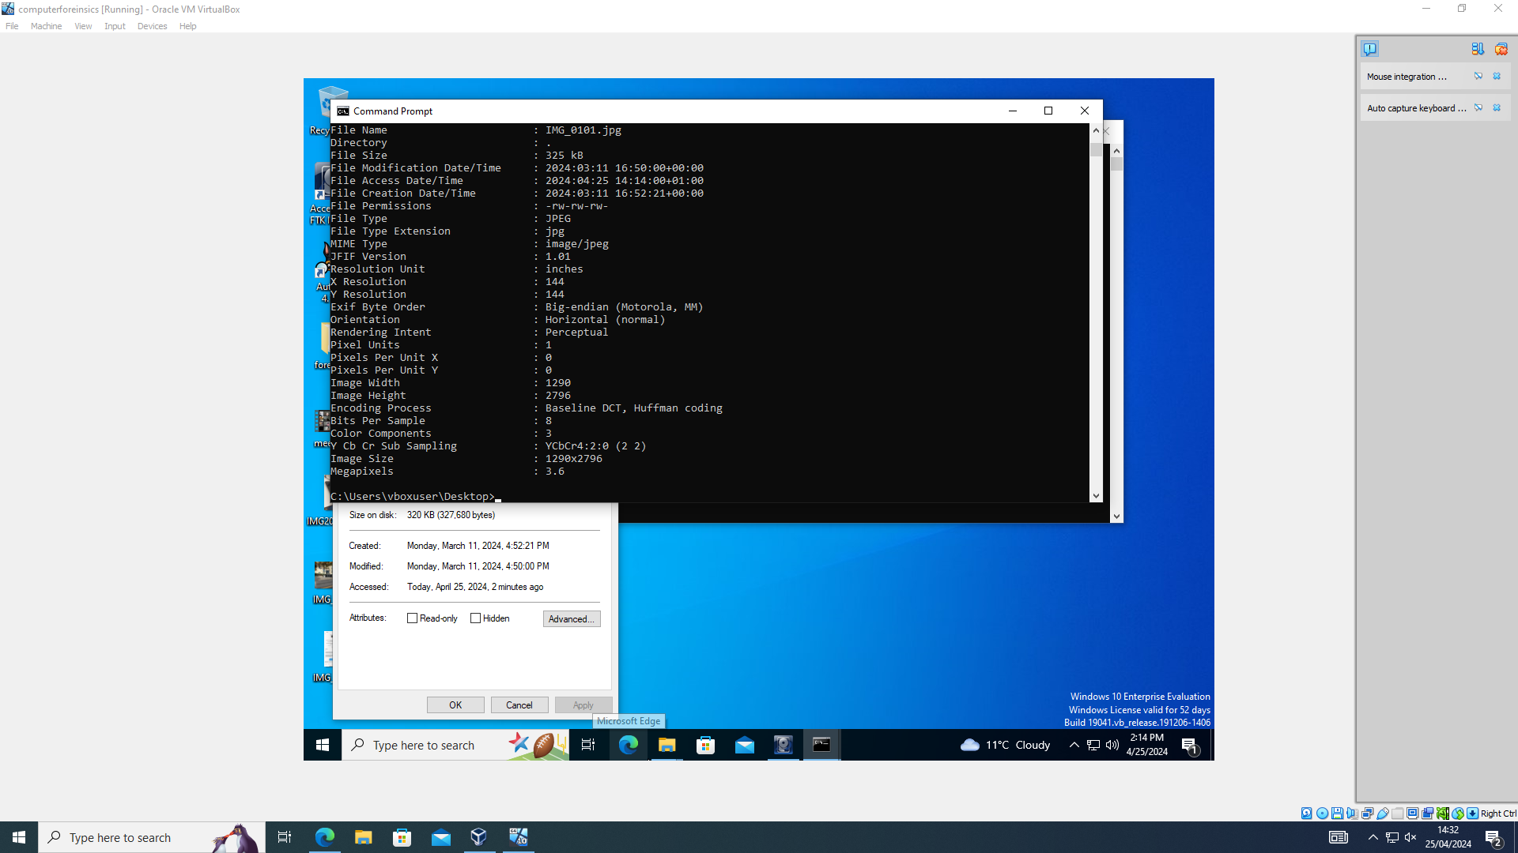
Command Prompt too is used for finding the location and information about image files. By using commands such as "dir" to list directory contents and "cd" to navigate directories, it can locate the image file and obtain basic information like file size, creation date, and last modified date. Furthermore commands like "exiftool" or "file" can provide more detailed metadata about the image, such as camera information, GPS coordinates, and even possible tampering indicators.
Annalisis of the image file

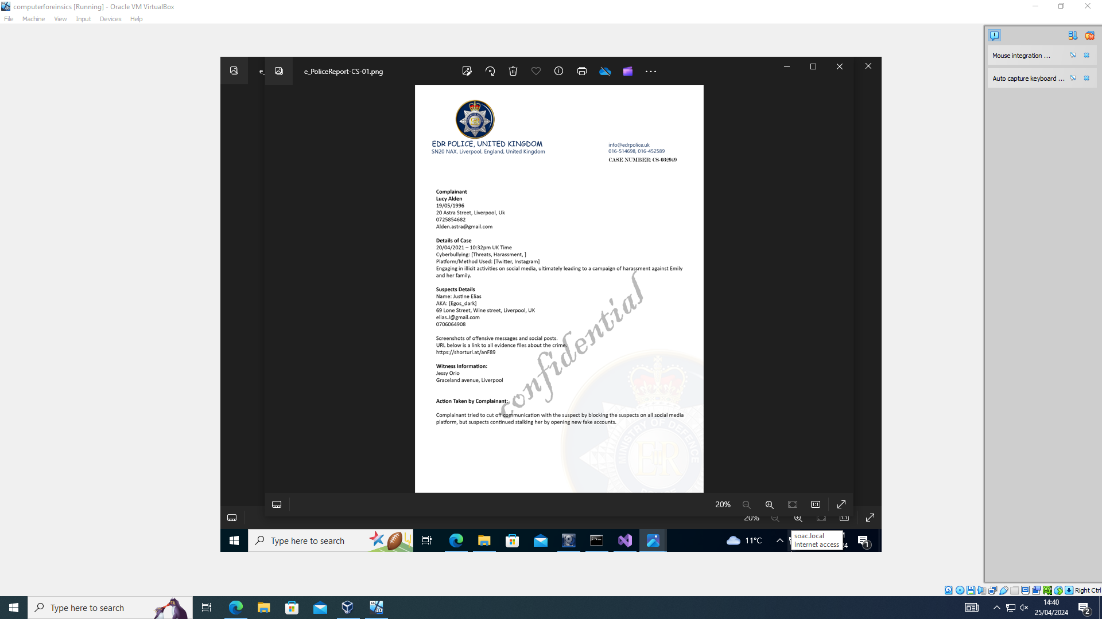

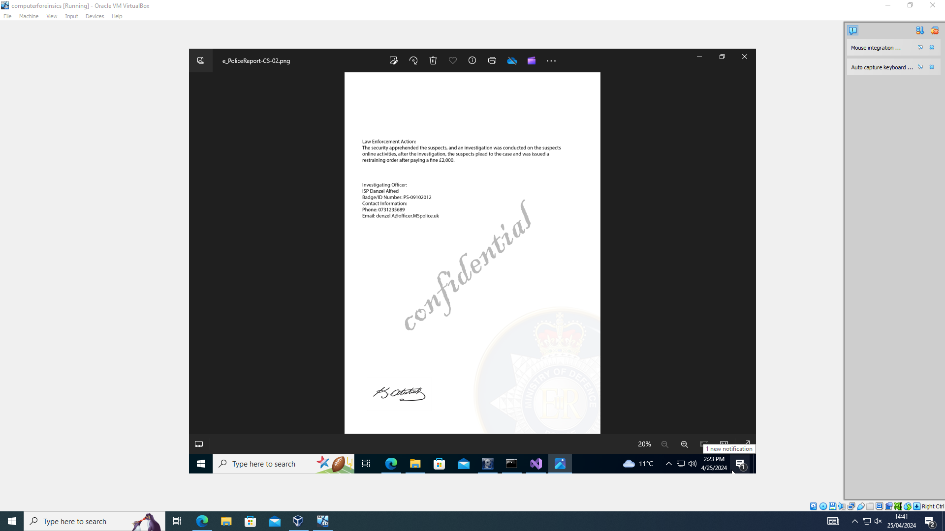

With the help of Visual Studio and i’s debugging tool we were able to decript this image .
​​The material supplied suggests that there is substantial proof of cyberbullying. First, the case specifics describe specific incidents of harassment and threats related to cyberbullying that took place on Twitter and Instagram on April 20, 2021, at 10:32 PM (UK Time). This sets the schedule and platforms for the project. Second, the pseudonym (Egos_dark) and contact information for the suspect, Justine Elias, are provided, indicating a deliberate attempt to hide identity or carry out illicit acts. Third, Lucy Alden, the complainant, gives her contact information and a thorough account of the harassment, including the suspect's actions and their consequences.Furthermore, the witness account provided by Jessy Orio supports the events even more. The screenshots of insulting communications and social media posts—which can be accessed via the provides URL. These screenshots most likely provide concrete proof of the cyberbullying, exposing the type and intensity of the victim's and her family's harassment. In conclusion, the judgment that cyberbullying occurred in this instance is strongly supported by the combination of in-depth reports, witness testimony, and direct proof in the form of screenshots.

For this image we decided to use command prompt to see if we could get any information on the location or the coordinate, we did find one however it matched none of the other pictures and did not give us much information, without more detail we cannot say that there was any cyberbullying attempt

conversation screenshots

The screenshots show a trend where a male asks girls about their hobbies at first, seeming polite. But then he moves right on to inquiring about their favourite colour, place of residence, and favourite cafe. Then, even though they don't respond, he goes on to ask for their email address, Instagram handle, and other private information. He gives off the impression that he wants to date them and has a stalker-like demeanour. He continues after being turned down several times. Additionally, he provides them a dubious link that might compromise their machine. This type of behaviour is harassment and cyberbullying.

We tried annualizing the other's evidence but without useful information or anything concrete to confirm cyberbullying

