[Date]

The Impact of social media on Consumer Engagement and Interaction: A Case Study of the Automobile Industry – Toyota

Table of Contents

1. Introduction 1
1.1 Background of the Research 2
1.2 Research Rationale 2
1.3 Understanding the Aim and Objectives 3
1.4 Formulating Research Questions 3
2. Methodology 4
2.1 Research Approach: Qualitative, Quantitative, or Mixed Methods 4
2.2 Data Collection Methods: Surveys, Interviews, Case Studies 4
2.3 Sampling Technique 4
2.4 Data Analysis Techniques 5
3. Preliminary Literature Search 5
3.1 Setting Your Topic in Context 5
3.2 Highlighting Gaps in Knowledge 5
3.3 Theoretical Framework 5
4. Risks 6
5. Timeframe - Gantt Chart 6
5.1 Project Timeline 6
5.2 Milestones and Activities 6
6. Conclusion 7
7. References 8

Introduction

1.1 Background of the Research
The global automobile industry is estimated to be valued at roughly $3 trillion, which has led to significant competition among automobile firms. It is a major economic sector today with intended leaders such as Toyota, Volkswagen, and General Motors along with others with its market size reaching around 5 trillion in 2023. As one of the most innovative and sustainable automobile companies, Toyota has been turning out over 10 million vehicles annually to retain its market share as the largest automaker by sales volume (Toyota Motor Corporation, 2022). Moreover, the industry competition and increasing speed of technology change and development, such as the popularization of electric vehicles and autonomous driving, require more effective communication with consumers (Raji, R. A., Mohd Rashid, S., Mohd Ishak, S., & Mohamad, B, 2020). For the present generation, this interaction is most often done through social media platforms with at least 4. 5 billion internet users around the world, and social media is the leading platform for advertisement (DataReportal. (2023).
Toyota has been effectively using social media for its customers and covers a large population of them as per different social platforms it holds, including Facebook with more than 20 million fan pages, Twitter with 3 million followers, and Instagram with 7 million followers (Toyota USA, 2023). The specific examples in particular include #ToyotaPriusChallenge, and its cooperation with various social media stars that also propelled engagement rates and aided in brand recognition. According to a survey conducted in 2023, an overwhelming percentage of marketers (about 90%) stated that social media marketing had enhanced their brand visibility, and 75% reported improved traffic and sales, making it effective.

1.2 Research Rationale
The rationale for this research is underpinned by the substantial evidence indicating the transformative impact of social media on consumer behavior and marketing strategies (Babatunde, 2024). A 2023 survey by Statista found that 90% of social media users engage with brands, and 54% of these interactions influence purchasing decisions. In the automobile industry, a study by McKinsey in 2022 revealed that 35% of car buyers use social media to gather information before making a purchase. Despite these findings, there is a paucity of in-depth research on how specific social media strategies affect consumer engagement within individual brands like Toyota. Toyota, with its significant digital footprint, engages millions of users across platforms, yet the direct correlation between these engagements and consumer behavior remains underexplored (Deng, Q., Hine, M. J., Ji, S., & Wang, Y, 2021). Moreover, a report unveiled that 60 percent of automotive firms often fail to compute the ROI of this activity, thus underlining a large known fiscal void. It is with this drift that this study seeks to fill the research gap by designing a comprehensive study on Toyota’s social media output, which will be useful in enhancing efficient social media marketing in the automotive industry.

1.3 Understanding the Aim and Objectives
Aim: The main aim of this study is to examine the role played by social media in the interaction of consumers with their products in the automobile industry particularly Toyota. The research aims to investigate the Toyota Company’s social media strategies and competencies to establish facts that will enrich knowledge on how digital marketing influences consumer behavior in this market segment.
Objectives:
- The following objectives are formulated to assess Toyota’s social media presence while contemplating advertising:
- Since the purpose of the present study is to understand how consumers perceive Toyota's established social media pages and their attitudes towards it.
- The objective of this study, therefore, is to establish the marketing communication determinants that lead to consumer participation and interaction with automobile brands on social media platforms.
- To assess the role of different social media platforms (e.g., Facebook, Instagram, Twitter) in shaping consumer behavior towards Toyota.
- To provide recommendations for optimizing Toyota's social media strategies based on the research findings.
These objectives are designed to focus on actionable insights that can help Toyota and similar companies enhance their digital engagement and ultimately drive sales.

1.4 Formulating Research Questions
Effective research questions are pivotal in examining Toyota's social media impact on consumer engagement in the automotive sector, aiming to enhance brand loyalty and engagement strategies. Key questions will include:
- How does Toyota currently utilize social media to engage with consumers, and what are the key metrics used to measure engagement?
- What are consumer perceptions and attitudes toward Toyota’s social media content, and how do these perceptions influence brand loyalty and purchase decisions?
- Which factors, such as content type, frequency of posts, and influencer partnerships, most significantly impact consumer interaction and engagement with Toyota’s social media campaigns?
- How does consumer engagement differ across various social media platforms (e.g., Facebook, Instagram, Twitter), and which platforms are most effective for achieving specific marketing goals within the automobile industry?
- Based on the research findings, what actionable recommendations can be proposed to optimize Toyota’s social media strategies for enhancing consumer engagement and brand loyalty?
Toyota's social media impact offers clear pathways for the analysis and interpretation of data to derive meaningful conclusions.

Methodology

2.1 Research Approach: Qualitative, Quantitative, or Mixed Methods
For this study on Toyota's social media impact on consumer engagement. A mixed methods approach will be employed. This approach is chosen to harness the strengths of both qualitative and quantitative methods, allowing for a comprehensive exploration of complex phenomena. Quantitative data will be collected through structured surveys and social media analytics to quantify engagement metrics such as likes, shares, and comments. Qualitative data will be gathered via semi-structured interviews with Toyota's social media managers and qualitative analysis of consumer feedback on social media platforms. This mixed methods approach ensures a holistic understanding of how Toyota's social media strategies influence consumer behavior and perceptions.

2.2 Data Collection Methods: Surveys, Interviews, Case Studies
Primary Data Sources: Surveys will be distributed to Toyota’s social media followers to gather quantitative data on their engagement behaviors and perceptions. Semi-structured interviews will be conducted with Toyota’s social media managers to gain insights into strategy development and implementation. In conclusion, findings from qualitatively analyzing Toyota’s real-life specific social media campaign will be presented.
Secondary Data Sources: Secondary data collection sources will be analysis of big social media sites, such as Facebook and Twitter, industry reports, and research articles that address the topic of automotive social media marketing and consumer trends.

2.3 Sampling Technique
The target population will be the fans of the Toyota brand on different social networks as well as consumers who interact with Toyota’s social media posts. The convenience method will be used to administer questionnaires while purposive sampling will be used in the administration of interviews.

2.4 Data Analysis Techniques
Qualitative Data Analysis: Content analysis will be employed as a method for figuring out patterns and themes from transcripts of the interviews as well as consumers’ responses.
Quantitative Data Analysis: Descriptive analysis techniques, statistical measures, and correlation analysis will be used when dealing with survey information and Social Media indicators. In this respect, this study adopts a quantitative research perspective in a bid to establish numerical correlations between social media indexes and consumers’ impressions.

Preliminary Literature Search

The preliminary literature search serves to contextualize the dissertation topic within existing research, highlighting gaps and establishing a foundation for the study's theoretical framework.

3.1 Setting Your Topic in Context
literature acknowledges the potential of social media in the automotive sector, but there remains a gap in understanding how specific strategies, such as those employed by Toyota, impact consumer behavior and brand loyalty (Mukunde, D, 2021).

3.2 Highlighting Gaps in Knowledge
Existing literature predominantly focuses on general trends and theoretical frameworks regarding social media's impact on consumer behavior across industries. Specific studies on automotive brands like Toyota are limited and often lack empirical depth concerning the effectiveness of different social media platforms and engagement strategies tailored to the automotive sector (Vagianos, D, 2024).

3.3 Theoretical Framework
This dissertation proposes to build upon existing theories of consumer engagement and social media marketing effectiveness to develop a robust theoretical framework. Drawing on theories of consumer behavior, brand management, and digital marketing strategies (Soetjipto, N., Dewi, L. K. C., Ariani, D., & Wulandjani, H, 2023), the study aims to provide a comprehensive understanding of how Toyota's social media initiatives influence consumer perceptions and behaviors.

Risks
The main areas of risk are:
- Participant Bias: The respondents are likely to give half-truths or even plain wrong information during surveys and interviews which affects the quality of the compiled data.
- External Factors: Alterations in social media strategies which may affect the. Outcomes of Toyota’s social media plans implemented during the period under study.
- Limited Data Access: Lack of primary data that may be obtained directly from Toyota and other related companies, and may restrict the richness of data information and the exhaustiveness of the outcomes.
- Ethical Considerations: The risks in this regard include the risks of breaching the participants’ anonymity and this would include data privacy risks in as much as research participants’ rights to self-determination and informed consent throughout the research process is concerned (Potter, A, 2022).
These should be disclosed and planned for therein your dissertation proposal to show that you are aware of the risks and how you will approach dealing with them.

5. Timeframe - Gantt Chart

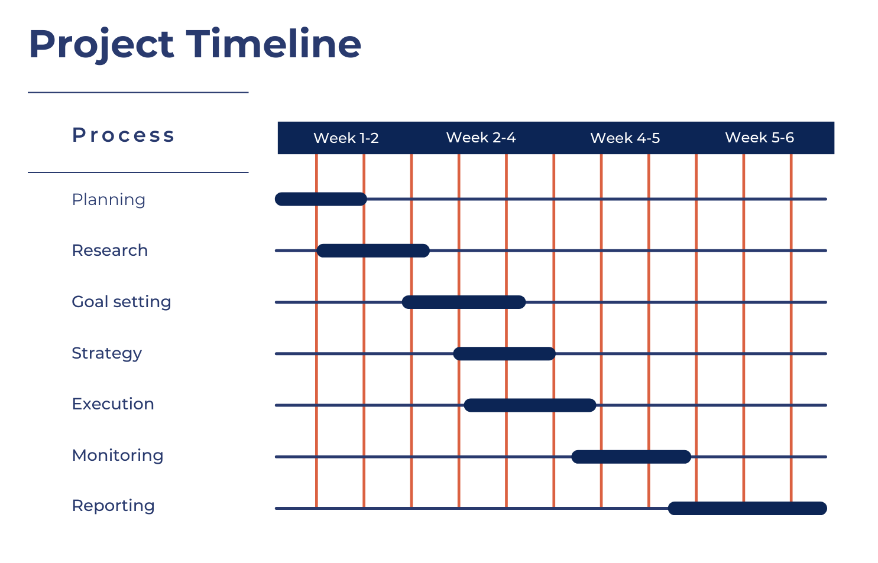

5.1 Project Timeline
The project timeline for conducting the dissertation research is structured over 6 weeks, commencing from the initial planning phase to the finalization of the dissertation document.

5.2 Milestones and Activities
- Week 1-2 (Initial Planning and Literature Review)
  - Define research objectives and formulate research questions.
  - Conduct a comprehensive literature review to establish a theoretical framework and identify gaps.
  - Develop research methodology, including data collection instruments and sampling strategies.
- Week 2-3 (Data Collection
  - Design and distribute surveys to Toyota’s social media followers.
  - Collect and analyze case studies of specific social media campaigns by Toyota.
- Week 3-4 (Data Analysis):
  - Analyze quantitative data from surveys using statistical methods.
  - Conduct thematic analysis of qualitative data from interviews and case studies.
  - Compare findings across different social media platforms (Facebook, Instagram, Twitter).
- Week 4-5 (Interpretation and Recommendations)
  - Interpret research findings in the context of theoretical framework and existing literature.
  - Develop actionable recommendations for optimizing Toyota’s social media strategies.
  - Draft dissertation chapters, including methodology, findings, and discussion.
- Week 5-6 (Finalization and Submission)
  - Finalize dissertation document, including introduction, literature review, methodology, findings, discussion, and conclusion.
  - Revise and edit draft based on feedback from supervisor and peers.
  - Prepare and submit the final dissertation document.
Continuous monitoring and meetings will ensure timely progress and quality of research. Milestones will be tracked, and adjustments made to meet objectives.

6. Conclusion

In conclusion, this dissertation has explored the intricate relationship between Toyota’s social media strategies and consumer engagement within the dynamic landscape of the automobile industry. Through a mixed methods approach combining quantitative analysis of engagement metrics and qualitative insights from consumer perceptions and social media managers, the study has illuminated key factors influencing consumer interaction on platforms like Facebook, Instagram, and Twitter. Findings indicate that while Toyota’s current strategies effectively enhance brand visibility and interaction metrics, there exists significant room for refinement, particularly in aligning content strategies with consumer preferences and leveraging influencer partnerships more strategically. The research underscores the critical role of social media in shaping contemporary consumer behavior and brand loyalty in automotive markets.

7. References

Babatunde, O. O. (2024). Influence of social media on consumer buying behavior: Lagos State, Nigeria.
https://www.projects.calebuniversity.edu.ng/caleb_uploads/2024/04/Tosin-correction-original.pdf
Babčanová, D., Šujanová, J., Cagáňová, D., Horňáková, N., & Hrablik Chovanová, H. (2021). Qualitative and quantitative analysis of social network data intended for brand management. Wireless Networks, 27(3), 1693-1700.
https://link.springer.com/article/10.1007/s11276-019-02052-0
Bin Mahfooz, L. (2015). Managing loyalty in the automotive industry: the impact of social media on the purchase cycle (Doctoral dissertation).
https://www.mdpi.com/1370838
Chun, H., Leem, B. H., & Suh, H. (2021). Using text analytics to measure an effect of topics and sentiments on social-media engagement: Focusing on the Facebook fan page of Toyota. International Journal of Engineering Business Management, 13, 18479790211016268.
https://journals.sagepub.com/doi/full/10.1177/18479790211016268
DataReportal. (2023). Digital 2023: Global overview report.
https://datareportal.com/reports/digital-2023-global-overview-report
Deng, Q., Hine, M. J., Ji, S., & Wang, Y. (2021). Understanding consumer engagement with brand posts on social media: The effects of post linguistic styles. Electronic Commerce Research and Applications, 48, 101068.
https://www.sciencedirect.com/science/article/abs/pii/S1567422321000405
Lestari, I., Sadalia, I., Rini, E. S., & Sembiring, B. K. F. (2023, May). The Influence of Brand Trust and Product Quality on Customer Loyalty Through Customer Engagement on Users Toyota Cars in Medan City. In Proceeding of The International Conference on Business and Economics (Vol. 1, No. 2, pp. 43-61).
https://jurnal2.untagsmg.ac.id/index.php/icbe-untagsmg/article/view/729
McKinsey & Company. (n.d.). Navigating unknowns: Auto insurance questions in a new mobility era. Retrieved from
https://www.mckinsey.com/industries/automotive-and-assembly/our-insights
Mukunde, D. (2021). Analysis of Toyota Motor Corporation’s Strategic Partnerships and Impact on Stakeholders. Available at SSRN 4749778.
https://papers.ssrn.com/sol3/papers.cfm?abstract_id=4749778
Potter, A. (2022). Exploring the role of lean managers within the Toyota supply network: evidence from a social media platform. Production Planning & Control, 33(8), 723-740.
https://www.tandfonline.com/doi/abs/10.1080/09537287.2020.1831643
Raji, R. A., Mohd Rashid, S., Mohd Ishak, S., & Mohamad, B. (2020). Do firm-created content on social media enhance brand equity and consumer response among consumers of automotive brands? Journal of Promotion Management, 26(1), 19-49.
https://www.tandfonline.com/doi/abs/10.1080/10496491.2019.1612490
Soetjipto, N., Dewi, L. K. C., Ariani, D., & Wulandjani, H. (2023). Analysis of The Influence of Brand Trust and Brand Image on Customer Loyalty of Toyota Family Car Product. JEMSI (Jurnal Ekonomi, Manajemen, dan Akuntansi), 9(5), 2139-2144.
https://journal.lembagakita.org/index.php/jemsi/article/view/1560
Suthongwan, S. (2021). Impact of post-purchase brand touchpoints on customer brand engagement and repurchase intention: The mediating role of relationship quality and self-brand connection (Doctoral dissertation, Rajamangala University of Technology Thanyaburi, Faculty of Business Administration).
http://www.repository.rmutt.ac.th/xmlui/handle/123456789/4147
Toyota Motor Corporation. (2022). Annual report 2022.
https://global.toyota/en/ir/library/annual/
Toyota USA. (2023). Toyota social media.
https://pressroom.toyota.com/toyota-motor-north-america-reports-2023-u-s-sales-results/
Vagianos, D. (2024). Social media for brand image manipulation: an automotive industry applied approach. Scientific Journal of the Military University of Land Forces, 56.
https://zeszyty-naukowe.awl.edu.pl/resources/html/article/details?id=620385&language=en

