Title Page

Student Name: Ria Richards

Student Number: 2212998

Lecturer Name: Zahida Khan

Contents Page

Title page……………………………………………………………….Pg1
Contents Page…………………………………………………………Pg2
Introduction Page……………………………………………………...Pg3
Research Design………………………………………………………Pg4
Results Pages………………………………………………………….Pg5
………………………………………………………….Pg6
Discussion Page……………………………………………………….Pg7
Conclusion Page……………………………………………………….Pg8
Reference Page………………………………………………………..Pg9
Appendix Page…………………………………………………………Pg10

Introduction

This report will cover the topic of, are digital skills important for studies and the workplace. We were placed into groups and given our research question, What is the most used digital tool used by students at uwtsd? We believed Moodle would be the most used digital tool used by students at uwtsd. We presented our findings in a powerpoint presentation. Our research was done by using the online library, google and a questionaire. Moodle is becoming more common for students and in the workplace as content is acessable 24 hours wherever you are and on most divices. Also its importance since the coming of covid 19. This report will include bar charts and pie charts showing the results of the questionnaire.

Research Design

The task was to answer the question: what is the most digital tool used by uwtsd students? We formed our group and decided that moodle is the most used digital tool by uwtsd students. This was based on our own experience of being uwtsd students and what we believed to be important to the uwtsd students. The research methods we used were on the online library and google. (2022 Smart Learning based on Moodle E-learning Platform and Digital Skills for University Students). This article desribes. Moodle E-learning platform and its importance since the coming of covid 19. (Taylor and Francis online 2013). This is an article of the study of 3 students in other parts of the world and discussed the effectivness of moodle. We asked a total of 7 questions about the reasons why students use moodle and its importance to them. Also any changes they would like to see on the E-learning platform. We ensured that all questions asked were justified and kept confidental.

Results

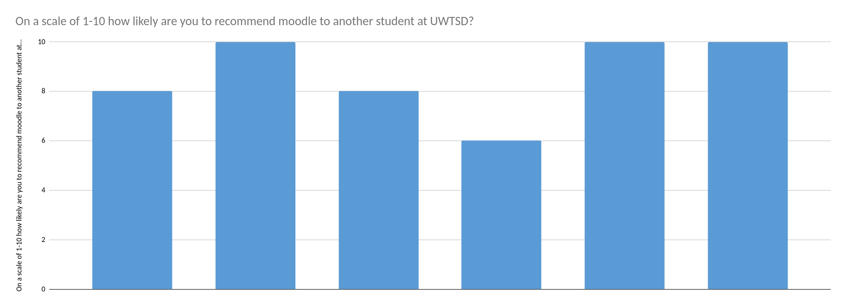

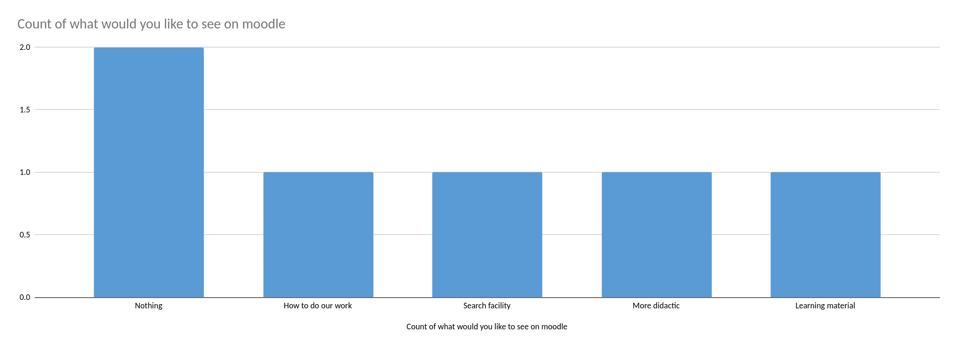

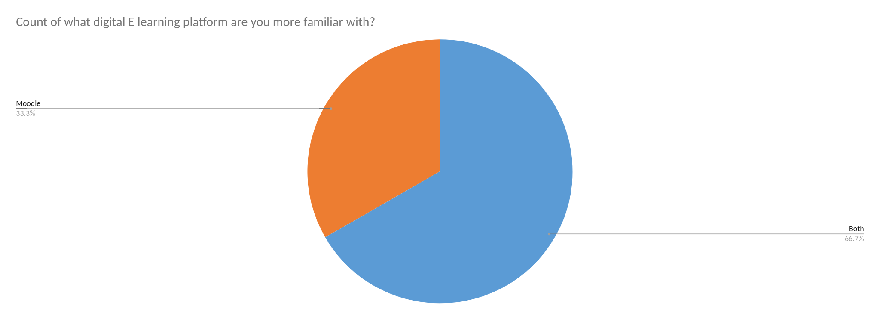

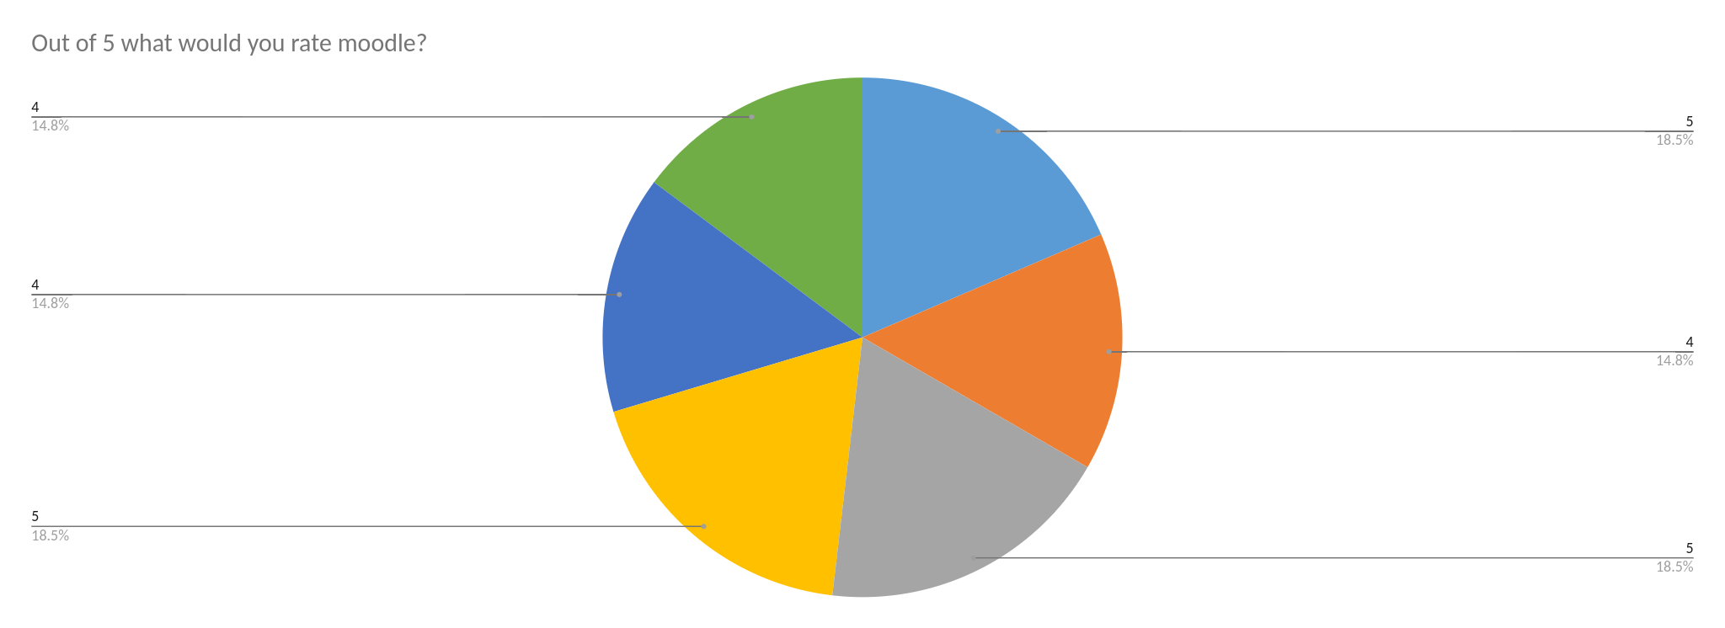

Discussion

My results show that all uwtsd students are familiar with Moodle but also shows that students also use other sources. The results show clearly more students use both. In my opinion the results prove that Moodle is a very useful resource for uwtsd students. This is what our group thought in the beginning when answering the question. In total 6 students answered our questionnaire. The results show that the researchers were right in their studies that students use moodle to help alongside their studies as the score from out of 10 students would recommend moodle is quite high. I don't believe the results show any different finding of what we researched. Students are very confident with using moodle and familiar with it, as the results show a high amount thought no changes needed to be made to moodle and gave a high rating for moodle content. This confirmed what our hypothesis detailed, Moodle is accessible 24 hours and used more in higher education and in the workplace. I was not able to guess the answers students would give. This is because every student has different learning styles and use other resources Ig. google. These results were no surprise to me due to being a uwtsd student myself. I have the experience of using moodle.

Conclusion

This report shows the research methods used to answer the question and also the results from our finding by conducting a questioniaire. Pie charts and graphs show clear thoughts of uwstd students in their confidence of using moodle. The research shows that moodle is a more common tool with the coming of covid 19 in the workplace and higher education.

Reference list.

Haider Th.Salim Alrikabi, Nabaa Ali Jasim, Ban Hassan Majeed, Abass Ahmed Zkear, & Ibtihal Razaq Niama ALRubeei. (2022). Smart Learning based on Moodle E-learning Platform and Digital Skills for University Students. International Journal of Recent Contributions from Engineering, Science & IT, 10(1). https://doi.org/10.3991/ijes.v10i01.28995

Appendix

https://forms.office.com/Pages/ShareFormPage.aspx?id=-REPTm4EBUWcuNshUjEeIRv8QH5sV3FNgmFwOlMP8SJUOVBTOVVPN1o3SVdKVjIzQVZRWU9EUk5URy4u&sharetoken=oGWrS8ludfkSoBAFOYoO

