Writing Module: Academic and Employability Skills

Module Code: BMSW 4001

Student Name: Angel Stoyanov

Student ID: 2106796

Assignment Title: Reflective review on Employability skills(report)

Lecturer Name: Dr Buddhi Pathak

Table of Contents

1 Introduction

2 Reflective reports on how the learning in this module has helped you develop a range of employability skills
2.1 Time Management
2.2 Finding Information? Research skills
2.3 Presentation skills
2.4 Digital skills
2.5 Planning and organisation

3 Explain how you are developing the chosen skills and the tool you are using

4 Support your work from formative feedback received from task1 assignment draft and classroom activity

5 References

1 INTRODUCTION

As part of the module and this class I have been given a task and attention of using the formative feedback received on task 1 Assignment draft and the feedback received from completing the activity below, individually produce a reflective report on how the learning in this module has helped you develop a range of employability skills. I have chosen to report five employability skills: Time management, finding information, presentation skills. digital skills, planning and organisation

2.1 TIME MANAGEMENT

Time management is action that determine ability to manage, planning and organizing your time between particular activities. Managing and controlling your time spent on specific activities (personal, educational or professional) increases your chance to achieve future goals, efficiency, successful productiveness and outcome of what you have done.
To become a successful leadership time management also requires self-motivation by clarifying tree simple things- vision, mission, time which are important component for success (Yukl,2012).
Time management efficiency is perception on personal and organisational productivity called quality time (Fleet,2020 ch1) and depends on how you take responsibility to set your time limits for each activity, take time to plan ahead, set to do list, take breaks, get organized, eliminate distractions, learn to say no- example of that is from classroom activity Donna time management problems, how every time she has been invited to go out and she never said no and follow the time management efficiency steps.
The benefits of developing and managing time management effectively enable you to work smarter with less stress, get more job done in less time, quality result, creating peaceful environment.
Notes: This employability skill has helped me to better manage my time, be more organise and follow settled future plans. Everything began thanks to enroll myself in this course, studying these modules and makes me really happy to be part of it. Very important part of gaining this skill is thanks to lectures who are very professional and the way that they present their lesson is completely understand full. I hope to continue developing this skill will open more opportunities for me in the future, not only in professional but in personal needs as well.
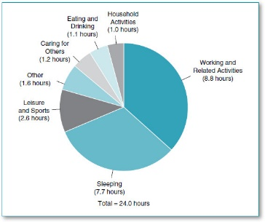

2.2 FINDING INFORMATION? RESEARCH SKILL

Finding information/research skills are ability to find quality information that is relevant and appropriate to your searches- either business marketing investigation, school assignment and etc…To able to reach this quality you need to know where to start your research and identifying your needs- that could be facts, ideas, arguments. Constructing your findings will help you perform an effective research strategy and saving time. The places where you can start finding valuable and truly information is book, e-books in libraries databases, journals, internet sites and government reports. When you find Information, you must make evaluation of it and reliable tool for that is CRAAP test. Through CRAAT test you can check whether the information contains high quality sources, when was published and is it up to date, you used different sources before you choose the right one. It is also critical to know who published the information/book and why? What is the idea and aims?
In addition, tips that may help you with finding appropriate information are entering general keywords not the full alignment as that will miss useful items, keep notes of what words you have used to avoid duplications, apply methodology – has the sources of data been clearly explained, evidence presented, does it contain any unanswered questions?

Notes: This part of the employability skills gave me a lot of useful information and helped me to develop my research skills. This is thanks to the passed sessions that I had during the school program and what I have learned from them is to use useful tools such as CRAAP test that will help me to complete quality searches.



2.3 PRESANTATION SKILLS

Delivering a perfect presentation is always challenging, that is why the needed of improving its skills are highly demanding. To present high quality presentation you must be well prepared for it.
The first thing you need is a more than perfect written presentation to make an influence.
Also make sure you know your audience, what do you want them to hear, what will motivate them to response to their wishes, grab attention and confidence as the audience responds to the way of using your voice and body. Before stand-up front of the audience benefit for you it will be if you make practise. Try to deliver it in a room to the walls where you can get use to hear your own voice with different volumes.
You must stay clearly visible to the audience making contact with them by using your body language, eye contact, spoken contact to able to keep their interesting and believe, that you truly interested talking to them.
Keep to the main object. Do not undervalue and overvalue the audience, be yourself and remember you have limited period of time to tell the audience what they want to hear.
You must breathe steadily and deeply to improve the quality and capacity to speak clearly for longer time of period. Be ready in that case to have a drink to hand to put down you thirst.

Notes: Presentation skills sessions was very challenging to me as never had delivered live presentation even using power point. However, I did my first presentation really well by developing my digital skills using power point and team communication. I have received positive feedback for presentation presented “principles of avoiding power point death”.
My feedback from the second presentation classroom activity Donna time management was not that good as the first one, but not always presentation could be perfect and if is failed ones you have to keep working hard and never give up. Please see attached appendix on the last page


2.4 DIGITAL SKILLS

Digital skills are basic competency that people need to use nowadays technologies. According to (Keogh, 2015) technology is the paper and pen of our time and it is a way which we experience most of our time. Enable people to effectively and critically evaluate and information using range of IT tools and strategies to find, create, connect and collaborate with people to achieve professional, personal and academic goals (Grech,2016). To develop competence and efficiency in digital skills you must have motivation to engage- take part in their study and gain experience how to operate with them to get the mot of technology.
Nowadays statist state that digital skills are closely related to employability. Some institutes believe that in the future 90% of the workplaces will require a range of digital skills which will lead to the need for more in-depth study, otherwise will cause difficulties to people find a job or to progress in their current. The latest European Commission report — International Digital Economy and Society Index (I-DESI 2018) — stated that 80.5% of Australians, 80.2% of Icelanders and 79.3% of New Zealanders have digital skills.
Digital skills allow to optimize times and cost, understand how the electronic devices works, increase the pace of reflection and the speed of transferring information to every place of the world. This include know and know how to operate with different softwares, how to connect to internet, send emails, collecting information, social media, marketing advertising, digital image and video editing, power point, excel, word and many more….
The importance of having these skills today are extremely required due to covid-19 pandemic. The old ways of doing things like shopping, accounting and all jobs that can be shifted from physically to online activity has changed significantly the critical to business and workforce.

Notes: Before I came to this course I had already some basic digital experience like searching, software and apps operating, smartphones and etc, but thanks to study module digital skills and research method I have acquired wider knowledge of using it. Example is that I have never been used power point or excel in my life, but thanks to the programme learning and practising, classroom activities and homeworks I know and know how.


2.5 PLANNING AND ORGANISATION

Many employers consider the ability to plan and organise as necessarily. The development in all kinds of business in today world requires more and more quality employee. The modern recruiters want you show that you are flexible, organised and dedicated, display attention in deeper details, effective management of resources and time, planning and demonstrating adaptation to changes. Failing to proper organise yourself will lead to chaos in your planning and increase the stress and effectiveness. Knowing that what you want to achieve will give you a clear vision, what the final result will pay you back.
In order to set your goals, you must also set timetable and deadlines to able to manage your time in workplace, schools or even your own time. Furthermore, creating a to-do list give you benefit of that to prioritise which task is more important and which one can go to pending list for later finishing.
Notes: Planning and organisation skills has helped me to improve my efficiency. The factor is that I have learned to be more organised by taking notes, setting time structure and plan strategies, that allows me to analyse and prioritise what needs to be done first for successful completing.

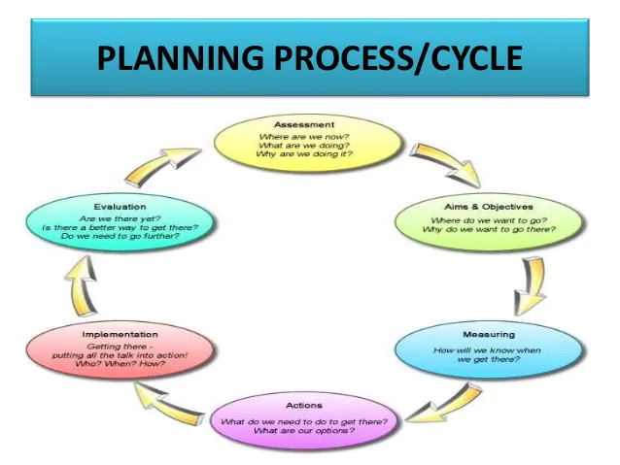

3. HOW YOU DEVELOP THIS SKILLS

It was not easy developing these skills, because this is my first year as student in higher education and been part of the learning process was challenging. As described the skills above accepting the challenge by myself made me more motivated and believed in myself, that I will manage to go through the learning process and understand why I needed to improve them. The tips that helped me are the excellent way how the lecturers presented their sessions, the home and class activities. That involved me of using very useful and successful tools like 4D strategies, CRAAP test for researches and the pyramid for DIKW, critical thinking and reflective writing. I find them very challenging because when you do something for first time is always tough, but the key is to keep practising it and I will get used to it.

4. SUPPORT YOUR WORK FROM FORMATIVE FEEDBACKS RECEIVED

The feedback received from Donna time management activity cannot completely proof excellency because of the mistakes done, but I believe day to day I will get more exercises and experience to improve my skills. I am gladder from completing the other exercise for reflecting writing Gibb’s cycle. I have attached as an appendix the feedbacks that I have excluding that for task1, as my assignment was not ready by the 10th week of module. In the future I will do more training on tasks and tools using for gathering the information and not last to follow the lecturer guidance for receiving feedback on time.

6 REFERENCES

Sorenson, R.D., Goldsmith, L. and DeMatthews, D. (2016) The principal’s guide to time management: instructional leadership in the digital age. Thousand Oaks: Corwin.

Van Fleet, D.D. (2020) Quality time: productivity through time management. North Carolina: Information Age Publishing.

Durham university (2021) Research Skills: Evaluating your search
Available at: https://libguides.durham.ac.uk/research_skills
(Accessed 6 December 2021)

Bradbury, A. (2006) Successful presentation skills. 3rd ed. London: Kogan Page.

Bellanca, J. (2021) Personalized deeper learning: blueprints for teaching complex cognitive, social-emotional, and digital skills. Bloomington, Indiana: Solution Tree Press.

Iberdrola (2021) Digital skills: are we ready for the digitisation of employment
Available at: https://www.iberdrola.com/innovation/digital-skills
(Accessed 06 December 2021)

University of Bradford (2021) Planning and organisation
Available at: https://www.bradford.ac.uk/careers/develop-skills/planning/#:~:text=These%20include%3A%201%20Researching%20%E2%80%93%20identify%20possibilities%2C%20keep,ability%20to%20work%20well%20with%20other%20people.%20
(Accessed 06 December 2021)

Adair, J. (2013) Develop Your Leadership Skills. 2nd ed. London: Kogan Page.

APPENDIX



