Student p number: 1705615
Dorota Konefal- Photography in the Arts
Module: Ways of Perceiving
Module code: M4X01559

The exhibition I am planning to do would be about wars, because I think it’s a very important theme as war has been a major part of human history since the earliest days of man. It has pushed for vital advances in medicine, music, art and engineering to just name a few. However along with these advances is devastation which I will demonstrate in the exhibition with a series of black and white photographs from a plethora of artists.
This presentation will show how wars look and how it has affected the lives of our ancestors and our current lives. This is not just a personal issue but a global one, corrupting relations with other cultures and individuals. Wars are always a sign of destruction, aggression and mortality.
From the earliest centuries wars were painted by a lot of artists that volunteered to do that.
Wars will never end. It’s something that will happen again and again. Even now in this current political climate another global war is not an impossibility.
I would use a lot of photographs from a different artists like: James Nachtwey, David McLellan, Eddie Adams, Don McCullin, Eugene Smith.

All those artists are journalists and war photographers that were risking their lives to take those pictures. I chose them, because I want to focus more on photographs that are really serious. I think that it shows more emotions and it’s more realistic. By those photos we can deeply explore the sense of how tough it was for a lot of people those times. Work that I want to exhibit will be mostly about World War I, World War II, Wars in Vietnam and Africa. All photographs that I chose were taken during this period but those situations can repeat any moment. Some of them are even happening now and I think that it’s very important to show people how does the war looks like.
The exhibition would be presented in The Gallery at 164 Munro House, Duke Street, Leeds LS9 8AG. The walls would be painted black, so there is a high contrast of the work that I would want to hang. I would like to use black and white.

Carl Philipp Gottfried (or Gottlieb) von Clausewitz was born on 1 June 1780 and he died on 16 November 1831.He was a Prussian general and military theorist who studied the psychological and political aspects of war. The most known work in the philosophy of war is “On War” by Carl von Clausewitz. Unfortunately he didn’t finish his book, because he died, but there still were a lot of important information about wars that he has examined. Still a lot of people use them nowadays. “On War” is mainly about observations on strategy with questions about the human nature and the purpose of war and what is the most important he especially examines the teleology of war.
He was discussing the tactic and strategy that soldiers are using on the war. His conclusions were influenced by his experiences in the Prussian Army.
The first thing that is written is his dialectical thesis is: "War is thus an act of force to compel our enemy to do our will." The second important thing is a dialectical antithesis where he wrote: "War is merely the continuation of policy by other means." His deep examination of the nature of war is his famous known "trinity," that is saying the war is "a fascinating trinity-composed of primordial violence, hatred, and enmity, which are to be regarded as a blind natural force; the play of chance and probability, within which the creative spirit is free to roam; and its element of subordination, as an instrument of policy, which makes it subject to pure reason."

The degree to which Clausewitz managed to reexamine his book to reflect that synthesis is the subject of much disputation. His final reference to war and “Politik”, goes beyond his another quoted antithesis: "War is simply the continuation of political intercourse with the addition of other means. We deliberately use the phrase 'with the addition of other means' because we also want to make it clear that war in itself does not suspend political intercourse or change it into something entirely different. In essentials that intercourse continues, irrespective of the means it employs. The main lines along which military events progress, and to which they are restricted, are political lines that continue throughout the war into the subsequent peace."

In “On War”, Clausewitz notices that all wars are the sum of decisions, actions, and reactions in an uncertain and dangerous way. He also asks us about the complex nature of war, that includes both the socio-political and the operational and underlines the state of policy. He encourages us to think if the wars are because we- people are full of anger and aggression or is it something different like political argument between two leaders of countries.

Picture 1 is a black and white photograph that had been taken by American photojournalist and photographer Eddie Adams in 1968 during the war in Vietnam. He also won a Pulitzer Prize one year after he took this amazing photograph and World Press Photo award. It is an important photograph, because It freezes his moment of mortality and shows the brutality of war.
Picture 2 had been taken during the World War II that is a documentation of the conflict in the Pacific between 1942-1945. It was taken by an American Photojournalist and photographer- Eugene Smith. He was known as a war photographer but also as a person that used to take photos of ethical standards. This photo shows a bomb explosion that is an evidence of total destruction.
Picture 3 is a black and white photograph that had been taken by an American photojournalist and war photographer- James Nachtwey. He has documented a lot of armed conflicts and social issues when he was spending time in South Africa and Latin America. This photo had been taken in Sudan in 1993. Where we can notice a starving child wrapped in a dirty blanket. Pictures like this help a lot of people in Africa, because when other people see something that sad they make donations.
Picture 4 is a photograph of a child taken by a British photojournalist Don McCullin that was usually taking pictures during wars. This picture had been taken in Biafra in 1969, but things like this are often seen in Africa and other poor countries. This boy is very exhausted and starving.
Picture 5 is a black and white old photograph that had been taken by David McLellan an official war photographer in 1917-1918. McLellan is known for his work capturing the massive scale of operations on the Front. This photograph presents lines of German prisoners that are walking guarded by British soldiers in France during the World War I. The town is very devastated and I can notice that the building is going to fell over.

Picture 1
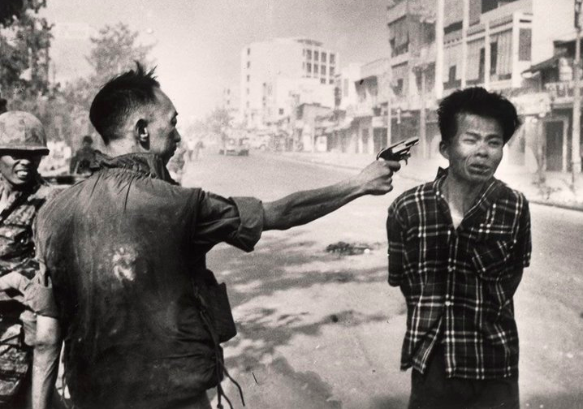
Eddie Adams/ AP – Vietnam

Picture 2
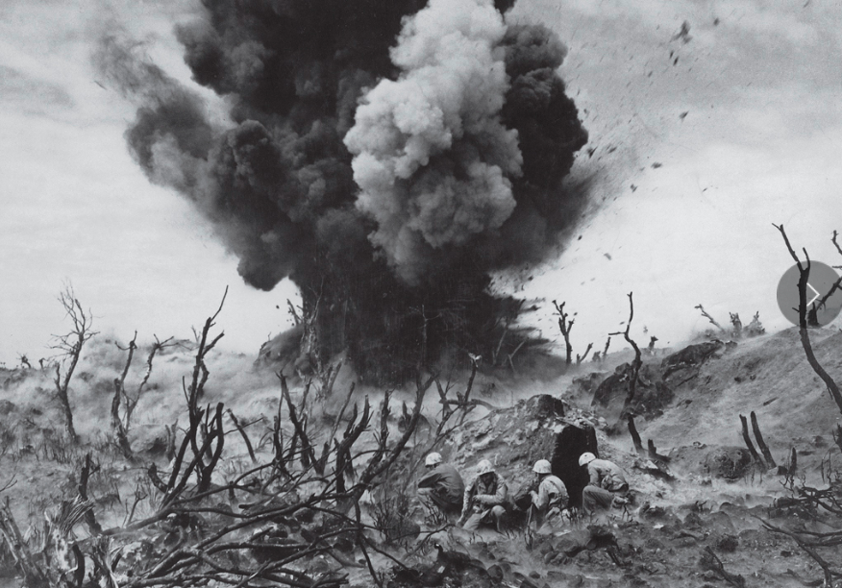
Eugene Smith– World War II

Picture 3
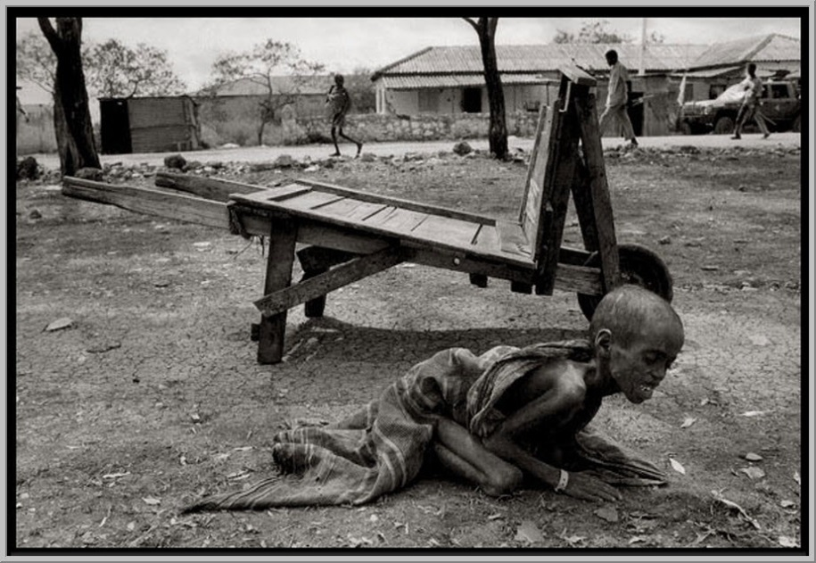
James Nachtwey- South Africa

Picture 4
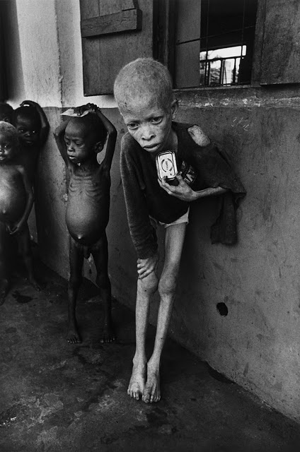

Don McCullin "Albino Boy"- Africa

Picture 5
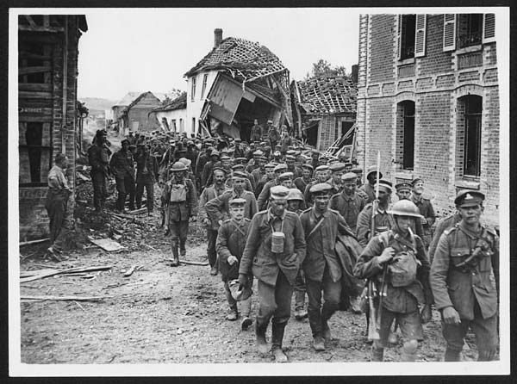
David McLellan

Bibliography:
https://www.clausewitz.com/item/Beyerchen-ClausewitzNonlinearityAndTheUnpredictabilityOfWar.htm
https://www.britannica.com/biography/Carl-von-Clausewitz

https://en.wikipedia.org/wiki/Carl_von_Clausewitz#Theory_of_war
https://en.wikipedia.org/wiki/Philosophy_of_war

