Content Page
Part 1- Goals- page 1-3
Part 2- Academic poster- page 4
Part 3- Essay- page 5-11
AI acknowledgment- page 12-13

Short term goal- 1 year- become more confident in presenting and public speaking
Specific
I want to improve my confidence in public speaking and presenting. This includes group discussions, speaking to new people, and presenting university assignments without feeling very nervous. I want to accomplish this because it will help me in my personal, academic and work life. To achieve this, I need to put myself out there and speak about my thoughts and feelings without worrying what others think. A constraint could be staying quiet because I feel anxious or feel my point is not valid enough.
Measurable
I will measure my progress by taking part in university presentations, group work and discussions and asking my lecturers for feedback. I will know I have achieved this goal when I can give a presentation or speak to an unfamiliar person confidently with little to no nerves and can get my point across clearly.
Achievable
I can accomplish this goal by gradually putting myself out of my comfort zone. I will be well prepared and rehearsed for presentations, take part in more class discussions and make small talk with people I do not know. I can increase this and become more confident.
Relevant
This goal will help me at university and in my future work. I will need to complete presentations and interviews, meet new people and communicate with others. This is important for my future career as a primary school teacher as I will need to meet new staff, parents and children.
Time bound
I have given myself one year to achieve this goal. I hope my confidence will gradually grow and may achieve it sooner. I will work on this regularly especially at university and when going into new school settings through my teaching assistant agency.
Mid-term goal- 3 years- complete my university course and get my degree
Specific
I want to complete my two-year early years education and care course and then complete another year of teacher training, such as PGCE, to gain my teaching qualification. I want to achieve this because my long-term goal is to become a primary school teacher. The requirements are attending university and completing assignments. Constraints may include managing my workload, deadlines and balancing university work with personal life.
Measurable
I will measure my progress by completing assignments, meeting deadlines, attending classes and using feedback from lecturers. I will know I have achieved this when I have completed my university course and additional year of teacher training.
Achievable
I can achieve this goal by staying organised, attending university, completing work on time and asking lecturers for help when needed. I will also gain experience through working in school settings, helping me develop the skills to become a teacher.
Relevant
This goal will help me achieve my long-term goal of becoming a primary school teacher. My university course will give me knowledge and the additional teacher training course will allow me to progress towards becoming a qualified teacher.
Time bound
I have given myself three years to achieve this goal. I aim to complete my two-year course and a further year of teacher training. I will regularly check my progress to make sure I am staying on track and not falling behind with workload.

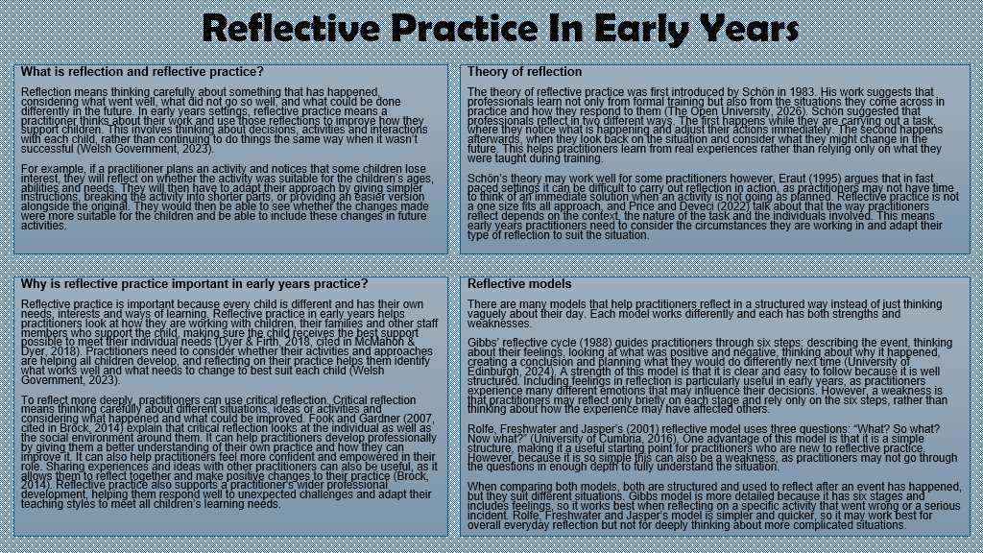
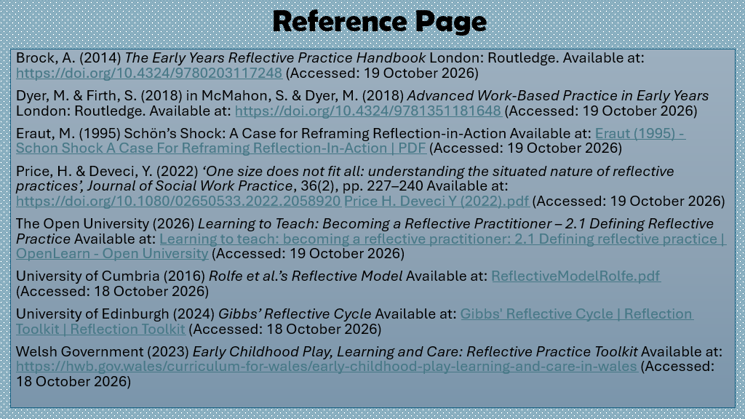

Professional practice in early years
Professional practice is important in early years because every child has their own individual needs, interests, abilities, experiences and ways of learning. As a practitioner in an early year setting, they have the responsibility to provide every child with a safe, supportive and inclusive learning environment. The National Association for the education of young children (NAEYC,2020) stated that relationships, observation, assessment, curriculum planning and professionalism are an important part in early years practice. All these areas work together to support children’s learning and development. The UNCRC also states that children have individual rights that should be respected (United Nations, 1989). Therefore, professional practice includes values, communication, multi-agency working, observations, planning and respecting children’s rights. These areas allow a practitioner to understand all children individually and provide them with the best support for their needs so they can develop, participate in every activity and feel included.
Professional values are important because they influence how practitioners behave, make decisions and work with children, families and other professionals. Practitioners should demonstrate values such as respect, honesty, fairness, equality, confidentiality and responsibility. These values help gain professional relationships with children and others who support them and help focus on the needs and the wellbeing of children. The Code of Professional Practice for Social Care Workers states that professionals should respect other peoples dignity, promote equality and diversity, and maintain professional relationships (Social Care Wales, 2026).
A practitioner should not allow their personal opinions or assumptions to influence their decisions when working with children and their family. They should realise that every child is different from one another. Early years professionals should understand children’s learning and development whilst considering their family, culture, community and experiences (NAEYC, 2020). As a result, practitioners should consider their own attitudes but ensure these do not create barriers for a child. For example, a practitioner who values the importance of equality should identify if an activity is not accessible to a certain child and be able to adapt the activity instead of just expecting the child to cope.
Professional responsibility is also important because practitioners are responsible for their decisions and actions. This includes protecting confidential information, maintaining boundaries and getting advice when a child's needs are beyond their knowledge. The Additional Learning Needs Code for Wales places children and their families at the centre of decisions about additional learning needs (Welsh Government, 2021). Professional values are important because they provide a foundation for inclusive and respectful practice.
Effective communication is important because practitioners communicate with wide range of individuals including children, families, colleagues and other professionals regularly. It helps practitioners understand children's needs, feelings and interests. Communication needs to be adapted because children communicate in different ways. Some may communicate through speech, while others may use facial expressions, gestures or even pictures. The Department for Education (2023) talks about the importance of understanding individual children and identifying the support they may need.
McLeod (2026) talks about Vygotsky's theory which shows the importance of social interaction in children's learning and development. His concept of the Zone of Proximal Development suggests that children achieve more with the appropriate support than they may be able to achieve working independently. This is significant because practitioners can identify children's current abilities through observation and provide suitable support to help them develop. As children's skills and confidence increase, the support can gradually be reduced. This demonstrates how observations, communication and individualised support can work together to meet children’s individual needs.
Children should also be given opportunities to express their views. Practitioners should listen to all communication, both verbal and non-verbal when planning experiences and consider children's preferences. Communication with families is equally important as parents and carers have knowledge about a child's development and experiences that practitioners do not have (NAEYC, 2020). Effective communication between professionals can also promote consistency when a child may require additional support (Social Care Wales, 2026).
Multi-agency working involves different professionals working together to support a child and their family. This could include health visitors, early years practitioners, teachers, social workers, speech and language therapists and additional learning needs professionals. This is important because one professional may not have all the knowledge and skills required to understand and support a child's needs.
Working with other professionals allows different areas of expertise to be brought together. For example, an early years practitioner may identify that a child has difficulties with communication. A speech and language therapist will then provide specialist strategies that can be used during everyday activities. This can provide consistency for the child and help the child develop to their full potential.
The Department for Education (2026) identifies multi-agency working, joint planning and communication with families as important elements of providing joined-up support. The Additional Learning Needs Code for Wales also promotes collaboration between professionals and families when identifying and meeting children's additional learning needs (Welsh Government, 2021). However, multi-agency working will be less effective when communication is poor or families are not appropriately involved. Effective multi-agency working can therefore provide a more consistent and appropriate response to individual needs.
Observation is a key part of early years practice because it allows practitioners to understand children through what they see and hear. NAEYC (2020) identifies observation, documentation and assessment as important areas of practice. Observations can provide information about children's development, strengths and interests as well as highlighting areas where additional support may be required.
The Department for Education (2023) explains that assessments involve developing knowledge of children and using this knowledge to shape teaching and learning experiences. Observation should therefore have a clear purpose and provide practitioners with an understanding of children's development.
Observations are particularly significant when meeting individual needs because children do not all develop in the same way or at the same rate. For example, an observation may show that a child is confident communicating with adults but experiences difficulties communicating with other children. This information could be used to provide opportunities to develop social skills.
Observations can also reduce the risk of practitioners making assumptions about behaviour. A child who does not participate in an activity may not necessarily be uninterested. The activity may be too difficult, the instructions may not be clear, or the child just prefers a different way of learning. Careful observation will allow practitioners to consider possible reasons before deciding what support is appropriate. Estyn (2023) highlights the relationship between observation, assessment and planning. Observation should therefore inform professional decisions rather than simply record what a child has done.
Planning is closely connected to observation because practitioners can use information gathered about children to decide what experiences, resources and support should be provided. NAEYC (2020) identifies including an engaging curriculum when planning is an important area of early childhood practice.
The Department for Education (2023) explains that information gathered about children should be used to shape teaching and learning experiences. Planning should therefore be suited to children's individual interests, development and needs rather than providing the same experiences for every child.
For example, if an observation identifies that a child is interested in animals but has difficulty participating in large group activities, a practitioner could provide an animal-themed activity within a smaller group. This would build on the child's interests while providing an opportunity to develop social skills.
Inclusive planning is important because children may require different levels or types of support. Some children may require more time, simplified instructions or alternative ways of doing an activity. Planning is therefore significant because it enables practitioners to respond to individual children and provide appropriate learning experiences.
The UNCRC is important to professional practice because it recognises children as individuals with their own rights. It was adopted by the United Nations in 1989 and contains rights relating to children's protection, development, participation and equality (United Nations, 1989).
Article 2 states that children should have their rights respected without discrimination, including discrimination relating to disability (United Nations, 1989). This is connected to inclusive early years practice because practitioners need to ensure that children are not excluded because of their abilities, culture or language.
Article 3 states that the best interests of the child should be a main priority in decisions concerning children (United Nations, 1989). Practitioners should therefore consider what is most appropriate for the individual child when making decisions about learning and wellbeing.
Article 12 states that children have the right to express their views and have those views taken seriously (United Nations, 1989). Practitioners should provide opportunities for children to make choices. Children's views may be communicated through spoken language, facial expressions or behaviour.
Article 31 recognises children's right to relax, play and take part in activities appropriate to their age (United Nations, 1989). This is relevant to early years because play provides opportunities for children to explore, practise skills, express themselves and develop relationships.
The UNCRC therefore provides a rights-based framework for professional practice. Respecting children's rights supports inclusive practice and helps create environments where children feel valued, listened to and able to participate.
Overall, professional values, communication, multi-agency working, observation, planning and the UNCRC work together to meet children's individual and inclusive needs. Professional values influence how practitioners behave and make decisions, while communication supports understanding between children, families and professionals. Multi-agency working brings together different knowledge and expertise, while observations help practitioners understand children's strengths, interests and areas requiring support. Planning allows this information to be used to provide appropriate learning experiences.
The UNCRC provides a rights-based framework by ensuring that children's views, best interests, equality and participation are considered (United Nations, 1989). These aspects of professional practice are interconnected. When applied together, they can support an inclusive early years environment that recognises every child as an individual and provides appropriate opportunities to learn, develop, participate and feel included.
Reference list
Department for Education (2023) Development Matters: non-statutory curriculum guidance for the early years foundation stage. Available at: https://assets.publishing.service.gov.uk/media/64e6002a20ae890014f26cbc/DfE_Development_Matters_Report_Sep2023.pdf (Accessed: 23 October 2026)
Department for Education (2026) Inclusive early years fund: best practice guidance for local authorities. Available at: https://www.gov.uk/government/publications/inclusive-early-years-fund-2026-to-2027/inclusive-early-years-fund-best-practice-guidance-for-local-authorities (Accessed: 23 October 2026)
Estyn (2023) A curriculum for funded non-maintained nursery settings. Available at: https://estyn.gov.wales/improvement-resources/a-curriculum-for-funded-non-maintained-nursery-settings (Accessed: 23 October 2026)
McLeod, S. (2026) ‘Zone of proximal development’, Simply Psychology. Available at: https://www.simplypsychology.org/zone-of-proximal-development.html (Accessed: 24 October 2026)
National Association for the Education of Young Children (NAEYC) (2020) Developmentally appropriate practice. Available at: Developmentally Appropriate Practice (Accessed: 24 October 2026)
Social Care Wales (2026) Code of professional practice for social care workers. Available at: https://socialcare.wales/codes-of-practice-and-guidance/code-of-professional-practice-for-social-care-workers (Accessed: 24 October 2026)
United Nations (1989) Convention on the Rights of the Child. Available at: https://www.ohchr.org/en/instruments-mechanisms/instruments/convention-rights-child (Accessed: 25 October 2026)
Welsh Government (2021) The Additional Learning Needs Code for Wales 2021. Available at: The Additional Learning Needs Code for Wales 2021 (Accessed: 23 October 2026)

I acknowledge the use of Microsoft 365 copilot on the 25th of October 2026 to put my reference list in alphabetical order
Prompt:
Put this Harvard reference list in alphabetical order
Department for Education (2026) Inclusive early years fund: best practice guidance for local authorities. Available at: https://www.gov.uk/government/publications/inclusive-early-years-fund-2026-to-2027/inclusive-early-years-fund-best-practice-guidance-for-local-authorities (Accessed: 23 October 2026)
Department for Education (2023) Development Matters: non-statutory curriculum guidance for the early years foundation stage. Available at: https://assets.publishing.service.gov.uk/media/64e6002a20ae890014f26cbc/DfE_Development_Matters_Report_Sep2023.pdf (Accessed: 23 October 2026)
Welsh Government (2021) The Additional Learning Needs Code for Wales 2021. Available at: The Additional Learning Needs Code for Wales 2021 (Accessed: 23 October 2026)
Estyn (2023) A curriculum for funded non-maintained nursery settings. Available at: https://estyn.gov.wales/improvement-resources/a-curriculum-for-funded-non-maintained-nursery-settings (Accessed: 23 October 2026)
National Association for the Education of Young Children (NAEYC) (2020) Developmentally appropriate practice. Available at: Developmentally Appropriate Practice (Accessed: 24 October 2026)
Social Care Wales (2026) Code of professional practice for social care workers. Available at: https://socialcare.wales/codes-of-practice-and-guidance/code-of-professional-practice-for-social-care-workers (Accessed: 24 October 2026)
McLeod, S. (2026) 'Zone of proximal development', Simply Psychology. Available at: https://www.simplypsychology.org/zone-of-proximal-development.html (Accessed: 24 October 2026)
United Nations (1989) Convention on the Rights of the Child. Available at: https://www.ohchr.org/en/instruments-mechanisms/instruments/convention-rights-child (Accessed: 25 October 2026)

I confirm that I have not presented any AI generated text in my own work. I confirm I have copies of my drafts, notes, and other resources I used before, and after the use of AI tools which I may be asked to provide in evidence.

