27/10/2026
Adeel Ahmad
Student Id:- 2607840
Assignment Component 1
E-Portfolio
Contents
Task 1: Warehouse Bookkeeper 2
Task 1a: My Chosen Career 2
Task 1b: AI Assistants 2

Task 1: Warehouse Bookkeeper

Task 1a: My Chosen Career

A warehouse bookkeeper is responsible for keeping financial records organised and accurate. Their duties include checking invoices, recording payments, calculating costs and keeping records of stock purchases. They use computers and spreadsheets to help manage business information.
Important skills for this career include numeracy, IT, organisation and attention to detail. Numeracy helps with calculations, while IT skills help with Excel and accounting software. Good organisation helps keep records up to date, and communication skills are useful when speaking to suppliers and warehouse managers [1].
My study skills will help me prepare for this career. Research skills will help me find reliable information, and time management will help me complete work on time. I can also practise Excel formulas and maths to improve my accuracy. These skills will help me become more confident and prepared for employment.[2]

Task 1b: AI Assistants

AI assistants can help warehouse bookkeepers organise information and complete tasks more efficiently.
ChatGPT can explain bookkeeping topics and help create example stock tables. I could use it to learn how to calculate the total value of warehouse stock. However, I must check its answers because AI can make mistakes.
Microsoft Copilot can help with Excel formulas and spreadsheets. I could use it to calculate stock costs and organise financial information. This could save time, but I would need to check the results.
Gemini can help with research and creating checklists. I could use it to create a checklist for checking invoices against delivery records. However, I would need to make sure its information is correct.

Overall, these tools could save time and help me learn new skills. However, I would protect confidential information and check all important calculations before using them at work.

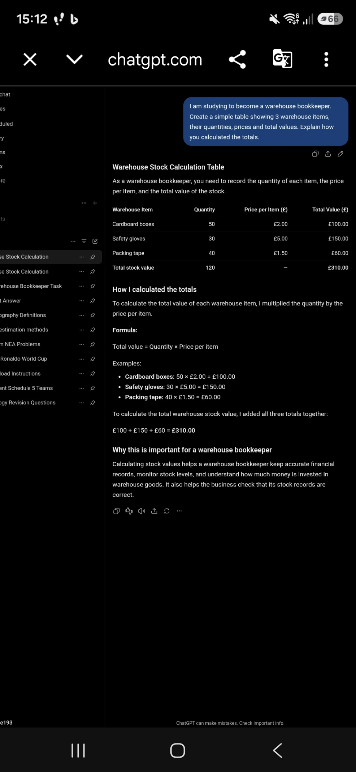
Figure 2 shows ChatGPT creating a sample warehouse stock table and explaining the calculations.

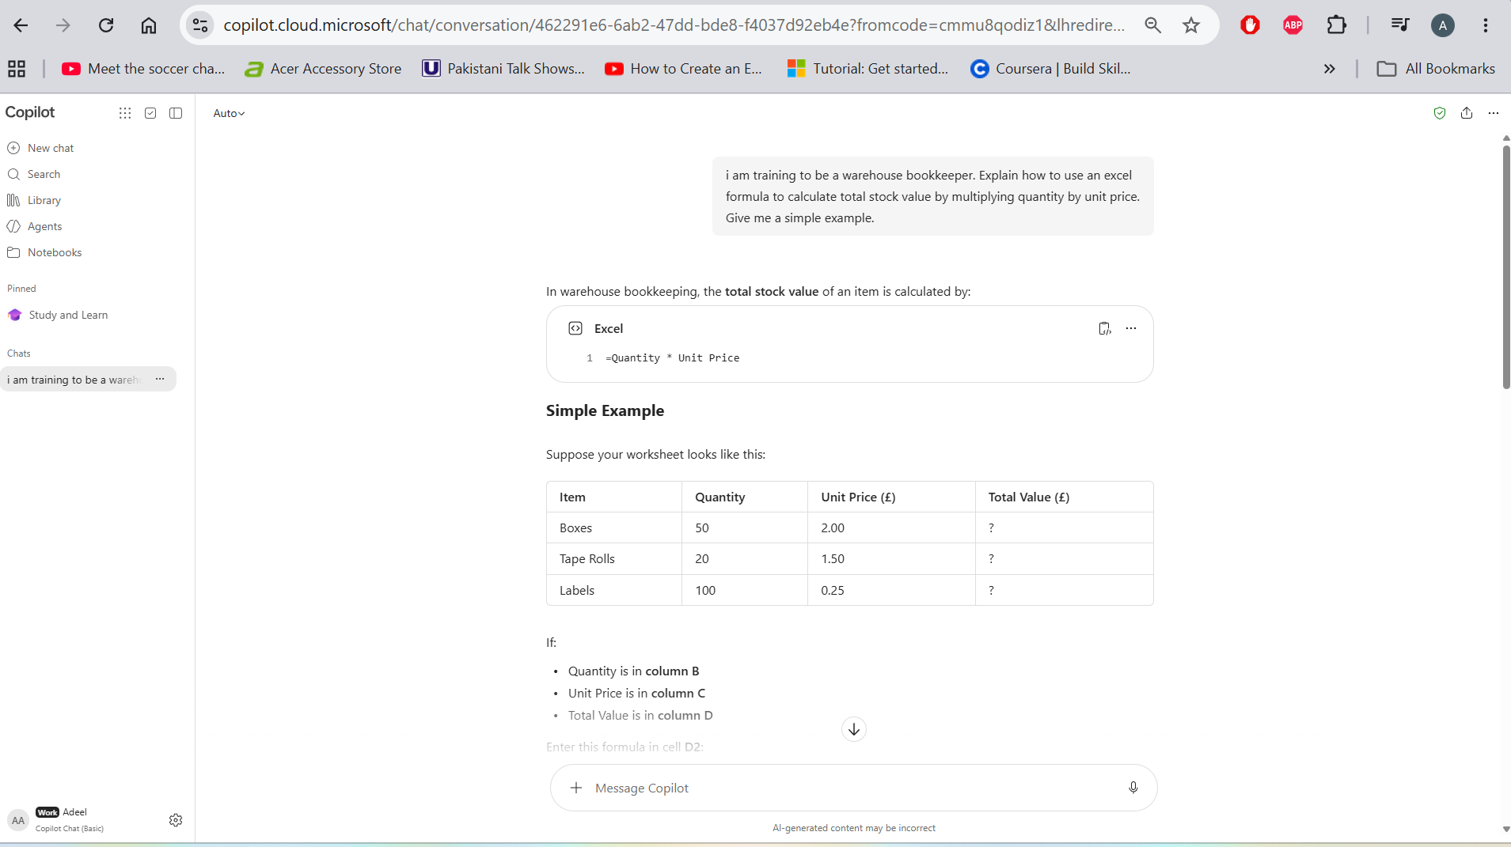
Fig 3 (a)
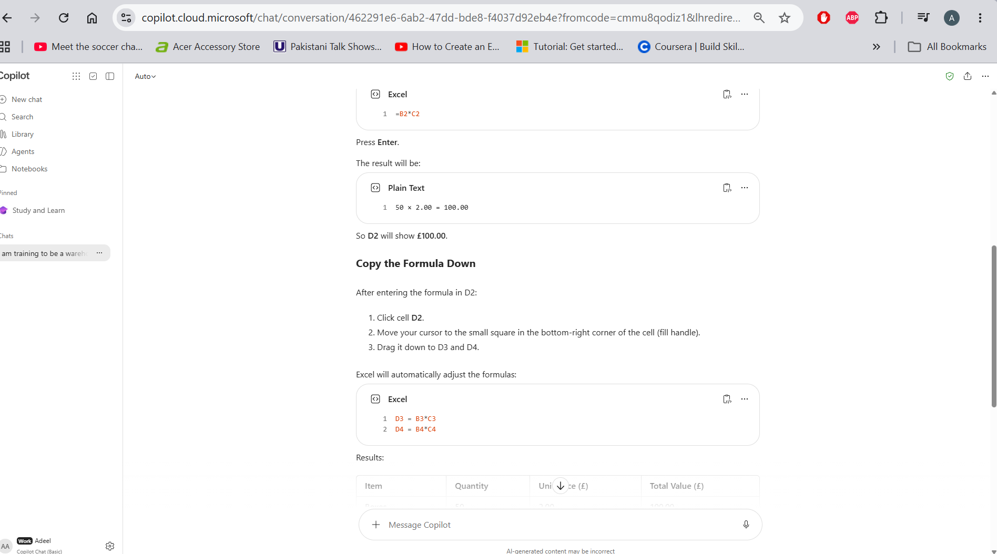
Fig 3 (b)
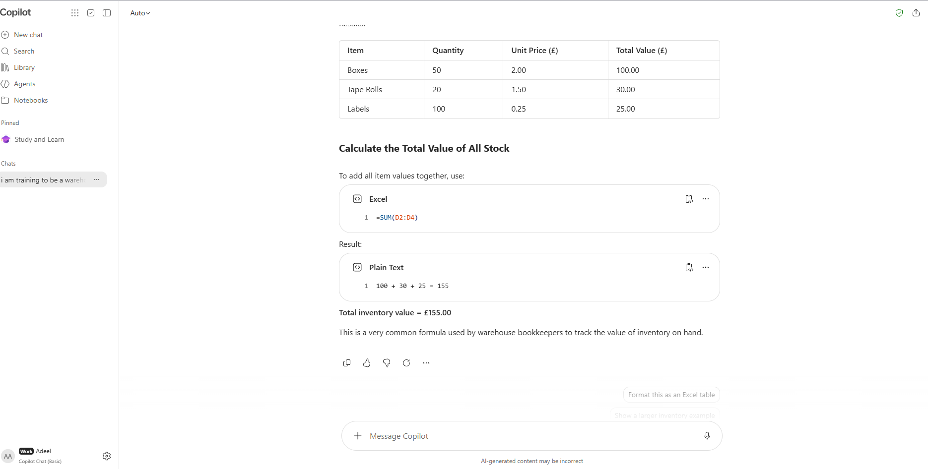
Fig 3 (c)
Caption: Figure 3(a,b&c) shows Copilot explaining an excel formula that can help calculate warehouse stock values.

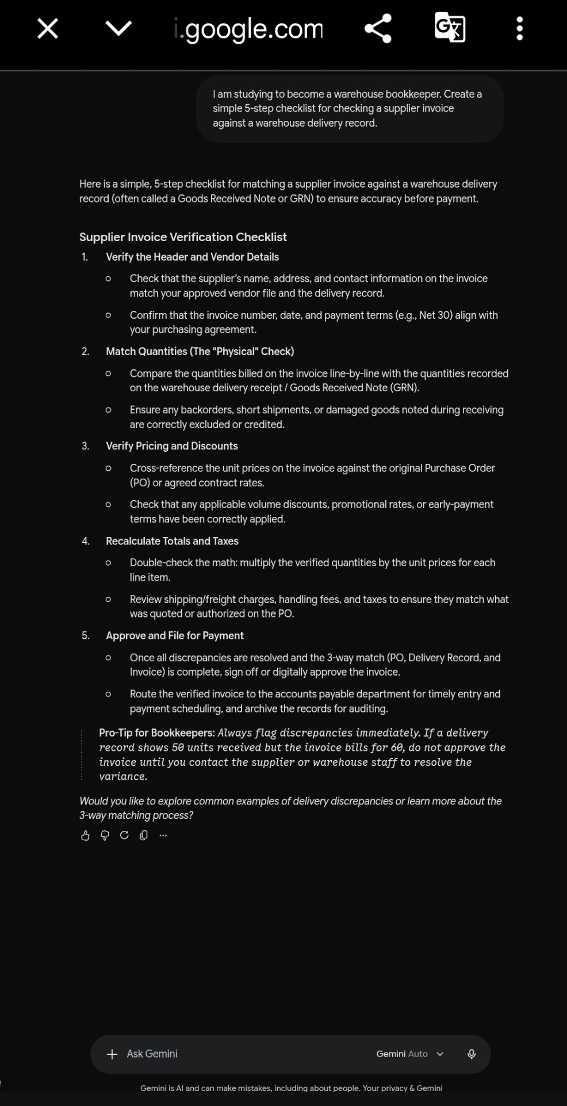

Caption: Figure 4 shows Gemini creating a checklist to help a warehouse bookkeeper check invoices.

References
[1] National Careers Service, “Bookkeeper,” *Explore Careers*. [Online]. Available: https://nationalcareers.service.gov.uk/job-profiles/bookkeeper.
[2] S. Cottrell, *The Study Skills Handbook*, 6th ed. London, U.K.: Bloomsbury Academic, 2024.
[3] OpenAI, “ChatGPT,” [Online]. Available: https://chatgpt.com/.
[4] Microsoft, “Microsoft Copilot,” [Online]. Available: https://copilot.microsoft.com/.
[5] Google, “Google Gemini,” [Online]. Available: https://gemini.google.com/.

