Learning Log Report
Swansea Lower Valley
Jessica Lewis
2012798
Learning Log Report on Swansea Lower Valley

Swansea Lower Valley was successful during the industrial revolution period for two main reasons. The first reason being that the coal that came from the valley was easily accessible. The second reason being the river which provided plenty of water while also providing short, necessary transport links. The area of Swansea was made attractive for industrial development by the construction of the Swansea Canal because of the low ground between the canal and the river which was ideal for supplying raw materials from both land and sea. The city of Swansea was also referred to as ‘Copperopolis’ in the 18th and 19th centuries because of the strength of the copper smelting plants and it is one of the earliest industrial centers of Wales (Cadw.gov.wales, 2016).

The main players connected to this era and the history of Swansea Lower Valley are the Vivian Family. The first family member to be involved, in around 1800, was John Vivian who became a managing partner in the copper works at Penclawdd and Loughour which was owned by the Cheadle Brassware Company of Staffordshire. John Vivian’s second son was then made a manager at the copper works in Penclawdd in 1806. Shortly after that the business ‘Vivian and Sons’ began; this was a British metallurgical and chemicals business based at Hafod. John and his two sons were all partners in this new business which leased land in the Hafod and established the Hafod Smelting Works and Mills.

By the 1940’s, Vivian and Sons were among the largest Smelting works in the world and in 1853 the company obtained the White Rock Copper Works at Foxhole and joined with another company called Williams, Foster & Co. of Morfa. By the 1880s copper smelting in Swansea slowly came to an end as other industries took its place. This was due to it being cheaper to smelt ores at the mines in Chile as a result of the decreasing quality of Cornish ore.

Vivian and Sons continued trading until 1924 before being joined with two other Swansea firms; Williams, Foster & Co. and Pascoe Grenfell & Sons. This establishment then became British Copper Manufactures LTD, which was involved in a few other mergers along the years until its closure in 1980.

The process started in 1717 when Bristol industrialists started the copper and brass industry in Swansea. Copper is an easily workable metal that could be formed in to cooking and industrial vessels and therefore it became widely popular throughout the world. The Bristol-financed ‘White Rock’ copper works of 1737 was made and this included the ‘Great Work House’. This work house contained a single row of furnaces, that were very loud, which then led to the manufactured pots and pans which were then distributed from warehouses in London as far as Belgium, France, Germany and the Netherlands.

The reason that the copper and brass smelting industry moved to Swansea is because it was the nearest large coal field to the copper mining areas of Cornwall and Devon. The River Tawe was beneficial because the deepest three tidal miles could carry sailing ships up to the 13 main smelting works that were built alongside the river for incoming goods.

Matthew Boulton and other Birmingham manufacturers built and operated two more of the riverside copper smelters at Swansea by the 1780’s. This was so they could meet their developing need for copper and brass in order to produce ornaments and utilitarian goods, such as candlesticks. Matthew Boulton opened a mint to make copper coins in 1789.

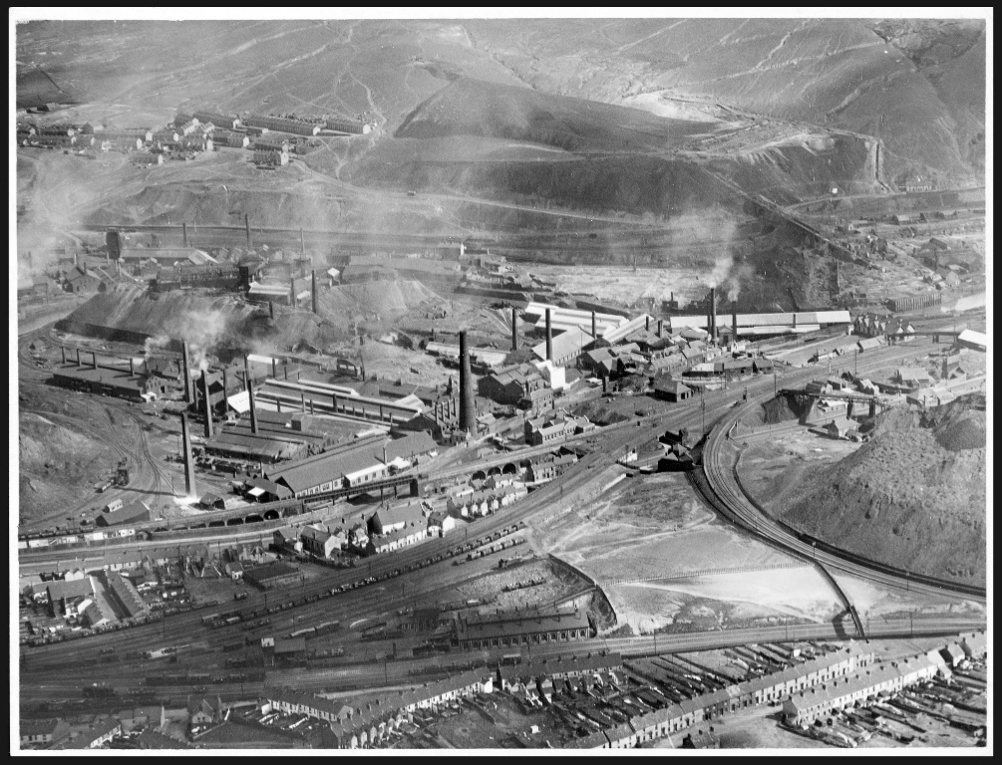
The first copper works in Swansea were set up in Landore in 1720 by two men called Dr Lane and Mr. Pollard, who had both also owned copper mines in Cornwall. By 1820, 90% of all the copper smelting that happened in Britain could be located within 20 miles of Swansea and it was considered the world center for copper ore smelting and metal manufacturing (Swansea Museums, 2020).
Photograph of the Copper Works in the Lower Swansea Valley (Museum Wales, 1920s)

In 1810, the firm ‘Vivian and Sons’ founded the first of the copper works therefore employing thousands of workers for the riverside Hafod Copper works at Swansea. This copper works was designed with an uncommon ‘Model Furnace House’, which had two large lines of extremely loud furnaces which made the heat from the coal fires reflect down onto the melting copper ore rather than mixing with it and contaminating the metal.

Beside the copper works, resident manufacturers built houses and churches for those who worked in the copper works and big schools for the workers children. This was mainly because workers were expected to work long hours and they would also be working in poor conditions. The work environment could also be dangerous due to machinery trauma, poor ventilation because work places were cramped with workers and exposure to toxic materials. However, the community was ruined by Sulphur smoke from the copper works because it produced a rainfall of diluted sulphuric acid that affected the farm land nearby and everyone living in the area. (Channel 4, 2013)

There social issues during the industrial revolution were both positive and negative. The positive parts were that there was an increase in wealth due to the fact that there were many more jobs available, this increase in wealth also saw an increase in health with people being able to afford better diets, better housing and being able to purchase goods for cheaper. Education also increased during the industrial revolution. However, there were also negative impacts on the social issues including poor working conditions for those working in factories and copper works, child labor became an issue because it was the cheapest form of labor and pollution became worse making some people ill.

Technology greatly enhanced during the industrial revolution, starting with spinning and weaving where machines were made to produce thread and yarn. Next was the steam engine which generated power. Then people began to find ways to harness electricity by using magnets and creating electric railways and tramways. Other technological products that were discovered during the industrial revolution include the telegraph, the telephone, the internal-combustion engine and the automobile (Duignan, 2020).

The industrial revolution transformed the local and national economy. Economic and historical research has shown that the industrial revolution has been linked to a rise in education, longer life spans, growth in income, both individual and national and improved quality of life (Ross, 2020). Economies that had been based on agriculture were introduced to machine manufacturing and the factory system. This means they had new machines, power sources, and new ways of working. This led to easier ways of producing materials and goods, which led to better profit, which led to better and improved lives for many people.

Referencing List
Britannica.com, Duignan (2020). Inventors and Inventions of the Industrial Revolution. https://www.britannica.com/list/inventors-and-inventions-of-the-industrial-revolution

Cadw.gov.wales. (2016) Hafod and the Lower Swansea Valley: Understanding Urban Character. https://cadw.gov.wales/sites/default/files/2019-05/Hafod%20and%20the%20Lower%20Swansea%20Valley-%20Understanding%20Urban%20Character_0.pdf

Channel 4. (2013) Swansea Copperopolis. https://www.channel4.com/programmes/time-team/articles/all/swansea-copperopolis/472#:~:text=The%20City%20of%20Swansea%20was,its%20history%20of%20copper%2Dsmelting

Investopedia, Ross (2020) How Can Industrialization Affect National Economies of LDCs? https://www.investopedia.com/ask/answers/042015/how-can-industrialization-affect-national-economy-less-developed-countries-ldcs.asp

Museum Wales. (1920s) Copper works in the Lower Swansea Valley, photograph. https://museum.wales/collections/online/object/6277c6d4-422d-3bf0-a791-f4eafc951c04/?field0=string&value0=low&field1=with_images&value1=on&page=2

Swansea Museum. (2020) The Beginning of the Copper Industry. http://www.swanseamuseum.co.uk/whats-on/past-exhibitions/copperopolis/the-beginning-of-the-copper-industry?doing_wp_cron=1608290079.7616860866546630859375#:~:text=the%20refined%20metal.-,The%20first%20copper%20works%20in%20Swansea%20were%20established%20in%20Landore,owned%20copper%20mines%20in%20Cornwall.&text=The%20hard%20glistening%20coals%20hillsides,a%20short%20sea%20journey%20away

