Academic Report

Student Name: Andrei Florin Stefan
Student ID: 2027355

Strategies for avoiding plagiarism in academic writing

Executive summary
Academic skills refer to the talents and habits which are beneficial for academic different activities like research, learning, writing reports, presentation and others relevant. Generally, academic skills include skills and activities like analysis, communication, planning, technological skills, studying, test-taking, academic writing, presentation, referencing, creative and critical thinking etc (Philpot, Curnick, Soars and Soars, 2013). Apart from these, academic writing is one of the most significant and required skills in academic level. Moreover, it is required in professional level in many cases. However, in academic writing plagiarism is one of the biggest concerns for the days now. It is a heinous activity in academic level as well as punishable. Therefore, throughout this report strategies for avoiding plagiarism in academic writing have been demonstrated as if students can write report, research and others effectively. Thus, they can success in their academic and professional lives.


Contents
Executive summary 2
Introduction 4
Strategies for avoiding plagiarism in academic writing 4
Conclusion and recommendations 7
References 7

Introduction
Academic writing denotes formal style of writings which are generally used in universities as well as scholarly publications. Academic writing might include research paper, articles, dissertation, reports and others relevant. On the other hand, plagiarism denotes stealing the works, some parts of works or articles or published anything of others without prior permission (Gilmore, 2009). In academic writing plagiarism is a heinous and punishable act. Therefore, throughout this report the strategies for avoiding plagiarism in academic writing will be discussed elaborately.
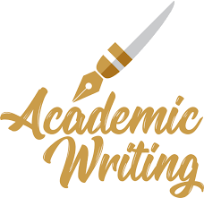

Strategies for avoiding plagiarism in academic writing
In the following excerpts from research articles and books have been presented on strategies of avoiding plagiarism in academic writing-
Robert A. Harris focused on using different sources of information and data effectively can help in avoiding plagiarism such as- books, research articles and others. According to his book, students should use practical, and useful rhetorical devices in order to avoid plagiarism, improving their writing, and putting a significant impact on writing (2021). Generally, a few students use practical theories, and rhetorical devices in their writing therefore, they make plagiarism in their writing. Students should increase emphasis on synthesis writing. That means students should not go for directly writing or copying anything from any writers’ works rather they should focus on synthesis writing on the works of others. Moreover, students should apply their own thinking in their writing in order to give a strength or power to the writing of them. Along with these students should read any article or book or others closely in order to get better grasps on writing of others as if they can paraphrase effectively. And finally, students should organize and position their resources in order to strengthen central arguments of their writing.
RaihanahM. M, Ruzy Suliza Hashim, ArezouZalipour, and Muhamad AzriMustaffa conducted research on avoiding plagiarism of undergraduate students in case of their academic writing. According to the authors of that research paper, students should cite effectively from published research articles or others in order to avoid plagiarism in their writing. They should give credit to writers in their writing (M.M, Hashim, Zalipour and Mustaffa, 2011). Students should not go for directly copying any writing or anything from any writer’s works rather they should paraphrase through their analytical and engaging thinking and writing. The authors focused that most of the students face problems regarding to these aspects in case of writing and they cannot avoid plagiarism. Therefore, they should go for consulting with their teachers and others relevant to discuss on how plagiarism in their writing. Finally, the authors focused on the issues like- students in undergraduate levels have face problems regarding to paraphrasing from the work or writing of others, the cannot present writing in a critical manner, they have problems in summarizing text of others effectively, and they cannot cite correctly in most of the cases. Therefore, they are often found plagiarized in terms of their writing. In order to avoid plagiarism students should have better grounds in these areas.
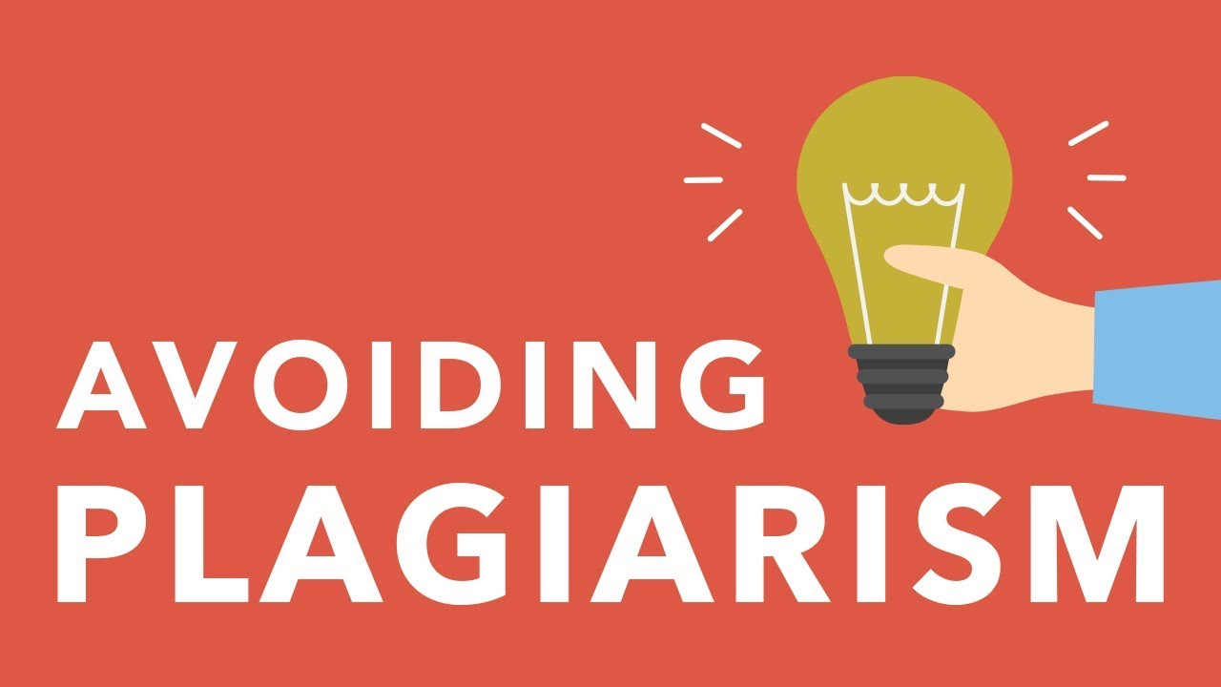
In accordance with the research article of Anderson, plagiarism is one of the biggest concerns in the academic writing and for students. The trend of plagiarism has been increasing for the last several years (Anderson, 2009). However, he came up with several strategies in order to avoid plagiarism in academic writing of students. Such as- students should understand what actually make a file or writing plagiarized and they should avoid these, students should learn what can make their writing plagiarism free, they should go for checking the rules regarding to copyright, they should learn the ways of citing references properly, they should learn the ways of paraphrasing effectively, they should review file and writing again and again, and finally, they should discuss with their professors or others relevant on strategies for avoiding plagiarism.
From the excerpts of the research we can come to the conclusion that there are some strategies for avoiding strategies like-
- Students should paraphrase effectively.
- They should learn the ways of avoiding plagiarism and the things which can make a file or writing plagiarized.
- They should discuss the plagiarism issues with their professors or others relevant.
- They should check rules and regulations of copyright.
- They have to cite properly and give credit to authors in their writing.
- Before submitting or after finishing files or writing students should review these again and again.
- Students should apply their creative thinking and analytical as well as critical writing abilities in their writing.
- They should go for applying practical theories and rhetoric.
- They must not copy writing, works, any parts or anything of others’ works directly.
- Lastly, they should read any article, research paper; books and others closely in order avoid plagiarism in their writing.
In conclusion, there are some other common strategies for avoiding plagiarism in academic writing. Such as- summarizing, keeping tabs on sources, seeking advice of others, using plagiarism checker, using quotation marks, and knowing the types of plagiarism etc.

Conclusion and recommendations
Academic writing is one of the vital academic skills. Academic writing should be effective, plagiarism free, and attractive. If students follow the mentioned strategies in writing academic articles, research papers, reports and others they could avoid plagiarism. As academic writing contributes to different writings related to projects, research, programs and others in professional as well as personal life, therefore, students should be careful in case of avoiding plagiarism and making their writing effective.

References
- 2021. [online] Available at: <https://www.amazon.com/Using-Sources-Effectively-Robert-Harris/dp/113828968X> [Accessed 30 June 2021].
- Anderson, I., 2009. Avoiding plagiarism in academic writing. Nursing Standard, 23(18), pp.35-37.
- Gilmore, B., 2009. Plagiarism. Portsmouth: Heinemann.
- M.M, R., Hashim, R., Zalipour, A. and Mustaffa, M., 2011. Developing a Critical Response, Avoiding Plagiarism among Undergraduate Students. Procedia - Social and Behavioral Sciences, 18, pp.517-521.
- Philpot, S., Curnick, L., Soars, L. and Soars, J., 2013. Academic skills. Oxford: Oxford University Press.

