HUMAN RESOURCE MANAGEMENT
Table of Contents

Introduction: 3
A. The current state of the labour market in the UK 3
B. Changes in Human Resourcing Strategies in the post-COVID, post 7
Brexit external environment: 7
Emerging Changes in Human Resourcing Strategies in the Post-COVID Scenario in the UK: 7
Post-Brexit Human Resourcing Strategies in the UK: 10
Conclusion: 12

Introduction:
A country’s overall economic performance depends on its industries and labor practices. The Human Resources strategies determine the practices of the industries of the nation, in this case, the UK. The strategies are influenced by multiple factors for the UK recently COVID-19 pandemic and Brexit have impacted the most changes in its labour practices. In this report, the current state of the UKs labour market is discussed. Then the changes in HR strategies in the Post-COVID scenario are elaborated. The after part is focused on the impact of Brexit on HR practices. Thus, the report concludes its findings.

The current state of the labour market in the UK
The employment rate of the UK has been estimated to be about 75.7% as of June 2023 (Leaker, 2023). This is 0.1 percentages lower than March 2023 and this decrease in the employment rate was mainly because of the full-time employees and workers who are self-employed. The unemployment rate for June 2023 has increased by 0.3 percent and this has been driven by the people who have been unemployed for a minimum of 6 months. The estimated vacancy numbers had also fallen by 66,000 in a single period to 1,020,000 and this has been for the 13th consecutive time (Leaker, 2023).
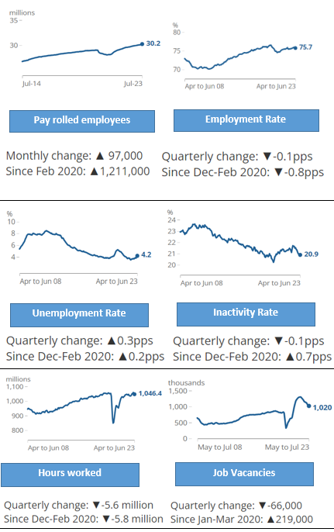
Figure 1: Overview of the current labour market in the UK
(Source: Leaker, 2023)
The above figure illustrates the six important indicators to understand the summary of the current labour market in the UK. Talking about the Payroll employed as of July 2023 has increased by 30.2 million which has an overall change of 97,000 every month (Leaker, 2023). This is above the pre-pandemic period. However, the Employment rate has decreased to 75.7% which sees a quarterly change of (0.1 positive pay system). The Unemployment rate explains that it is above than the pre-pandemic period and the quarterly change is around 0.3pps (Office for National Statistics, 2023). The main reason behind this change is the initiation of different self-employed people. The Inactivity rate has decreased to (0.1pps) but is well above than the pre-pandemic period (Office for National Statistics, 2023). The Hours worked chart shows that it has decreased in the quarter to (5.6 million). Overall, it can be said that the labour market has suffered and this is affecting the performance of the UK’s industries as well.
Elaborating on the labour market in detail then as of January 2023, there have been around 1.16 million vacancies which remain right and unfilled at higher levels. The Labor market focuses on the companies having little choice but to adjust the remuneration packages under the cost-of-living crisis (Office for National Statistics, 2023). The Office for National Statistics states that wages have increased at a fast rate over the last 20 years. The average private sector growth in regular pay is 7.2% and this is yet to meet the inflation of price (Office for National Statistics, 2023). The Office also explains that 43% of the companies make moves to pay better employees to work for them at any cost. The labour market has been softening in the UK as a proof the Bank of England that increases in the interest rates were seen 14 times since December 2021 (Albanesi and Kim, 2021). A fall of 66,000 employments was seen for three months till June in which a massive drop in the employment was seen which was 567,000 (Office for National Statistics, 2023). The market was unable to cope with the growing number of self-employment as people might have concluded that full time employment might not be as high-earning as self-employment. Despite an increase in the number of people inactive due to the pandemic or long-term sickness, there have been people who are looking for work in recent months (Brown and Souto-Otero, 2020). This is mainly because of the squeeze in household budgets and the increase in cost-of-living problems. The combination of weak labour demand and an increase in labour supply caused the unemployment rate to increase by 0.3 per cent to 4.2 per cent in the March to June quarter of 2023 (UK jobs market is cooling despite record pay growth, 2023). The annual pay growth of the labour market was 7.8% in 2001 and it increased to 8.2% in 2023.
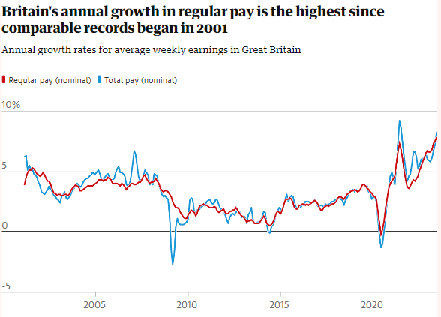
Figure 2: Annual growth in regular pay since 2001
(Source: UK jobs market is cooling despite record pay growth, 2023)
The earning level may increase as well along with the increase in interest rates. The monetary policy committee stated that inflation has made it hard for the people and the total pay is running ahead of price increment (UK jobs market is cooling despite record pay growth, 2023).
Coming into 2023, the market was stumbling but it was maintained properly as the use of the Labor Force Survey explained the engagements of the job market. To understand the problems that are making it hard for the labour market to stand, it will be analyzed through Self-Assessment, Claimant Count and others. The strategy named 'The Labor Market Enforcement Strategy 2023 to 2024 explained the ways problems will be analyzed through suitable evidence and questionnaires (Biomass strategy 2023, 2023). These questionnaires will provide evidence of the published strategies and improve compliance. The Employment Agency Standards Inspectorate (EAS) provides information by using different formats to support the companies and workers as well. It uses certain mechanisms to support employers to be compliant. One of the mechanisms is the use of enforcement letters to educate agencies. This was also collaborated with a range of partners and built a public profile by prompting Key Information Documents for the agency workers. Gangmasters & Labor Abuse Authority provides a mixed approach for compliance and deterrence compliance based on labour providers. The work includes campaigns on social media and providing leaflets which lure many students and people who are in search of a job (Eichhorst, Marx and Rinne, 2020). Another compliance named NMW enforcement legislation is not different to the above two and has been promoting work-seekers for years (Biomass strategy 2023, 2023). National Minimum Wage (NMW) targeted better communication with the stakeholders and flagging underpayment risks. This made newer changes like an increase in the wage rate and the inclusion of more workers.

Changes in Human Resourcing Strategies in the post-COVID, post

Brexit external environment:

Emerging Changes in Human Resourcing Strategies in the Post-COVID Scenario in the UK:
The COVID-19 pandemic had a huge impact on the globe and can be considered the largest shift in Human Resourcing strategies, and the UK is no exception. The aftermath of the COVID-19 pandemic brought a paradigm shift in the Human Resource strategies of larger organizations in the UK to keep the organizations running during the pandemic and post-pandemic scenario. This global crisis or pandemic compels organizations to adapt instantly to unprecedented challenges, significantly altering the approaches to HR practice. These emerging changes can be characterized by new work cultures with a blend of remote working, digitalization, and more focus on work-life balance.

Remote and Flexible Work Arrangements: The pandemic compelled organizations to viable remote work arrangements, as the pandemic made travelling and gathering in a place risky and restricted. Thus the viability of remote working was underscored and largely accepted and promoted during the pandemic. According to a survey conducted by the Office for National Statistics (ONS) in April 2020, around 46.6% of employed people in the UK worked from home at least temporarily (Cameron, 2020). This trend of working from home environment or remotely prompted the companies to reevaluate the need for office space use and resulted in potential cost savings and a broader talent pool, which allows the hiring of more employees from afar, minimizing the need for physical office presence. The study by Gartner points out that 87% of HR leaders in the UK believe this hybrid work model will become the norm, and this shift toward remote work is likely to endure (Stein, 2022).

Digital transformation: The travel restrictions and lockdowns made organizations rely on technology to maintain their businesses, operations, and communication. This compelled shift towards technology surged the demand for digital skills across multiple industries in the United Kingdom. This instant need for technological expertise was met by additional training and upskilling opportunities mostly organized by the industries. As remote work necessitates digital proficiency, HR strategies are increasingly becoming more focused on fostering a culture of continuous learning and resource delivery for the skill development of employees (Sharma, and Kumar, 2022).

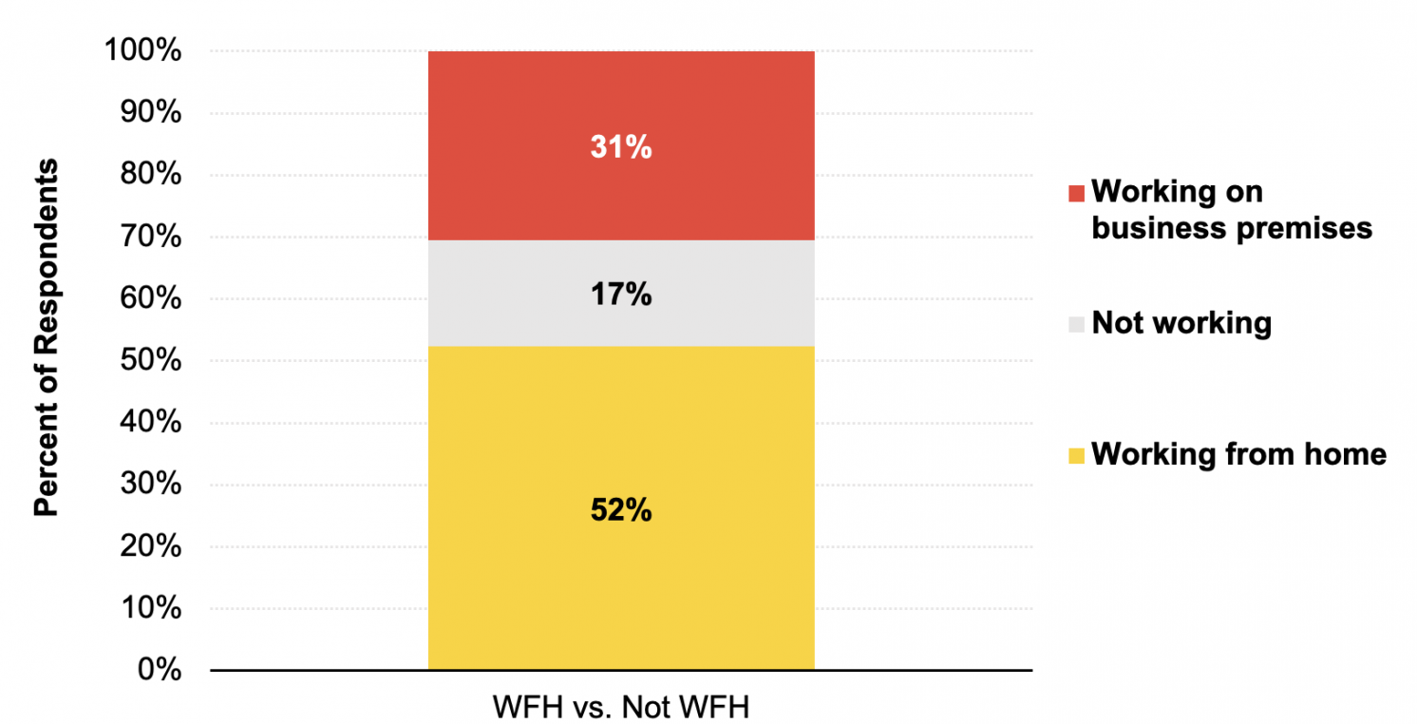
Figure 3: WFH in 2021
(Source: CEPR, 2023)

Prioritizing Employee’s Well-being: The pandemic has taught people to value time and the togetherness of family, and organizations need a holistic approach to employee well-being to keep employees engaged. Companies in the UK now prioritize work-life balance, flexible scheduling, and mental health support for employees. A study by Deloitte revealed that organizations have expanded well-being programs or resources to improve employees' work-life balance and mental health (Przytuła, Strzelec, and Krysińska-Kościańska, 2020). This shift also highlights that employee mental health and morale are essential for sustaining productivity and therefore, the companies are reevaluating the performance metrics according to challenges to remote work and personal circumstances.

Decision-Making Based on Data: The digitalization of HR processes also generated a large amount of data which organizations can leverage for much more informative decision-making. These analytical HR strategies are gaining popularity as they allow more precise insights into performance, engagement, and retention. Currently, these HR analytics are becoming paramount for business in the UK, and multiple CEOs consider HR analysis essential for their organizations to identify trends and tailor strategies to improve the performance of the company.

Diversity, Equity, and Inclusion (DEI): The UK in particular has come through multiple events in past years regarding Diversity, Equity, and Inclusion which amplified the significance of these parameters, including the Black Life Matter movement (Heatherly et al., 2022). In post COVID-19 scenario UK organizations reevaluating hiring practices to promote diversity at every level and ensure equal opportunity for everyone. This shift towards DEI is imperative for fostering innovation, creativity and creating a more inclusive work environment.

Organizational Crisis Management: Organizational crisis management is related to managing and mitigating the crisis and resuming operations and employment during the pandemic. The COVID-19 pandemic made it difficult for traditional operations and travelling to the organizations creating the crisis. Thus, organizational crisis management is approached using multiple HR strategies to minimize the halt and loss. The most important fact of organizational crisis management is the efforts to manage the crisis may begin beforehand but the practices remain constant after the crisis is over (Grissom, and Condon, 2021). Therefore, many HR approaches taken during the COVID-19 pandemic are still being practised in multiple organizations in the UK.
The COVID-19 pandemic has impacted organizations all over the UK and transformed HR strategies from multiple perspectives. The HR practices have been influenced by the COVID and post-COVID scenarios. The changes in aspects of work and operation, digital transformation, prioritized employee well-being, data-based decision-making, DEI, and crisis management practices are prominent. These changes in HR strategies are helping the UK industries to provide and promote a more accepting work culture and vice versa influencing employees to perform tier best and benefit the organizations in return.

Post-Brexit Human Resourcing Strategies in the UK:
The completion of Brexit was on 31st December 2020, which impacted a significant period for United Kingdoms’ external relationship. The change in trade, regulation, and immigration policies due to Brexit has had an irresistible impact on human resource strategies within the UK. Many important shifts in terms of recruitment procedure, talent management, and planning the workforce, these changed strategies are discussed in the following.

Immigration and Talent Acquisition: Most visible impact of Brexit on human resourcing has been the reconfiguration of the immigration rules; the points-based immigration system has impacted the process of hiring talents from foreign countries. Thus, skilled workers need to meet some criteria such as a job offer from an approved sponsor, a certain level of proficient English, along with a minimum point threshold (Wakisaka, and Cardwell, 2021). This is implied to ensure the UK attracts skilled individuals to contribute to the economy. Thus, in the UK industries, HR strategies recalibrated to hire international candidates maintaining these rules and from a narrower pool. These changes in migration also made it difficult to find many candidates as many are showing lesser interest in UK industries after Brexit (Portes, and Springford, 2023).
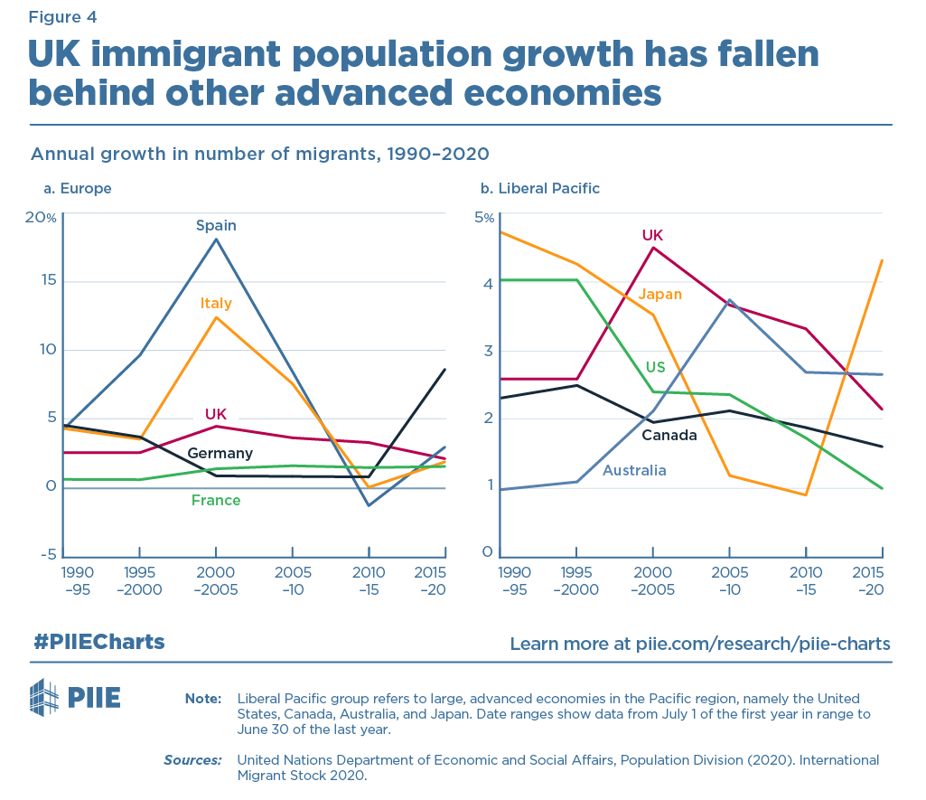
Figure 4: Change of Immigration in the UK after Brexit
(Source: PIIE, April 27, 2022)

Supply Chain Disruptions and Stuffing: Due to Brexit there are changes in trade agreement and customs practices which directly impacts supply chain disruptions (Cohen, and Lee, 2020). This has impacted the workforce planning of multiple organizations, forcing them to reassess their supply chain practices. This leads to a focus on localized workforce solutions, and direct changes are seen in terms of recruitment strategies and supply chain planning, a more agile approach to staffing is an immediate response to Brexit.

Regulations and Skill Development:
Coming out of EU regulations has shown the need of navigating new compliance requirements for UK-based businesses. Organizations adapted resourcing strategies according to the shifts in data protection, employment laws, and trade. Thus, a space for upskilling the existing workforce along with hiring more skilled candidates is created. This is shown in a study that suggests many employers invested in the training and development of employees after Brexit (Rolfe, Runge, and Hudson-Sharp, 2019.). The HR departments are now more focused on training initiatives for employees in the evolving regulatory and economic landscape to ensure necessary skill possession in the new environment.

Local Talent and Diversity Promotion: The tightening immigration rules in the post-Brexit scenario forced the companies to focus more on the local talent pool, increasing the investment in the cultivation of homegrown talents through apprenticeship programs, internships, and education schemes (McKenna, Fletcher, and Griffiths, 2019). The focus is also impacted on diversity inclusion and a more talent-based pool without discrimination as the organizations seek to attract diverse local talents. Many organizations are starting to increase emphasis on diversity and inclusion initiatives with a broader social and business aspect, to reflect a broader population. The changes due to Brexit also increased the talent haunt competition among organizations making more places for talented local candidates with improved packages (Breschi et al., 2020). The strategies of Human Resources hugely impacted by Brexit through the initial wave has been sustained, the proper strategies are showing improved result in terms of local talent pool, supply chain reassessment, and upskilling of existing employees.

Conclusion:
The current labour market of the UK suggests a decrease in employment and this need to be overcome to hold a stable economy for the nation. Events such as the COVID-19 pandemic and Brexit have impacted the labor market mostly. The Post-COVID scenarios introduced practices like remote and flexible working models, digital improvements, data-driven decision-making, and employee well-being whereas Post-Brexit scenarios changed in the hiring practices due to changes in migration rules, supply chain disruptions due to changes in trade regulation, and import-export changes.
References
Albanesi, S. and Kim, J., 2021. Effects of the COVID-19 recession on the US labour market: Occupation, family, and gender. Journal of Economic Perspectives, 35(3), pp.3-24.
Biomass strategy 2023 (2023) - gov.UK. Available at: https://assets.publishing.service.gov.UK/government/uploads/system/uploads/attachment_data/file/1178897/biomass-strategy-2023.pdf (Accessed: 16 August 2023).
Breschi, S., Lawson, C., Lissoni, F., Morrison, A. and Salter, A., 2020. STEM migration, research, and innovation. Research Policy, 49(9), p.104070.
Brown, P. and Souto-Otero, M., 2020. The end of the credential society? An analysis of the relationship between education and the labour market using big data. Journal of Education Policy, 35(1), pp.95-118.
Cameron, A., 2020. Coronavirus and homeworking in the UK: April 2020. Office for National Statistics, London.
CEPR, (2023), Working from home is revolutionising the UK labour market, Available at: https://cepr.org/voxeu/columns/working-home-revolutionising-UK-labour-market (Accessed: 17 August 2023).
Cohen, M.A. and Lee, H.L., 2020. Designing the right global supply chain network. Manufacturing & Service Operations Management, 22(1), pp.15-24.
Eichhorst, W., Marx, P. and Rinne, U., 2020. Manoeuvring through the crisis: Labour market and social policies during the COVID-19 pandemic. Intereconomics, 55, pp.375-380.
Grissom, J.A. and Condon, L., 2021. Leading schools and districts in times of crisis. Educational Researcher, 50(5), pp.315-324.
Heatherly, K.A., Yang, S.U., Browning, N. and Kim, E., 2022. Words, money, or action? How corporate social advocacy drove media coverage in response to the Black Lives Matter protests of 2020. The Public Relations Journal, 5(2), pp.1-22.
Leaker, D. (2023), Labour market overview, UK: August 2023, Labour market overview, UK - Office for National Statistics. Available at: https://www.ons.gov.UK/employmentandlabourmarket/peopleinwork/employmentandemployeetypes/bulletins/UKlabourmarket/latest#main-points (Accessed: 16 August 2023).
McKenna, S., Fletcher, G. and Griffiths, M., 2019. Hiding in the light: Recognising UK mid size businesses as a distinct category and their economic and social value to the nation.
Office for National Statistics (2023), GOV.UK. Available at: https://www.gov.UK/government/organisations/office-for-national-statistics (Accessed: 16 August 2023).
PIIE, (April 27, 2022), The UK and the global economy after Brexit, Available at: https://www.piie.com/research/piie-charts/UK-and-global-economy-after-brexit (Accessed: 17 August 2023).
Portes, J. and Springford, J., 2023. The impact of the post-Brexit migration system on the UK labour market. Contemporary Social Science, 18(2), pp.132-149.
Przytuła, S., Strzelec, G. and Krysińska-Kościańska, K., 2020. Re-vision of future trends in human resource management (HRM) after COVID-19. Journal of Intercultural Management, 12(4), pp.70-90.
Rolfe, H., Runge, J. and Hudson-Sharp, N., 2019. Immigration policy from post-war to post-Brexit: How new immigration policy can reconcile public attitudes and employer preferences. National Institute Economic Review, 248, pp.R5-R16.
Sharma, D.N.K. and Kumar, N., 2022. Post-Pandemic Human Resource Management: Challenges and Opportunities. SSRN.
Stein, S., 2022. Hybrid Workplace Hacks: Strategies to Set Up and Lead Successful In-Person and Remote Teams. John Wiley & Sons.
UK jobs market is cooling despite record pay growth (2023), The Guardian. Available at: https://www.theguardian.com/business/2023/aug/15/UK-jobs-market-is-cooling-despite-record-pay-growth (Accessed: 16 August 2023).
Wakisaka, D. and Cardwell, P.J., 2021. Exploring the trajectories of highly skilled migration law and policy in Japan and the UK. Comparative Migration Studies, 9(1), pp.1-18.

