A Report focussing on:

The overview of the SA1 FOG Project.
A summary of the different usages and overviews
within the project;
Cost Usage and Resource Usage.

Prepared by:
A.George

Date Completed:
January 11th 2022

Table of Contents
Page Number
- Report Summary 3

- Project Overview 4
- Cost Usage and Overview 6

- Resource Usage 7

- Conclusion 8

1.0
Report Summary
The aim of this report is to show the client an overview of the SA1 FOG Project. The overview will show the client an initial budget and a breakdown of the resource usage and cost usage. The overview will be represented visually to give a clearer understanding to the client. They will summarise all overviews, giving a brief description of what is being shown in the individual charts.

2.0
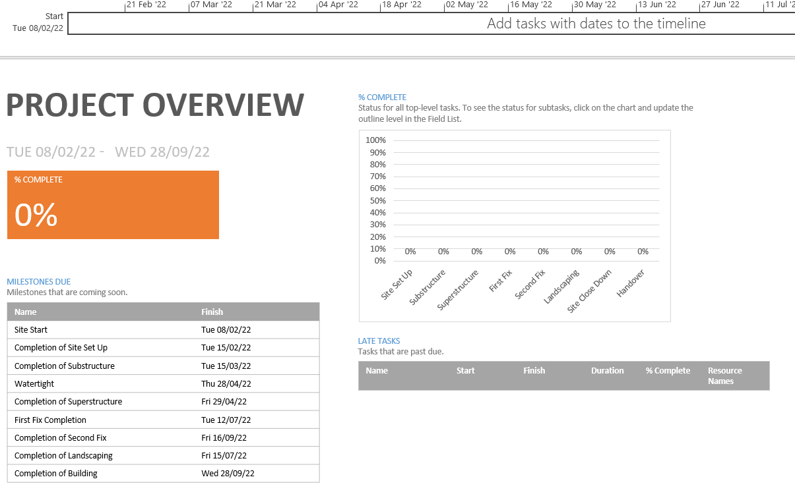
Project Overview
Figure 1.
The chart above shows a brief project overview (Figure 1.). Within the overview, information such as the key start date and end date are detailed. The project is due to start on the 8th of February 2022 as stated in the project brief and to complete the by project by 28th September 2022. To achieve the end date of 28th September 2022, work will be followed closely by the on-site manager. It will be the aim to complete the project before the end date stated.
You can also find an overview of the Project Milestones finish dates. These milestones are set at important events within the schedule and offer an overview to show the current stages of the project. It is important to remember that these dates can change depending upon the progress of construction.

Below is a visual representation of what the project overview will look like once tasks have been started (Figure 2.) and important milestones have been reached. Tasks are updated by the Site Manager via the Project Chart which in turn will change how this chart will represent the different data. As you can see the milestones that have been reached are no longer represented and are taken off the list under Milestones Due.
We can also track the total hours of the project (Figure 3.) and how many hours have already been put into the project. This way we can keep track of the labour on site and ensure that the construction is running on time.
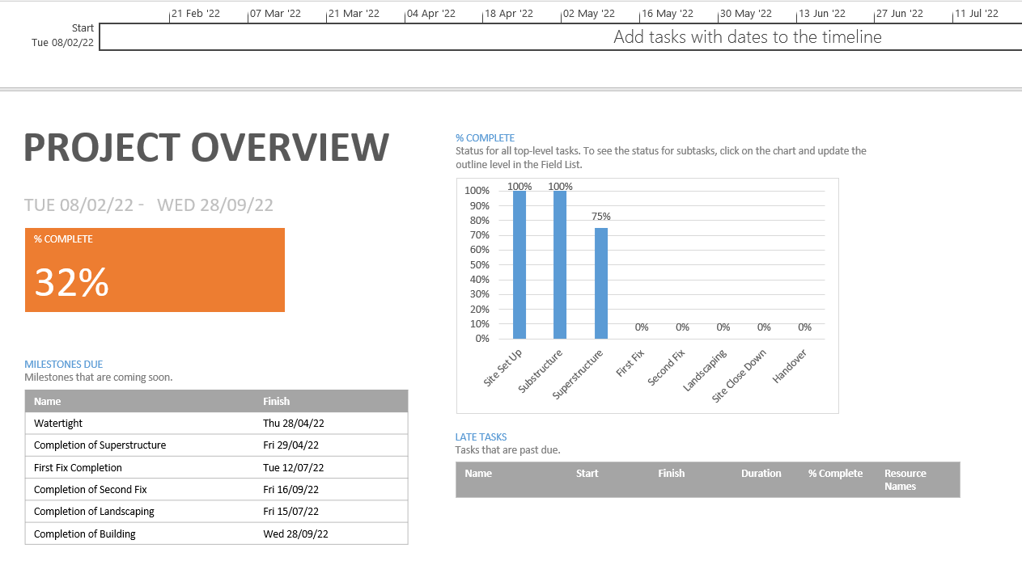

Figure 2.
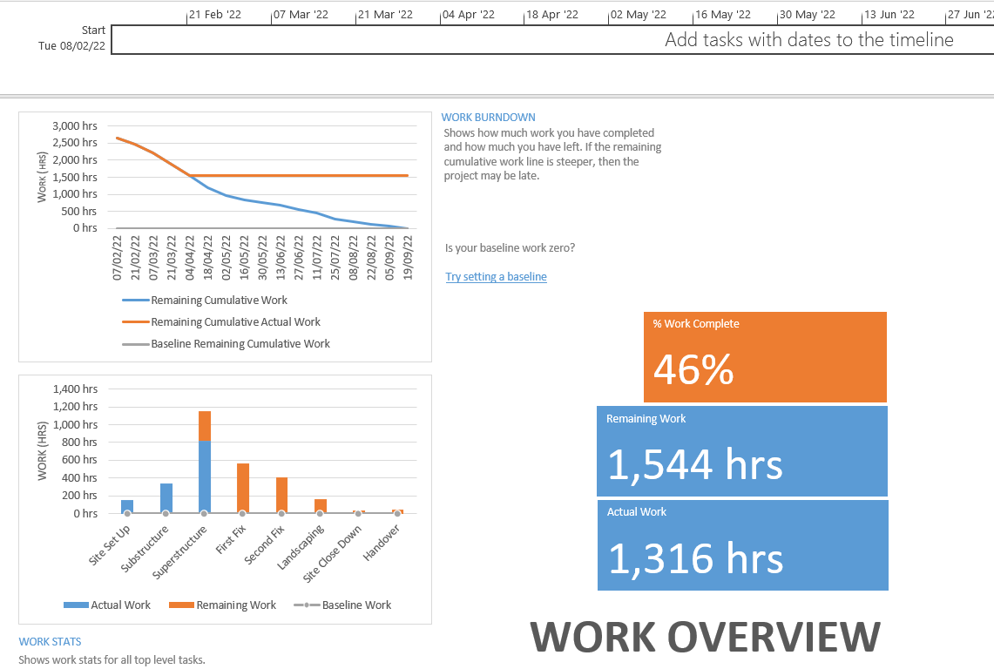
Figure 3.

2.0
Cost Usage and Overview
Below is a visual representation of the Cost Overview (Figure 4.) for the project. It’s a simple and digestive way to represent important information from the project.
The overview shows the overall cost to build part 1 of the FOGs is £63,370.27. This is calculated by the materials used, cost of labour and hiring of plant/machinery. It is important to remember that not all coatings are shown within this figure and extras cost are to be added.
We can also see a breakdown of the cost within the individual summaries, i.e. the cost to carry out the work within the Substructure totals around £24,820.00.
This overview can help track the budget and any procurement requirements, if any area of the project is starting to run over budget this will become obvious and will be a helpful tool to make any cost savings in any other area to avoid going over budget.
As tasks are completed, the % completed will increase along with the tasks that have been completed.
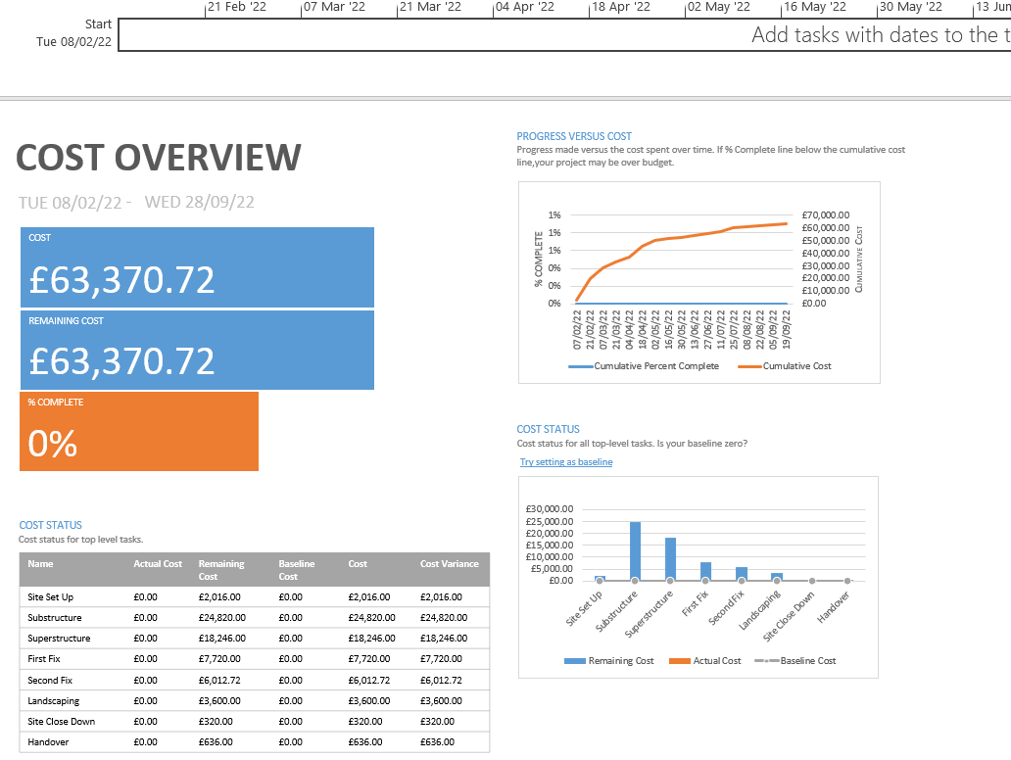
Figure 4.
3.0
Resource Usage
Resource Overview gives a clear understanding of the different types of trade that will be carried out on site. The graph shows how many hours each trade will be on the project. Looking at the overview, the main trade on site will be a labourer, totalling 880 hours of work throughout the duration of the project. The overview can allow us to track the hours of each individual resource and see who is above the allocated hours, allowing the management to carry out a review into why that trade is spending longer than necessary.
The tracking can also allow us to see if more tradespeople are required to prevent a burnout on a singular individual.
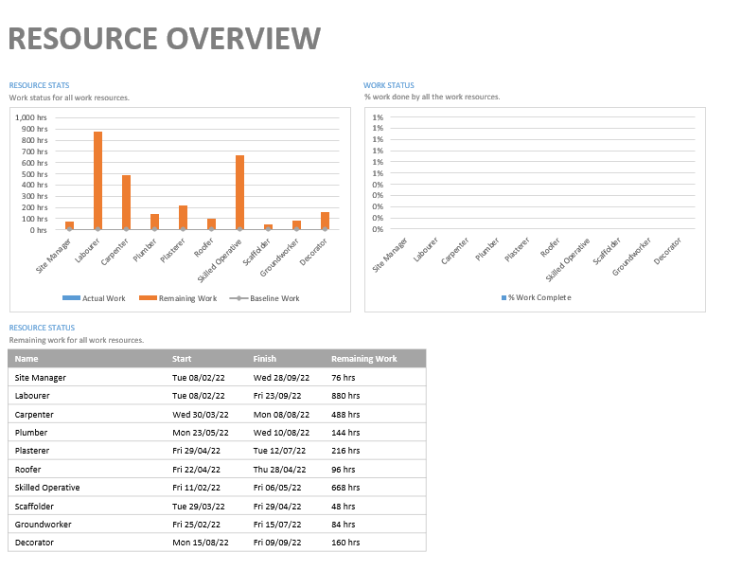
Figure 5.

5.0
Conclusion
To conclude, it is imperative that the Project Plan is followed strictly. To achieve this, it will be important for the Site Manager to carry out regular inspections and updated the chart as much as possible to ensure information is accurate. By following the plan, a quality build will be achieved, in a reasonable time and within the budget that is set at the beginning of the project.

