Guide to submitting an assignment via Turnitin on UWTSD Moodle

 | - Locate the UWTSD website, www.uwtsd.ac.uk , and click on ‘Quick Links’ as indicated
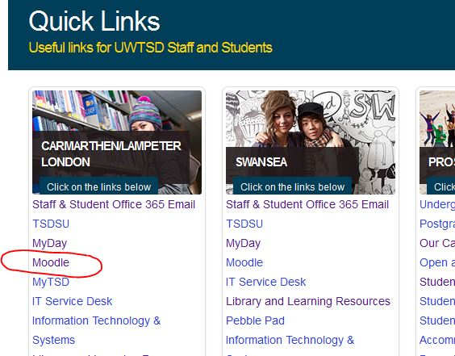 | - Now click on ‘Moodle’ in the ‘Carmarthen/ Lampeter/ London’ column on the left
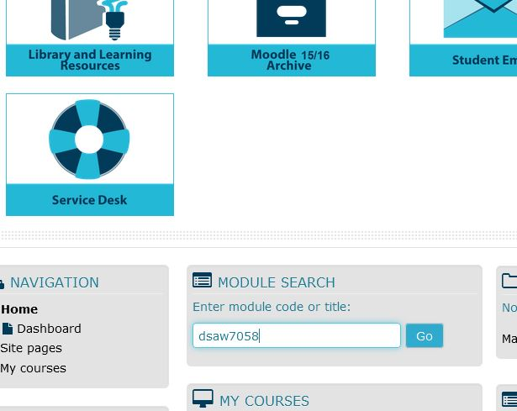 | - You will need to log in to Moodle using your student number and password (your student number is sent to you upon enrolment).  You should see the module you need (ie. ‘DSAW7058’) listed on the initial Moodle page, but if not, you can search for it as indicated
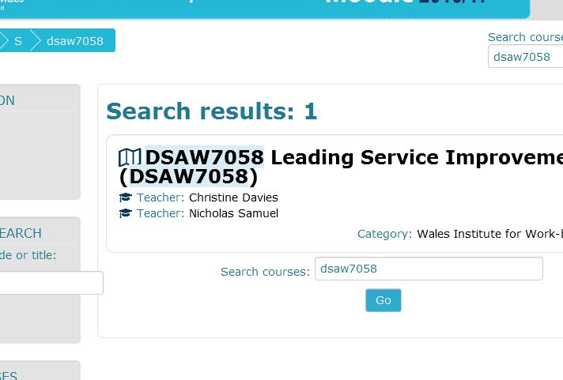 | - Click on the Module title to open the module
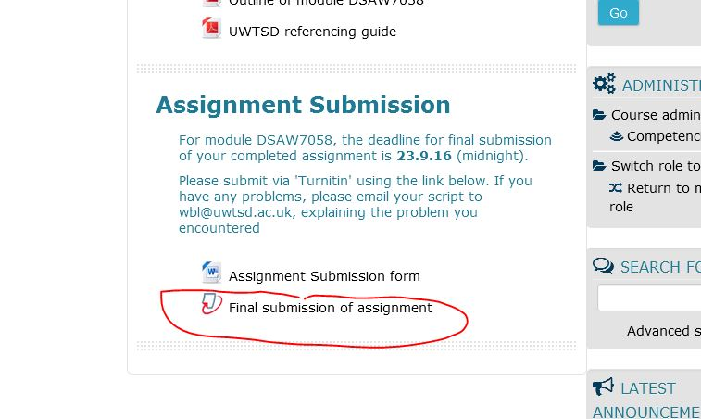 | - Scroll down to ‘Assignment Submission’, and click on ‘Final submission of assignment’ as indicated
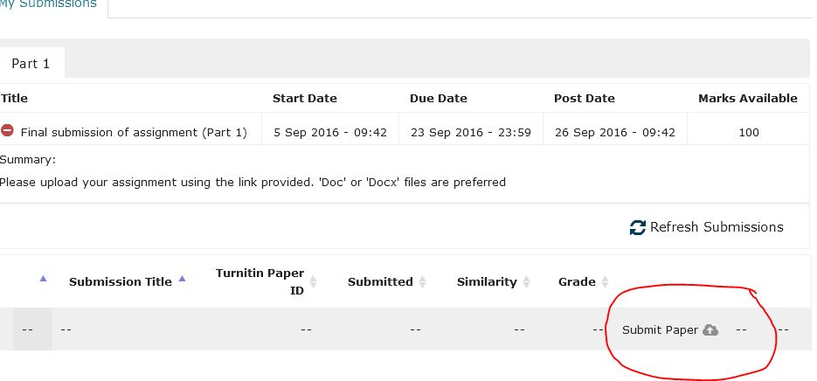 | - You should see a screen with the appearance as shown. Click on ‘submit paper’ in the lower right-hand corner as indicated
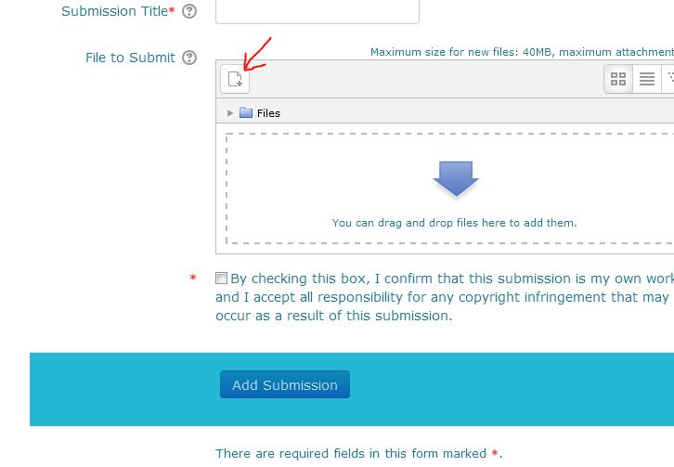 | - You now need to provide a title (eg. ‘assignment for DSAW7058’), and then upload your document. If you open the folder containing this, you can drag and drop the document into the box with the arrow. Alternatively, click on ‘Add’ (indicated with the red arrow) to navigate to the file where your assignment is located. Lastly, click on ‘Add submission’
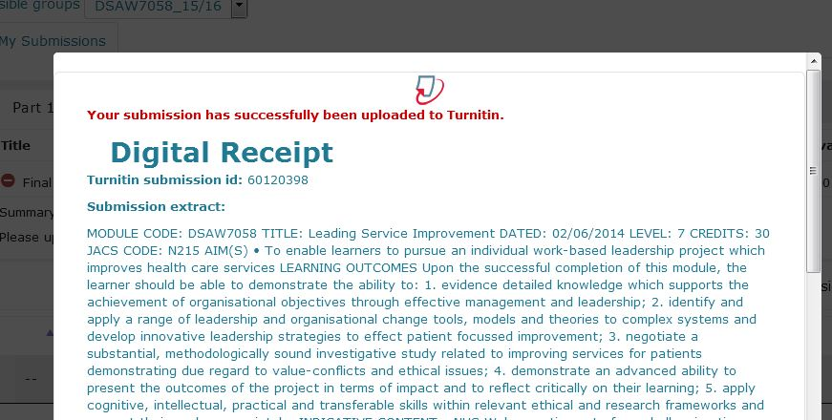 | - If you have submitted correctly, you should now see a page entitled ‘digital receipt’ as shown (close by clicking on tope right hand corner). You will also receive an email acknowledging your submission.  If this does not work for some reason, email your assignment to ‘wbl@uwtsd.ac.uk ’ before the deadline.

