MODULE CODE: LCBB5004
MANAGING PEOPLE
ASSESSMENT 2
‘’Human Resources in LIDL Supermarket’’
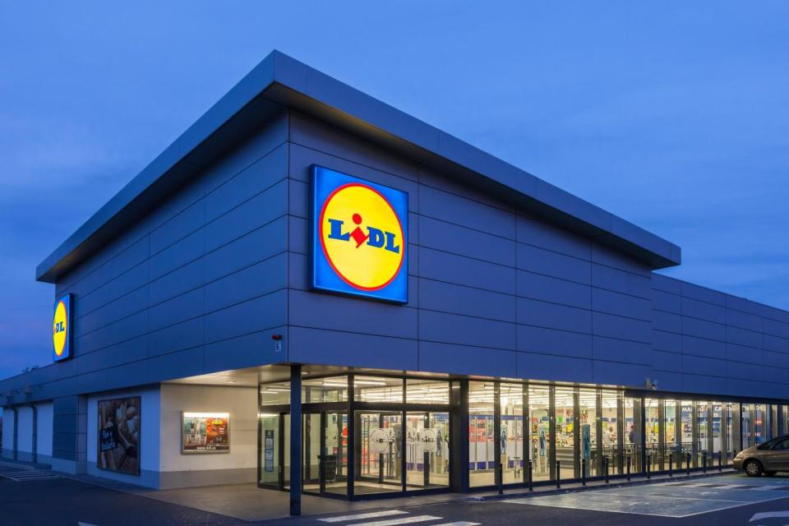

Name — Juan D. Quintero
Student ID — 1815072
Lecture — Husam Alharahsheh

Abstract

In this essay it will be discussed about HRM Policies of Lidl, how the company manage to implement HR Strategies such training, development and engagement within the organization.
The argument will be based on how these topics link with the HR strategy and why are very important within the organization in order to develop new policies in the future as society is in progress and each country and companies are operating in a different way.
This paper aims to address key questions such as: why organization needs robust and progressive HRM policies. It may be related on how the society progress and the new changes that organizations are facing with the new technologies, workforce, competitors and landscape of government interfering in the economy that is progressing continuously.

Introduction

The retailer's organizations are challenging with attracting, training, developing and engaging employees, that is why HR department must focus to ensure that the policies and procedures are met. The retail industry is facing increased competition and workforce composition changes (Morgeson & Campion, 2003).
This paper examines the supermarket Lidl and its HR strategy, how their policies will support managers and workers to performance within the company, it will be showed how the training, development and engagement can be composed as is important to recognize the importance of them within the company (Kavanagh & Thite, 2009) as it will be essential to determine the HR structure that involve training, career development practices and retaining. It is important to define these practices as it creates structure around the companies. HRM systems take in a key the role of each employee as it used for recruitment, training, development, engagement and reward system (Singh, 2008. Kavanagh and Thite, 2009).
New practices and policies of HR is due to the World that has been changing rapidly as consequence of the advancements in technology, E-commerce, new methods of work such flexibility, work from home, schedules, contracts, salaries, holidays, new training procedures and as a result, business need to be more competitive (Latif, K, Jan, S, & Shaheen, N 2013). The competitiveness of the new century made that employees need to be on top of their jobs, Jahanzeb and Bashir (2013) add that companies should have employees who can adapt in a changeable business environment quicker than the normal.

The Company ‘’Lidl’’

Lidl is a German food storage that is founded in 1930s. Lidl established itself by focusing on a discount strategy consistently (Andersen and Poulfelt,2006). However, they started updating their concept by adding more articles. Today, Lild has more than 8000 stores across 25 countries. The first UK store was founded in 1994, but now there are 700 stores and 13 regional distribution centres across UK, employing more than 23000 people. It is the ninth largest supermarket and the sixth most visited. It has 80 supermarkets over the greater of London with intentions of expander to 250 over the years (GVA, 2018).
Lidl vision is focused in providing quality products at market leading value. The mission of Lidl is to ensure market leading quality and value by constantly innovating and optimising their efficient processes, driven by technology and people, working in the communities positively. Also achieving long term success by investing in the recruitment, training and development of the people.
Lidl operates with different departments that are link with human resources strategies. The employee relation and engagement enable the culture that embodies their initiative standards and where all workers have a sense of security inside the work environment, worth and enlivened to perform at their best, the aim of this department is to look after their employee's relations, their health and wellbeing.
Their people strategy is underpinned by their core values such respect, recognitions, trust and responsibility that depend on individuals, procedures and culture. Viable worker commitment guarantees that all employees are adjusted, motivated and performing as well as could be expected for the organization.
Within this area the department contributes necessary tools and training to the employees in order to growth and make the company profitable by its workforce, training and developing people for the job they do and the job are taking in the job they are doing in the job that they want to do.

Training
Training within an organization should be a key point for a HM strategy as every organisation operates different and it will help to best develop of the company and hence it will get better results. Within every organization there will be different people doing different roles, each one will have a different background and skills. The training must be adapted to each employee on based of their skills and experience, but it should be with the aim to fill the gap of the role that is require. Every employee can be trainable, it will be always possible to make their jobs better through training.
However, this is should be in placed in the human resources strategy. People who are more receptive for training will be easier to deliver training and therefore new knowledge. The challenges that a HR can face in regards of the investment of training of a company are there the following; firstly, people will be more capable to do the job and they will acquire more capabilities which means that they will be more attracted for competitors.
Secondly, if the company is no able to retain their employees as they might leave as a result of their improved skills (Kennet,2013) That is why HR need to develop a retaining practice along with the training. Some authors pointed out, that training will have an effect on employees of feeling that the organization is giving them something – like training, interests, high salary- are likely to be loyal their organizations. Also, training can improve employee morale and happier employee are less likely to leave the organizations (Fisher,2012).
HRM policies such as selective hiring, training and use of rewards to retain are more likely to adopt high-involvement work practices, including team, engagement (Pil and MacDuffie, 1996). According to Shaw and Preumushi (1997) HRM had a great impact on productivity and quality of the employees.

In Lidl Corporation recognize that employees are not the same and each training should different. How they offer different practice such mentoring training day to day, -more info-. The role is best carried out by manager in the line who has the skills and the management to guide the employee and suggest practical solutions.

Development Employees

Developing people plays an important role within the organization as it will prepare the next generation of leadership of the company. Human Resources Development helps individual enhance their level of productivity and understanding of the job requirement to performance better and therefore employees will enhance the values and objectives of the company. Also, help new employees to understand the culture of the company.
In a few words, development is to improve managerial performance by imparting knowledge, changing attitudes, or increasing skill. Thus, it can exist various programmes to develop employees. The aim of development strategies is to enhance the future performance of the organisation itself. Therefore, development must be engaged with the company HR structure and must not be a onetime event but be over a longer period (Leibowitz, 1986).
In Lidl offer many different techniques toward developing. The company helps everyone to achieve something new whether they are on their job training, digital resources or apprenticeships. Lidl needs to be awareness of modern and innovation methods in the implementation of roles. Lidl’s goal is to support employees their personal development with digital resources
Lidl being a large company in a sector which is quite competitive they must put their employees under developing strategies to deliver the workforce that the retailer sector expects. How Lidl have been operating over the year to get to their people with all vary of development opportunities. Lidl has launched videos, books, podcast and courses to develop their skills also every employee, specially, managers will be given a specific development path that it will help them to achieve their goals. (Lidl)

Engagement

Engagement is a process of identification with the goals of the organization (Reichers 1985). According to Jaros (1997) this is process due to the employee’s psychological state for those employees that experienced higher organizational commitment tend to be more engage and performance better.
Lidl have a plan to retain employees, a package of benefits and compensation. The pay rate in the company is above average within the food retailers’ sector, in some countries employees are entitled to have insurance and a retirement plan. Also, the company offer a vary of flexibility in the workplace. Lidl is the first supermarket retailer to pay to pay the recommended living wage within the UK according to Chief executive Ronny Gottschlich (BBC) .Try-level wages will increase from £9.00 to £9.30 per hour outside of London and £10.55 to £10.75 within the M25, with employees earning up to £11.70, depending on location and length of service. (Lidl GB). Lidl are proud of different benefits such good pension scheme, cycle to work scheme and after five years working in the company employees can have up to 3 sabbatical years.
Over the years has been investing e Lidl employees raising salaries, introduction new learning and developing methods, and adapting new strategies of HR in accordance of the current marketplace.
The company is very structured in terms of HR Development and Engagement planning as the principle value of the company is invest in people.

Discussion

Lidl is one of the best retailers that offer not just great benefits and work environments to their employees also to their customers that can feel in every store a great environment to do their shopping. Employees are in title to get different benefits out of work such reasonable discounts when they buy in any store of Lidl that recognize the value that they have. It could say that employees can be happier and enhance the values of Lidl organization.
Furthermore, Lidl work goal-oriented and result-oriented, as a result, Lidl has created great HR practices and policies that offer to its employees, that can be reflected in employee's satisfaction and friendly work environment.
New procedures need to be place in practices in accordance with the new trends, innovation and technology of the retailer sector, and this need be trusted by manager and each member of the organization to prosper in business environment. As advancements are being necessary for each organization to success.
This new procedures and policies need to be introduced within the HR strategies. Therefore, with the introduction of new methods regarding with the method of production, HR turns in to a value management tool that will lead the organization to progress (HR Policies and Procedures Manual, 2019).

Conclusion

As organization are operating in different environments that are not static and they can be affected by different factors. Human resources need to provide the culture and objectives of the organizations. Putting in place different strategies need to be according with the culture of the company. New challenges in the retailer industry are changing the business environment, new methods of productions are being necessary for companies that need to introduce new strategies in different areas of the organizations. Thus, this is a work for HR department to introduce innovations, new learning skills, developing practices and retaining benefits in accordance with the new landscape of the world. Some of this backwards are making organizations to be success if the adapt their strategies and hence their employees will performance according with the values and objectives of the company.
The HRM practices needs to be integrated with the overall strategies to ensure that HM resources will be effective to implement task and duties within the organization.
To sum up, human resources management in organizations assume a special strategy role since policies and practices must create organizational capacities that lead to better results. Where HR practices and policies need to be proceeded in different areas such training, development and retaining employees, bringing growth to the company, enhancing the values and reputation of the company within the marketplace.

References
Andersen, M., & Poulfelt, F. (2006). How the new market leaders are redefining business strategy. Discount business strategy, 75‐105.
Chatzimouratidis, A, Theotokas, I, & Lagoudis, I 2012, 'Decision support systems for human resource training and development', International Journal Of Human Resource Management, 23, 3, pp. 662-693
Fisher, J 2012, 'Training and Development', Business People, pp. 76-77, Business Source Complete, EBSCOhost, [Accessed on the 29th April]
Jaros, S.J. (1997), “An assessment of Meyer and Allen’s (1991) three-component model of organizational commitment and turnover intentions”, Journal of Vocational Behavior, Vol. 51 No. 51, pp. 319-337, available at: https://doi.org/10.5465/AMBPP.1995.17536599
Jehanzeb, K and Bashir, A. (2013). Training and development and its benefits to employee and organisation: A conceptual study. Available: http://www.iiste.org/Journals/index.php/EJBM/article/viewFile/3947/4005. [Accessed on the 27th April]
Jehanzeb, K. and Beshir, N.A. (2013) Training and Development Program and Its Benefits to Employee Organization: A Conceptual Study. European Journal of Business and Management, 5, 243-252.
Kavanagh, M., & Thite, M. (2009). Human Resource Information Systems: Basics, Applications and Future Directions. Sage publications inc.
Kennett, G 2013, 'The Impact of Training Practices on Individual, Organisation, and Industry Skill Development', Australian Bulletin Of Labour, 39, 1, pp. 112- 135, Business Source Complete, EBSCOhost, [accessed on the 29th april]
Latif, K, Jan, S, & Shaheen, N 2013, 'Association of Training Satisfaction with Employee Development aspect of Job Satisfaction', Journal Of Managerial Sciences, 7, 1, pp. 159-178, Business Source Complete, EBSCOhost,[accessed on the 29th April]
Leibowitz, Farren, Z.B., & Kaye, B.L. (1986). Designing Career Development Systems. (1st Ed.). San Francisco: Jossey-Bass Publishers.
Morgeson, F., & Campion, M. (2003). Work design. Handbook of psychology: Industrial and organizational psychology, 12(2), 423‐452.
Pil, F., and MacDuffie, J.P. (1996), ‘The Adoption of High-involvement Work Practices,’ Industrial Relations, 35, 423– 455.
Reichers, A. (1985) "A Review and Reconceptualization of Organizational Commitment". Academy of Management Review,10,465-476.
Shall, R B (1997) Trust in the balance, Jossey Bass. San Francisco, CA.

Online
A career a Lidl less ordinary. https://careers.lidl.co.uk/life-at-lidl/your-development [Accessed on the 24th April]
Policies and Procedures in the Workplace: The ultimate Guide https://i-sight.com/resources/policies-and-procedures-in-the-workplace-the-ultimate-guide/#Why [Accessed on the 24th April]
Lidl Employees Are Given Control Over Their Own Development With Totara’s Learning Management Systems. https://www.totaralearning.com/en/customer-stories/lidl [Accessed on the 25th April]
Lidl to invest over £10 Millions in its employees as it announces increase in hourly wages.https://corporate.lidl.co.uk/media-centre/pressreleases/201911_lidlincreaseemployeewages [Accessed on the 25th April]
Representations to Draft London Plan Lidl UK GmbH Representation.https://www.london.gov.uk/sites/default/files/Lidl%20UK%20GmbH%20-%20GVA%20%282975%29.pdf [accessed on the 29th April]

