JAMES WILLIAMS
UWTSD – SWANSEA
MOTORSPORT MANAGEMENT
P150594
MODELLING LOGISTICS OPERATIONS LEVEL 5
M5X1280

Report (1)

Task description
Critically discuss the role of models in providing solutions to logistics OR motorsport management problems.

Table of contents (2)
- Opening Title and Task Description
- Table of contents
- Introduction to Task Discussion
- Optimization Modelling
- Variables
- Types of Optimization Programming
- Linear and Non Linear Programming
- Heuristic systematic modelling
- SCOR
- Discrete Models
- Simulation Models
- Conclusion
- Bibliography

Introduction to Task Discussion (3)
The report will conduct a discussion as to the role of modelling providing solutions for motorsport industry problems. The role of business process modelling is simple- by analysing through various modelling techniques businesses can make calculated decisions to both improve productivity and efficiency throughout the supply chain. Modelling is linked strongly throughout the supply chain and ensures systems run as efficiently as possible.
Various modelling methods and approaches are used to optimize or simulate certain outcomes which in turn helps to improve the overall supply chain by strengthening connections and generally creating a more controllable system with (hopefully) fewer unseen variables.
The Modern Analyst explains the importance of business process modelling – ‘Business Process Modelling is becoming a higher priority for business managers and analysts as there is an increasing emphasis in organizations to document, understand and improve their business processes. Managers and business owners are realizing that operating their businesses without well documented processes is just like a pilot who is flying blind without properly functioning instruments and navigation. Well documented and streamlined processes are essential in a smooth functioning of a team as they help ensure consistency, trackability and focus towards a shared goal.’ (Modernanalyst.com, 2018)
Throughout this report the various modelling techniques such as heuristic, supply chain operations reference, the simulation and optimization models giving examples and analysis of all and linking back to the Motorsport related companies and their problems.
Finally, after analysing the individual types the report will conclude on the results- such as how the methods enable companies to run their business smoother and more efficient using models – making calculated and sometimes automated decisions.

Optimization modelling (4)
When looking at the different approaches to modelling we discover two main types of approach which enable the operator/business to calculate either precise mathematical results with optimum solutions or to set up a series of tests to understand the characteristics of a situation to make the correct choice of solution to the problem. These are examples of optimization and simulation modelling approaches.
Optimization models use precision in mathematical algorithms / equations including tolerance values to calculate precise values. The Managing supply chains – a logistics approach describe the optimization approach as ‘precise mathematical procedures that are guaranteed to find the “best,” or optimum, solution and approaches essentially select an optimal course of action from a number of feasible alternatives’ (UWTSD power point Mod/logistics op 2018)
There are 4 types of optimization models and can be segregated in to different groups via the nature of their objective function and constraints. The optimization model can call on algorithms to suit the nature of the objective function and constraints to allow for a calculated solution to be achieved in the most efficient way. The four types of optimization model are as follows: unconstrainted optimization, quadratic program optimization, non-linear program optimization and linear program optimization. It is extremely important the correct optimization model is identified to use the correct tailored algorithms for accurate precise results. (Neos-guide.org, 2016)
To conduct am optimization model investigation there are specific sets of data which need to be obtained; decision variables, result variables and uncontrollable variables / parameters. These sets of a data are all closely linked with the different sets of optimization models used.
Variables (5)
Decision variables are often alternative courses of action available within the situation. Decision variables can be influenced by the other variables on occasion. These variables do have a bearing on the final decision but due to the fact of – being affected by other variables it does not contribute to the overall decision as influentially as other variables used in the calculation. Giving an example of a decision variable within motorsport is simple, we could say the number of mechanics working on a world rally car over the rally week – can be described as a decision variable.
The result variables within optimization modelling are often the last variable to be accounted for or calculated – as it says (result variable). Decision variables can be a large influencing factor on the overall result variable but can also be influenced by the relationship / correlation between the other variables. A good example within motorsport may be the fuel calculations a rally engineer must conduct before he allows the rally car to head to the stages- the car must have enough fuel to complete the stages and road mileage back to refuel- (fuel consumption/mile X number of miles= fuel needed- the result variable)
Uncontrollable variables/ parameters generally have the overall control of the final calculation result. Uncontrollable variables can be described as parameters as they are not influenced and have a large effect on the result. In motorsport and more specifically – rallying certain parameters are set by the governing body (Federation Internationale Autosport) or organisers (Wales Rally GB) to achieve specific results or avoid any failures. A good example to use is the road section route in which the cars must take between stages- it is not on influenced variable and therefore cannot be changed- unless an accident occurs.

Types of Optimization Programming (5)
Within optimization – there are different types of programming which occur. Linear programming is a popular modelling solution- ‘Linear programming is a mathematical approach to the problem of allocating limited resources among competing activities in an optimal manner. Specifically, it is a technique used to maximize revenue, Contribution Margin (CM), or profit function or to minimize a cost function, subject to constraints. Linear programming consists of two important ingredients: (1) objective function and (2) constraints, both of which are linear. In formulating the LP problem, the first step is to define the decision variables that one is trying to solve. The next step is to formulate the objective function and constraints in terms of these decision variables.’ (www.allbusiness.com, 2018)
In simple terms, ‘Linear programming is a simple technique where we depict complex relationships through linear functions and then find the optimum points. The important word in previous sentence is depict. The real relationships might be much more complex – but we can simplify them to linear relationships. Applications of linear programming are everywhere around you. You use linear programming at personal and professional fronts. You are using linear programming when you are driving from home to work and want to take the shortest route. Or when you have a project delivery you make strategies to make your team work efficiently for on time delivery.’ (Analytics and scientists, 2017)
An example of a linear programming problem is seen every day logistically within motorsport. A delivery truck from MSPORT world rally team is delivering parts to six different customers throughout Cumbria, the delivery driver wants to take the most efficient route but arriving at each destination at the allocated time (assuming the routes between destinations are linear to simplify the situation). Finding the best route is called operational research- this is an approach to decision making linked with linear programming. LP here, is used to formulate the optimal solution given the constraints – it is calculated by taking the real-world situation and transferring it into a mathematical solution. By assuming the journeys between are simple (straight lines) we can simplify the situation enough to understand in simple terms the solution for the situation, however we know in real life terms the journeys and routes would be a lot more complex with traffic jams and road rules taking place. (Analytics and scientists, 2017)

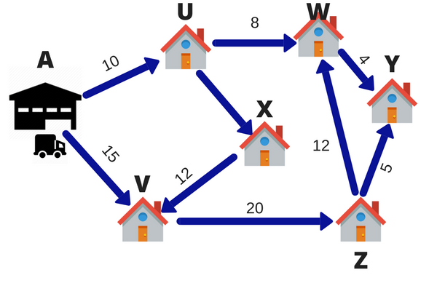
Figure 1.0 shows the simplified route for travelling (considering assumptions) the letters represent the different destinations and the numbers – the mileage between destination. (Analytics and scientists, 2018)

Linear Programming / Non Linear Programming (7)
LP programming is also typically used to either minimise costs or maximise profits with varying levels of inputs. Usually used for models with many alternatives. For example, within motorsport Linear programming modelling can be used to analyse and create solutions for teams selling parts to customers. The teams aim would be to sell a driveshaft at a competitive price, keeping quality high but lowering the manufacture costs as much as possible. This in terns creates a good profit margin- which is an area this example of linear programming can be found to be very useful.
Non-linear programming is described as the ‘process of solving a system of equalities and inequalities, collectively termed constraints, over a set of unknown real variables, along with an objective function to be maximized or minimized, where some of the constraints or the objective function are nonlinear. Nonlinear programming problems are in general more difficult to solve than linear programming problems, and often the solution found is only a local optimum. The solution methods for nonlinear programming models vary, which can result in different nonlinear solvers giving different local optima for the same problem.’ (AIMMS, 2015)

Heuristic systematic model (8)
‘The heuristic-systematic model of information processing, or HSM, is a widely recognized communication model by Shelly Chaiken that attempts to explain how people receive and process persuasive messages. The model states that individuals can process messages in one of two ways: heuristically or systematically. The guiding belief with this model is that individuals are more apt to minimize their use of cognitive resources thus affecting the intake and processing of messages. HSM is quite like the elaboration likelihood model, or ELM. Both models were predominantly developed in the early to mid-1980's and share many of the same concepts and ideas’ (En.wikipedia.org, 2018)
Heuristic models are known to be able to deal with broad problems, but do not provide a definite or optimum solution for the problem. This approach can help to reduce to a manageable size by closing the problem enough, so that in the mean time a better solution can be found. Furthermore, this approach is often using to condense large amounts of information to an appropriate amount.
This approach is found in the supply chain but can be biased therefore must be used with a degree of care as it is governed by availability, accessibility, and applicability. An example of HRM in motorsport may be- trying to understand the mechanics in a rally team need more than 30 minutes to service a car, when they may only get an allocated 30 minutes. The solution being add more mechanics to share the work load, but this does not dive us a definite solution to the problem. (Bhattacharjee, 2018)
Supply Chain Operations Reference (SCOR) (9)
‘Supply-chain operations reference (SCOR) model is a process reference model developed and endorsed by the Supply Chain Council as the cross-industry, standard diagnostic tool for supply chain management. The SCOR model describes the business activities associated with satisfying a customer's demand, which include plan, source, make, deliver and return.’ (En.wikipedia.org, 2018)
SCOR is the most recognised supply chain framework and benefits the system by increasing the speed of system implementations, creates accurate process efficiency /effectiveness, improves inventory turns, supports group learning objectives, improves business agility and the overall operational performance. (Apics.org, 2018)
The diagram below shows how the SCOR system breaks the supply chain down into different segments.

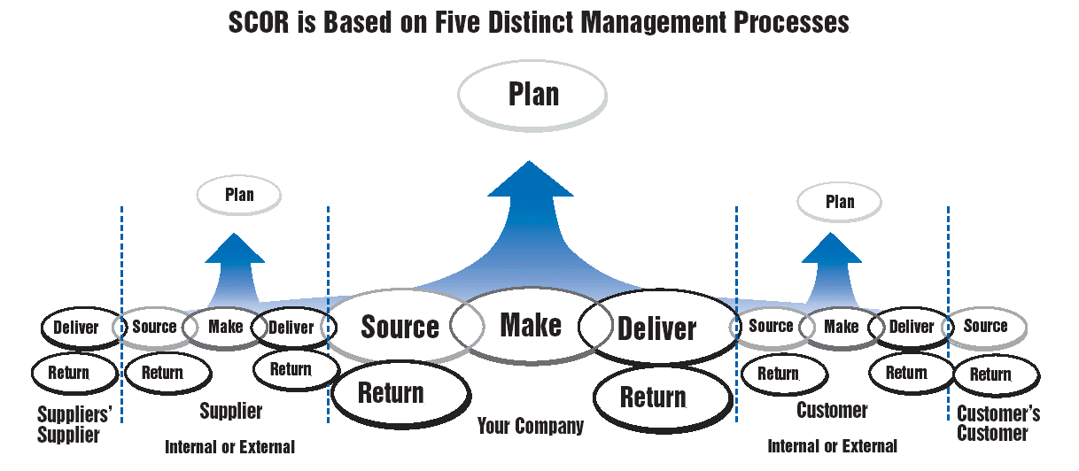
Figure 2.0 -diagram shows the SCOR system broken into the relevant segments. (Google.co.uk, 2018)
As mentioned above SCOR is broken down into five different stages of activity which must be completed to ensure the customers demand is met.
Planning,
‘these are processes that relate to demand and supply planning. Standards must be established to improve and measure supply chain efficiency. These rules can span compliance, inventory, transportation, and assets, among other things.’ (Handshake.com, 2018)
Source,
‘this step in the SCOR model involves any processes that procure goods or services to meet a demand (real or planned). Material acquisitions and sourcing infrastructure are examined to determine how to manage the supplier network, inventory, supplier performance, and agreements. This stage should help you plan on when to receive, verify, and transfer a product in the supply chain.’ (Handshake.com, 2018)
Make,
T meet planned / actual demand this process sees the product (s) be transformed to their final state. This step is very important, especially in the manufacturing industries with – made to order /made to stock products. The process includes all the steps in making the product and the managing of equipment and facilities.
Deliver,
Considers any process which involves getting a product out of warehousing / order and on to distribution. This process considers customer service, product lifecycles, assets and importing/ exporting duties.
Return,
The final step- the business must be ready to receive any returns for any reason. The organisation must be equipped to handle the return of defective products, packaging or containers. The final step involves the application of business rules, assets, return inventory and regulatory requirements.
SCOR would be used in Motorsport to as set out- improve and maintain the efficiency of team travel and wanted parts for race weekends, whilst preventing the occurrence of an accident or mistake which could potentially affect the team’s performance over the race weekend.
Discrete Models (10)
Discrete models are used purely for discrete sets of data. Usually discrete data can be described as data in which a continuous pattern in results can not be seen or found – random data. There are many examples of discrete data within motorsport industries. Specifically, at rally events the number of competitors can change in a discrete way. In 2018 the border counties rally was cancelled due to a lack of entries via competitors, whereas the year before the entries were full and the rally was successful. More examples- the number of spectators at events, the number of people buying merchandise- completely discrete data as there would be no apparent pattern.
Simulation Models (11)
Simulation modelling is described as a mathematical representation of a problem, with solving alternatives for various scenarios, and solutions compared for decision making, drawing insights, testing hypotheses, and making inferences (Keebler, 2006) (UWTSD power point Mod/logistics op 2018)
Simulation modelling is a useful process as it allows the company to simulate implementing a system or product overtime, to study the characteristics and decide on a decision – whether to implement or not. There are three main types of simulation modelling; Monte Carlo Simulation, Operational Gaming Simulation and a System Simulation Model- as above.
‘Monte Carlo Simulation- or probability simulation, is a technique used to understand the impact of risk and uncertainty in financial, project management, cost, and other forecasting models.’
‘In a Monte Carlo simulation, a random value is selected for each of the tasks, based on the range of estimates. The model is calculated based on this random value. The result of the model is recorded, and the process is repeated. A typical Monte Carlo simulation calculates the model hundreds or thousands of times, each time using different randomly-selected values. When the simulation is complete, we have many results from the model, each based on random input values. These results are used to describe the likelihood, or probability, of reaching various results in the model.’ (Riskamp.com, 2018)
The system simulation modelling use software to conduct real life simulations. This type of simulation is seen vastly in Motorsport – where teams use simulators which imitate accurately the action of rallying a car – to train drivers and massively reduce the risk of failure or damage when taking to the track for real. This in tern keeps costs down in the long term and the effort in which it takes to drive a simulator is far less than that of an actual race car- no need for licenses etc.
The operational gaming model accounts for human behaviour and strategic settings. It is a very efficient way of solving a problem and uses solution concepts to resolve problems;
-Dominant strategy equilibrium
-Subgame perfect nash equilibrium
-Bayesian equilibrium
-Weak perfect Bayesian equilibrium
-Nash equilibrium
Dominant strategy equilibrium is the most common form in motorsport industries. It can be seen in almost every decision teams make (mostly) one team will decide and the others follow suit. A strategic move to buy the strongest rally car for the events ahead can be followed by other competitors to remain competitive and remove any variables between teams. This is a behaviour which can be analysed and usually represents a ‘safe decision’ (less to lose) in motorsport.
Conclusion (12)
In conclusion, this report has analysed the individual types of models and how they are applied to real world problems within the motorsport industry. The report has explained and given examples of how the models work or would work within a motorsport industry- benefitting the corporation. The report has simplified the various models and explained the workings of algorithmic structures and variables seen in the optimization processes.
The report has also looking into the workings of supply chain operations reference model and how the system enables the corporations to be as efficient as possible throughout the relevant activities.
It is clear to see the obvious benefits of modelling to a motorsport organisation throughout the report- evidently reducing the costs or damages by simulating events and deciding on implanting strategies or products. It creates a ‘safety net’ for companies by reducing the room for error in decision which in turn reduces the risk of failure and the negative effect on the organisation.

Bibliography (13)
References
AIMMS. (2015). Non Linear Programming. [online] Available at: https://aimms.com/english/developers/resources/solvers/nonlinear-programming/ [Accessed 29 Oct. 2018].

Analytics, B. and scientists, I. (2017). Introductory guide on Linear Programming explained in simple english. [online] Analytics Vidhya. Available at: https://www.analyticsvidhya.com/blog/2017/02/lintroductory-guide-on-linear-programming-explained-in-simple-english/ [Accessed 29 Oct. 2018].

Analytics, B. and scientists, I. (2018). Introductory guide on Linear Programming explained in simple english. [online] Analytics Vidhya. Available at: https://www.analyticsvidhya.com/blog/2017/02/lintroductory-guide-on-linear-programming-explained-in-simple-english/ [Accessed 29 Oct. 2018].

Apics.org. (2018). SCOR Supply Chain Operations Reference Model | SCOR Framework | APICS. [online] Available at: http://www.apics.org/apics-for-business/frameworks/scor [Accessed 29 Oct. 2018].

Bhattacharjee (2018). Heuristic-systematic model (HSM) of persuasion. [online] Slideshare.net. Available at: https://www.slideshare.net/OracleUltimate/heuristicsystematic-model-hsm-of-persuasion [Accessed 29 Oct. 2018].

En.wikipedia.org. (2018). Heuristic-systematic model of information processing. [online] Available at: https://en.wikipedia.org/wiki/Heuristic-systematic_model_of_information_processing [Accessed 29 Oct. 2018].

En.wikipedia.org. (2018). Supply chain operations reference. [online] Available at: https://en.wikipedia.org/wiki/Supply_chain_operations_reference [Accessed 29 Oct. 2018].

Google.co.uk. (2018). SCOR - image. [online] Available at: https://www.google.co.uk/search?q=scor+supply+chain&safe=active&source=lnms&tbm=isch&sa=X&ved=0ahUKEwi3u6LxxazeAhVIW8AKHegBCbgQ_AUIDygC&biw=1920&bih=920#imgdii=4-neUr3tAbGA5M:&imgrc=x8U0wMwTYu9c-M: [Accessed 29 Oct. 2018].

Handshake.com. (2018). SCOR Model & Supply Chain Management | Handshake. [online] Available at: https://www.handshake.com/blog/scor-model [Accessed 29 Oct. 2018].

Modernanalyst.com. (2018). 5 Key Benefits of Business Process Modeling > Business Analyst Community & Resources | Modern Analyst. [online] Available at: https://www.modernanalyst.com/Resources/Articles/tabid/115/ID/1728/5-Key-Benefits-of-Business-Process-Modeling.aspx [Accessed 29 Oct. 2018].

Neos-guide.org. (2016). Types of Optimization Problems | NEOS. [online] Available at: https://neos-guide.org/optimization-tree [Accessed 29 Oct. 2018].

Riskamp.com. (2018). Monte Carlo Simulation. [online] Available at: https://www.riskamp.com/files/RiskAMP%20-%20Monte%20Carlo%20Simulation.pdf [Accessed 29 Oct. 2018].

www.allbusiness.com. (2018). Linear Programming. [online] Available at: https://www.allbusiness.com/barrons_dictionary/dictionary-linear-programming-lp-4942501-1.html [Accessed 29 Oct. 2018].
UWTSD Lecture 1 – Modelling and Logistics Operations 2018

