
BMHP5015

Component 1: Online Portfolio of Set Exercises

Student Name: Nazira Mostafa Suliman Mahmoud
Student ID: 2319081
Lecturer’s Name: Tswani Khumalo
Table of Contents
Task 1 - Personal Brand 3
Task 2 - Network Map and Rationale 4
Task 3 - Blog 6
Introduction 6
Main Body 6
Conclusion 6
Task 4- NHS Equality, Diversity and Inclusion Quiz 8
Task 5 - A Letter to Yourself 10
Task 6 - Gantt Chart 11
Task 7- Making Changes- Report 12
Abstract 12
Introduction and Proposed Change 12
Application of the Fishbone Model 12
Conclusion 13
Task 8 - Self-Reflection 14
References 15
Appendix – Network Map 17
Tables of figures
Figure 1: Network Map 4
Figure 2: Burnout UK Trainees 7
Figure 3: Gantt Chart 11
Figure 4: Fishbone Diagram 13

Task 1 - Personal Brand
My personal brand is in line with Sunshine Early Years Nursery, and it is associated with warmth, inclusiveness and quality early childhood care. I have the values of delivering a safe, nurturing, and stimulating environment, which facilitates the emotional, social, and academic growth of children. The Early Years Foundation Stage (EYFS) statutory framework is the guiding document of my professional practice as it provides child-centred learning, effective safeguarding, and facilitation of equality and diversity in the early years education.
To build my personal brand further and advance my employment goals, I would like to improve my professional identity in the context of the early years sector using the concept of continuous professional development (CPD). This involves completing training on safeguarding, special educational needs and disabilities (SEND), paediatric first aid, updates to statutory frameworks in EYFS, and early years practitioner leadership courses so that my practice is up to date and evidence-based (Department for Education, 2021). The creation of a powerful online presence with the help of professional platforms and the dissemination of best practices will also make more people learn about my values and knowledge. This will include participation in professional networks, including early years practitioner forums, local authority early years networks, as well as online networks like LinkedIn to exchange learning and keep abreast of best practice. The collaboration and long-term career development will also be encouraged through networking with other professionals in the early years field and local organisations.
A successful and unified personal brand will also help me become more employable, as it will show that I am a thoughtful and informed practitioner who can implement the EYFS into practice by planning play-based activities, conducting observations, and relying on the assessment to address the unique developmental needs of each child (The Foundation Stage Forum 2022).

Task 2 - Network Map and Rationale
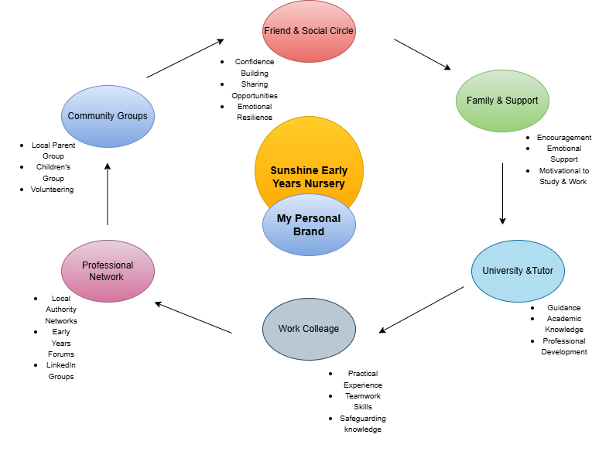
Figure 1: Network Map
Source: (Self-created, 2026)
Sunshine Early Years Nursery is in the centre of my network map since this is my personal brand and professional identity. The circular model also shows me that various aspects of my life are in a constant motion of creating and enhancing this brand.
The support of family is the starting point of the network, which offered emotional support and hardiness during difficult stages of juggling between university, employment, and personal life. This assistance helped me to stay committed to delivering my objectives. The circle further shifted to friends and my social network, which assisted in creating confidence and motivation.
The second step was the university tutors, who provided me with academic knowledge and occupational advice, making me realise safeguarding, the EYFS framework, and reflective practice (Fu and Zhang, 2024). Teamwork and day-to-day experience in early years settings enhanced my practical skills, as developed by work colleagues.
The circle is perpetuated by the professional networks, e.g. the local authority early years forums and LinkedIn groups, that update on best practice and career opportunities. Last but not least, community groups help me to understand the needs of families and the inclusive practice (Boat, Miranda, and Syvertsen, 2022).
This circular model demonstrates that my network is connected and continuous, and all the aspects of it strengthen my personal brand and contribute to long-term professional development.

Task 3 - Blog
Title: Burnout in UK Healthcare Workers

Introduction
Healthcare workers are the pillars of the UK health system, but most of them are finding it hard to cope with the mounting pressure. The problem of burnout among UK healthcare workers has been growing in concern, not only in terms of the well-being of the staff but also in the quality and safety of patient care. Knowing the reasons behind burnout occurrence and why it is important is the key to the future of healthcare.

Main Body
Burnout is defined as emotional exhaustion, low performance and detachment towards work. Healthcare professionals in the UK have to endure long working hours, a shortage of staff, and increased patient demand, especially in the NHS (NHS Staff survey, 2024).
In recent reports, it has been indicated that a considerable percentage of healthcare personnel report stress-related symptoms such as anxiety, sleep disturbances, and emotional exhaustion. The Health and Safety Executive has stated that work-related stress has been found to be among the most common causes of sickness absence in the health and social care industry. When the well-being of the staff is impaired, patient care may be impaired as well by an increase in errors, a decrease in empathy, and an increase in staff turnover.
Burnout is a problem that needs organisational and individual response. Employers can contribute by encouraging workable workloads, the provision of mental health services and a culture of employees being appreciated and heard (NHS Employers 2024).

Conclusion
Burnout among healthcare workers in the UK is not an individual problem; it is a systemic problem. Promoting the well-being of staff is a key to safe, caring, and sustainable care. The UK will be able to safeguard its healthcare workers and the patients who need them by focusing on mental health and workplace support.
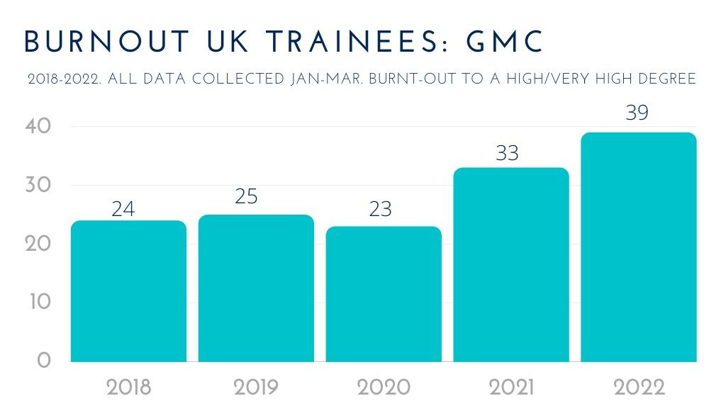
Figure 2: Burnout UK Trainees
Source: (Author, 2022, https://judithjohnsonphd.com/)

Task 4- NHS Equality, Diversity and Inclusion Quiz
- What is the primary goal of the NHS Equality, Diversity, and Inclusion Improvement Plan?
The overall aim is to establish a just, non-discriminatory NHS where everyone in the staff and patients is treated with respect and equity, and everyone has equal opportunities and care (Buka, 2024).
- How does the NHS EDI Improvement Plan propose to tackle the gender pay gap?
It seeks to guarantee clear compensation systems, promote flexible work and have more women in senior and leadership positions (Shrotri, Mensah, and Chakravorty, 2022).
- What is meant by the term ‘intersectionality’ as used in the NHS EDI Improvement Plan?
Intersectionality acknowledges the fact that individuals may experience discrimination on several intersecting levels, depending on the characteristics of race, gender, disability, and age (von Liebenstein, 2021).
- Why is it important for the NHS to create a psychologically safe work environment?
Psychological safety will motivate personnel to report errors or issues without any fear of punishment, enhance collaboration, well-being, and patient safety (Hunt et al., 2021).
- How does the NHS EDI Improvement Plan suggest improving the experience of internationally recruited staff?
It encourages the use of inclusive onboarding, peer support groups, and training to ensure that international employees can fit well into NHS working environments (Hemmings, N., Buckingham and Palmer, 2021).
- What role does leadership play in advancing EDI objectives according to the NHS Improvement Plan?
Leaders are supposed to lead by example of inclusive behaviour, confront discrimination and entrench EDI objectives in organisational culture and policy (Assessment et al., 2025).
- Identify one way the NHS EDI Improvement Plan aims to reduce health inequalities within the workforce.
Through improving the data transparency of the workplace, and recruitment and career progression differences between underrepresented groups (Hemmings, Buckingham, and Palmer, 2021).
- Why does the NHS EDI Improvement Plan emphasise the importance of collecting and analysing data on protected characteristics?
Quality data can be used to determine the trends in inequality, track progress, and hold oneself accountable to enhance inclusion outcomes (Krishnan et al., 2025).
- Explain how flexible working policies can contribute to equality and inclusion in the NHS workforce.
They enable the employees who have caring responsibilities or disabilities to strike a balance between work and life to support retention and accessibility (Ejebu et al., 2025).
- What is one strategy mentioned in the NHS EDI Improvement Plan to combat bullying and harassment in the workplace?
The plan has policies of zero tolerance, strengthening reporting processes, and training to establish a culture of respect and safety at work (Hemmings, Buckingham, and Palmer, 2021).

Task 5 - A Letter to Yourself
24 Willow Court
Aston
Birmingham
B6 7TR
Dear Younger Me,
I am writing to you when all is overwhelming. You are attempting to balance university, employment and personal lives, and sometimes it seems like there are no hours in the day. Your health is failing, yet you continue to push yourself by telling yourself that struggling is a sign of weakness and not an indication that something must be changed.
What I have learnt about it since that time is that emotional intelligence is as important as it is made out to be. Being able to identify and understand your own feelings would have allowed you to realise that being stressed, anxious or exhausted was not in any way unjustified. Emotional intelligence would also have assisted in communicating well with other people, whether it was seeking flexibility at work or calling your friends and tutors when things got too much.
Another skill that I would have had more confidence in is resilience. The failures at the time were seen as failures, but now I realise that it was an opportunity to develop. Resilience would have assisted you in coming to terms with the fact that you do not have to be perfect to be successful and that taking breaks does not mean giving up, but rather safeguarding your health.
One thing I could say to you is to be kinder to yourself. You are trying the best you can, and that is all.
With understanding,
Me

Task 6 - Gantt Chart
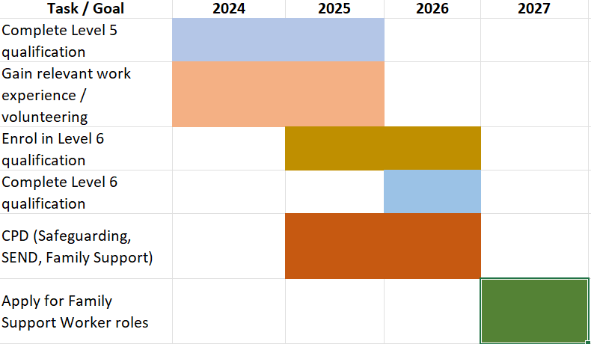
Figure 3: Gantt Chart
Source: (Self-Created, 2026)
Rationale
This Gantt chart is a systematic approach towards my long-term career objective of becoming a Family Support Worker. The chronology starts with the accomplishment of my Level 5 qualification that gives me the necessary knowledge and skills to work in the field of family and support services. In addition to this, relevant work experience and volunteering will enable me to put the theoretical learning into practice and work on the essential interpersonal skills.
The second step is to enrol and pursue a Level 6 qualification that will further enhance my knowledge of safeguarding, child development, and family-centred support. Throughout this time, I will also participate in the continuous professional development (CPD), such as training in safeguarding, special educational needs and disabilities (SEND), and family support practice. This keeps my skills and knowledge up to date and within the professional standards.
The last phase is to apply for the position of Family Support Worker, based on the obtained qualifications, experience, and professional competencies during the process. Altogether, the Gantt chart can be helpful in terms of time management, goal setting, and progression planning.

Task 7- Making Changes- Report

Abstract
The report describes a proposed change in the workplace in a care home facility to enhance communication and reduce staff burnout. It is found that one of the changes is the introduction of regular structured staff supervision sessions as a way of improving staff wellbeing, performance, and quality of care. An analysis of the factors that influence successful implementation and identification of possible barriers is conducted with the help of the Fishbone (Ishikawa) Model (Pramusinta, Jepisah, and Hasbi, 2025).

Introduction and Proposed Change
I would like to introduce monthly formal supervision meetings for care staff as a manager of a care home. This will make communication better, offer emotional support, and make the staff feel appreciated and heard. Good supervision has been found to enhance the morale and care outcomes of staff.

Application of the Fishbone Model
The causes that can influence the success of this change are identified by the application of the Fishbone Model. These are people, processes, environment and resources. Some of the skills required are leadership, communication, emotional intelligence, and conflict resolution skills (Babatunde, Sunday, and Adeshina, 2023). Managers need to be in a position to engage in reflective dialogue and give constructive feedback.
The possible obstacles are staff resistance, time and limited staffing. These can be resolved by communicating the advantages of supervision, flexible working hours and support of senior management (Kossek, Gettings, and Misra, 2021). This will also be supported by training the managers on supervision skills to enable effective implementation.
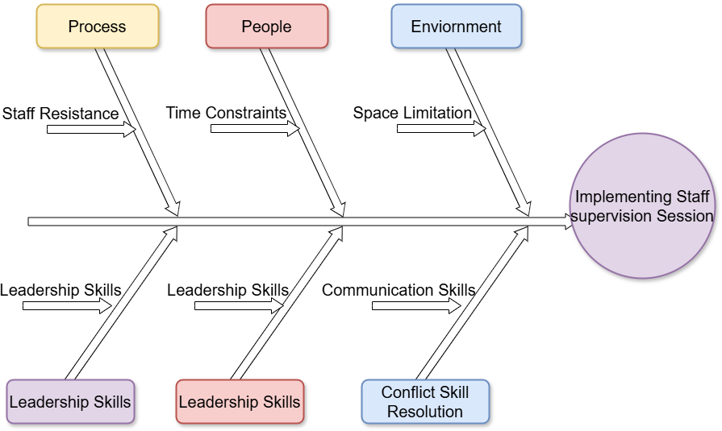
Figure 4: Fishbone Diagram
Source: (Self-Created, 2026)

Conclusion
This change can lead to the improvement of the well-being of the staff and the quality of care delivered by addressing the root causes of stress and communication problems. The application of the Fishbone Model allows for the identification of barriers and sustainable change support.

Task 8 - Self-Reflection
This reflection applies Gibbs Reflective Cycle to understand what I have learned in this module and how it has helped me develop personally and professionally (Nwati and Thuthukile, 2021).
Description:
The issues that I interacted with during this module are personal branding, emotional intelligence, resilience, networking, and reflective practice. These dimensions provoked me to consider my strengths and weaknesses, and my career goals.
Feelings:
First, I was unsure of how to identify my personal skills and project myself as a person. Thinking about my experiences helped me to realise that I underrated the worth of my current knowledge and personal attributes.
Evaluation:
One of the good results of this module was that I gained more self-awareness and confidence. This knowledge of emotional intelligence made me realise that I can use emotional intelligence to better my communication and professional relationships. Nevertheless, I found that I should keep on building my career contacts and leadership confidence.
Analysis:
The module has emphasised the role of reflective practice in determining the learning needs and making realistic goals. The use of reflection has enabled me to be stronger in dealing with challenges, embracing change, and pursuing continuous professional growth (Johns, 2025).
Conclusion:
I have also been taught that self-reflection is critical to development and strength. I have now understood better how my skills and values can be related to my career goals.
Action Plan:
I will also maintain reflective journaling, feedback, and CPD in future practice to facilitate continuous professional growth.

References
Assessment, A.R.E., Krishnan, M., Orlando, C. and Cook, J., (2025). What works to promote employer action and behaviour change in relation to equality, diversity and inclusion (EDI).
Babatunde, F., Sunday, H. and Adeshina, O., (2023). Emotional intelligence in conflict management and leadership effectiveness in organizations. International Journal of Research, 10(3).
Boat, A.A., Miranda, A. and Syvertsen, A.K., (2022). Enhancing education and career pathways through peer and near-peer social capital. Journal of Youth and Adolescence, 51(7), pp.1287-1304.
Buka, P. ed., (2024). Patient Safety in Clinical Practice: A Diverse Approach to Safe Healthcare for All. Taylor & Francis.
Department for Education (2021) Department for Education, GOV.UK. Available at: https://www.gov.uk/government/organisations/department-for-education (Accessed: 16 February 2026).
Ejebu, O.Z., Ellis, J., Sun, L., Ball, J., Philippou, J., Rafferty, A.M., Painter, S. and Turnbull, J., (2025). Values and workplace expectations to facilitate retention: perspectives from nurses at two ends of the career spectrum. Journal of Nursing Management, 2025(1).
Fu, Q. and Zhang, X., (2024). Promoting community resilience through disaster education: Review of community-based interventions with a focus on teacher resilience and well-being. PLoS one, 19(1).
Hemmings, N., Buckingham, H. and Palmer, W., (2021). Attracting, supporting and retaining a diverse NHS workforce. London: Nuffield Trust.
Hunt, D.F., Bailey, J., Lennox, B.R., Crofts, M. and Vincent, C., (2021). Enhancing psychological safety in mental health services. International journal of mental health systems, 15(1).
Johns, C., (2025). Becoming a reflective practitioner. John Wiley & Sons.
Kossek, E.E., Gettings, P. and Misra, K., (2021). The future of flexibility at work. Harvard Business Review, 28.
Krishnan, M., Roberts, C.P., Pearmain, I.D. and Sealy, T., (2025). Tackling workforce inequalities in health and adult social care.
NHS Employers (2024). Supporting our NHS people experiencing stress, NHS Employers. Available at: https://www.nhsemployers.org/articles/supporting-our-nhs-people-experiencing-stress (Accessed: 18 February 2026).
NHS Staff survey (2024). NHS Staff survey 2024 national results briefing published: March 2025. Available at: https://www.nhsstaffsurveys.com/static/c1a573e95b1a49428676ef4b24f5efe7/National-Results-Briefing-2024.pdf (Accessed: 18 February 2026).
Nwati, M.P. and Thuthukile, J., (2021). Pre-service social sciences teachers' reflections on a teacher preparation program. International Journal of Learning, Teaching and Educational Research, 20(5).
Onyejesi, C.R., James, T. and Kharicha, K., (2025). Understanding why health professionals are leaving the UK national health service (NHS)–A systematic review and narrative synthesis. Journal of Health Services Research & Policy.
Pramusinta, A., Jepisah, D. and Hasbi, M., (2025). Ishikawa Diagram as a Tool for Resolving and Mapping the Causing Factors of Problems. International Journal of Advanced Multidisciplinary Research and Studies, 5(2).
Shrotri, N., Mensah, E. and Chakravorty, I., (2022). An Anti-Racist National Health Service: The Future of EDI roles. Sushruta Journal of Health Policy & Opinion, 15(2).
The Foundation Stage Forum (2022) Everything you need to know about observation - and why we do it, The Foundation Stage Forum Ltd. Available at: https://eyfs.info/articles.html/observation-hub/everything-you-need-to-know-about-observation-and-why-we-do-it-r213/ (Accessed: 18 February 2026).
von Liebenstein, S., (2021). Introducing fatness and law–Discrimination, disability, intersectionality. Fat Studies, 10(2).

Appendix – Network Map
https://url-shortener.me/FDGL

