Joshua Boyce (1600551)

Religious Diversity in LondoN
HPRS6025 Study Guide

Contents:

Page 1: Contents Page
Page 2: General Introduction
Page 2: Religious Diversity in London
Page 3-6: Hinduism (BAPS Shri Swaminarayan Mandir, Neasden)
Page 7-10: Islam (Baitul Futuh Mosque of the Ahmadiyya Community, Morden)
Page 11-13: Judaism (Bevis Marks Synagogue/Jewish Museum)
Page 14: Conclusion
Page 15: Bibliography
Page 16: Image References

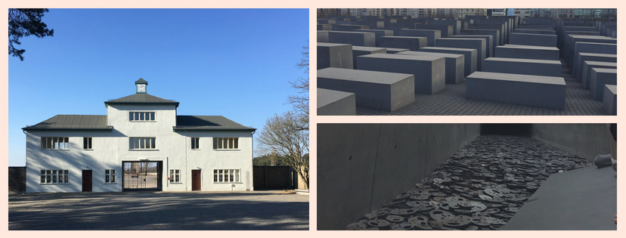
General Introduction
The following study guide shall aim to describe some of the most significant centres for worship in London which represent religious diversity namely BAPS Shri Swaminarayan Mandir, Baitul Futuh Mosque, and Bevis Marks Synagogue. The study guide shall describe general and practical information about each religious site as well as addressing the historical, cultural and religious significance of each.

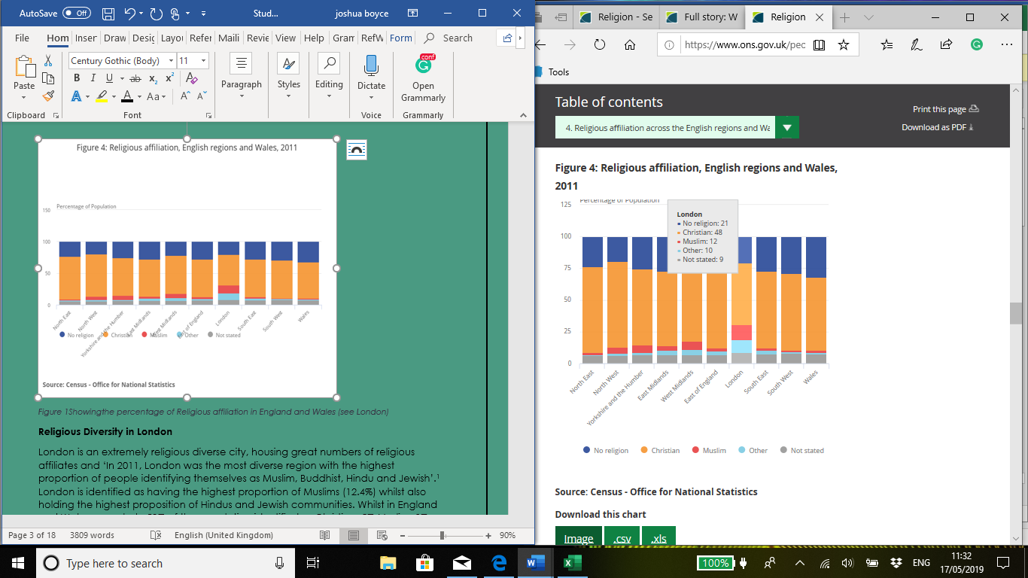
Figure 1: Showing the percentage of Religious affiliation in England and Wales (see London)
Religious Diversity in London
London is an extremely religious diverse city, housing great numbers of religious affiliates and ‘In 2011, London was the most diverse region with the highest proportion of people identifying themselves as Muslim, Buddhist, Hindu and Jewish’. London is identified as having the highest proportion of Muslims (12.4%) whilst also holding the highest proportion of Hindu and Jewish communities. Whilst in England and Wales as a whole 59% of the population identified as Christian, 5% Muslim, 2% Hindu and 1% Jewish.
This shows that the study of religion and the significance of religious places of worship particularly in England and Wales is still valid due to religious belief representing over 65% of the population. Particularly in London, there are many significant religious sites some of which are discussed in this study guide, offering a place of worship, devotion where London’s religiously diverse culture can grow.
Hinduism (BAPS Shri Swaminarayan Mandir, Neasden)
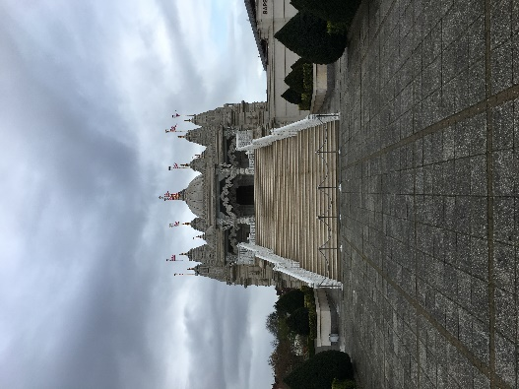
General Information:
The BAPS Shri Swaminarayan Mandir in Neasden is one of the most famous religious landmarks in London and is Europe’s first traditional Hindu temple. Opened in 1995, Neasden Temple as its popularly known was constructed according to ancient Vedic architectural texts using no structural steel instead using 5,000 tonnes of Bulgarian limestone and Italian Carrara marble, hand-carved in India and then shipped to London. The fifth spiritual successor of Bhagwan Swaminarayan was inspired to build a traditional Hindu Temple in London which was brought to fruition by the work of over 3,000 volunteers. The Hindu Temple is open to the public and includes an exhibition on the roots of Hinduism and the origins of BAPS.
Figure 2: a picture of the outside of the Mandir in Neasden.
Visitor information
- Dress Code: Respectable clothing to be worn and footwear to be removed upon entering the Mandir.
- Free Parking
- No Smoking, food, drink or chewing gum on the premises
- Video & Photography may be taken only of the exterior
- Exhibition price: £2.00 Adults. OAP & Children (6-16) £1.50.
- Disabled access throughout.
- The visit should take approx. 1.5 hours.
Practical Information
Visiting Times:
Entry to the Mandir (free admission) 9:00-18:00 daily
Viewing Sacred Deities 9:00-12:15 & 16:00-18:00 daily
Midday Arti Ritual Service 11:45 daily
Address:
105-119 Brentfield Road, Neasden, London, NW10 8LD
Public Transport:
Closest train stations: Wembley Park, Stonebridge Park and Neasden.
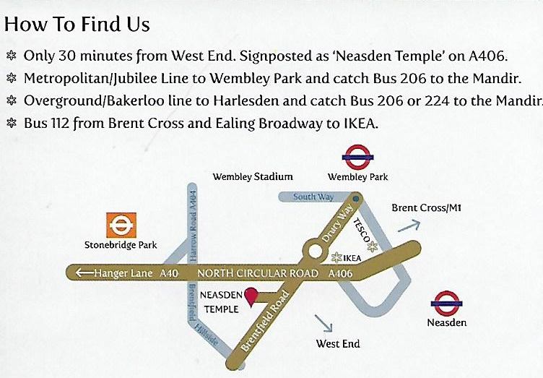

Figure 3: map showing the location of the Mandir.
BAPS & The Swaminarayan Movement
Bochasanwasi Shri Akshar Purushottam Swaminarayan Sanstha (BAPS) is a global socio-spiritual organisation established in 1907 CE by Brahmaswarup Shastriji Maharaj based on the Vedic teachings expounded by the founder of the Swaminarayan tradition, Bhagwan Swaminarayan (1781-1830 CE). It centres itself on social action aided by global volunteers numbering around 55,000 youths and over 950 sadhus. Bhagwan Swaminarayan is the founder of the tradition, a figure who the Mandir is dedicated to and regarded as a manifestation of God during his time on earth. The movement is focused on devotion (particularly to Swaminarayan) and is placed in the theological tradition of Ramanuja.
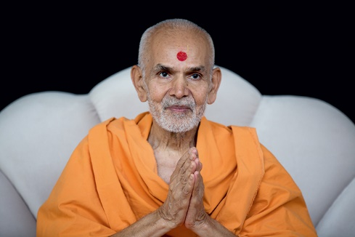
The Swaminarayan Hindu Mission is the British branch of BAPS which is the fastest-growing religious movement worldwide among Gujarati Hindus (the majority Hindu population in the UK) with over 370 temples boasting several hundred thousand followers. His Holiness Mahant Swami Maharaj (1933-present) is the sixth spiritual successor of Bhagwan Swaminarayan and as such the guru and spiritual leader of the BAPS movement. He leads a strictly austere life of celibacy, has no worldly wealth or possessions and continues to travel the world to inspire others to devote themselves.
Figure 4: His Holiness Mahant Swami Maharaj londonmandir.baps.org/about/his-holiness-mahant-swami-maharaj/
The Mandir
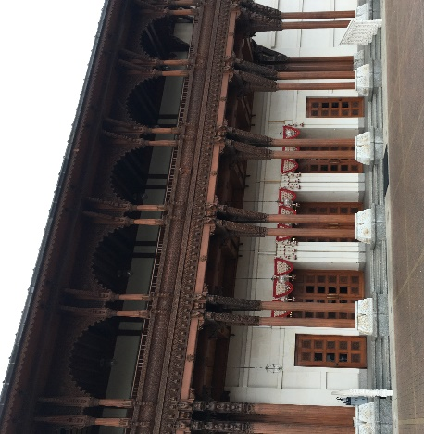
Initially, in countries outside of India, Hindu temples were converted from schools, homes or deconsecrated churches however as Hindu communities began to become wealthier, there was a growing interest in the construction of purpose-built temples. The temple is also an important tourist venue which offers a tour of the facilities on offer including a video showing the construction of the mandir and an exhibition on Hinduism.
The Haveli
The word Haveli derives from the Arabic meaning “partition” or “private space”. The traditional Haveli is situated alongside the Mandir with beautiful, intricate carvings using English Oak and Burmese Teak. The Haveli houses various facilities including a large prayer hall, library and shop among others.
The Abhishek Mandap
The Abhishek Mandap is a beautiful ritual chamber located opposite the exhibition which forms the base for a ritual puja performed daily. The Abhishek involves the ritual pouring of water and is used as a form of prayer and devotion commemorating Bhagwan Swaminarayan’s journey as a child travelling around India blessing the land and liberating individuals. One can witness this ritual puja, however, to guarantee this it would be best to check the timings before visiting.
Figure 5: a picture of the outside of the Haveli.
Understanding Hinduism Exhibition
For an additional fee of £2.00 per person, one can experience the understanding Hinduism exhibition providing an interactive experience for visitors. This is highly recommended as it gives a fascinating insight into the origin, beliefs and practices of Hinduism, the contribution of Hindu seers and the contribution of the Swaminarayan movement.
Historical, Cultural and Religious Significance
The BAPS Shri Swaminarayan Mandir in Neasden is an important place of religious worship in both the United Kingdom and particularly in London as a place which has historical, cultural and religious significance attached. It is hugely significant as the first traditional Hindu temple in Europe, a testament to London’s religiously diverse nature and overall acceptance of other religious traditions. It has allowed a purpose-built centre for worship and devotion for Hindu’s in London but also through the BAPS organisation and their social outlook has allowed it to be used educationally. The exhibition on Hinduism provides even the most casual of tourists an opportunity to learn about the origins, beliefs and practices of Hinduism whilst understanding the sect associated with the Mandir in more depth. Therefore culturally, it has allowed London in particular, to accept the traditional Gujarati population of Hindu’s and allowed the implementation of their religious practices outside of India. This has been a common issue regarding the nature of Hinduism following migration to other non-Hindu countries. It is notable, however, that Hinduism has been able to adapt the religion outside of India reinterpreting to suit western values, being resourceful and showing Hindu’s to be ‘…flexible people able to live, work, and create communities in many, quite different settings’.

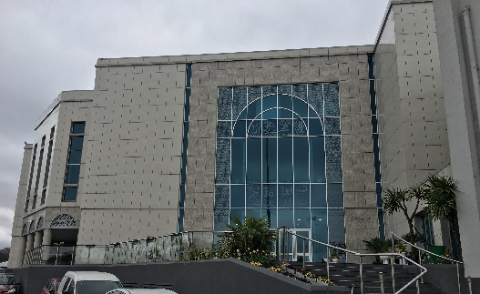
Baitul Futuh Mosque of the Ahmadiyya Community, Morden
General Information:
The Baitul Futuh Mosque in Morden opened in 2003 and is one of the largest Mosque’s in Western Europe (it can accommodate up to 10,000 people). The Mosque belongs to the community of the Ahmadiyya sect within Islam (a minority sect). The Baitul Futuh Mosque is built on the site of a disused dairy and when under construction was (and still is) a focus of Islamophobic protest and protest among other Muslims, particularly Sunni Muslims due to the historical and political unrest in Pakistan with regards to the Ahmadi Muslims. The funds to redevelop the site and to build the Mosque complex (approx. 13 million) were raised by the Ahmadiyya Muslim community.
Figure 6: a picture of the outside of the Mosque in Morden.
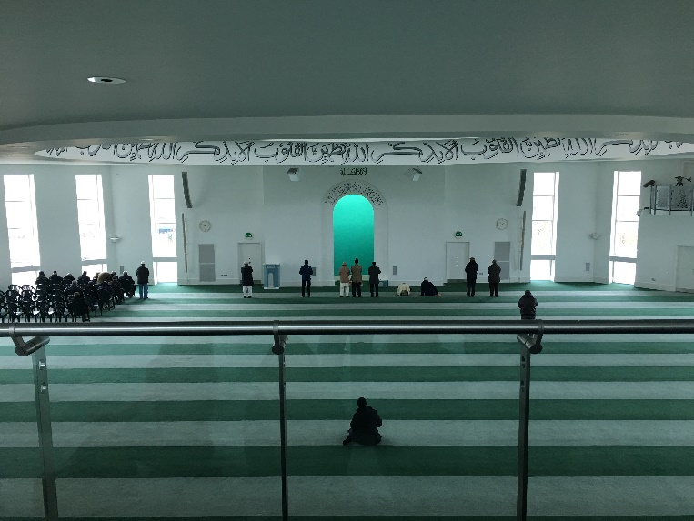
The Mosque is renowned for its state-of-the-art facilities including a gym, bookshop, library and soundproof playroom for children. The Mosque is centred on serving the local community for example twice a week they feed the homeless in London, hire out their facilities (their multi-purpose hall)to a local college for exams and welcomes approximately 4,000 school children a year.
Visitor information
- Visitors must be clean wearing modest clothing. Footwear to be removed upon entering.
Figure 7: A picture of the prayer hall in the Mosque
- Free Parking
- No Smoking, food, drink or chewing gum on the premises
- Video & Photography are permissible throughout.
- Disabled access throughout.
- Allow approx. 2 hours for the visit.
- It is advised to contact the Mosque prior to visiting to arrange a tour and the possibility of observing worship.
Practical Information
Address:
181 London Road, Morden, SM4 5HF
Public Transport: Closest train stations: Morden, Morden South.
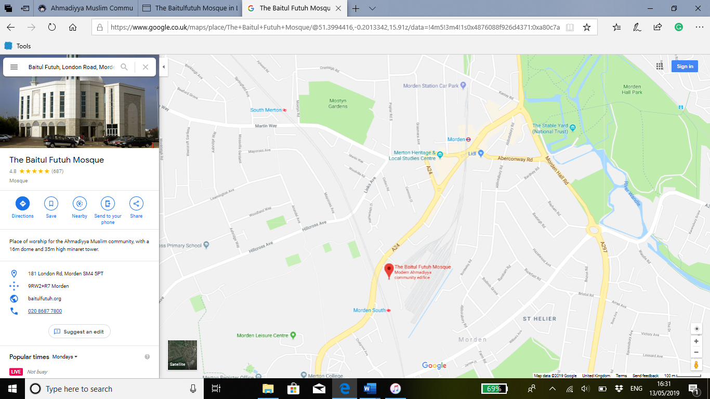
The Mosque also has global television capabilities due to the success of the movement and the Mosque’s status within the Ahmadiyya community where the current leader resides. Therefore, Muslim Television Ahmadiyya Internation is an important initiative for the community, providing 24-hour access in many different languages to the message of Islam promoted by the leader of the movement.
The Ahmadiyya Movement
The Ahmadiyya movement was founded by Mirza Ghulam Ahmad (1835-1908) in 1889 in Punjab and now boasting over four million members in over 193 countries. Having devoted himself to Islam in 1877 and set about modernising the religion, by 1891 he revealed himself to be promised Messiah for Muslims. He claimed to be a prophetic receiving divine revelation and a manifestation of some earlier prophets such as Jesus and Muhammad.
Figure 8: A Map of the area surrounding area in Morden
The Ahmadiyya movement divides the Islamic community and is a party to quite severe persecution in some countries such as Pakistan (laws against Ahmadiyya community), declared not to be Muslims by those who are concerned about the validity of the founder's claims and the status of Muhammad as the final prophet.
The Ahmadiyya community in Britain was firmly established in 1913 and with London’s first purpose-built Mosque in Putney being finished in 1924, the movement is one of the oldest and most established Muslim organisations in Britain.
The Ahmadiyya community emphasise Islam as being a religion of peace; rejecting all forms of terrorism and injustice stating that ‘our Jihad is not…swords, guns or bombs…Our Jihad is of tolerance, justice and human sympathy’.
Leadership
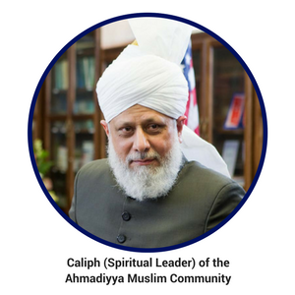
Following the passing of the founder Mirza Ghulam Ahmad, the Ahmadiyya community appointed a Khalifa (spiritual system of leadership) to be his successor and ensuring strong leadership for the movement. His Holiness Hazrat Mirza Masroor Ahmad is the current Khalifa of the Ahmadiyya Muslim community having been elected into office in 2003 as the fifth Khalifa of the community. He lives in London having been exiled from Pakistan and as such the Mosque provides the basis for the Ahmadiyya movement not only in Britain but also globally. His duties include meeting world leaders, promoting different initiatives (e.g. National Peace Symposium in 2004) and ensuring the success of the movement under his direction.
Figure 9:
The Ahmadiyya Muslim’s have established schools in many countries are concerned about social welfare. They have opened hospitals and medical clinics as well as setting up charities such as Humanity First in the UK to improve the quality of life for some of the poorest and most vulnerable in society.
Historical, Cultural and Religious Significance
The Baitul Futuh Mosque in London is an extremely important religious sight particularly for the Ahmadiyya Muslim community globally and in the United Kingdom. It symbolises a place of refuge for the leader Hazrat Mirza Masroor Ahmad and Ahmadi Muslims in general from the intolerance and persecution that they suffer both in the United Kingdom and around the world (e.g. Pakistan). London has shown itself to be a place where religious diversity is allowed to flourish and given what the Ahmadi community contributes to the local community, seems to have a good relationship overall with the community that it serves.
Religiously, for the Ahmadiyya Muslim community, the Mosque is of extreme importance due to the leader seeking refuge in London. As the largest Mosque in Europe and due to their television capabilities the Mosque often attracts high profile speakers like the leader of the community and therefore attracts many visitors who can have direct contact with the leader of their community or who may watch it on television.
Of course, being the largest Mosque in Europe, it has its own historical and cultural significance attached as a tourist hotspot, attracting thousands of visitors, school children and Muslims every year. There was clearly a need for Ahmadi community to expand its infrastructure in London having attempted to expand the London Mosque in the 1990s, only to have planning permission refused, however, with the building of the iconic Baitul Futuh Mosque complex, it has allowed for the growth of the movement in London.
For Morden and London more generally, the community aspect of the Ahmadi Muslim’s provides access to Islam, to learning more about the misconceptions surrounding the movement and Islam as a whole, educating those whom it comes into contact with through love. From feeding the homeless, hiring out its facilities and welcoming school visits this shows a real level of social responsibility from the movement to integrate into society and to contribute to its local community. The Ahmadiyya Muslim community will undoubtedly continue to suffer from persecution both in the UK and globally by extremists or by Muslims who do not regard the movement as legitimate. Although, its spirit of love for all and hatred for none and strong leadership particularly in the UK, will continue to sustain the movement and will surely see growth in the future.

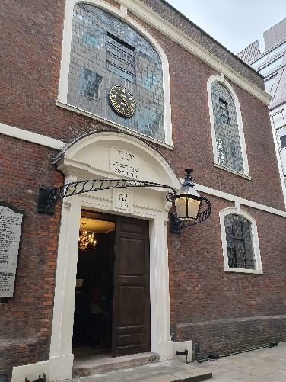
Judaism (Bevis Marks Synagogue
Figure10: The outside of the Synagogue (picture taken from author's private collection)
General Information:
Bevis Marks in London is the oldest surviving Synagogue in Britain and the only Synagogue in Europe to have held continuous services for over 300 years. Synagogue simply means ‘meeting room’ and is a place for Jews to come together to pray. Sephardic Jews are those who are descendants of those who escaped from the Spanish and Portuguese Inquisitions.
Visitor information
- Photography is not permitted inside the Synagogue.
- There are no visiting hours on the following: Jewish Sabbath, Jewish Festivals, Tisha B’Ab and Bank Holidays.
- Groups should contact the Synagogue before-hand.
- Tours are available Sunday 11:00 am, Wednesday 11:30 am and Friday 11:30 am.
- Men should cover their heads upon entering the Synagogue (kippahs are supplied).
Practical Information
Visiting Hours:
Monday, Wednesday, Thursday: 10:30-2: 00 pm
Tuesday, Friday: 10:30-1:00pm
Sunday 10:30-12:30pm

Service Times:
Shabbat Services | Weekday Services
Friday Night Service: 7:30 pm (followed by Kiddush) | Shahrit: Monday to Friday 7:15 am
Shabbat Morning Service: Zemirot
8:30am; Sepher 10:15am

Admission Fees:
Adults: £5.00
Senior Citizen: £4.00
Child £2.50
National Trust: £2.50

Address:
Bevis Marks Synagogue, Bevis Marks, EC3A 7LH
Public Transport:
Closest train stations: Aldgate (4 minutes’ walk) and Liverpool Street Station (7 minutes’ walk).
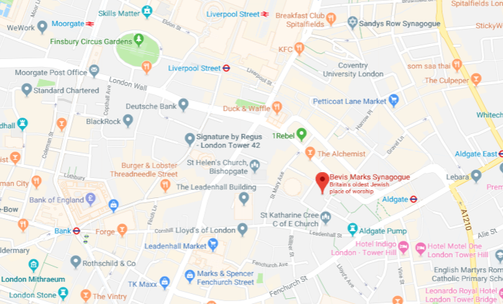
Figure 11:
Bevis Marks Synagogue
Following the resettlement of Jews in Britain around 1656 under the blessing of Oliver Cromwell, the Spanish and Portuguese Jews worshipped in a building in Creechurch Lane and added to in 1674. However, by 1694, the congregation outgrew the building and therefore an initiative to construct a new and larger Synagogue began.
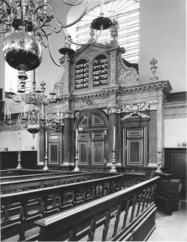
Bevis Marks Synagogue was built in 1701 by architect Joseph Avis to replace the Synagogue in Creechurch Lane. Joseph Avis was a church builder, commissioned by the Sephardi community to blend the building with other places of worship in the area. As such, the interior reflects the nature in parts of chapels built in the same period whilst much of the seating and other features precede Bevis Marks. The Synagogue itself is hidden away from the main road and can only be seen once one has entered through the courtyard due to a requirement when they sought planning permission, that the Synagogue should not be visible from the street.
Figure 12: Pictured, The Torah Ark in Bevis Marks
Interestingly, the synagogue has suffered damage over the year including during the World Wars and by the IRA and yet remained intact. The Synagogue belongs to the Sephardi Orthodox community and was the place of worship for the Spanish and Portuguese Jews. In fact, despite descendants of the original Spanish and Portuguese families being few, the services and traditions at Bevis Marks still take the form of a traditional Spanish and Portuguese service. Bevis Marks is the primary Synagogue of the Sephardi community however there are others such as the Wembley Sephardi Synagogue. Due to the lack of people living in the old part of the city where the Synagogue is based, the Synagogue enjoys relatively low numbers for its services (approx. 40 people on Shabbat).
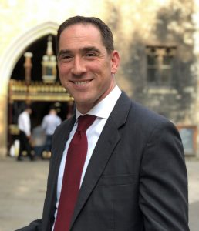
The current Rabbi for the Sephardi community in the UK and Bevis Marks is Senior Rabbi of the Sephardi community Joseph Dweck (2013-present). American born Dweck has served in places such as Brooklyn, New York and currently resides in London. As the Senior Rabbi, Dweck’s role is to sit on a number of boards for example as a President of The Council of Christians and Jews and to deliver many services, prayers and lectures on Judaism.
Figure 13: The Current Senior Rabbi

Historical, Cultural and Religious Significance
As the oldest surviving Synagogue in Britain, Bevis Marks is an extremely important place of Jewish heritage and worship both in the United Kingdom and for Jews (particular Sephardi) around the world. Its very construction signals the gradual acceptance of the Jews in the UK following the resettlement which took place under Oliver Cromwell in 1656 allowing for the growth of Sephardi Jews in London and as such the need for a larger facility. Having been the only Synagogue in Europe to have held continuous services and prayers for over 300 years only heightens its significance having survived through two world wars and various other events.
Despite the decline in congregation numbers due very much to the lack of Jews living in the area, the Synagogue continues to attract the Jewish community to prayers and services each year. Bevis Marks is also an important tourist attraction for the community in London holding regular group tours and opening the doors of the Synagogue to the public to witness the history held inside. This shows the community outlook of the Synagogue, still seeking to educate those about the Synagogue in London, the Spanish and Portuguese Jewish community in London and about Judaism in general.
Although it may not be such an important religious building for Ashkenazi for example (descending from the Middle East), and despite the community of Sephardic Jews being a minority (particularly in London), the site continues to attract many visitors each year and continues to hold prayers and services in the tradition of their ancestors. With its work on tourism alongside this, it is likely that the Bevis Marks Synagogue will be an important tourist venue and place of Worship in London.

Conclusion
During this study guide, all three of these important religious sites in London have been outlined and analysed using practical and general tourist information whilst discussing the historical, cultural and religious significance of each.
Each of the sites are important in different ways for their respective religions and contribute to the community in which they live in some way, showing how these religious communities have attempted to assimilate into western society. The BAPS Shri Swaminarayan Mandir in Neasden is Europe’s first traditional Hindu temple, Baitul Futuh Mosque is one of the largest in Europe whilst Bevis Marks Synagogue is the oldest surviving Synagogue in Britain. Whilst for some of these sites (e.g. the Mosque), their significance may only be for tourists and the particular branch of religion they belong to, it is clear that these sites are religiously, historically and culturally important for the city of London, the United Kingdom and throughout the world.

Bibliography
Office for National Statistics, ‘Religion in England and Wales 2011’, https://www.ons.gov.uk/peoplepopulationandcommunity/culturalidentity/religion/articles/religioninenglandandwales2011/2012-12-11. [Accessed: 17 May 2019]
BAPS Shri Swaminarayan Mandir London, ‘Nilkanth Abhishek Mandap’ (leaflet). [Date Obtained: 04 April 2019]
Vivekjivandas. Sadhu, Hinduism: Festivals, Rituals and Symbols (Gujarat: Swaminarayan Aksharpith, 2016)

Knott. Kim, Hinduism: A Very Short Introduction (Oxford: Oxford University Press, 1998)
BAPS Shri Swaminarayan Mandir London, ‘Understanding Hinduism: Exhibition Guidebook’ [Date Obtained: 04 April 2019]

Rippin. Andrew, Muslims: their religious beliefs and practices (London: Routledge, 2012)
Ahmadiyya Muslim Community, ‘True Islam’(leaflet), [Date Obtained: 02 April 2019]
Kenneth. Rubens. Kenneth, ‘Bevis Marks Synagogue and the City Churches’, Jewish Historical Studies, Vol. 37, 2001. [Online] Available at www.jstor.org/stable/2978003. [Accessed: 17 May 2019]
Flood. Gavin, An Introduction to Hinduism (Cambridge: Cambridge University Press, 1996)
Bruce. Steve, Religion in Modern Britain (Oxford: Oxford University Press, 1995)
Solomon. Norman, Judaism: A Very Short Introduction (Oxford: Oxford University Press, 2014)
Abbas. Tahir, ed, Muslim Britain: communities under pressure (London: Zed Books Ltd, 2005)
Balzani, Marzia. "A TALE OF TWO AHMADIYYA MOSQUES: RELIGION, ETHNIC POLITICS, AND URBAN PLANNING IN LONDON: RUSSIAN REVIEW OF SOCIAL RESEARCH RUSSIAN REVIEW OF SOCIAL RESEARCH." Laboratorium 7.3 (2015): 49,71,217. [Accessed: 17 May 2019]
The Baitul Futuh Mosque, http://www.baitulfutuh.org/, [Accessed: 17 May 2019]
Ahmadiyya Muslim Community UK, http://www.loveforallhatredfornone.org/about-the-ahmadiyya-muslim-community/, [Accessed: 17 May 2019]
BAPS Shri Swaminarayan Mandir, http://londonmandir.baps.org/, [Accessed: 17 May 2019]
Jewish Communities and Records, ‘Bevis Marks Synagogue’, https://www.jewishgen.org/jcr-uk/London/city_bevis/index.htm, [Accessed: 17 May 2019]
The Sephardi Community, ‘Bevis Marks’, https://www.sephardi.org.uk/bevis-marks/, [Accessed: 17 May 2019]

Image References:
- Figure 1: Showing the percentage of Religious affiliation in England and Wales (see London). Office for National Statistics, https://www.ons.gov.uk/peoplepopulationandcommunity/culturalidentity/religion/articles/religioninenglandandwales2011/2012-12-11, [Accessed: 17 May 2019].
- Figure 2: a picture of the outside of the Mandir in Neasden (picture taken from the author’s private collection)
- Figure 3: a map showing the location of the Mandir. The map is taken from BAPS Shri Swaminarayan Mandir London, ‘A London Landmark: National Geographic’ (leaflet). [Date Obtained: 04 April 2019].
- Figure 4: His Holiness Mahant Swami Maharaj. Shri Swaminarayan Mandir London, http://londonmandir.baps.org/about/his-holiness-mahant-swami-maharaj/, [Accessed: 17 May 2019].
- Figure 5: a picture of the outside of the Haveli (picture taken from the author's private collection)
- Figure 6: a picture of the outside of the Mosque in Morden (picture taken from the author’s private collection).
- Figure 7: A picture of the prayer hall in the Mosque (picture taken from the author’s private collection.
- Figure 8: A Map of the area surrounding area in Morden. Google Maps, https://www.google.co.uk/maps/place/The+Baitul+Futuh+Mosque/@51.3994416,-0.2013342,15.91z/data=!4m5!3m4!1s0x4876088f926d4371:0xa80c7a9d2fd01cda!8m2!3d51.3970918!4d-0.199341, [Accessed: 17 May 2019].
- Figure 9: Picture of His Holiness Hazrat Mirza Masroor Ahmad. Ahmadiyya Muslim Community UK, http://www.loveforallhatredfornone.org/about-the-ahmadiyya-muslim-community/, [Accessed: 17 May 2019].
- Figure 10: The outside of the Synagogue (picture taken from author's private collection)
- Figure 11: A map showing the location of the Synagogue. Google Maps, https://www.google.com/maps/place/Bevis+Marks+Synagogue/@51.5142576,-0.0813168,16z/data=!4m12!1m6!3m5!1s0x4876034cd7f57247:0x82a9a7ff2f26e26!2sBevis+Marks+Synagogue!8m2!3d51.5142543!4d-0.0791335!3m4!1s0x4876034cd7f57247:0x82a9a7ff2f26e26!8m2!3d51.5142543!4d-0.0791335?hl=en-GB, [Accessed: 17 May 2019].
- Figure 12: Pictured, The Torah Ark in Bevis Marks. The Sephardi Community, https://www.sephardi.org.uk/bevis-marks/history-design/, [Accessed: 17 May 2019].
- Figure 13: The Current Senior Rabbi. The Sephardi Community, https://www.sephardi.org.uk/senior-rabbi/, [Accessed: 17 May 2019].

Office for National Statistics, ‘Religion in England and Wales 2011’, https://www.ons.gov.uk/peoplepopulationandcommunity/culturalidentity/religion/articles/religioninenglandandwales2011/2012-12-11. [Accessed: 17 May 2019].
BAPS Shri Swaminarayan Mandir London, ‘Nilkanth Abhishek Mandap’ (leaflet). [Date Obtained: 04 April 2019].
Sadhu Vivekjivandas, Hinduism: Festivals, Rituals and Symbols (Gujarat: Swaminarayan Aksharpith, 2016), p. 81.
Kim Knott, Hinduism: A Very Short Introduction (Oxford: Oxford University Press, 1998), p. 103.
BAPS Shri Swaminarayan Mandir London, ‘Understanding Hinduism: Exhibition Guidebook’ [Date Obtained: 04 April 2019], p. 62.
‘Understanding Hinduism: Exhibition Guidebook’, p. 60.
Kim Knott, 1998, p. 99.
For further information regarding the Ahmadiyya Movement see Andrew. Rippin, Muslims: their religious beliefs and practices (London: Routledge, 2012), pp. 304-5.
Ahmadiyya Muslim Community, ‘True Islam’(leaflet), [Date Obtained: 02 April 2019].
For more information see: Kenneth. Rubens, ‘Bevis Marks Synagogue and the City Churches’, Jewish Historical Studies, Vol. 37, 2001, p. 117. [Online] Available at: www.jstor.org/stable/2978003. [Accessed: 17 May 2019]

