Effective Team Work and Communication

Name: Sufola Akhter Rima
Student Number: 2029793
Tutor: Lloyd Beharry
Module: BMSW4002

Contents
1. Introduction 3
2. Models of Communication 4
2.1 Shannon and Weaver Model 4
2.2 Schramm’s Model 6
2.2 Berlo’s Model 7
3. Communication Skills 9
3.1 Verbal Communication 9
3.2 Non-Verbal Communication 9
3.3 Active and Empathetic Listening 10
4. Conclusion 11
References 12

Introduction

Communication is a process of conveying information between the respective parties through verbally or non-verbally to meet the social and working expectations by understanding the information (Maund, 2017). It is the most essential part to the human being to meet the social needs, as well as to run the business operations, as it is only communication through which the leaders and followers are connected to execute their roles and responsibilities, resulting in the achievement of ultimate goals. Efficient communication includes several procedures and policies while conveying the right news to the relevant parties, to make them understand the meaning and purpose of the communication. But the inefficient, i.e., poor communication results in negative impacts in all the sectors, especially in the workplace. Poor communication would be responsible for lower productivity, an uncontrollable working environment, ineffective collaboration, and stakeholders’ dissatisfaction. To avoid such negative effects and increase stability in the workplace, organisations should focus on good and effective communication.

Models of Communication
There are several conceptual models being used in the workplace to confirm effective communication process among the relevant parties effectively. Among these, three models of communication are being discussed here by mentioning their important points and suggestions.

Shannon and Weaver Model
This communication model is proposed considering the technological part of communication that focuses on linear communication to ensure effective communication through a suitable channel by encoding and decoding processes (Businesstopia, 2021). This model discusses communication by dividing the elements into six parts, where every part plays a significant role in delivering and receiving the desired messages securely. This model is highly effective in interpersonal communication as it focuses on the single communication process with effective feedback. This model includes the noise that defines the disturbances in the channel while the message is being sent to the receiver. Right detection of noises that could hamper the communication process could help the sender and receiver ensure an effective and successful communication where both parties are satisfied. Moreover, as this is a two-way communication that includes feedback makes the communication more viable applicable to perform both personal and professional communication.
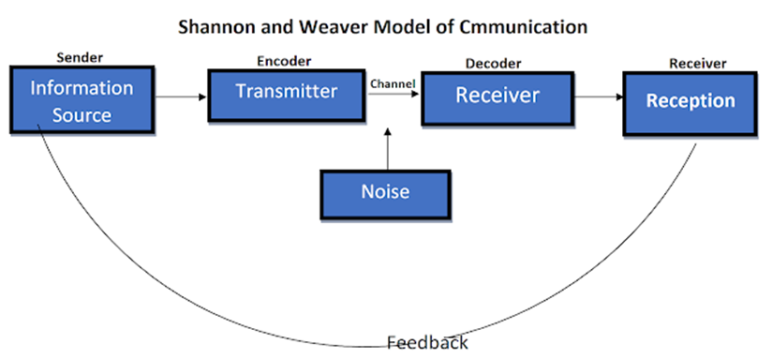
Figure 1: S and W’s model of Communication; (Mishra, 2017).

This model proposed that the noises could destroy the effective level of communication, and the probable noises should be identified first to make the communication uninterrupted. However, this communication cannot be found effective in group or mass communication (Mishra, 2017). The feedback is less significant to the feedback sender than the source or sender of the messages, it is a linear communication process that cannot be used in handling complex situations.
In the case study of Maria and Pedro, there is a noise of the medium or channel that makes Pedro misunderstand the main topic of the communication held, resulting in miscommunication. The noise disbursed the message from the sender, Maria, resulting in the receiver, Pedro, getting another name ‘Kitchen’ instead of ‘Chicken’. Hence, according to the Shannon and Weaver model of communication, the noise is responsible here that makes the receiver Pedro misunderstand the core thing of the message, resulting in ineffective communication. The S/W model discusses the noises among its six factors of communication, that makes the receiver misunderstand the delivered message (Mishra, 2017). The noise takes place between the encoder and decoder which are responsible for transferring the message working as a transmitter, and inherent within the channel. In the case of Maria and Pedro, the core message was delivered or misunderstood by Pedro for the noise held in the transmitting process. Mainly, the noise was generated by the phone call which made Pedro misunderstand the main thing. The distortion held by the noise is mainly the physical noise that might hamper the motive and objective of the communication significantly.
This confusion, held by the noise, can be prevented by taking feedback from the receiver that is the receiver confirms the sender that he/she gets this message from their conversation and the sender can then be sure that he has delivered the message to the concerned receiver successfully. If Pedro provides feedback to Maria by saying that she is being asked him to meet her in the kitchen; then Maria can send Pedro another message that she was asking Pedro not to meet her at the kitchen, instead of getting a Chicken. So, by being aware of the noises that could be held and taking confirmation from the receiver that the receiver properly misunderstood the message, the confusion can be prevented. Here, in this case, Pedro can also prevent his confusion by confirming the message to Maria, that is feedback. There are lots of examples that happen in real business and non-business operations- like getting a portion of the whole message that makes the receiver confused about the messages or instructions. So, this S/W model includes the noises that should be identified and prevented to ensure uninterrupted and clear transformation of messages.

2.2 Schramm’s Model

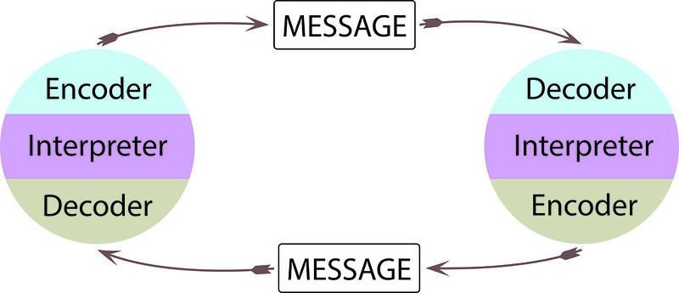
Figure 2: Schramm's communication model; (Schramm’s Model, 2021).

This communication model proposed that to make communication effective, there must be an encoding and decoding system while transferring the message between sender and receiver. This model argued that the communication must be ineffective until the sender receives any feedback from the intended receivers, regardless of verbally or non-verbally (Elleström, 2018). This model assumes that communication is a two-sided model whereas the S/W model includes the linear model of communication. The two-sided model enables the receiver to get the exact message as the communication can be said effective only when the receiver sends feedback to the senders of the message. The sender can easily get confirmed that the receiver receives the intended news or message, and the likelihood of miscommunication can be prevented. In the S/W model, the noise is focused on the basic elements and, this model focuses on the feedback that is the communication can be effective only when the receiver sends the message or feedback to the sender. However, this model also includes the basic parts of the communication, including sender, receiver, and messages, along with the focused part -feedback, in the cycling process.

This model also includes the noise which can be easily minimised or eliminated by the focused part -feedback that helps in confirming both parties that the intended message is delivered and received (Schramm's Model, 2021). In the above-mentioned case study of Maria and Pedro, the misunderstanding between Pedro and Maria is because the noise happened over the telephone. The effective feedback from Pedro can eliminate this misunderstanding- Pedro could call her back again to confirm what he heard was right or not. Then Maria could clarify her intention again resulting in effective communication.
There are several real-life examples like in my friend’s company, the boss asked them, including my friend, to perform an unspecified task- “You people must call me at exactly 10:00”. They heard their boss except for the time which is the most important one in this communication. Then, they were confused about the time resulting in ineffective communication.” But they could send feedback to their boss to ask them the time again that could reduce their confusion and make the communication more effective. So, the interruption or noise can be reduced or eliminated by the effective feedback that makes the communication effective and successful with both parties’ understanding.

Berlo’s Model
- 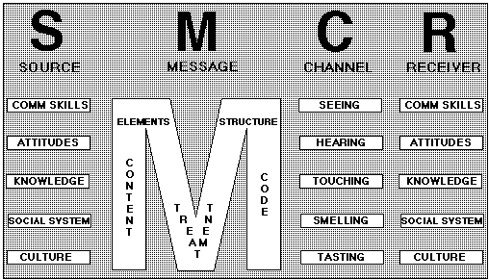
- Figure 3: Berlo’s Communication Model; (Berlo’s Model, 2021)

- This communication model describes several influential factors that might affect communication significantly. This model also includes the basic parts of commination along with the influential factors of source and destination. This model states that the senders’ capabilities- skills, attitude, culture, knowledge, etc., to deliver the message in the understanding means, and receivers’ capabilities to understand or decode the intended message have significantly affected the level of communication’s effectiveness (Businesstopia, 2021). The message’s contents, structure, intends, etc. are also crucial factors that define the message towards the receiver. The main objectives of the communication might be hampered by these considerable factors. This model is somehow straightforward and is used in several communication standards. This communication model has some limitations including- it does not consider the noise that is highly considered in delivering and receiving the message properly, and it is a one-way process as there is no feedback system which is available here (Elleström, 2018). However, this model focuses on the factors affecting the communication process and the understanding level.

In the case study of the Professor and Village people, there is a misunderstanding between the speakers and village people because of knowledge and cultural differences among them. When the professor is trying to communicate with them, the villagers do not understand his high-level language resulting in inefficient communication. The sender needs to ensure that the message is understandable to the receivers; otherwise, the communication cannot be effective (Locker, 2013). And even, they cannot provide feedback to the Professor as they do not even understand the message and there is a cultural difference between the receivers and senders. In Maria and Pedro’s case study, they fail to send and receive feedback resulting in ineffective communication. Only feedback can make the message more sophisticated by confirming the sender, Maria, that the receiver, Pedro, has got the intended message. In the Eggs case study, there is also a cultural difference between the parties of the communication- that is described in Berlo’s model of communication as an influential factor in as a part of sender’s integral part of communication skill. ER is shown unable to understand the message’s meaning as she has different cultural practices. This misunderstanding is also described by Berlo’s model as the interpersonal traits of the sender and receiver play a considerable role here.

Communication Skills
Communication skills refer to the interpersonal skills that enable the parties of communication to understand the senders of messages and deliver understandable messages through an effective channel (Cenere, 2015). This skill is the crucial part to make the communication more effective as the higher the communication skills then the higher the understanding, decoding, level of the encoded messages. This skill is being ranked higher as the most required skill in daily business and non-business life. There are several communication skills which are required, which can be categorised into different headings-

Verbal Communication
Verbal communication skill includes the usage of language while communicating in the spoken and written form of communication. This skill is highly efficient in building a relationship based on mutual trust between the senders and receivers of the communication (McDuffie. 2021). Verbal communication is the first and foremost part of effective communication as almost all instructions in the everyday life in both business and non-business works are provided in the verbal form- speaking and writing. The verbal skills help the receiver understand the sender’s intended message effectively, considering several influential factors. Hence, verbal communication is the most used form of communication, especially in the business organisation, without which no collaborative works can be performed.

Non-Verbal Communication
This communication includes the signals that help in performing communication or helping verbal communication through the non-verbal platform. Non-verbal communication is performed without using words that affect verbal communication significantly (Gozalova, 2016). It helps in emphasising the words used in verbal communication. The parties of communication are influenced by the physical movements or expressions while speaking or expressing their language. Facial expression, relevant gestures are the most used non-verbal communication skills that help the senders to make the message more understandable within the visual distances, even in crowded places. Changing the tone of voice is also used as a widely used non-verbal form of communication. Non-verbal communication skill helps in supporting the message and conveying the feelings regarding the messages.

Active and Empathetic Listening
Active listening refers to the practice of listening by engaging with the partner in the pattern of listening (Simon, 2018). Listening is also a considerable skill that has a significant impact on understanding the senders of the messages. Listening is important to understand, learn, enjoy, and obtain relative information from a suitable source. In the business situation, the subordinates should have the active listening skill to understand the leaders clearly regarding their job-related instruction. Empathetic listening refers to the dynamic activity that helps the communicators be more attentive and responsive (Parks, 2015). This communication includes the feeling from the receivers’ response that arises from the active and listening. When one of the partners says bad news, another partner should be empathetic in hearing the first one by considering his position, and vice-versa. Both communication skills help in building better skills and understanding resulting in better working experience and competitive advantage.

Conclusion
This report has discussed communication along with its different models that are used to ensure effective communication. Different models consider different natural forms of communication intending to a different perspective that works for better communication. Noise is the part that takes place while transferring messages among and it can be handled by ensuring feedback. Some case studies and real-life examples have been addressed by the different models. The communication skills have also been discussed under the different headings that are crucial for understanding and making the messages understandable to the users. The communicators should focus on the different influential factors and the communication skills that will make the communication more viable and understandable to the users.

References
Businesstopia. 2021. Berlo's SMCR Model of Communication - Businesstopia. [online] Available at: <https://www.businesstopia.net/communication/berlo-model-communication> [Accessed 20 December 2021].
Businesstopia. 2021. Shannon and Weaver Model Of Communication - Businesstopia. [online] Available at: <https://www.businesstopia.net/communication/shannon-and-weaver-model-communication> [Accessed 20 December 2021].
Cenere, P., Gill, R., Lawson, C. and Lewis, M., 2015. Communication Skills for Business Professionals 7. Cambridge University Press.
Elleström, L., 2018. A medium-centered model of communication. Semiotica, 2018(224), pp.269-293.
Gozalova, M.R., Gazilov, M.G., Kobeleva, O.V., Seredina, M.I. and Loseva, E.S., 2016. Non-verbal communication in the modern world. Mediterranean Journal of Social Sciences, 7(4), pp.553-553.
Locker, K.O. and Kienzler, D.S., 2013. Business and administrative communication. McGraw-Hill; Irwin.
Managementstudyguide.com. 2021. Berlo's Model of Communication. [online] Available at: <https://www.managementstudyguide.com/berlo-model-of-communication.htm> [Accessed 20 December 2021].
Managementstudyguide.com. 2021. Schramm's Model of Communication. [online] Available at: <https://www.managementstudyguide.com/schramm-model-of-communication.htm> [Accessed 20 December 2021].
Maund, A., Schriek, M. and Tinkler, P., 2017. Certificate in Higher Education: Skills for the Workplace Student Yearbook.
McDuffie, A., 2021. Verbal Communication. Encyclopedia of Autism Spectrum Disorders, pp.5029-5029.
Mishra, S., 2017. Shannon and Weaver model of communication.
Parks, E.S., 2015. Listening with empathy in organizational communication. Organization Development Journal, 33(3), p.9.
Simon, C., 2018. The functions of active listening responses. Behavioural processes, 157, pp.47-53.

