Initial Exercises for Functions 2

1a Write a function that will receive a mark from the main program and make a comment on it (eg Above 70 –Excellent… Above 40 Pass … Below 40 Fail) Call your function markcomment

1b. Ask the user to enter a mark in the main program. Call the markcomment function and pass this mark to it to get a comment.

Sample output:

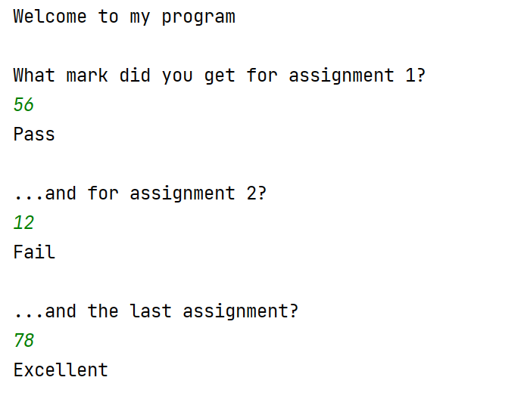

1c Extend your main program to ask for three marks. Call the markcomment function each time

Sample output:

2a. In my shop, I am having a sale today, with 15 per cent off everything.

Write a function (called calculatediscount) that will receive a float value, and calculate the sale price.

Then, ask the user for two prices the main program and each time, pass the values through to the function.

Sample output:

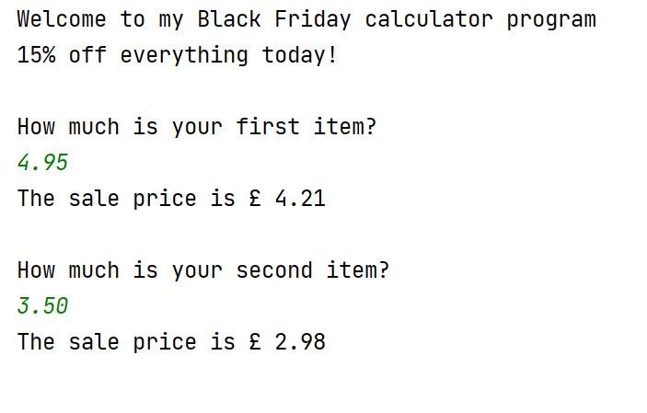

2b In 2a, we allowed the user to check the price of 2 sale items. Re-write the main program so that they can check as many items as they want (hint: use a while loop in the main program)

Sample output:



