January 2022

Professional Portfolio

Table of contents

Reflective Commentary……………………………………………………………………………3
References……………………………………………………………………………………….7
Portfolio of Evidence……………………………………………………………………………….9
Evidence 1: Background Information………………………………………………………..10
Section A: Mission Statement……………………………………………………………..10
Section B: HDYO’s Values…………………………………………………………………11
Section C: Mid Year Report 2021…………………………………………………………12
Evidence 2: Reflective Logs………………………………………………………………….13
Evidence 3: Volunteering Process…………………………………………………………...15
Section A: Ambassador profile and meeting mintues…………………………………..15
Section B: Involvement off placement…………………………………………………….17
Section C: Letter invitation for congress committee…………………………………….18
References…………………………………………………………………………………..19
Appendices…………………………………………………………………………………..20

Reflective Commentary

A requirement of the counselling skills and approaches module this semester was to secure a placement opportunity. This would enable myself to demonstrate and develop my counselling skills (Midwinter & Dickson, 2015), and critically reflect on my experience within the organisation, providing me with the opportunity to identify ways in which I can improve on future practice within a therapeutic environment (Tarrant, 2014). I felt strongly about volunteering for an organisation I had a personal connection with. Thus, I decided to carry out my placement experience with the Huntington’s Disease Youth Organisation (HDYO, 2021), where I had already been volunteering with for a number of months as an ambassador.

HDYO aim to improve the lives of young people impacted by Huntington’s Disease around the world (HDYO, 2021). Due to my personal connection surrounding Huntington’s Disease, I really felt the impact and how much the support is needed for young people and their families. However, due to my personal relationship with this condition, one could argue, this may affect my emotional well-being and I would not benefit from developing my counselling skills. HDYO (2021) & HDA (2021) highlight how being impacted by HD can seriously affect individuals in how they feel emotionally. Nevertheless, although I have this connection, I admire what HDYO do and I strived do anything I could to get involved and support others, which has also helped me.

As an ambassador, myself and other young people from the HD community around the world, come together with a shared goal of raising awareness around HD (HDYO, 2021). Furthermore, we share our experiences and ideas in what we can do to connect the HD community and raise awareness for the disease. This enables me to have the opportunity to develop my active listening skills, an essential skill within counselling and psychotherapy (Nelson-Jones, 2011). Thus, this will encourage other ambassadors to share their experiences and give ideas as they will feel heard and understood (Kabir, 2017), by individuals who are going through some of the same experiences. However, being affected by HD can bring out a range of negative emotions such as, fear, anxiety, anger and sadness (Zarotti, 2020). Therefore, one could argue, by actively listening to others and their experiences surrounding HD, this could elicit these negative thoughts and feelings. However, Graham et al (2008), highlight the importance of allowing oneself to sit and feel negative emotions, rather than avoiding them. Therefore, this suggests, having this experience and opportunity to be an ambassador for HDYO, is allowing me to feel these emotions, helping myself through helping others. Nevertheless, it is very rewarding to be part of a group who all want to support the HD community and raise awareness for the condition.

HDYO provide resources and support for all young people impacted by HD and peer to peer support groups proved to be extremely beneficial for individuals who may be struggling or just wanted to connect with the HD community (HDYO, 2021). I personally felt that having the opportunity to be involved and to support other individuals would be extremely fulfilling. However, I knew how tough it was for myself to come to terms with being impacted by HD, it could actually be argued, I have not fully come to terms with it. As a result, I did not want this to affect the way I would support individuals within the support group.

Due to my personal connection with HD, one could argue, I am able to be my authentic self, have an understanding of the conditionand be completely non-judgmental towards others. Carl Rogers (1957), emphasised how these three characteristics, known as the ‘core conditions’, are essential in sufficient growth occurring for the client. Furthermore, Rogers asserted that the therapeutic relationship between the therapist and client is of primary significance (Gillon, 2007), and if a there is a strong therapeutic relationship, these core conditions can be conveyed. Therefore, if I am able to obtain a respectable relationship with the individuals within the support group, I can convey these core conditions, demonstrating not only my counselling skills, but my good listening skills which will be vital for these individuals. However, I found that during the meetings, I was very conscious of actively listening to others within the group. I was suppressing my own thoughts and feelings and thus, not expressing my authentic self towards others within the group. An example of this, was when individuals within the support group would question me on my experience surrounding HD and I would not be completely open and honest. This need to conceal parts of myself is synonymous to the hidden self-area within the Johari window as I was aware I was concealing certain aspects of my behaviour but chose not to reveal them to others within the group (West & Turner, 2011). Therefore, one could argue that I have not fully come to terms with being impacted by HD and thus, not comfortable with talking about my own experience. Nevertheless, as a young person affected by this genetic condition, I have felt overwhelmed on several occasions and this has directly influenced my emotional wellbeing, struggling to open up to anyone about how I really feel. it is suggested that being part of a support group can strengthen mental wellbeing (Plumridge et al, 2012), and it will allow oneself to feel comfortable being around others who are impacted by the same condition.

Although at first, I found it challenging to open up about how being almost shaped by this condition made me feel, being surrounded by such a warm community, who really want to support others and raise awareness around this condition has really empowered me to become more involved, talk about my experience and do all I can in supporting the HD community. I have realised that being affected by HD is a ________ ________ to come to terms with (HDYO, 2021), and it has made me understand that I may never fully accept it and that is okay. However, having this experience in having my placement through HDYO, becoming an ambassador, being part of these support groups has encouraged me to move forward and do all I can to support the HD community, alongside supporting myself.

References
Gillon, E., (2007), Person cenred psychology: An introduction. London: Sage Publishers.
Graham, M. S. & Huang, Y. J. & Helgeson, V. S. (2008), The positives of negative emotions: Willingness to express negative emotions promotes relationships. Personality and Social Psychology Bulletin. 34(3), 394-406. Doi:10.1177/0146167207311281

Huntington’s Disease Association. (2021), Getting Emotional Support. HDA. Available at: https://www.hda.org.uk/getting-help/if-you-have-juvenile-huntingtons/getting-emotional-support

Huntington’s Disease Youth Organisation (2021), About us. HDYO. Available at: https://en.hdyo.org/a/28-about-hdyo

Huntington’s Disease Youth Organisation (2021), Emotional Wellbeing. HDYO. Available at: https://en.hdyo.org/a/208-emotional-wellbeing

Huntington’s Disease Youth Organisation. (2021), Get support & Resources. HDYO. Available at: https://en.hdyo.org/t/1-support

Huntington’s Disease Youth Organisation (2021), HDYO Ambassadors. HDYO. Available at: https://en.hdyo.org/a/682-hdyo-ambassadors

Huntington’s Disease Youth Organisation. (2021), HDYO Website, Available at: https://en.hdyo.org/

Huntington’s Disease Youth Organisation. (2021), Living in a family with HD. HDYO. Available at: https://en.hdyo.org/a/62-living-in-a-family-with-hd

Kabir, S. S. M. (2017), Communication Skills. In: Essentials of Counselling. 95-116. https://www.researchgate.net/profile/Syed-Muhammad-Kabir/publication/325844168_COMMUNICATION_SKILLS/links/5b3112840f7e9b0df5c7f217/COMMUNICATION-SKILLS.pdf?origin=publication_detail

Midwinter, R. & Dickson, J. (2015), Embedded counselling and communication skills: A relational skills model. Routledge & Taylor & Francis Group.

Nelson-Jones, R. (2011), Basic Counselling Skills: A Helper’s Manual. London: Sage Publications.

Plumbridge, G & Metcalfe, A. & Coad, J. & Gill, P. (2012), The role of support groups in facilitating. Families in coping with a genetic condition and in discussion of genetic risk information. Health Expectations. 15(3), 255-266. https://onlinelibrary.wiley.com/toc/13697625/2012/15/3

Rogers, C. (1957), The necessary and sufficient conditions of therapeutic personality change. Journal of Consulting Psychology. 21(2), 95-103. Doi:10.1037/h0045357

Tarrant, P. (2013), Reflective Practice and Professional Development. London: Sage Publications.

West, R. & Turner, L. H. (2010), Understanding interpersonal communication: Making choices in changing times (2nd Ed.), United Kingdom: Wadsworth Cenage Learning.
Zarotti, N. & Dale, M. & Eccles, F. & Simpson, J. (2020), Psychological Interventions for People with Huntington’s Disease: A Call to Arms. Journal of Huntington’s Disease. 9(3), 231-243. Doi:10.3233/JHD-200418

Portfolio of Evidence

Evidence 1: Background informaiton
Section A
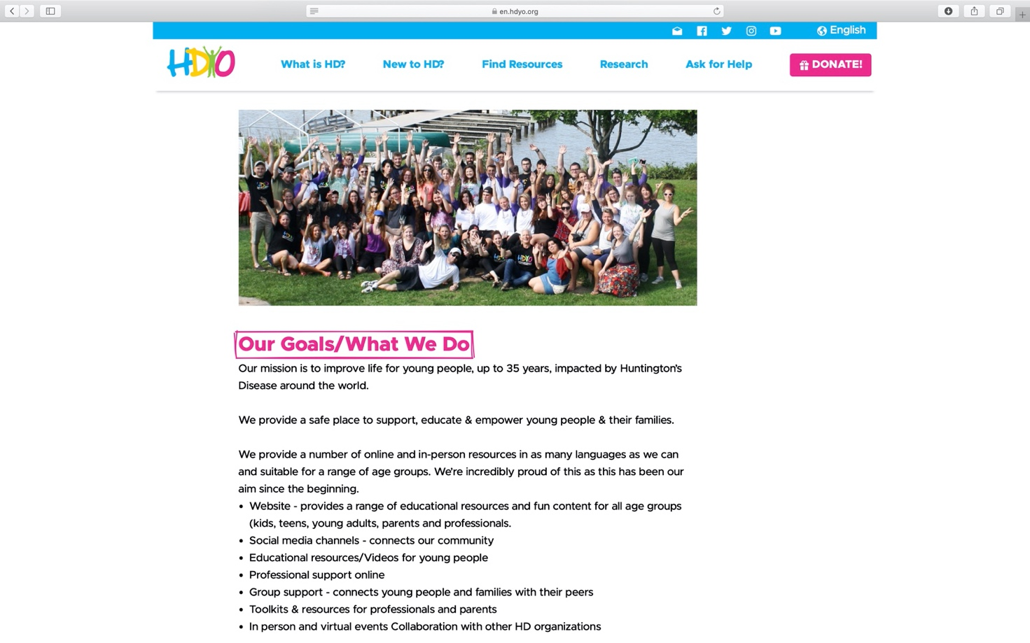

HDYO place emphasis on ‘support’ ‘educate’ and ‘empower’ and the need for these in order to improve the lives of young people impacted by HD all over the world.
HDYO’s mission highlights the importance of improving life for young people impacted by Huntington’s Disease around the world

Section B
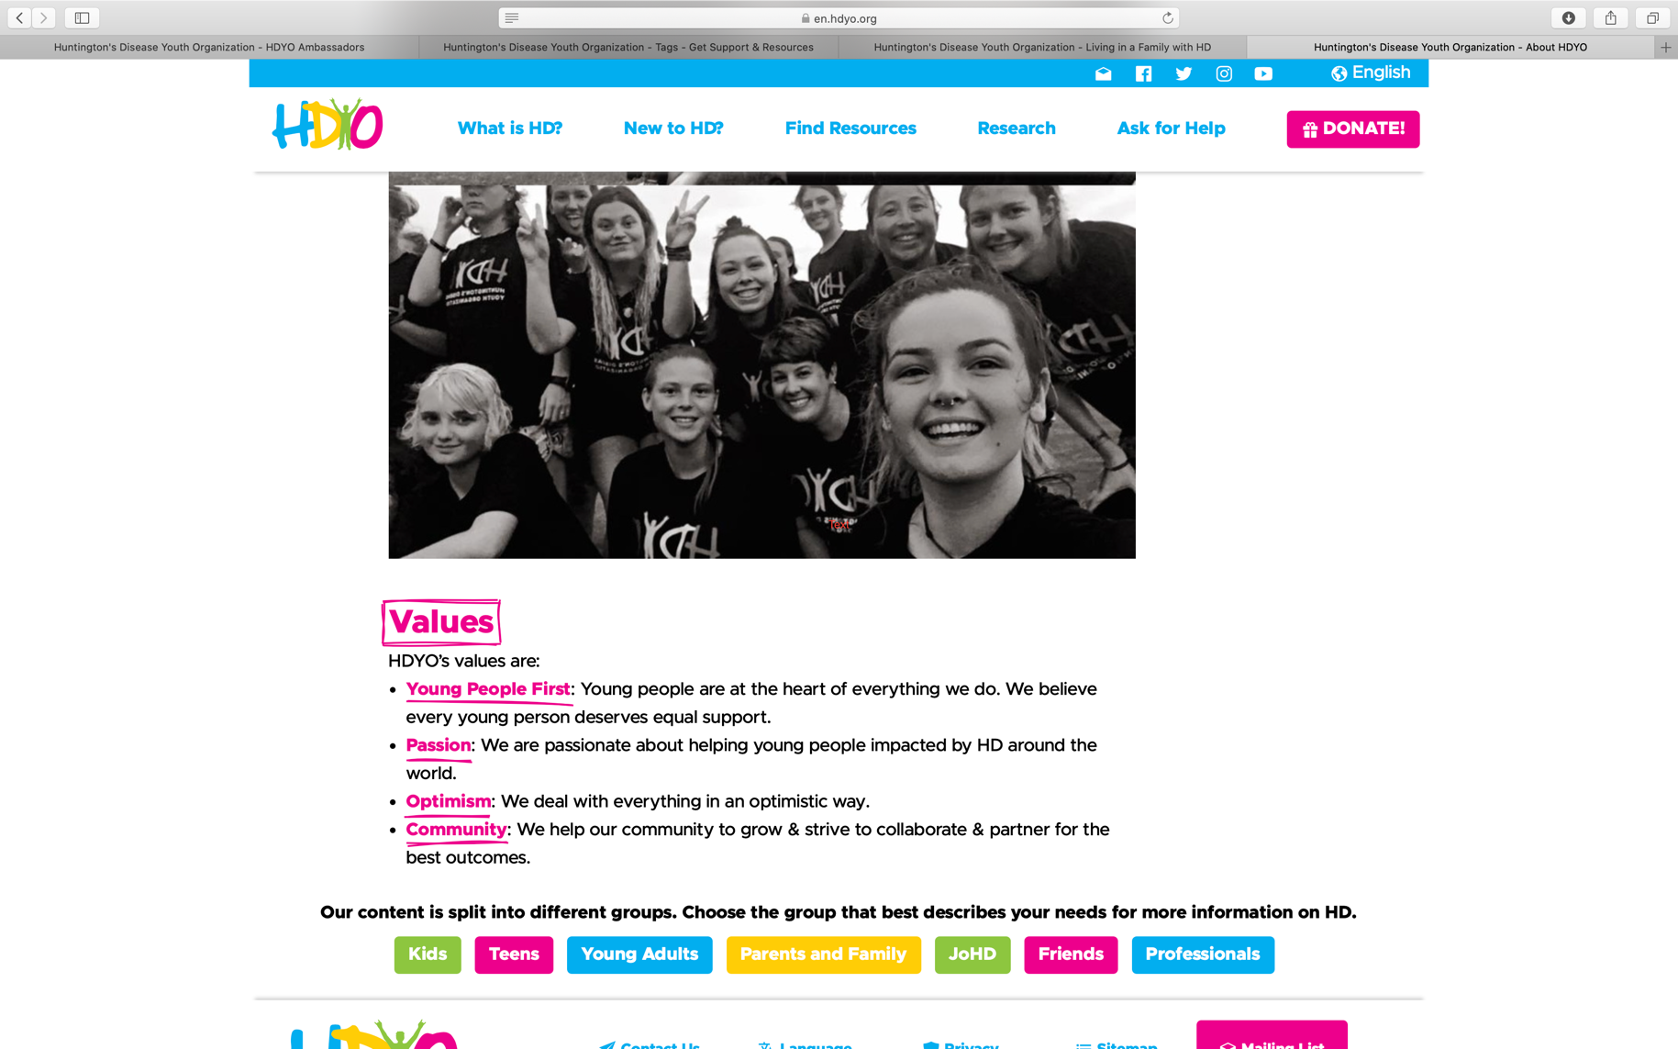
Section B

HDYO’s values underpin the reality of what HDYO is actually all about. Not only do they put young people at the forefront of everything, the passion and drive they have to support the community is remarkable (HDYO,2021).
These values can also be viewed as important within the counselling process (Egan, 1975). HDYO highlight underlying counselling skills in many roles, always putting young people first, being passionate and dealing with things in an optimistic way in supporting the HD community,

`Section C
Below is the front page of HDYO’s mid year report 2021. For the full report see: https://en.hdyo.org/downloads/hdyo-2021-mid-year-report.pdf
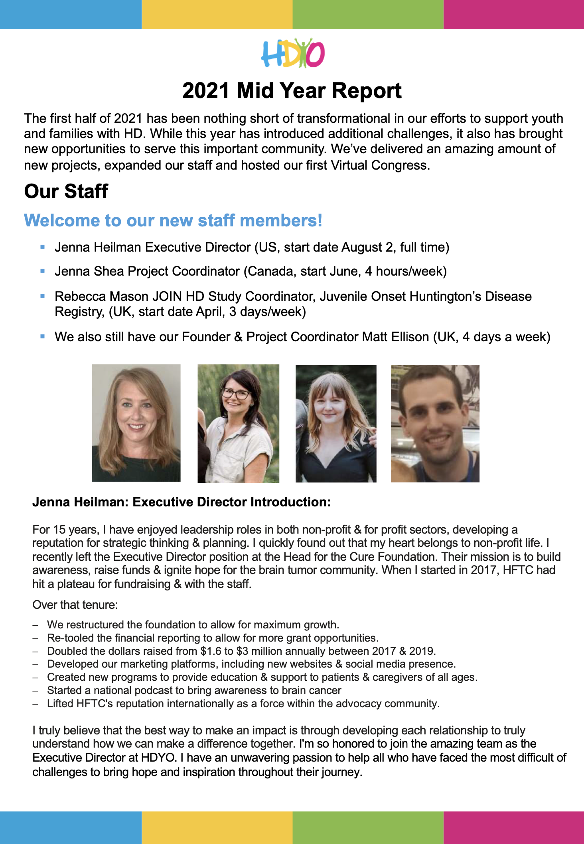
HDYO’s mid-year report 2021 provides those in the HD community with an update from the first half od 2021. The staff changes and also updates from the first virtual congress from March 2021

Evidence 2: Reflective Logs

Below you will find selection of entries from my ongoing reflective logbook during my experience with the Huntington’s Disease Youth Organisation (HDYO). These logs detail certain tasks I undertook, meetings I attended and considered my thoughts and feelings throughout.

Example Log Book
Student Name: | Carly Evans
Name of Host Employer: | HDYO - Huntington’s Youth Organisation

Record of project work carried out (add more entries as needed)
Date: | 08-01-2022
Tasks completed: | Monthly Ambassadors Meeting
Reflection: | Being affected by HD has always made me experience a variety of negative emotions. However, becoming an ambassador for HDYO is something I feel extremely privileged and proud to be involved in. Furthermore, this experience has really supported me in feeling empowered to educate others and raise awareness for HD. Our first meeting of 2022 went very well, with exciting news about this years virtual congress in March 2022 finding out we have some incredible guest speakers. We also discussed HDYO’s 10th birthday this year, providing ideas on what we can do to celebrate. A number of us had some creative and exciting ideas which can be built on over the next few meetings.

Date: | 22nd November 2021
Tasks completed: | Annual Congress Committee Meeting
Reflection: | Due to the on going COVID-10 pandemic, HDYO’s annual congress which usually takes place in Glasgow, Scotland has had to be delivered virtually. HDYO’s annual congress is an opportunity for the HD community to come together with insightful talks, research updates. Peer support and more. I was extremely grateful to be asked by Matt, the founder of HDYO to be a part of the committee to gather ideas for the virtual congress in March 2022. The other members of the committee did this for last years event so they already knew what was expected and what they wanted to do differently for 2022 and this made me take a little step back in the first meeting. However, I was made to feel really comfortable and was asked on my views of certain ideas and if there was anything specific I felt important to input which made me feel more at ease for the next update meeting.

Date: | 25th October 2021
Tasks completed: | Peer Support Meeting
Reflection: | I have always been quite reluctant to attend any support groups in the past regarding HD or any other experiences. However, having the opportunity to run these meetings really opened my eyes to how impactful it is for young people to communicate with others in the community. I did feel I was suppressing myself in the first few sessions however, I felt a lot more comfortable as everyone got to know one another that everyone is going through similar experiences. Therefore, this made me feel more comfortable in opening up and not concealing myself as much.

Evidence 3: Volunteering Process
Section A
Captured below is my profile for HDYO ambassadors and some minutes which were colleczted during our recent meeting at the beginning of January 2022
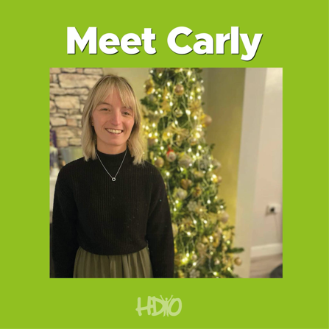

(HDYO, 2021)

To: HDYO Ambassadors
Date: January 10, 2022
Re: January Meeting Notes

Announcements and Welcome
- First meeting of the year 2022!
- Welcome Mackenzie from Canada!
Recapping 2021:
- Thank you for all ideas for videos and willingness to join in. Whatever you'd like to do and whenever you’re able to do it, we appreciate it. Don't feel pressured to have to join in if you’re busy.
Upcoming in 2022:
- We're entering year 10 for HDYO, but because of Congress and other things we'd like to extend the celebration year-round and use it as an opportunity to share our new resources like breaking down barriers programme, JOIN HD juvenile onset registry and Congress (Using it as a way to fundraise all year).
- We get a tremendous amount of support from sponsorships, but we want to engage the community as well.
- Some things that we will be posting in the future is that Roche will be launching a post about the research news, HDSA will be posting too and EHA as well, so there will be lots of opportunities to hear about the next steps and what that means for the HD community.
- We also have lots of exciting news about other trials and research updates.
We will need your guys help throughout the year as you've done fantastically in the 2021.
Congress:
- Congress is coming up on the 5th & 6th March. It is completely free for family members or anyone in the community, we have a fantastic draft for panels, from different experiences, like testing positive/testing negative etc.
- Other things are that we will be doing in Congress are social media contests, a photobooth wall, we will have a lounge with a variety of chat rooms; so people can connect .
In addition our resources will be available in our exhibitor booth.
In the US, Trey Gray (a drummer from Brooks and Dunn) tested positive in 2003 and he has seen his uncle and mom go through the HD cycle. He's been featured in a number of documentaries, so we contacted him about participating in Congress, and he said yes! So, he will be talking about his journey
- This year's Congress will be 2 shorter days 2x 4 hr days and a extra slot (very early morning UK), so that those in Australasia will be able to participate.
- We have enough sponsorship to also do some translation for easy access of information.
- If you have any changes or additions to the different organisations who have been contacted to participate in Congress, let Jenna know.
10 Year Celebration
- Also there may be a possible concert with Trey for HDYO 10 year
- HDYOs Big 10
  - Runs from June until March next year. 10 themes or events over the next 10 months. So we need your guys help to get your thinking caps on.
  - Ideas:
    - June starts with a launch party.
    - July - 10k walk or run and the theme is being active. Encourage people to sign up for big runs/walks over the year
    - Aug - Holiday theme (10 countries?)
    - Sept
    - Oct - the big 1HDYO quiz (big online event but encourage people to run their own fundraiser events too.)
    - Nov –
    - Dec - 10 days of giving for Giving Tuesday
    - Jan - Health and Wellbeing
    - Feb - March - Congress Closing Party
Idea, for ambassadors 1 year anniversary in May, we can do a longer session with a party to celebrate.
If you see something cool or have any great ideas or any feedback please send it to us and thank you all once again for helping out!

Section B
The below image demonstrates my determination in raising awareness around huntington’s disease, raising over £1800 (One thousand eight hundred pounds) for HDYO by jumping out of a plane completing a tandem skydive. My volunteering experience goes beyond a placement experience.

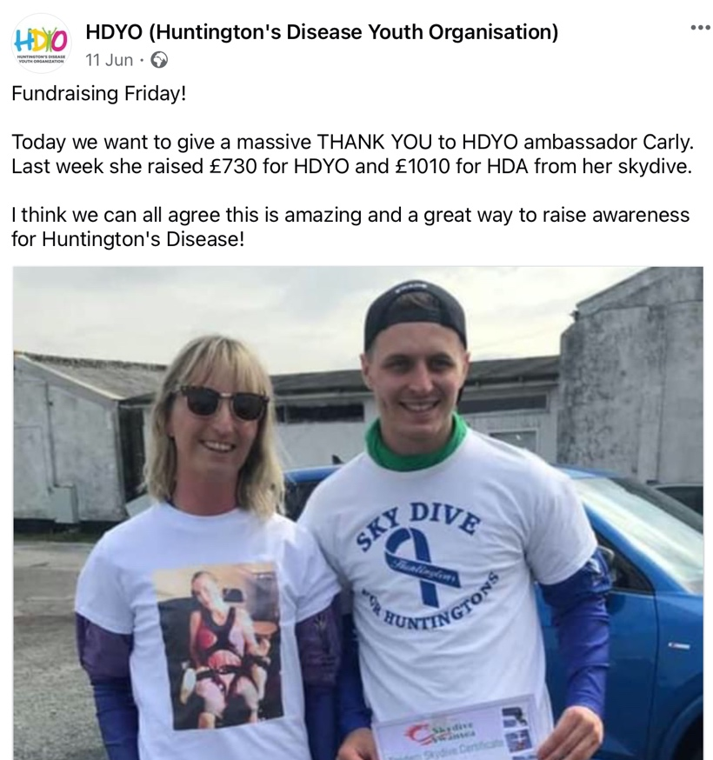

(HDYO, 2021)

Section C
The below is an email from HDYO executive director Jenna, inviting me to be a part o the HDYO Virtual Congress committee 2022.

Subject: HDYO Congress Committee
﻿
Carly:

We have been honored to have you join our HDYO Congress Committee that began meeting in October 2021 to help plan, strategize and organize this event to help young people impacted by HD across the globe. Duties include helping brainstorm speakers, learning how to improve the experience for young people and helping promote the event. This work is instrumental to the success of our event that will be held March 5-6, 2022.

Jenna Heilman
Executive Director
Huntington’s Disease Youth Organization

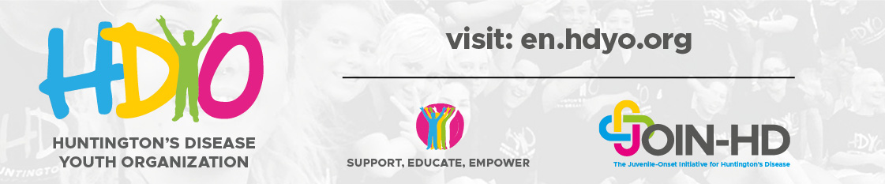

References

Egan, G. (1975), The skilled helper: A systematic approach to effective helping. CA: Brooks/Cole.
Huntington’s Disease Youth Organisation. (2021), HDYO Website, Available at: https://en.hdyo.org/

Huntington’s Disease Youth Organisation (2021), About us. HDYO. Available at: https://en.hdyo.org/a/28-about-hdyo

Huntington’s Disease Youth Organisarion. (2021), HDYO Ambassadors. Available at: https://en.hdyo.org/a/682-hdyo-ambassadors

Huntington’s Disease Youth Organisation. (2021), HDYO Logo. Available at: https://en.hdyo.org/

Huntington’s Disease Youth Organisation. [@hdyofeed] (June 11th 2021), Fundraising Friday! Today we want to give a massive THANK YOU to HDYO ambassador Carly. Last week she raised £730. [Photograph] Instagram. Available at: https://www.instagram.com/hdyofeed/p/CP_TtIAAhWK/?utm_medium=share_sheet

Huntington’s Disease Youth Organisation. (2021), HDYO Mid Year Report July 2021. HDYO. Available at: https://en.hdyo.org/downloads/hdyo-2021-mid-year-report.pdf

Appendices

Appendix A

Carly:

We have been honored to have you
Have you on board with us here at HDYO and are delighted you have chosen us for your placement at university.
We have invited you to join our HDYO Congress Committee that began meeting in October 2021 to help plan, strategize and organize this event to help young people impacted by HD across the globe. Duties include helping brainstorm speakers, learning how to improve the experience for young people and helping promote the event. This work is instrumental to the success of our event that will be held March 5-6, 2022.

We also are happy to have you participate in our Ambassador program that began in May 2021. It’s been an amazing way to connect with young people across many countries.

We are so grateful for all the other prohects you are taking part in to support HDYO and thank you once again for using this experience for your university placement.

Jenna Heilman
Executive Director
Huntington’s Disease Youth Organization

Appendix B
Placement Information Form
Name of Student: | Carly Evans
Proposed Placement Setting and Address: | The Huntingtons youth organisation – online based
Proposed Dates of Placement: | October 2021 – ongoing
Name of Contact for Venue:  Please also state their position: | Matt Ellison – Project coordinator and founder of HDYO – Huntingtons youth organisation
Email Address: | Matt@hdyo.org
Telephone Number for Contact at Placement:
Is a DBS required for you to attend this placement? | - No  If Yes, have you applied for this?  - Yes applied on _________________  - No
Explain how your role in this organisation/on this placement meets the criteria for the assessment for the module | I have for the last five months been an ambassade for the Huntingtons youth organisation. I want ton continue this role as part of my placement experience this term. This rolewill enable myself to practice my activel listening skills when ambassadors from around the world come together to raise awareness and support one another.as we come together to raise awareness. Active listening is an important and essential counselling skill and this role will enable myself to have further practice.

ALL information must be provided. Incomplete forms will be returned to the student.
Please return this form to Ruth Groff (ruth.groff@uwtsd.ac.uk)
Points for submission:

Appendix C
From: Ruth Groff
Sent: 11 October 2021 13:51
To: Matt@hdyo.org
Subject: Voluntary/Placement Opportunity

Dear Matt Ellison,
Carly Evans has been in contact and wishes to extend her current voluntary opportunity with Huntington’s Youth Organisation as a placement for her BSc Psychology and Counselling programme. I understand, you are already in agreement, but here is a letter of explanation. If you have any other concerns, please do not hesitate to get in contact.
Kind regards,

Cofion Cynnes,
Ruth

Ruth M Groff MPS MA FHEA BACP Registered Accredited Member
Programme Manager: MA Advanced Counselling Theory and Research
Yr Athrofa | Institute of Education and Humanities – Academic Discipline of Psychology and Counselling
Prifysgol Cymru Y Drindod Dewi Sant | University of Wales Trinity Saint David
SA1 - Campus
Abertawe | 1 Swansea

Appendix D

Attendance record
To whom it may concern,
I can confirm that Carly Evans has been involved with HDYO since May 2021, with her placement experience commencing 1st September 2022. We have been honored to have Carly on board with us and she has been an incredible asset to HDYO and the HD community. Although Carly has finished her placement hours at the end of Januay 2022, she will continue to be an ambassador and be involved in many projects throughout 2022. She is also going to do a talk at our annual congress on 5-6 March 2022 and continue to develop on her counselling skills and support us here at HDYO.
I hope this is sufficient for you.

Jenna Heilman
Executive Director
Huntington’s Disease Youth Organization

