PROBLEM SOLVING AND DECISION MAKING

UNIVERISTY OF WALES SAINT TRINITY DAVID
STUDENT NAME: Adrian Pop
STUDENT NUMBER: 2109183

LECTURER NAME: Chijioke Uba
MODULE CODE: 4004

PROGRAMME: CERTIFICAT OF HIGHER EDUCATION IN SKILLS FOR THE WORKPLACE

Table of content
Contents
ABSTRACT 2
1.0 ITRODUCTION 3
2.0 PESTEL Analysis 3
3.0 Fishbone Diagram 5
4.0 PMI – Evaluation of alternative solutions to abseenteism 7
5.0 Implementation of the action plan based on the solution 9
6.0 References 11

ABSTRACT

In this report, we will discuss reducing long-term absenteeism in the Mid Cheshire Hospitals NHS Foundation Trust (MCHT), where you will learn about the causes of the problem using the analysis PESTEL and FISHBONE diagrams, and we will attempt to provide an alternative solution to reduce long-term absence in the Mid Cheshire Trust. By conducting these stages, we will also learn about the impact on trust, the patients and workers who cause this absence overall, and, last but not least, the nature of the problem.

ITRODUCTION

Absenteeism is a difficult problem to manage, and this has negative consequences such as a reduction in the quality of services provided, Absence from work can have a negative influence on the team's morale.
In the case of the Mid Cheshire Hospital NHS Trust, the situation is extremely significant and long-term, as evidenced by a rise in absentia from 2007 to 2012. This is an issue caused by long-term absenteeism, which has resulted in significant financial losses for the Mid Cheshire Trust, while the trust and the patients have to suffer as a result of low-quality services. The yearly financial losses exceed one million. The losses are consistent operationally since the level of service offered to the customers is low, but the social costs are also persistent because the patients will be dissatisfied with the waiting time and the services obtained.
In the next step of the Report, I will present the PESTEL analysis to find the external, environmental causes of the problem.

2.0 PESTEL Analysis

- PESTEL: PESTEL Analysis helps to examine the macro-environment (the environment that influences business choices indirectly) in which the firm works. Managers must recognise macro-environmental developments that impact their strategic decision. PESTEL analysis can be used to identify these. Acknowledging various outdoor pool allows firms to leverage while minimising dangers.
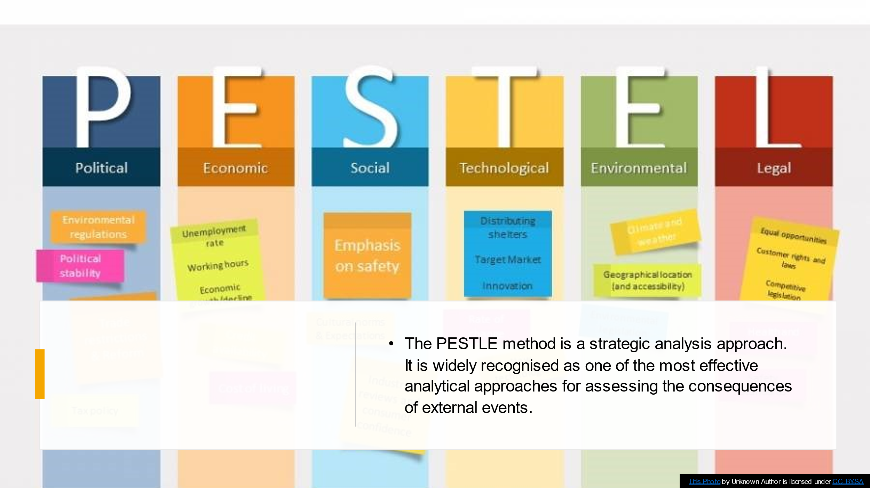
PESTEL ANALISYS FOR MID CHESHIRE HOSPITAL NHS TRUST ABSEENTEISM
- POLITICAL; BREXIT: A political external factor such as Brexit can lead to a long-term absence of the employee because, as we all know, whenever another company or the NHS employees are of different nations, Brexit has caused a problem of absenteeism because, in order to have the legal right to work and the legal right to stay, some steps must be taken in order to obtain the rights. These stages take time and demand plenty attention because a mistake might result in a rejection of your rights, and you cannot use your right to work without these documents.
- ECONOMIC; TAX: As we all know, an external economic issue such as bridge taxes causes long-term absenteeism, provided that NHS personnel are paid on a fixed wage, as are employees paid on a per-hour basis. Which allows them the opportunity to work less hours in order to pay fewer taxes to the state, and all at once the pleasure is on their side, so does the thought of fewer hours fewer taxes. So that it may be considered that taxes can result in a longer-term absence, employees should agree to a little lower compensation with a lower tax deduction than a slightly higher salary with a larger tax deduction since the gross monthly cumulation is higher.
- SOCIOLOGICAL; EDUCATION: Another external factor, as interesting as educational sociology, can have an impact on the problem of absenteeism; when we talk about education, we don't just mean school; we also mean the education received by the child; if there is an example that should not be followed by a child, he learns and that is what he will do in the future. But, all at once, we can discuss how a factor such as education can cause long-term absences because generations have changed many students among the ranks of the employees, giving us the understanding that absences can be caused by education by the fact that these student employees have courses, exams for which they must learn or participate in courses in order to not be excluded from the courses. As a result, education can have an effect on absenteeism.
- TECHNOLOGICAL; SKILLS: External factor such as technological in our case we have chosen skills, because of this factor that is, the staff who does not have a rich CV in terms of knowledge, qualifications this due to the lack of personnel may have an influence on others in being absent from work because we do not have the necessary qualifications do not want to exercise work for others or feel aggrieved by this or again may have higher financial expectations based on skills that they have.
- ENVIROMENTAL; CLIMATE: Is an external element that can encourage certain individuals not to come to work, causing personal pain such as headaches, anxiety, other states of depression that sap your energy, which is why a factor like as the climate can induce absenteeism.
LEGAL; HEALT AND SAFETY: This is a factor that raises some concerns, but it still contributes to absenteeism because even if the trust's employees are not provided with adequate protective equipment, or the equipment used causes them problems, and the employees do not feel safe, which causes people not to show up at work; alternatively, some have suffered from more serious health issues that make them concerned about their safety at work, or have encountered problems with patients who have put them at risk.
We discovered these reported external variables in inducing long-term absenteeism using the PESTEL model.
Following the following phase of the report, fishbone diagrams will be given to see the internal and external sources of the problem.

3.0 Fishbone Diagram

- FISHBONE DIAGRAM

Kaoru Ishikawa the teacher by trade was the first man and for the first time he used a visual diagram called the fish bone diagram because he brings with the skeleton bone of a fish. It has become a key diagnosis of analysis and illustration of the problems within the analysis of the main causes, which even today brings successes in projects to improve the services. The fishbone analysis starts with a problem and gives a framework for separating and categorising the reasons. Typically, there are six categories, however this might vary depending on the situation. This approach allows for the analysis of problems and, when used with colleagues, provides everyone with an understanding of the situation, allowing for the development of solutions cooperatively.
In the fish bone diagram down below, causes such as illness (infection); Mental health (anxiety, depression); or acute medical condition (cancer, stroke, heart attack) lead to our problem because all of this requires a long time of recovery and regaining personal confidence in order to be able to work again. Management (poor cooperation, pressure to succeed) can contribute to the problem of long-term absenteeism; this is an internal reason that places a lot of strain and weight on the shoulders of an employee, who eventually becomes fatigued and loses interest in the job.
Fish bone diagram it is used to see the environmental internal and external cause of the problem.

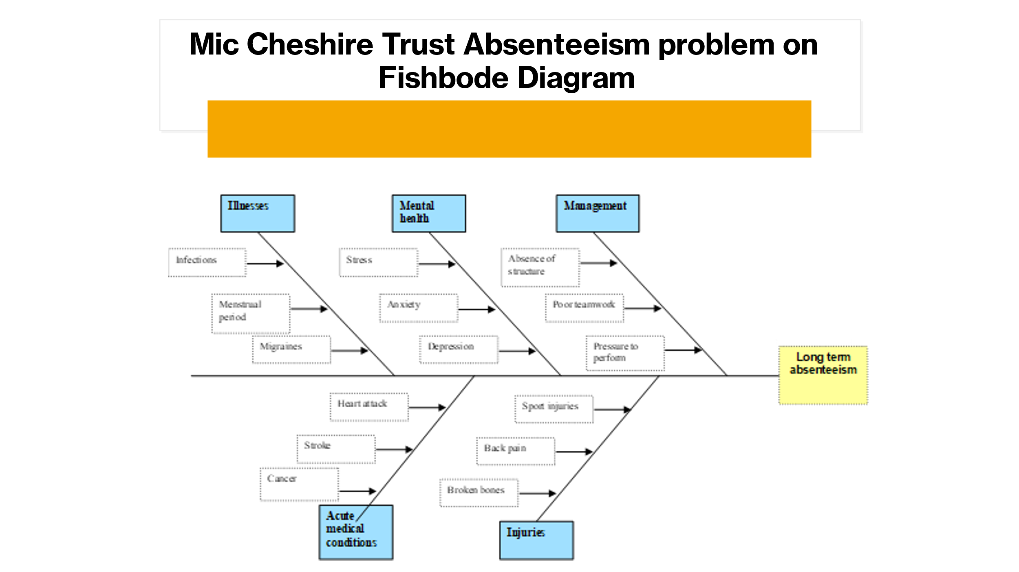
In the next sections of the report, I will attach an evaluation of a remedy to the problem experienced by the personnel at Mid Cheshire Hospital NHS Trust, which we shall discuss.

4.0 PMI – Evaluation of alternative solutions to abseenteism

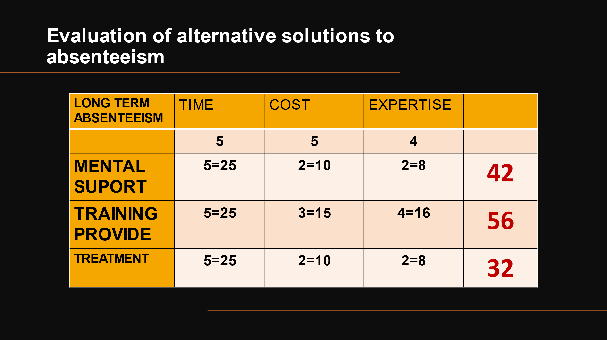
In the table above, we proposed three diverse ways for minimising absenteeism: mental support, training, and treatment. We added a comment to each solution on a scale of 1 to 5, based on the time, cost, and evaluation. After the final calculation, the training provide solution had the highest score, indicating that it is one of the solutions that might minimise absenteeism. Since Mid Cheshire Hospital Trust has been struggling with the problem of absenteeism for a long time, we scored with the maximum of 5 because the problem must be solved as soon as possible, the cost of the solution was also scored with 3 because the loss of money is already very high and the costs are very important, but it did not receive the maximum score all at once due to the fact that the trainings can come from within the Trust, which causes us to diminish. The expertise was given a four because it necessitates extra attention and a well-established expertise to identify the trainings required to provide employees with all they require in the sector.
Although the other solutions did not receive a higher score than training, they should not be overlooked because trust employees who require mental support or treatment are solutions that mid Cheshire Hospital NHS can consider by coming up with support from within for their employees and assisting them with the treatments they will strengthen faster and be able to resume work more easily.
With all of information reported, and a winning score of 56 points in the following, you will develop an action plan for Training Provided.

5.0 Implementation of the action plan based on the solution
ACTION | DESCRIPTION | TIMELINE | STAFF RESPONSIBLE
Identify the adequate equipment for TRAINING and document them | Line managers and hospital staff that are persistently absent to outline specific needs  Write these up in a logbook | 03/04/2022 TO  17/04/2022 | HR
Identify programme recipients | Use attendance register to identify staff that are persistently absent; those that have less trainings or those that need to be specialised | 18/04/2022 to  25/04/2022 | HR
Identify the best candidate or candidates to provide the trainings | HR and Line managers to determine the best candidate or candidates (e.g., using Check trade and local listings), and to liaise whit the trainers to agree contract. | 02/05/2022 to  09/05/2022 | HR and Line managers
ACTION PLAN
Create a programme schedule | Schedule to include time, trainings, and dates, and to be communicate to line managers and relevant staff | 12/05/2022 to 19/05/2022 | HR

MONITORING
ACTION PLAN | DESCRIPTION | TIMELINE | STAFF RESPONSIBLE
Engagement | Responses to Trainer questions | Daily | Trainer coach
Understanding | Use quiz, equipment, and direct questions | Daily | Trainer coach
Participation/Attendance | % Off staff in the sessions of trainings using register | Daily | HR

EVALUATION

PERFORMANCE INDICATOR | DESCRIPTION | TIMELINE | STAFF RESPONSIBLE
Staff and patients’ feedback | Staff attendance and survey of patients | Weekly | HR

6.0 References

- Absenteeism. Kenton,2022, Investopedia Accessed on 03/04/2022 available at Absenteeism Definition (investopedia.com)
- BBC, Bitesize 2022,Accessed on 03/04/2022,Avaialable at PESTLE analysis - Critical thinking and problem solving - WBQ National: Foundation KS4 Revision - BBC Bitesize
- Creately,2022,Accessed on 05/4/2022 ,Available at How to Write an Action Plan | Step-by-Step Guide with Templates (creately.com)
- Gillard, M. (2012). PMI - Plus Minus Intersecting. Innovation-creativity.com. Retrieved from:
http://www.innovation-creativity.com/pmi.html
- Reliable Plant ,Jonathan Trout, Accessed on 07/04/2022,Available at Fishbone Diagram Explained | Reliable Plant

