Data Security, Governance and Compliance Course Work

Data Security, Governance and Compliance
2304705
Jinwei Xu
January 8, 2024

Abstract
This article begins by examining two widely used frameworks: Information Technology Infrastructure Library (ITIL) and ISO 27001. Regarding ITIL, we outline its key management processes, encompassing various phases such as service strategy, service design, service transition, service operation, and continuous service improvement. When discussing ISO 27001, the focus is on the essential steps for establishing an information security management system. These models play a crucial role in assisting NatureGarden (NG) Company in achieving its information security objectives.
Subsequently, the article analyzes NG Company's information security goals, policies, strategies, and governance, providing detailed insights into how the company manages risks and ensures information security from multiple perspectives.
The article also critically explores the effectiveness of continuously updating information security regulations and standards, emphasizing the importance of striking a balance between speed and quality during the update process.
In conclusion, this article summarizes the above content to provide a comprehensive understanding of NG Company's information security management.
Table of Contents
1. Security Framework Research 1
1.1 ITIL 1
1.2 ISO 27000 2
1.2.1 Steps for Establishing an Information Security Management System (ISMS) 2
2. Information Security Solution Design 4
2.1 Information Security Objectives 4
2.2 Information Security Policies 4
2.3 Information Security Strategies 5
2.3.1 Data Encryption 5
2.3.2 Data Minimization 5
2.3.3 Formulating Data Retention Policies 5
2.3.4 Ensuring Wireless Network Security 5
2.3.5 Strengthening Device and Access Control 5
2.3.6 Conducting Risk Management 5
2.4 Risk Management 6
2.4.1 Risk Assessment 6
2.4.2 Risk Treatment 7
2.5 Information Security Governance 7
2.5.1 Data Encryption 7
2.5.2 Data Minimization 7
2.5.3 Implementation of Data Retention Policies 7
2.5.4 Ensuring Wireless Network Security 7
2.5.5 Strengthening Device and Access Control 8
2.5.6 Risk Management 8
3. The Effectiveness of Continuously Updating Information Security Regulations and Standards 9

Table of Acronyms
AES Advanced Encryption Standard
GDPR General Data Protection Regulation
ISO/IEC International Organization for Standardization/International Electrotechnical Commission
IoT Internet of Things
ISMS Information Security Management System
ISO International Organization for Standardization
IT Information Teachnology
ITIL Information Technology Infrastructure Library
MDM Mobile Device Management
MFA Multi-Factor Authentication
NG NatureGarden
SSL/TLS Secure Sockets Layer and Transport Layer Security
VPN Virtual Private Networks
WPA3 Wi-Fi Protected Access 3

Table of Figures
Figure 1. ITIL 2
Figure 2. Steps for Establishing an ISMS 3
Figure 3. Information Security Solution Design 4
Figure 4. Risk Management 6

Introduction
In modern society, information security is of paramount importance for global enterprises, particularly for large corporations like NatureGarden (NG) Company. Information security not only safeguards sensitive data but also supports customer trust and upholds the company's market reputation. As a company operating globally, NG faces a range of information security challenges, including user data security, intellectual property protection, and network security.
This article aims to analyze and design information system security, governance, and compliance strategies suitable for NG Company. The article delves into widely used security frameworks such as ITIL and ISO 27001 as a foundation to ensure information security at NG, covering security objectives, policies, strategies, governance, and risk management.
Furthermore, the article will critically explore the rationality and effectiveness of continuously updating information security regulations and standards.
In the first chapter of the article, we will explore common security frameworks and their applications. The second chapter will focus on designing specific approaches to information security for NG Company. The third chapter will discuss the necessity and impact of continuously updating information security regulations and standards.

Security Framework Research
This article examines two security frameworks: ITIL and ISO 27001. According to D. Wang et al. [1], ITIL and ISO 27001 are two standards pursued by enterprises.

ITIL
Information Technology Infrastructure Library (ITIL) is a best practice standard for Information Teachnology (IT) service management widely adopted globally. According to M. Marrone and L. M. Kolbe [2], applying ITIL can help businesses improve IT service quality, standardize IT services, enhance customer satisfaction, and increase the reliability and availability of IT services. According to M. Blumberg et al. [3], ITIL's management processes encompass five stages: service strategy, service design, service transition, service operation, and continuous service improvement.
Service strategy defines the goals and strategies of IT services. Formulating a service strategy involves considering details such as service objectives, market demands, resource investments, and value benefits.
Service design builds upon the foundation of service strategy. Organizations need to develop service design plans and determine service levels, processes, and documentation internally and externally.
The service transition phase implements the service design plans. This stage involves activities such as service testing, service delivery, and service deployment.
The service operation phase follows the service transition and aims to ensure the continuous operation of IT services. This stage includes activities such as fault handling, event management, and security management.
The continuous service improvement phase, occurring after the service transition, focuses on analyzing and improving issues that arise during the service operation.
ITIL's management processes effectively coordinate and manage IT services both internally and externally, enhancing the quality and efficiency of IT services.

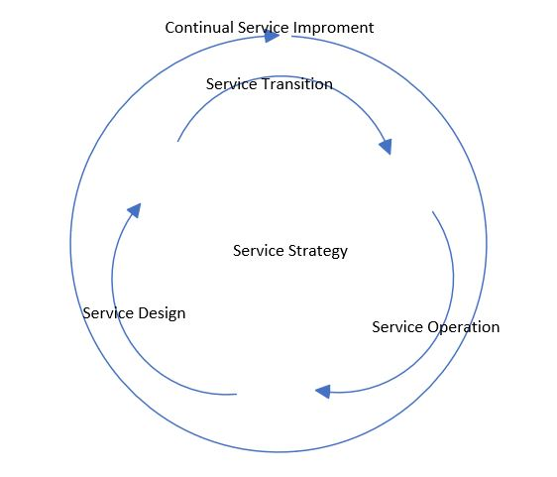
Figure 1. ITIL

ISO 27000

ISO/IEC 27000 is an information security standard developed by the International Organization for Standardization (ISO). ISO/IEC 27000 is one of the most representative standards in the international information security field.
The most crucial standard in the ISO 27000 series is ISO 27001. ISO 27001 describes how to establish an Information Security Management System (ISMS). According to I. M. Lopes et al. [4], implementing an ISMS based on ISO 27001 offers advantages such as identifying and mitigating threats and vulnerabilities within the organization, enhancing the organization's ability to predict, manage, and respond to disasters, and ensuring compliance with current laws and regulations.

Steps for Establishing an Information Security Management System (ISMS)
ISO 27001 provides specific steps for establishing an ISMS in chronological order:
Firstly, the organization defines its objectives, environment, and so on.
Secondly, the organization establishes its overall policies and strategies regarding information security, provides a plan for the ISMS, and commits to its scope.
Thirdly, principles and methods for risk assessment are developed and risk assessment is carried out.
Fourthly, principles and methods for risk treatment are formulated, and risk treatment is implemented based on the results of risk assessment.
Fifthly, Control measures are implemented following the principles of risk treatment, and controls consistent with the organization's principles are selected from the standard controls in Appendix A.
Sixthly, internal audits and management reviews are conducted to assess the performance of control implementation.
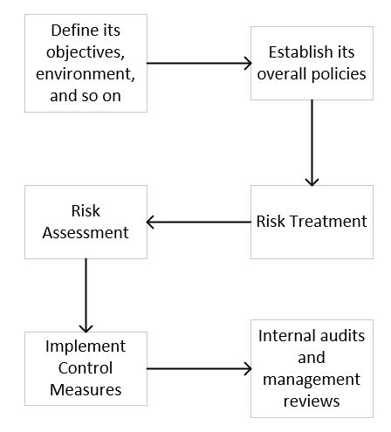
Figure 2. Steps for Establishing an ISMS

Information Security Solution Design
After researching ITIL and ISO 27001, an information security solution tailored to meet NG Company's needs has been designed.
This article begins by identifying NG Company's information security objectives, followed by the determination of NG Company's information security policies and strategies in sequence. The article places particular emphasis on the implementation of risk management within the company's information security strategy. Finally, the article outlines the information security governance for NG Company.
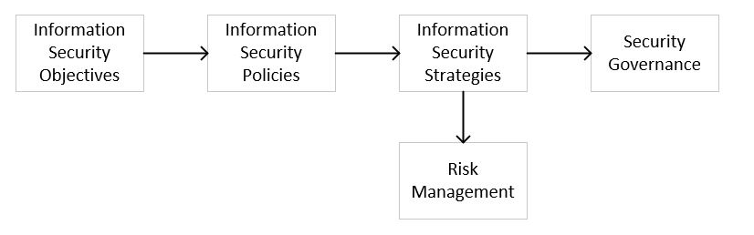
Figure 3. Information Security Solution Design

Information Security Objectives
The first step is to analyze NG Company's internal and external environments and then establish the company's security objectives.
Internally, NG Company relies on global business operations and wireless network infrastructure through cloud services, providing flexible IT solutions but also introducing network security risks. Key security challenges include how to address issues related to employees and customers accessing company resources using personal devices and effectively managing the vast amount of personal information collected. Additionally, safeguarding valuable intellectual property worth billions of dollars is a critical task.
Externally, the growing public concern about data privacy and security, along with compliance requirements associated with varying national data protection laws, presents additional challenges for NG Company.
Therefore, NG Company's security objectives focus on data security, network security, protection of intellectual property, and compliance.

Information Security Policies
After establishing the security objectives, this article outlines NG Company's information security policies. These policies encompass: implementing comprehensive risk management, ensuring data security, enhancing network security defenses, safeguarding intellectual property, and ensuring full compliance.

Information Security Strategies
To implement NG Company's policies regarding information security, the company will adopt a series of specific strategies, such as data encryption, data minimization, the formulation of data retention policies, ensuring wireless network security, conducting risk management, and strengthening device and access control, to ensure that these policies are effectively executed and reflected in day-to-day operations.

Data Encryption
NG Company should protect data on servers by encrypting it using Advanced Encryption Standard (AES), implement SSL/TLS protocols for secure data transmission, and utilize Virtual Private Networks (VPN) and encrypted email systems to ensure communication security and safeguard sensitive information.

Data Minimization
NG Company should limit the types and amount of data collected, gathering only the minimum information necessary for business purposes. The company should regularly review databases, remove outdated data, and enforce strict data access controls.

Formulating Data Retention Policies
NG Company should establish clear data retention policies specifying the retention periods and secure disposal times for different types of data to ensure that data is not stored indefinitely.

Ensuring Wireless Network Security
NG Company should strengthen wireless network security by enhancing password policies, using the latest Wi-Fi Protected Access 3 (WPA3) security protocol, regularly updating wireless devices and router firmware, and providing a separate network for guests.

Strengthening Device and Access Control
NG Company should implement access control systems and Multi-Factor Authentication (MFA), regularly update network devices, and use Mobile Device Management (MDM) software to monitor connected devices, thereby enhancing security control over devices and network resources.

Conducting Risk Management
Risk management is a critical component of NG Company's security strategy, involving the identification, analysis, and mitigation of information security risks to ensure the security of company data and assets. Through this strategy, the company can effectively address potential security threats.

Risk Management
NG Company should conduct risk management following the requirements of ISO 27001. According to F. Kitsios et al. [5], ISO 27001 stipulates that information security policies protect the confidentiality, integrity, and availability of data through the implementation of a risk management process.
Risk management includes risk assessment and risk treatment.
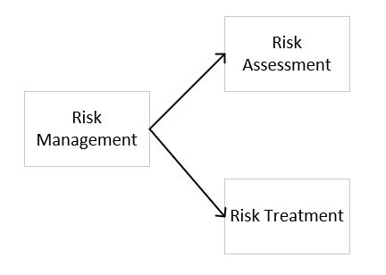
Figure 4. Risk Management

Risk Assessment
NG Company's risk assessment should comprise four parts: setting risk acceptance criteria, identifying information security risks, analyzing information security risks, and evaluating information security risks.

Setting Risk Acceptance Criteria
Initially, NG Company needs to determine the level of risk that can be accepted and establish corresponding policies, specifying which risks can be accepted, which require mitigation measures, and which must be avoided.

Identification of Information Security Risks
In the risk assessment phase, the company needs to meticulously identify all critical IT assets, including hardware, software, and data, and assess potential threats such as malware attacks, hacking, internal security threats, and natural disasters.

Analysis of Information Security Risks
During the risk analysis phase, the company will estimate the likelihood of each threat occurring and its potential impact on the business. Simultaneously, the impact of events like data breaches or system disruptions on company operations will be analyzed, and risks will be categorized into different levels, such as low, medium, or high.

Evaluation of Information Security Risks
In the risk evaluation stage, the company will conduct a comprehensive assessment of various information security risks based on the analysis results and established risk acceptance criteria, ensuring the effectiveness of risk management.

Risk Treatment
NG Company's risk treatment should encompass three parts: selecting risk treatment options, determining necessary control measures, and formulating a risk treatment plan.

Selecting Risk Treatment Options
NG Company should first choose appropriate risk treatment options based on the results of the risk assessment. This includes deciding which risks can be accepted, which require mitigation measures, and which risks need to be addressed through other means.

Determining Necessary Control Measures
To implement the chosen risk treatment options, NG Company needs to identify all necessary control measures. These measures can be either internally designed by the company or acquired externally. NG Company should compare the identified control measures with those in ISO 27001 Appendix A to ensure that no essential measures are overlooked.

Formulating a Risk Treatment Plan
Lastly, NG Company needs to develop a specific information security risk treatment plan.

Information Security Governance
To effectively implement the information security strategy, NG Company relies on close collaboration among teams.

Data Encryption
The IT department is responsible for implementing data encryption, utilizing advanced encryption standards like AES to encrypt server data, managing SSL/TLS protocols, maintaining VPN, and encrypted email systems to ensure the security of data transmission and storage.

Data Minimization
Led by the compliance department in collaboration with IT, human resources, and business departments, regular data reviews are conducted. Technical tools are employed to remove unnecessary data, and employee awareness of data minimization is enhanced through training.

Implementation of Data Retention Policies
The compliance department develops data retention guidelines and collaborates with the IT and data management teams to regularly review data storage, ensuring compliance with policy requirements.

Ensuring Wireless Network Security
Managed by the network security team, they are responsible for configuring and maintaining security protocols for wireless networks, such as WPA3, updating firmware, and managing guest networks.

Strengthening Device and Access Control
Jointly managed by the IT security team and the human resources department. The IT security team is responsible for implementing access control systems and multi-factor authentication, while the human resources department handles employee training and policy development regarding device usage and network access.

Risk Management
The risk management department collaborates with the IT, compliance, and business departments to jointly identify technical and compliance risks, conduct regular risk assessments and reviews, and formulate mitigation strategies. Through cross-departmental cooperation, NG Company comprehensively manages risks to ensure robust and secure operations.

The Effectiveness of Continuously Updating Information Security Regulations and Standards
In the digital age, ensuring information security is of paramount importance. With rapid technological advancements and an increase in cybersecurity threats, governments and security standard organizations are responsible for updating relevant regulations and standards. These updates require businesses to adapt to new requirements to protect their digital information, but they also present challenges. This article explores the importance of updating regulations and standards in maintaining cybersecurity and the potential issues that businesses may encounter when adapting to these changes.
The rapid advancement of technology, especially in the field of information technology, has significantly altered the way we handle, store, and transmit information. For example, the rise of cloud computing enables businesses to remotely store and access vast amounts of data, but it also brings new security risks such as cross-border data flow, data privacy protection, and the security of cloud service providers. Simultaneously, the proliferation of the Internet of Things (IoT) has led to the interconnection of countless devices, increasing entry points for network attacks and posing unprecedented challenges to traditional cybersecurity measures.
In this context, existing regulations and standards often struggle to keep pace with technological developments. For instance, the International Organization for Standardization (ISO) has responded directly to technological advancements by establishing security standards for cloud services and IoT. The popularity of cloud computing has introduced new modes of data storage and management, requiring new security measures to protect sensitive data stored in the cloud. In response, ISO has developed specialized cloud service security standards, such as ISO 27017, which provides practical guidelines to ensure information security. According to F. Abdullayeva[6], ISO 27017 is an ISO standard developed based on ISO 27002 specifically for cloud computing.
Additionally, the rapid growth of IoT has raised concerns about device security and secure data transmission. To address these challenges, ISO has introduced a series of standards, such as ISO 27030, aimed at providing guidance for the design, implementation, and management of IoT. These standards focus on maintaining data integrity, confidentiality, and availability within the ever-expanding network of interconnected devices.
Therefore, to effectively protect sensitive and confidential information, governments and security standard organizations need to continuously update and revise their security policies and practices to align with the latest technological developments.
With the continuous advancement and application of network technologies, the threats of cyberattacks and data breaches are growing at an unprecedented pace, posing serious challenges to businesses and even national security. A prominent example is the Colonial Pipeline incident. According to The New York Times[7], in 2021, the company fell victim to a severe ransomware attack, resulting in the forced shutdown of its 5,500-mile-long oil pipeline. This pipeline reportedly transported 45% of the fuel supply for the eastern United States, and its closure led to fuel supply shortages across the entire region. To regain access to its data and services, Colonial Pipeline ultimately paid a ransom of five million dollars in Bitcoin. This incident not only highlighted the significant threat that cyberattacks pose to critical infrastructure and national security but also revealed the vulnerability of businesses when facing cyber extortion.
This ransomware attack, which paralyzed a critical energy infrastructure, underscores the importance of cybersecurity. Therefore, the continuous updating of regulations and standards is crucial for protecting both business and national security.
As public awareness of information security continues to rise, so does the demand for the rapid development and improvement of relevant regulations and standards. In the digital age, the security and privacy of personal data have become a focal point of public concern, driving the rapid development and enhancement of related regulations and standards. The implementation of the General Data Protection Regulation (GDPR) by the European Union is a clear manifestation of this trend.
General Data Protection Regulation (GDPR) responded to the growing public concern over strengthening personal data protection and privacy rights by establishing stricter data processing rules and higher privacy protection standards, significantly raising the level of information security. This phenomenon demonstrates that the practice of continuously developing new or updating existing regulations and standards is a sound one.
However, the continuous updating of regulations and standards can be a double-edged sword for businesses, with one of the most significant challenges being increased implementation costs. Whenever regulations and standards change, businesses need to invest considerable resources to ensure that their operations and processes comply with the new requirements. For small and medium-sized enterprises, these costs can consume a significant portion of their budgets. For financially constrained businesses, continually adapting to new regulations and standards can pose a significant financial burden.
Therefore, while updating regulations and standards is crucial for enhancing information security and protecting customer data, the impact on the economic burden of businesses should not be underestimated.
Despite the frequent updates to laws and standards aimed at improving security and adaptability, doing so may also introduce some uncertainties. Firstly, implementing new standards takes time and adaptation. If standards change too quickly, companies may not have adapted to the old standards before new ones are introduced. This can lead to implementation delays or incomplete compliance, affecting security effectiveness. Secondly, the effectiveness of new standards often needs to be tested over time in practice. While new regulations aim to address the latest threats, they may lack long-term validation, and their effectiveness may differ from their intended goals. Additionally, frequent updates may make it challenging for businesses to focus on critical security issues, potentially overlooking some fundamental but essential security measures.
Therefore, while the frequent updating of regulations and standards is well-intentioned, practical challenges in terms of effectiveness assessment may arise. Striking a balance between information security and the burden on businesses is essential when updating regulations and standards in the digital age.

Conclusion
This paper has explored various security frameworks, including ITIL and ISO 27000, and has designed a comprehensive set of strategies covering information security goals, policies, strategies, and governance to ensure the security of NG Company's information. Additionally, we have critically examined the practice of continuously updating information security regulations and standards.
However, this study did not fully encompass the latest security threats and technological advancements in the examination of NG Company's information security, highlighting the need for NG Company to continuously adapt to emerging security challenges. Furthermore, the article did not delve deeply into the cultural and behavioral factors influencing information security. Information security is not solely a technical issue but is also closely related to organizational culture and employee behavior. Future research can further explore how these factors impact the effective implementation of information security.
In the ever-evolving digital age, information security is crucial for businesses. Therefore, large companies must continually update and improve their information security measures to address new challenges. When updating information security regulations and standards, finding a balance between speed and quality is paramount to ensure that new standards are both practical and efficient, thereby safeguarding the security of personal and corporate data.

References
[1] D. Wang, D. Zhong and L. Li, “A comprehensive study of the role of cloud computing on the information technology infrastructure library (ITIL) processes,” Library Hi Tech, vol. 40, no. 6, p. 1958, Dec 8, 2022.
[2] M. Marrone and L. M. Kolbe, “Uncovering ITIL claims: IT executives’ perception on benefits and business-IT alignment,” Information Systems and e-Business Management, vol 9, no. 3, pp. 363-380, June 29, 2010.
[3] M. Blumberg, A. Cater-Steel, M. M. Rajaeian and J. Soar, “Effective organisational change to achieve successful ITIL implementation: Lessons learned from a multiple case study of large Australian firms,” Journal of Enterprise Information Management, vol 32, no. 3, p. 498, May 21, 2019.
[4] I. M. Lopes, T. Guarda and P. Oliveira, “How ISO 27001 Can Help Achieve GDPR Compliance,” 2019 14th Iberian Conference on Information Systems and Technologies (CISTI), June 22, 2019, Coimbra, Portugal.
[5] F. Kitsios, E. Chatzidimitriou and M. Kamariotou, “The ISO/IEC 27001 Information Security Management Standard: How to Extract Value from Data in the IT Sector,” Sustainability, vol 15, no 7, p. 5, Mar 27, 2023.
[6] F. Abdullayeva, “Cyber resilience and cyber security issues of intelligent cloud computing systems,” Results in Control and Optimization, vol 12, p 6, July 17, 2023.
[7] N. Perlroth, “Colonial Pipeline paid 75 Bitcoin, or roughly $5 million, to hackers,” New York Times, May 13, 2021. [Online]. Available: https://www.nytimes.com/2021/05/13/technology/colonial-pipeline-ransom.html?searchResultPosition=6. [Accessed Jan. 8, 2024].

