

Programme: BA Business Management
Module Code and Title: LCBB6003- Leadership and management, theory, and practice
TASK 2: Individual Task- A Lessons Learned Report
Student Name: Nicoleta Madalina Rusu
University Name: University of Wales Trinity Saint David
Student ID: 2121755

Executive Summary
Jeff Bezos, Olive Ann Beech, Ohio Columbus Barber, and Elon Musk are the four business leaders who focused on demonstrating an effective leadership and management index to operate their business operations. Jeff Bezos had specific leadership strengths that helped him set the business up for long-term success. Olive Ann Beech focuses on the significance of a growth mindset and values feedback to develop its business operations. O. C. Barber's management and leadership style need a clear hierarchy to be developed. Elon Musk had an optimistic view and prioritised the meeting of the organisational goals. The leadership models and theories are trait leadership, transformational leadership, and transactional leadership.

Table of Contents
Introduction 4
Evaluating the characteristics of the four business leaders 4
Application of theories, concepts, and models of leadership 5
Conclusion 5
References 6

Introduction
The report will evaluate the characteristics of the four business leaders: Jeff Bezos, Olive Ann Beech, Ohio Columbus Barber, and Elon Musk. The leadership theories, concepts, and models of leadership will be expressed in this report to understand the leadership indexes of these four business leaders.

Evaluating the characteristics of the four business leaders
Jeffrey Preston Bezos (Amazon): 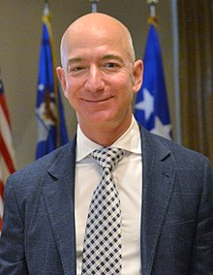 I have learned that Jeff Bezos exhibits a blend of several leadership styles, primarily transformational, but also includes autocratic and charismatic leadership elements. J. Bezos is recognized for his transformational leadership, which focuses on inspiring and motivating employees to innovate and drive change. He encourages a culture of continuous learning, empowerment, and innovation within Amazon. This leadership style has been instrumental in Amazon’s growth, fostering a customer-driven environment and promoting a culture of high standards and relentless pursuit of goals.
Ohio C. Barber (Diamond Match): 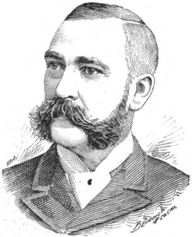 Initiatives focus on societal challenges that are too complex for any one discipline or industry to solve alone. The empathetic characteristics and visionary leadership helped Ohio C. Barber to develop its product and understand the needs of the customers.
"America's Match King": Barber earned this nickname due to his control over the Diamond Match Company, which held 85% of the U.S. match market by 1881[O. C. Barber. Wikipedia]. This dominance was achieved through strategic mergers and acquisitions, consolidating 12 match-producing companies into the Diamond Match Company [O. C. Barber. Wikipedia].
Under Barber's leadership, the Diamond Match Company not only produced matches but also manufactured the machinery used to make them. This vertical integration was a significant innovation that streamlined production and reduced costs [Downtown-Diamond Match Tour].
Olive Ann Beech (Beech Aircraft Corporation): 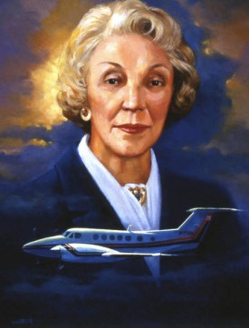 I have understood that the leader Olive Ann Beech was a pioneering business leader in the aerospace industry, co-founding Beech Aircraft Corporation and leading it to significant success. Olive Ann Beech demonstrated a clear and compelling vision for Beech Aircraft Corporation. She aimed to build the finest aeroplanes in the world, a goal she pursued relentlessly. Her forward-thinking approach was evident in her decision to invest in turboprop technology instead of jets, which proved to be a lucrative move for the company in the 1960s. (The Legendary Legacy of Olive Ann Beech).
Elon Musk (SpaceX, Tesla): 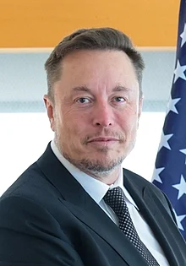 The visionary leadership of Elon Musk helped to balance practical situation management with a vision-sharing index. I have noticed that Elon Musk is optimistic and concentrates on developing his vision in adverse business situations. Musk understands his priorities to meet the organisational goals and the problem-solving skills of Musk concentrated on resolving the business problems (CIO Look, 2024).

Application of theories, concepts, and models of leadership
Trait leadership theory: I have learned that trait leadership theory is important to make people effective leaders through their inherent traits. These traits include intelligence, decisiveness, vision, creativity, risk-taking, and problem-solving (Benmira and Agboola, 2021). This leadership theory helps Jeff Bezos, Olive Ann Beech, Ohio Columbus Barber, and Elon Musk to develop their managerial as well as leadership effectiveness.
Transformational leadership theory: This theory states that transformational leaders inspire their followers to develop higher organisational outcomes. This leadership is used in different organisations to recover the gap between leadership and management (Benmira and Agboola, 2021). This leadership theory is applied by Jeff Bezos, Olive Ann Beech, Ohio Columbus Barber, and Elon Musk while they face adverse business situations.
Transactional leadership model: This leadership model refers to the leadership style that concentrates on exchanging punishments and rewards for specific behaviours of the individuals (Benmira and Agboola, 2021). I have learned that transactional leadership helps leaders to offer rewards for attaining goals and punish them for their failure to meet the organisational goals.

Conclusion
The characteristics of Jeff Bezos, Olive Ann Beech, Ohio Columbus Barber, and Elon Musk have been expressed who are successful business leaders. Trait leadership, transformational leadership, and transactional leadership model are the leadership models and theories which have been discussed in this report.

References
Jeff Bezos Leadership Style: https://www.studysmarter.co.uk/explanations/business-studies/business-case-studies/jeff-bezos-leadership-style/ [Accessed 22 July 2024]

https://www.mtdtraining.com/blog/jeff-bezos-leadership-style.htm/ [Accessed 22 July 2024]
https://upload.wikimedia.org/wikipedia/commons/0/03/Jeff_Bezos_visits_LAAFB_SMC_%283908618%29_%28cropped%29.jpeg

Ohio Columbus Barber picture https://en.wikipedia.org/wiki/File:Ohio_Columbus_Barber.png
https://en.wikipedia.org/wiki/O._C._Barber[Accessed 22 July 2024]
Downtown-Diamond Match Tour http://www.cityofbarberton.com/294/Downtown-Diamond-Match-Tour[Accessed 23 July 2024]
Town Founding & Early Growth http://cityofbarberton.com/282/Part-II-Town-Founding-Early-Growth[Accessed 23 July 2024]
The Legendary Legacy of Olive Ann Beech https://media.txtav.com/202936-the-legendary-legacy-of-olive-ann-beech
San Diego Air & Space https://sandiegoairandspace.org/hall-of-fame/honoree/olive-beech[Accessed 25 July 2024]
Picture https://sandiegoairandspace.org/img/hof_portraits/_hof_medium/oabeech_large.jpg
Benmira, S. and Agboola, M., (2021). Evolution of leadership theory. BMJ leader, pp.leader-2020.
CIO Look, (2024). What makes Elon Musk a successful entrepreneur? Available at: https://ciolook.com/what-makes-elon-musk-a-successful-entrepreneur/ [Accessed 22 July 2024]

Elon Reeve Musk
https://upload.wikimedia.org/wikipedia/commons/thumb/7/7b/The_Prime_Minister%2C_Shri_Narendra_Modi_meeting_Mr._Elon_Musk_in_New_York%2C_USA_on_June_20%2C_2023_%282%29_%28cropped%29.jpg/220px-The_Prime_Minister%2C_Shri_Narendra_Modi_meeting_Mr._Elon_Musk_in_New_York%2C_USA_on_June_20%2C_2023_%282%29_%28cropped%29.jpg[Accessed 22 July 2024]

