
A Report on the design of a factory process sorting 4 different size boxes
Applied Programmable Logic Controllers (ACDA6000)

By Oliver Bunyan

C&P Engineering Services Ltd
Table of Contents
Introduction 2
Existing PLC’s 3
Design of a Factory Process 4
PLC Tags 4
PLC Ladder Logic build 8
HMI Screen 27
Factory I/O Build 30
Alarm and Warning Strategy of the Process 31
Flow Chart 36
References 37

Introduction

Within this report is the documentation of the PLC programme created to control a factory process that sorts of 4 boxes into different conveyors to be taken to the next step of the process. Each of the boxes will individually be sorted by the use of sensors and pushers. The report shows the different controls within Tia 16 that controls the process, the HMI screens that can be used to control the process and also for indication, and also the Factory I/O build that was built to be controlled by the PLC.

Existing PLC’s

PLCs are used in almost every automated system that is here on earth, from traffic lights to automatic car park gates and massively in factories to control large processes automatically. There are many different PLCs to choose from on the market. The main two PLCs are the fixed PLC and the modular PLC.

Fixed PLCs are small compact PLCs which are best used for single operations. They are small PLCs that have all the equipment that make up a PLC built within such as power supplies, I/O modules and CPUs built within one unit. While purchasing them from the manufacturer the buyer is provided with a fixed number of Inputs and outputs depending on the size they buy. This doesn’t allow the PLC to be extended if extra I/O’s are required for the process they’re controlling. On top of that, the memory within the fixed PLC’s are a lot smaller than that of a modular PLC that can be bought. [1]

Fixed PLC

Advantages | Disadvantages
The cost of a fixed PLC is a lot cheaper than that of a modular PLC | They’re one whole unit so when they break down they’re harder to repair
Suitable for smaller scale process’s | Restricted use due to not being expandable
Easier to programme | Have Less Memory than a Modular PLC

Modular PLCs are far superior to fixed PLCs. The number of I/O modules can be extended If more terminals are required to control the process. By using modules on a PLC all the components that build a PLC are pieced together, allowing for the flexibility of different components placed together. The modules to be used on the PLC can range from CPU’s, motherboards, and I/O modules. This type of PLC is a lot more powerful than the fixed PLC and can have its memory also extended. If a process further down the line needed to have additional steps and controls, these are possible as opposed to using a fixed PLC where that’ll need a full PLC replacement. [2]

Modular PLC

Advantages | Disadvantages
Easier to troubleshoot when it comes to problems which in return equals less downtime | The cost of a modular PLC is a lot more expensive than a fixed PLC
Expandable modules for upgrades down the line | Programming of a modular PLC can be more tricky than that of a fixed PLC
Larger memory and greater power than the fixed PLC

Design of a Factory Process

The factory process to sort out 4 different boxes and their weights was created using the Tia 16 software for the PLC ladder logic, and Factory I/O to simulate the PLC. The PLC being used is the Siemens S7-1200.

PLC Tags

Within each ladder logic software, there are PLC tags which are essentially a name for memory locations. PLC tags are used to give functions of the process a name for their operation and depending on what they're doing they have a different address tag type. The different tags used within this factory process are shown below in figures 1, 2, 3 and 4.

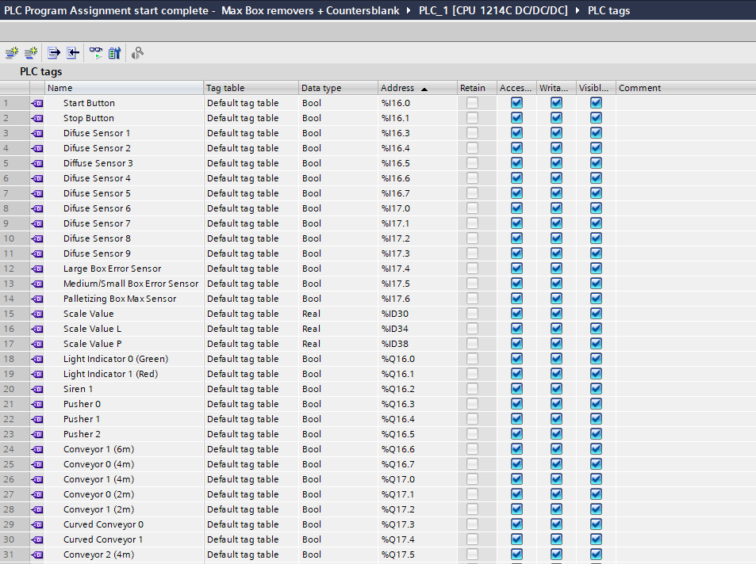
Figure 1 - PLC Tags 1-31 of PLC ladder diagram

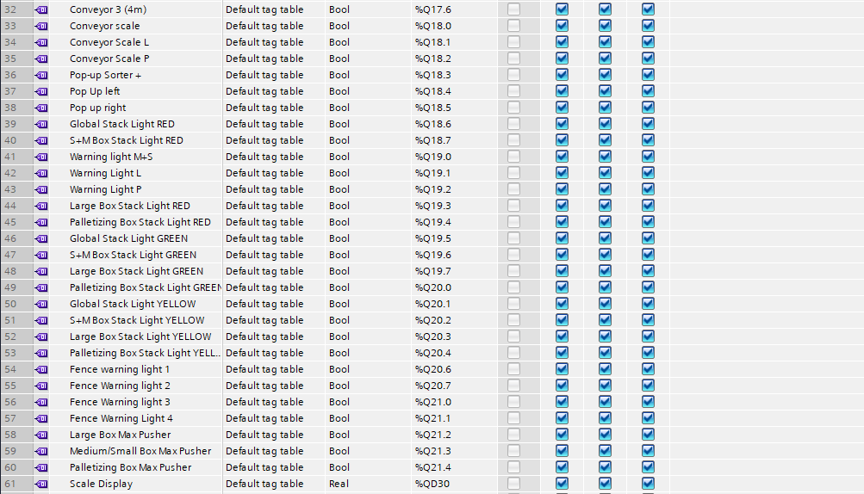
Figure 2 - PLC Tags 32-61 of PLC ladder diagram

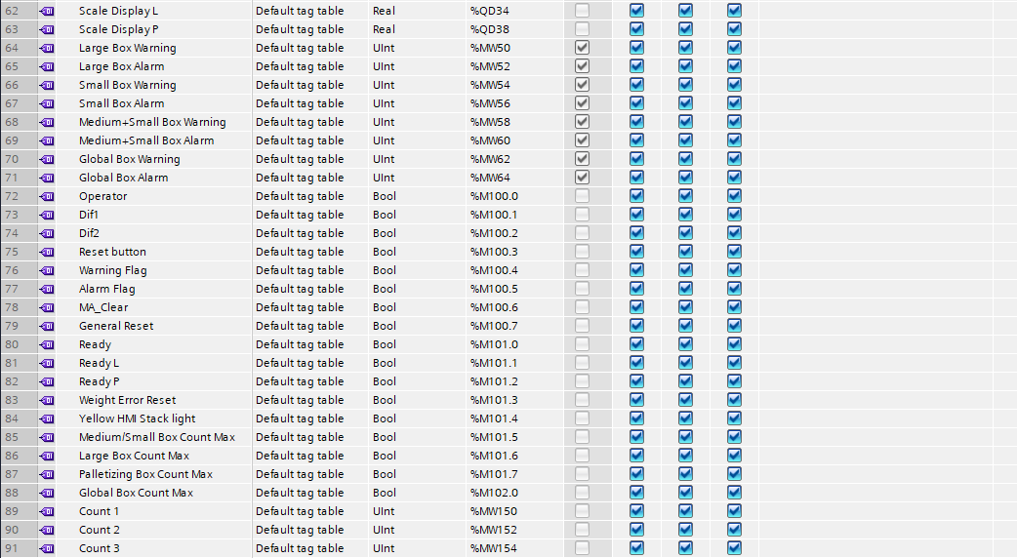
Figure 3 - PLC Tags 62-91 of PLC ladder diagram

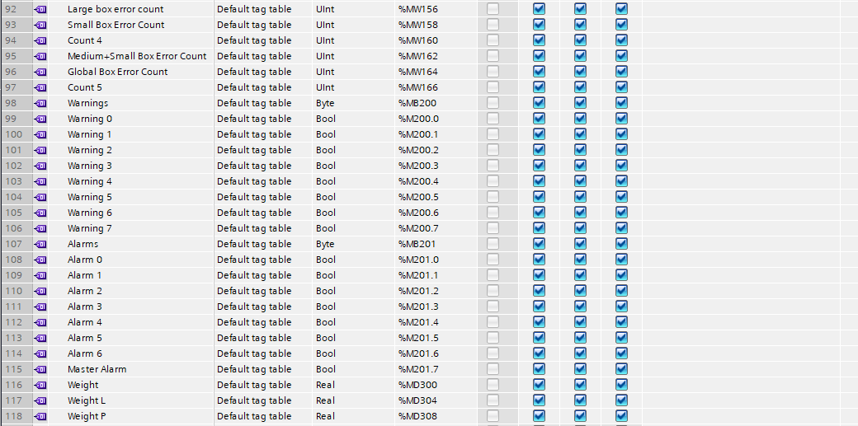
Figure 4 - PLC Tags 92-118 of the PLC ladder diagram
There is a total of 118 tags within this system with different address tags. The address tags range from inputs, outputs, Memory bits, Memory words and memory bytes, output words, output double words and memory double words.

The inputs ‘I’ and the outputs ‘Q’ correspond with the inputs and outputs placed on the driver of the PLC used within Factory I/O. The factory I/O driver and the corresponding tags are shown in Figures 5 and 6. When setting the tags to a function within Tia 16, the true or false value of the inputs and outputs within factory I/O will influence the ladder diagram and vice versa.

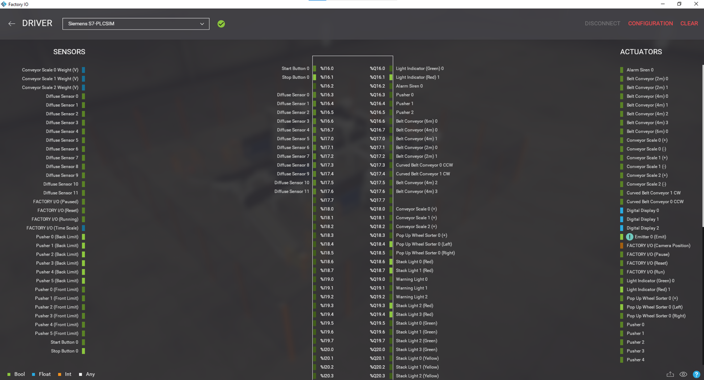
Figure 5 - Siemens S7-1200 PLC Sim within Factory I/O used to set inputs and outputs on the PLC to be simulated

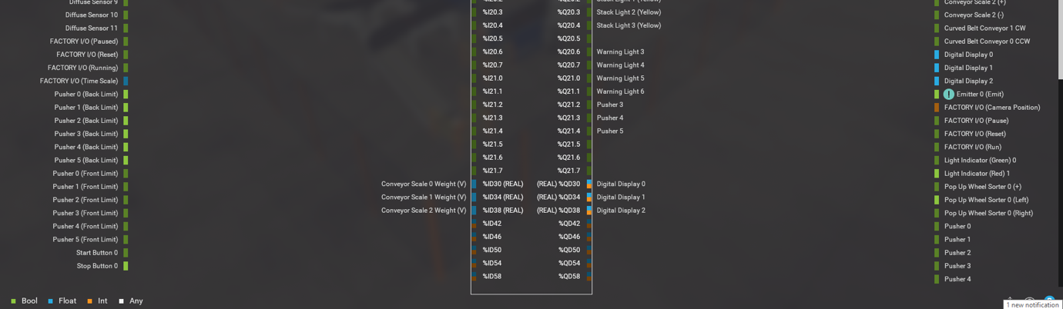
Figure 6 - Siemens S7-1200 PLC Sim within Factory I/O used to set inputs and outputs on the PLC to be simulated continued
The inputs shown on the driver within Figures 5 and 6 are inputs within factory I/O and the outputs are also functions within factory I/O.

The number of bits within the driver was changed to 48 to allow for enough I/O’s within the program. As a byte is 8 bits the number of bits needs to go up in 8s when adding more bools that’s how 48 bits was given for the driver as shown in figure 7.

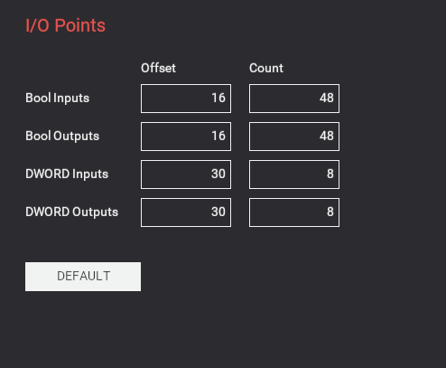
Figure 7 - Offset number of the PLC driver + number of bools for the inputs and outputs
Within the PLC tags for this programme, there is also data types such as memory words, memory bits, memory bytes, output words, output double words and memory double words.

The memory bit is used to store a temporary digital logic result, which can be caused by any of the I/O’s in the programme. They’re not physical Inputs or outputs. Memory bits are required to use the HMI to correspond with the PLC.

Memory words (MW) within the PLC tags go up in address numbers of 2 due to there being 2 bytes per MW. Memory double words (MD) go up in address numbers of 4 due to there being 4 bytes per MD. Within figure 4 you can see the warnings PLC tag is MB200. This allows all the warning bits to be within the memory byte 200. Which is useful when programming. [3] [4]

PLC Ladder Logic build

With the use of Tia 16 the PLC ladder logic could be created. This software is a programming language that is created to control industrial control applications. Numerous programming languages could be used but ladder logic is the one used within this process build.

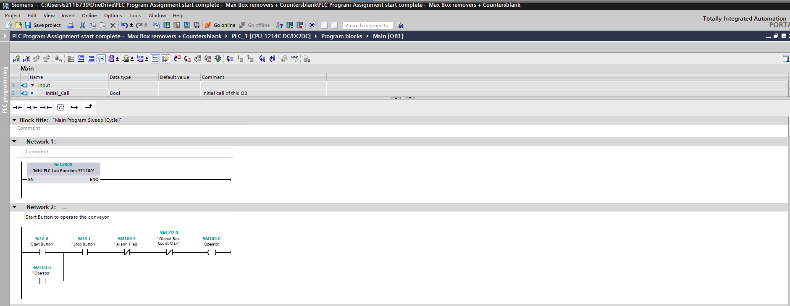
Figure 8 - Rung 1 of the PLC ladder logic showing the start and stop commands

Rung 1 of the ladder logic within figure 8 is how the process would start. Using a normally open (NO) contact which can be closed by a switch on either the panel within factory I/O or on the HMI root screen. This would activate the memory bit output “operator” which latches itself on in till it's broken by either the “stop button”, “alarm flag” or the “global box count max” being pressed, as they’re normally closed (NC) contacts and get broken once they turn true.

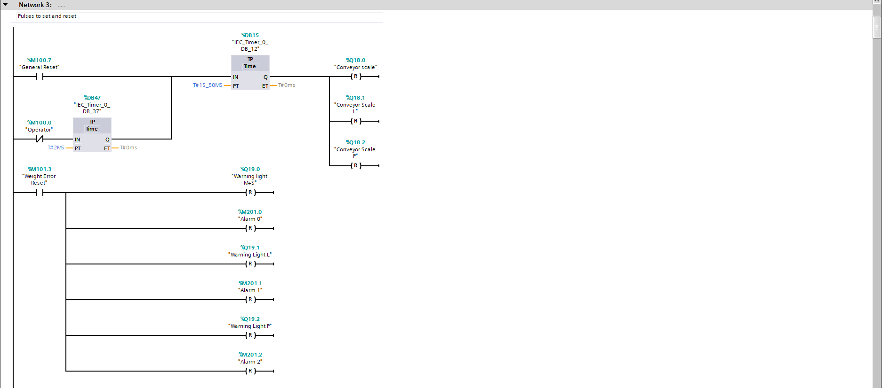
Figure 9 - Rung 3 of the PLC ladder logic, using inputs to reset outputs of different components in the PLC programme

In figure 9 a “general reset” memory bit was created as a tag which could close the normally open input when pressed on the HMI. This would set the time pulse to start which is 1.050 seconds long. This allows the signal to stay true for that duration of time after the input has been pressed. This is used to reset all the conveyor scale outputs, which get set further along the ladder logic. Also as the “operator” is normally closed, when the machine stops, this will also send a true signal to the time pulse to reset the conveyor scales of each of the boxes. This will give a 2mS time pulse. A memory bit input called “weight reset error” is a button on the HMI in figure 37, this is pressed and closes the NO contact to reset all warning lights and alarms that are given off when one of the conveyor scales receives the wrong weight box down them. Pressing this button will also reset the weight on the scales to 0.0 to continue the process once the wrong box has been removed from the conveyor as shown in figure 10.

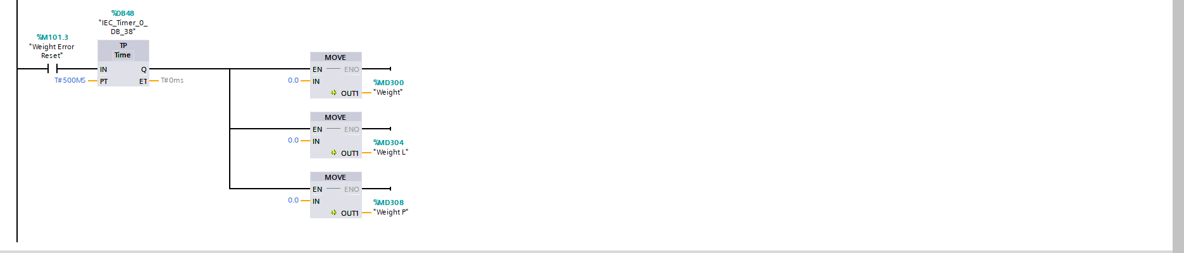
Figure 10 - Rung 3 of ladder logic progressed, with a weight error reset button resetting the weights

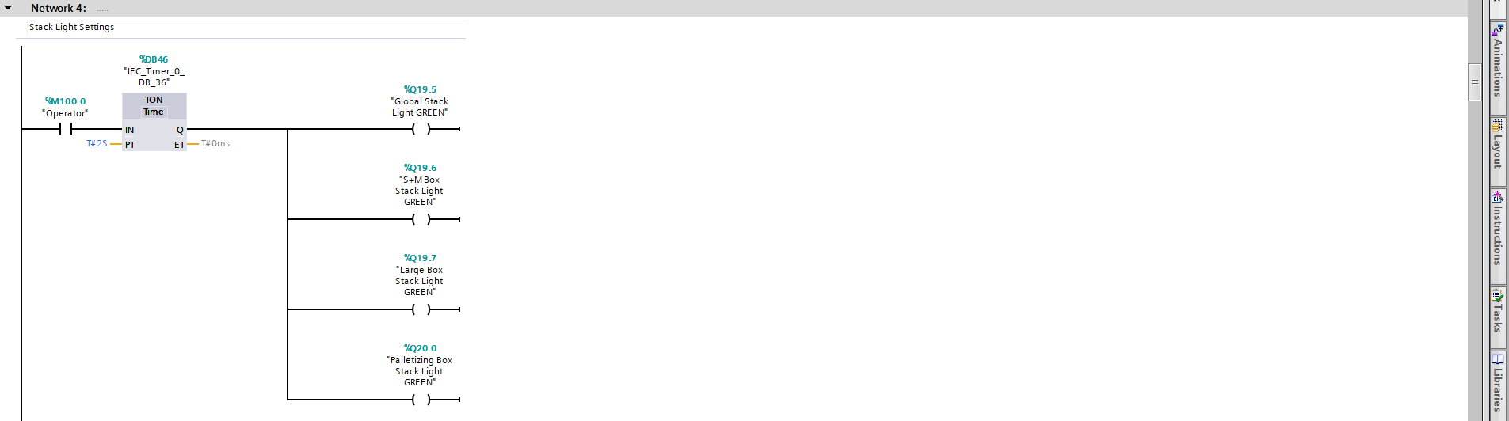
Figure 11 - Rung 4 consisting of The functions to control the stack lights green light


Figure 12 - Rung 4 showing operator tag functioning different stack light coloured lights

Figure 11 and 12 is rung 4 which consists of the functions to control the different coloured lights on the stack light. When the operator memory bit becomes true, it sets a time on pulse of 2 seconds before the green light of each of the stack lights can be turned on to show that the process is operating. When the tag operator is false, the NC will be active allowing the Red light on the stack lights to be on, showing the process being off.

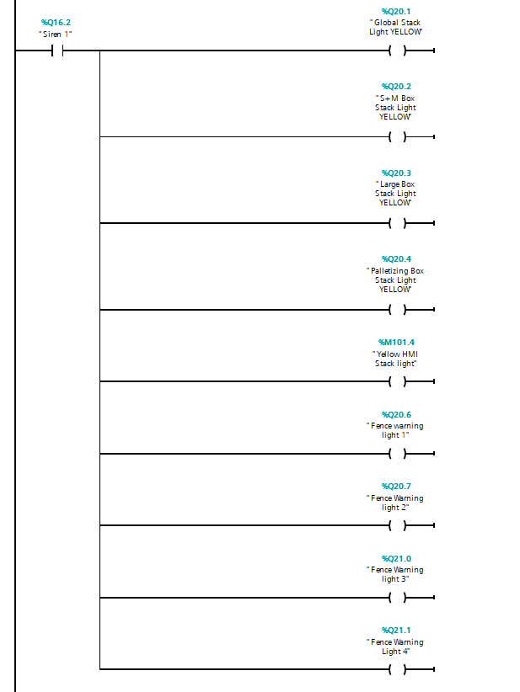
Figure 13 - Rung 4 showing the outputs given when the NO siren 1 contact is closed

Figure 13 is rung 4 continued which shows that when the siren is active, which is only active for 2 seconds shown in figure 15 each of the fence warning lights and amber-coloured stack lights will be on to show the process is starting.

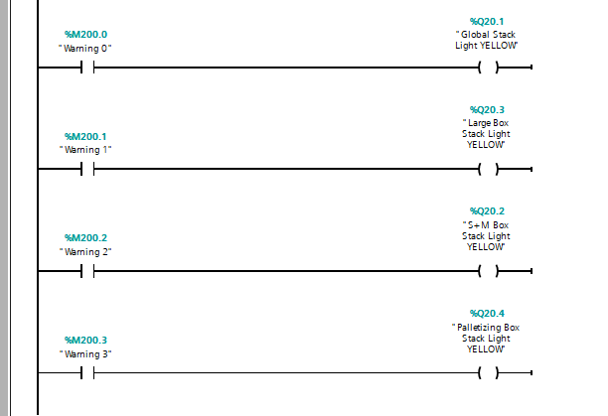
Figure 14 - Warning inputs given from error in the box counts which give an amber light output on the stack light local to the conveyor

Within figure 14, rung 3 continued with the input to become true which would light the amber-coloured light on the stack light local to each of the conveyors, this was to happen when either of the numbers of the box count errors had reached its warning number, it would then light the stack light local to it to notify the personnel what conveyor the error is on.

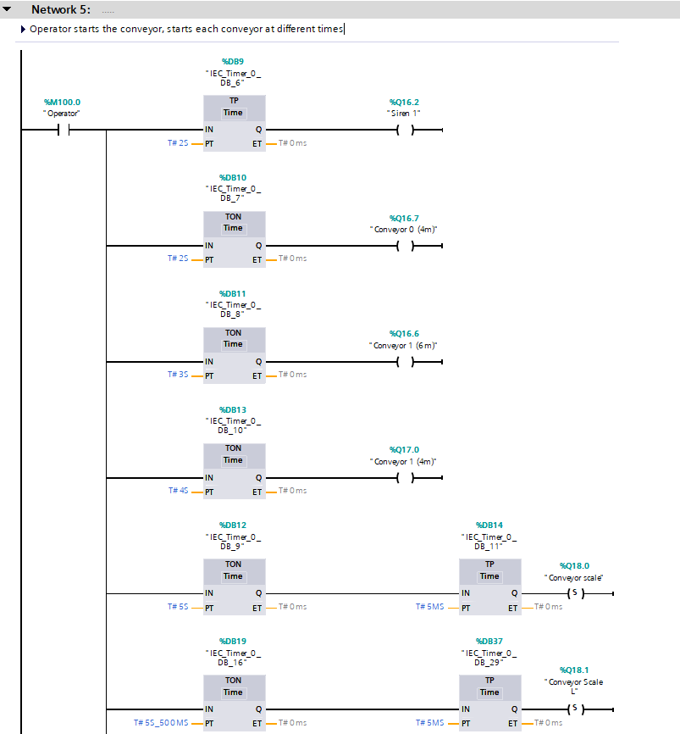

Figure 15 – Rung 5 showing when the operator tag is true all the Time on timers turn on each conveyor in sequential and not the same time

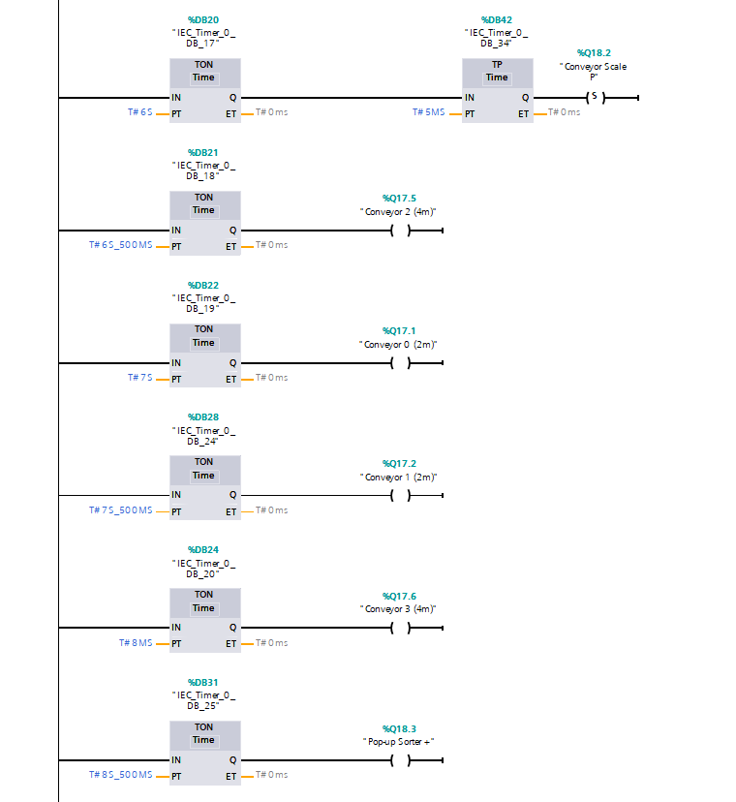
Figure 16 - Rung 5 showing when the operator tag is true all the Time on timers turn on each conveyor in sequential and not the same time

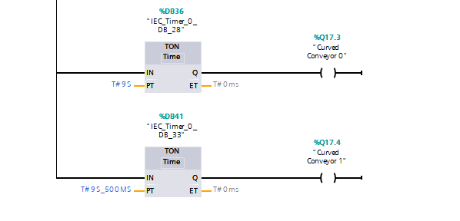
Figure 17 - Rung 5 showing when the operator tag is true all the TON timers turn on each conveyor in sequential and not the same time

Figures 15, 16 and 17 show how all the conveyor outputs within factory I/O are controlled. When the NO contact “operator” becomes live due to the start button being pressed, each conveyor will come on after the TON timer is complete. A TON is a timer that doesn’t give an output until it receives an input, and the time set is complete. This was helpful to set up so that all the conveyors started slightly after one another so there wasn’t a big surge of current required at start-up. Each of the scale conveyors will receive an output to set them on but only as a pulse for 5mS due to them needing to be reset elsewhere.

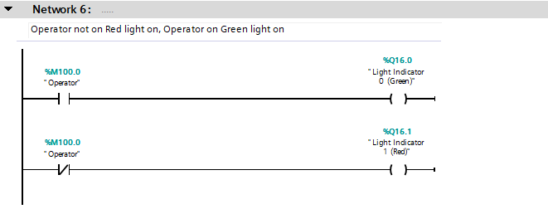
Figure 18 - Indicator lights within factory I/O to show if the process is running or not

Figure 18 is the outputs for the light indicators on the panel within factory I/O, being controlled by whether the operator memory bit tag is true or false.

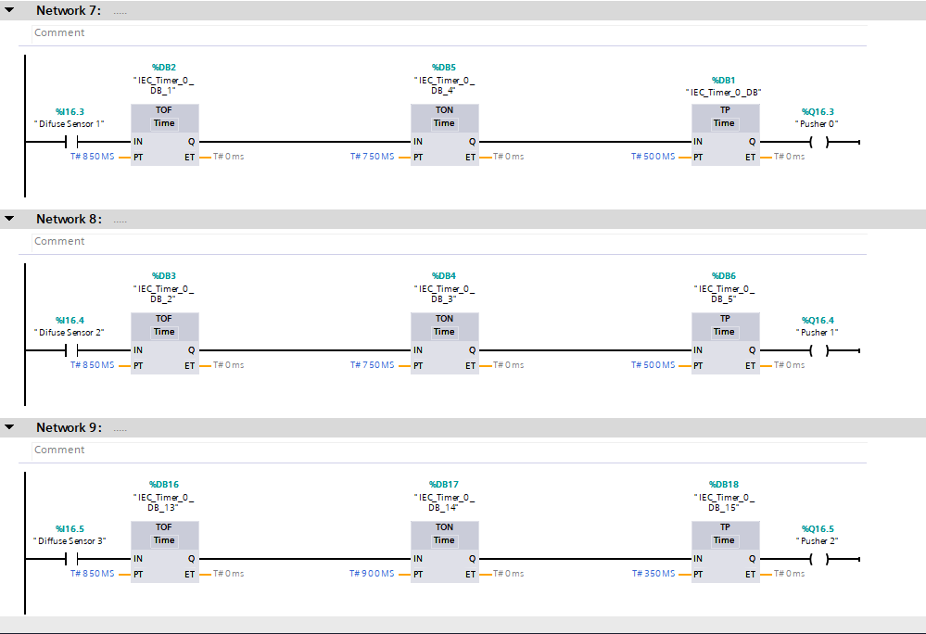
Figure 19 - Rung 7, 8 and 9 showing the functions that control each of the pushers that push the box's down to the correct conveyors
Figure 19 shows rungs 7,8 and 9 which are what control the 3 pushers that push the boxes down the conveyors. They feature 3 different timers which control the pusher's timing from when the input sensors are triggered by the boxes. When the input sensor is triggered, a TOF timer allows the sensor's input to stay active for the set time which is 850mS. This then moves on to the TON timer which holds it for 900mS before allowing an output, this allows the box to go from the sensor to in line with the pusher before it's set active. The time pulse is used as it allows the pusher to stay active for the set time of 350mS, enough time for it to extend out enough to push the box and then go back in.

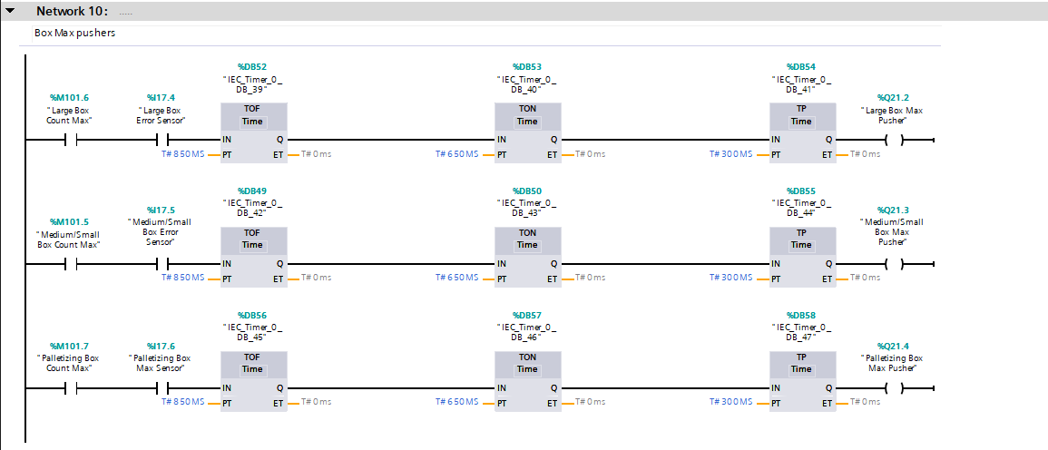
Figure 20 - Example of rung 10 showing the pushers which control pushing the boxes off when the max box count has been met
Figure 20 shows the pushers that become active once the max box counter of each size box is met. The memory bit outputs in Figures 21 and 22 become active allowing the NO contacts on rung 10 to close and then when the sensors triggered for the pushers are true, the same time sequence that's used in figure 19 is done to then push each of the boxes off the other direction so that the set number of boxes only go down the conveyors to be weighed.
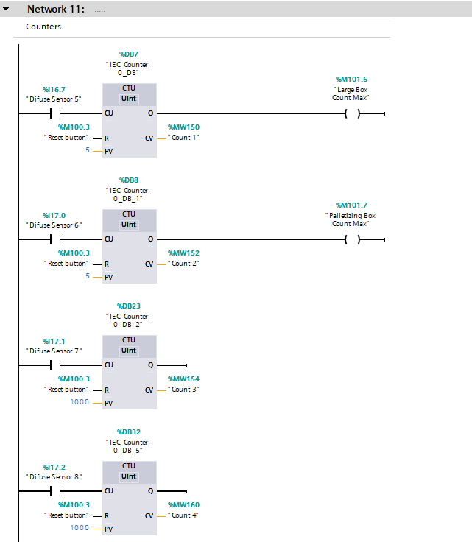

Figure 21 - Counter functions to count the number of times sensors were triggered to get a box count and to use for the error box count also
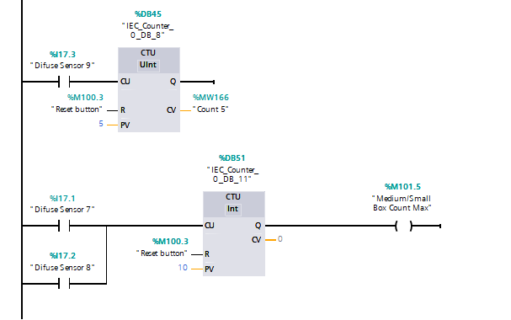
Figure 22 - Counter functions to count the number of times sensors were triggered to get a box count and to use for the error box count also

Figures 21 and 22 involve using counters to count the number of times a sensor has been triggered. These counts will allow the counting to be displayed on the root screen of the HMI shown in figure 34, The number of counts allowed for this process was 5 boxes for the large and palletizing box, and 10 for the medium and small boxes before the boxes need to be manually taken to the next location and the process restarted. When these numbers were met the counter would give out an output which is a memory bit which allows the max box count pushers to be triggered in figure 20. The counters need to be UINT because the counts are memory word bits which are 2 bytes.

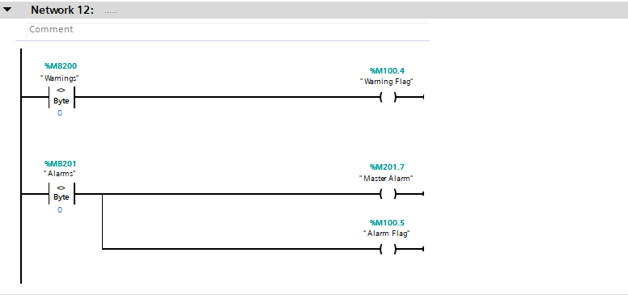
Figure 23 -Memory byte for Warnings and Alarm memory bits within the byte controlling outputs
Figure 23 inputs use a comparator function with the PLC tag type Memory byte. Within these memory bytes are 7 bits which are marked up as alarms or warnings, if either of these bits within the bytes becomes greater or lower than 0 it will set an output on the memory bit outputs in rung 12.

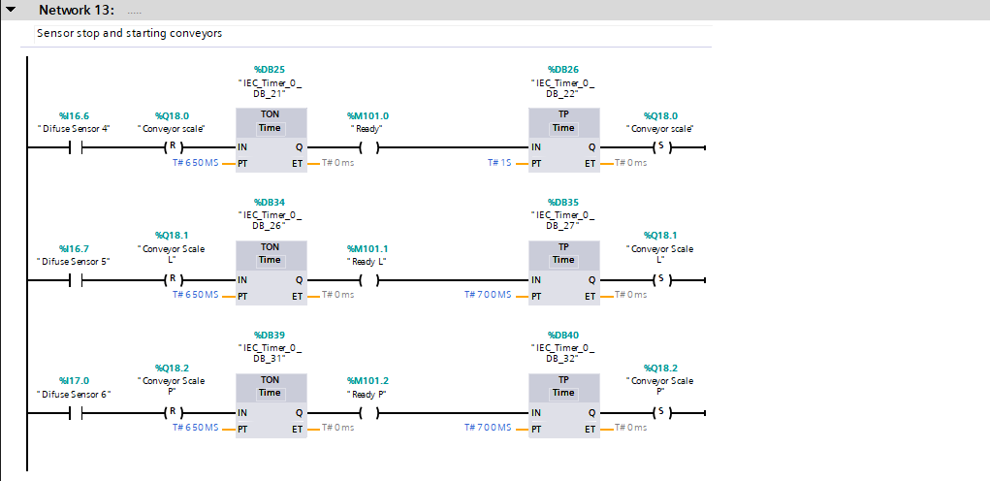
Figure 24 - Sensors used to stop and start the scale conveyors to take the weight value needed
Figure 24 is rung 13 which controls the stopping of the scale conveyors for the weight value of the boxes to be taken in rung 14. When the sensor is triggered the conveyor scale will be reset. The “ready” memory bit tags will be held on for 650mS, enough time for the weight to be taken, then the conveyor scales are back set again with a TP timer of 700mS and 1 second to allow the box to move out of the way of the sensor when its set again or the scale will reset

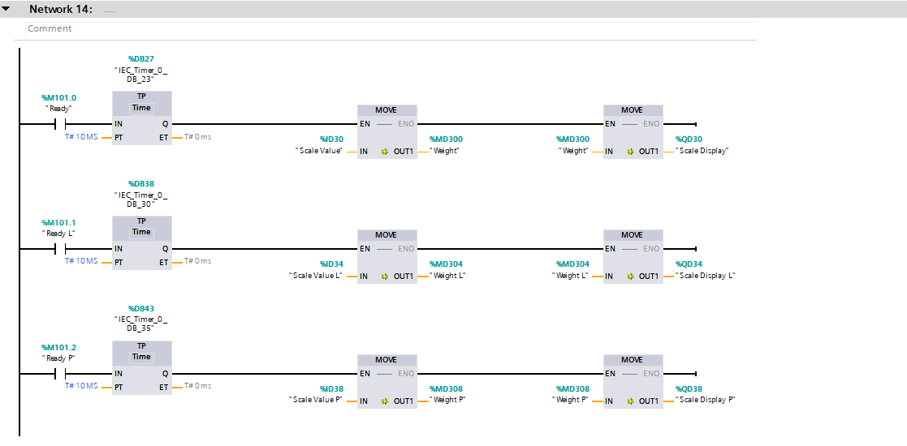
Figure 25 - Inputs used to display the scale value on to the scale + HMI
Figure 25 shows rung 14 when the input received from rung 13 closes the ready NO inputs and allows the timers to be set to measure the scale of the conveyor to place onto the digital display + the HMI.

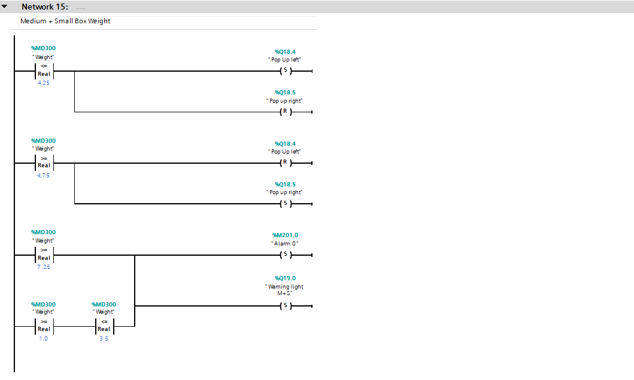
Figure 26 - Weight error controls to set alarms when the medium + small box conveyor receives a wrong weight box
Figure 26, 27 and 28 shows comparators used with set numbers of comparator inputs. If the weight is either greater or less than the number inputted the input will be true and send a signal to the relevant outputs to set alarms on and warning lights on. The alarms and warning lights for weight will then be reset when the weight error reset button is pressed as shown in figure 9. Also the small and medium boxes are sent to the relevant conveyor using this method by setting and resetting the pop-up conveyor right or left depending on the weight.

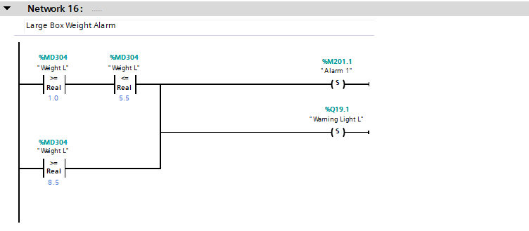
Figure 27 - Rung 16 showing the controls to set an alarm and warning light if the large box weight is incorrect

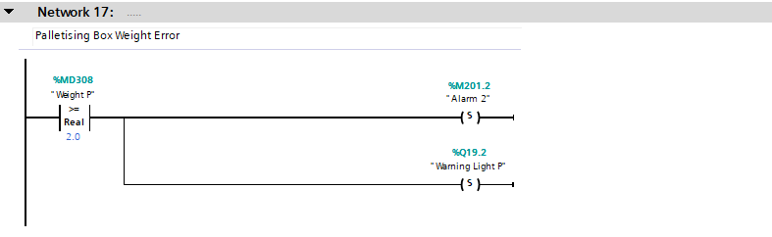
Figure 28 - Rung 17 showing the controls to set an alarm and warning light if the palletizing box weight is incorrect
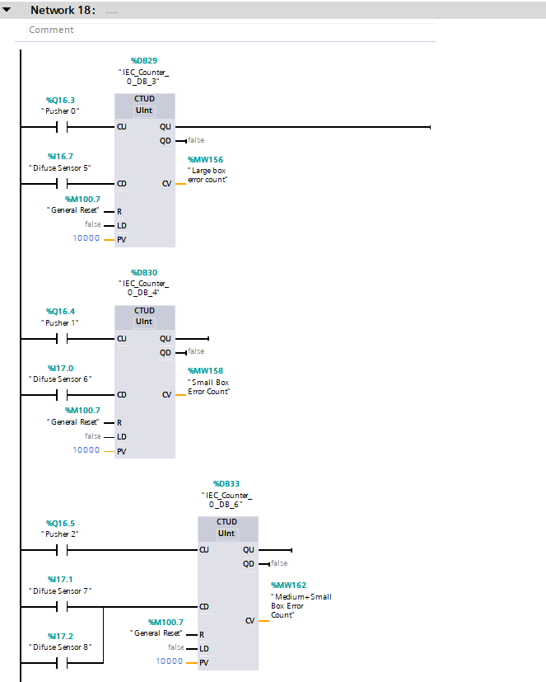
Figure 29 - Rung 17 is the counters that count the boxes up and down for the error box counts
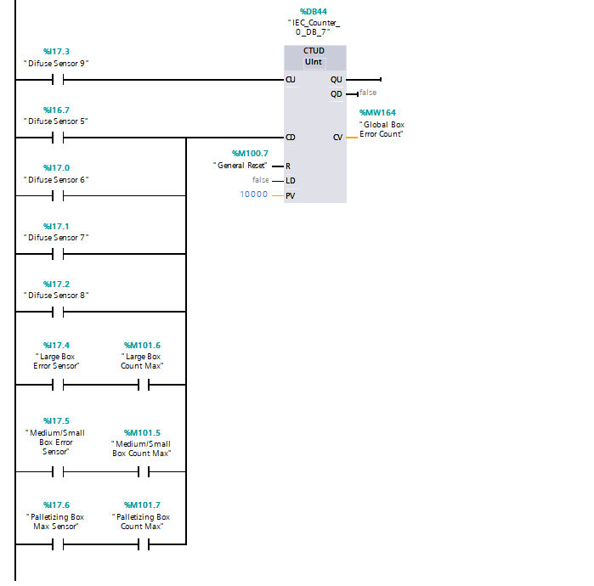
Figure 30 - Rung 17 progressed showing the global error box count max

Figures 29 and 30 are rung 17 which show the counters that will be used for error box counts. The counters will count up when the relevant sensors are triggered and count down when the final sensors are triggered to show the box has made it through the process. This will then work with the values set on the HMI in figure 36 and set warning lights and alarms when the number of boxes set don’t go through. When the box count max is met, different sensors will do the counting down for the boxes.

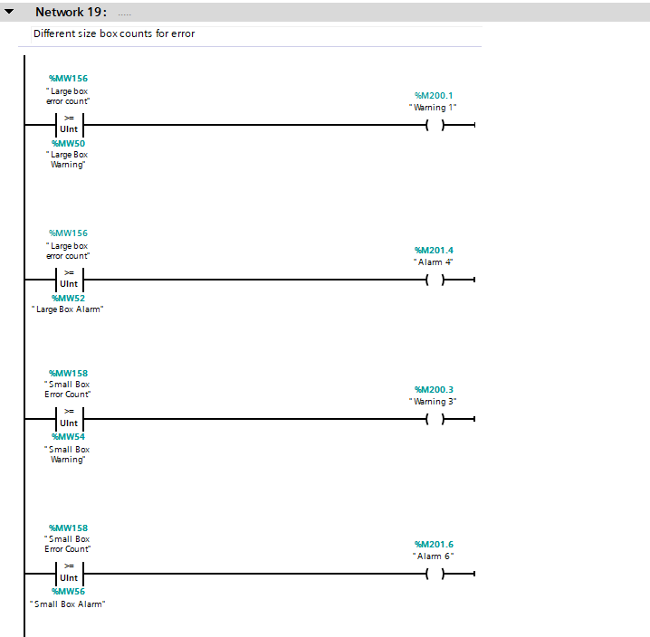
Figure 31 - Rung 19 Large box and palletizingl box warning and alarm counts
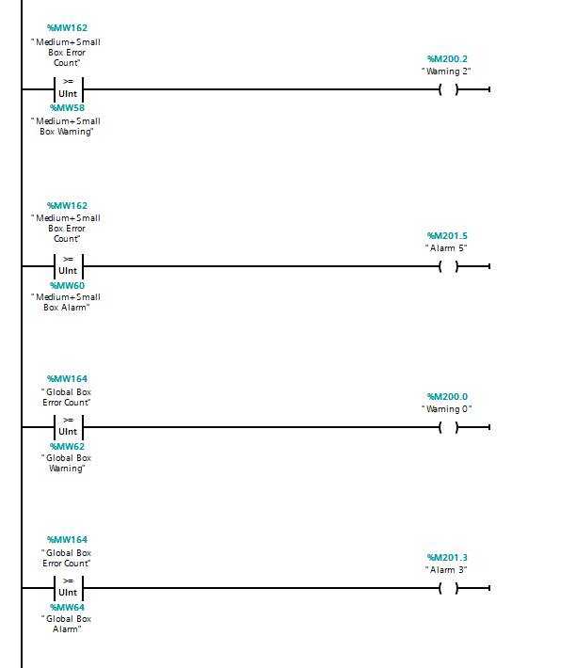
Figure 32 - Rung 19 Small+Medium and global box warning and alarm counts
Rung 19 is the different comparators which set the alarm or warning bits. The comparators are set for the value to “equal” to and use the memory word PLC tag. The PLC tags are linked with the number boxes in the HMI in figure 36 If the errors then become equal to the set warning and alarm numbers, the corresponding warning light or alarm will flag and cut off the circuit.

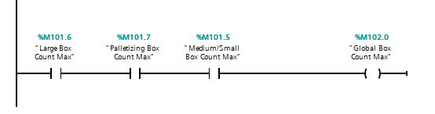
Figure 33 - Rung 3 displaying the controls which set the output to stop the circuit once the global box count max is met
Figure 33 is the controls within run 3 which allows output “global box count max” to become active once the other NO contacts become NC. This output breaks the rung 2 operator output and causes the process to stop till the boxes have been cleared and the “reset” button is pressed on the root screen.

HMI Screen

The HMI Screen allows the Process to be controlled electronically on a screen away from the location of the process. It also allows alarms and warnings flagged within the process to be highlighted on the HMI.

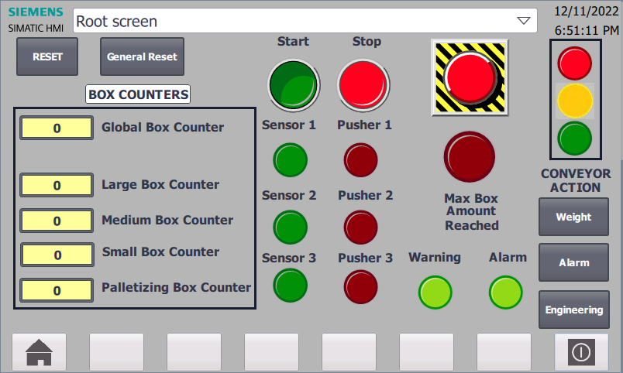
Figure 34 - Root screen of the HMI which will control the PLC
Within the root screen, the counters can be seen which will allow the user to see exactly how many of each box has gone through, and when each size box has reached the max amount set. The start and stop can be used to start the process as well as stop it and the emergency stop can be pressed to fully stop the process when needed. The reset button used resets the box counter figures while the general reset button resets the error box counters and the scale conveyors. When each of the sensors that trigger the pushers are active they illuminate the sensor lights, and the pushers active illuminate the pusher lights. When the Max box amount is reached, or a warning or alarm is triggered the lights illuminate to show the operator. The weight, alarm and engineering buttons take the operator to the relevant screens.

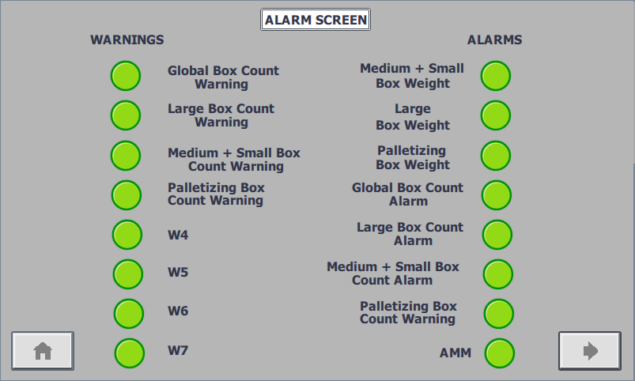
Figure 35 - HMI Alarm screen
Figure 35 is the Alarm Screen on the HMI has indicators that light red whenever the relevant alarm or warning is flagged within the process, allowing the operator to see where the faults have occurred. The arrow bottom right leads the HMI to the next page.

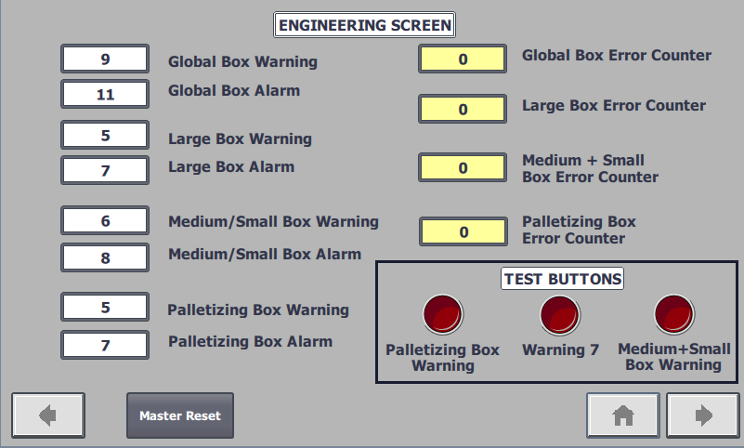
Figure 36 - HMI Engineering screen

Figure 36 is the engineering screen on the HMI. The Engineering screen has test buttons that can be used to test out warnings and alarms. Also, the warning and alarm values set are shown on the left which are how many box errors there can be in till the warning is flagged and then the alarm that will stop the process. The boxes on the right will do the counting for each of the boxes.

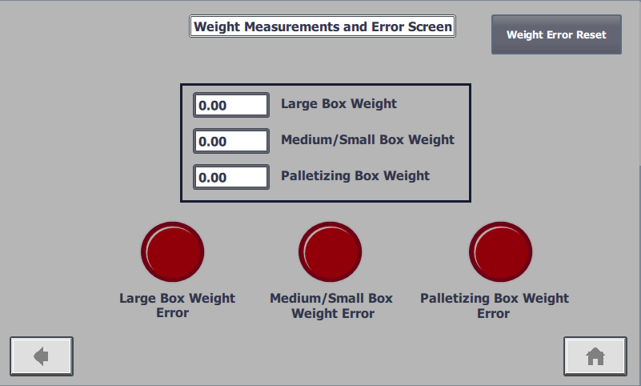
Figure 37 - HMI Weight measurements & Error screen
Figure 37 is the weight measurements & error screen which allows each of the scale conveyor weights to be displayed on the screen, as well as whenever the scales receive a weight that they’re not meant to receive, the warning lights will indicate where the error weight is at. The weight error reset is pressed once the wrong weight box is removed from the conveyor scale.

Factory I/O Build

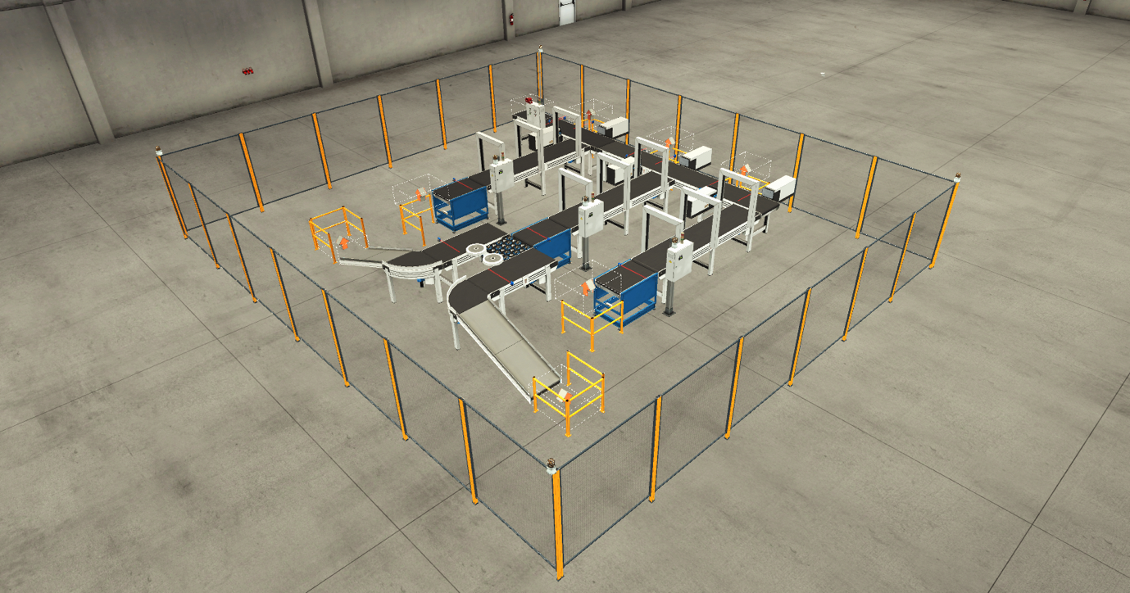
Figure 38 - Factory I/O Build overview
Figure 38 is the factory I/O build that the PLC programme is going to be controlling. All of the inputs and also outputs of the system can be seen within this software and controlled. There are removers and package emitters to remove the boxes and add the boxes automatically to the process.

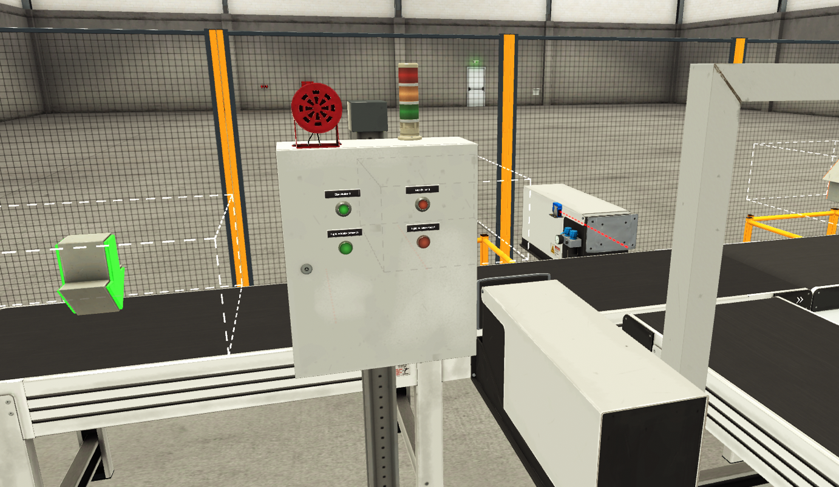
Figure 39 - Manual Panel local to the conveyors to control the Process
Figure 39 shows the manual panel local to the conveyors, where the system can be started and stopped. It also has a red and green light on it to display whether the system is running.

Alarm and Warning Strategy of the Process

For any machine process or system, there are always procedures put in place to ensure that the system knows when to strike a warning or Alarm. Errors can come in the form of mechanical errors such as measurements or precision. It’s important to have a system in place otherwise the build-up of errors can cause disruption to production or even damage some of the process/machinery down the line.

There are lots of different ways to set warnings and errors. In the process, if the equipment or is very important and producing or exporting expensive equipment, the error allowance is going to be very small due to the large risks of even one item being missed or damaged. If the factory process was manufacturing cars, the risks are a lot higher, with the weight and price of car body parts, potentially damaging the machinery or just the parts being damaged themselves. There are also larger risks to car manufacturing companies such as production risks, if there were errors in production, new cars being manufactured will be delayed and not released at the initial dates set. Therefore, large car manufacturing processes will have warnings and alarms set all over to ensure that these problems don’t arise, they are crucial to a manufacturing process and especially within a PLC system. [1]

The PLC process ladder control diagram created had numerous warning and alarm systems to ensure maximum safety of the machinery and personnel in the area.

The main warning strategy involved counting boxes and setting a warning threshold and an alarm threshold. These warnings and alarms covered the Large, medium, small and palletizing boxes as well as a global box count to cover all of the boxes in the process.

An acceptance of box errors was calculated to allow 3 boxes not to pass through before a warning and 5 boxes before the system stops and alarm is set. As the lengths between the count of some boxes and the countdown of some boxes were slightly longer, some of the sizes required a larger number. The calculated numbers are shown in figure 36.

Depending on what box had a warning or error count, this was displayed on both the HMI and on the stack lights on top of the local panel to each of the different size boxes. When a warning was displayed, the stack light amber light would be displayed as shown in figure 1 and when the alarm was reached the stack light red was lit with the system stopping as shown in figure 2. Both these lights would also be displayed on the HMI on various screens such as the root screen in figure 3 and the alarm screen in figure 4, where the warning light of the global count was also met. The system could not be restarted until the “general reset” button was used on the root screen of the HMI shown in figure 3. This would reset the error counting counters. The “Master Reset” button on the engineering screen in figure 36 would then need to be pressed to fully reset the system so that it could start again. The master reset cannot be used in till the alarm and warnings are reset. This system is in place for all of the different types of boxes and allows the workers to distinguish what conveyor is causing the most errors and rectify the problem before carrying on with the process.

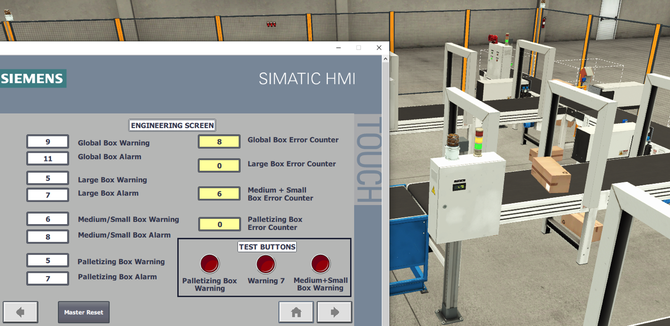
Figure 40 - Medium + Small Box Error counter warning reached and amber light on stack light set on

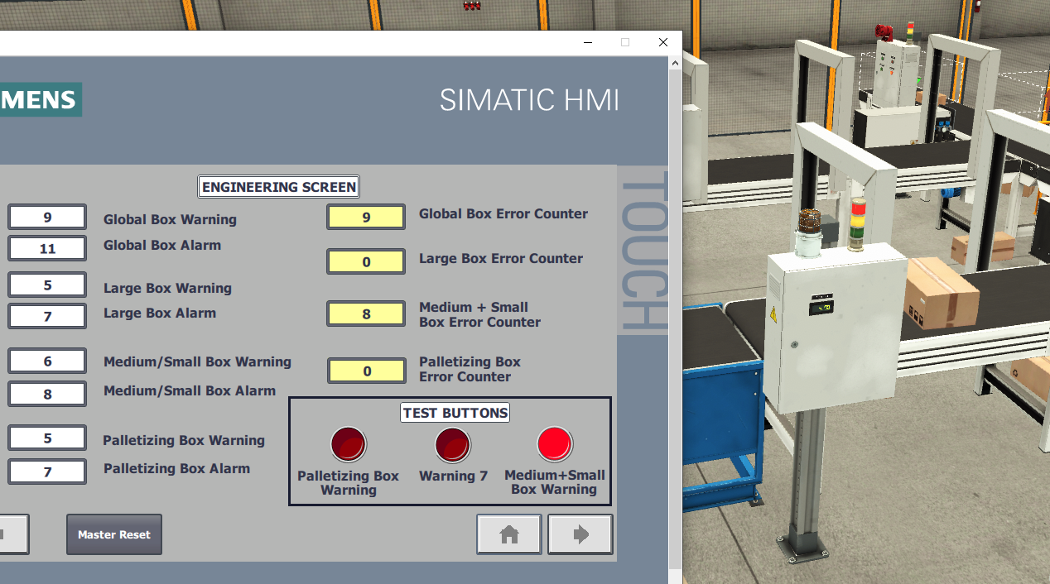
Figure 41 - Medium/small box error alarm reached with system stopping and stack light displaying red light

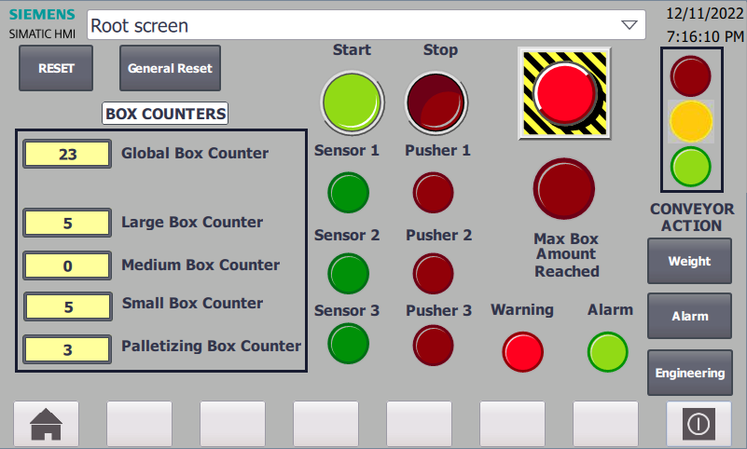
Figure 42 - Warning Light displayed red once any of the size box's error count reaches the warning value

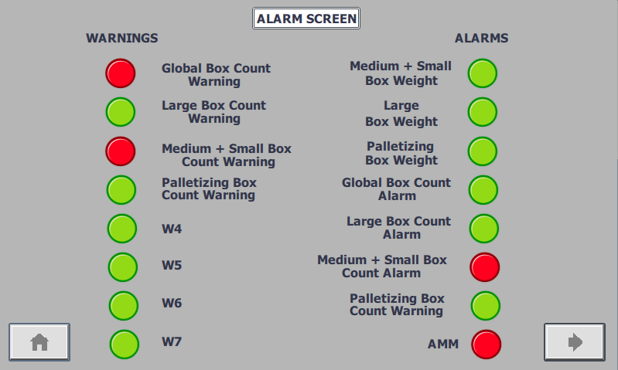
Figure 43 - Alarm screen displaying Warning lights and Alarm lights of wherever the warning or alarm is within the process, as well as the master alarm being on

The next alarm strategy is to do with the weight of the boxes. Each box gets placed down the correct conveyor before getting weighted to ensure it is the correct box to go down that conveyor. All of the boxes have a set weight therefore it is easy to set the system up to cause alarms if the correct box weight isn’t met. If either a large box or palletizing box was to go on to the medium/small box conveyor scale, it would stop the process and the warning light above the panel local to that conveyor scale would be set off to tell the workers where the problem has arisen as shown in figure 44. Figure 45 shows the weight screen showing where the weight error is. When the box has gone down the wrong conveyor, it must first be manually removed, before the weight error reset button can be pressed in figure 45. This system applies to all box-size conveyors with conveyor scales.

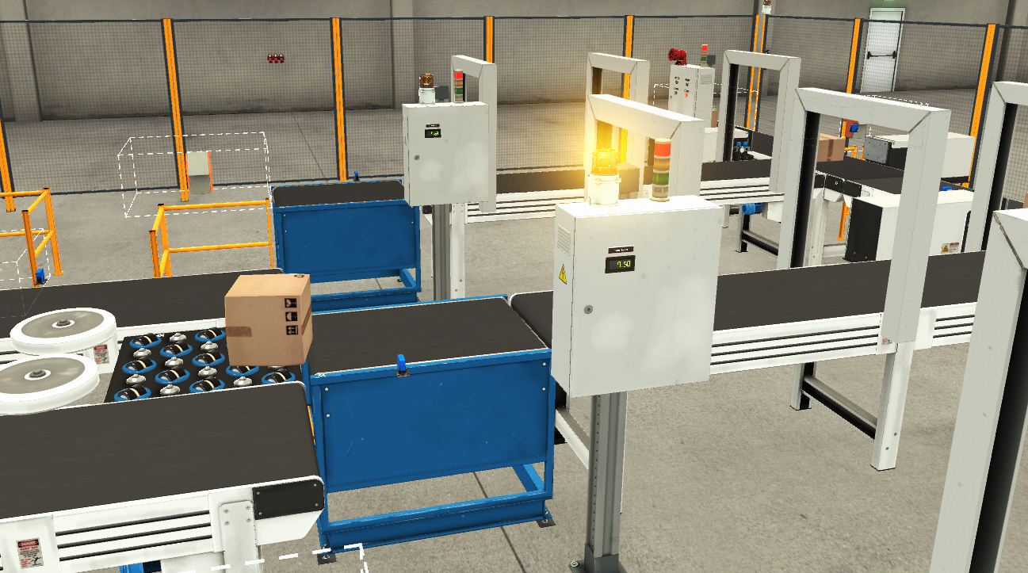
Figure 44 - Large box has gone down the medium/small box conveyor causing an error to arise and warning light to turn on and the system to stop
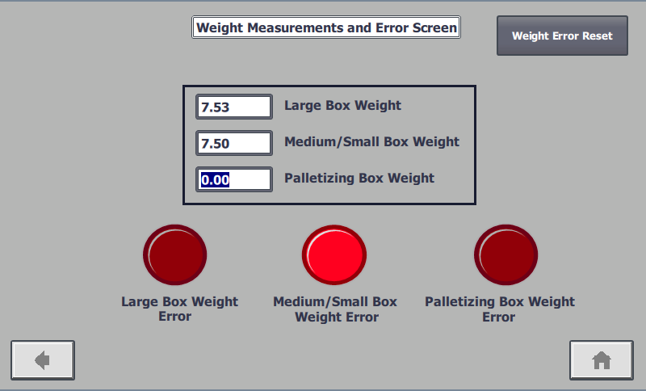
Figure 45 – Weight Measurements and Error screen on HMI showing the box weights on each conveyor and where an error has occurred from

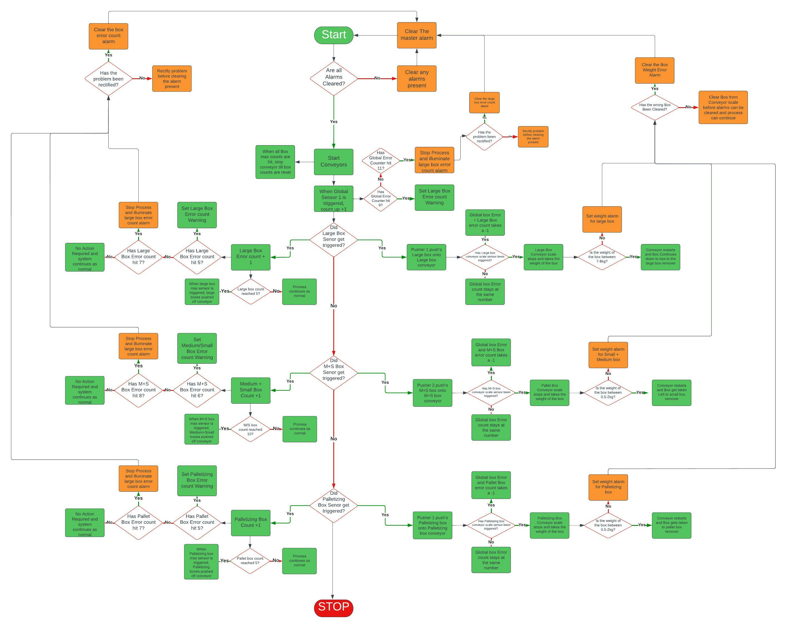
Flow Chart
Figure 46 - Flow Chart of the PLC Programme built

The Flow Chart shown in
Figure 46 is the steps of the process that controls
The PLC programme and
build within factory I/O.
each of the steps carried
through the flow chart
must be true before the next step can be continued.

References

[1] | C. Gilbert, “Continuing education workforce training - Advantages of a Modular PLC Over a Fixed PLC?,” 19 08 2014. [Online]. Available: https://blog.cetrain.isu.edu/blog/bid/353287/advantages-of-a-modular-plc-over-a-fixed-plc. [Accessed 14 12 2022].
[2] | “Electrical Volt - Difference between Compact PLC and Modular PLC,” [Online]. Available: https://www.electricalvolt.com/2022/08/difference-between-compact-plc-and-modular-plc/. [Accessed 15 12 22].
[3] | J. G. (. Todora, “The PLC Tutor,” 11 November 2009. [Online]. Available: http://theplctutor.com/cntrllgxmem.html. [Accessed 10 12 22].
[4] | M. B. Tanoy Kumar Paul, “Industrial Data Communication - PLC and External Application,” in 2016 International Conference on Industrial Engineering and Operations Management, Kuala Lumpur, 2016.
[5] | M. H. Häntsch, A. Identifying, analyzing, and assessing risk in the strategic planning of a production network: the practical view of a German car manufacturer., Springer-Verlag Berlin Heidelberg, 2013, p. 133.

