
Skills for the Workplace
Module Assignment Submission
Student Name: | |Andrew Mc Kay
Student Number: | 2014519
Module No: | BMSK4005
Module Title: | Professional Career Development

Statement of Confirmation of Authenticity
By the act of making this submission, the student declares that this is the work of the student named above. The work has not, in whole or in part, been knowingly presented elsewhere for assessment, or where assessment has been built on a previous assessment, this has been identified. Where materials have been used from other sources it has been properly acknowledged. If this statement is untrue, the student acknowledges that an assessment offence has been committed.
Attention is drawn to the plagiarism and unfair practice policies of both the University and of ILM.

Table of Contents
Section 1: Know how to identify development needs 3
1.1 Identify learning styles for self and another 3
1.2 Use a simple technique for identifying development needs for self & another 4
1.3 Identify potential barriers to learning for self and another. 5
1.4 Explain how these barriers to learning can be overcome. 6
Section 2: Know how to develop self & others to achieve organisational objectives 6
2.1 Analyse learning/development options to meet needs of self & another. 6
2.2 Identify support mechanisms for the development of self & another 6
2.3 Prepare development plans for yourself and another person 7
2.4 Method used to monitor the development of self & another. 8
Section 3: Know how to prepare for the recruitment process 8
Reflection on the recruitment process 8
3.1 Description 8
3.2 Feelings 9
3.3 Evaluation 9
3.4 Analysis 9
3.5 Conclusion 9
3.6 Action Plan 9
References 10
Appendix A 10
Appendix B 10
Appendix C 10
Appendix D 10
Appendix E 11

Section 1: Know how to identify development needs

Identify learning styles for self and another
It is recognised that students have a variety of learning styles. The VARK inventory (VARK is an acronym for visual, aural, read/write, and kinaesthetic learning modalities) is easy to use and can give students information on how to maximise their learning as suggested by (Marcy, 2001).
The VARK learning style was firstly described in a1992 study after many thousands of hour student observation by Neil D. Fleming and Coleen E. mills as suggested by research at (University of Kansas, School of Education and Social Sciences, 2019)
Flemings research in 1995 looked at the VARK and under the identified headings they explained how the different learners were best served to maximise their learning experience. They are as follows, suggested by (Leung et al, 2014); Students with a
- Visual preference learns best from presentation of materials using graphs, charts and diagrams
- Aural learners prefer to receive information through listening;
- Read/write learners prefer to take in information through writing and reading from printed words;
- Kinaesthetic learners gain better understanding of materials through concrete examples and applications.
The article goes on to say that the “most recent version of the VARK questionnaire consists of 16 questions and identifies a person’s preferred method or mode of presenting and processing information.”
The learner has undertaken a VARK questionnaire (VARK Learn Limited, 2020), that should best explain their preference, (multiple answers are allowed) but also you can leave blank any questions that do not apply. Under the VARK profile my preferences to learning were as follows: Visual 4, Aural 15, Read/Write 7, Kinesthetic 8.
You can find the writers VARK results in Appendix A.
Honey and Mumford, learning style questionnaire:
The Honey and Mumford learning styles were developed in 1986 by Peter Honey and Alan Mumford. Inspired by Kolb’s learning style model they developed their own (LSQ) They asked about general behavioural tendencies in order for the learner to understand how they learn in order to become an effective learner. The suggestion is that by “Knowing your learning style helps individuals to make smarter decisions in adjusting the learning opportunities and your preference of best learning, increases the range and variety of experiences which are potential learning opportunities, improves learning skills and awareness” (Zwanenberg, 2016).
The student having undertaken a Honey and Mumford questionnaire recognises many traits that that have identified them as an Activist and Pragmatists. The student feels that there can be no argument that they are best when “having a go” or that “role play” has an important part in their learning style. The suggestion that applying what they learn and valuing “the information / ideas that they are given” are key in planning. The planning stage is the most suited to pragmatist’s as suggested by Ault (2020)
Further evidence of the student’s identification to successful learning can be once again found in Zwanenberg, (2016), who suggest without disagreement that: Activists are those individuals who learn by doing. Activists need to get their hands filthy. They have a receptive way to deal with learning, including themselves completely and without inclination in new encounters. The learning activities can be brainstorming, problem solving, group discussion, puzzles, competitions, role-play etc.
The Pragmatists side of the learner is once again caught in the description: These individuals have the capacity to perceive how to put the learning into practice in their present reality. Conceptual ideas and recreations are of constrained utility unless they can see an approach to put the concepts practically in their lives. Experimenting with new ideas, speculations and methods to check whether they work is their mode of action. They learn better through taking time to think about how to apply learning in reality, case studies, problem solving and discussion. (Rumson, 2017)
I completed an analysis of my learning style using VARK (ref) the results of which can be seen in Appendix A.

Although I am happy with the outcome of either of their results with their learning style they feel that Honey and Mumford’s perspectives are close to their own belief’s particularly around the learn least from in their module handout (Ault, 2020) which stated: Learning involves a passive role, i.e. listening to lectures, monologues, reading and watching. Due to Covid19 restrictions, I feel at distance from the classroom environment where engagement and sharing experiences were the norm. I also identified that there are some students who thrive in the “distant learning experience” however they feel this type of learning is somewhat sterile to their experiences, given that they have always been taught in a classroom environment. I feel that although the suggestion is you are in a “learning” room unfortunately you are the only person in that room and sometimes this does not capture that direct intervention/dialogue/experiences with the other students.

SWOT for myself.

STRENGTHS  - Research  - Reflection  - Communication | WEAKNESSES  - Motivation  - Distractions  - Overthinking  - Time management  - IT  - Vocabulary
OPPORTUNITIES  - Personal Development  - Recognised Qualification | THREATS  - Rest  - Recordings  - Brinkman  - Time management  - This type of learning during C19

Use a simple technique for identifying development needs for self & another

SWOT for Person 2
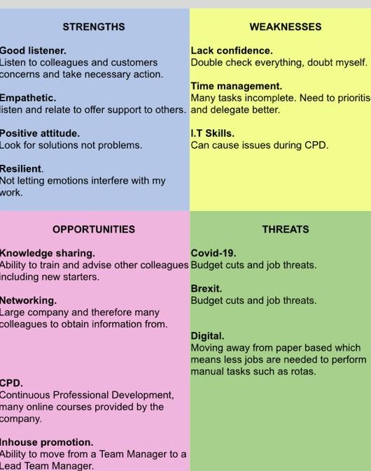
Here once again, a SWOT analysis will help in identifying both my needs and another’s. The SWOT process if used correctly should encourage the student to start to turn their Threats into Opportunities, Weakness into a Strength and Strength into an Opportunity. As the student develops, they will find that their SWOT analysis will also change, due to this process and the identification of other personal / family/ work or Study changes. In actual fact the writer would like to suggest that the SWOT process is both organic and fluid as life and circumstances change. It may be advantages at this point to define the meaning of SWOT as described as:

- Strengths are described as internal positive attributes or capabilities a person has control over and can make full use of.
- Weaknesses are negative aspects and attributes which have little control over.
- Opportunities are uncontrollable external events a person can potentially leverage.
- Threats are uncontrollable external factors that might overcome or damage the strengths and opportunities. (PESTLEanalysis, 2016)

Identify potential barriers to learning for self and another.
There can be many barriers to learning for the both students, however they have both identified what they see as their most challenging:
Barriers for myself.
- IT Skills
- Time management,
- The demands of Family, Friends and Work Colleges,
- General Health,
- Lack of financial support,

Barriers for Person 2
Externally:
• Work- lack of time
• Friends/Family- as they need me around
Internal:
• Lack of confidence
• IT Skills

In addition to their personal barriers the following have been identified as the most common by Unionlearn (2020);
- Physical/Mental Condition. ...
- Environment. ...
- Lack of Confidence. ...
- Previous Bad Experience. ...
- Fear of Failure. ...
- Old Dog New Tricks. ...
- Lack of Motivation. ...
- Fear of Change.

1.4 Explain how these barriers to learning can be overcome.
:
Myself
Barriers | Overcome
- Time to do work | - Plan when you are going to do your assignments, research and reading. This could be a regular day or a time frame in the day/every day. Develop that work/life balance.
- The needs of Family, Friends, Work colleagues | - Explain what you must do, and what you hope to achieve. Don’t keep anybody in the dark and at times take their assistance. Provide or develop a time table that can be displayed at work, or in your home
- Finance | - Student finance may be able to help. There could be bursary’s available, the HWB would be a useful place to start.
- General Health | - Continue with medication to control Diabetes, regular check-ups at Doctors.
- Skills, IT, Presenting: | - Enrol for the University skills help, look at your TSD/HWB in order to address some of these issues. Seek the assistance of your Peers or fellow students. The university have a Library that would contain books to address these issues.

Person 2
Barriers | Overcome
- Lack of confidence | There are several ways in which this barrier could start to be rectified by Person 2. The following have been taken from an article on 22 Oct “2018:  “How to Overcome Low Self-Esteem and Negativity”  - Surround Yourself with the Right People.  - Get to Know Yourself/Become Your Own Best Friend.  - Acknowledge Where You Need Change.  - Don't Compare Yourself to Others.  - Repeat Positive Affirmations.  - Take Care of Yourself.  - Give Back.  In addition, they may consider contacting Student services via the HWB, who offer support with this type of barrier
- IT Skills | - The skills session at the University will certainly help. Their VARK assessment suggests that by doing Practical exercises, Talking, Discussing, listening (Appendix A) makes them an ideal candidate to be peer led in this field.
- Work- lack of time | - The second person could chat to their employer, who may not be aware that they are attending this course and in response help them with some time for their studies. The university will provide them with a letter confirming their attendance on this course. Present a timetable and the programme of study for them to understand the commitment that is being made and the skills they could be acquiring as a result of their endeavours.
- Friends/Family- as they need me around | - The person could, after having holding a frank but honest conversation with family and friends relinquish some of their responsibilities. Ask them to buy into their aspirations and explain this will only be a small-time scale within the bigger picture. Once again, a timetable of their schedule would help in explaining what and when they have to do their work.

Section 2: Know how to develop self & others to achieve organisational objectives

2.1 Analyse learning/development options to meet needs of self & another.
Once again, a SWOT analysis is a useful tool to help achieve organisational objectives. By using the SWOT, we are able to look at each other’s Strengths, Weaknesses, Opportunities and Threats and discuss how we could turn these into positives for both parties. The formula for doing this is relatively simple as we explore how to turn a Weakness into a Strength, Strength into an Opportunity, Threats into an Opportunity.
Strength into an Opportunity: As identified one of my Strengths is, that I enjoy research. By linking up with Study skills at the University I would be able to identify different areas for my research, therefore expanding my knowledge.
Threats into an Opportunity: A major threat for me is time management. Here is an ideal opportunity to discuss with work colleagues how I struggle with this. They in return could offer some advice and support on how they manage, and offer advice on how I could structure my work better, therefore helping me to understand from someone else’s perspective positive ways to manage my time management.
Weakness into a Strength: IT for the me is a weakness. Having identified through the VARK results (Appendix A) that I best learn aurally. By seeking guidance from work colleagues / family members when needing how to do something, I would be spoken to as its being done, therefore helping my learning style.
To identify how to address the above a factor to bear in mind would be to explore the VARK. (Appendix A) Here, you would identify your best way of learning and try to incorporate into a positive way to address those issues and opportunities in the SWOT analysis. (Section 1.1)
An additional resource that can be used to answer this question would be the relevant Gomad in Appendix E, which offers the user to take Action, Measure Results and finally recognise their Personal Responsibility to achieve recognised goals.
Offer an alternative way to identify the best ways and support systems that you may require to learn and develop through Gomad. This includes offering a personal score of what you think would be a good indication to reach these targets. It may be beneficial to suggest that in any of the development needs or learning styles tools (Gomad, Swot, Kolb) honesty in your answers is required in addition a factor to also consider is how you are feeling at the time or even the time of day you complete your analysis’s. One of the best ways to arrive at a balanced answer is to complete whichever style you choose several times. (BSMK4005, 2020)
Although I found Gomad quite difficult to navigate I did however identify that I need in order to learn I really need to understand the questions that are being asked of me. My personal development would be aided if I did not overthink the question but answered it simply incorporating the answers to what is being asked in the question and not diversify into other avenues. In addition, I believe that by sharing the results of my learning and asking for help will help in my personal development.

2.2 Identify support mechanisms for the development of self & another

The SWOT analysis aided by SMART will help in identifying support mechanisms and focus the mind on meeting targets. By using both methods and developing a Personal Development Plan (PDP) as set out in Writing a Personal Development Plan will aid all parties in their development. (Spruce, 2020)
- Set yourself goals.
- Prioritise those goals.
- Set yourself deadlines for when you want to achieve them.
- Recognise threats and opportunities.
- Develop your skills or increase your knowledge.
- Use your support network.
- Measure your progress.

2.3 Prepare development plans for yourself and another person

Part 1: Personal Analysis
See SWOT Analysis in 1.2

Part 2: Setting Goals

Myself
What do I want to learn? | What do I have to do? | What support and resources will I need? | How will I measure success? | Target Date for Review
IT | Practice as much as possible on my computer and believe any mistakes can be rectified. Be bold, make notes to remember how I got there | Ask people to show me what to do, and then do it myself.  Sign up for a skills session with the University. Practice, then practice again. | Keep some written record on what you’ve been shown to do and how you got there. Then try to get where you wanted to be without referring to those notes | On going process until I can remove from a weakness in my SWOT analysis
Vocabulary | Stop using the same words when writing and speaking. Develop my writing style so that I can explore other suitable words / Phrases | Review my dictionary and thesaurus in order to improve my vocabulary when writing essays or simple pieces of work. Go through the thesaurus to look for other words that mean the same. | Read and reflect on my work check the same word does not occur too many times.  Not having to think (to much) about what I’m going to say and early recognition of the words I would like to say. | Daily, weekly until my writing and speech flows more freely.
Time management | In order to address my time management, I need to concentrate on not getting distracted, overthinking and leaving things to the last minute.  To rectify these situations, I need to make small but significant changes when I’m doing my Uni work. For example, I could switch of my phone and not go on the internet during my studies/writings. Keeping family friends and work colleagues aware of when I’m studying should encourage them not to disturb me. | I should keep a diary in order to plan my Uni work or print off the Uni timetable in order to recognise submission dates and plan my way through to that date.  I could ask a colleague or fellow student to help keep me on track even start up a friendship forum where we each could support one another with our various issues. | Being fully fulfilled that the work I have done is of a reasonable standard because I have not had to stop and start. The sense of satisfaction when the work goes in several days before the last hour/ day of submission. | Continual assessment of identified issues through until  November 2021 which is the last submission date.

Person 2
What do I want to learn? | What do I have to do? | What support and resources will I need? | How will I measure success? | Target Date for Review
Lack of confidence | Identify that their recorded strengths within their SWOT analysis are: being a good listener, having a Positive attitude and Empathetic. | Their VARK results are clear in that they learn better whilst talking, discussing, Listening, this may suggest that a positive mentor would be a good support mechanism. They could access a talking book service to understand and learn. | Complete a series of SWOT analysis during their period of study to move their weakness into a strength. | On going process however, September 2021 may be a good time to reflect on the progress made.
How to adapt to Brexit/Covid19/  funding issues | Funding has been identified, so they need to explore budget streams and potential new funding streams that are going to replace European funding or are there to support Covid-19. | Funding streams to replace EU funding would be found on main government websites. Contact your local CVC (County Voluntary Centres) who will offer support in sourcing and Funding bid writing. Internet researches will highlight potential funders. | Budget streams should remain constant with spending or given the opportunities there could be extra funding being brought in. There may be an opportunity to identify gaps in service and address them. Review your budgets constantly and measure against past incomes/budgets. | Weekly, Monthly Annually.
Part 3: Personal Objectives

Personal
Short Term Goals (next 12 months)
- To complete my first assignment on time and subsequently all following assignments.
- Complete this course. January 2022

Medium Term Goals (2-3 years)
- Complete the degree January 2025

Long Term Goals (3-5 years)
- Self-improvement
- Take organisation to another level

Person 2
Short Term Goals (next 12 months)
- To complete my first assignment on time and subsequently all following assignments.
- Complete this course. January 2022

Medium Term Goals (2-3 years)
- Complete the degree January 2025

Long Term Goals (3-5 years)
- Self-improvement
- Take organisation to another level

2.4 Method used to monitor the development of self & another.

The SWOT analysis has been used to identify personal weaknesses and threats to the development of myself and a colleague. In addition, a useful aid to help both parties develop would be their learning logs and a PDP (Personal Development Plan). Both help in the direction in which they would like to go and in the particular the learning logs, a tool of reflection on previous lessons and how you felt and what was learnt, and how you could incorporate these into a SMART plan in order to address within a timescale. One of my identified weaknesses within the SWOT analysis was my IT skills. In order to identify what type of learner I am, I undertook a VARK assessment and learnt that I am a strong aural learner, therefore I would need to practice on my laptop or get someone (a support mechanism) to physically show and discuss/ talk me through how to do things as opposed to taking a formal training course.
Kolb’s learning style (McPheat, 2017) as seen below, would help in the development of us both.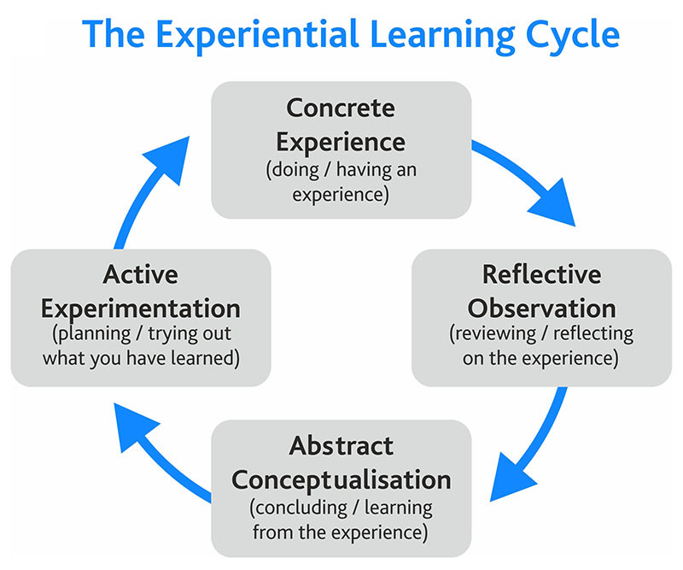

Section 3: Know how to prepare for the recruitment process

Reflection on the recruitment process


Above is the Gibbs reflective Cycle (Gibbs, 1988) which I have used to understand the process for an interview that I have undertaken as described in the following:

3.1 Description.
I was particularly fed up in work one day as it seemed to be the same old every day, so I decided that I was going to search for a new job perhaps in a different geographical area. I had a look on a few websites searched the internet for a new position in youth and community work.
There were several posts that interested me, one in particular, but the closing date for the applications was the following day by 10.00am. The post was for a music-based youth organisation in Kent. It was a one-year fixed contract 40-hour post for a Youth Programme Manager. However, I had never worked in a city-based youth setting before.
When I attended the interview, I was ushered into a room with several other candidates I introduced myself and they responded positively. Two in particular then went into a dialogue that suggested they were local and knew of the organisation. They apparently knew the interview team and many of the trustees. I suggested to them that, that was great and thanked them for their verdicts on the individuals, however I also said to them jokingly that I felt a bit intimidated now, having listened to them and what they had to say.

3.2 Feelings.
I felt I had a series of skills and experience that would fit into the Job description and identified with a few of the key activities and responsibilities that were needed for the post. The person specification fitted like a glove and the qualifications didn’t seem to be that great. I believed that I was a pretty good fit particularly around the knowledge, skills and abilities that were required. However, with only a 12-month contract, could I satisfy myself that I could make improvements for the benefit of all the stakeholders?
My confidence did take a bit of a knock when I met several of the other candidates at the interview. They intimidated me with their local knowledge, resulting in me not focusing on my strengths in the actual interview. I’ve learnt that I need to make time to research any company / organisation that I intend to apply for a position in, in exchange I will feel energised and confident that I’ve thoroughly gone through a process that puts me in that position to become employed by them. I will in the future not enter any type of dialogue with other prospective candidates and if there are any conversations about members of the panel etc make sure I ask them not to make their observations known to myself and if appropriate any other candidate.

3.3 Evaluation.
Overall, this was a pretty negative experience. I actually jumped and made a rather rash decision when not having a particularly good day. I rushed the application and because my IT skills are not the greatest decided to hand write the application instead of down loading and filling it in. As previously mentioned, I felt intimidated by the other candidates and literally had made my mind up about panel members and the organisation prior to going in to my interview.

3.4 Analysis.
I lost my energy for the interview and ultimately the position during that time in the waiting room. I did not focus on asking inquisitive questions back to the panel, instead asked mundane questions like holidays and pension. I should have interviewed the panel in their skills and experiences, in order for me to make a fair and balanced opinion about my prospective employers and for them to recognise that here they had someone who had thought about the interview process and shown an interest in them and the organisation.

3.5 Conclusion.
Rushing this application and not leaving the time (or energy) to do research on the organisation, research interview skills and look at key questions for the panel has in my opinion resulted in a negative interview. I need to do my research prior to any application. This in return dismisses any need for loosing confidence at the interview stage and should reinforce your self-belief that you have done as much possible to sell yourself to an organisation

3.6 Action Plan
I will amend my CV so that it is up to date. Generate a draft covering letter that can be adapted at short notice, thus saving time. I will allow myself time to prepare for interviews. My IT skills need support and I will do this by working with a colleague to improve them. Overall, I feel passing this course will open up my career into potentially different pathways.

References

Ault, Julia (2020) Honey and Mumford Learning Styles. Honey and Mumford summary handout for module no: BMSK4005. University of Wales Trinity Saint David.
BSMK4005 (2020) Presentation 5, slides 5 -7 University of Wales Trinity Saint David.
Cert HE Skills for the Workplace Module: BMSK4005 slides no4, 6-16 inclusive
Contributor, PESTLEanalysis (2016) Role of SWOT Analysis in Personal Development. Available at: https://pestleanalysis.com/role-of-swot-analysis-in-personal-development/ (Accessed on: 20 November 2020)
Gibbs, G (1988) Learning by Doing: A guide to teaching and learning methods. Further Education Unit. Oxford Polytechnic: Oxford.
Leung et al (2014) VARK LEARNING STYLES AND STUDENT PERFORMANCE IN PRINCIPLES OF MICRO- VS. MACRO-ECONOMICS Journal of Economics and Economic Education Research, Volume 15, Number 3, 2014. Available at: https://www.alliedacademies.org/articles/vark-learning-styles-and-student-performance-in-principles-of-micro-vs-macroeconomics.pdf (Accessed on: 20 November 2020)
Marcy, Vanessa (2001) Adult Learning Styles: How the VARK Learning Style Inventory can be used to improve student learning. The Journal of Physician Assistant Education: April 2001 - Volume 12 - Issue 2 - p 117-120. Available at: https://journals.lww.com/jpae/Citation/2001/07000/AdultLearningStyles__How_the_VARK_LearningStyle.7.aspx (Accessed 20 November 2020)
McPheat, Sean (2017) What are KOLB’s Learning Styles and what do they mean? Available at: https://www.skillshub.com/what-are-kolbs-learning-styles/ (Accessed on: 20 November 2020)
Minsky, Bonnie (2018) How to Overcome Low Self-Esteem and Negativity. Available at: https://thriveglobal.com/stories/how-to-overcome-low-self-esteem-and-negativity/ (Accessed on: 20 November 20)
Rumson, Ruby (2017) Honey and Mumford Learning Styles. Available at: https://www.eln.io/blog/honey-and-mumford-learning-styles (Accessed on: 20 November 2020)
Spruce, Hannah (2020) What is a personal Development Plan? Free PDP Template PDF. Available at: https://www.highspeedtraining.co.uk/hub/personal-development-plan-template/ (Accessed on: 20 November 2020)
Unionlearn (2020) Common Barriers to Learning. Available at: https://www.unionlearn.org.uk/common-barriers-learning (Accessed on: 20 November 2020)
University of Kansas, School of Education and Social Sciences (2019) 4 Different Learning Styles You Should Know: The VARK Model. Available at: https://educationonline.ku.edu/community/4-different-learning-styles-to-know#:~:text=The%20acronym%20%E2%80%9CVARK%E2%80%9D%20is%20used,Mills.&text=These%20different%20learning%20styles%E2%80%94visual,of%20hours%20of%20classroom%20observation. (Accessed 20 November 2020)
VARK Learn Limited (2020) VARK a guide to learning preferences. Available at: http://vark-learn.com. (Accessed 20 November 2020)

Appendix A
Myself

PERSON 2
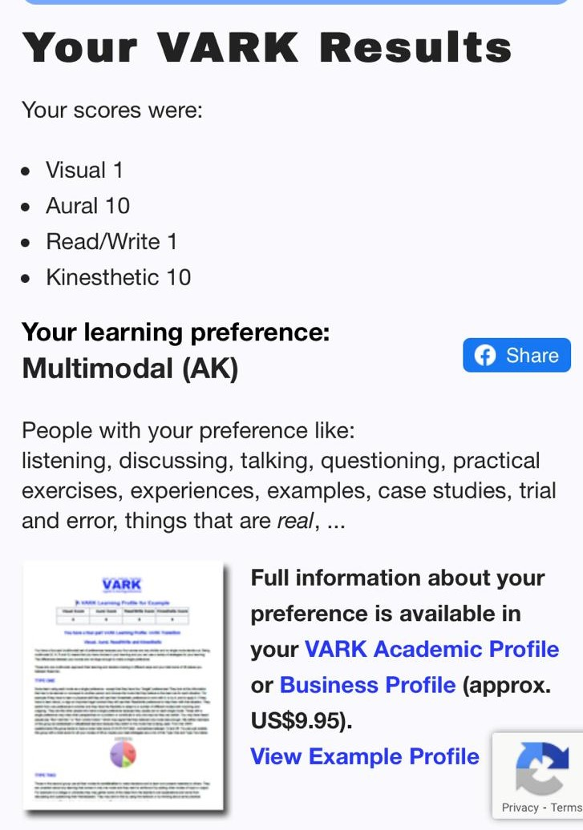

Appendix B
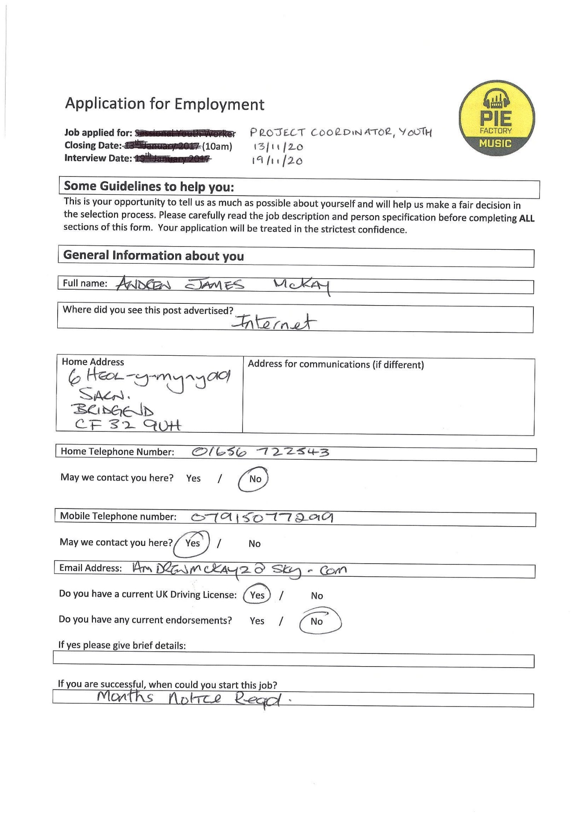
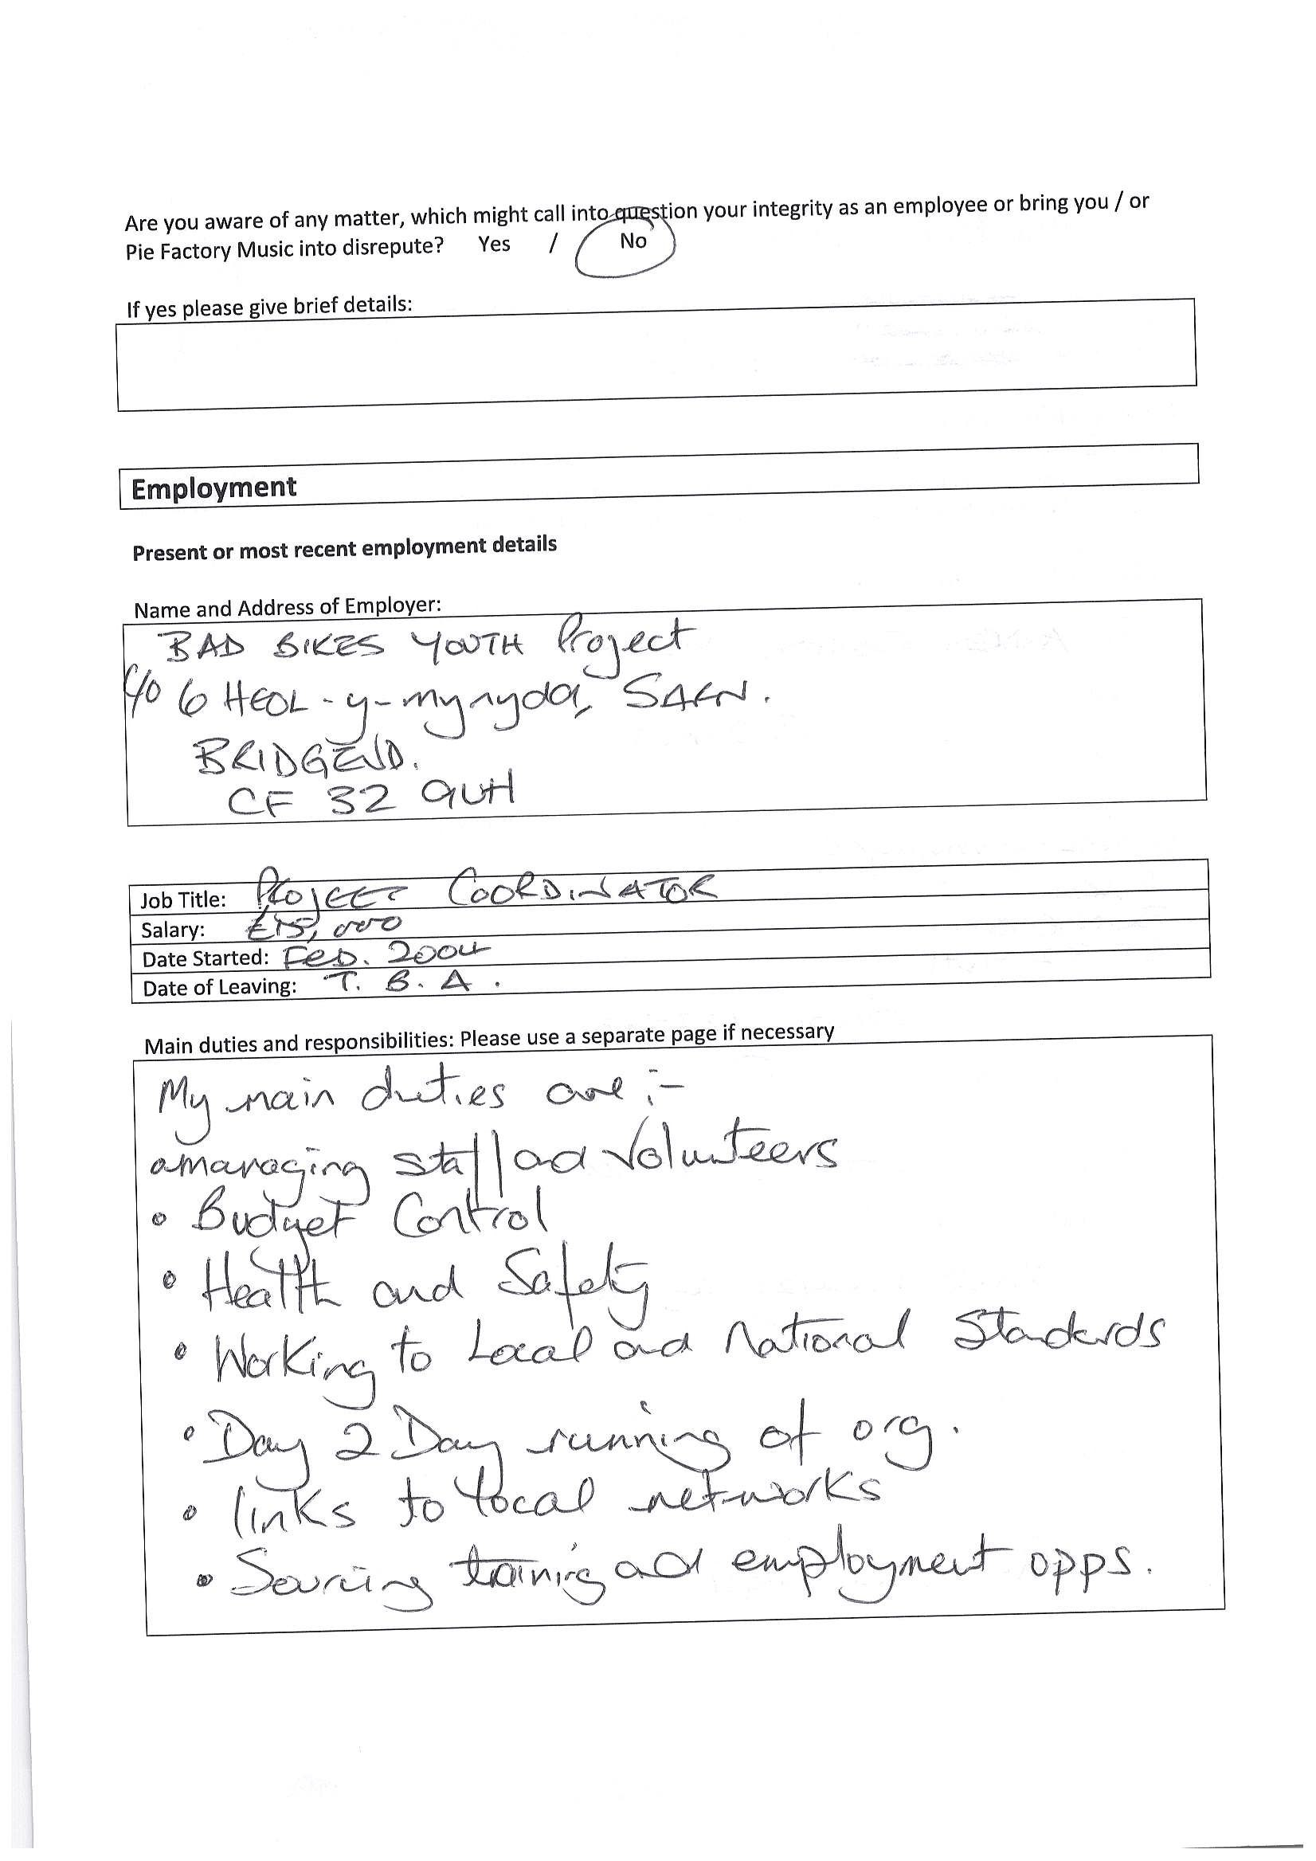
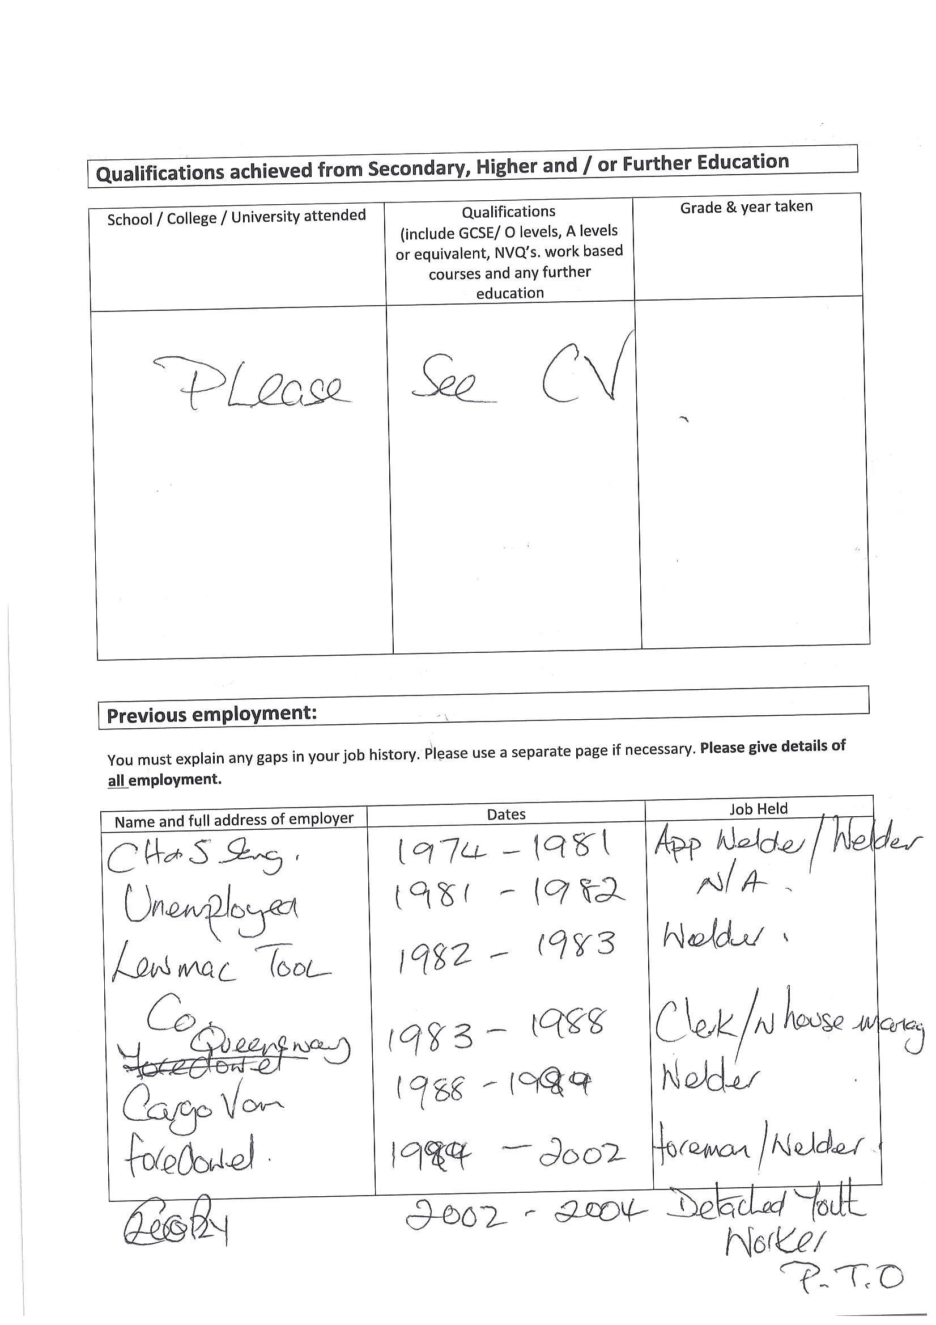
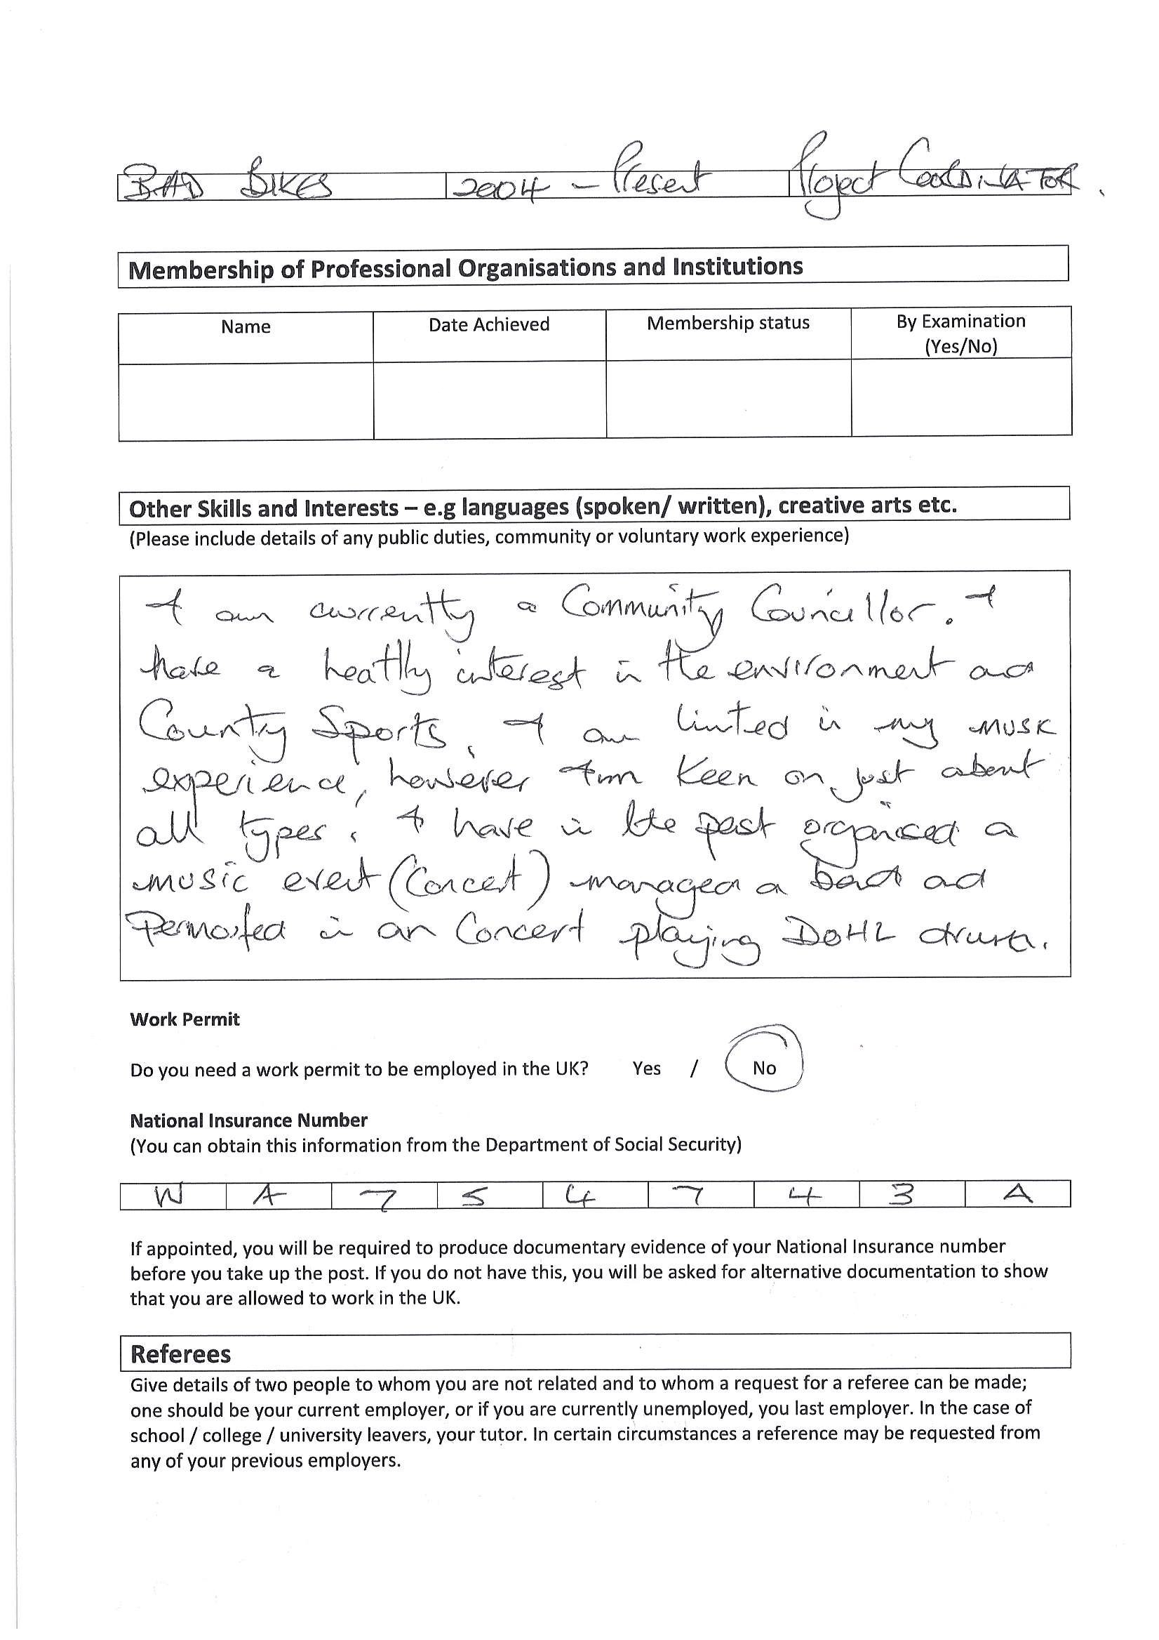
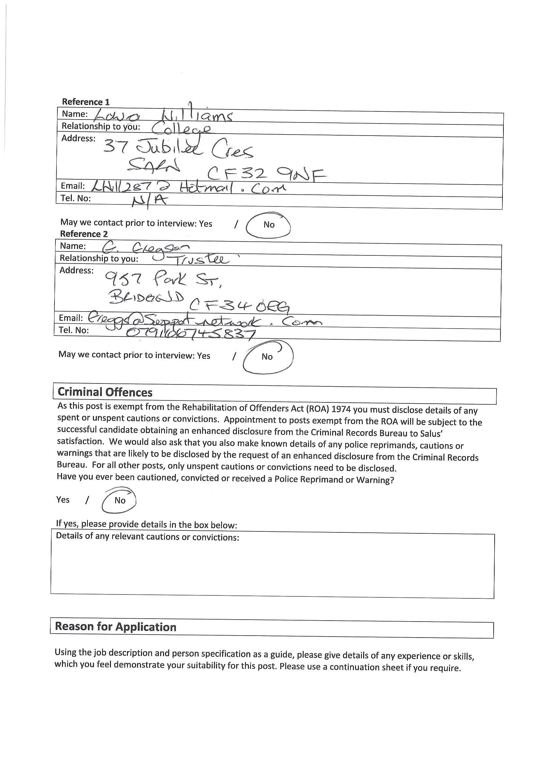
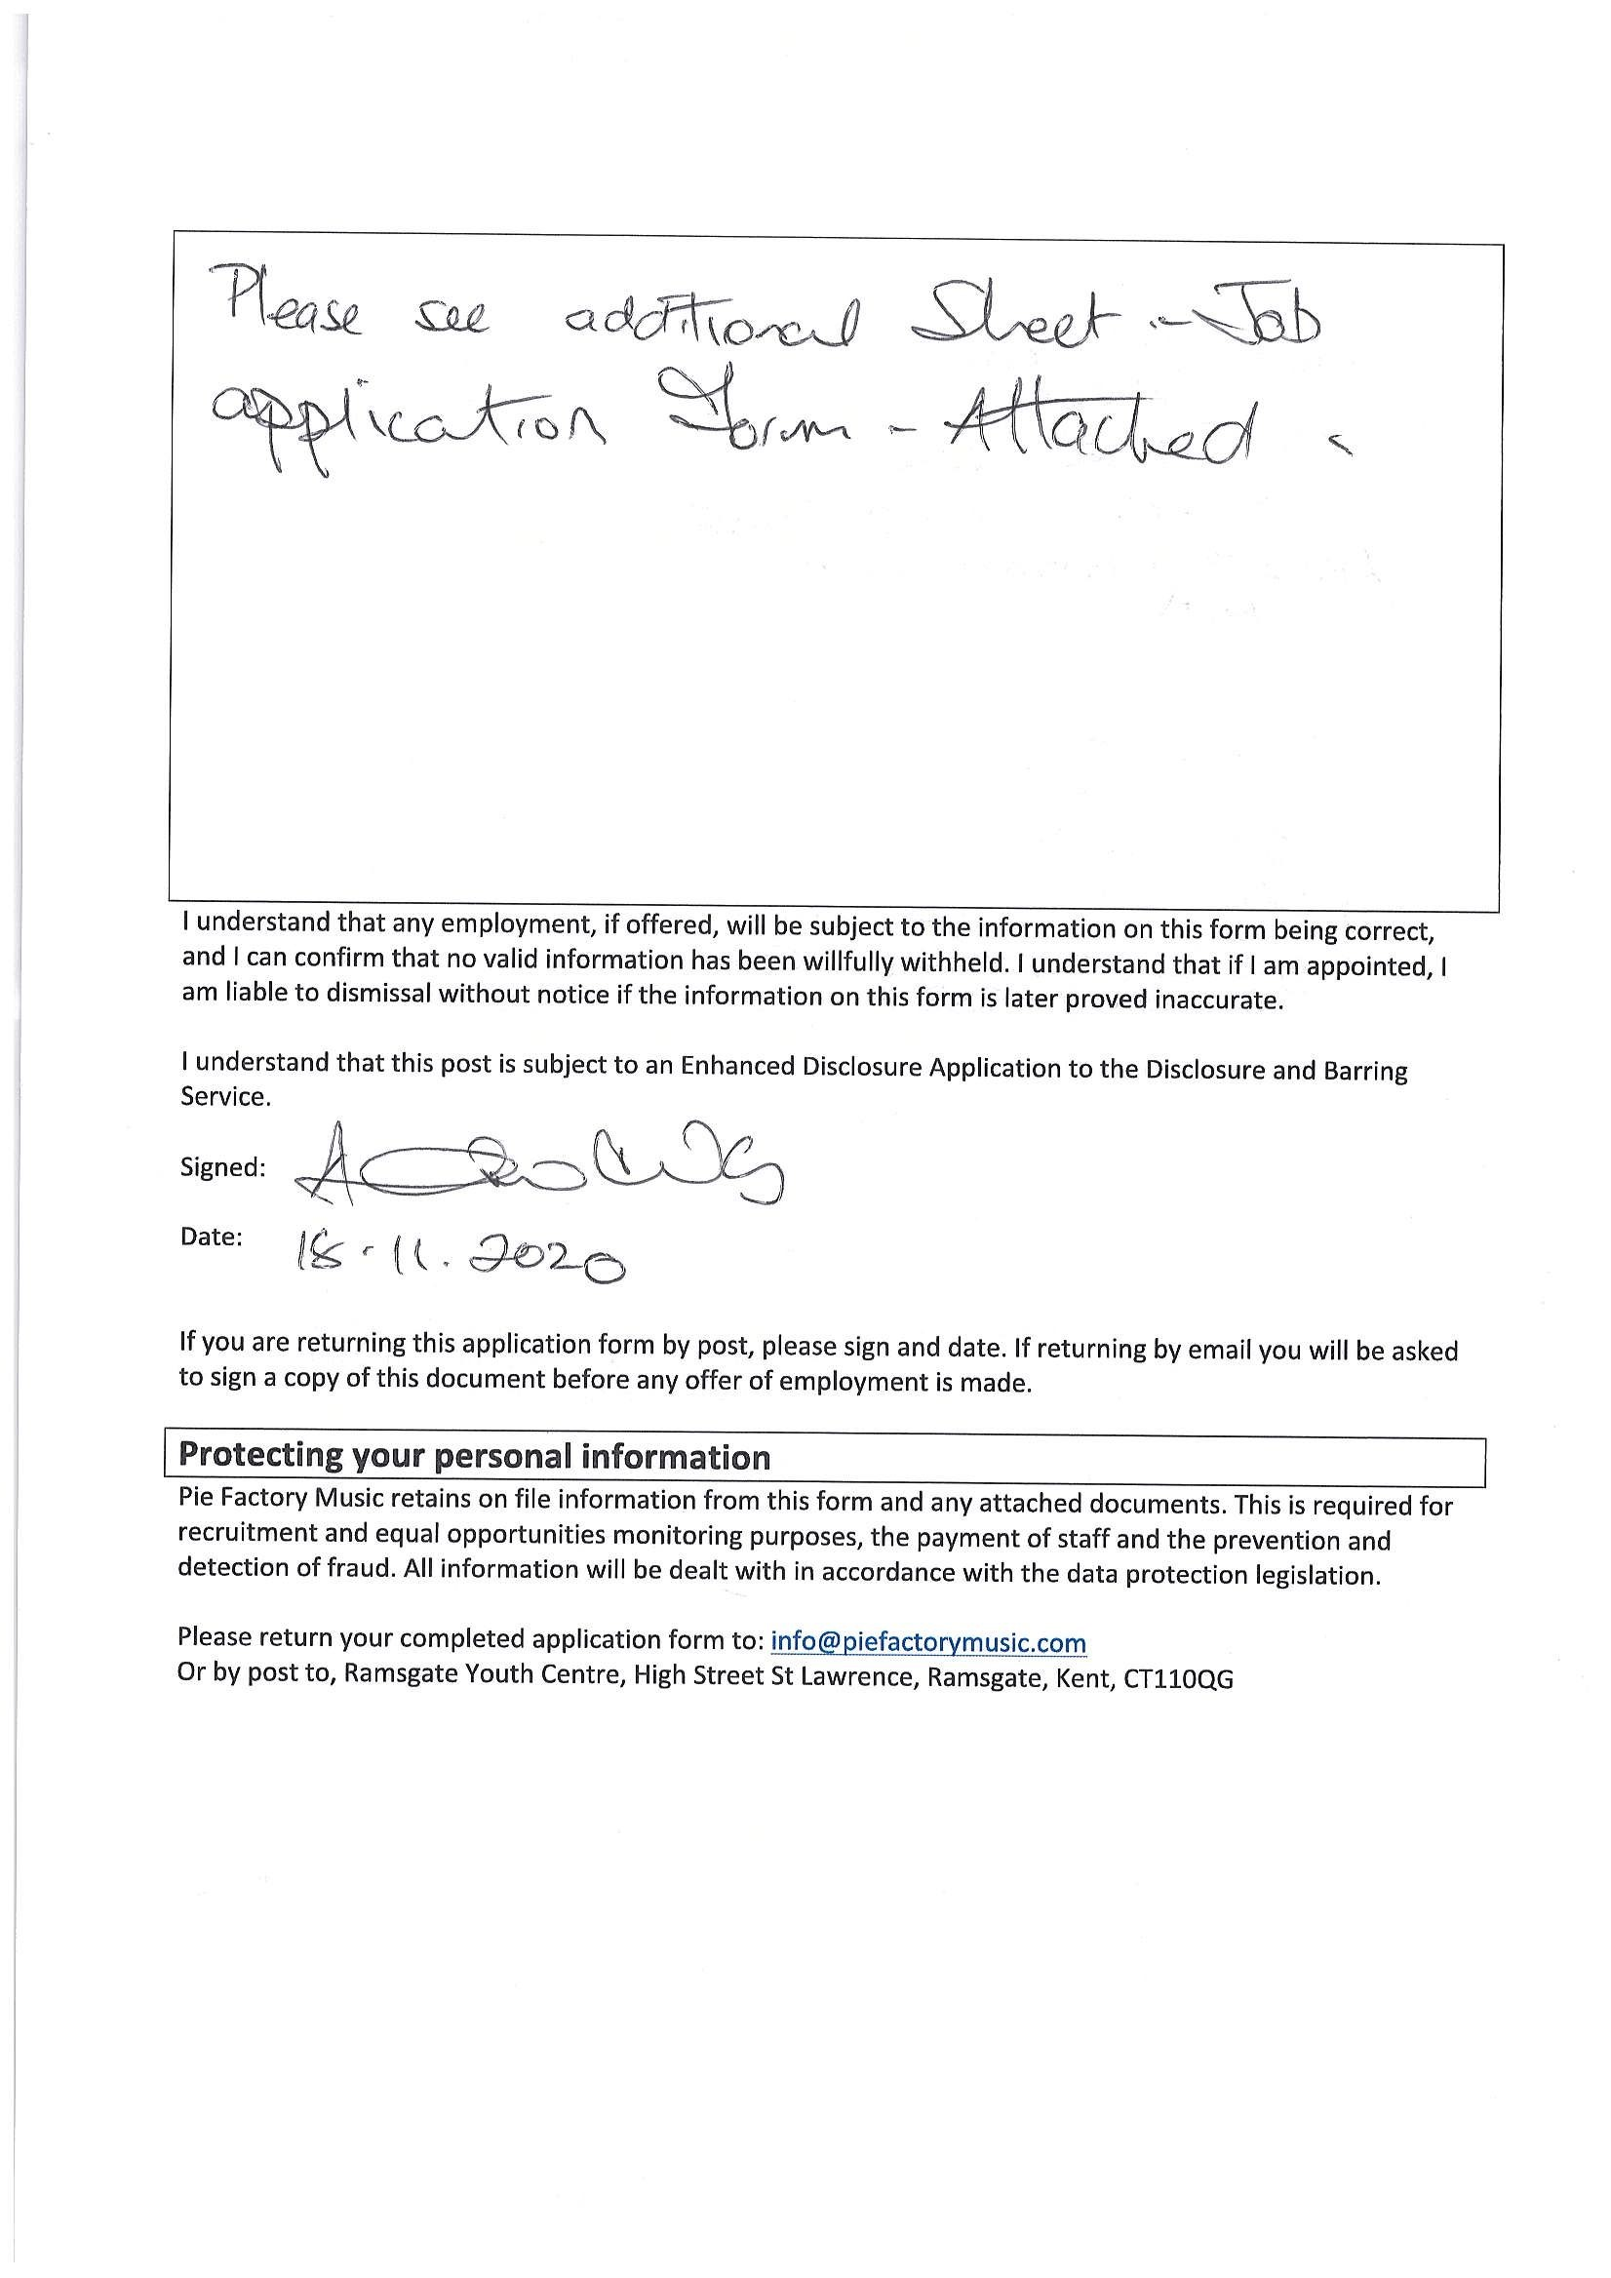
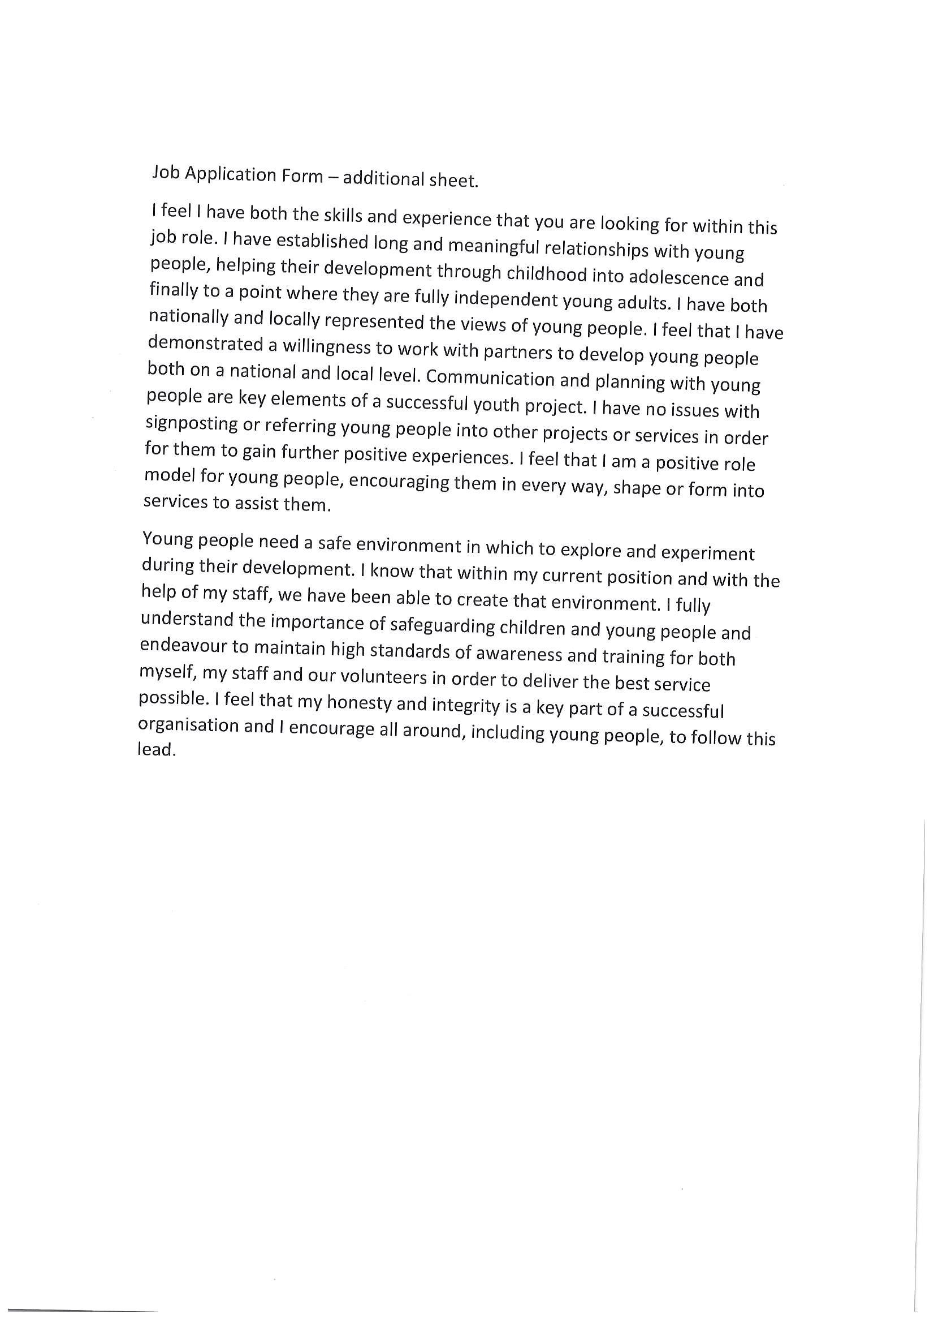

Appendix C

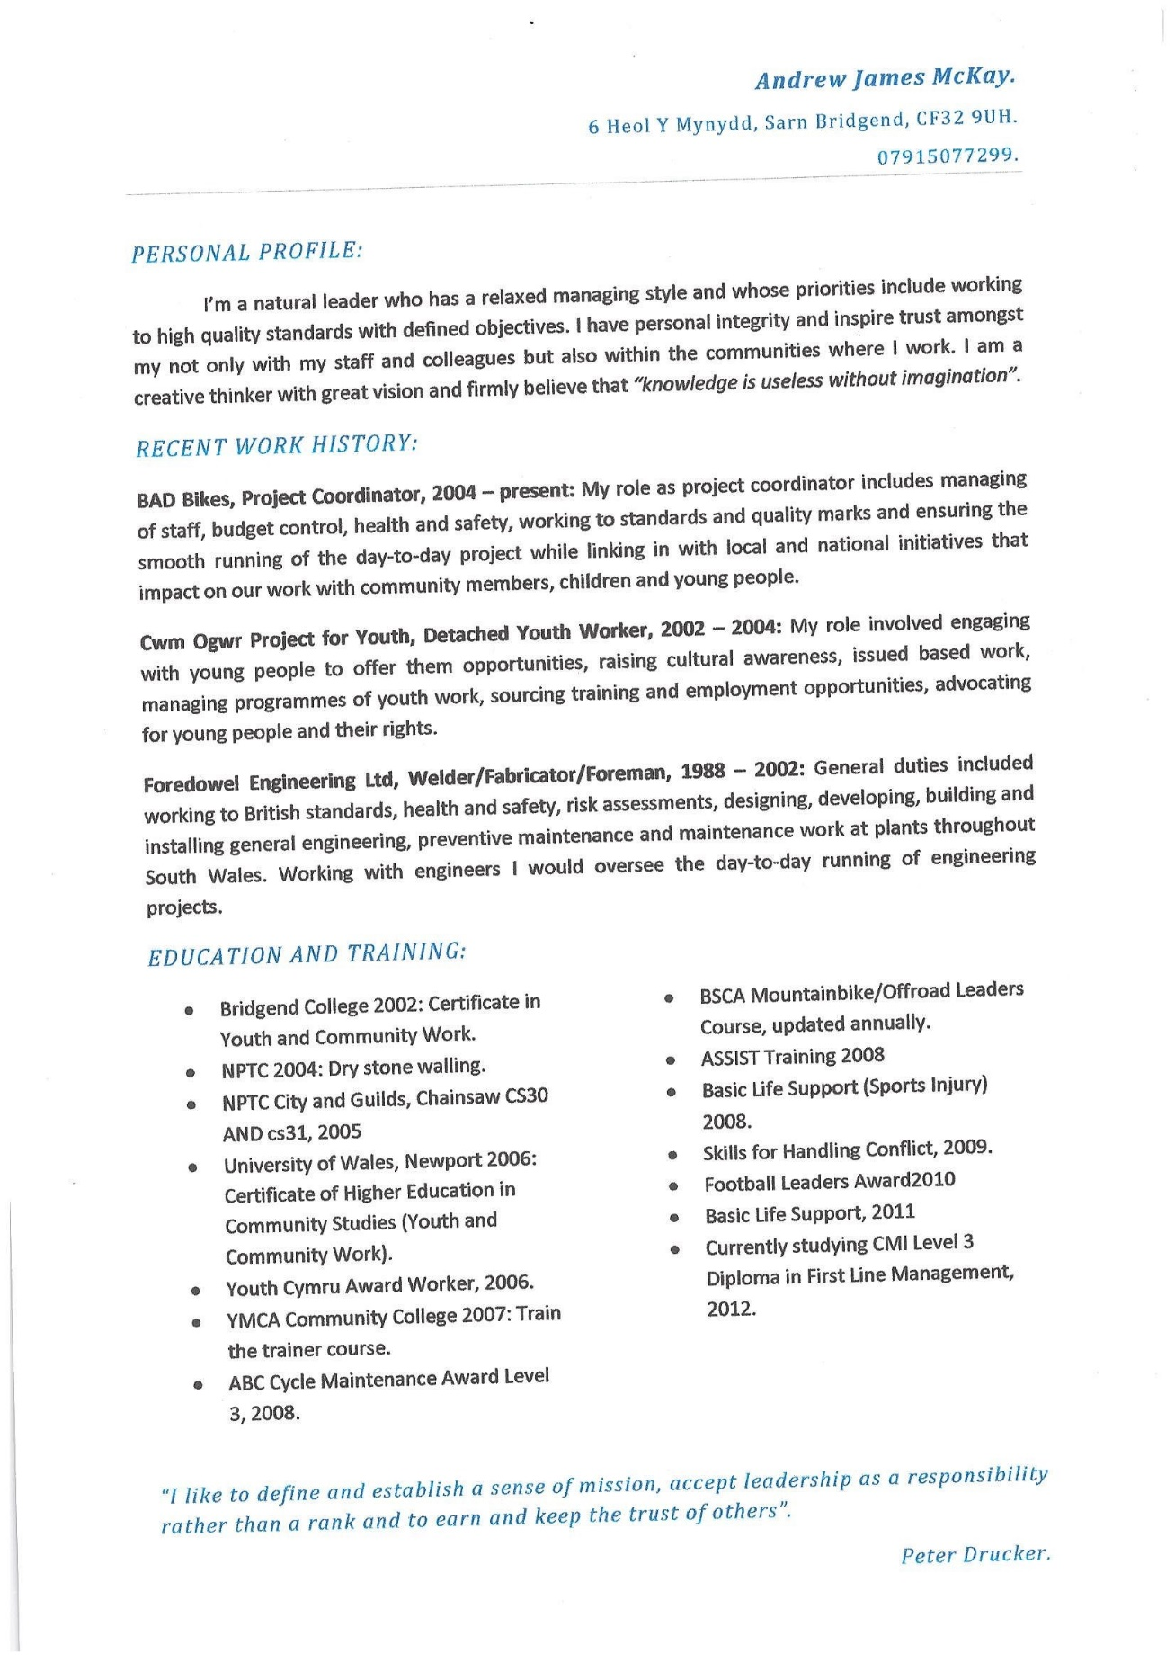

Appendix D

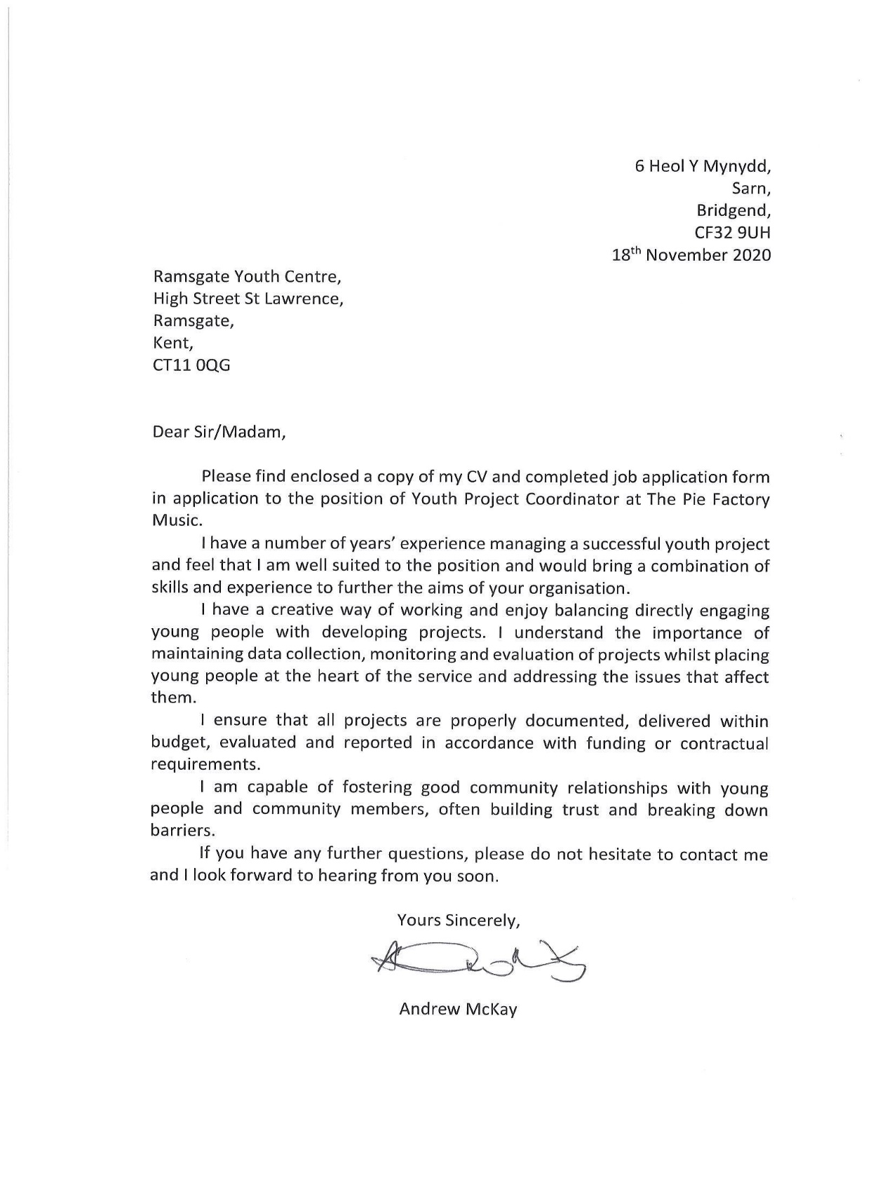

Appendix E


