

Name : Mohammad Tofayel Ahmed.
Student Number: 1811755 .
Module Title: Entrepreneurial Perspective.

Assignment Title: ‘How crucial is market research for an entrepreneur to avoid making mistakes and failures’

Lecturer’s Name: Gladius Kulothungan

Table of Content:

- Introduction: 3
1.1 History: 3
1.2 Importance of an Entrepreneur and Innovation 4
- Market Analysis 5
2.1 Why entrepreneurs are failing 5
2.2 Why Market research is Crucial 11

- Market research and use of research techniques and tools 14
4.1 Market segmentation 16
4.2 SWOT 22
4.3 Porter’s five forces 23

- Recommendation 24

- Conclusion: 24

- Reference and Bibliography: 26

1. Introduction: When an individual has an innovative idea and willing to do business with limited resources, responsible for all risk and rewards is called entrepreneur. According to Schumpeter, an entrepreneur is an innovator. He also said an entrepreneur is a creator of new product or quality, creator of new method of production, new source of supply, create a new market and creator of new organisation or industry (Iversen, Jørgensen and Malchow-Møller, 2008).

Creating a new business, taking financial risk for the purpose of making a profit is called entrepreneurship. Another way we can say, entrepreneurship is a combination of ideas, process, hard work, risk and adaptation to the changing business market (Khera, 2018)

There is difference between entrepreneur and entrepreneurship. Entrepreneur is a person and entrepreneurship is a process. Entrepreneur is an organiser and entrepreneurship is an organisation. Entrepreneur is a creator and entrepreneurship is a creation.

The purpose of this report writing is to understand what is an entrepreneur, entrepreneurship, importance of entrepreneurship and innovation for a country, why entrepreneurs are failing and how to avoid mistakes and failures by doing market research.

1.1 History: In the thirteenth century, the word entrepreneur originally came from an old French word ‘entreprendre’. Which means, to do something or engage. In the sixteenth century, anyone who undertakes a business was being referred to as an entrepreneur. In 1730, economist Richard Cantillon used the entrepreneur word in an academic way and identified the characteristics of an entrepreneur is willing to take financial risk for a business. In 1775, he mentioned about the concept of entrepreneur in his book called ‘Essai sul la Nature du Commerce en General’ (Iversen, Jørgensen and Malchow-Møller, 2008). After observing the merchants, craftsmen, and farmers he developed these early theories of the entrepreneur (Price, 2015). In 1800, economist John Stuart and Jean Baptiste popularised the academic use of entrepreneur. They mentioned an entrepreneur is creating value from the less productive area and using available resources into productive ones. John Stuart also mention in his book Principles of Political Economy, an entrepreneur is a person who assumes the management of the business and risk. In his book, he gave a clear view of an entrepreneur and other business owners. For example, shareholders of business can assume the risk but they do not participate in the day to day operations or management as an entrepreneur (Sobel, 2019).

1.2 Importance of an Entrepreneur and Innovation: The connection between market research and entrepreneur is without market research an entrepreneur can not be successful and without an entrepreneur, market research can not perform itself alone. A nation's development and prosperity depend on it entrepreneurship and innovation. Without it, a nation can not move forward.

Entrepreneurs are national assets. Entrepreneurship developing the way we live, the way we work and the way we think. Entrepreneurship is a fundamental feature of our social life and economy. The importance of entrepreneurship and value of it is very big and worldwide.
- Entrepreneurs creating business
- Creating jobs,
- Drive economic growth
- Contributing to national income
- Bringing social change
- Community development
- Innovative product and service
98% of the UK economy was contributed by private sectors business. All the entrepreneurs providing an excellent range of innovative ideas and SMEs that driving the private sector forward (Iwcapital.co.uk, 2019).

Nowadays entrepreneurs are more into innovations. With innovation, an entrepreneur can improve the standard of living, create wealth, create jobs and contribute more in the national economy. Importance of entrepreneur is very high and broad from promoting social change to driving innovation (Seth, 2019). Many experts say entrepreneurship is about three things and that is innovation, innovation, and innovation. Many people say innovation need only if there is a demand in the market. Innovation can be new products, develop an old product with more value, a new way of doing business or a name. For example, in 1991 Craig Sam and Jo Fairley launched a bar of organic chocolate with the name of Geen and Black Organic. Green represents organic and Black represent the dark of cocoa. Just after that, they created a history of £100 million worth of a company (Stokes, Wilson and Mador, 2010).

2 Market Analysis: Market analysis in a process of combining all information that affect a marketplace. To analyse the market at first we will focus on why entrepreneurs are failing, what are the common mistakes entrepreneurs are making in the market and how important is market research to solve those mistakes to face up to the modern competitive market.

2.1 Why entrepreneurs are failing in the market: Any success depends on entrepreneur skills. An entrepreneur should have the skill of optimism, vision, risk tolerance, leadership, motivation, communication, problem-solving, decision making, business knowledge, and creative thinker, etc. Even after having all these skills, still, many entrepreneurs are failing with their bright business ideas. According to Bloomberg, within 18 months, 8 out of 10 entrepreneurs are failing. It is really staggering. Which means 80% entrepreneur will fail in less than 2 years (Marr, 2016). There is only one common mistake of them is taking decisions by assuming without doing any market research.

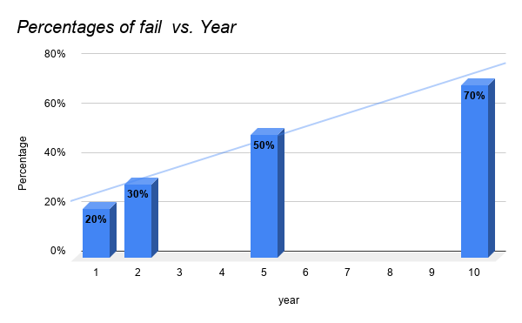
Figure 1: Column Chart - Percentages of small business failure.

According to the Bureau of Labor Statistics in the USA , 20% of small businesses fail in the first year, 50% fail in the second year, and 50% in fail in the fifth year. In the year of the tenth 70%, small businesses fail eventually (McIntyre, 2019)

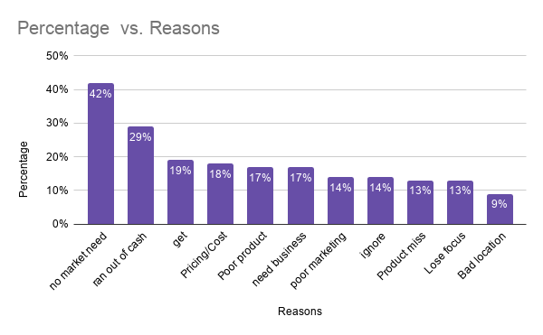
Figure 2: Column chart - Top reason why entrepreneurs are failing
According to CB Insights, 42% small business failed because there was no demand for their services and products. 29% failed because they did not have enough money. 19% of them failed because of too much competition. 18% of them failed because of price strategy was not right. Also, many of them failed because of poor products, business model, poor marketing, lose focus and bad location, etc (Griffith, 2014).

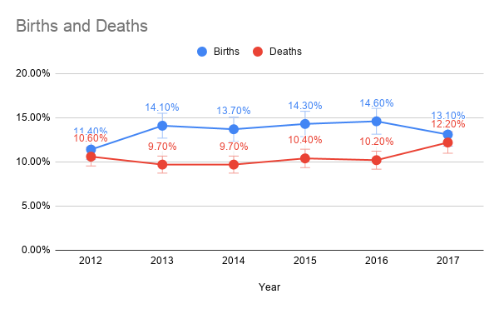

Figure 3: Source: Office for National Statistics
The number of UK business rates has grown up since 2014 and there is a dramatic fall in business births in 2017. Since 2012, the gap between births and deaths in 2017 is the smallest (Shaw, 2018) The biggest error entrepreneurs are making while launching a new business without knowing any difference between exact fact and assumption. Without market research, everything is just guesswork
Before even entering a market if they assume:
- Their products going to meet what consumers want.
- No interest to find out the actual competitors.
- Making random price without knowing how much customers will pay (iResearch Services, 2018)
An entrepreneur should understand the difference between assumption and fact. Everything is just guesswork without market research (Burke, 2016). An entrepreneur should be aware of that.

All these reasons make market research very crucial for an entrepreneur to avoid failing with their businesses.

There are many more common mistakes that entrepreneurs are making nowadays:

2.1.1 Market Demand: Many entrepreneurs are failing to understand if there is a demand for business in the market. An entrepreneur can come up with a brilliant product, huge budget, and a good pricing structure but if there is no one wants to buy or there is no one to buy then there is nothing to do. If there is no demand and no people to buy then there is no necessary to sell that product and service (Otar, 2018).

2.1.2 Proper Plan: Without a proper plan, en entrepreneur can not have success. Having proper business is a vital part of any new business. Having a brilliant idea and business can help to set a target but to reach the target a proper plan is a key to success (Mercy, 2018).

2.1.3 Not Smart Enough: It is not about IQ here. Many entrepreneurs know about their idea but they do not know about the market that will accept the idea or reject. Nor do they know who the real competitors in the market or understand how accidental, unscheduled, uncontrollable innovation actually works. An entrepreneur should be capable of seeing what everyone else sees and what they want to see (Andriole, 2016)

2.1.4 Monopoly: Many entrepreneurs have a mindset that there are no competitors in the market, but in reality, there are hundreds or thousands of players already exist in the market. Having confidence in you are the best in town is good but assuming that you are the only one is definitely not good (Akbar, 2017).

2.1.5 Marketing: Lack of marketing is another mistake that entrepreneurs are making. Many entrepreneurs think that without marketing they can do well. Even after being established many big business organisations are doing their marketing because they want to sustain in this competitive market. No marketing means someone opened up a company and do not want other people to know (Akbar, 2017). An entrepreneur must do marketing for their products and services to the relevant audience about it. Marketing is the most notable factors in the failure of entrepreneurs in 2018 (Mercy, 2018).

2.1.6 Funds: Many entrepreneurs are not putting the right amount of money in the right place and that is why they are failing. At the beginning a small amount of capital is fine but an entrepreneur should keep enough reserve funding ready to make the next move (Akbar, 2017). An entrepreneur needs financial back up all the time. Without enough capital and funds is almost certainly a suicide (Mercy, 2018).
2.1.7 Competitors: Many entrepreneurs underestimate their competitors and many of them do not even know how many competitors are present in the market. An entrepreneur must take competitors very seriously and take them as a threat. Entrepreneurs are not keeping their eyes on the strengths and weaknesses of competitors (Mercy, 2018).
2.1.8 Pricing: Pricing is one of the major reasons why entrepreneurs are failing. Many entrepreneurs often fail to have a proper pricing strategy. Without knowing the existing market price or without doing the comparison they put a higher price for their products. Higher prices mean push away potential customers and it will cause to sustain in the market (Otar, 2018).
2.1.9 Selection of Business: For an entrepreneur, it is very important to decide which business to adapt. Every business has the potential to reach millions but not every business is appropriate to him/her. Having an innovative idea is brilliant. After that, an entrepreneur must do market research and choose the right location to start up a business. It is good to keep a note of the pros and cons of every business and then select a suitable business (Mercy, 2018).
2.1.10 Too much competition: Too much competition is another reason why entrepreneurs are failing. Today’s business world is very competitive. Many entrepreneurs do not realise that at the beginning about that. They start facing competition after starting the business. Too much competition kills the business and it becomes hard to run (Harvardentrepreneurship.org, 2019).
2.1.1 Limited opportunities: Sometimes, a good idea can fail to meet the expectation. An entrepreneur must find out the level and scope opportunities before starting up a business. Otherwise, it may cause the customer not wanting to buy the product or service (Harvardentrepreneurship.org, 2019).

2.2 Why market research is crucial : After analysing the mistakes and failures, it is important to find the solution and the solution is market research. A business without market research is a ship without a compass. Entrepreneurs and businesses need information about opportunities, market demands, performance, problems, challenges, and competitors, etc. All this information can be acquired through market research. Market research helps an entrepreneur to assess the business risk, decrease business risk, reduce the inter and external issues and it creates opportunities too (Kappel, 2019). Many entrepreneurs fail to follow the real channels to find their target market, and then they lose money and business. Entrepreneurs often feel that they know their customers and competitors without gathering proper information and feedback. That is a huge mistakes they do without realising. Market research is an absolute key to success (Schmidt, 2015).

Here are some crucial points to understand why an entrepreneur should do market research:

3.1 Market Condition: By doing market research an entrepreneur can gain valuable information about market conditions. The market condition can depend on seasonal, government policy, customer taste, trend, etc.

3.2 Public Reaction and feedback: Consumer feedback is the biggest advantage for an entrepreneur by undertaking market research. The feedback helps the entrepreneur to make necessary changes if needed. An entrepreneur can receive public reaction by introducing the business idea by adapting market research (iResearch Services, 2018).

3.3 Differentiate: Market research helps the entrepreneur to find out if there is already existent products in the market in the form of another shape or products. If the products exist then entrepreneur should think about how to make it different than others by creating new value with innovative ideas (iResearch Services, 2018).

3.4 Demographic: Market research allows an entrepreneur to have a potential customer base demographically. Demographic information is very important to know about age, gender, income, occupation, family size, race, nationality, religion etc (Bhasin, 2019).

Can all the competitors meet customer demand level?
Are there any competitive advantages to meet customer demand?

3.5 To have a better idea: The chairman of specialist SME research company said, ‘shooting in the dark can be the worst mistake for an entrepreneur. That will be just a waste of resources, hard work and time. An entrepreneur may make mistakes even after sufficient information but it is always better to be prepared’ (Business Matters Magazine, 2018).

3.6 Innovation: Innovation is a never ending process. Through market research, an entrepreneur can easily find out the question of where is the gap, what kind of innovation are available, is there any demand for it? If one entrepreneur is in problem then it becomes an opportunity for other entrepreneurs and it is the nature of innovation and it is fundamental of entrepreneurship (Bessant, Tidd and Bessant, 2011)

3.7 Stay Focused: Market research informs the entrepreneur what consumers want. It helps the entrepreneur to make a list of priorities, manage time effectively. It also guides the entrepreneur to have short or long term strategy and keep everything organized without any frazzle.

3.8 Better insight on your customer: Market research helps an entrepreneur to understand the spending habits, frequently purchasing habits, consumers demand and expectation.
It allows an entrepreneur to focus on certain products and services to retain its loyal customers. The more information you get, the more you understand about the customers. It helps the business to meet directly customers needs. Market research can help an entrepreneur to have a full map of the ideal customers around the targeted area.

3.9 Knowledge about the competitors and how to approach the market: Competitors are taking away the customers which means they have done their market research to stay ahead in the business game. Market research helps an entrepreneur to assess the market and identify the competitors. Also, it helps to find out what performed the best for competitors and the weaknesses of competitors. An entrepreneur can learn from competitors, utilize these gaps, remodel the products or services with creativity and get more customers. For an entrepreneur, it is important to learn about the competitors, industry players, their pricing and marketing strategy (Jordan, 2018).
3.10 Trends and Relevance: We all know what happened to Blockbuster and Nokia. Blockbuster went bankrupt and Nokia still struggling to get back in the mobile phone business. In the year 2000 Blockbuster was its top pick and the company was offered to do partnership business by Netflix. The CEO of Blockbuster refused the offer and today Netflix worth $28 billion dollars (Satell, 2014). In the age of smartphones, Nokia is far behind than Apple. Netflix and Apple did their market research on their competitors, customers demands and trends. They utilized every gap in movie show business and smartphone segments. In order to sustain and stay relevant, an entrepreneur should not only wait for the change but predict the change too.
3.11 Reduce the Risk: Market research helps an entrepreneur to understand that present risk, upcoming risk and it also reduces the risk. By reducing the risk, it also helps to identify the available options and increases confidence. By reducing the risk the entrepreneur can take other risk and shifts the odds in favor that a business needs to grow (Schmidt, 2015).
3.12 Market demand: Without market research an entrepreneur will not have a proper idea of the business market, customers demand, buying behavior, etc. By doing market research an entrepreneur can find out the demand of market, opportunities, ideas, and ways to be more effective and successful. For example, Brandon Baker, owner and head chef of Loveletter Cakeshop said they used to focus on word of mouth or organic search strategy for his business. After doing market research he found that most brides asked their friends family members and searched online for vendor recommendations. He also found the demand that great percentage of brides are asking to have a wedding cake as part of their venue package. It was a huge opportunity to focus on and be more effective. After doing a partnership with venue organiser this strategy has proven tremendously effective. Without market research, it would have years after years to understand the market (Schmidt, 2015).
4. Market research and use of research techniques and tools: Market research is a process of gathering all valuable information about a specific market or and industry. Through market research tools this report will evaluate all available information with recommendation. Market research not only helps to avoid the mistakes and failures but also helps to find the opportunities and develop new ideas.
Many established big brand and local fashion clothing shops are closing every year. In 2018, approximately 2,500 shops were closed from UK high streets (Butler, 2019). It was the fastest rate in the last nine years. The customers are switching to online purchase rather than coming to a physical store. Not only in but in all Europe is the rapid transformation of online shopping. Reduction of physical stores is happening all over Europe, just because of the way our customers doing shopping, according to Fleming, managing director of European restructuring at consultancy (Williams, 2017).

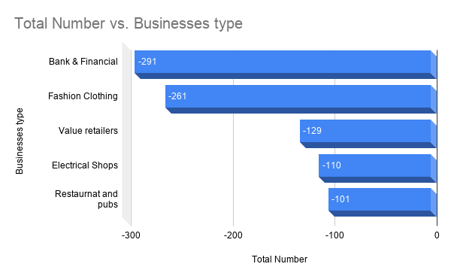
Figure 4: Source - The Guardian (Butler, 2019).

In the year 2018, the total number of closed business organisation like Bank & Financial and fashion Clothing company were 291 and 261 respectively. Many well known companies like Poundworld, Blue Inc, Jacques Vert, New Look had to close down their highstreet branches because of the online switch behavior of consumers (Butler, 2019). Companies are still making money online but it is the employees that suffer the most, especially those who used to work in the store. Blockbuster used to be the UK's most popular video rental shop. Because of high online competition, the company closed all stores from the year 2010 to 2013. Even the US giant Toys R Us closed its UK stores after getting hit from online competition. Approximately 2,000 people lost their jobs (Chown, 2018). Coast, the fashion chain company also closing their 24 stores from the high street and 300 jobs set to go (Wood and Butler, 2018).
It seems only fashion clothing companies are suffering the most. It can be addressed as a national or a problem that all small, medium or big entrepreneurs are facing in this modern age.

Through market research, let's see if there is any hope for fashion clothing business. Also, if there is any opportunity, space and customers customers for new and old entrepreneurs to start up or shift from their existence business to online store.

4.1 Market segmentation: The purpose of doing market segmentation is to divide all the potential customers into groups. Market segmentations helps an entrepreneur to understand the market more easily. If an entrepreneur divide a market based on the result of market segmentation then there is a much higher chance of success. Through market segmentation, an entrepreneur can create a marketing strategy and promote their business. Traditionally market research is divided into four sections: Geographic, Demographic, Psychographic and Behavioral.

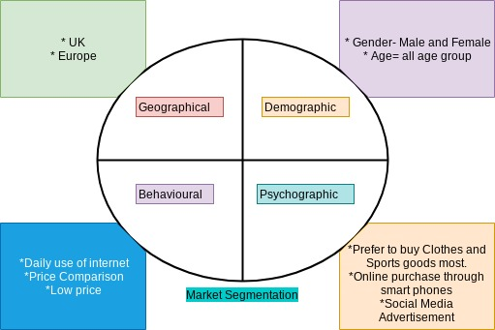

4.1.1 Geographic: According to Mintel’s Online Fashion UK 2017, British people are going to spend £16.2 billion on clothing, footwear, and fashion accessories through online. The online fashion market going to increase By 2022, online fashion market expected to grow 79% (Mintel, 2017). Seven out of ten (66%) internet users in the UK have purchased fashion items online. Which means, three internet users are shopping from physical clothing stores.

Most of the trusted site said UK highstreet shops are getting replaced by online shopping. For the Primark, it was the opposite. According to The Guardian, Primark saw a 3% sales rise in the past six months to 3rd of March 2018 (Butler, 2018). High street giant JD sports also saw a 33% rise in sales in 2018. Primark is known for selling inexpensive and good quality products and JD is known for selling athleisure trend. Which is sports type clothing. From that information, we can agree that price and trends also matters into the modern business including online option (O'Gorman, 2019)

Fashion clothing company Gap also closing 200 stores not only in the UK but worldwide. According to The Sun, Gap was suffering from rising poor sale performance and costs and high competition from Target and Amazon (Grahns, 2019).

In the UK, 90 households have internet access. In 2017, 93% of internet users shopped online sellers in the UK, 31% shopped online from EU countries and 31% from all over the world (Adegeest, 2017)

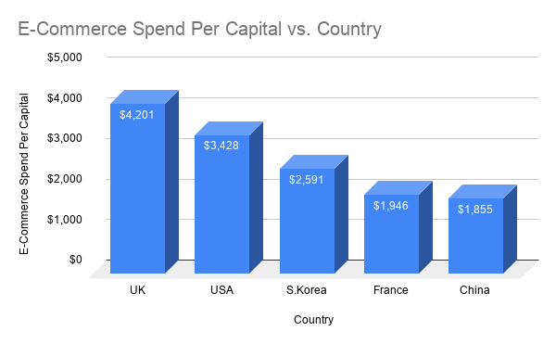
Figure 5: Chart - Top E-Commerce Spender Country (Frisby, 2018)

From the chart it is very clear that UK spending more money on e-commerce than any other countries. Which is a strength for all online business owners.

4.1.2 Demographic: Not only young customers are doing online shopping. 54% of internet users over 45 age people also bought their clothing items online (Mintel, 2017). According to Mintel, 85% of female internet users aged between 16 to 24 purchased their garments online. Percentage of men (60%) was lower 10% than women (71%) have bought clothes online (Mintel, 2017).

56% of female online shoppers and 60% of women aged between 25-44 have returned their purchase. 34% of online fashion shopper did not return due to the hassle of returning. 74% of online shoppers asking for more return options (Mintel, 2017). Many fashion clothing companies introduce new trendy clothes for teenage girls during late July and August before the school year begins.

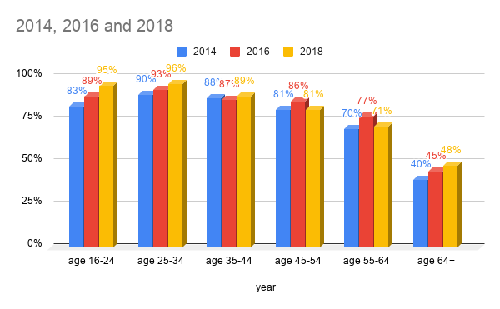
Figure 6: Column chart - Different age group purchases online in the year 2012, 2014 and 2018 (Sabanoglu, 2019).

According to Statista.com, age group of 16-24, 25-34, 35-44-year old online users purchasing through online is increasing constantly. However, the rest of the age groups purchasing rate is also over 70%. Except for age group 60+ (Sabanoglu, 2019)

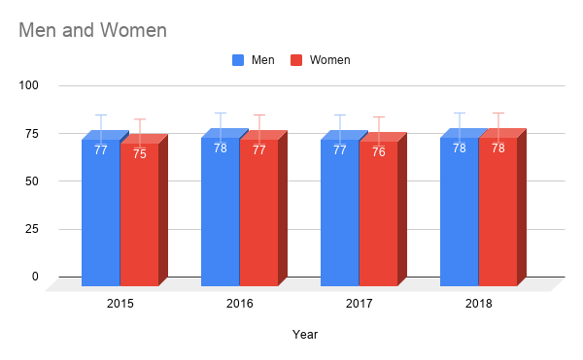
Figure 7: Men and women who purchases online from the year 2015 to 2018 (Sabanoglu, 2019)

The online purchasing percentage difference between British men and women are not that big. It is only one and two percent different and the year 2018 it was equal 78% from both sides (Sabanoglu, 2019).

4.1.3 Psychographic: It is expected that £25 billion pounds due to spent by British people via their mobile phones in 2019, which will be 66% higher than last year. UK customers are more likely to shop via mobile phone go to a shopping mall. More than 30 million UK citizens are set to use mobile phones to shop online. Which will be 12 million higher than the year 2018. Smartphone devices are very popular than desktop and laptops (Stevens, 2019).

69% of UK smartphone device users said they purchased clothes online, 51% of them purchased books and 47% said they purchased groceries (Stevens, 2019).
84% of online customers have used their laptop/desktop to buy clothes online. However, the use of a smartphone device is also growing (Mintel, 2017).

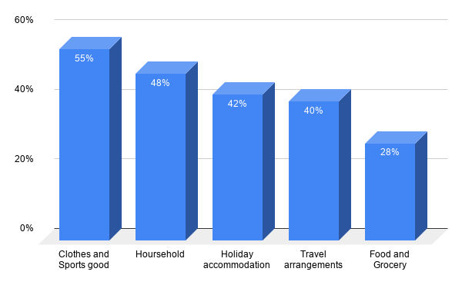

Figure 8: Chart: Most popular product/services purchased online in the UK 2018 (Sabanoglu, 2019).

Approximately 80% of British population shop online and their favorite online products are Clothes and Sports good. Second and third product/service are household goods 48% (furniture, toys etc) and Holiday accommodation 42% respectively (Sabanoglu, 2019). That is why all physical stores in the high street are in danger.

4.1.4 Behavioral: 86% of British people using the internet at least six hours daily. 86% of internet users search their products online first before purchase and 81% of the are going to purchase something. Which mean there is massive potential in online business. 35% of them use comparison sites for the purpose of finding the cheap and best product. By doing that 38% of UK shoppers start their journey by buying from Amazon. 51% of British shoppers believe that Amazon offers the cheapest prices with the same quality products (Evans, 2019). Which means, low price also matters. UK customers are responding to social media advertising better than ever. 40% of internet users who have seen advertisements in social media shopped online more (Evans, 2019). The purchasing behavior of British people are changing. Online shopping saves time and it is very convenient to fit their busy life too. However, total usage and trust in online shopping is growing (Mintel, 2017).

4.2 SWOT analysis:
Strength  - Figure 5 says UK spending more money on eCommerce than any other countries. Which means that the UK market is established. For an entrepreneur it is a strength.  - According to figure 6, age between 16 to 44 years old are making more online purchases than anyone else and the rate of purchasing growing high every year. | Weakness  - Only 26% of small businesses tried to make their online eCommerce store (Sophy, 2019). Which means the rest of them did not develop their online store. No online store means more chance to collapse.  - All Entrepreneurs needs cash flow for all time.
Opportunities  - 74% of small businesses do not have online stores (Sophy, 2019). Which means they can join with rest and grab the opportunity to meet customer demand and become successful.  - Advertising in Social Media is cheap and easy to do. 71% of UK online customers who have had good social media advertising experience with a brand and they recommend others too (HAINLA, 2019).  - The online low pricing strategy can make a big difference. | Threats  - Entrepreneurs are starting to realise that having an online business is the future. Competition is already here and in future it will go higher.  - Moving on to online means in the future there will be very less physical store in the UK.  - UK market is an international market. There will always be competition between national and international entrepreneurs.

4.3 Porter’s five forces
New Entrance: Low.
- Only 26% of small businesses have an online store. At the moment, not many are entering into online business because they have not realised the future of online business.
Bargaining power of supplier: Medium
- Bargaining power of supplier will be there always. An entrepreneur must work on market demand and negotiate it smartly.
Threats of Substitute: Low
- For clothing and sports, good depends on design and quality. As long as an entrepreneur make sure their designs are different and go with trends then there will not be any substitute.
Bargaining power of buyers: Medium
- From the market segmentation, we saw there are potential online based customers available. UK online customers are buying from big brands, Amazon, eBay, Alibaba etc but not many small clothing fashion brands are in online business yet. The products small business is selling might not be available online to compare with big brands.
Threats of Rivalry: Low to Medium.
- Threats of rivalry can be low to medium if all entrepreneurs keep update themselves about competitors and their prices through market research. Also, an entrepreneur can develop their own innovative idea to be different than competitors.

5. Recommendation:

- After doing market research, an entrepreneur should have a plan on a computer or on paper instead of having it in mind. Set some target for the next 12 months.

- After doing research, we found that many high street fashion clothing and other shops are closing. Which mean this is an opportunity for all existing non clothing entrepreneurs to expand and open a new business in the highstreet.

- Entrepreneurs often try to understand the market closely with their first customer, which is a good thing to do. By doing market research they can cast a bigger net to acquire the full range of market (Burke, 2016).

- From students to working-class people, everyone using social media. It is very easy to get connect with customers through social by advertising. It is a great platform to advertise in this modern age.

- Entrepreneurs should be serious about marketing. Through market research, an entrepreneur can target which one or two marketing platforms will be most beneficial for the business.

- Regular conduct market research to determine what customers need, make a plan and act on their feedback.

- From the Behavioral segment, we can see that 47% of smartphone device users ordering grocery. That grocery comes big superstores like Tesco, Sainsbury, Iceland, etc. What about local grocery shop? If an entrepreneur creates an app to connect all grocery stores just like Airbnb, Just Eat then it can be a game changing idea.
- The online website is also very crucial in this modern age. All online purchasing is happening through websites. All entrepreneurs must act on that because online business is the present and it will be the future.

- The ease of shopping via mobile phone is helping to rise online demand.A mobile phone is a very important part of our daily life. A mobile phone is not for calling, also for a dictionary, translator, watch, entertainer, a camera, etc. Entrepreneurs must realise the importance of mobile phone and create mobile friendly websites and apps too. Nowadays many making websites is not a big deal. For a small business to a medium, a website can make a big difference.

- From Demographic Segmentation we see, 74% of customers were asking for more options for return, which is a big issue for the online fashion business. As a new or old entrepreneur, it is time to act on customers feedback. They can do partnership business with a local shop as a delivery and collection point.

- According to many experts, UK high streets going to adjust by having coffee shops rather than disappear (Grut, 2017) An optimist entrepreneur will find an innovative idea to do business. They can introduce something new or existing business which can not be served or delivery home. For example, Gym, Bowling and other indoor games.

- 65% of UK shoppers claim themselves as loyal shoppers (Evans, 2019). Which means that an entrepreneur can start introducing a loyalty scheme and reward their loyal customers.

6. Conclusion: To Conclude, I would like to say market research is very crucial for an entrepreneur. It provides all valuable information about the market. It helps to identify and analyse the needs of the market, demands of customers and performance competitors. I hope this report will help any entrepreneur to understand why and how market research helps to make better decisions, when to develop and market their products and services and as well as achieving the business goals and growth. Online business is the present and the future of all business and our national economy. However, UK consumers behavior is not actually different than anywhere (Evans, 2019) It is a trend that all entrepreneurs need to understand and make their move along with innovative ideas.

Reference & Bibliography :

Adegeest, D. (2017). UK online shopping behaviour revealed. [online] Fashionunited.uk. Available at: https://fashionunited.uk/news/retail/uk-online-shopping-behaviour-revealed/2017080825414 [Accessed 24 Aug. 2019].

Akbar, H. (2017). 5 Reasons Why Entrepreneurs Fail. [online] Medium. Available at: https://medium.com/@hakbar2707/5-reasons-why-do-entrepreneurs-fail-158483b9cf4e [Accessed 25 Aug. 2019].

Andriole, S. (2016). 10 Reasons Why Entrepreneurs Fail. [online] Forbes.com. Available at: https://www.forbes.com/sites/steveandriole/2016/04/01/10-reasons-why-entrepreneurs-fail/#6465af7a42d9 [Accessed 28 Sep. 2019].

Baijal, R. (2016). 4 reasons why entrepreneurship is important. [online] Entrepreneur.india. Available at: https://www.entrepreneur.com/article/269796 [Accessed 23 Aug. 2019].

Bessant, J., Tidd, J. and Bessant, J. (2011). Innovation and entrepreneurship. Chichester (England): John Wiley & Sons, p.4.

Butler, S. (2019). Almost 2,500 shops lost from top 500 UK high streets in 2018. [online] the Guardian. Available at: https://www.theguardian.com/business/2019/apr/10/more-than-2400-shops-lost-from-top-500-uk-high-streets-in-2018-banks [Accessed 1 Sep. 2019].

Bhasin, H. (2019). Demographic segmentation - What is demographic segmentation. [online] Marketing91. Available at: https://www.marketing91.com/demographic-segmentation/ [Accessed 27 Aug. 2019].

Burke, K. (2016). How Important Is Market Research for Entrepreneurs? [Podcast]. [online] Textrequest.com. Available at: https://www.textrequest.com/blog/important-market-research-entrepreneurs/ [Accessed 1 Sep. 2019].

Chown, A. (2018). Well-known brands that have disappeared from UK high streets | lovemoney.com. [online] Lovemoney.com. Available at: https://www.lovemoney.com/gallerylist/53030/wellknown-brands-that-have-disappeared-from-uk-high-streets [Accessed 1 Sep. 2019].

Evans, I. (2019). UK Consumer Behaviour: What Do The British Want? | Wordbank. [online] Wordbank (UK). Available at: https://www.wordbank.com/uk/blog/uk-consumer-behaviour/ [Accessed 1 Sep. 2019].

Frisby, J. (2018). The World's Biggest Online Spenders Revealed | New Research 2019. [online] Website Builder Expert. Available at: https://www.websitebuilderexpert.com/blog/worlds-biggest-online-spenders/ [Accessed 1 Sep. 2019].

Grahns, A. (2019). Gap is closing more than 200 stores in yet another blow for the high street. [online] The Sun. Available at: https://www.thesun.co.uk/money/8536645/gap-closing-stores-uk-us-high-street/ [Accessed 1 Sep. 2019].

Griffith, E. (2014). Startups are failing because they make products no one wants. [online] Fortune. Available at: https://fortune.com/2014/09/25/why-startups-fail-according-to-their-founders/ [Accessed 1 Sep. 2019].

HAINLA, L. (2019). 21 Social Media Marketing Statistics You Need to Know in 2019. [online] Dreamgrow.com. Available at: https://www.dreamgrow.com/21-social-media-marketing-statistics/ [Accessed 1 Sep. 2019].

Harvardentrepreneurship.org. (2019). 10 Reasons Why Entrepreneur Fail Their Business | Financial and Business Resources, Ideas, Tips. [online] Available at: https://www.harvardentrepreneurship.org/246/10-reasons-why-entrepreneur-fail-their-business.html [Accessed 31 Aug. 2019].

iResearch Services. (2018). How Important is Market Research for Entrepreneurs?. [online] Available at: http://www.iresearchservices.com/how-important-is-market-research-for-entrepreneurs/ [Accessed 28 Aug. 2019].

Iversen, J., Jørgensen, R. and Malchow-Møller, N. (2008). Defining and measuring entrepreneurship. Boston: Now Publishers Inc, pp.4-5.

Iversen, J., Jørgensen, R. and Malchow-Møller, N. (2008). Defining and measuring entrepreneurship. Boston: Now Publishers Inc, 2008, p.6.

Iwcapital.co.uk. (2019). The importance of entrepreneurship to the UK economy | IW Capital. [online] Available at: https://iwcapital.co.uk/the-importance-of-entrepreneurship-to-the-uk-economy/ [Accessed 2 Sep. 2019].

Jordan, A. (2018). Why market research is so important for a start-up business. [online] Small Business UK. Available at: https://smallbusiness.co.uk/why-market-research-is-so-important-for-a-startup-business-2371778/ [Accessed 23 Aug. 2019].

Kappel, M. (2019). Conducting a Market Analysis for Your Small Business. [online] Patriot Software. Available at: https://www.patriotsoftware.com/accounting/training/blog/how-to-conduct-a-market-analysis/ [Accessed 18 Aug. 2019].

Khera, R. (2018). Entrepreneur Definition - What is Entrepreneurship?. [online] MoreBusiness.com. Available at: https://www.morebusiness.com/business-entrepreneurship/ [Accessed 30 Aug. 2019].

Mercy (2018). Top 10 Reasons for Entrepreneurs Failure in 2018 - Rescue a CEO. [online] CBNation. Available at: https://rescue.ceoblognation.com/2018/03/21/top-10-reasons-for-entrepreneurs-failure-in-2018/ [Accessed 1 Sep. 2019].

Marr, B. (2016). The top 9 reasons small businesses fail - Hiscox Business Blog. [online] Hiscox Business Blog. Available at: https://www.hiscox.co.uk/business-blog/top-9-reasons-small-businesses-fail/ [Accessed 26 Aug. 2019].

McIntyre, G. (2019). What Percentage of Small Businesses Fail?. [online] Fundera. Available at: https://www.fundera.com/blog/what-percentage-of-small-businesses-fail [Accessed 1 Sep. 2019].

Mintel. (2017). UK Online sales of clothing, fashion accessories and footwear grow by 17% in 2017. [online] Available at: https://www.mintel.com/press-centre/fashion/uk-online-sales-of-clothing-fashion-accessories-and-footwear-grow-by-17-in-2017 [Accessed 28 Aug. 2019].

O'Gorman, V. (2019). Are we witnessing the end of high street shopping?. [online] Theboar.org. Available at: https://theboar.org/2018/06/high-street-versus-online-shopping/ [Accessed 2 Sep. 2019].

Otar, C. (2018). Council Post: What Percentage Of Small Businesses Fail -- And How Can You Avoid Being One Of Them?. [online] Forbes.com. Available at: https://www.forbes.com/sites/forbesfinancecouncil/2018/10/25/what-percentage-of-small-businesses-fail-and-how-can-you-avoid-being-one-of-them/#2e493de343b5 [Accessed 16 Aug. 2019].

Price, R. (2015). How does economics connect to entrepreneurship?. [online] Global Entrepreneurship Institute. Available at: https://news.gcase.org/2015/09/04/how-does-economics-connect-to-entrepreneurship/ [Accessed 1 Sep. 2019].

Sabanoglu, T. (2019). Share of individuals who made purchases online in Great Britain in 2008-2018, by gender. [online] Statista. Available at: https://www.statista.com/statistics/276076/online-purchasing-penetration-in-great-britain-by-gender/ [Accessed 1 Sep. 2019].

Sabanoglu, T. (2019). Most popular goods purchased online in Great Britain 2018. [online] Statista. Available at: https://www.statista.com/statistics/275973/types-of-goods-purchased-online-in-great-britain/ [Accessed 2 Sep. 2019].

Sabanoglu, T. (2019). Online purchasing penetration by age Great Britain 2012-2018 | Statista. [online] Statista. Available at: https://www.statista.com/statistics/275972/online-purchasing-penetration-in-great-britain-by-age/ [Accessed 2 Sep. 2019].

Satell, G. (2014). A Look Back At Why Blockbuster Really Failed And Why It Didn't Have To. [online] Forbes.com. Available at: https://www.forbes.com/sites/gregsatell/2014/09/05/a-look-back-at-why-blockbuster-really-failed-and-why-it-didnt-have-to/#3f3c9be41d64 [Accessed 1 Sep. 2019].

Schmidt, S. (2015). Why Market Research Matters. [online] Blog.marketresearch.com. Available at: https://blog.marketresearch.com/why-market-research-matters [Accessed 1 Sep. 2019].

Seth, S. (2019). Why Is Entrepreneurship Important to the Economy?. [online] Investopedia. Available at: https://www.investopedia.com/articles/personal-finance/101414/why-entrepreneurs-are-important-economy.asp [Accessed 1 Sep. 2019].

Shaw, B. (2018). Business demography, UK - Office for National Statistics. [online] Ons.gov.uk. Available at: https://www.ons.gov.uk/businessindustryandtrade/business/activitysizeandlocation/bulletins/businessdemography/2017 [Accessed 1 Sep. 2019].

Sobel, R. (2019). Entrepreneurship. [online] Econlib. Available at: https://www.econlib.org/library/Enc/Entrepreneurship.html [Accessed 1 Sep. 2019].

Sophy, J. (2019). 74 Percent of Small Business Websites Have No eCommerce - Small Business Trends. [online] Small Business Trends. Available at: https://smallbiztrends.com/2016/06/small-business-ecommerce-trends.html [Accessed 1 Sep. 2019].

Stevens, B. (2019). £25bn to be spent using smartphones in 2019 as medium overtakes shopping centres - Retail Gazette. [online] Retail Gazette. Available at: https://www.retailgazette.co.uk/blog/2019/01/25bn-spent-using-smartphones-2019-medium-overtakes-shopping-centres/ [Accessed 24 Aug. 2019].

Stokes, D., Wilson, N. and Mador, M. (2010). Entrepreneurship. London: Thomas Rennie, pp.2-5.

Williams, O. (2017). 'What we're seeing is a revolution': How the internet is remaking the British High Street. [online] Business Insider. Available at: https://www.businessinsider.com/future-british-high-street-internet-brexit-retail-2017-8?r=US&IR=T [Accessed 9 May 2019].

Wood, Z. and Butler, S. (2018). Coast fashion chain closes high street stores. [online] the Guardian. Available at: https://www.theguardian.com/business/2018/oct/11/coast-fashion-chain-closes-high-street-stores [Accessed 1 Sep. 2019].

