Research Methods and Data Analysis
Module Code: M7xM00672

Rhysian Jones - 1809710
MSc Applied Computing

Assignment 1: Data Analysis

Abstract:
This work will analyse two samples: mature students’ satisfaction and younger students’ satisfaction. Twenty students in total were given a satisfaction questionnaire with a maximum score of 60 with 60 meaning high satisfaction. The aim is to determine whether these samples are significantly different making the question: Is mature students’ satisfaction different to younger students’ satisfaction?

Background Theory:
The Null Hypothesis.
The Null Hypothesis is used to disprove a theory, thereby proving the opposite must be true.
For example, for two sets of data you can hypothesise that the means are equal.
This makes H₀: µ1=µ2.
H₁ is the alternate hypothesis which must be true if H₀ is proven to be false. So H₁: µ1≠µ2.
In significance testing, the null hypothesis is assumed to be true until it is proven to be significantly unlikely to produce the data given[1].

Ronald Fisher devised an experiment which outlines this method; Lady Tasting Tea [2]. The experiment involves a lady who claimed to be able to tell how a cup of tea was made just by tasting it. Fisher’s experiment gave presented the lady with eight cups of tea in random order, four made one way, four made the other way. The null hypothesis proposed was that the lady could not tell the teas apart and it was pure chance. The lady correctly identified all eight cups of tea. The probability of this occurring by chance is 1/70 so the null hypothesis was rejected.

Type I and Type II Errors.
A type I error occurs when the null hypothesis is erroneously rejected.
A type II error occurs when the null hypothesis is erroneously accepted.
The significance level of a test will tell you the probability of an error occurring.
p=0.05 means that there is a 5% chance that the result could occur by chance so there is a 5% chance of a type II error where the null hypothesis is erroneously accepted. [3]
Increasing the significance level will increase the chance of a type II error while also decreasing the chance of a type I error because the two are inversely proportional (if you are less likely to falsely accept, you are more likely to falsely reject and vice versa).

Student’s T-test.
The two sample t-test can be used to determine whether two sets of data are significantly different. [4]
For two samples with different variances and the same size which are unpaired or independent, the t-test involves calculating $t_{obt}=\frac{{\overline{X}}_{1}-{\overline{X}}_{2}}{\sqrt{\frac{{SD}_{1}^{2}+{SD}_{2}^{2}}{n}}}$ and comparing this to t_{crit} for the correct degrees of freedom from t distribution critical values chart. If the value of t_{obt} is greater than the value of t_{crit}, the difference in the means of the two samples is significant at that significance level. This result is used to either accept or reject the null hypothesis.

This test can be carried out either one-tailed or two-tailed. A two-tailed test will determine whether the samples are significantly different but not which direction the difference is. The two-tailed test also has a higher chance of a type I error because the chance of the result occurring by chance is equal on both sides of the probability graph whereas the one-tailed test only has this probability on one side. The diagram below explains how this probability looks:
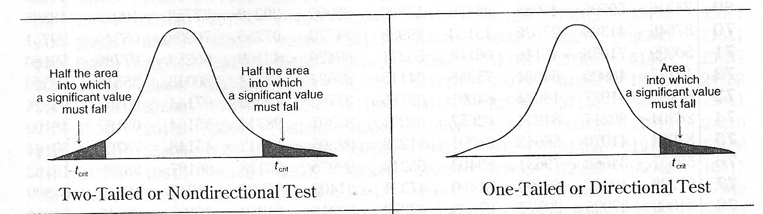
[5] (The shaded areas are all equal in value so the two-tailed test has double the shaded area)

A one-tailed test will determine whether the samples are significantly different and the direction of that difference. For example, it can tell you that the samples’ means are different and the second sample’s mean is greater than the first’s. This method gives a higher chance of accepting a hypothesis erroneously because of the smaller shaded area on the graph.

Where outliers are present in the data, the t-test will not give an accurate result because these outliers can give the data a skewed distribution curve and Student’s t-test works best for data with a normal or close-to-normal distribution.

Method:
The hypothesis chosen as H₀ was that the means of the two samples are equal.
H₀: µ1=µ2
H₁: µ1≠µ2
Before carrying out t-testing, some simple data analysis was carried out on the data finding the mean, mode, range, variance and standard deviation of the samples. This analysis was used to identify outliers by selecting a cutoff of three standard deviations away from the mean. A frequency distribution was also created for the samples which was used to get a general idea of trends.

The significance levels given were p=0.10, p=0.01 and p=0.02. These were used in the t-testing which was carried out using excel’s data analysis package.
The expected difference in means was chosen as 0 in line with the hypothesis.
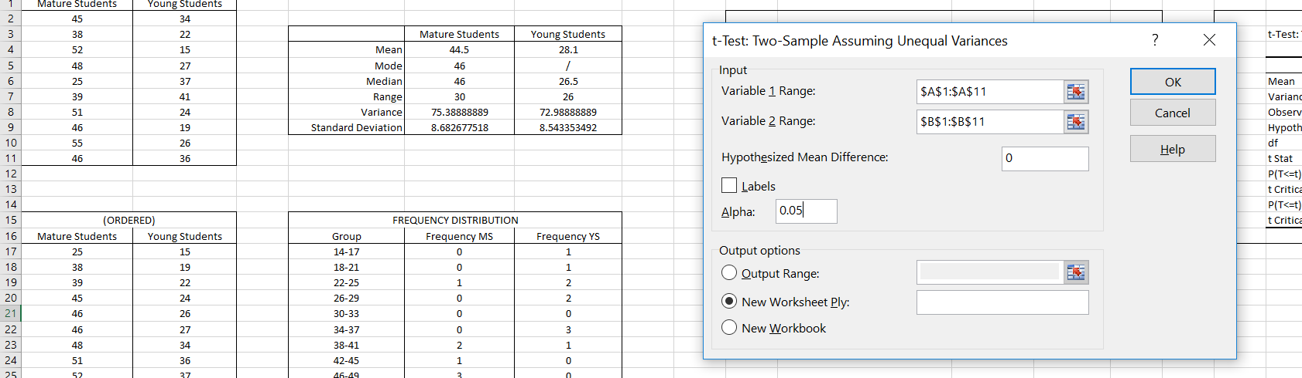
Once a t-test had been carried out for each significance level, the generated results were used to accept or reject the hypothesis (if t_{obt} is greater than t_{crit}, the difference in means is significant at that significance level). The data was also used to determine the direction of the difference in the means.

Results:
The results of the preliminary data analysis are shown below:
 | Mature Students | Young Students
Mean | 44.5 | 28.1
Mode | 46 | /
Median | 46 | 26.5
Range | 30 | 26
Variance | 75.38888889 | 72.98888889
Standard Deviation | 8.682677518 | 8.543353492

The frequency distributions are shown below:
(ORDERED) |  |  | FREQUENCY DISTRIBUTION
Mature Students | Young Students |  | Group | Frequency MS | Frequency YS
25 | 15 |  | 14-17 | 0 | 1
38 | 19 |  | 18-21 | 0 | 1
39 | 22 |  | 22-25 | 1 | 2
45 | 24 |  | 26-29 | 0 | 2
46 | 26 |  | 30-33 | 0 | 0
46 | 27 |  | 34-37 | 0 | 3
48 | 34 |  | 38-41 | 2 | 1
51 | 36 |  | 42-45 | 1 | 0
52 | 37 |  | 46-49 | 3 | 0
55 | 41 |  | 50-53 | 2 | 0
 |  |  | 54-57 | 1 | 0

The results of the t-tests for the three given significance levels are shown below:
 | t-Test: Two-Sample Assuming Unequal Variances |  | [p=0.1]
 |  | Mature Students | Young Students
 | Mean | 44.5 | 28.1
 | Variance | 75.38888889 | 72.98888889
 | Observations | 10 | 10
 | Hypothesized Mean Difference | 0
 | df | 18
 | t Stat | 4.257546666
 | P(T<=t) one-tail | 0.000236832
 | t Critical one-tail | 1.330390944
 | P(T<=t) two-tail | 0.000473663
 | t Critical two-tail | 1.734063607

 | t-Test: Two-Sample Assuming Unequal Variances |  | [p=0.01]
 |  | Mature Students | Young Students
 | Mean | 44.5 | 28.1
 | Variance | 75.38888889 | 72.98888889
 | Observations | 10 | 10
 | Hypothesized Mean Difference | 0
 | df | 18
 | t Stat | 4.257546666
 | P(T<=t) one-tail | 0.000236832
 | t Critical one-tail | 2.55237963
 | P(T<=t) two-tail | 0.000473663
 | t Critical two-tail | 2.878440473

 | t-Test: Two-Sample Assuming Unequal Variances |  | [p=0.02]
 |  | Mature Students | Young Students
 | Mean | 44.5 | 28.1
 | Variance | 75.38888889 | 72.98888889
 | Observations | 10 | 10
 | Hypothesized Mean Difference | 0
 | df | 18
 | t Stat | 4.257546666
 | P(T<=t) one-tail | 0.000236832
 | t Critical one-tail | 2.213703252
 | P(T<=t) two-tail | 0.000473663
 | t Critical two-tail | 2.55237963

Analysis:
From the preliminary data analysis, it can be seen that the means of the two samples differ greatly, giving an idea of the final results after t-testing. It can also be seen that the two samples share similar ranges, variances and standard deviations. This implies high accuracy as the two samples behave similarly and have similar spread. It would be expected that inaccurate data would exhibit a large difference in the spread of data between samples.
The outlier analysis shows that there are no outliers in the given data using the threshold of three standard deviations from the mean. The lowest value in the mature student dataset (25) is more than two standard deviations below the mean making it the only candidate to be an outlier using this method but it has not been considered one in this analysis.

(ORDERED) |  | Anomalies:  3 or more SDs from mean
Mature Students | Young Students
25 | 15
38 | 19
39 | 22 | Young: | Mature:
45 | 24 | 25.5 away from 28.1 | 26 away from 44.5
46 | 26 | min 2.6 | min 18.5
46 | 27 | max 53.6 | max 70.5
48 | 34
51 | 36
52 | 37
55 | 41 | No anomalies in young or mature

It is interesting to note that the frequency distribution curves for the data appear to be skewed and each have large tails on one side. This implies that outliers are present but could also just be a symptom of a small sample size.

The frequency distributions show that the samples vaguely follow offset curves. The roughness of these curves indicates that more data is needed to properly analyse these samples. When these datasets are plotted on the same axes, it can be seen that the mature dataset is skewed towards the right while the young dataset is skewed towards the left, again hinting at the final results of analysis.

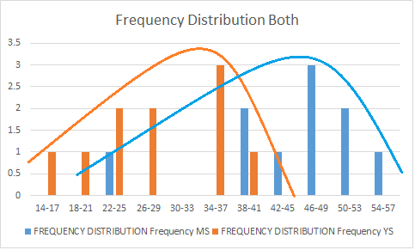

The t-test results for each of the three given significance levels all show that there is a significant difference in the means of the two samples for both one-tailed and two-tailed tests (T stat is larger than T critical. T stat is t_{obt} here).
This allows for the null hypothesis H₀: µ1=µ2 to be rejected for each significance level and for the alternative hypothesis H₁: µ1≠µ2 to be accepted. We can now say that the two samples have a significant difference in mean.
The one=tailed test results tell us the direction of the difference. Because the t stat value is positive, the first sample inputted into the test has a larger mean than the second sample. In this case, the first sample inputted was the mature students sample so we can now say that the mature students sample has a mean that is significantly different and also greater than the younger students sample.
To test this, two samples with known difference can be tested. The order of the samples determines the polarity of t stat. If the sample with a known smaller mean is tested first, t stat is shown to be negative.

Further testing was carried out in order to find a significance level where the null hypothesis could not be rejected. The results of these tests are shown below:
 | t-Test: Two-Sample Assuming Unequal Variances |  | [p=0.001]
 |  | Mature Students | Young Students
 | Mean | 44.5 | 28.1
 | Variance | 75.38888889 | 72.98888889
 | Observations | 10 | 10
 | Hypothesized Mean Difference | 0
 | df | 18
 | t Stat | 4.257546666
 | P(T<=t) one-tail | 0.000236832
 | t Critical one-tail | 3.610484885
 | P(T<=t) two-tail | 0.000473663
 | t Critical two-tail | 3.921645825

At p=0.001, t stat is higher than t crit for both tests so the null hypothesis is rejected.

 | t-Test: Two-Sample Assuming Unequal Variances |  | [p=0.0001]
 |  | Mature Students | Young Students
 | Mean | 44.5 | 28.1
 | Variance | 75.38888889 | 72.98888889
 | Observations | 10 | 10
 | Hypothesized Mean Difference | 0
 | df | 18
 | t Stat | 4.257546666
 | P(T<=t) one-tail | 0.000236832
 | t Critical one-tail | 4.648014155
 | P(T<=t) two-tail | 0.000473663
 | t Critical two-tail | 4.965706285

At p=0.0001, t stat is lower than t crit for both tests so the null hypothesis is accepted.

 | t-Test: Two-Sample Assuming Unequal Variances |  | [p=0.0003]
 |  | Mature Students | Young Students
 | Mean | 44.5 | 28.1
 | Variance | 75.38888889 | 72.98888889
 | Observations | 10 | 10
 | Hypothesized Mean Difference | 0
 | df | 18
 | t Stat | 4.257546666
 | P(T<=t) one-tail | 0.000236832
 | t Critical one-tail | 4.151103691
 | P(T<=t) two-tail | 0.000473663
 | t Critical two-tail | 4.463853045

At p=0.0003, t stat is higher than t crit for the one-tailed test but lower than t crit for the two-tailed test. This means that the null hypothesis would be rejected for the one-tailed test but accepted for the two-tailed test. This makes sense because the two-tailed test has double the shaded area on the graph and thus twice the chance to fall into that area.

Conclusion:
The overall findings from this analysis show that the two samples, mature students’ satisfaction and younger students’ satisfaction are significantly different. The mature students’ satisfaction was found to be higher on average than the younger students’ satisfaction.
This data would be more reliable if the sample sizes had been far larger as the population of students is clearly many magnitudes larger than twenty. That being said, from the data given, the result is very conclusive.

References:

[1] - J. Neyman and E. S. Pearson, “On the Problem of the Most Efficient Tests of Statistical Hypotheses,” Philos. Trans. R. Soc. A Math. Phys. Eng. Sci., vol. 231, no. 694–706, pp. 289–337, Jan. 1933.

[2] - Ronald Fisher, “The Design of Experiments,” 1935

[3] - Mabrouka Abuhmida, “Lecture 6, Inferential Statistics” (accessed 28.11.18)

[4] - Student, “THE PROBABLE ERROR OF A MEAN,” Biometrika, vol. 6, no. 1, pp. 1–25, Mar. 1908.

[5] - Mabrouka Abuhmida, “Lecture 7, The T Test” (accessed 28.11.18)

