ACCA7033 Ethical Hacking
Final Report
Research into Cyber Security Attacks and Penetration Testing for a Virtualised Simulated Company

Student Name | Dhaval Rami
Student ID | 2528086
Programme | MSc Cybersecurity and Digital Forensics
Module | Ethical Hacking
Module Code | ACCA7033
Lecturer | Dr. Dipo Dunsin
Submission Date | 17th August 2026 (2pm)
Word Count | 5160 words

Abstract
This report discusses both strategic and practical ethical hacking. The first part examines the cyber incidents suffered by Marks & Spencer and Co-op in the UK in 2025. The incidents demonstrated the potential of operational disruption, exposure of customer data, financial impact, reputational damage and law enforcement involvement that can occur through cyber-attacks against large retailers. The analysis covers the timeline of the incident, the behaviour of the threat actors, the probable causes of the incident, challenges in detecting and responding to the incident, and strategic recommendations. It also allows for mapping the attack pattern to MITRE ATT&CK techniques to reveal how social engineering, valid-account abuse, service discovery, data access, and ransomware-style impact can all play a role in modern retail-sector attacks.
The second part involves a controlled practical red-teaming exercise of a simulated organisation ABCD Ltd. A VirtualBox host-only lab was configured with Kali Linux, Windows Server 2022, a Windows 11 Domain client and two extra VMs - BASICPT2 and Metasploitable. Rules of engagement, threat emulation plan, lab design, Active Directory configuration, discovery of hosts, discovery of services, and three controlled findings were all part of the engagement. The results showed that the root shell was exposed, anonymous SMB share access and SQL injection were found in DVWA. All testing was confined to the authorised lab subnet and destructive testing, malware, denial-of-service and real data access were all avoided.
The results of the two tasks collectively point to the need for enhanced identity controls, secure configuration, network segmentation, application security testing, monitoring and incident-response preparedness.

Table of Contents
Abstract i
List of Figures iv
List of Tables v
1. Introduction 1
2. Task 1: Strategic Threat Analysis - The M&S and Co-op UK Cyber Attack 1
2.1 Incident Summary and Timeline 1
2.2 Threat Actor Profile and Motive 3
2.3 MITRE ATT&CK Mapping and Attack Chain 4
2.4 Root Cause and Security Control Failures 6
2.5 Detection and Response Analysis 7
2.6 Strategic Recommendations 8
3. Task 2: Red Team Engagement - ABCD Ltd Complete Penetration Testing 9
3.1 Executive Brief 9
3.2 Practical Engagement Overview 9
3.3 Rules of Engagement and Scope 10
3.4 Lab Design and Network Architecture 10
3.5 Corporate Environment Configuration 12
3.6 Tools and Threat Emulation Plan 12
3.7 Enumeration Results 13
3.8 Finding 1: Exposed Root Shell Service 14
3.9 Finding 2: Anonymous SMB Share Access 14
3.10 Finding 3: SQL Injection Weakness in DVWA 15
3.11 Overall Risk Summary and Remediation Roadmap 16
3.12 Detection Gap Analysis 17
3.13 Ethical, Legal and Safety Considerations 17
4. Overall Conclusion 18
References 19
Appendices 21
Appendix A: Rules of Engagement and Lab Scope 21
Appendix B: Threat Emulation Plan 21
Appendix C: Lab Inventory and Network Diagram 22
Appendix D: Tools and Techniques Justification 24
Appendix E: Rollback and Snapshot Plan 25
Appendix F: Evidence Checklist 25
Appendix G: Practical Evidence Screenshots 27

List of Figures
Figure 1: ACCA7033 lab network diagram 11
Figure 2: BASICPT2 Nmap service enumeration output. 27
Figure 3: Metasploitable Nmap service enumeration output. 28
Figure 4: Controlled verification of exposed root shell access on Metasploitable. 29
Figure 5: Anonymous SMB share listing on BASICPT2. 29
Figure 6: Anonymous SMB share access verification on BASICPT2. 30
Figure 7: DVWA login page on Metasploitable. 30
Figure 8: DVWA security level configured to low. 31
Figure 9: DVWA SQL injection normal query and controlled payload result. 32
Figure 10: Controlled findings summary table. 33
Figure 11: VirtualBox Manager showing all lab VMs powered off after testing. 34

List of Tables
Table 1: Timeline of Key Publicly Reported Events 2
Table 2: MITRE ATT&CK Mapping for the M&S and Co-op Retail Attack Pattern 5
Table 3: Lab IP Addressing Plan 11
Table 4: Practical finding risk summary 16

Introduction
Cyber-attacks against large retail organisations have become a major business risk because retailers depend on digital ordering, payment processing, stock management, supply chains, customer communication and distributed store operations. A cyber incident in this sector can interrupt online trading, affect store replenishment, expose customer information, reduce public trust and create financial, regulatory and operational pressure (Admass, Munaye and Diro, 2024). The 2025 cyber incidents affecting Marks & Spencer and Co-op in the United Kingdom demonstrate this risk clearly. M&S reported an expected impact of around £300 million on 2025/26 operating profit before mitigation, insurance and trading actions, while Co-op confirmed that member personal data had been accessed, with later reporting stating that data relating to 6.5 million members was stolen (Tidy and Rahman-Jones, 2025).
The wider UK threat environment also supports the importance of this topic. The UK Cyber Security Breaches Survey 2025/26 reported that 43% of businesses experienced a cyber breach or attack in the previous 12 months (CloudSwitched Team, 2026).
This report consists of two interrelated sections. Task 1 contains a strategic threat analysis of the M&S attack, the Co-op attack, and an incident timeline, threat actor behaviour, likely root causes, MITRE ATT&CK mapping, issues identified with detection and response, and recommendations. Task 2 is a controlled red team engagement in an isolated lab set up with a VirtualBox host-only network for ABCD Ltd. It has rules of engagement, threat emulation planning, lab design, enumeration, three controlled findings and remediation.

Task 1: Strategic Threat Analysis - The M&S and Co-op UK Cyber Attack

Incident Summary and Timeline
M&S was the most obviously disrupted organisation. On 22 April 2025, the company declared that it was dealing with a cyber incident and on 25 April it suspended online and app orders to allow for a recovery effort (Davey and Sandle, 2025). This was a commercial serious as online ordering is a direct sales channel and it is associated with fulfillment, customer service and stock movements. M&S subsequently confirmed that some personal customer's information had been stolen but said there was no payment card details or account passwords that could be used. The incident later proved to have a financial material impact with M&S estimating a negative impact on operating profit before mitigation, insurance and trading actions of approximately £300m for 2025/26.
A similar retail data-related incident happened at co-op. In a statement on May 2, 2025, Co-op admitted that it had been breached by a third party in its handling of data about current and former members (Malenko and Muvija, 2025). The organisation stated that the affected data included names and contact details, but not passwords, bank details, credit card details or transaction information. Later reports said the data of 6.5 million members was stolen. This demonstrates that even if payment information isn't posted, names, addresses, email addresses and phone numbers can be used for phishing and impersonation and follow-on fraud.
Law-enforcement activity also highlighted the seriousness of the campaign. On 10th July 2025, the National Crime Agency made four arrests in connection with a series of attacks against M&S, Co-op and Harrods (National Crime Agency, 2025).
Table 1: Timeline of Key Publicly Reported Events
Date | Organisation | Event | Strategic significance
22 April 2025 | M&S | M&S announced that it was managing a cyber incident. | Start of public incident disclosure.
25 April 2025 | M&S | Online and app orders were paused during recovery. | Direct impact on digital sales and customer service.
1-2 May 2025 | UK retail sector | NCSC and ICO issued statements about incidents affecting retailers. | The incidents became a sector-level concern.
2 May 2025 | Co-op | Co-op confirmed member data had been accessed. | Customer/member data exposure confirmed.
13 May 2025 | M&S | M&S confirmed that some personal customer data had been taken. | Data breach dimension confirmed.
14 May 2025 | Co-op | Co-op stated that systems were running normally and stock availability was improving. | Recovery progress communicated publicly.
21 May 2025 | M&S | M&S estimated around £300 million operating profit impact for 2025/26 before mitigation. | Financial impact became measurable.
10 July 2025 | NCA | Four arrests announced in relation to attacks on M&S, Co-op and Harrods. | Law-enforcement investigation confirmed.
16 July 2025 | Co-op | Reporting stated that 6.5 million Co-op members had data stolen. | Scale of member data exposure became clearer.
Source: Author’s analysis based on official and public reporting links listed in the References section, including M&S, Co-op, NCSC, NCA, Reuters and BBC reports.
The timeline shows that M&S faced stronger operational and financial disruption, while Co-op’s public impact centred on member-data exposure. Together, the cases show why retail cyber-attacks should be treated as business-resilience events, not only technical incidents (Chidukwani et al., 2022).

Threat Actor Profile and Motive
Public reporting linked the UK retail attacks to financially motivated cybercrime activity rather than state-sponsored espionage. M&S chairman Archie Norman later stated that the company believed the ransomware operation behind its April 2025 cyber-attack was DragonForce (Davey and Young, 2025). Reuters also reported discussion of Scattered Spider in relation to the wider campaign and its association with DragonForce ransomware. However, because full forensic details have not been publicly released, this report treats the attribution as public reporting and victim-statement based rather than confirmed technical attribution.
Scattered Spider-style activity is relevant because official advisories describe the group as using social engineering, phishing, push bombing and SIM-swap techniques to obtain credentials and bypass multi-factor authentication. This makes the key risk not only weak technical infrastructure, but also weak identity verification, help-desk processes and privileged-access governance (Ghafir et al., 2018). Public reporting that attackers may have tricked IT help desks into resetting passwords is consistent with this type of behaviour.
The likely motive in the M&S and Co-op incidents was financial extortion. M&S experienced major operational disruption and estimated a significant profit impact, while Co-op faced large-scale member-data exposure. Both outcomes create pressure on victim organisations. The key strategic lesson is that modern retail threat actors combine human manipulation with technical exploitation (Pollini et al., 2021). Retailers therefore need strong identity controls, secure MFA recovery processes, privileged-access monitoring, segmentation and rehearsed incident-response plans.

MITRE ATT&CK Mapping and Attack Chain
MITRE ATT&CK is used in this report to translate the M&S and Co-op incidents into a structured pattern of adversary behaviour. Full forensic details have not been publicly released, so the mapping below combines publicly reported behaviour with reasonable analytical inference based on Scattered Spider-style retail-sector activity. It should therefore be treated as an attack-pattern model rather than a confirmed forensic reconstruction of every step.
The likely attack chain began with identity compromise rather than a purely technical perimeter exploit. Public reporting suggested that attackers may have impersonated employees and persuaded IT help desks to reset passwords. This aligns with social-engineering and valid-account abuse techniques, where attackers use apparently legitimate access to enter the environment and reduce the chance of early detection (Thomopoulos, Lyras and Fidas, 2024). After access is obtained, attackers may perform internal discovery, identify file shares or business systems, collect data and create operational disruption through ransomware-style activity (Schmitt and Flechais, 2024).
Table 2: MITRE ATT&CK Mapping for the M&S and Co-op Retail Attack Pattern
Phase | Technique | ATT&CK ID | Relevance to the incident pattern
Reconnaissance | Active Scanning | T1595 | Attackers may identify exposed systems, login portals, supplier routes or remote-access infrastructure before attempting access.
Initial Access | Phishing / social engineering | T1566 | Public advisories describe Scattered Spider-style activity as using phishing and social engineering to gain credentials.
Initial Access | Spearphishing Voice | T1566.004 | Help-desk impersonation and phone-based social engineering align with vishing-style access attempts.
Initial Access / Persistence | Valid Accounts | T1078 | Reset or stolen credentials can allow access through legitimate accounts rather than obvious malware.
Initial Access | Exploit Public-Facing Application | T1190 | Public-facing web, VPN, identity or remote-access systems can provide entry points if vulnerable or misconfigured.
Discovery | Network Service Discovery | T1046 | Once inside, attackers normally identify internal services, systems and exposed management interfaces.
Discovery | Network Share Discovery | T1135 | Retail organisations often hold shared operational, logistics and customer-support data on internal file shares.
Execution | Command and Scripting Interpreter | T1059 | Attackers may use command shells, PowerShell or scripts after gaining access to execute actions and automate tasks.
Collection | Data from Network Shared Drive | T1039 | Data-extortion attacks often involve locating and copying accessible internal files or customer records.
Impact | Data Encrypted for Impact | T1486 | Ransomware operations can encrypt systems to disrupt business operations and increase pressure on the victim.
Impact | Service Stop | T1489 | Attackers may stop services or disrupt systems to support ransomware deployment or recovery pressure.
Exfiltration | Exfiltration Over Web Service | T1567 | Data-theft extortion may involve moving stolen data through external services or infrastructure.
Source: Author’s analysis using MITRE ATT&CK (MITRE, 2025a–g).

Root Cause and Security Control Failures
This report does not make any one confirmed technical entry point, as the full forensic root cause of the M&S and Co-op incidents has yet to be made public. But public reports and official guidance focus on the problems with identity and access-management systems. The biggest likely problem identified was inadequate identity verification at the help-desk. Technical controls could be overcome if attackers are able to “talk their way” into resetting passwords or MFA devices by getting support staff to do so.
Another likely weakness was the lack of robust recovery measures coupled with reliance on standard MFA. While it can be effective, MFA can be compromised by push fatigue, SIM Swapping or malicious device re-enrolment (Sinigaglia et al., 2020). For this reason, MFA reset, recovery and new-device registration should not be considered regular support activities, but high-risk security events. More stringent approval and logging and verification should be enforced, particularly for privileged, high-risk accounts (Khan et al., 2023).
The third flaw was that it failed to detect legitimate-account abuse. If attackers are using valid accounts the activity may appear to be that of a normal employee. Therefore, monitoring for retailers for unusual password resets, new MFA devices, risky logins, and privileged group changes, abnormal file access, and large data movement are all necessary. Detection should use a combination of identity, endpoint, network, cloud and service-desk logs.
The fourth weakness was business-continuity dependency. M&S was forced to halt orders placed via its website and app, highlighting the impact of a cyber incident on trading, fulfilment and customer service. The other area of data exposure that was highlighted by the co-op data is data-governance risk, since names and contact details can still be used to support phishing and impersonation even if the payment details are not exposed.
In general, the root cause lesson is retailers must think of Identity, help-desk, recovery in case of MFA, monitoring, access and resilience as a single connected control environment. If the segmentation, detection and recovery planning is not robust enough, then a single weak account-recovery process will be a major business incident (Colabianchi et al., 2025).

Detection and Response Analysis
The two examples of the M&S and Co-op indicate how hard it is to detect attacks when legitimate credentials are used, or when help-desk and remote-access systems are exploited. Malicious activity can be disguised as something other than malware, meaning that you must be able to see into identity logs, endpoint activity, network traffic, cloud platforms, and service-desk records to detect it (Ahmad et al., 2021).
M&S suspended online and app orders whilst cooperating with external cyber experts. This was a costly business decision, but it supported containment, investigation and recovery. However, M&S went on to confirm that it had been breached by a third party and some personal customer data had been stolen, and urged customers to change their passwords as a precaution.
Co-op also stressed early containment in limiting access to the system to prevent any impact on the broader business. It later reported that systems and stock-ordering processes were returning to normal. This indicates that containment can be temporary, yet can help limit the potential for broader compromise.
The primary detection principle is to be able to detect suspicious identity activity sooner. Retailers should monitor password resets, MFA-device changes, privileged group changes, impossible travel, unusual file-share access, large downloads and remote access from unfamiliar devices or locations.

Strategic Recommendations
These M&S and Co-op events demonstrate that cyber security is a business-resilience issue and not just an IT issue for large retailers. The first is to improve the identity verification of help-desk agents. Improve authentication for password resets, MFA resets and privileged-account recovery; call-back to registered numbers and complete logging of privileged-account recovery and MFA resets. This decreases the likelihood of social engineering exploiting support processes.
The second is to enhance MFA resiliency. Standard MFA should be enhanced by providing phishing-resistant options like passkeys or security keys for administrators, help-desk personnel, and users with access to sensitive systems.
The third recommendation is to enhance identity and behaviour monitoring. Risky sign-in, impossible travel, new MFA registration, privileged group changes, unusual remote access, and abnormal file-share activity, in addition to large downloads, should be monitored by retailers. These alerts need to be correlated over different identity platforms, endpoint tools, cloud logs, VPN records and service-desk systems.
The fourth suggestion is to use segmentation and least privilege. It should not be possible to access ecommerce, store operations, warehouse systems, customer-service systems and internal file shares from a single account or device. Role-based access, different privileged accounts and network compartmentalization can limit the impact of an attack.
The fifth recommendation is to conduct testing of resilience and recovery. Retailers need to practice ransomware, identity compromise, data breach and e-commerce outages (Carias et al., 2021). Before an actual incident, offline backups, recovery time objectives, manual store procedures, and supplier communication and customer communication plans should be tested.

Task 2: Red Team Engagement - ABCD Ltd Complete Penetration Testing

Executive Brief
This hands-on exercise involved the examination of ABCD Ltd in an isolated VirtualBox host-only ethical hacking lab. The objective was to demonstrate the potential internal business risk arising from exposed services, weak configuration and vulnerable web applications and to ensure testing is authorised, controlled and non-destructive.
The lab had Kali Linux installed, along with a Windows Server domain controller, Windows 11 domain client and two vulnerable targets BASICPT2 and Metasploitable. Three results were confirmed. However, Metasploitable revealed a root shell service on port 1524, which was rated Critical, as it was a complete compromise of the server. BASICPT2 revealed an anonymous SMB share, High, which means that unauthenticated access may give up information within the system. DVWA exhibited SQL injection behaviour, which was rated High as the handling of input is described as insecure, with the possibility of revealing database records.
The key suggestions are to remove exposed services that are dangerous, disable anonymous file sharing, implement least privilege, use parameterized queries and keep an eye on suspicious activity and keep performing vulnerability scans regularly.

Practical Engagement Overview
Task 2 is a controlled red team engagement for ABCD Ltd. The aim was to create and validate an ethical hacking lab to demonstrate the vulnerabilities that could be found by an attacker and verify the chosen risks within an authorised space. All testing was done on a VirtualBox host only network.
The engagement was structured as follows: Rules of engagement were established, a threat emulation plan was created, the lab was set up, discovery and enumeration were completed, three findings were validated, evidence was captured and remediation was recommended. The goal was not to compromise and to get the most of the system, but to prove that it is possible to conduct safe ethical hacking practice by engaging in scoped testing, gathering evidence, and explaining the risks to the business.

Rules of Engagement and Scope
Prior to testing a Rules of Engagement document was prepared to outline the scope of assessment, limits of safety and ethics. This was required because ethically, red team activity must be approved, scoped and controlled (Lachkov, Tawalbeh and Bhatt, 2022).
The authorised network was limited to 192.168.56.0/24. Testing was permitted only against the assessment virtual machines: Kali Linux, ACCA7033-DC01, ACCA7033-CLIENT01, ACCA7033-BASICPT2 and Metasploitable. Excluded: Public internet systems, 3rd party websites, host operating system and networks outside the lab subnet.
Activities covered were host discovery, service enumeration, identification of vulnerabilities, exploitation of a deliberately vulnerable host, and evidence collection via the browser. Denial of service testing, malware deployment, persistence, destructive commands, real systems testing and exfiltration of real data were all prohibited.
The safe word STOP-ABCD-LAB was the kill switch used for the engagement. In the case of an unstable VM, if activity appeared to be negatively impacting systems outside of lab, if encountering real data, or if encountering a destructive risk, testing would cease immediately. The entire Rules of Engagement evidence is available in Appendix A.

Lab Design and Network Architecture
The lab was set up in Oracle VirtualBox with host-only network. This enabled the assessment VMs to communicate with one another without exposing vulnerable machines to public networks. The lab subnet was configured as 192.168.56.0/24, with the Windows host adapter using 192.168.56.1. Vulnerable targets were assigned DHCP addresses, and core systems assigned static addresses, for testing purposes.
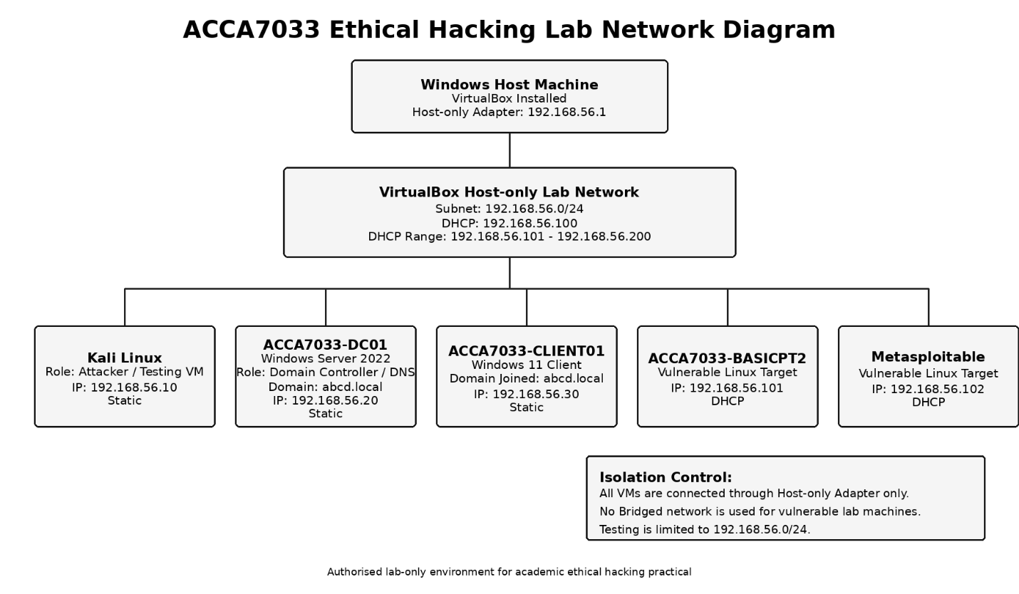
Figure 1: ACCA7033 lab network diagram
Source: Author’s own lab configuration.
Table 3: Lab IP Addressing Plan
System | Role | IP address | Addressing method
Windows host adapter | VirtualBox host-only adapter | 192.168.56.1 | Static
DHCP server | VirtualBox DHCP service | 192.168.56.100 | Static service address
Kali Linux | Attacker / testing workstation | 192.168.56.10 | Static
ACCA7033-DC01 | Domain controller / DNS server | 192.168.56.20 | Static
ACCA7033-CLIENT01 | Domain-joined Windows client | 192.168.56.30 | Static
ACCA7033-BASICPT2 | Vulnerable Linux target | 192.168.56.101 | DHCP
Metasploitable | Vulnerable Linux target | 192.168.56.102 | DHCP
Source: Author’s own lab configuration.
One of the major safety measures taken was network isolation. There were no vulnerable machines configured to have bridged networking, and testing was limited to the host-only subnet. To aid repeatability and lab safety, screenshots of the host-only adapter, the DHCP configuration, and the VM network settings and the final powered-off state were captured.

Corporate Environment Configuration
A small Active Directory environment was set up to make the ABCD Ltd lab more realistic. The Windows Server 2022 VM was renamed DC01, assigned the static IP address 192.168.56.20, and promoted as the domain controller and DNS server for the abcd.local domain. This created a simple enterprise identity context for the hands-on activity.
The Windows 11 client VM was renamed as CLIENT01 and given the static IP address 192.168.56.30, with DC01 as the DNS server, and also joined to the abcd.local domain. Verifying domain membership was done via both System Properties and command-line output, both of which proved the client's identity as being part of the simulated corporate network.
Active Directory Users and Computers was used to create the ABCD_Ltd_Lab organisational unit with Users, Groups and Computers sub-OUs. Dummy users and departmental security groups were set up for a small organisation. The computer object CLIENT01 was added to the custom Computers OU.

Tools and Threat Emulation Plan
There were no random tests, but rather, a threat emulation plan was followed (Haq and Khan, 2021). The simulated attacker was described as an opportunistic threat actor that has only access to the internal lab subnet. The goal was to find the active hosts, count the exposed services, and determine the weaknesses and verify three controlled findings without harming anything.
A Kali Linux computer was used as a testing workstation. Nmap was able to do host discovery and service/version enumeration. Only netcat was used to check the existence of the exposed shell service on Metasploitable, and smbclient was used to check for the existence of anonymous SMB on BASICPT2. Firefox had browser-based service verification support, and the DVWA SQL injection demonstration. Configuration of domain and lab was done by using windows administration tools.
The activity was mapped to the MITRE ATT&CK. Discovery and enumeration matched up with T1595 Active Scanning and T1046 Network Service Discovery. SMB testing coordinated with T1135 network share discovery and T1039 data from network shared drive. The exposed shell and SQL injection demonstrations were related to T1190 Exploit Public-Facing Application and T1059 Command and Scripting Interpreter, respectively, where command execution was verified.
No real malware, persistence, payloads or command and control were used. The complete tools justification and threat emulation plan is provided in appendices.

Enumeration Results
Enumeration has been done only for the authorised vulnerable targets from Kali Linux. Host discovery confirmed BASICPT2 at 192.168.56.101 and Metasploitable at 192.168.56.102, both reachable from Kali at 192.168.56.10.
Nmap service/version detection on BASICPT2 identified exposed services including SSH on port 22, Apache HTTP on port 80, SMB/Samba on ports 139 and 445, AJP on port 8009 and Apache Tomcat 9.0.7 on port 8080.
Metasploitable exposed a wider attack surface, including FTP, SSH, Telnet, SMTP, DNS, Apache HTTP, Samba, remote shell services, NFS, MySQL, PostgreSQL, VNC, IRC, AJP and Tomcat. An interesting fact is that one of the ports, 1524, was determined to be a bindshell service, which means it has the potential of direct remote command-execution.
The findings were planned based on the results of the enumeration. BASICPT2 was chosen for SMB testing because file-sharing services were revealed. The port 1524 was selected for exposed shell testing as chosen as the port in Metasploitable, and DVWA was accessible for web app testing.

Finding 1: Exposed Root Shell Service
The first controlled finding was done on Metasploitable at 192.168.56.102. Nmap is enumerating services; it has detected port 1524/tcp as open and identified a bindshell service. The condition was considered Critical as an exposed shell service can be used to execute commands remotely without normal authentication.
The verification was carried out using Kali Linux with the help of Netcat. Commands executed to verify user context, hostname and working dir were harmless. The output displayed that the Metasploitable system had root-level access. No destructive commands are issued and no real data accessed.
A real organisation's “root level” shell access would be a server compromise. A threat might be able to edit files, add malware, and create accounts, or disrupt services — or use the server to move laterally. This is found to be MITRE ATT&CK T1190 Exploit Public-Facing Application and T1059 Command and Scripting Interpreter.
The recommended remediation steps are to remove unauthorized shell services, to configure firewalls to block inbound access, to implement secure baseline configurations and to regularly scan for listening ports that may not have been authorized, and to monitor for unusual remote-access activity. The evidence of this is stored in 59_metasploitable_1524_bindshell_root_access.png, which is backed up by the Metasploitable Nmap scan.

Finding 2: Anonymous SMB Share Access
The second controlled finding was located on BASICPT2 192.168.56.101. Nmap found SMB/Samba on ports 139/tcp and 445/tcp, so a non-destructive check of the SMB/Samba was made using smbclient on Kali Linux.
There were no authentication checks made on the available shares and an Anonymous disk share was displayed in the output. A second attempt revealed that the share could be accessed without a username or password and it was found that there was a file called staff.txt in the directory listing. There was no downloading, opening, editing, deletion or uploading of files. Only confirmation was given that there was unauthenticated access to the share.
The finding was rated High due to the fact that anonymous file-share access may reveal the internal information like staff list, operational files, scripts, backups or configuration data. Phishing, reconnaissance and lateral movement can be facilitated by low value files. The MITRE ATT&CK T1135 Network Share Discovery and T1039 Data from Network Shared Drive are the finding maps that are correlated.
Recommended remediation measures: disable anonymous SMB access, add authentication to all shares, implement least privilege, eliminate unnecessary shares, review share permissions frequently and watch for atypical use of shared folders.
There is evidence in 61_basicpt2_smb_anonymous_share_listing.png and 62_basicpt2_smb_anonymous_share_access.png.

Finding 3: SQL Injection Weakness in DVWA
The third controlled find was found on the Metasploitable from 192.168.56.102 in DVWA. DVWA was accessed from Kali Linux with the security set to Low to showcase a web application vulnerability for it to be seen in a deliberately vulnerable lab environment.
Initially, a baseline test was conducted with a normal user ID value that resulted in one response. Then a controlled SQL Injection input was entered through the same field and this caused the application to return more than the desired SQL query result. This confirmed that the user input was not properly validated and/or parameterised before using it in the database query.
The finding has been rated High, as SQL injection can give attackers the ability to circumvent application logic and gain access to sensitive information in a database. The finding's correlation category is MITRE ATT&CK T1190 Exploit Public-Facing Application, as the vulnerability was shown with a public-facing weak web interface. Able to identify that no destructive SQL was run, and no real data was accessed.
The recommended remediation steps are: Prepared statements and parameterised queries, Server side validation of input, Least privilege database permissions, Suppress detailed database errors, Review secure code, Regularly test web applications for security. The screenshots of the evidence are stored from 64_metasploitable_dvwa_login_page.png to 68_dvwa_sql_injection_payload_result.png.

Overall Risk Summary and Remediation Roadmap
Each of the three controlled findings illustrates a distinct, but related, type of risk. Exposed root shell on Metasploitable was an indicator of total compromise of a server. The anonymous SMB share on BASICPT2 demonstrated the potential vulnerability of internal information through weak file-sharing permissions. The DVWA SQL injection weakness demonstrated how unsafe input can make it possible for unwanted access to the database. Combined, these results demonstrate how exposed services and weak configuration and vulnerable applications can provide an internal attack path.
Table 4: Practical finding risk summary
Finding | Target | Main weakness | Risk rating | Business impact
Exposed root shell service | Metasploitable | Port 1524 allowed direct shell access | Critical | Complete system compromise
Anonymous SMB share access | BASICPT2 | File share accessible without authentication | High | Internal information disclosure
SQL injection in DVWA | Metasploitable | Unsafe input handling in web application | High | Unauthorised database access
Source: Author’s own controlled lab testing.
The priority action for immediate remediation is to get rid of hazardous exposed services. Unnecessary remote shell services, legacy services and administrative interfaces should be disabled unless there is a clear business requirement. Firewalls should only allow access to a few authorized management hosts and internal scanning should be performed to detect unexpected listening ports.
The next thing that is crucial is getting file sharing services. Anonymous SMB access should be disabled, all shares should be authenticated and access permissions should follow least privilege. Access to shared folders should be periodically audited and any access to shared folders that is unusual should be documented and investigated.
The third priority is to enhance the security of Web applications. Prevent SQL injection by using parameterised queries, using prepared statements, validating inputs on the server and using least-privilege accounts on the database. Before deployment and after significant changes, secure code review and regular testing of the applications should be conducted.

Detection Gap Analysis
The practical findings highlight the areas where monitoring should be present within a true organisation. Vulnerability scanning, firewall review, asset management and endpoint monitoring should detect any unexpected shell service like 1524. If there are any connections to high-risk internal services that are unusual, investigate also.
Anonymous SMB access should be blocked, logged and reviewed. Reconnaissance could be assisted by share enumeration and it should be monitored for unauthenticated share access, unusual directory listing and access from unexpected hosts.
The following are possible indicators of a SQL injection attack: Web Server logs, Application logs, Database alerts, Web Application Firewall events. Suspicious inputs, changes in input size, changes in response size and other unusual characters should be explored.

Ethical, Legal and Safety Considerations
All testing was performed only inside the authorised ABCD Ltd VirtualBox lab, limited to 192.168.56.0/24. No public systems, third-party websites, real organisations or external networks were scanned or attacked.
BASICPT2 and Metasploitable were deliberately vulnerable academic targets and were isolated using host-only networking. The exploitation demonstrations were limited to harmless verification: the shell test confirmed context only, the SMB test did not download or modify files, and the SQL injection test was performed only in DVWA.
No destructive commands, denial-of-service activity, malware, persistence, real C2 framework or real personal data were used. Evidence was controlled through screenshots, logs and VM snapshots.

Overall Conclusion
This report examined ethical hacking from both strategic and practical perspectives. Task 1 analysed the 2025 M&S and Co-op cyber incidents and showed how retail cyber-attacks can create operational disruption, customer-data exposure, financial loss, reputational pressure and law-enforcement involvement. The analysis identified that modern retail attacks are not just technical events but business-resilience events – impacting online trading, identity governance, customer trust and executive decision making.
The incidents also showed the importance of identity security. According to public reports and official guidance, the social engineering techniques, help-desk vulnerabilities, credential abuse and recovery procedures were central issues in the broader retail-sector attack.
Task 2 translated these lessons to a controlled red team engagement for ABCD Ltd. Kali Linux, Windows Server, Windows 11, BASICPT2 and Metasploitable are used to build a VirtualBox host-only lab. Root shell access, anonymous SMB share access and SQL injection in DVWA were successfully shown. These results demonstrated the potential for internal risk from these exposed services, weak file-sharing configuration and insecure web application input handling. From the real-world examples and the ABCD Ltd lab, it is clear that organisations should have more robust identity controls, secure configuration, application security testing, monitoring and segmentation, and have rehearsed and planned for incident response should one weakness become a major business incident.

References
Admass, W.S., Munaye, Y.Y. and Diro, A.A. (2024) ‘Cyber security: State of the art, challenges and future directions’, Cyber Security and Applications, 2(0), p. 100031. Available at: https://www.sciencedirect.com/science/article/pii/S2772918423000188 (Accessed: 10 August 2026).
Ahmad, A. et al. (2021) ‘How can organizations develop situation awareness for incident response: A case study of management practice’, Computers & Security, 101(0), p. 102122. Available at: https://www.sciencedirect.com/science/article/abs/pii/S0167404820303953 (Accessed: 10 August 2026).
Carias, J.F. et al. (2021) ‘Cyber Resilience Self-Assessment Tool (CR-SAT) for SMEs’, IEEE Access, 9(0), pp. 80741–80762. Available at: https://www.researchgate.net/publication/352098258_Cyber_Resilience_Self-Assessment_Tool_CR-SAT_for_SMEs (Accessed: 10 August 2026).
CloudSwitched Team (2026) ‘UK Government Drops the 2026 Cyber Reality Check: 612,000 Businesses Breached, Revenue Impact Doubles — The CSBS 2025/2026 Decoded for SMEs’, CloudSwitched News, 30 April. Available at: https://www.cloudswitched.com/news/uk-cyber-security-breaches-survey-2025-2026-sme-wake-up-call (Accessed: 10 August 2026).
Chidukwani, A. et al. (2022) ‘A survey on the cyber security of Small-to-Medium businesses: Challenges, research focus and recommendations’, IEEE Access, 10(0), pp. 85701–85719. Available at: https://researchportal.murdoch.edu.au/esploro/outputs/journalArticle/A-survey-on-the-cyber-security/991005541828407891 (Accessed: 10 August 2026).
Colabianchi, S. et al. (2025) ‘Transforming threats into opportunities: The role of human factors in enhancing cybersecurity’, Journal of Innovation & Knowledge, 10(3), p. 100695. Available at: https://www.sciencedirect.com/science/article/pii/S2444569X25000459 (Accessed: 10 August 2026).
Davey, J. and Sandle, P. (2025) ‘After 46-day cyberattack pause, M&S resumes online orders’, Reuters, 10 June. Available at: https://www.reuters.com/business/retail-consumer/uks-ms-resumes-online-orders-following-cyber-incident-2025-06-10/ (Accessed: 10 August 2026).
Davey, J. and Young, S. (2025) ‘M&S believes DragonForce behind ransomware attack, says chairman’, Reuters, 8 July. Available at: https://www.reuters.com/business/retail-consumer/ms-cyberattack-was-carried-out-by-dragonforce-chairman-says-2025-07-08/ (Accessed: 10 August 2026).
Ghafir, I. et al. (2018) ‘Security threats to critical infrastructure: the human factor’, The Journal of Supercomputing 2018 74:10, 74(10), pp. 4986–5002. Available at: https://link.springer.com/article/10.1007/s11227-018-2337-2 (Accessed: 10 August 2026).
Haq, I.U. and Khan, T.A. (2021) ‘Penetration Frameworks and Development Issues in Secure Mobile Application Development: A Systematic Literature Review’, IEEE Access, 9(0), pp. 87806–87825. Available at: https://www.researchgate.net/publication/352305904_Penetration_Frameworks_and_Development_Issues_in_Secure_Mobile_Application_Development_A_Systematic_Literature_Review (Accessed: 10 August 2026).
Khan, H.U. et al. (2023) ‘Role of authentication factors in Fin-tech mobile transaction security’, Journal of Big Data 2023 10:1, 10(1), pp. 138-. Available at: https://link.springer.com/article/10.1186/s40537-023-00807-3 (Accessed: 10 August 2026).
Lachkov, P., Tawalbeh, L. and Bhatt, S. (2022) ‘Vulnerability Assessment for Applications Security Through Penetration Simulation and Testing’, Journal of Web Engineering, 21(7), pp. 2187–2208. Available at: https://journals.riverpublishers.com/index.php/JWE/article/view/7153 (Accessed: 10 August 2026).
Malenko, A. and Muvija, M. (2025) ‘Britain’s Co-op says hackers have extracted customer data’, Reuters, 2 May. Available at: https://www.reuters.com/sustainability/boards-policy-regulation/britains-co-op-says-hackers-have-extracted-customer-data-2025-05-02/ (Accessed: 10 August 2026).
National Crime Agency (2025) ‘Retail cyber attacks: NCA arrest four for attacks on M&S, Co-op and Harrods’, 10 July. Available at: https://www.nationalcrimeagency.gov.uk/news/retail-cyber-attacks-nca-arrest-four-for-attacks-on-m-s-co-op-and-harrods (Accessed: 10 August 2026).
Pollini, A. et al. (2021) ‘Leveraging human factors in cybersecurity: an integrated methodological approach’, Cognition, Technology & Work 2021 24:2, 24(2), pp. 371–390. Available at: https://link.springer.com/article/10.1007/s10111-021-00683-y (Accessed: 10 August 2026).
Schmitt, M. and Flechais, I. (2024) ‘Digital deception: generative artificial intelligence in social engineering and phishing’, Artificial Intelligence Review 2024 57:12, 57(12), pp. 324-. Available at: https://link.springer.com/article/10.1007/s10462-024-10973-2 (Accessed: 10 August 2026).
Sinigaglia, F. et al. (2020) ‘A survey on multi-factor authentication for online banking in the wild’, Computers and Security, 95(0), p. 101745. Available at: https://research.tue.nl/en/publications/a-survey-on-multi-factor-authentication-for-online-banking-in-the/ (Accessed: 10 August 2026).
Tidy, J. and Rahman-Jones, I. (2025) ‘Co-op boss confirms all 6.5m members had data stolen’, BBC News, 16 July. Available at: https://www.bbc.com/news/articles/cql0ple066po (Accessed: 10 August 2026).
Thomopoulos, G.A., Lyras, D.P. and Fidas, C.A. (2024) ‘A systematic review and research challenges on phishing cyberattacks from an electroencephalography and gaze-based perspective’, Personal and Ubiquitous Computing 2024 28:3, 28(3), pp. 449–470. Available at: https://link.springer.com/article/10.1007/s00779-024-01794-9 (Accessed: 10 August 2026).

Appendices

Appendix A: Rules of Engagement and Lab Scope
This appendix contains the updated Rules of Engagement prepared for the ABCD Ltd simulated red-team practical. It defines the authorised lab network, in-scope systems, out-of-scope systems, permitted activities, prohibited activities, safe word, stop conditions, escalation process and ethical/legal constraints.
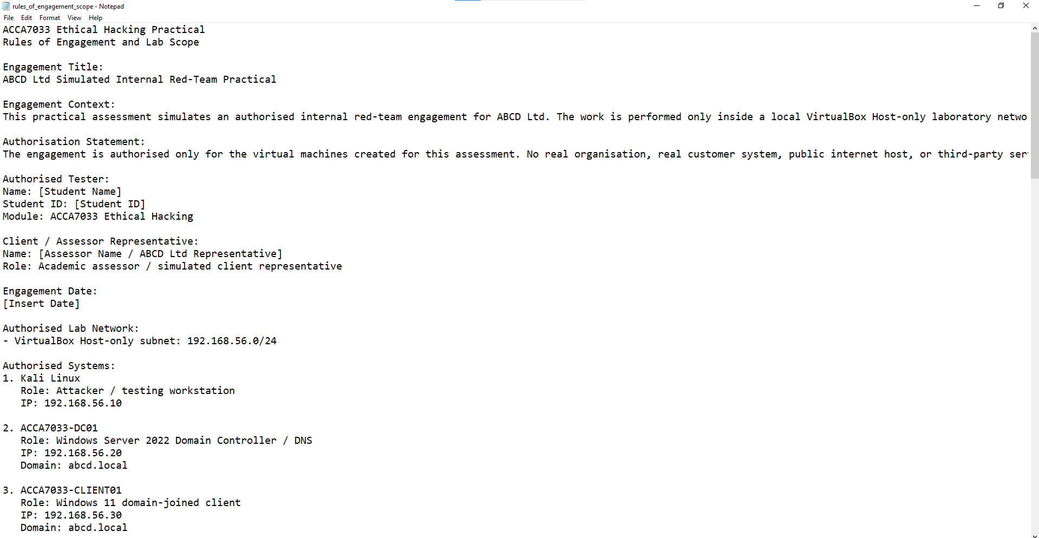

Appendix B: Threat Emulation Plan
This appendix contains the updated Threat Emulation Plan for the ABCD Ltd lab. The plan defines the simulated threat actor, campaign objective, testing sequence, success criteria and MITRE ATT&CK mapping for each phase of the practical engagement.
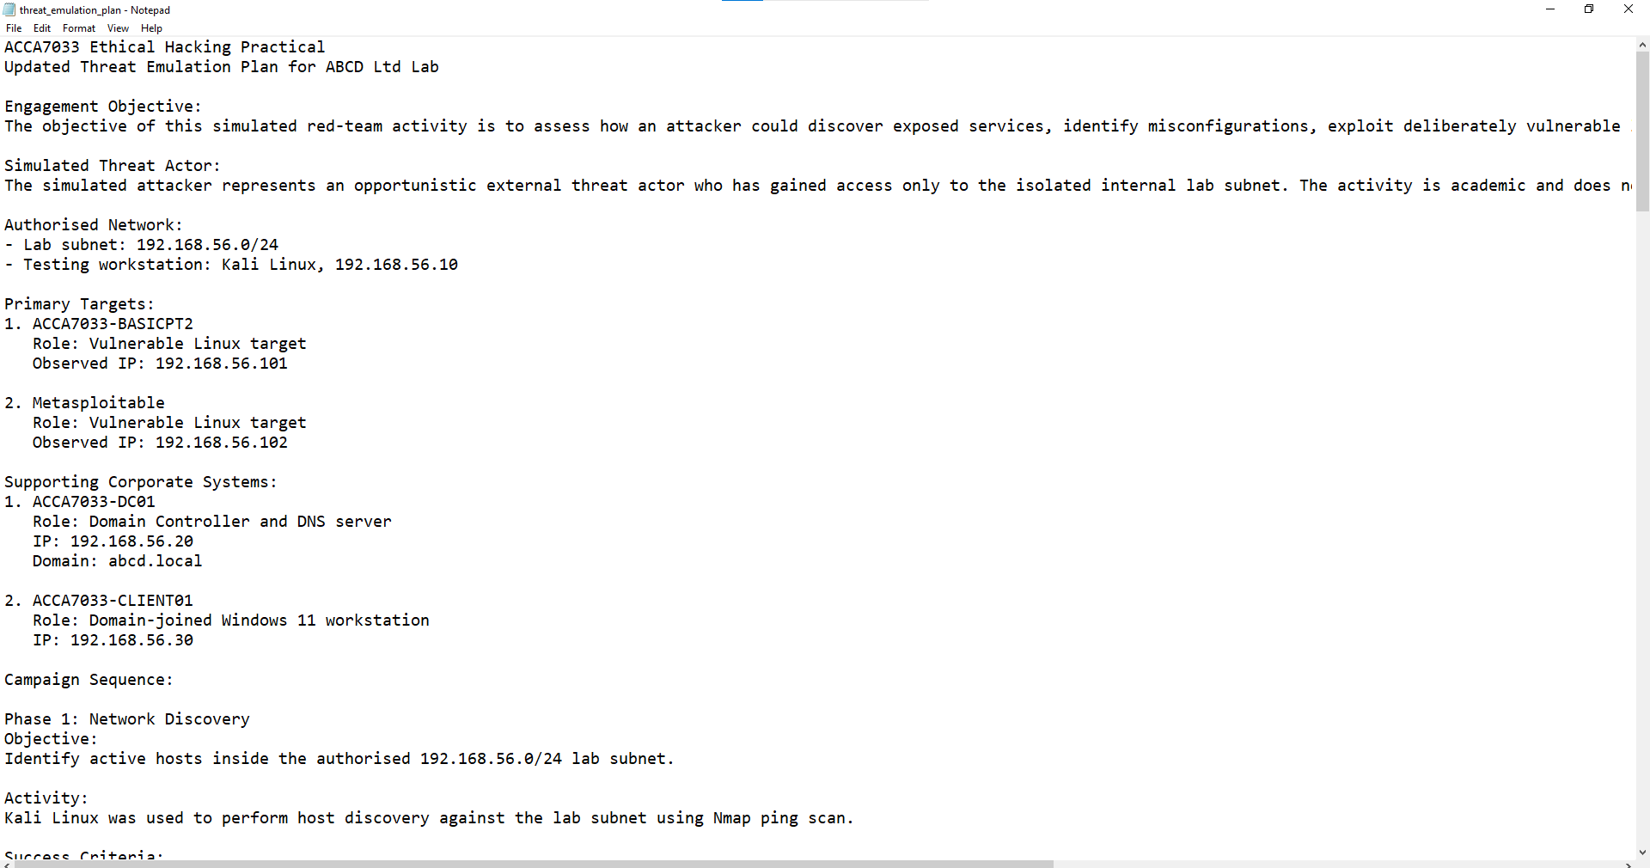

Appendix C: Lab Inventory and Network Diagram
This appendix contains the lab inventory, IP addressing plan and final network diagram used for the practical environment.
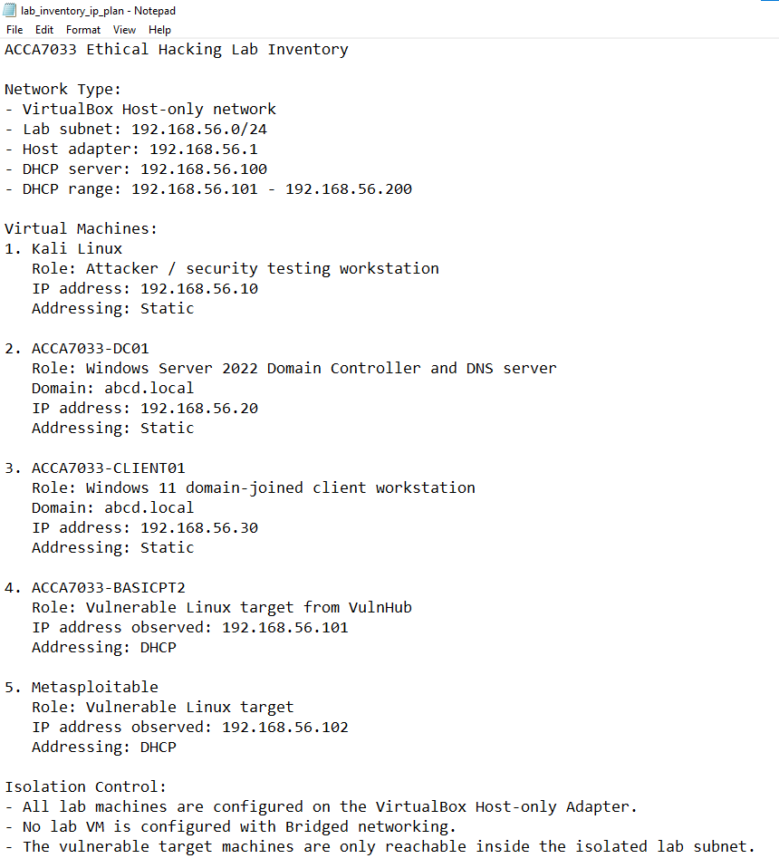

Appendix D: Tools and Techniques Justification
This appendix explains the tools used during the practical work, including VirtualBox, Kali Linux, Nmap, Netcat, smbclient, Firefox, DVWA and Windows administration tools. It also explains why real C2 frameworks, malware persistence and stealth payloads were not used in this academic lab.
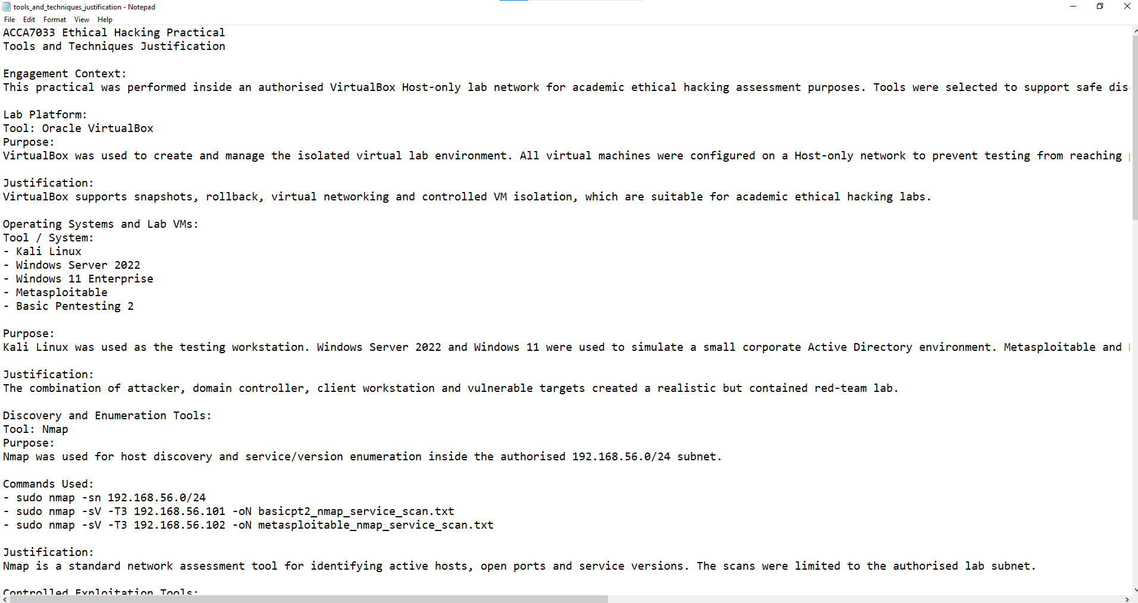

Appendix E: Rollback and Snapshot Plan
This appendix contains the rollback and snapshot plan used to support safe testing and repeatability. It lists the key snapshots for DC01, CLIENT01, Kali, BASICPT2 and Metasploitable.
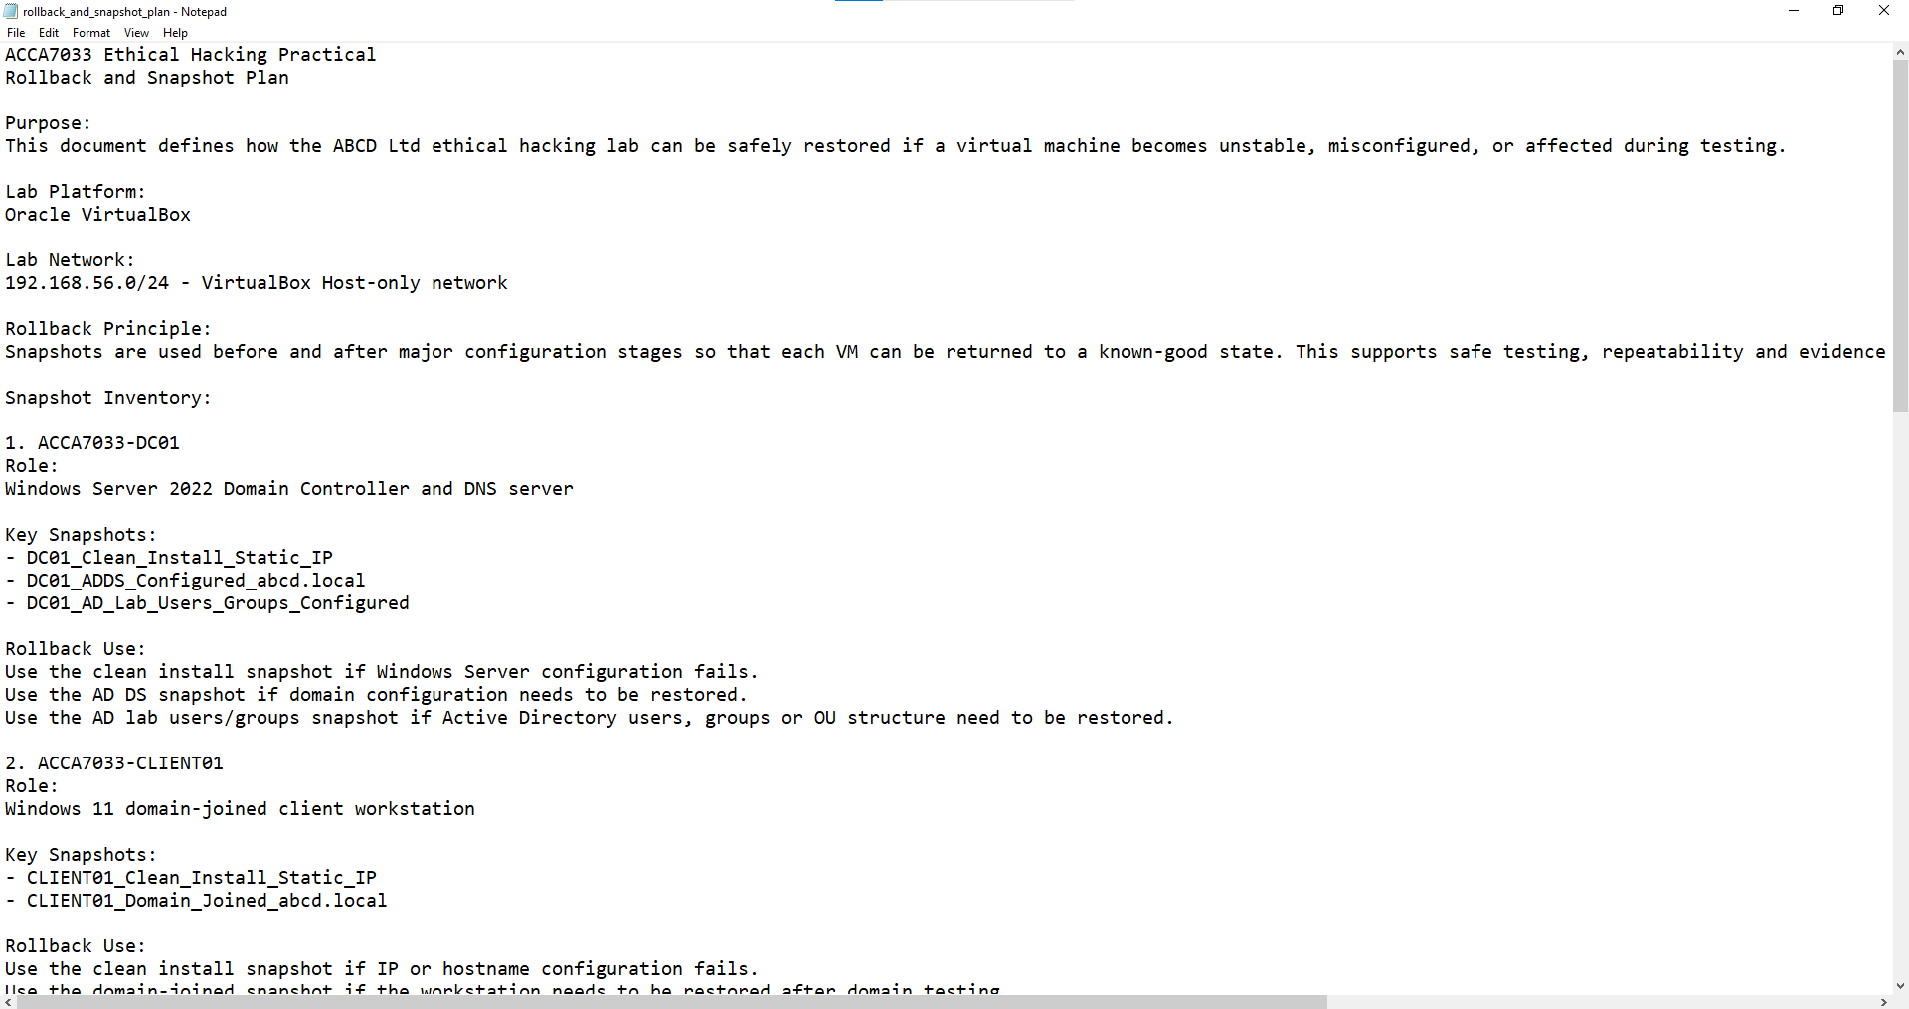

Appendix F: Evidence Checklist
This appendix contains the final evidence checklist used to organise screenshots, logs, summaries and practical proof files.
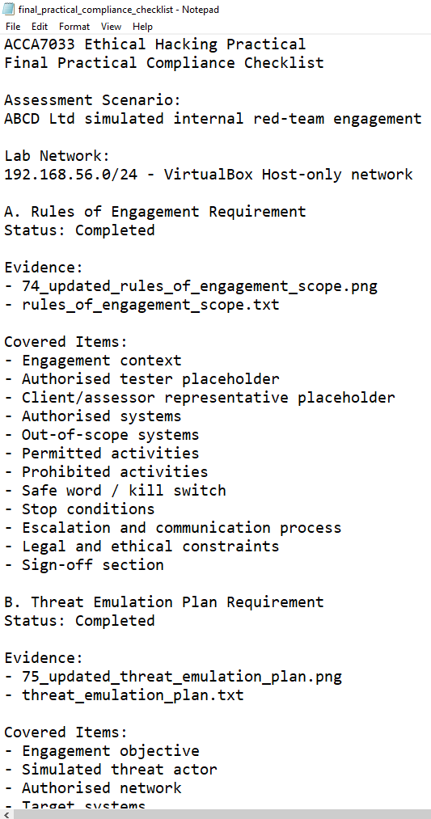

Appendix G: Practical Evidence Screenshots
This appendix contains selected screenshots from the practical engagement. The full evidence package is stored in the project Screenshots folder.
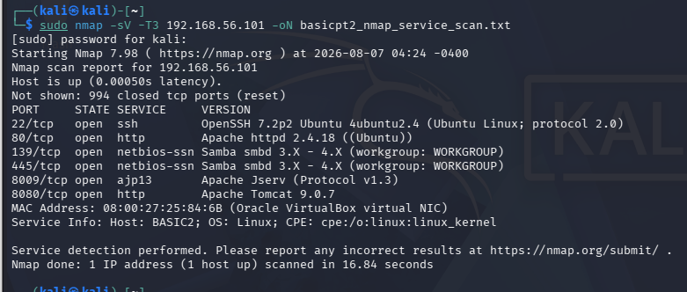
Figure 2: BASICPT2 Nmap service enumeration output.
Source: Author’s Kali Linux lab output.
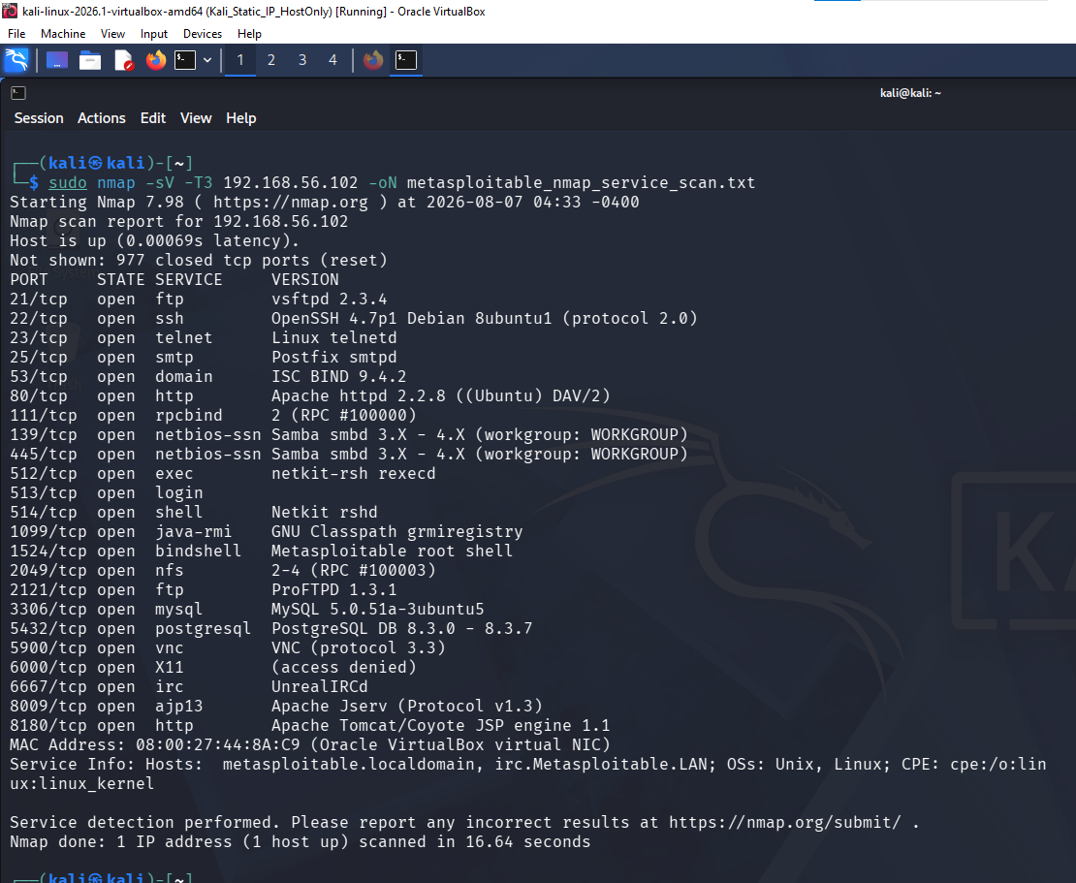
Figure 3: Metasploitable Nmap service enumeration output.
Source: Author’s Kali Linux lab output.
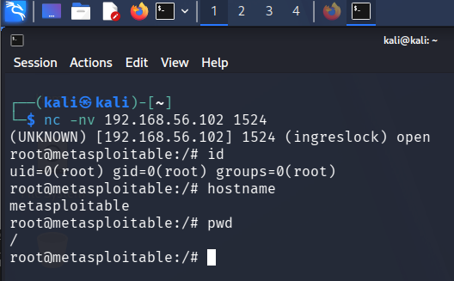
Figure 4: Controlled verification of exposed root shell access on Metasploitable.
Source: Author’s Kali Linux lab output.
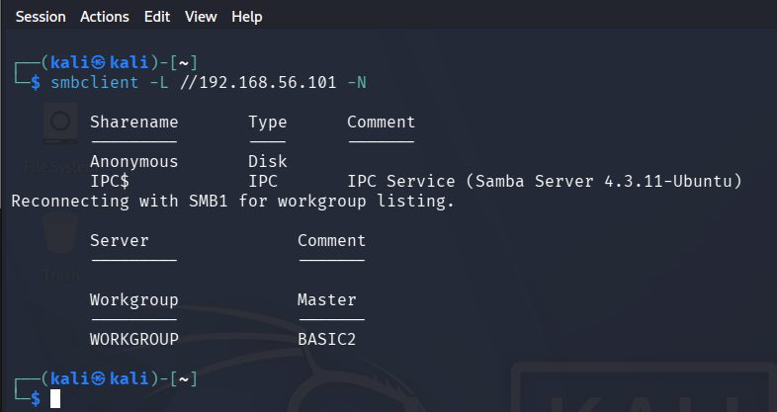
Figure 5: Anonymous SMB share listing on BASICPT2.
Source: Author’s Kali Linux lab output.
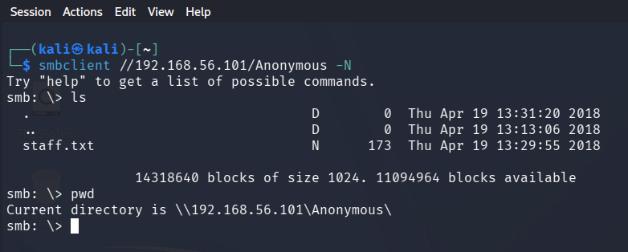
Figure 6: Anonymous SMB share access verification on BASICPT2.
Source: Author’s Kali Linux lab output.
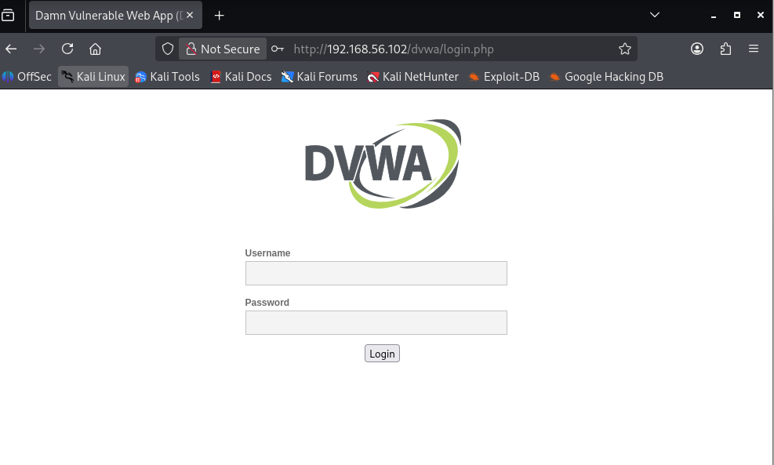
Figure 7: DVWA login page on Metasploitable.
Source: Author’s DVWA lab testing.
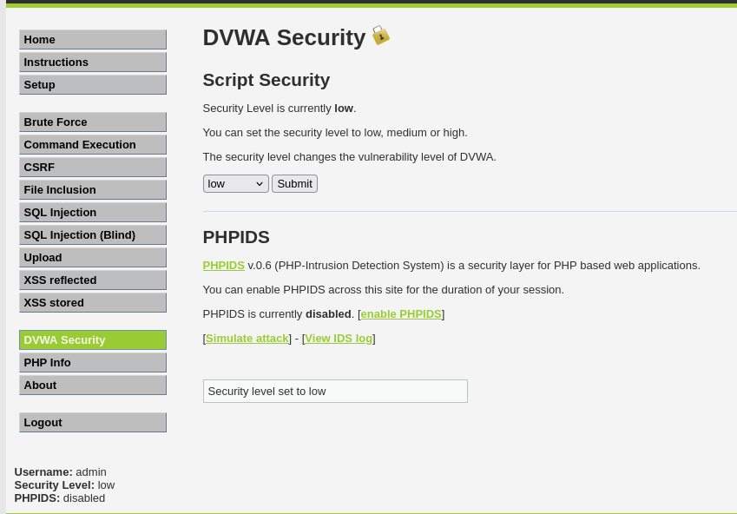
Figure 8: DVWA security level configured to low.
Source: Author’s DVWA lab testing.

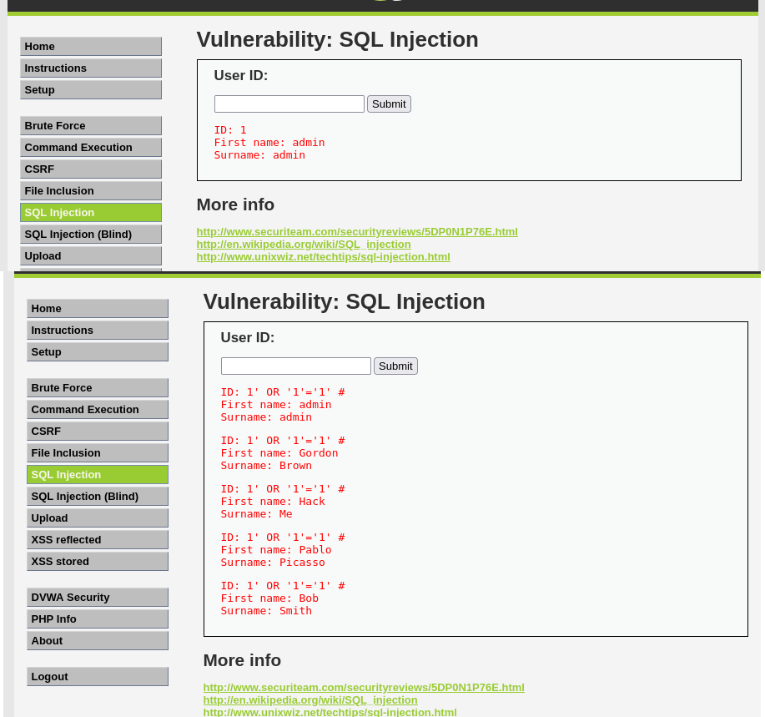
Figure 9: DVWA SQL injection normal query and controlled payload result.
Source: Author’s DVWA lab testing.
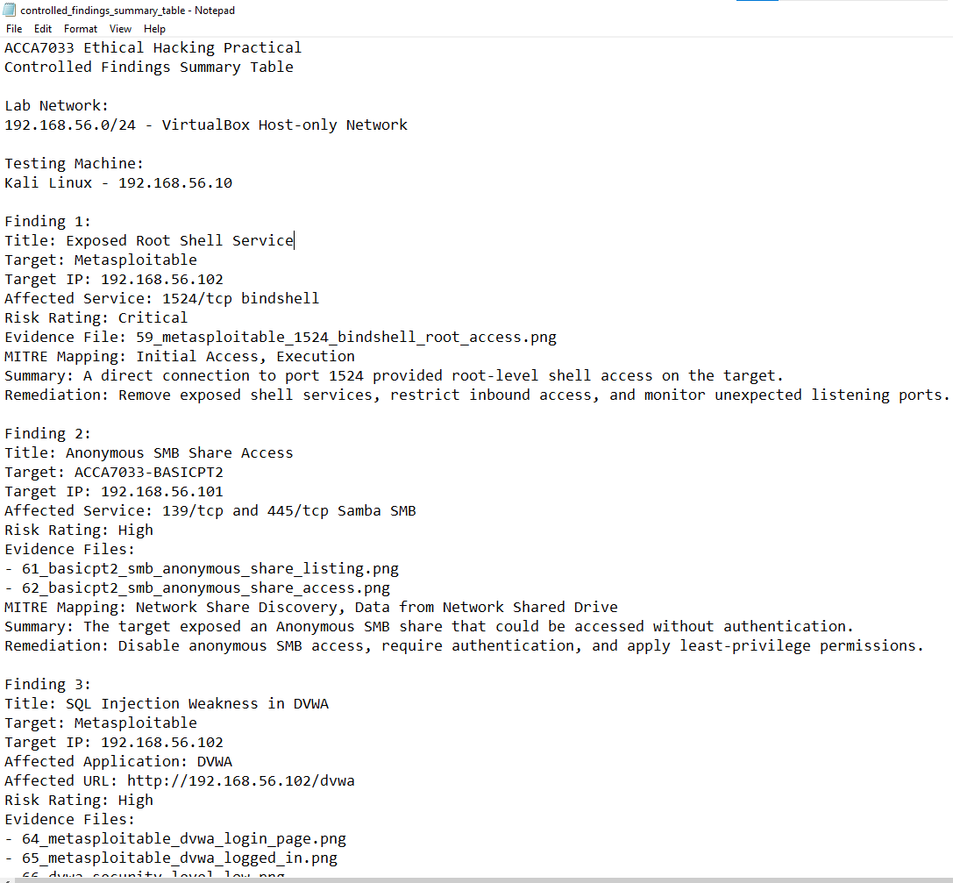
Figure 10: Controlled findings summary table.
Source: Author’s own controlled lab testing.
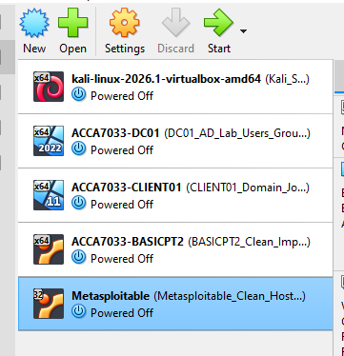
Figure 11: VirtualBox Manager showing all lab VMs powered off after testing.
Source: Author’s own lab configuration.

