Developing Emotional Intelligence Skills for the Workplace

Module Code:

Module Tutor:
Student Name:
Student Number:

Date of Submission:
Table of Contents
Introduction 4
1. Importance of developing emotional intelligence in the workplace and the relationship between emotional intelligence, effective management communication, and business advantage 5
1.1 Importance of developing emotional intelligence 5
Effective communication 5
Managing difficult situation and conflict resolution 5
Employee engagement and positive attitude 6
Self-motivation and motivating others 6
1.2 Relationship between emotional intelligence and effective management communication 7
Stress and response 7
Emotional awareness 7
Accountability and responsibility 8
Non-verbal communication 8
Show humor and humility 8
2. Models of emotional intelligence applying to Unilever Plc. and explain the extent of meeting the development needs of the individual 10
2.1 EI based on traits 10
2.2 EI based on abilities 10
2.3 Mixed models of EI 12
Goleman model 12
Bar-on model 14
2.4 EI models to meet the development needs of individual 15
3. Importance of emotional intelligence and mindfulness in the workplace and developing emotional intelligence to help an organization to gain competitive advantage 17
3.1 Essence of EI and mindfulness in the workplace 17
Mental and emotional health 17
Stress tolerance 17
Increase of attention span 18
Workplace memory 18
3.2 Developing EI to gain competitive advantage 18
Communication through empathy 18
Handling stress and improving business outcomes 19
Adaptability and collaboration 19
Leadership capabilities 19
Conclusion 21
References 22

Introduction
Emotional Intelligence (EI) refers to the use of professional relationship, communication with others, motivating oneself to ensure personal and organizational success (PositivePsychology.com, 2019). The EI is used to assess the emotions of others and how that emotion affects people around us. EI has become an integral part of organizational and personal success in the last decade. It is first defined in 1990 and also known as emotional quotient and soft-skills (C. Allen, 2017). It is an integral part of assessing the phycological state of people in an organization by processing emotional information and using those in real life. The concept of EI has become a major issue for organizational success as it helps to perfect motivation for employees. This assignment focuses on the importance of developing emotional intelligence in the workplace, the relationship between EI and effective management, applying EI models in Unilever Plc, meeting development needs of people using EI, and use of EI to ensure competitive advantage.

Importance of developing emotional intelligence in the workplace and the relationship between emotional intelligence, effective management communication, and business advantage
The use of EI in the workplace has become essential because it helps employees to make a clear judgment in a different situation, assessing impulses of others and controlling own impulses, making humor in tensed situation to defuse the tension, effective communication with others, solving problems, and coping with changes (trainer, 2019). Self-awareness, self-regulation, intrinsic motivation, empathy, and social skills are five essential parts of emotional intelligence. Use of all those components makes the organizations more functioning and efficient in operations management.

1.1 Importance of developing emotional intelligence
The essence of EI in the workplace is very high though the concept of EI is new in the organizational context. According to the World Economic Forum, it is the sixth of the top 10 skills that employees will need to possess to be successful in the workplace (Cherry, Fletcher and O’Sullivan, 2017). The followings are some of the important aspects of developing EI in the workplace.

Effective communication
Most of the successful organization consider EI over the IQ while hiring people for the organization as it provides a better return in the long run. It helps the organization to be more informed and communicated using all the potentials of the self-awareness and social skills. As EI provides the ability to understanding the emotional state of others, people can communicate perfectly with each other (Cherry, Fletcher and O’Sullivan, 2017). The organizations like Unilever Plc. are ensuring training and development program of employees to develop the EI. It is eventually helping the organization to ensure inter-organizational communication. EI helps the organization to ensure the effective, positive, and well though verbal and written communication which makes-the process of conflict resolution and decision making easier (trainer, 2019). The social skills of employees make communication skills better. Thus, EI helps the workplace to become more effective by ensuring effective communication.

Managing difficult situation and conflict resolution
Self-awareness, self-regulation, empathy, and social skills are most crucial for the successful operations of the companies. It also helps the employee to reduce workplace conflict and managing difficult situations (Td.org, 2019). Conflict in the workplace makes the situation worse where people think of fight or flight. EI makes the situation lighter by making a calm statement of facts; ask questions to each other, and listening to each other. Social skills make the situation more congenial for resolving the conflicts. On the other hand, difficult situations are handled with care and effective communication with the use of emotional intelligence. Assessing the emotional state of the others in the workplace helps the employees and managers to take the appropriate decision (Td.org, 2019). Difficult situations become easier for employees and managers. Thus, difficult situations and conflicts are resolved by the EI.

Employee engagement and positive attitude
Employee engagement refers to the extent of the involvement of the employees with the organization and level of discretionary effort to the organization works. The more the level of employee engagement, the more the possibility of organizational success (Cherniss and Goleman, 2018). The larger organizations focus on employee engagement to make sure the tasks are accomplished by motivated employees. It also ensures the positive attitude of the employees toward the other employees and tasks of the organization. EI ensures employee engagement through self-motivating. It also helps employees to be more efficient by using self-motivation and effective communication (Cherry, Fletcher and O’Sullivan, 2017). Social skills of the employees will make the process of being acquainted with each other and make an impression to have a welcome. Thus, EI is helping the organizations and employees to ensure employee engagement and positive attitude among the employees.

Self-motivation and motivating others
One of the most crucial aspects of the EI is to ensure the intrinsic motivation of the employees. The level of EI among the employees makes them love their job. That means the employees can have the opportunity to re-examine their jobs and find out what they love and hate about their jobs (Cherniss and Goleman, 2018). It makes them more aware of their job and thus become self-motivated. Listening to others and effective communication with the employees make them more conscious of the way to motivate others (Cherry, Fletcher and O’Sullivan, 2017). It also helps the employees to set their goal statements clear and meaningful to them. Thus, they become more motivated toward their work.
The above-mentioned aspects are some of the importance of EI in the organizational context. There are some other essential aspects such as improved leadership, making people feel loved, solving business problems, conflict resolution, the practice of being calm, etc.(Chernissand Goleman, 2018). Thus, EI helps the organizations to use it to ensure effectiveness and efficiency in the workplace.

1.2 Relationship between emotional intelligence and effective management communication
Emotional intelligence is a new concept in business management and effective communication. But the impact of EI in business management and communication is considered one of the major success factors for business organizations. The relationship between the EI and management communication are not direct rater it focuses on the indirect relationship (C. Allen, 2017). EI creates skills that make communication and management effective for organizations. The followings are some of the ways of EI and effective management communication relate together.

Stress and response
The main task of effective management is to formulate the business decisions for an organization and accomplishing those decisions and goals. This task requires the attention to detail from the top management to the employees. As one of the most crucial aspects of EI is to find out the stress in the workplace and resolving that, making business decisions and goal achievement become easier for the organization (Cherry, Fletcher and O’Sullivan, 2017). EI helps the employees to assess the stress level of others which makes the management more effective to motivate for achieving goals of the organization. Decreasing the stress and responding to those makes the management effective by the use of EI.

Emotional awareness
Emotional awareness refers to the ability to recognize the emotions of oneself as well as of others and applying that awareness to achieve personal and organizational goals. EI creates emotional awareness among managers, leaders, and employees (PositivePsychology.com, 2019). It makes them more productive by making everyone more motivated toward the tasks of the organization. The communication among the employees becomes more effective through the use of emotional awareness. It helps people to understand the emotional state of the employees. Managers become more efficient in decision making and communicating with others in the organization (trainer, 2019). The leadership of the team leaders and managers becomes more effective with respect to motivating others and finding the strength and weaknesses of the employees. Thus, the relationship between EI and effective management helps organizational goal achievement.

Accountability and responsibility
Being accountable for any task makes the management more reliable and trustworthy to the employees. Responsibility, on the other hand, makes the employees and managers more engaged with the organization. The EI makes the employees and manager more accountable for the tasks and responsible for the roles and duties (PositivePsychology.com, 2019). The application of EI in organizations like the Unilever Plc. is making the employees more engaged in operations management. The communication among the employees is becoming more effective as all the employees share the responsibility and accountability of specific tasks. Sharing responsibility with the team members and employees makes the management more effective and trustworthy (Cherry, Fletcher, and O’Sullivan, 2017). Thus, EI relates to effective management and communication in each and every organization.

Non-verbal communication
Non-verbal communication is one of the most essential parts of effective communication in the organization. EI makes employees more efficient in understanding body languages, voice tone, eye contact, etc. (PositivePsychology.com, 2019). The communication becomes more efficient by using non-verbal communication. Employees need to learn to exercise and control non-verbal communication to make the tasks more efficient. Self-regulations make the employees more efficient in understanding the importance of communicating within the organization (trainer, 2019). Thus, non-verbal communication helps the employees of an organization to make business management and communication easier.

Show humor and humility
Letting the works of one to speak for him/her is better than speaking him/her. The use of humor in any situation makes the socialization of the employees easier. It also makes the management effective by ensuring the informal environment in discussing the decisions (Cherry, Fletcher and O’Sullivan, 2017). Showing humility toward the employees of the organization makes the inter-relations between the employees more effective (Cherry, Fletcher and O’Sullivan, 2017). The relationship between employees becomes based on honor and mutual respect. EI makes the employees more efficient in using humor and humility in the workplace as it provides the basics of social skills and self-awareness. Thus, the EI relates to business management and communication in the organizations.
The relationship between EI and effective management communication is essential for ensuring the effectiveness and efficiency (C. Allen, 2017). Embracing emotions in the workplace makes the workplace more productive by providing perfect stimuli for the employees. Except for the relations described above, there are some other aspects of relationships as well. Being thoughtful of needs of others, thinking twice before doing, and taking care of others are some of them that directly or indirectly create a relationship with the EI and management communication (Cherry, Fletcher and O’Sullivan, 2017). All these are developed through the EI which eventually helps the organization to be managed efficiently and communicate effectively.

Models of emotional intelligence applying to Unilever Plc. and explain the extent of meeting the development needs of the individual
There are plenty of EI models that are used by different organizations to ensure the individual development of the employees and managers. The EI models can be divided into three major categories such as EI model based on traits, EI model based on abilities, and mixed model of EI. The followings are the application of EI models in Unilever Plc. and application of the models in the development of employees of the organization.

2.1 EI based on traits
According to Sarkar (2017), emotional intelligence refers to the disposition of behavior and the ability to process emotional information and perceptions of others. It focuses on the framework of individuals’ personality. It helps the employees to assess the behavior and emotional information of the other employees of the organization. The trait EI is measured using self-report, Swinburne University emotional intelligence test (SUEIT), Six seconds emotional intelligence assessment, and Schuttle self-report emotional intelligence test (SSEIT) (Hughes and Terrell, 2012).These tests make the employees and employer understand the level of emotional intelligence available to the employees. The Unilever Plc. uses this EI to measure the level of EI among the employees of the company (Unilever global company website, 2019). Comprehensive measurement of EI helps the organization to determine the level of development requires for the employees of the organization.

2.2 EI based on abilities
According to Hughes and Terrell (2012), emotional intelligence based on abilities focuses on four major aspects of individuals’ emotions. Perceiving emotions, managing emotions, understanding emotion, and facilitating thoughts using emotions are the four major ability type of emotional intelligence.
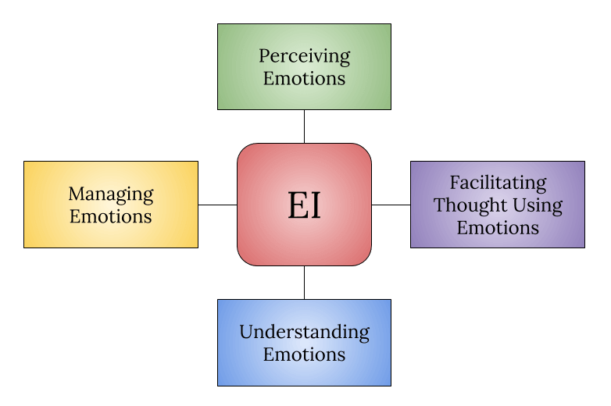
Figure 1 EI based on abilities
Source: (Sarkar, 2017).
Perceiving emotions refers to the ability of an individual to identify the emotions of oneself and others effectively. It is all about decoding the emotions of others to use it in controlling and motivating the employees. The ability to understand the faces, voice, smile, etc. is the main task of perceiving the emotions of others (Sarkar, 2017). The Unilever Plc. seeks this ability from the employees of the organization so that the socialization and cultural fit of the organization become stronger. The development needs of the individual can also be determined using the ability to perceive the emotions of others.
Facilitating thoughts using emotions means analyzing emotions after perceiving it. It focuses on the possible implications of the information of emotions. The employees of organizations incorporate this information into their higher-level cognitive functions for decision-making, considering perceptions of others, and problem-solving (Hughes and Terrell, 2012). Organizations like Unilever Plc. can use these cognitive functions for more informed and efficient decision-making in the long term (Unilever global company website, 2019). It will facilities the organizations to maintain sustainability and success in the long run through effective decision making in critical situations.
The third stage of emotional abilities is the understanding of emotions. It focuses on the relations of emotions of one another, change of emotions over time-based on situations, and predictability of others’ emotions (Sarkar, 2017). It is essential for organizational communication. Unilever Plc. can use the ability to understand the emotions of the employees to ensure effective communication in the organization. It will also be used by the management to determine the level of training and development required by the individuals (Unilever global company website, 2019). Employees with a high level of emotions management skills require lower personal and social skills training.
The last stage of the emotional intelligence model based on ability is managing own and others’ emotions. It focuses on handling the emotions of others’ effectively. Emotional intelligence helps the employees of the organization to manage people effectively (Hughes and Terrell, 2012). Emotions management makes stressful deadlines easier for employees and organizations.
Application of EI based on abilities can be very effective for organizations like the Unilever Plc. because it ensures the ability of the employees to understand and use the emotions in working places.

2.3 Mixed models of EI
The mixed models of emotional intelligence include emotional competencies model also known as Goleman model and Bar-on model also known as emotional-social intelligence (ESI) (Hughes and Terrell, 2012). Both of these models are applicable to large organizations like the Unilever Plc. The followings are the application of these two models in Unilever Plc. and meeting the development needs of individuals of the organization.

Goleman model
Daniel Goleman introduced a model of emotional intelligence known as emotional competencies model. It depicts the EI as personal competencies and skills. This model focuses on the 360-degree feedback model to assess the performance of the management (Sarkar, 2017). It also makes the proper uses of emotional intelligence in organizations. The Unilever Plc. uses this model of EI to ensure workplace harmony and efficient leadership (Unilever global company website, 2019). This model has divided the aspects between self and society versus recognition and regulation. The main four stages of Goleman model are self-awareness, social-awareness, relationship management, and self-management.
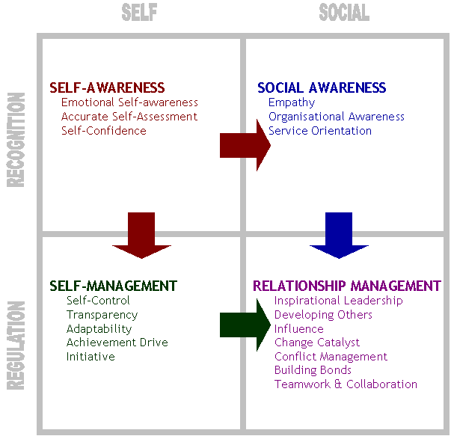
Figure 2 Goleman Model of EI
Source: (PositivePsychology.com, 2019).
Self-awareness is the first stage of the Goleman model of emotional intelligence. It states the recognition of self through emotional self-awareness, accurate self-assessment, and self-confidence. It helps the employees of the organization to recognize the emotions of others and control the emotions of self (Hughes and Terrell, 2012). This ability helps them to be more effective in the long run. Unilever Plc. uses this model for ensuring the best performance from the employees of the company. It is also integrated with the training and development program of the company so that employees can use their self-assessment to further development of the skills and knowledge and become a meaningful human resource for the organization (Roberts et al., 2017). So, it can easily be understood that self-awareness increases the self-confidence and help to ensure the development needs of oneself.
Social-awareness falls under the social recognition segment of the Goleman model of EI. It focuses on the social empathy, social awareness, and service orientation of the employees. it is the most crucial part for the leaders and managers of an organization because it provides the emotional understanding of others and social skills through this step of the model (Roberts et al., 2017). Most of the organization requires people who have higher social awareness to ensure that the tasks of the organization are being done correctly. Employees of Unilever Plc. require the understanding of the social skills to perform the tasks. Social skills make employees more productive in the organization (Unilever global company website, 2019).
The third stage of the model is to ensure the self-management of the employees and management of the organization. It considers the self-control, transparency, adaptability, and initiative. It ensures the self-regulation of the employees. This stage helps employees to control and use the self-potential in ensuring effective communication. It makes the employees more productive through enabling the self-motivation. Thus, self-management ensures the personal and professional development of the individual which in turn benefits the organization as well.
The last stage of the model is to ensure relationship management in an organization. It depicts the relationship in developing others, inspiring leadership, initiate and execute change, conflict management, and teamwork (Roberts et al., 2017). Effective communication among the employees and management become easier through relationship management. It is one of the most essential elements of organizational success. That is why this model is preferred by the organizations. Unilever Plc. also focuses on the relationship management of the organization through the use of the Goleman model (Unilever global company website, 2019).

Bar-on model
The bar-on model is developed by Israeli psychologist Reuven Bar-On. This model is also known as the Emotional Social Intelligence model. It deals with the two perspectives of EI interpersonal and intrapersonal (Arsenio, 2014). Inter-personal aspects of the model consider the interpersonal relationship of the individual to ensure the socialization in the workplace. It also considers the empathy and social responsibilities of the employees (Roberts et al., 2017). Intrapersonal perspective depicts the self-awareness, actualization, assertiveness, and independence. Like the Goleman model, this model also ensures the incorporation of the individual social skills to determine the emotional changes of others in decision making.
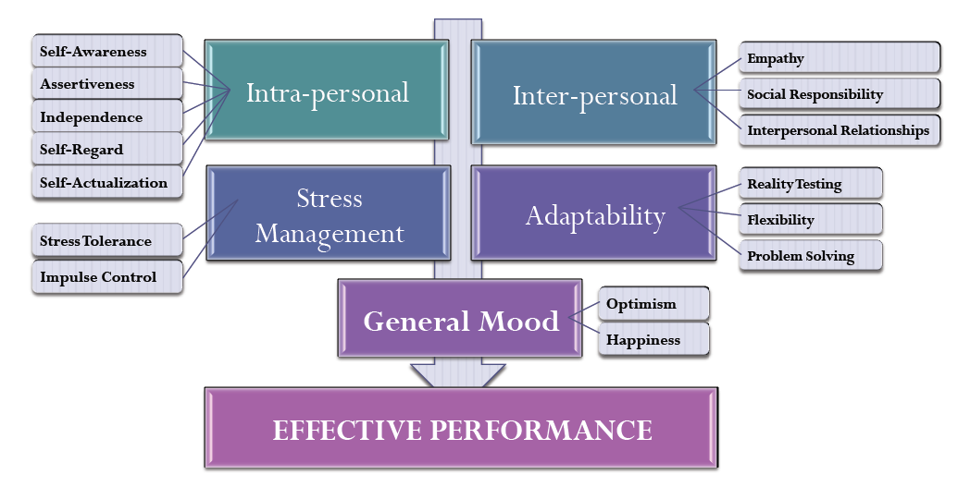
Figure 3 Bar-on Model of EI
Source: (Roberts et al., 2017).
Improvement of the intrapersonal skills leads to stress management which is very essential in the workplace and everyday life. On the other hand, interpersonal skills lead to the adaptability of the employees in different organizational situations (Arsenio, 2014). Adaptability ensures the flexibility and problem solving of different critical situations. All these skills bring optimism and happiness among the employees. Gradually these all ensure the effectiveness and efficiency in the operational performance of the organization (Roberts et al., 2017). Large companies like Unilever Plc. can use this model to increase the potential of the employees in goal achievement of the organization.

2.4 EI models to meet the development needs of individual
Unilever Plc. is one of the largest consumer products company operating more than 40 countries. Employees of the company come from a different culture and need to be effective in communication (Arsenio, 2014). The EI is new in the organizational paradigm but has a great influence over the people. So, to ensure the efficiency and effectiveness of the employees the larger organizations are using EI models for meeting the development needs of the individuals.
Currently, Unilever Plc. is using the Goleman model of EI to fulfill the development needs of the employees and to ensure the socialization and self-motivation of employees (Unilever global company website, 2019). Analysis of all the models clearly shows that the EI models based on ability and based on traits are not complete to ensure the individual and organizational development. On top of that, the use of the Goleman model is not enough because it fails to ensure the stress management and adaptability which are necessary for effective management, leadership, and personal development. So, Unilever Plc. requires to use the Bar-on model of EI along with the Goleman model to ensure efficiency and effectiveness from employee performance.

Importance of emotional intelligence and mindfulness in the workplace and developing emotional intelligence to help an organization to gain competitive advantage
There are several reasons behind the efficiency created by emotional intelligence and mindfulness in the workplace. The logic behind the EI and mindfulness in ensuring the success and competitive advantage is employee satisfaction and engagement in the tasks (Cherniss and Goleman, 2018). It creates the most essential environment of positivity in the organization which eventually makes the organizations more effective in communicating and goal achieving.

3.1 Essence of EI and mindfulness in the workplace
EI and mindfulness create a positive attitude towards the tasks of the organization. It has a strong relationship with workplace success and operational efficiency (Inc.com, 2019). The followings are some of the main importance of EI and mindfulness in organizations.

Mental and emotional health
Both the physical and mental health of the employees is essential to perform with persistence and accuracy. The larger organizations provide various options for the employees in the a to keep the mindfulness of the employees (Mentalfloss.com, 2019). In return, cool and happy employees become more productive for the organization. For example, organizations like Unilever Plc. has a gaming room, a restroom, and a great place for foods in the office which makes the employees happy and mindful while in the organization (Inc.com, 2019). The mental and emotional health of the employees through the training and development of the emotional intelligence in the organizations. In this way, EI and mindfulness create a more productive workplace.

Stress tolerance
Stress tolerance refers to the ability to handle stress in different level of life. In organizations, different situations bring critical situations for the employees which increases the stress of employees (Inc.com, 2019). As EI focuses on self-management and relationship management, the employees can reduce the level of stress significantly. Stress comes from the monotonous or mindless routine of life or organization. The focus on the self-motivation of the employees makes the process of mindfulness easier (Mentalfloss.com, 2019). A stress-free situation also helps the employees to become more creative and reduce the costs associated with the operations.

Increase of attention span
Attention span is a time a person can hold attention to anything. The mindfulness increases the concentration of the employees to listen to others. It helps the managers and leaders of the organization as they require to listen to others to ensure motivation and provide the feel of inclusion of the employees (Mentalfloss.com, 2019). The mindfulness and EI make the employees be more positive and attentive to others. The capacity of listening to others and considering others in decision-making is also considered in EI. Hence, EI and mindfulness increase the attention span of the employees.

Workplace memory
The sharpness of the brain works best in the mindful situation of people. The memory plays an essential part in the workplace as the employees can have to remember the information for quick use in different situations. It helps the employees to be more efficient in decision making and working with speed and accuracy (Mentalfloss.com, 2019). Larger organizations value the workplace memory of the employees and use that in organizational goal achievement. EI and mindfulness among the employees make them increase workplace memory (Inc.com, 2019). The organizations like the Unilever Plc. can take advantage of workplace memory to increase decision accuracy.
All these benefits mentioned above are part and parcel of the EI application in any organization. This is one of the main reasons for considering EI in organizational paradigm.

3.2 Developing EI to gain competitive advantage
Competitive advantage refers to the favorable position in any situation while compared to the peer group. It has become one of the main sources of success of an organization over the others. Missions of dollars are spent to ensure the competitive advantage in the industry (Mentalfloss.com, 2019). All the companies try to hold it to ensures sustainability in the long run. The followings are some of the ways through which companies ensure a competitive advantage over the other companies by developing EI.

Communication through empathy
Developing EI among employees increases the level of empathy toward each other. Empathy helps organizations to increase communication. Verbal and non-verbal communication is essential for effective communication in any situation. The empathy of the employees ensures both communications (Mentalfloss.com, 2019). Effective communication makes the organization more efficient in decision making and thus the goal achievement becomes easier as well. The better decision of the employees of an organization ensures the competitive advantage in the long-run. Thus, the development of EI among the employees will benefit the organization in maintaining competitive advantages.

Handling stress and improving business outcomes
Stress management is an essential part of emotional intelligence theories. Hence, the development of the EI in any organization will lead the employees of that organization to effective in stress management. Employees of larger organizations have to face stress in almost every task and decision (Cherniss and Goleman, 2018). To ensure the best outcome from a stressed situation is to reduce the stress which can be done by the socialization and self-motivation. Both the self-awareness and social awareness can be learned through EI development among the employees. The outcomes from the stressed situation are better for an organization with developed EI among the employees than that of an organization without EI.

Adaptability and collaboration
Workplace adaptability is essential for the better performance of the organization because it increases the collaboration (Mentalfloss.com, 2019). Adaptability ensures workplace efficiency. It also focuses on innovation as it provides the greater opportunity of the collaboration of ideas. The process of organizational success becomes easier with innovation. It also makes the employees more productive which eventually makes the organization competitive over the other companies in the industry (Cherniss and Goleman, 2018). Adaptability is one of the major parts of the EI and that is why it ensures the competitive advantage over other companies.

Leadership capabilities
Leadership capabilities of the employees increase a lot due to the application of the EI in the workplace. The EI focuses on the improvement of the social and personal skills of employees which are essential for a good leader. A good leader is a blessing for the organization. Most of the successful organization enjoy high-quality leadership (Cherniss and Goleman, 2018). The competitive advantage is one of the results of the high leadership qualities of the employees of the organization. So, competitive advantage can be ensured through the development of EI of the employees of the organization.
All these above-mentioned issues are essential for the competitive advantage of the organization achieved through the EI and mindfulness. Other than these there are some other sources of competitive advantages for an organization such as team performance, trust, and transparency among the employees (Cherniss and Goleman, 2018). So, it can be understood that competitive advantages can be ensured by the companies through the development of emotional intelligence among the employees of the company.

Conclusion
Emotional intelligence is a new horizon of gathering and applying personal and social skills in professional life. The field of EI is still under the development by the psychologist but the application of these can be beneficial for the business organizations. The large companies are introducing different models of EI in operations and employee development. the smaller companies also started using social skills training to ensure the self-motivation and effective communication within the organization. So, it can be concluded that the impact of EI in the workplace is enormous in different aspects. And if it can be used successfully in organizations, the performance of the organization will exceed its current level.

References
Arsenio, W. (2014). Emotional Intelligence and the Intelligence of Emotions: A Developmental Perspective on Mixed EI Models. Human Development, 46(2-3), pp.97-103.
C. Allen, J. (2017). Emotional Intelligence. La Vergne: Editorial Imagen LLC.
Cherniss, C. and Goleman, D. (2018). The emotionally intelligent workplace. San Francisco: Jossey-Bass.
Cherry, M., Fletcher, I. and O’Sullivan, H. (2017). Exploring the relationships among attachment, emotional intelligence, and communication. Medical Education, 47(3), pp.317-325.
Hughes, M. and Terrell, J. (2012). Emotional intelligence in action. San Francisco, CA: Pfeiffer.
Inc.com. (2019). Emotional Intelligence As Competitive Differentiator. [online] Available at: https://www.inc.com/james-kerr/emotional-intelligence-as-competitive-differentiat.html [Accessed 29 Aug. 2019].
Mentalfloss.com. (2019). 6 Benefits of Incorporating Mindfulness at Work. [online] Available at: https://mentalfloss.com/article/76310/6-benefits-incorporating-mindfulness-work [Accessed 29 Aug. 2019].
PositivePsychology.com. (2019). Emotional Intelligence Skills and How to Develop Them. [online] Available at: https://positivepsychology.com/emotional-intelligence-skills/ [Accessed 27 Aug. 2019].
PositivePsychology.com. (2019). Emotional Intelligence Skills and How to Develop Them. [online] Available at: https://positivepsychology.com/emotional-intelligence-skills/ [Accessed 28 Aug. 2019].
Roberts, R., MacCann, C., Matthews, G. and Zeidner, M. (2017). Emotional Intelligence: Toward a Consensus of Models and Measures. Social and Personality Psychology Compass, 4(10), pp.821-840.
Sarkar, B. (2017). Emotional Intelligence - Glimpses of Current Models and an Exploratory Study. SSRN Electronic Journal.
Td.org. (2019). Tap Into Your Emotional Intelligence to Resolve Conflict. [online] Available at: https://www.td.org/insights/tap-into-your-emotional-intelligence-to-resolve-conflict [Accessed 27 Aug. 2019].
trainer, s. (2019). Emotional Intelligence and Its Impact on Communication in the Workplace • Franchetti Communications. [online] Franchetti Communications. Available at: https://franchetti.com/emotional-intelligence-impact-communication-workplace/ [Accessed 27 Aug. 2019].
Unilever global company website. (2019). Unilever global company website | Unilever Global. [online] Available at: https://www.unilever.com [Accessed 28 Aug. 2019].

