
Cameron Davies – P150422
MECHANICAL AND MANUFACTURING ENGINEERING

Theories of Elastic Failure
Module - Advanced Stress & FEA
Contents
Introduction 2
Literature Review 3
Shear Strain Energy Per Unit Volume (Von Mises) 3
Maximum Shear Stress Theory (Guest-Tresca) 5
Maximum Principal Strain (Saint-Venant) 5
Main Body 6
Component 6
Shear Strain Energy Per Unit Volume (Von Mises) 7
Science Direct 8
Conclusion 10
References 11

Introduction

Elastic failure is often looked at while dealing with the design of structures, machine elements or any component of a particular machine (NPTEL, 2009). Physical properties of materials can usually be found from the results of experiments in which the components are subject to “simple stress conditions”. The most usual test is a “tensile test” in which the “value of stress at yield/fracture” can be determined. A machine part is generally subjected simultaneously to several different types of stresses whose actions combine; therefore, it is necessary to have some basis for determining the allowable working stresses so that failure may not occur. This leads onto the function of theories of elastic failure, of being able to predict from the behaviour of materials in a simple tensile test, when elastic failure will occur under any conditions of applied stress (NPTEL, 2009). A number of theories have been proposed for brittle and ductile materials. The most common theories are as follows (NPTEL, 2009);
- Maximum principal stress theory (Rankine)
- Maximum shear stress theory (Guest-Tresca)
- Maximum principal strain (Saint-Venant)
- Total strain per unit volume (Haigh)
- Shear strain energy per unit volume (Von Mises)
Within this report, some of the different theories of elastic failure will be analysed with a focus being on the theory of shear strain energy per unit volume (Von Mises). The aim being as to how it can be used to measure the amount of “elastic failure” within a component, which for the purpose of this report will look into the elastic failure of a resting block. The resting block is part of an assembly fixture, where it will be required to withstand the stress of both a chuck and a component, so that it can be later used within the fettling stage of the investment casting process.
A website called ScienceDirect provides access to a large database of scientific and medical research. This report will compare an article within ScienceDirect similar to the case of testing the elastic failure of the resting block, so it can be understood why the stress calculation is necessary and beneficial to a designer/engineer.

Literature Review

Shear Strain Energy Per Unit Volume (Von Mises)

Von Mises theory of stress is what this report will focus on, understanding how it can be beneficial in developing a component. Von Mises theory is considered to be “beneficial” for design engineers, as using information gathered from the theory, a designer can say whether a model will fail or not. This is by understanding that if the maximum value of Von Mises stress induced in a material is “more than” the strength of the material. The theory is said to be beneficial in most scenarios it is used for, “especially when the material is ductile”, (Learning Engineering, 2012).
Expression’s for Von Mises stress;
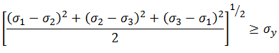
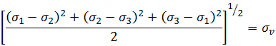
Learn Engineering (2012)
Using the following formulas, the engineer can check whether the Von Mises stress induced in the material, surpasses the yield strength of the material. The failure condition can be simplified as the formula shown below;
Learn Engineering (2012)
Von Mises theory which can also be known as maximum distortion energy criterion, finds “considerable experimental support”, especially for “very ductile materials and plane stress”. For these reason’s it has become more common in design, (Barsanescu, 2020). For “more than a hundred years”, the theory has been “developed and enhanced methodically” by “Hosford, Christensen, Tsai-Hill, etc”. The latest Von Mises theory combines the theories of “maximum strain energy” and “maximum distortion energy”, (Barsanescu, 2020).
For equipment, within the manufacturing industry, it is important to guarantee that a component is durable enough to withstand the required amount of stress/strain. Topology optimisation is a method that can be used within design to show what “excess material” is not needed. A number of patches with “predefined shapes” are used to simulate the “material failure”. The material properties of damaged models are incorporated by Von Mises stress to construct a “optimisation model”, (Wang, 2016). This would show one of the benefits of calculating the Von Mises stress of a component, as it would help in scenarios where topology optimisation is needed, and showing the different levels and areas of stress within a component.
Three-dimensional stresses and strains can build up in numerous directions. A way to express these multidirectional stresses is to summarise them into an “Equivalent stress”, also known as the “Von-Mises stress” (Autodesk, 2020). Using FEA (Finite Element Analysis), simulations can be run using different types of software applications, including Autodesk Inventor and Solidworks, to induce the level of shear strain energy per unit volume of a component. For example, on Autodesk Inventor, Von Mises stress results can be given by the use of colour contours to show the stresses calculated during the solution for the designed model. The deformed model will be displayed, with the colour contours corresponding to the values defined by the colour bar (Autodesk, 2020).
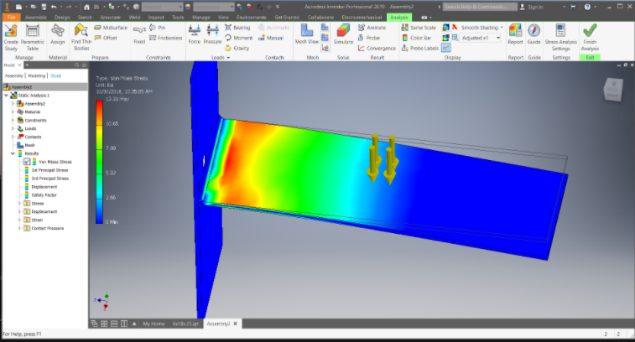
Autodesk (2020)
The above image is an illustration of the Von Mises stress being calculated within Autodesk Inventor on a component. As described by the colour bar, the different colour’s range from where the maximum and minimum stress that the component will be under, will be. This will be useful for an engineer/designer as when designing a component understanding where the most stress will be, will give them a chance to either add more support or alter the design to be better suited. For example, the above image has a lot of red on the edge of the plate near to the flat surface, meaning it is under a higher level of stress than the rest of the component. This could be considered an area of concern for the designer as it may break or cause damage.

Maximum Shear Stress Theory (Guest-Tresca)

Maximum shear stress theory, which can also be known as Tresca's or Guest's theory, is “often” used to forecast the “yielding of ductile materials”. Yield within ductile materials is usually caused by the movement of crystal planes along the maximum shear stress surface, (Engineering Fundamentals, 2020). A given point in the component can be considered “safe” as long as the “maximum shear stress” at that point is under the “yield shear stress” obtained from a “uniaxial tensile test”, (Engineering Fundamentals, 2020). The typical equations that can be used to derive maximum shear stress are as follows (Engineering Fundamentals, 2020);
An article by Manvatkar (2012), discusses occasions were testing maximum shear stress can be required, as it discusses the analysis of a tool. The bending stress and the maximum shear stress on a tool can be “estimated” following analytical relations from “solid mechanics” and using the computed results of “temperature field, torque and the distribution of force within a tool”. This can be beneficial to engineers, specifically to a tool designer, as they will be able to understand how small/big a tool they will need to design, as well as what internal details which are possible, through the use of testing the maximum shear stress of the design.
Components can potentially fail along the “direction” of the maximum shear stress in various loading states of “plane strain compression, uniaxial compression, shear, uniaxial tension and plane strain tension”. Different types of experiments have been able to reveal that ductile fracture takes place “along the direction” of the maximum shear stress in the wide loading conditions. Effects of the maximum shear stress must be “correctly resolved” in the modelling of a ductile component ensuring the correct “loading conditions” are applied for accurate results (Lou, 2018). This would show the importance of parameters such as the loads applied, being correctly labelled, as it could directly influence the results. The results may be wrong which will be misleading for designers/engineers.

Maximum Principal Strain (Saint-Venant)

The theory of maximum principal strain states, that yielding in a component subjected to a “complex/compound stress system”, originates when the maximum principal strain of the system becomes “equal” to the strain corresponding to the yield point, (Civil Engineering, 2020). The equations used to calculate maximum principal strain are as follows;
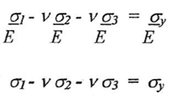
An article (Hassani, 2016), looks into an issue of circular orthotropic bars with multiple cracks being investigated, based on the Saint-Venant maximum principal strain theory. The problem being an orthotropic bar is being weakened by a Volterra-type screw due to pressure being applied, which was resulting in the cracks appearing. This article would be useful for an engineer as they would be able to understand what effects the maximum principal strain would have on particular component, which could potentially help give them ideas to reduce the level of damage occurring or prevent the damage altogether.

Main Body

Component
Chuck
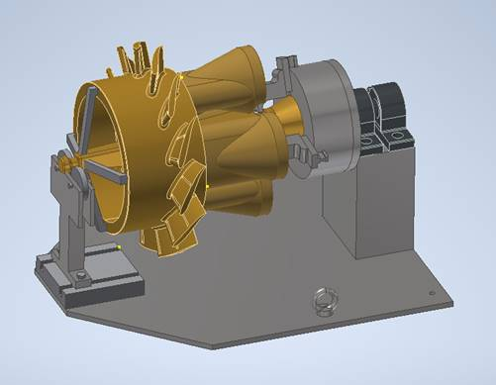
Bearing
Pillar
art
Part
Base Plate
Resting Block
Within the company Wall Colmonoy, the above parts need to be held in place for disassembly purposes. With the parts being made of Colmonoy metal, and varying in weight (depending on part) it will require a sufficiently strong JIG to support it. The component that will require the most analysis will be the resting block, as that is the part that is suspected to be under the most stress, with the chuck and the weight of the part pressuring on it. The designer/engineer will need to understand if the resting block can support the assembly. The resting block is made of the material mild steel.
Mild steel is a type of carbon steel with a low amount of carbon, it can be known as “low carbon steel.” Since its carbon and alloying element content are relatively low, there are several properties it has that differentiate it from higher carbon and alloy steels (Metal Supermarkets, 2020). Mild steel is used often by Wall Colmonoy mainly due to its low cost and high durability.

Shear Strain Energy Per Unit Volume (Von Mises)

Using Von Mises theory could be argued to be beneficial in developing the resting block as it will be able to be test if the “maximum value of Von Mises stress” induced in the material, is “more than” the strength of the material (Learning Engineering, 2012). This could be worked out using two different methods;
- Von Mises Theory Formula;
Learn Engineering (2012)
Where working out the required parameters and inputting them into the formula, will potentially be able to result in the corresponding Von Mises stress being found out and allowing the engineer/designer to understand if changes to the design are required or not.
- FEA (Finite Element Analysis)
With most companies having more advanced design software’s such as Autodesk Inventor and Solidworks. There is greater ability for the designer to use some of the software’s applications, such simulating the components/assemblies to work out their stress analysis. On Autodesk Inventor all materials must be specified, for the example of the resting block it would be set as mild steel, which would mean the correct weight would be applied to the analysis. Then the required forces would be applied, which as shown in the image below, one force is on the part, as it is applying stress on the chuck and resting block. Another force on the bearing’s connecting the chuck with the resting block. Both of these forces could cause different types of stress on the resting block.
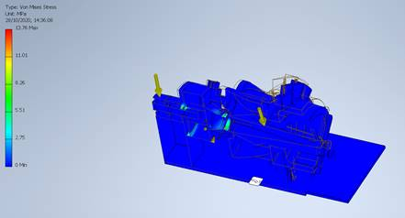
The above image shows the results of the Von Mises stress losses on the assembly. The blue indicates minimum stress, while as the colours on the chart scale up to red, there will be more stress. As shown the resting block is predominately blue which means there is very minor stress occurring on it, this could be down to a combination of the type of material as well as the component geometries. From these results the designer/engineer would be able to derive that the component (Resting Block) from the results of the Von Mises simulation analysis, is sufficient to be manufactured without the concern of failure occurring.

Science Direct

An article from ScienceDirect (De la Fuente, 2009) discusses the use and benefits of Von Mises analysis on a component. It mentions the use of using the theory’s formula and how it can be changed to get more accurate results. The article mentions that the method of testing the Von Mises stress of a component is “efficient” from a numerical point of view and has no limits from the size of the finite element model other than the capacity of the computer for standard normal mode vibration analysis, which can be considered beneficial for an engineer/designer as they would be able to understand the exact level of stress the component is under, which will help them know where support is required, or if changes will be needed. However, the article does go onto to discuss about how there can be many different scenarios in which the “stress field” is more complex. These could be situations where there are many different loads, and/or parameters that are required to understand the Von Mises stress on a component, and if the loads or parameters are incorrect then this could alter the “correct results” of the von mises analysis. Which would be misleading for the engineer as they wouldn’t be able to understand if the component is effective enough to be manufactured.
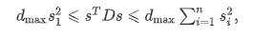
The above image, shows the variant of formula used to induce the Von Mises stress that can be used. Overall, the article discusses “an efficient method” for computation of Von Mises stress, where values of a component subjected to random loads are presented, as well as a procedure to allow for reliable analysis.
The Science Direct article would be important for a designer/engineer as it helps them understand the efficiency of working out the Von Mises stress of a component as well as what the best methods to consider would be. The issue brought up that there could be occasions where the Von Mises stress being calculated could be wrong or unreliable is something a designer/engineer has to understand. It reiterates the importance of understanding what and where the correct loads of stress on a component are, as well as getting the correct parameters required to calculate the von mises stress. For the example of testing the Von Mises stress on the resting block for the assembly within Wall Colmonoy, if the loads/parameters are mis-interpretated, then it would negatively affect the results. This could lead to the engineer designing a component that could potentially, eventually fail. This means the designer will need to know exactly what parameters are required. The article does show the benefits of working out the Von Mises stress on a component, as it will give the engineer/designer the knowledge of the potential weaker aeras within the component, and where more attention to detail is required if they need to alter the component in any way.
The point the article makes about understanding the correct parameters needed to work out the Von Mises stress of a component, shows the importance for both the formula and using FEA on design software’s, and getting the correct figures. For example, when the simulation of the resting block was undertaken on Autodesk Inventor, the loads would be inputted by the user/designer, if the loads were misplaced it would give wrong results.

Conclusion

The objective of the report was to discuss elastic failure and some of its different types of theories. The theories discussed in this report were; shear strain energy per unit volume (Von Mises), maximum shear stress (Guest-Tresca) and maximum principal strain (Saint-Venant). Elastic failure looks into a change in the normal constitutive behaviour of a material, usually in response to excessive loads or deformations that cause irreparable changes to the microstructure (Solid Mechanics, 2020). Understanding failure as an engineer can be argued to be important, as it gives understanding for when in the design stage of a component, asking the question what could go wrong.
This report looked into the component of a resting block, which is used as part of an assembly used as a JIG. The resting block will have the weight of a chuck and part constantly being weighed down on it, meaning that there will always be stress being applied on it. This is why when designing the resting block understanding the potential elastic failure is important, as it will give the designer understanding for what is required for the resting block to effectively function.
Shear strain energy per unit volume (Von Mises), was the main theory used to consider when developing the resting block, the theory can be calculated using the formula or by using FEA simulation functions, that are in different types of software applications. The results of the Von Mises stress shown in simulations in particular, are seen as beneficial as it will show the designer exactly what areas are weaker than others, this gives the designer a chance to strengthen these areas, so that the chances for failure are reduced. Sources such as an article from the website Science Direct, support the idea that understanding the Von Mises stress of a component is important in the developing stage, to help reduce part defects.
In conclusion, elastic failure can be argued to be a very useful learning curve for engineers, as the benefits it has in the planning/developing/designing stage of a component, will help reduce the risks of trial and error. Instead they can understand where the part will fail, and make the required changes to ensure the component is correct in the first place.

References
Rahimi, AS, Ayatollahi, MR, & Torabi, AR. (2020). Elastic–plastic damage prediction in notched epoxy resin specimens under mixed mode I/II loading using two virtual linear elastic failure criteria. International Journal of Damage Mechanics, 29(7), 105678952090534–105678952091116.
Ristaniemi, A, Stenroth, L, Mikkonen, S, & Korhonen, R.K. (2018). Comparison of elastic, viscoelastic and failure tensile material properties of knee ligaments and patellar tendon. Journal of Biomechanics, 79, 31–38. https://doi.org/10.1016/j.jbiomech.2018.07.031
Mercadé‐Prieto, Ruben, Allen, Rachael, Zhang, Zhibing, York, David, Preece, Jon A, & Goodwin, Ted E. (2012). Failure of elastic‐plastic core–shell microcapsules under compression. AIChE Journal, 58(9), 2674–2681. https://doi.org/10.1002/aic.12804
NPTEL (2009) ‘Strength of Material’s’ [Online] Available: https://nptel.ac.in/courses/112/107/112107146/#
Learn Engineering (2012) ‘Von Mises Stress’ [Online] Available: https://learnengineering.org/what-is-von-mises-stress.html
Barsanescu, Paul Doru, & Comanici, Ana Maria. (2016). von Mises hypothesis revised. Acta Mechanica, 228(2), 433–446.
Hongxin Wanga, Jie Liub, Guilin Wenab, Yi Min Xiec (2019). The robust fail-safe topological designs based on the von Mises stress ,Volume 171, 103376
Autodesk (2020) ‘Von Mises Stress’ [Online] Available: https://knowledge.autodesk.com/support/inventor-products/learn-explore/caas/CloudHelp/cloudhelp/2014/ENU/Inventor/files/GUID-853B3100-BF94-4BB7-8AC7-82F0BDA8481C-htm.html
Jirathearanat, Suwat, Hartl, Christoph, & Altan, Taylan. (2004). Hydroforming of Y-shapes—product and process design using FEA simulation and experiments. Journal of Materials Processing Technology, 146(1), 124–129. https://doi.org/10.1016/s0924-0136(03)00852-5
Engineering Fundamentals (2020) ‘Maximum shear stress’ [Online] Available: https://www.efunda.com/formulae/solid_mechanics/failure_criteria/failure_criteria_ductile.cfm#:~:text=The%20maximum%20shear%20stress%20criterion,the%20yielding%20of%20ductile%20materials.&text=Therefore%2C%20a%20given%20point%20in,from%20a%20uniaxial%20tensile%20test.
Manvatkar, V D, Arora, A, De, A, & DebRoy, T. (2012). Neural network models of peak temperature, torque, traverse force, bending stress and maximum shear stress during friction stir welding. Science and Technology of Welding and Joining, 17(6), 460–466.
Lou, Yanshan, Yoon, Jeong Whan, Huh, Hoon, Chao, Qi, & Song, Jung-Han. (2018). Correlation of the maximum shear stress with micro-mechanisms of ductile fracture for metals with high strength-to-weight ratio. International Journal of Mechanical Sciences, 146-147, 583–601.
CivilEngineering (2020) ‘Maximum Principal strain theory or Saint Venant theory’ [Online] Available: https://www.civilengineeringterms.com/mechanics-of-solids-2/maximum-principal-strain-theory-or-saint-vanant-theory-with-equations/
Das, H. T. (2016). Saint-Venant torsion analysis of bars with rectangular cross-section and effective coating layers. Applied Mathematics and Mechanics, 37(2), 237–252. https://doi.org/10.1007/s10483-016-2028-8
Metal Supermarkets (2020) ‘Mild Steel’ [Online] Available: https://www.metalsupermarkets.com/what-is-mild-steel/#:~:text=Mild%20steel%20is%20a%20type%20of%20carbon%20steel,are%20typically%20described%20as%20having%20a%20carbon%20content
De la Fuente, E. (2009). Von Mises stresses in random vibration of linear structures. Computers & Structures, 87(21), 1253–1262. https://www.sciencedirect.com/science/article/pii/S0045794909001825
Solid Mechanics (2020) ‘Failure’ [Online] Available: http://homepages.engineering.auckland.ac.nz/~pkel015/SolidMechanicsBooks/Part_I/BookSM_Part_I/09_Failure/09_Failure_01_Failure.pdf#:~:text=1%20Failure%20of%20Elastic%20Materials%20In%20terms%20of,For%20example%2C%20compressed%20rock%20will%20respond%20elastically%20up

