

Postgraduate/Distance Learning
Assignment coversheet & feedback form

THIS SHEET MUST BE THE FIRST PAGE OF THE ASSIGNMENT YOU ARE SUBMITTING (DO NOT SEND AS A SEPARATE FILE)

For completion by the student:
Student Name: Maria Raquel De Diego Samaniego

Student University Email: 2500924@student.uwtsd.ac.uk
Module code: HPCA7015  Module title: Foundations in Cultural Astronomy and Astrology | Student ID number: 2500924 |  |  | Educational support needs:  Yes/No
Assignment title: Essay based on a Sky Journal

Assignment due date: 27 November 2025
This assignment is for the 1st 2nd 3rd 4th 5th 6th module of the degree
I confirm that this is my original work and that I have adhered to the University policy on plagiarism.
Signed ……………………………………………………………
Email submission: if you are submitting this form via email, please tick this box □
(as a substitute for your signature) to confirm that you agree to the above declaration.
Assignment Mark
1st Marker’s Provisional mark
2nd Marker’s/Moderator’s provisional mark
External Examiner’s mark (if relevant)
Final Mark

NB. All marks are provisional until confirmed by the Final Examination Board.

For completion by Marker 1 :
Comments:

Marker’s signature: |  |  | Date:
For completion by Marker 2/Moderator:

Comments:

Marker’s Signature: |  | Date:
External Examiner’s comments (if relevant)

External Examiner’s Signature: |  | Date:

Essay Based on a Sky Journal
  - The Synergy of Darkness and Light in Cosmological Enchantment
Word count: 2,058

Introduction
Humanity has always been captivated by the magnificence of the sky. Likewise, the heavens have been a source of inspiration for the development of cosmologies, forms of artistic expression, and individual rapture. In one of the letters that Dutch painter Vincent van Gogh sent to his younger brother Theo, dated 11 August 1888, he wrote, among many other topics, the following:
And yet be clearly aware of the stars and infinity on high. Then life seems almost enchanted after all.
In this short passage, van Gogh suggests the possibility of experiencing enchantment in one’s life by being aware of the stars and the vastness of the heavens. The primary aim of this essay is to explore the cognitive and emotional mechanisms that drive the experience of enchantment derived from night sky observation, and how these emerge from our cosmological nature.

Methodology
The fundamental methodology is based on a phenomenology of the sky, where I have observed the night sky for thirty days from my home in Diest, Belgium, recording my observations in a personal ‘sky journal’ which will act as the main primary source supplemented by photographs or drawings of these observations. Kim Etherington says that creative illustrations can bring life and dimension to our data, reflecting the intellectual and emotional qualities to that which is being studied.
The phenomenology used is also connected to ideas of French philosopher Gaston Bachelard, who was an avid phenomenologist of the imagination, and who thought that phenomenology should not be addressed by static observation, but by working with matter which is, as Anton Vydra states, ‘incessantly transformed, matter which cannot be conceived in its “arrested” form, but only amid its dynamic process of permanent change’. This reference is specially interesting when dealing with such a changing phenomenon as the sky, as revealed by my observations.
The specific focus of observation was the dark night sky, in addition to two entries where the sky was observed before dawn and after sunset. The night period has different definitions. In this study we will consider the night as the period of time when the Sun is below the horizon, which is the astrological concept of night sect.

A Geography of Darkness
To open up this discussion, it is imperative to observe the connection between darkness and the notion of “origin”. Rilke, in The Book of the Monkish Life, expresses the idea of “coming from the darkness” when he writes:
You darkness whence I came,
I love you more than the light
which marks the world’s seam
by her gleaming for some orbit
Here, Rilke indicates that he is coming from the darkness. Biologically, we come from the darkness from our mother’s womb. But he underscores the connection to the dark sky by saying that he loves it more than the light marking the world’s seam. If we come from the darkness, one can argue that we are bound to it by the transcending universal feeling, which is love. Far along my night sky observations, on 28 October 2025, I wrote about the dark night as the choice of observation for this essay:
Why the night? I think this was a more intuitive decision than rational. I’ve always had a fascination with the dark night sky. Its mystery. Only in the night we see the stars. Planets. [...]. The night is what has allowed us to make sense of the stars, the constellations. To see how planets move. The night speaks differently than the day. And what the night conveys is deeper, more mysterious, but can be more real than the conceits of the day [...]. It is in the night [that] we are who we truly are. Some might say that darkness conceals. I think that darkness reveals. And the mystery of the night is closely related to the mystery of existence. When I looked at the starry night space, there was a point my cognition could not cross. There is mystery. [...]. Tonight the sky was dark. I could only see [the] darker shades of the backyard trees. No sense of colour. The sky was a black blanket. Decorated with shining stars. [...]. It was mysterious and enchanting. The night gives us those moments of wonder. It gives subtle light: just enough for imagination to do its work.
In this entry, there is an ontological point linking darkness with the mystery of existence, or we can say, creation. Interestingly, darkness has been mentioned in various cosmogonies across cultures, as Nicholas Campion has explored in Astrology and Cosmology in the World’s Religions. In Polynesian cosmogony, Campion indicates that everything originated from po: the dark. In the Popul Vuh, the “Plumed Serpent” emerged from the dark. In Greek cosmogony, one of the main assumptions is emergence from chaos, which may be equated with darkness. In fact, in Hesiod’s Theogony, it is said that day [light] came from night [darkness]. When it comes to Chinese cosmogony, Campion speaks about binary forces, yin and yang, darkness and light. And in Indian cosmogony, in the beginning, ‘darkness was hidden by darkness’.
So we can see how there is a general similarity across cultures with the night being linked to the beginning of all. In addition, the journal entry registers an experiential encounter with the celestial sphere, one that culminates in a perceived cognitive boundary where the scope of the observer exceeds the limits of cognitive consciousness. This is consistent with the phenomenological view articulated by John Gillies in Towards a Phenomenology of Shakespeare’s Sky, which posits the sky's inherent ungraspable nature and its resistance to definition as an object of prehension. Concurrently, the experience reflects Holmes Rolston III’s theoretical distinction between what can be scientifically measured in terms of vast distances in the space, and what can psychologically access our brain with the concept of ‘unthinkable distances’.
Furthermore, the aforementioned journal entry suggests that the presence of darkness in combination with minimal light functions as a catalyst for the imagination. As illustrated in Figure 1, darkness operates as the perceptual backdrop upon which subtle shades and limited luminescence become discernible. The visual complex in Figure 1, a direct representation of the observed scene, informs about the inspirational capacity of darkness and minimal light.
This dance between darkness and light, whether the stars and planets or the shed of artificial light from the urban landscape, can spark our imagination and creativity. This interplay gives us images that feed both art and deep thought. In fact, one could argue that this original connection between the sky's light and shadow has served as the primal inspiration for the development of the various cosmologies that exist. As Edward K. Kaplan said, imagination lives between earth and sky.


Figure 1. The Dark Sky. South East, 28 October 2025, 11:45 p.m., Diest, Belgium [digitally painted with PENUP].

The Interplay of Light and Darkness in Enchantment
In Art and Enchantment, Patrick Curry ponders on the general public assumption that experiences of enchantment only happen in art. Throughout the entries of my journal, the words “enchantment” and “wonder” appear multiple times, indicating the actual experience of enchantment by looking at the night sky. Furthermore, Campion has also reflected on his experiences of enchantment by looking at the sky phenomena in the night: the moon, planets, stars. That leaves us wondering: Is the sky art?
In nature, the night sky is one of the most galvanising pieces of work, inspiring astronomers to ask fascinating questions about the universe and moved by the mysterious and aesthetic experience of looking at the sky. Given this, the sky could be seen as a piece of art work from nature. In the journal entry of October 2, I explicitly used the word “canvas” when describing the view of Venus rising: ‘It is pre-dawn. The sky is a beautiful canvas for Venus to shine. She looks sovereign, free, powerful, full of herself’ (see Figure 2).
Painted against the backdrop of the darkness, a staging of light as been distinguished throughout the observed nights: the light from the Sun reflected on the planets and the Moon, the stars, and the visuals from the clouds illuminated by artificial light and, unfortunately, pollution. Or in the blue hours, the gleaming rays from the Sun that is about to rise or that has just set, creating a reverie of colours in the air of the night sky. In the entry of October 16, I wrote: ‘But leave me in that blue hour moment, with the Moon and her halo, with Jupiter for inspiration, to dream, to visually muse, to feel illusion, wonder, and being absorbed by the natural enchantment of the night’ (see Figure 3). This entry reveals an inspiring aesthetic evoking a multilayered feeling response of enchantment.
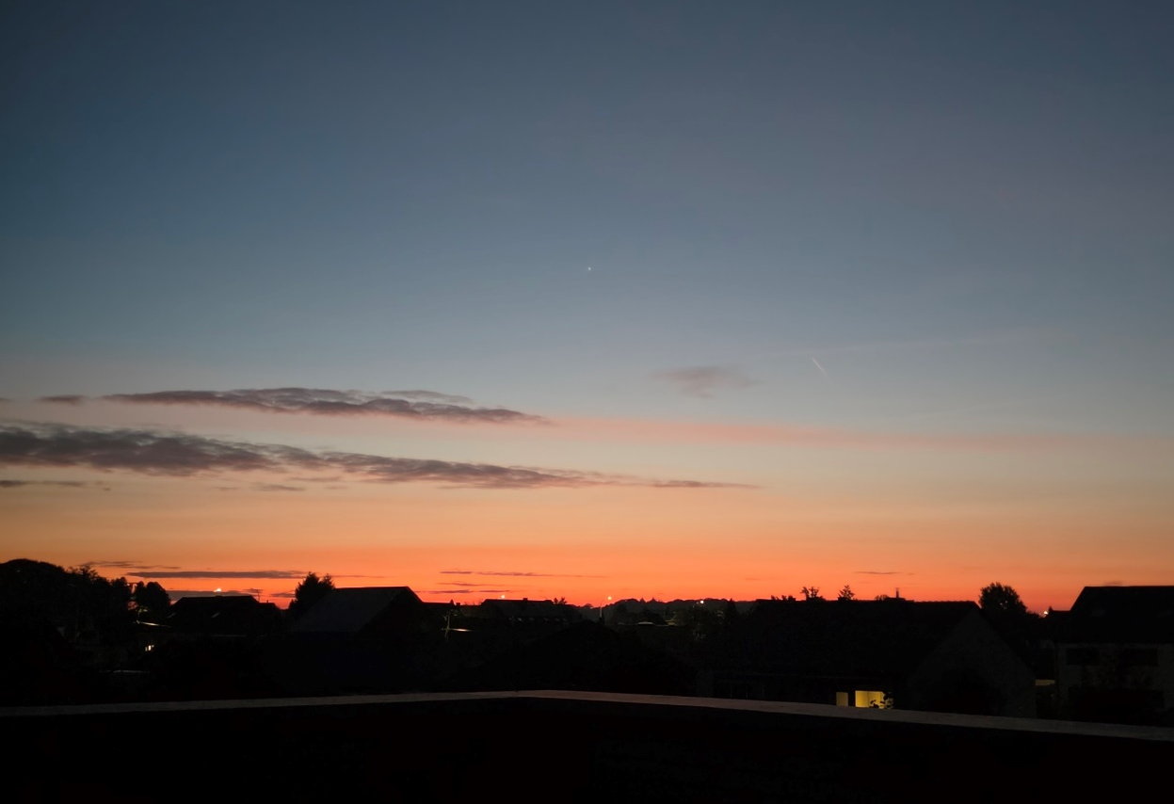
Figure 2. Venus Rising. South East, 2 October 2025, 7:02 a.m., Diest, Belgium.
Based on my study’s observations, enchantment can be defined as a profound experience of happiness, whether instant or gradual, that peaks and then slowly subsides, as a feeling of peace permeates the whole experience. The enchantment derived from observing the sky, however, can be different from the experience of viewing a piece of art, like a painting. This could be attributed to the association of the sky with the mystery of reality, which can elicit feelings of connection or belonging besides enchantment. And because watching the sky requires active participation in what one sees, and every sight is a one-of-a-kind experience, it can instantly lead to a connection with the cosmos, making it a uniquely special moment between the observer and the sky. This is exactly what Casey means when he discusses the Bachelardian phenomenology of the instant and the essential novelty by saying: ‘But in this jaillissement, this inconsistent gushing and unstable sprouting, we receive time’s gift. And we do so in two guises: the sudden and the surprising’.

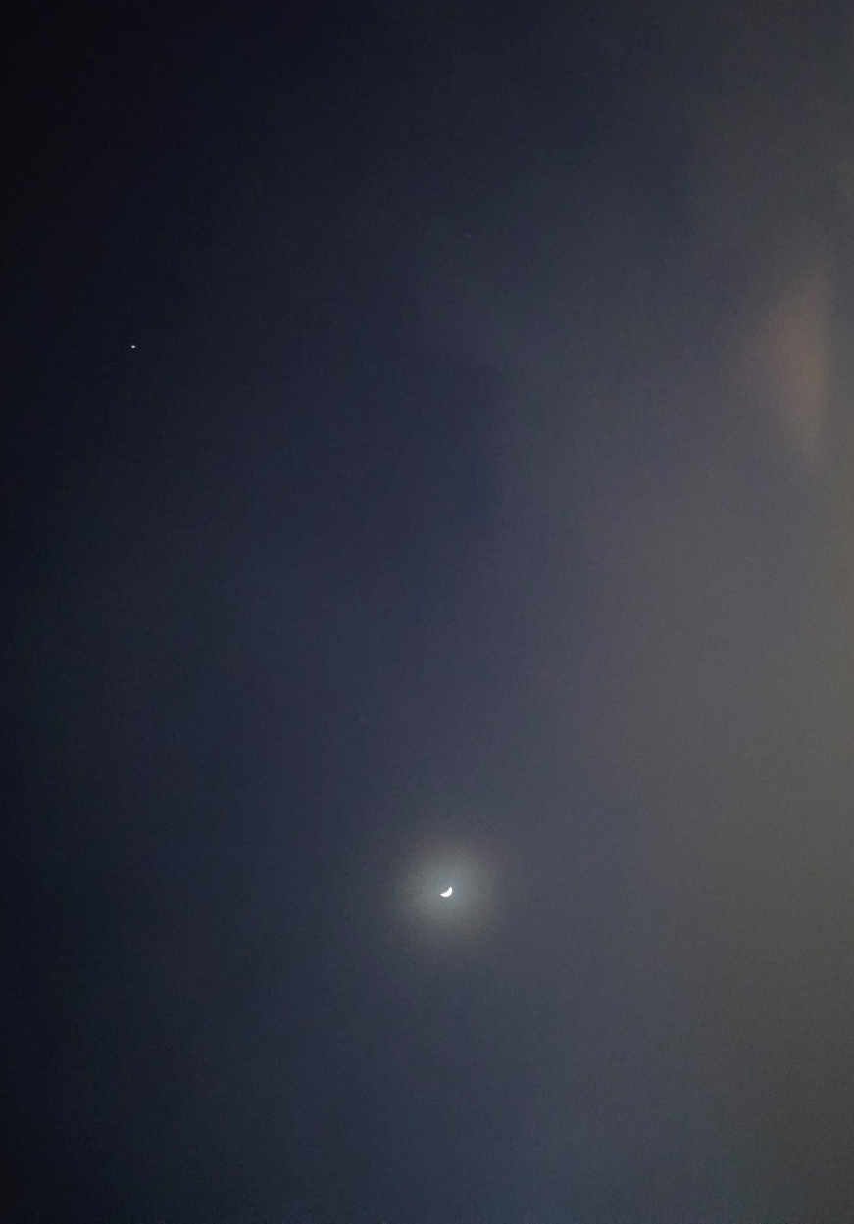
Figure 3. That Blue Hour. South East, 16 October 2025, 7:15 a.m., Diest, Belgium.

Thoughts from the Heavens
One of the suggestions that is possible to discern throughout the sky journal is that by looking at the heavens, one can get a sense of knowledge, notion, or reasoning. To illustrate this, we can look at the entry of October 2: ‘When I look at the night sky, [...], I always feel a strong inner desire to fuse with that very sighting. It makes me understand how much there is. The cosmos. And how small is any earthly worry to the vast sky and the stars’. Here, the main concluding reasoning appears to be the one of being small in comparison to the vast heaven. A sense of insignificance makes one understand how great the cosmos is compared to our daily preoccupations. This is the initial perception and the intuitive apprehension. But after a series of observations, on October 22 (see Figure 4), the aforementioned reasoning appears to be reversed:
[By] being immersed, looking at it [the heaven], it felt as if each star was a single being, saying “hi” from above [...]. From nothing to a sky full of stars (plus Saturn). [...] I love looking at the starry night. One never feels lonely. [...]. Some say that we are indeed insignificant compared to how vast the Universe is. I [now] disagree. It is that moment when one, alone, looks at the starry sky, that one can get an understanding of great significance. For being part of this vast universe.
Here we can see how, by a deeper comprehension, the previous sense of insignificance changes to an understanding of greater significance simply because of being part of reality, for co-participating in what there is. To get to this conclusion, the observer must pass the initial phases of perception and apprehension, in order to reach the third stage of comprehension. Gillies distinguishes apprehension from comprehension by saying that apprehension is grasping an object in an ungrounded way, while comprehension is grasping it in a way that is masterful.

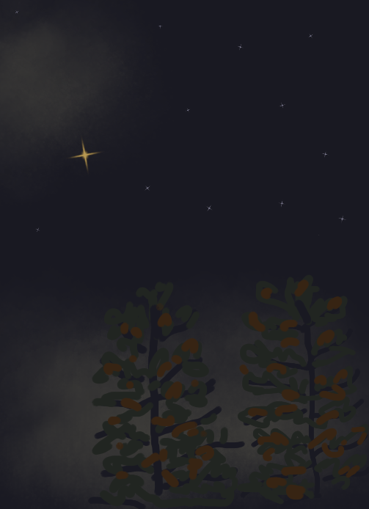
Figure 4. Saturn in a Sky Full of Stars. South East, 22 October 2025, 10:01 p.m., Diest, Belgium [digitally painted with PENUP]

Conclusion
Returning to the idea suggested in the initial quote from van Gogh’s letter, can life seem enchanted by being aware of the stars and infinity on high? From the observations made in this essay, we can assert that this is the case. This study suggests that the interplay between the primal cosmological quality of darkness and light, the unlimited vastness of the sky, and the feelings of connection and belonging aroused by a unique moment of observation between the observer and the dark sky, can evoke profound feelings of enchantment. Ultimately, the vast starry sky, existence, imagination, and enchantment are all inextricably interwoven.

Bibliography

Campion, Nicholas, Astrology And Cosmology In The World’s Religions (New York: New York University Press, 2012).
Campion, Nicholas, ‘Enchantment And The Awe Of The Heavens’, ed. By Enrico Maria Corsini, The Inspiration Of Astronomical Phenomena VI, 441 (Padua: ASP Conference Series, 2011), 415-422 (p. 419) <https://adsabs.harvard.edu/pdf/2011ASPC..441..415C> [accessed 6 November 2025].
Curry, Patrick, Art And Enchantment: How Wonder Works (Abingdon: Routledge, 2023) < https://r4-vlebooks-com.ezproxy.uwtsd.ac.uk/Reader?ean=9781000853247> [accessed 6 November, 2025].
Etherington, Kim, Becoming A Reflexive Researcher: Using Our Selves In Research (London: Jessica Kingsley Publishers, 2004).
Hand, Robert S., Night and Day: Planetary Sect in Astrology (Orleans, MA: ARHAT, 1995).
Hesiod, Theogony, Works And Days, Testimonia, ed. and transl. by Glenn W. Most (Cambridge, MA: Harvard University Press, 2007), p. 13, sect. 123 < https://www-loebclassics-com.ezproxy.uwtsd.ac.uk/view/LCL057/2007/volume.xml> [accessed 5 November 2025].
Kaplan, Edward K., ‘Gaston Bachelard's Philosophy Of Imagination: An Introduction’, Philosophy And Phenomenological Research, 33.1 (1972), 1-24 <https://www.jstor.org/stable/2106717?seq=1&cid=pdf-reference#references_tab_contents> [accessed 28 October 2025].
Gillies, John, ‘Towards A Phenomenology Of Shakespeare’s Sky’, Linguaculture, 14. 1 (2023), 69-81 <DOI: 10.47743/lincu-2023-1-0331> .
Rilke, Rainer. M., The Book Of Hours: Prayers To A Lowly God, trans. by Annemarie S. Kidder (Evanston: Northwestern University Press, 2001).
Rizo-Patron, Eileen, Edward S. Casey and Jason M. Wirth (eds.), Adventures In Phenomenology: Gaston Bachelard (Albany, NY: SUNY Press, 2017).
Rolston, Holmes III, ‘Celestial Aesthetics: Over Our Heads And/Or In Our Heads’, Theology And Science, 9. 3 (2011), 273-285 <DOI: 10.1080/14746700.2011.587663>.
Salimpour, Saeed, Russel Tytler and Michael T. Fitzgerald, ‘The Meeting of Old Friends: Exploring the Art‑Science Dynamic in the Context of Astronomy and Astronomy Education’, Science & Education, 34 (2025), pp. 2707-2737 <DOI: 10.1007/s11191-024-00604-1>.
Van Gogh, Vincent, The Letters Of Vincent Van Gogh, ed. by Ronald de Leeuw (London: Penguin Books, 1997) < https://www-vlebooks-com.ezproxy.uwtsd.ac.uk/Product/Index/662139?page=0&startBookmarkId=-1> [accessed 5 Nov 2025].

Vincent van Gogh, The Letters Of Vincent Van Gogh, ed. by Ronald de Leeuw (London: Penguin Books, 1997), p. 164 < https://www-vlebooks-com.ezproxy.uwtsd.ac.uk/Product/Index/662139?page=0&startBookmarkId=-1> [accessed 5 Nov 2025].
Kim Ehterington, Becoming A Reflexive Researcher: Using Our Selves In Research (London: Jessica Kingsley Publishers, 2004), p. 117.
Anton Vydra, ‘Bachelard Vis-À-Vis Phenomenology’, in Adventures In Phenomenology: Gaston Bachelard, ed. by Eileen Rizo-Patron, Edward S. Casey and Jason M. Wirth (Albany, NY: SUNY Press, 2017), pp. 91-106 (pp. 96-97).
Robert S. Hand, Night And Day: Planetary Sect In Astrology (Orleans, MA: ARHAT, 1995), p. 5.
Rainer M. Rilke, The Book Of Hours: Prayers To A Lowly God, trans. by Annemarie S. Kidder (Evanston: Northwestern University Press, 2001), p. 13.
Nicholas Campion, Astrology And Cosmology In The World’s Religions (New York: New York University Press, 2012), p. 35.
Nicholas Campion, Astrology And Cosmology In The World’s Religions, p. 57.
Ibid. p. 85.
Hesiod, Theogony, Works And Days, Testimonia, ed. and transl. by Glenn W. Most (Cambridge, MA: Harvard University Press, 2007), p. 13, sect. 123 < https://www-loebclassics-com.ezproxy.uwtsd.ac.uk/view/LCL057/2007/volume.xml> [accessed 5 November 2025].
Nicholas Campion, Astrology And Cosmology In The World’s Religions, p. 97.
Ibid. p. 113.
John Gilles, ‘Towards A Phenomenology Of Shakespeare’s Sky’, Linguaculture, 14. 1 (2023), 69-81 (p. 72) <DOI: 10.47743/lincu-2023-1-0331> .
Holmes Rolston III, ‘Celestial Aesthetics: Over Our Heads And/Or In Our Heads’, Theology And Science, 9. 3 (2011), 273-285 (p. 282) <DOI: 10.1080/14746700.2011.587663>.
Edward K. Kaplan, ‘Gaston Bachelard's Philosophy Of Imagination: An Introduction’, Philosophy And Phenomenological Research, 33.1 (1972), 1-24 (p. 5) <https://www.jstor.org/stable/2106717?seq=1&cid=pdf-reference#references_tab_contents> [accessed 28 October 2025].
Patrick Curry, Art And Enchantment: How Wonder Works (Abingdon: Routledge, 2023), p. 2 < https://r4-vlebooks-com.ezproxy.uwtsd.ac.uk/Reader?ean=9781000853247> [accessed 6 November, 2025].
Nicholas Campion, ‘Enchantment And The Awe Of The Heavens’, Ed. By Enrico Maria Corsini, The Inspiration Of Astronomical Phenomena VI, 441 (Padua: ASP Conference Series, 2011), 415-422 (p. 419) < https://adsabs.harvard.edu/pdf/2011ASPC..441..415C> [accessed 6 November 2025].
Saeed Salimpour, Russel Tytler and Michael T. Fitzgerald, ‘The Meeting Of Old Friends: Exploring The Art‑Science Dynamic In The Context Of Astronomy And Astronomy Education’, Science & Education, 34 (2025), pp. 2707-2737 (p. 2729) <DOI: 10.1007/s11191-024-00604-1>.
Edward S. Casey, ‘The Difference An Instant Makes: Bachelard’s Brilliant Breakthrough’, in Adventures In Phenomenology: Gaston Bachelard, ed. by Eileen Rizo-Patron, Edward S. Casey and Jason M. Wirth (Albany, NY: SUNY Press, 2017), pp. 19-28 (p. 22).
John Gillies, ‘Towards A Phenomenology Of Shakespeare’s Sky’, p. 71.

