Sea life automotive sculpture.
Introduction
For this project I intend to make an automotive sculpture that imitates sea life, a sculpture that will be able to be driven, but is not made for road use, with practicality being unimportant. The focus being upon the aesthetic. Only one will be hand built, to go with a series of other sea life inspired vehicles, which will be exhibited at galleries and car shows. The vehicle will bring attention to endangered species of sea life. As well as be an inspiration to designers (through unconventional material use and non-functional design).
Research
To start my research, I investigated art cars of the past and the artists involved with this area, and whether galleries would exhibit an automotive sculpture.
The first art cars I came across are the Bayerische Motoren Werke AG (BMW) art cars. The first 4 were all done on their own initiative and were not organised by BMW. These artists are Alexander Calder, Frank Stella, Roy Lichtenstein and Andy Warhol and were done from 1975-1979. Since these, BMW has commissioned artists to work on a particular car often, for adverts and special releases, but also for liveries for some of their race cars. These are cars with vivid hand paintings on and eye-catching wraps, using the artists’ style. 7 out of 19 of the art cars went on exhibition between October 2018 — February 2019, in Munich at the BMW museum. (BMW Group, 2017)
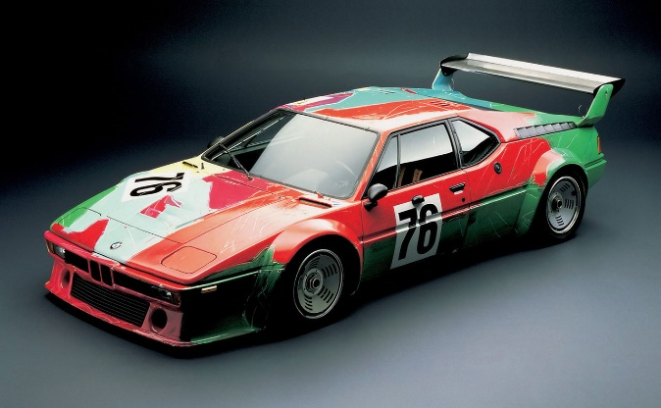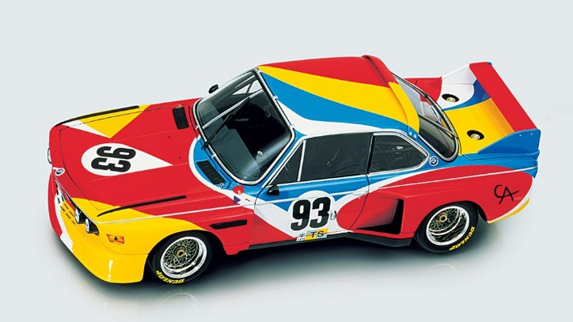
The New York Guggenheim held an exhibition called “the art of the motorcycle” in 1998 for 3 months, on display were 114 motorcycles chosen for their design excellence and, or historic importance. This exhibit attracted the largest crowds to ever attend the Guggenheim. And was exhibited around the world. (Falco, 2016)
Total attendance at these four venues was over 2 million, placing it in the top five exhibitions ever presented by any museum. (Falco, 2016)
Alastair Gibson is an artist who is inspired by sea life and makes carbon fibre sculptures of them, he has a 20-year background in Formula 1 as a mechanic and is fascinated by the similarities he saw between motorsport and sea creatures. In his pieces he uses carbon fibre extensively, with recycled parts from Formula 1 cars. Gibson is a forerunner of carbon fibre sculpting. (Carbon Art 45, 2020)
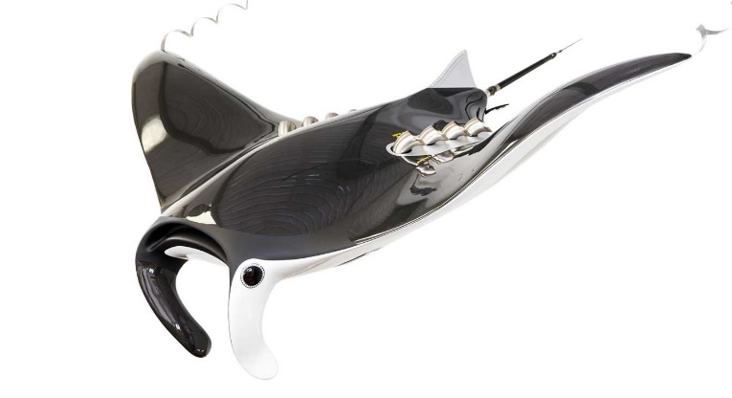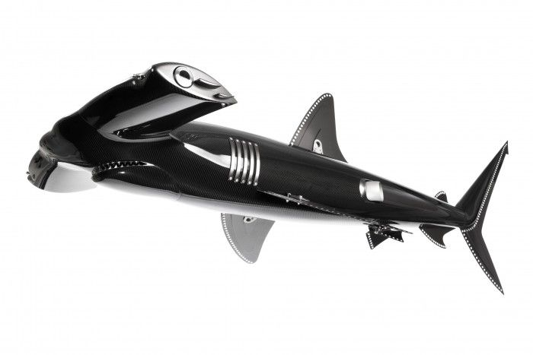
Art cars becoming more mainstream.
I plan to exhibit and then auction my vehicle in the next few years. The predicted market for art cars and specialist bespoke vehicles will grow exponentially in the future.
From my research, I believe that autonomous travel will take over the world, in some form of shared vehicles through a type of subscription service, like uber but a monthly/annual subscription. This is because autonomous vehicles are vastly safer than human driven vehicles. Data published by tesla reveals that a near-miss/ accident occurs every 3.34 million miles on autopilot, compared to the US national average of 492,000 miles with normal driver (Forbes, 2019). Statistics from the National Highway Traffic Safety Administration show 94% of serious accidents are from driver error, due to factors like; miscalculations, errors of judgment, speeding, drink-driving, and phone use (NHTSA, 2020).
Also,
… there are about 25 billion car trips per year, and with some 27 million cars, this suggests an average of just under 18 trips per car every week. Since the duration of the average car trip is about 20 minutes, the typical car is only on the move for 6 hours in the week: for the remaining 162 hours it is stationary – parked. (RAC foundation, 2012).
In the USA and UK, cars are not used 95% of the time, meaning they take up space. Changing to autonomous travel would mean car parks could be converted for recreational use.
Furthermore, the change to autonomous travel will mean there will be substantially less congestion. Most congestion is caused by human drivers, whereas autonomous vehicles do not prioritise themselves and work in union to optimise travel for everyone (Frank, 2020). This would mean people would spend less time on their daily commutes, giving people more free time, promoting human flourishing.
These factors determine that autonomous travel will come about, meaning people will not be required to own a vehicle. The change in vehicle usage and ownership will likely result in automotive enthusiasts owning a vehicle for pleasure and recreation, rather than afore mentioned. Many people will want track/ performance orientated cars for fun, whilst others would prefer a significant, bespoke vehicle for collections, showing and display.
The market for bespoke and limited-edition vehicles has already started to bloom, as high-end automotive companies have started to release many more limited-edition vehicles with bespoke options being more accessible than ever (at a price). This is because many people are becoming super rich: “Credit Suisse’s latest global wealth report shows there are 46.8 million millionaires (USD) worldwide, up 1.1 million over the last 12 months” and is estimated that 1,700 US people become millionaires each day (Millionaire foundry, 2020). Automotive companies want to provide for this growing market and compete to cater for the super-rich. Porsche revealed the new “Porsche Exclusive Manufaktur Heritage Editions”. These editions have unique bespoke options, because so many 911’s were getting expensive customization: “About 50 percent of 911’s get customized in some form by Porsche Exclusive Manufaktur” (Writer, 2020), they wanted to give the option for richer clients to have a more exclusive 911 than their peers.
It’s a trend we’re seeing repeated at Ferrari, Lamborghini, Aston Martin and McLaren, as they build ever-smaller runs of bespoke cars to cater for the rich list’s whims. (Pollard, 2019).
Endangered sea life.
Sea life and oceans need help, this project will raise awareness for sea life conservation. Overfishing is a huge problem destroying ecosystems, many shark species are endangered/ on brink of extinction due to overfishing (of their prey and themselves), “The latest research suggests that around 100 million sharks may be killed annually, often targeted for their fins.” (WWF, 2020). Another problem effecting oceans is habitat destruction, due to plastic pollution, changing climates and polluted water. (WWF, 2020)
We’ve seen albatrosses come back with their belly full of food for their young. You think it’s going to be squid, but it’s plastic (Sir David Attenbourgh, 2017)
Automotive sculpture parameters.
This vehicle is not meant to be ergonomic, comfortable or useful, everything is made to resemble a sea creature, to spark the imagination and excite the observers. It has no requirement for a specific number of passengers, or luggage compartments, and other things considered essential in daily commuting vehicles.
It is not intended for city roads or track days. The vehicle is going to be seen in exhibition spaces, personal collections, car events, where it will be prized for its aesthetics not for its function.
It will be exhibited at galleries around the world before anyone will own it. This is so it is used to spread awareness about endangered species of sea life, which is the piece’s primary goal.
I will exhibit my piece with a series of other similar automotive sculptures, I will have made, in galleries and exhibitions around the world for a couple of years, to give the opportunity for many people to see. It would take a couple of years to build this series of sea life sculptures, so the project would be finished by 2025, but there is no goal or deadline. Following this I would auction them or sell them to galleries. Some of the profits I make would go towards sea life conservation efforts.
There are many people who want to own spectacular or meaningful art for their private collections. Some people want to become involved in the art community, some want to help and support creatives they follow, in buying completed art works.
Our lives are enriched by beautiful and stimulating works, whether in the home or other spaces. We want to support the creative talents of artists and engage in the cultural dialogues of our time. We feel a strong emotional connection to the works we buy. The list goes on. And then there’s the added bonus that a work we purchase might go up in value. (Saatchi art, 2020)
I have no price goal for this project, as long as I am able to cover the costs of building and enough excess profit to be able to fund sea life conservation efforts. I hope after exhibiting it, the piece may get media coverage and if it becomes popular enough, it may become highly valuable. This is of no consequence to me though, my goal is to exhibit my piece and hope it becomes popular. This would further my career as an artist, and fund other automotive sculpture projects I plan to pursue.
When this art piece is produced, I will handcraft all the surfaces fit and shape to a pre-made/ bought chassis. The materials used would be the materials that best represented the sea creatures, not necessarily the best materials for use on vehicles. However, viable for use on a moving vehicle (not too heavy or fragile).
A replica will never be produced. If it were to be reproduced it would take away from the art piece. However, I would want to make a series of similar sculptures, but with different sea creatures represented. It would be worth having a series of sculptures, to fill an exhibition and not display a single piece, this is more impactful.
There are no ambitious performance goals for this vehicle, providing it could make a reasonable speed, minimum 30-40mph, for short drives on private roads or around car shows, so it can still be classed as a functioning vehicle to some extent.
The art piece needs to be a manageable size, so it can be transported and exhibited without issues, but it will not need to conform to any road legal restrictions, maximising length, width, height parameters.
Ideally, I would use a hydrogen powertrain, as this powertrain produces water as its only emission (when running). I like this proposal as there are many creative ways in which the water could be released: for example, running over body panels. Having a powertrain producing water, ties in with the sea theme. As well as promoting an alternative to fossil fuels, which benefits sea life. A negative of using this powertrain is that it is a relatively new technology, is expensive and hard to obtain. Therefore, for a sculpture I will be building it is impractical, as my budget will be low for initial projects. In future projects I would investigate hydrogen powertrains if I had a larger budget.
Alternatively, an electric powertrain could be used, as this has been tried and tested, and more accessible. However, this vehicle will be driven on occasion, not regularly, so the impacts of making a battery, outweigh zero emissions the powertrain produces.
The most practical solution is to recycle a second-hand engine. Lowering carbon footprint of this project. Although fossil fuels will be burnt, due to occasional use minimal fuel will be used, meaning the positive impact from raising awareness about endangered sea life, outweighs the emissions this engine would produce.
Conclusion.
The 2 designs taken forward are both inspired by sharks, one is heavily inspired by Manta Rays and the other is inspired by the Thresher Shark.
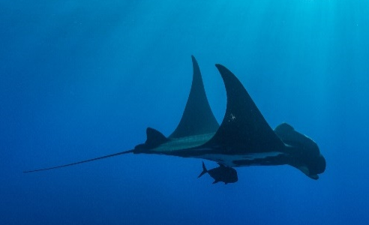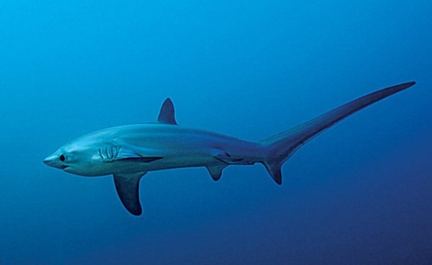
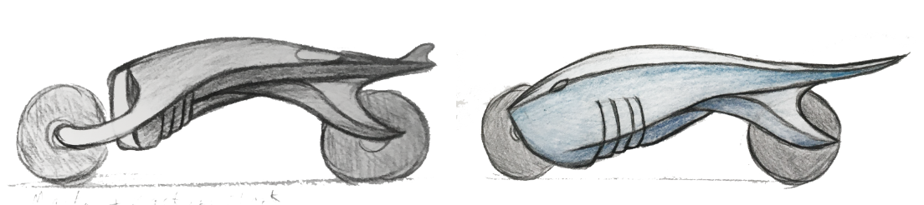I love the Manta Ray design, as the large mouth works well as the front air intake, the large gills can be manipulated into vents along the underside. The cephalic lobes (large appendages on either side of mount) work perfect as front forks.
The form of the Thresher Shark is very appealing, it looks so mean and aggressive. Motorbike’s share many key aspects with Thresher shark’s, built for speed and acceleration. I love how innovative this design is, the front wheel will be powered, and the rear wheel will steer. When the rear wheel turns to steer, the whole tail end pivots with it like a shark’s tail would move from side to side gracefully. The big cut out vents took inspiration from a Basking Shark’s large gills, compared to the undefined gills on a Thresher Shark.
It will have control panels imitating jellyfish, textured surfaces reminiscent of shark skin. I want every aspect of the vehicle to visually resemble a sea creature. For example, I have started to develop exhaust designs inspired by Remora Fish. Fish that attach themselves to sharks and other large sea creatures and live a symbiotic relationship (helping each other). A vehicle that tricks you into believing its cruising through the sea, as you watch it drive past.
For this shark piece, I have considered using coloured carbon fibre for much of the body work, the woven textured appearance is reminiscent of shark skin texture, it has a satin finish, which is smooth and shark-like. There is a multitude of ways to achieve a coloured carbon fibre finish: Hypetex, which uses technology that came from Formula 1 (F1), can produce coloured carbon fibre without using filamentized glass fibre, meaning their carbon does not lose the high-performance qualities of carbon (strength and lightweight). However, this material is extremely expensive, and my sculpture does not require high-performance qualities, therefore, I would use these other methods, for instance hybrid weaves with dyeable yarns such as glass, polyester and aramid, coloured copper wire woven into the fibre, spray on candy color is effective as a translucent paint (composites world, 2015).
The carbon will have to be moulded in a kiln, so this will have to be outsourced and will likely be the most expensive part of this project. To reduce costs, I will be painting over the carbon fibre, rather than using Hypetex carbon fibre. To do this, I will use candy colour method, as this would require me to do 3 coats, first using a metallic reflective basecoat, then candy color coat, and finally a clearcoat.
Design Parameter: | Description:
Target Customer | Galleries, art collectors, car collectors.
Aesthetics | An artistic motorbike reminiscent of sharks, but with visual references to other sea life.
Ergonomics | Needs to be able to accommodate a single driver, however it is not intended to be comfortable.
Size | Roughly 2m long, 1.3m tall, 0.8m wide.
Performance | No ambitious performance goals for this vehicle, minimum 30-40mph. I will probably use a second hand 100cc 2 stroke motorbike engine.
Environment | Will be kept in galleries or in private collections.
Production Quantity | I will be making one of these bikes. However, I intend on making a series of automotive sculptures to accompany it, for exhibiting.
Manufacturing  Properties | I want to handcraft as much as is plausible (important for me as an artist), carbon fibre shaping will likely have to be outsourced.
Materials Properties | Carbon fibre body for the weave aesthetic with candy coat of paint for colouration.
Target Product Cost | I intended to make little profit, enough to cover costs of production. If I were to make surplus profit, I would donate to sea life conservation.
Launch Date | I will launch this project when I have made a series of sea life sculptures to exhibit together in the next few years, by 2025.
Sustainability | I will be recycling an engine to reduce the carbon footprint of the project.

References
Autocar India, 2020. Porsche sees growing trend towards personalised vehicles. [Online]
Available at: https://www.autocarindia.com/car-news/porsche-sees-growing-trend-towards-personalised-vehicles-417650
[Accessed 7 november 2020].
Bird, G., 2018. The CAR Top 10: best art cars. [Online]
Available at: https://www.carmagazine.co.uk/features/top-10s/the-car-top-10-best-art-cars/
[Accessed 15 november 2020].
BMW Group, 2017. BMW art car. [Online]
Available at: https://www.artcar.bmwgroup.com/en/art-car/
[Accessed 20 october 2020].
Browne, E., 2019. Bugatti La Voiture Noire revealed as most expensive new car of all time. [Online]
Available at: https://www.autocar.co.uk/car-news/motor-shows-geneva-motor-show/bugatti-la-voiture-noire-revealed-most-expensive-new-car-all
[Accessed 5 november 2020].
Carbon Art 45 ltd, 2020. Alastair Gibson. [Online]
Available at: https://carbonart45.com/artist-profile/
[Accessed 15 november 2020].
Colbert, P., 2016. Why we vinyl wrapped a BMW 7 Series with a fried egg. [Online]
Available at: https://www.gq-magazine.co.uk/article/how-to-vinyl-wrap-a-car
[Accessed 12 november 2020].
Dans, E., 2019. Autonomous Driving And Elon Musk, The Visionary. [Online]
Available at: https://www.forbes.com/sites/enriquedans/2019/04/23/autonomous-driving-and-elon-musk-the-visionary/?sh=5ac2c1e95ec3
[Accessed 10 november 2020].
DeMattia, N., 2018. New BMW Art Cars Exhibit to open in Munich. [Online]
Available at: https://www.bmwblog.com/2018/10/12/new-bmw-art-cars-exhibit-to-open-in-munich/
[Accessed 9 october 2020].
Falco, C. M., 2016. Art of the Motorcyle. [Online]
Available at: https://wp.optics.arizona.edu/falco/art-of-the-motorcycle/#top
[Accessed 20 october 2020].
Farnworth, R., 2020. How Self-Driving Cars Will Reverse a 10,000 Year Trend. [Online]
Available at: https://medium.com/swlh/how-self-driving-cars-will-reverse-a-10-000-year-trend-816ba43e4964
[Accessed 27 october 2020].
Frank, B. A., 2020. How Self-Driving Cars Will Reduce Traffic Congestion. [Online]
Available at: https://medium.com/swlh/how-self-driving-cars-will-reduce-traffic-congestion-8bad5594c5d0
[Accessed 26 november 2020].
Gardiner, G., 2015. Colored carbon fiber. [Online]
Available at: https://www.compositesworld.com/articles/colored-carbon-fiber
[Accessed 24 november 2020].
Guilfoyle, U., 1998. The Art of the Motorcycle. [Online]
Available at: https://www.guggenheim.org/exhibition/the-art-of-the-motorcycle
[Accessed 23 october 2020].
Hall-Geisler, K., 2017. How Art Cars Work. [Online]
Available at: https://auto.howstuffworks.com/art-car.htm
[Accessed 26 october 2020].
Harithas, J., 1997. ART CAR MANIFESTO. [Online]
Available at: https://artcarmuseum.com/art-car-manifesto/
[Accessed 27 october 2020].
Marr, B., 2020. 5 Ways Self-Driving Cars Could Make Our World (And Our Lives) Better. [Online]
Available at: https://www.forbes.com/sites/bernardmarr/2020/07/17/5-ways-self-driving-cars-could-make-our-world-and-our-lives-better/?sh=27eb15c742a3
[Accessed 12 november 2020].
millionaire foundry, 2020. 42 Best Millionaire statistics, facts and Resources for 2020. [Online]
Available at: https://millionairefoundry.com/millionaire-statistics/
[Accessed 7 november 2020].
Nica, G., 2016. Design Concepts for the 18th and 19th BMW Art Cars Revealed. [Online]
Available at: https://www.bmwblog.com/2016/06/15/design-concepts-18th-19th-bmw-art-car-revealed/
[Accessed 24 october 2020].
Pollard, T., 2019. Bugatti Voiture Noire: £13m hyper-coupe is world's most expensive car. [Online]
Available at: https://www.carmagazine.co.uk/car-news/first-official-pictures/bugatti/la-voiture-noire/
[Accessed 5 novembr 2020].
Saatchi Gallery, 2020. How to Buy Art You Love. [Online]
Available at: https://www.saatchiart.com/stories/how-to-get-started-collecting-art/
[Accessed 17 october 2020].
Schmitt, A., 2016. It’s True: The Typical Car Is Parked 95 Percent of the Time. [Online]
Available at: https://usa.streetsblog.org/2016/03/10/its-true-the-typical-car-is-parked-95-percent-of-the-time/
[Accessed 29 october 2020].
WWF, 2020. Oceans. [Online]
Available at: https://www.worldwildlife.org/initiatives/oceans
[Accessed 16 october 2020].
WWF, 2020. Shark. [Online]
Available at: https://www.worldwildlife.org/species/shark
[Accessed 15 october 2020].

